Supplementary Information
Shea tree agroforestry systems in Northern Ghana: Population structure, management of trees and impact of canopy microclimate

Thea Jepsen, Gaia Stopponi, Niels O. G. Jørgensen

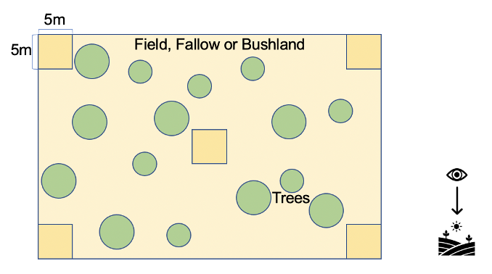
Fig. S1. Graphic presentation of the sampling setup for measuring the size distributions and densities of shea trees in the three land-use types. This sampling setup was inspired by Aleza et al., (2015).

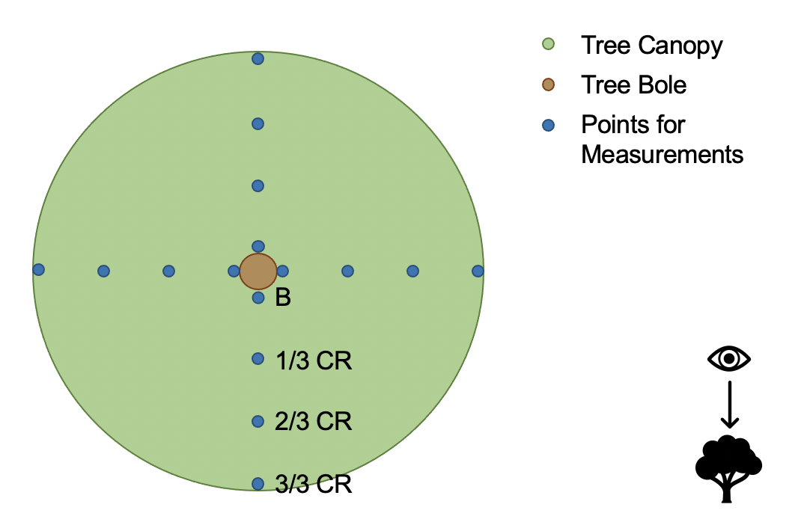
Fig. S2. Graphic presentation of points for measurements of climate variables under a shea tree canopy.
B = tree bone (next to trunk); CR = canopy radius.

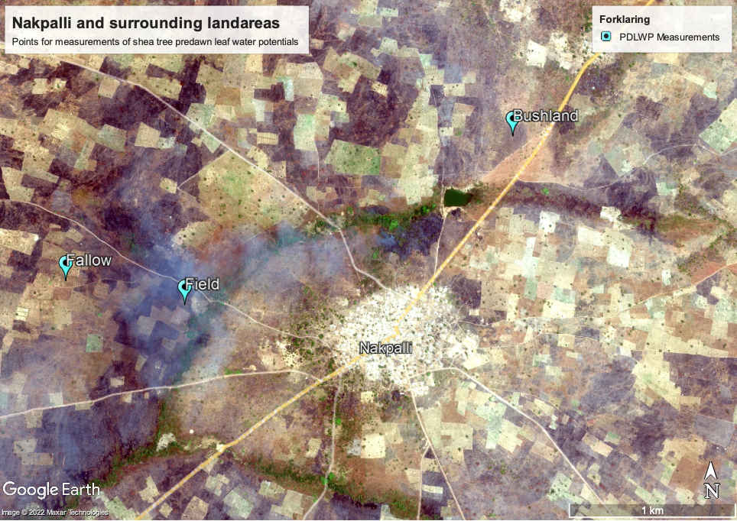
Fig. S3. Map of the locations for measurements of predawn leaf water potentials of shea trees.

Appendix A. Shea tree size distributions in fields, fallows and bushlands
Weibull was the best overall choice of distribution, providing the flexibility needed to fit all data from the three land-use types. These functions are widely used by foresters to describe tree size-distributions (Coomes & Allen, 2007) as follows:
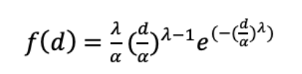
Where f(d) is the probability density, d is the tree diameter at breast height, λ is the shape parameter and α is the scale parameter. This is a probability density function, where f(d) is the probability of a variate (in this case shea tree) to have the diameter d: f(d)=PR[D=d]. Determination of Weibull curves for distribution of tree size classes was calculated in the R-software using the package fitdistrplus. Weibull curves were fitted to size distribution histograms (trees/ha) by overlay in Microsoft Excel version 16.59.

Comparison of shape and scale parameters in the three land-use types
To detect whether the shape and scale parameters provided by the functions for the Weibull distribution curves were different for the three land-use types. Shape and scale parameters for the size distributions in the 10 fields, 10 fallows and 10 bushlands were analyzed using a one-way ANOVA test:
S_{ij}=Land-use_{i} +Error_{ij} Error∼N(0,σ²)
Where S_{ij} is the shape or scale parameter of the ji’th population, Land-use_{i} is effect of the i’th land-use type (1,2,3) and Error_{ij} is residual error, assumed to be following a normal distribution with equal variance.
Appendix B. Densities of shea trees in fields, fallows and bushlands
To detect the effects that land-use may have on shea tree densities of larger shea trees >130 cm in height and of minor shea trees and seedlings <130 cm in height respectively the data were analyzed using a one-way ANOVA test:
D_{ij}=Land-use_{i} +Error_{ij} Error∼N(0,σ²)

Where D_{ij} is the shea tree (><130 cm) density (expressed in trees/ha) of the ji’th observation, Land-use_{i} is effect of the i’th land-use type (1,2,3) and Error_{ij} is residual error, assumed to follow a normal distribution with equal variance. In cases of unequal variance and/or where data was not normally distributed, data were fitted to the model using log-transformation.

Appendix C. Below-canopy microclimate
To detect the effects that shea trees may have on soil temperature, air temperature and photosynthetically active radiation at different distances to the trunk, compared to outside shea tree canopies one-way ANOVA tests with random effects of site and tree were applied. The distances to the were expressed in zones:

M_{ijk}=Zone_{i}+SITE_{j}+TREE_{k}+Error_{ijk} Error∼N(0,σ²)

M_{ijk} is the value of the microclimate variable (expressed in °C or µmol*s⁻¹) of ijk’th observation
Zone_{i} is effect of the i’th zone (1,2,3,4)
SITE_{j} is the random effect of site j (1,2,3,4)
TREE_{k} is the random effect of tree k (1,2,….5)
Error_{ijk} is residual error, assumed to follow a normal distribution with equal variance.

In cases of unequal variance and/or where data was not normally distributed, data were fitted to the model using log-transformation.

Appendix D. Yields of yams cultivated underneath and outside shea tree canopies
To detect possible effects of shea trees on yam yields at different distances to the trunk (expressed in zones) compared to yam yields outside shea tree canopies, a linear mixed model i.e., a one-way ANOVA test with random effects of site and tree was applied:

Y_{ijk}=Zone_{i}+SITE_{j}+TREE_{k}+Error_{ijk} Error∼N(0,σ²)

Y_{ijk} is the yield Y (expressed in kg/ha) of ijk’th observation
Zone_{i} is effect of the i’th zone (1,2,3,4)
SITE_{j} is the random effect of site j (1,2)
TREE_{k} is the random effect of tree k (1,2,….9)
Error_{ijk} is residual error, assumed to follow a normal distribution with equal variance.

The data were fitted to the model using log-transformation.

Appendix E. Pre-dawn water potentials of shea tree leaves from fields, fallows and bushlands
To detect the effects that land-use may have on shea tree predawn leaf water potentials a linear mixed model namely a one-way ANOVA with random effects was applied:

W_{ik}=Land-use_{i} +TREE_{k}+Error_{ik} Error∼N(0,σ²)

W_{ik} is the ψ_{p} (expressed in bar) of the ik’th observation
Land-use_{i} is effect of the i’th land-use type (1,2,3)
TREE_{k} is the random effect of tree k (1,2,….30)
Error_{ik} is residual error, assumed to follow a normal distribution with equal variance.
The data were fitted to the model using log-transformation.

Table S1.
Assessed area and number of measured trees on fields, fallows and bushlands.
 | Number of trees measured | Land area logged (ha)
Fields | 218 | 8.25
Fallows | 227 | 7.22
Bushlands | 237 | 3.26
Total | 682 | 18.74

