Table 1. The collection location, built age, and photograph of tabia samples.
Denotation | Collection Location | Date | Photograph
JY | Jingyuan Fort, Jinji Mountain, Beilun District, Ningbo City, Zhejiang Province, China. | 1880 AD | 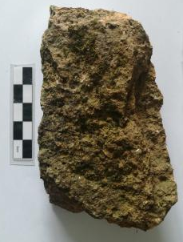
PY | Pingyuan Fort, Jinji Mountain, Beilun District, Ningbo City, Zhejiang Province, China. | 1887 AD | 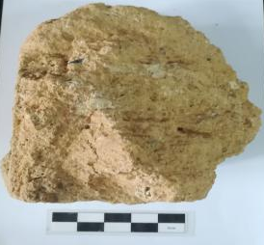
ZY | Zhenyuan Fort, Li Mountain, Beilun District, Ningbo City, Zhejiang Province, China. | 1880 AD | 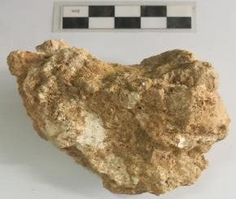
HY | Hongyuan Fort, Li Mountain, Beilun District, Ningbo City, Zhejiang Province, China. | 1887 AD | 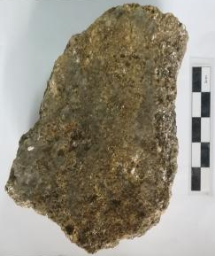
NW | Nanwan Fort, Tang Mountain, Zhapu Town, Pinghu City, Zhejiang Province, China. | 1894 AD | 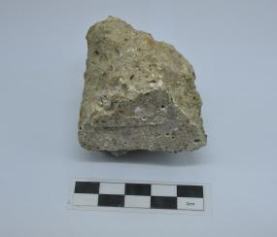
TFG | Tianfeigong Fort, Haitang Road, Zhapu Town, Pinghu City, Zhejiang Province, China. | 1874 AD | 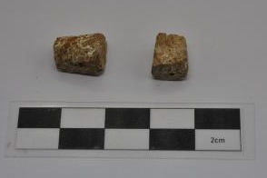
LW | Longwan Fort, Longwan Mountain, Longwan District, Wenzhou City, Zhejiang Province, China. | 1883 AD | 