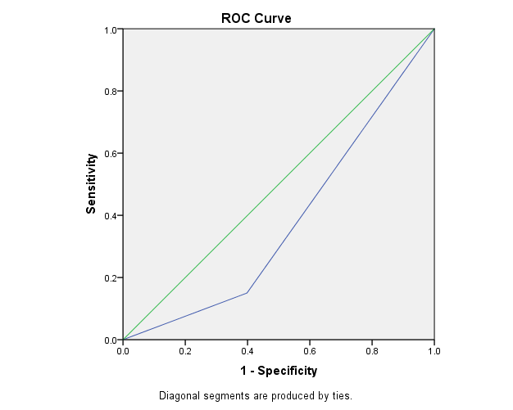
Supplementary figure 1: Receiver operating curve (ROC) analysis of the PRS classes.

Supplementary table 1: Area under curve (AUC) in ROC analysis.
Area | Std. Error | p value | 95% Confidence Interval
Area | Std. Error | p value | Lower bound | Upper bound
0.38 | .06 | 0.07 | 0.26 | 0.49

