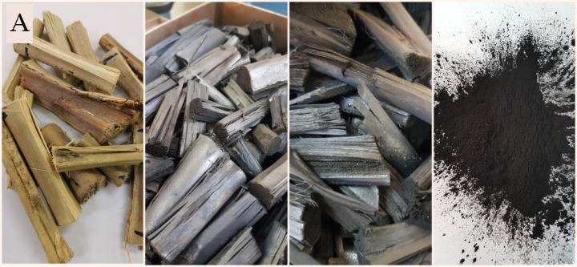
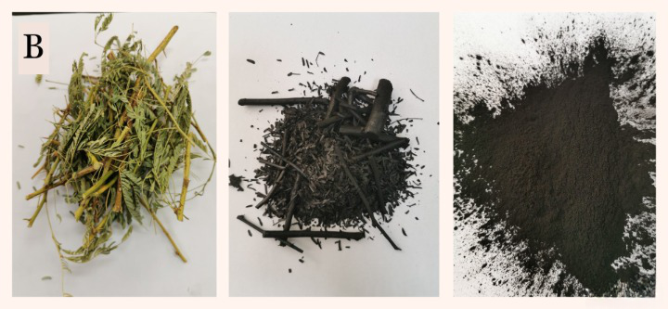
Supplementary Fig. 1. Preparation of tested biochar a) date palm and b) Prosopis

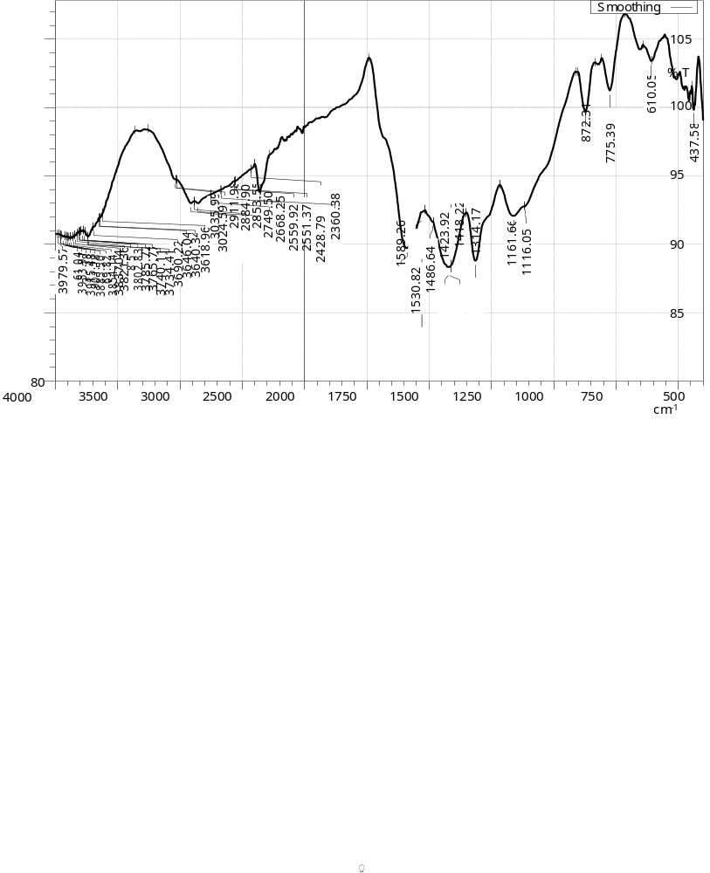
Supplementary Fig. 2. X-ray diffraction analyses of date palm biochar (B1)

Supplementary Fig. 3. The X-ray diffraction analyses of Prosopis biochar (B2)

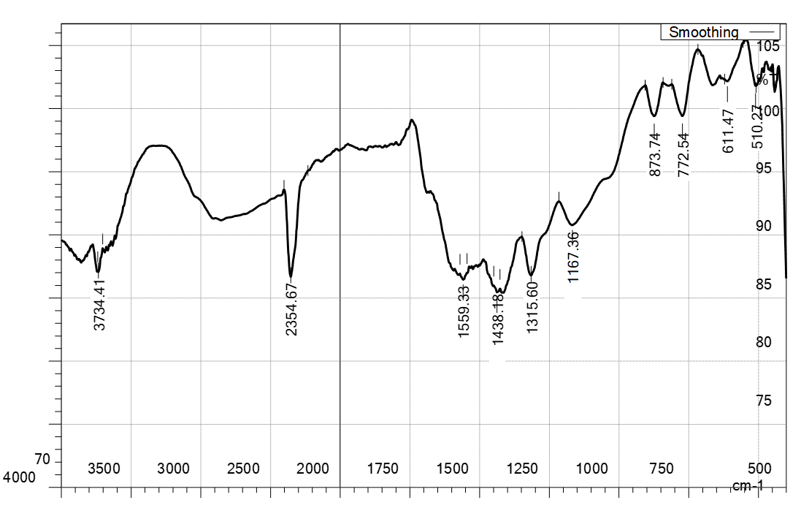

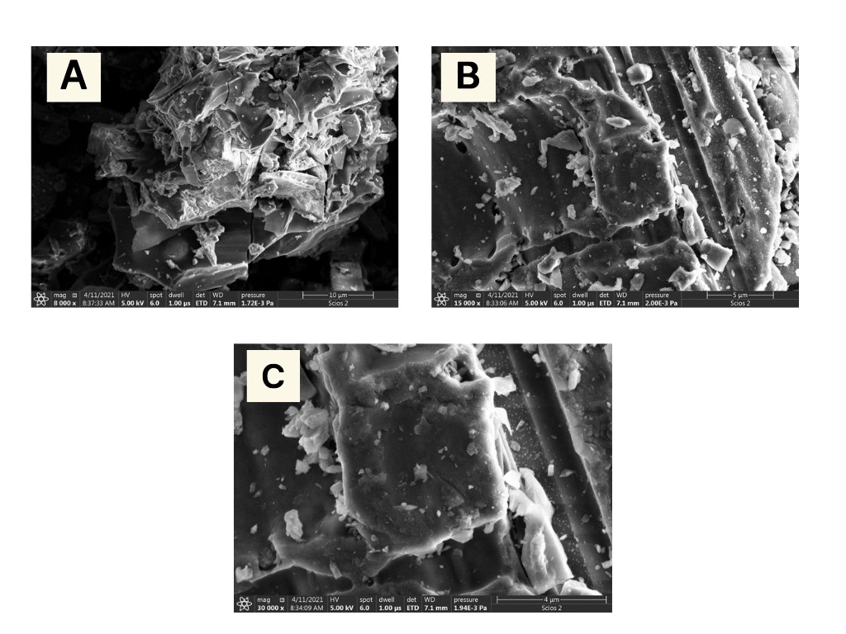
Supplementary Fig. 4. Characteristics of a date palm biochar, a) SEM at × 8000 magnification, b) SEM at X 15000 , c) SEM at X 30000

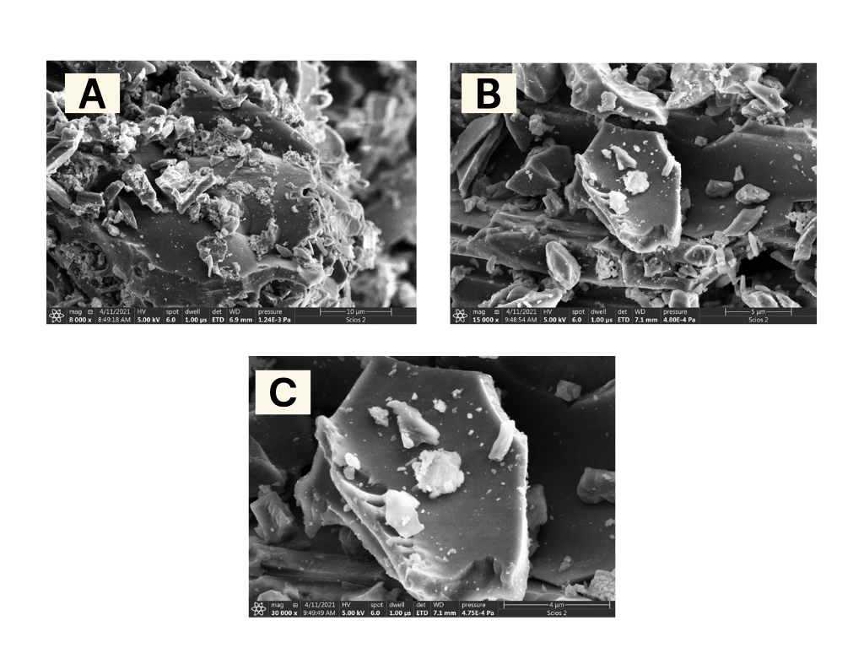
Supplementary Fig. 5. Characteristics of a Prosopis biochar, a) SEM at × 8000 magnification, b) SEM at X 15000 , c) SEM at X 30000

