Additional Figure 1. The gels are represented for ANGPTL4 in Figure2A
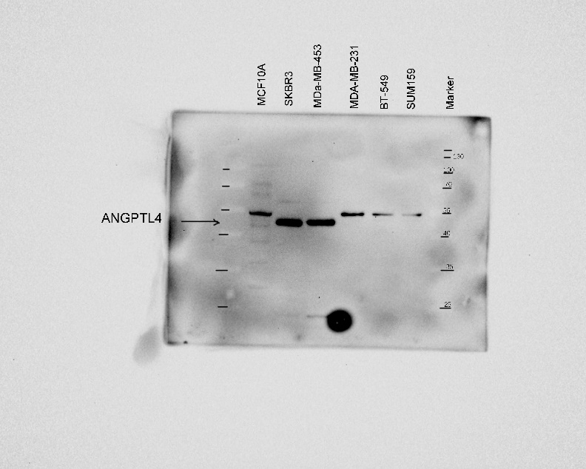

Additional Figure 2. The gels are represented for GAPDH in Figure2A

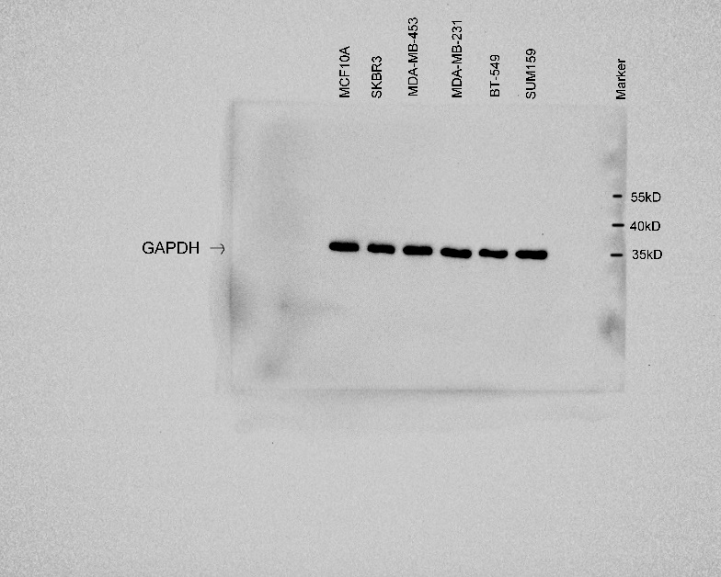

Additional Figure 3. The gels are represented for ANGPTL4 in Figure2B

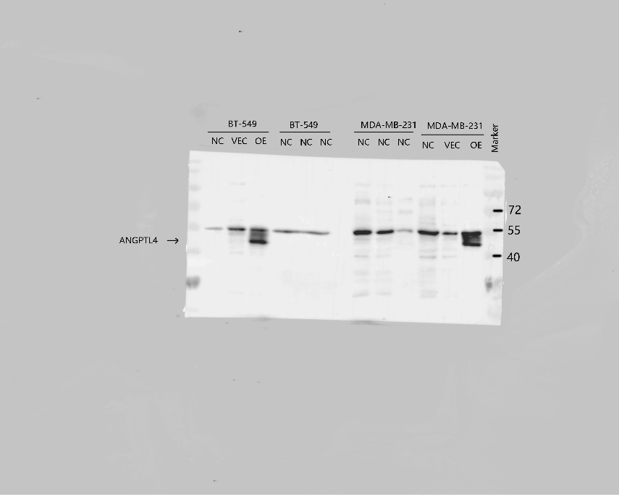

Additional Figure 4. The gels are represented for GAPDH in Figure2B
