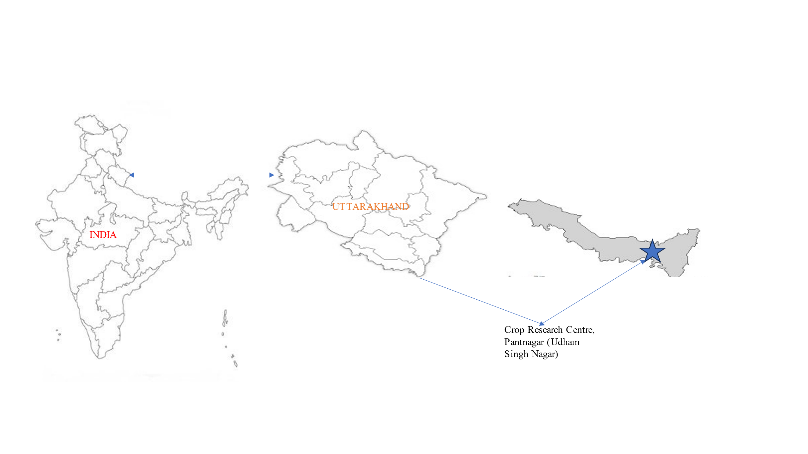
Fig. 1. Map of study area

Fig. 2: Standard meteorological week wise weather condition during crop growth period at Pantnagar

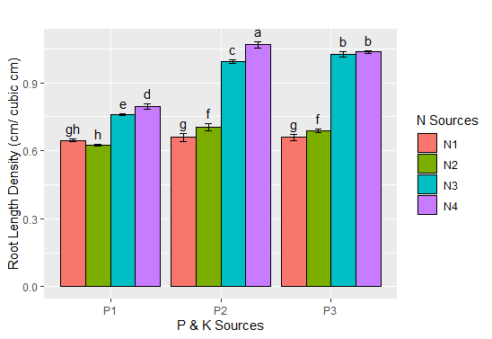

Fig 3a: Interaction effect of P & K sources and N sources on the root length density. Error bars represent SE (N1: Control; N2: 3 sprays of nano urea alone; N3: Basal @ 50 kg N/ha + 2sprays of nano urea; N4: RDN; P1: Recommended P & K; P2: IMBP + Nano DAP; P3: IMBP + Nano K).

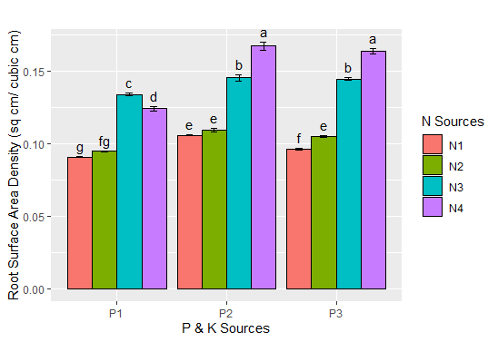

Fig 3b: Interaction effect of P & K sources and N sources on the root surface area density. Error bars represent SE (N1: Control; N2: 3 sprays of nano urea alone; N3: Basal @ 50 kg N/ha + 2sprays of nano urea; N4: RDN; P1: Recommended P & K; P2: IMBP + Nano DAP; P3: IMBP + Nano K).
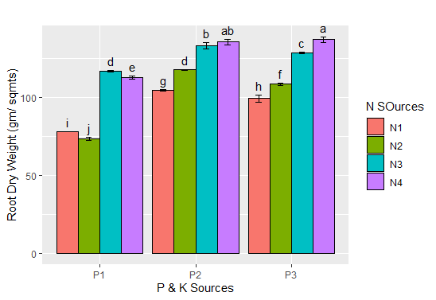
Fig 3c: Interaction effect of P & K sources and N sources on the root dry weight. Error bars represent SE (N1: Control; N2: 3 sprays of nano urea alone; N3: Basal @ 50 kg N/ha + 2sprays of nano urea; N4: RDN; P1: Recommended P & K; P2: IMBP + Nano DAP; P3: IMBP + Nano K).
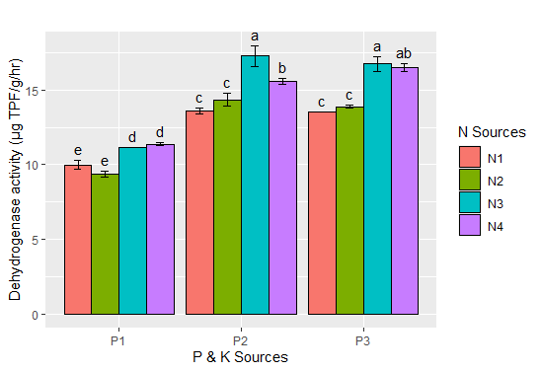
Fig 4: Interaction effect of P & K sources and N sources on dehydrogenase activity in rhizosphere of wheat. Error bars represent SE (N1: Control; N2: 3 sprays of nano urea alone; N3: Basal @ 50 kg N/ha + 2sprays of nano urea; N4: RDN; P1: Recommended P & K; P2: IMBP + Nano DAP; P3: IMBP + Nano K).

Fig 5: pH, EC and Organic Carbon as affected by different sources of nitrogen, phosphorus and potassium (Pooled mean). NS stands for non-significant values for parameter. Error bars are on the basis of standard deviation values.
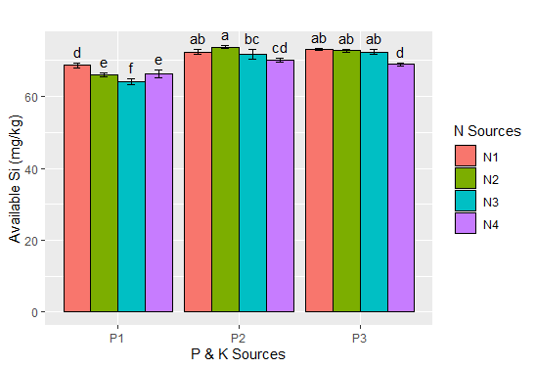
Fig 6: Interaction effect of P & K sources and N sources on available silicon (mg/ kg of soil) after harvest. Error bars represent SE (N1: Control; N2: 3 sprays of nano urea alone; N3: Basal @ 50 kg N/ha + 2sprays of nano urea; N4: RDN; P1: Recommended P & K; P2: IMBP + Nano DAP; P3: IMBP + Nano K).

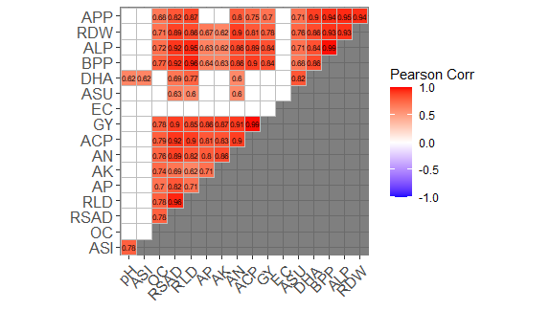

Fig 7: Correlation analysis (p=0.05) between different parameters and grain yield of wheat. Blank cells represent non-significant correlation (APP: Actinomycetes Population; RDW: Root dry weight; ALP: alkaline phosphatase activity; BPP: Bacteria population; DHA: Dehydrogenase activity; ASU: Available sulphur; EC: Electrical conductivity; GY: Grain yield; ACP: acid phosphatase activity; AN: available nitrogen; AK: Available potassium; AP: Available phosphorus; RLD: Root length density; RSAD: Root surface area density; OC: Organic carbon; ASI: Available silicon).

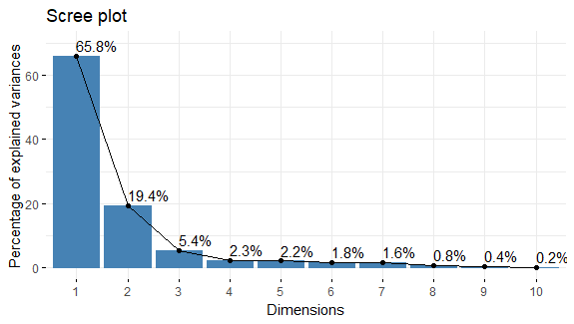
Fig 8: Scree Plot for the Principal Component Analysis

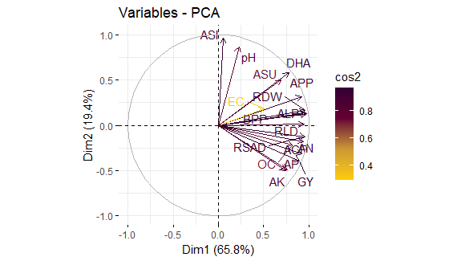
Fig 9: Principal Component Analysis for different parameters

