Supplementary Information
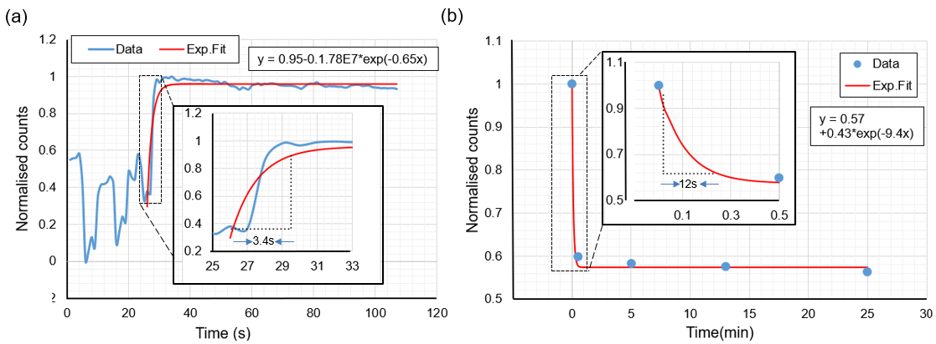
Supplementary Fig S1. Response time of the sensor. (a) Normalised counts of 107 images were recorded on the camera in real-time at 1 frame-per-second. The initial power fluctuation is an artifact of input light source variation. Inset: the region in which the rise time has been calculated from the fit to the data, showed for better clarity. The rise time is calculated to be 3.4 seconds. (b) Normalised counts among five intensity profiles were recorded on the camera for pH 2 (first data point) and pH 11 (next four consecutive data points) and the exponential fit to data. Inset: region in which the fall time has been measured from the fit to the data. The fall time is calculated to be 12 seconds.

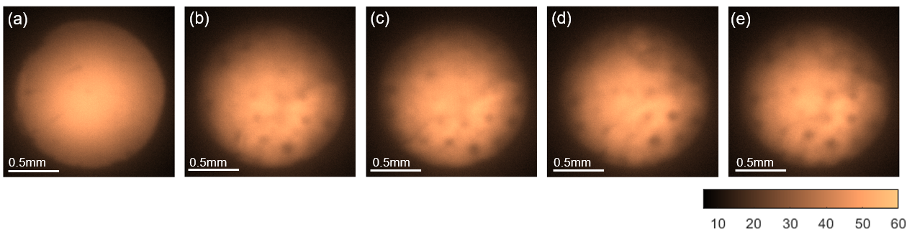
Supplementary Fig S2. False color images of the MCF sensor signal for pH 8.13. (a) Reference image before the obstacles filled in port 2. (b-e) Images taken after inserting the obstacles in port 2. The sensor plug was inserted in port 2 and an image is recorded on the camera. The sensor plug was then removed from the port and reinserted, and the images were taken three more times. Each time, the sensor plug is slightly rotated resulting in changes in the obstacle position across the sensor.

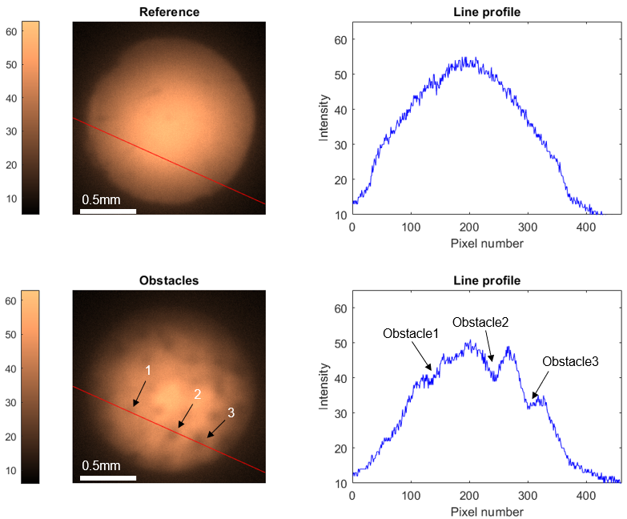
Supplementary Fig S3. Intensity profile across the sensor for the reference (top) and in the presence of obstacles (bottom). The intensity line profile across the sensor when there is no obstacle present shows a clear Gaussian profile while the line profile in the presence of obstacles across the same sensor region (red lines) clearly shows 3 valleys (reduction of signal), indicating the presence of three obstacles (marked as 1,2, and 3 in the bottom left image).

