Supplementary materials, S1. Countries or special districts in analytical distinction regions for plastics waste flows.
Region No. | Regions defined | Countries or special districts
1 | Africa | Algeria, Angola, Benin, Botswana, British Indian Ocean Territories, Burkina Faso, Burundi, Cabo Verde, Cameroon, Central African Republic, Chad, Comoros, Congo (Brazzaville), Congo (Kinshasa), Cote d'Ivoire, Djibouti, Egypt, Equatorial Guinea, Eritrea, Eswatini, Ethiopia, French Southern and Antarctic Lands, Gabon, Gambia, Ghana, Guinea, Guinea-Bissau, Kenya, Lesotho, Liberia, Libya, Madagascar, Malawi, Mali, Mauritania, Mauritius, Mayotte, Morocco, Mozambique, Namibia, Niger, Nigeria, Reunion, Rwanda, Sao Tome and Principe, Senegal, Seychelles, Sierra Leone, Somalia, South Africa, South Sudan, St Helena, Sudan, Sudan (through Jul 2011), Tanzania, Togo, Tunisia, Uganda, Zambia, Zimbabwe
2 | Australia and Oceania | Australia, Christmas Island, Cocos (Keeling) Islands, Cook Islands, Fiji, French Polynesia, Heard and McDonald Islands, Kiribati, Marshall Islands, Micronesia, Nauru, New Caledonia, New Zealand, Niue, Norfolk Island, Palau, Papua New Guinea, Pitcairn Islands, Samoa, Solomon Islands, Tokelau, Tonga, Tuvalu, Vanuatu, Wallis and Futuna
3 | Europe | Albania, Andorra, Armenia, Austria, Azerbaijan, Belarus, Belgium, Bosnia and Herzegovina, Bulgaria, Croatia, Cyprus, Czech Republic, Denmark, Estonia, Faroe Islands, Finland, France, Georgia, Germany, Gibraltar, Greece, Hungary, Iceland, Ireland, Italy, Kazakhstan, Kosovo, Kyrgyzstan, Latvia, Liechtenstein, Lithuania, Luxembourg, Macedonia, Malta, Moldova, Monaco, Montenegro, Netherlands, Norway, Poland, Portugal, Romania, Russia, San Marino, Serbia, Serbia (Jan 2007 - Dec 2008), Serbia and Montenegro (Aug 2003 - Dec 2006), Slovakia, Slovenia, Spain, Svalbard, Jan Mayen Island, Sweden, Switzerland, Tajikistan, Turkey, Turkmenistan, Ukraine, United Kingdom, Uzbekistan, Vatican City
4 | North America | Canada, Greenland, Mexico, St Pierre and Miquelon
5 | Central America and Caribbean | Anguilla, Antigua and Barbuda, Aruba, Bahamas, Barbados, Belize, Bermuda, British Virgin Islands, Cayman Islands, Costa Rica, Cuba, Curacao, Dominica, Dominican Republic, El Salvador, Grenada, Guadeloupe, Guatemala, Haiti, Honduras, Jamaica, Martinique, Montserrat, Netherlands, Antilles (through Apr 2011), Nicaragua, Panama, Sint Maarten, St Kitts and Nevis, St Lucia, St Vincent and the Grenadines, Trinidad and Tobago, Turks and Caicos Islands
6 | South America | Argentina, Bolivia, Brazil, Chile, Colombia, Ecuador, Falkland Islands (Islas Malvinas), French Guiana, Guyana, Paraguay, Peru, Suriname, Uruguay, Venezuela
7 | Asia Near East | Bahrain, Gaza Strip Administered by Israel, Iran, Iraq, Israel, Jordan, Kuwait, Lebanon, Oman, Qatar, Saudi Arabia, Syria, United Arab Emirates, West Bank Administered by Israel, Yemen
8 | Asia-South | Afghanistan, Bangladesh, India, Nepal, Pakistan, Sri Lanka
9 | Asia-Other | Bhutan, Brunei, Burma, Cambodia, Indonesia, Japan, Korea, North Korea, South Laos, Macau, Malaysia, Maldives, Mongolia, Philippines, Singapore, Syria, Taiwan, Thailand, Timor-Leste, Vietnam

Supplementary materials, S2: Description of: i) processes considered, and ii) Ecoinvent processes used.
Commodity ↓ | Process | Ecoinvent process
LCA stage →
Granulated Slag (2618) | Landfilling | Basic oxygen furnace waste {RoW}| treatment of, residual material landfill | APOS, U | Slag, unalloyed electric arc furnace steel {RoW}| treatment of, residual material landfill | APOS, U
 | Ore extraction and benefication | Gravel, crushed {RoW}| production | APOS, U
 | Supplementary Cementitious Material | Cement, blast furnace slag 70-100% {US}| cement production, blast furnace slag 70-100% | APOS, U
Slag, Dross, Scalings (2619) | Landfilling | average incineration residue {RoW}| treatment of, residual material landfill | APOS, U
 | Ore extraction and benefication | Gravel, crushed {RoW}| production | APOS, U
 | Supplementary Cementitious Material | Cement, blast furnace slag 70-100% {US}| cement production, blast furnace slag 70-100% | APOS, U | Ground granulated blast furnace slag {US}| production | APOS, U
Ash & Residues (2620) | Landfilling | Inert waste, for final disposal {RoW}| treatment of inert waste, inert material landfill | APOS, U
 | Municipal incinerator | Lignite ash {RoW}| treatment of lignite ash, municipal incineration | APOS, U
 | Ore extraction and benefication | Gravel, crushed {RoW}| production | APOS, U
 | Supplementary Cementitious Material | Cement, blast furnace slag 21-35% {RoW}| cement production, blast furnace slag 21-35% | APOS, U
Ash&slag Nesoi (2621) | Landfilling | Average incineration residue {RoW}| treatment of, residual material landfill | APOS, U
 | Municipal incinerator | Lignite ash {RoW}| treatment of lignite ash, municipal incineration | APOS, U
 | Ore extraction and benefication | Gravel, crushed {RoW}| production | APOS, U
 | Supplementary Cementitious Material | Cement, blast furnace slag 21-35% {RoW}| cement production, blast furnace slag 21-35% | APOS, U
Ferrous Waste (7204) | Landfilling | Scrap steel {RoW}| treatment of, inert material landfill | APOS, U
 | Municipal incinerator | Scrap steel {RoW}| treatment of scrap steel, municipal incineration | APOS, U
 | Ore extraction and benefication | Iron ore, beneficiated, 65% Fe {RoW}| iron ore beneficiation to 65% Fe | APOS, U; Iron ore, crude ore, 46% Fe {GLO}| iron mine operation, crude ore, 46% Fe | APOS, U
 | Collection and sorting | Iron scrap, sorted, pressed {RoW}| sorting and pressing of iron scrap | APOS, U
 | Supplementary Cementitious Material | Cement, blast furnace slag 21-35% {RoW}| cement production, blast furnace slag 21-35% | APOS, U
Copper Waste (7404) | Landfilling | Copper slag {GLO}| treatment of copper slag, residual material landfill | APOS, U
 | Municipal incinerator | Scrap copper {RoW}| treatment of, municipal incineration | APOS, U
 | Ore extraction and benefication | Copper {GLO}| copper production, solvent-extraction electro-winning | APOS, U
 | Ore extraction and benefication | Copper {RoW}| production, primary | APOS, U
 | Supplementary Cementitious Material | Cement, blast furnace slag 21-35% {RoW}| cement production, blast furnace slag 21-35% | APOS, U
 | Hydrometallurgy | Copper {GLO}| treatment of non-Fe-Co-metals, from used Li-ion battery, hydrometallurgical processing | APOS, U
 | Pyrometallurgy | Copper {GLO}| treatment of non-Fe-Co-metals, from used Li-ion battery, pyrometallurgical processing | APOS, U
Nickel Waste (7503) | Landfilling | Nickel smelter slag {RoW}| treatment of, residual material landfill | APOS, U
 | Municipal incinerator | Refinery sludge {RoW}| treatment of, hazardous waste incineration | APOS, U
 | Ore extraction and beneficiation | Copper concentrate, sulfide ore {GLO}| nickel mine operation, sulfidic ore | APOS, U
 | Smelting and hybrid | Nickel, 99.5% {GLO}| smelting and refining of nickel ore | APOS, U
 | Supplementary Cementitious Material | Cement, blast furnace slag 21-35% {RoW}| cement production, blast furnace slag 21-35% | APOS, U
Aluminum Waste (7602) | Landfilling | Dross from Al electrolysis {RoW}| treatment of dross from Al electrolysis, residual material landfill | APOS, U
 | Municipal incinerator | Scrap aluminium {RoW}| treatment of, municipal incineration | APOS, U
 | Ore extraction and benefication | Bauxite {GLO}| bauxite mine operation | APOS, U
 |  | Bauxite, at mine/GLO US-EI U
 | Rotary and reverbatory furnaces for aluminium billets production. | Aluminium scrap, new {RoW}| treatment of, at refiner | APOS, U
 | Extrusion, trim, milling, and dross to produce wrought aluminium billets | Aluminium scrap, new {RoW}| treatment of, at remelter | APOS, U
 | Recovery and pre-treatment of secondary Al | Aluminium scrap, post-consumer {RoW}| treatment of, by collecting, sorting, cleaning, pressing | APOS, U
 | Supplementary Cementitious Material | Cement, blast furnace slag 21-35% {RoW}| cement production, blast furnace slag 21-35% | APOS, U
Lead Waste (7802) | Landfilling | Lead smelter slag {GLO}| treatment of, residual material landfill | APOS, U
 | Municipal incinerator | Lead in car shredder residue {RoW}| treatment of, municipal incineration | APOS, U
 | Ore extraction and benefication | Bulk lead-zinc concentrate {GLO}| zinc mine operation | APOS, U
 | Ore benefication and lead production | Lead {GLO}| primary lead production from concentrate | APOS, U
 | Smelting | Lead {RoW}| treatment of scrap acid battery, remelting | APOS, U
 | Supplementary Cementitious Material | Cement, blast furnace slag 21-35% {RoW}| cement production, blast furnace slag 21-35% | APOS, U
Zinc Waste (7902) | Landfilling | Zinc slag {GLO}| treatment of zinc slag, residual material landfill | APOS, U
 | Municipal incinerator | Zinc in car shredder residue {RoW}| treatment of, municipal incineration | APOS, U
 | Ore extraction and benefication | Bulk lead-zinc concentrate {GLO}| zinc mine operation | APOS, U
 | Ore extraction and benefication | Copper concentrate, sulfide ore {GLO}| zinc mine operation | APOS, U
 | Preparation | Zinc {GLO}| zinc scrap, post-consumer to generic market for zinc | APOS, U
 | Supplementary Cementitious Material | Cement, blast furnace slag 21-35% {RoW}| cement production, blast furnace slag 21-35% | APOS, U
 | Hybrid | Zinc {RoW}| primary production from concentrate | APOS, U
Tin Waste (8002) | Landfilling | Tin slag {GLO}| treatment of tin slag, residual material landfill | APOS, U
 | Municipal incinerator | Scrap tin sheet {RoW}| treatment of scrap tin sheet, municipal incineration | APOS, U
 | Ore extraction and benefication | Tin concentrate {RoW}| tin mine operation | APOS, U
 | Smelting | Tin {RoW}| production | APOS, U
 | Supplementary Cementitious Material | Cement, blast furnace slag 21-35% {RoW}| cement production, blast furnace slag 21-35% | APOS, U
Cermets (8113) | Landfilling | Inert waste, for final disposal {RoW}| treatment of inert waste, inert material landfill | APOS, U
 | Supplementary Cementitious Material | Cement, blast furnace slag 21-35% {RoW}| cement production, blast furnace slag 21-35% | APOS, U
All Metal Waste | Landfilling | Inert waste, for final disposal {RoW}| treatment of inert waste, inert material landfill | APOS, U
 | Municipal incinerator | Refinery sludge {RoW}| treatment of, hazardous waste incineration | APOS, U
 | Supplementary Cementitious Material | Cement, blast furnace slag 21-35% {RoW}| cement production, blast furnace slag 21-35% | APOS, U
 | Smelting | Antimony {RoW}| production | APOS, U
 |  | Cobalt {GLO}| production | APOS, U
 | electrolysis | Magnesium {RoW}| magnesium production, electrolysis | APOS, U
 | electrolysis | Manganese {RoW}| production | APOS, U
 | Hybrid- pyro and hydro | Molybdenum {RoW}| production | APOS, U
 |  | Tantalum, powder, capacitor-grade {GLO}| production | APOS, U

Supplementary materials, S3: Assumptions made to evaluate processing of metal waste and scrap, slag, ash, and residues (Ally et al., 2021; Araujo et al., 2022; Kinnunen et al., 2022).
Commodity | Assumptions
Granulated Slag (2618) | Metal Content: Slag contains about 10% metals (largely iron, but possibly also some manganese, chromium, etc.).  Mineral Content: For cement production, 60% of the slag is mineral matter useful for cement production (mainly calcium and silica).  Losses: 10% is unrecoverable losses like dust, gases, or other unusable residues.  Efficiency: Metal recovery processes have an average efficiency of 80%, and mineral recovery for cement is about 85%.
Slag, Dross, Scalings (2619) | Metal Content: Contains around 10% metals (mostly iron, but potentially also trace metals like manganese, chromium, etc.).  Mineral Content: 50% of the waste material is composed of mineral matter useful for cement production.  Losses: 20% of the material cannot be recovered due to various losses such as volatilization, process inefficiencies, etc.  Efficiency: 80% efficiency for metal recovery processes and 85% for mineral recovery.
Ash & Residues (2620) | Metal Content: Contain about 5% metals (which could include a range of metals depending on the source).  Mineral Content: 40% of the material could be useful as mineral matter in applications like cement production.  Losses: 25% of the waste material is not recoverable due to various forms of loss, including volatilization and inefficiency.  Efficiency: For metal recovery, assume a 75% efficiency. For mineral recovery, assume 85% efficiency.
Ash&slag Nesoi (2621) | Seaweed ash: 90wt.%, WTE ash: 10wt.% (as per assessment of trade data)  Seaweed Ash: Contains roughly 5% metals (predominantly potassium, sodium, calcium, and trace elements), and 20% mineral matter that could potentially be used in agriculture as a soil conditioner.  Waste-to-Energy Ash: Contains roughly 10% metals (such as iron, aluminum, and copper), and 40% mineral matter that could potentially be used in construction materials like cement.  Losses: 30% of the seaweed ash and 20% of the waste-to-energy ash is not recoverable.  Efficiency: 70% efficiency for metal recovery from both types of ash, and 80% for mineral recovery.
Ferrous Waste (7204) | Metal Content: Composed mainly of iron and steel, with varying amounts of impurities like copper, aluminum, zinc, etc.  Mineral Content: 10% of the material could be converted into slag that can be further processed for use as construction material or in cement production.  Losses: 10% of the waste material is not recoverable due to various forms of loss, including contamination, inefficiency, or volatilization.  Efficiency: For metal recovery, assume a 90% efficiency.
Copper Waste (7404) | Metal Content: Predominantly copper, with minor amount of impurities like tin, nickel, and zinc.  Mineral Content: 5% of the material could potentially be converted into slag or other forms of waste that can be further processed.  Losses: 5% of the waste material is not recoverable due to inefficiencies, contamination, or other forms of loss.  Efficiency: For metal recovery, assume a 95% efficiency rate.
Nickel Waste (7503) | Metal Content:Predominantly nickel, with some trace amounts of impurities like copper, cobalt, and iron.  Mineral Content: 5% of the material could be converted into by-products that can be further processed for other uses.  Losses: 5% of the waste material is not recoverable due to inefficiencies, contamination, or other forms of loss.  Efficiency: For metal recovery, assume a 95% efficiency rate.
Aluminum Waste (7602) | Metal Content: Consists of aluminum, with some minor impurities such as silicon, iron, and copper.  Mineral Content: 5% of the material could be converted into by-products like slag that can be further processed.  Losses: 5% of the waste material is not recoverable due to inefficiencies, contamination, or other forms of loss.  Efficiency: 95% efficiency rate for metal recovery.
Lead Waste (7802) | Metal Content: Primarily made up of lead with a mix of impurities like antimony, zinc, and copper.  Mineral Content: About 5% of the material could be converted into by-products like slag, which can be further processed.  Losses: 5% of the waste material is not recoverable due to inefficiencies, contamination, or other forms of loss.  Efficiency: 95% efficiency rate for metal recovery.
Zinc Waste (7902) | Metal Content: Mainly composed of zinc, with smaller amounts of impurities like iron, copper, and aluminum.  Mineral Content: Around 5% of the material could be converted into by-products such as slag or dust, which can be further processed.  Losses: 5% of the waste material would not be recoverable due to inefficiencies, contamination, or other forms of loss.  Efficiency: 95% efficiency rate for metal recovery.
Tin Waste (8002) | Metal Content: Predominantly composed of tin, with a mix of impurities such as copper, lead, and iron.  Mineral Content: About 5% of the material could be turned into by-products like slag or dust, which can be further processed.  Losses: 5% of the waste material would not be recoverable due to inefficiencies, contamination, or other forms of loss.  Efficiency: 95% efficiency rate for metal recovery.
Cermets (8113) | Metal Content: Primarily consists of metallic and ceramic elements.  Mineral Content: Around 5% of the material could be converted into by-products or further processed for other uses.  Losses: 5% of the waste material would not be recoverable due to inefficiencies, contamination, or other forms of loss.  Efficiency: 95% efficiency rate for material recovery.
Other Metal Waste | Metal Content: Primarily consists of various metals like tantalum, manganese, antimony, etc.  Mineral Content: Around 5% of the material could be turned into by-products like slag or dust, which can be further processed.  Losses: 5% of the waste material would not be recoverable due to inefficiencies, contamination, or other forms of loss.  Efficiency: efficiency rate for metal recovery.

Supplementary materials, S4: Sample calculations for estimating metals and minerals recovery and attenuated losses.
The potential recovery of metals and minerals from 30 million tons of slag from iron or steel manufacturing would depend on a multitude of factors including the exact composition of the slag, the efficiency of the recovery processes used, the market value of the metals and minerals, and environmental regulations. Below is a hypothetical breakdown, based on generalized figures and assumptions:
Assumptions:
- Metal Content: Assume that the slag contains about 10% metals (largely iron, but possibly also some manganese, chromium, etc.).
- Mineral Content: For cement production, assume that 60% of the slag is mineral matter useful for cement production (mainly calcium and silica).
- Losses: Assume that 10% is unrecoverable losses like dust, gases, or other unusable residues.
- Efficiency: Metal recovery processes have an average efficiency of 80%, and mineral recovery for cement is about 85%.
Calculations:
Metal Recovery:
- Total Metal Content: 0.10×30,000,000 tons=3,000,000 tons0.10×30,000,000tons=3,000,000tons
- Recoverable Metals: 0.80×3,000,000 tons=2,400,000 tons0.80×3,000,000tons=2,400,000tons
Mineral Recovery for Cement:
- Total Mineral Content: 0.60×30,000,000 tons=18,000,000 tons0.60×30,000,000tons=18,000,000tons
- Recoverable Minerals: 0.85×18,000,000 tons=15,300,000 tons0.85×18,000,000tons=15,300,000tons
Losses:
- Total Unrecoverable: 30,000,000−(2,400,000+15,300,000)=12,300,000 tons30,000,000−(2,400,000+15,300,000)=12,300,000tons
Summary:
- Attenuated Metals Recovery: 2,400,000 tons
- Minerals for Cement Recovery: 15,300,000 tons
- Losses: 12,300,000 tons

Supplementary materials, S5: Breakdown of ferrous waste and scrap, and other metals
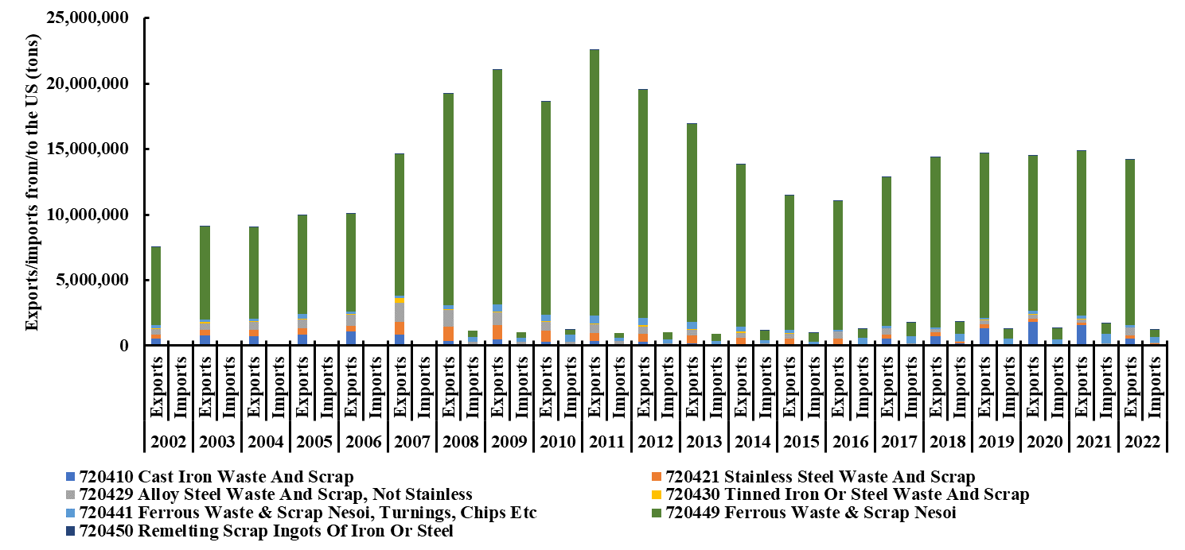
Figure S4A. Breakdown of ferrous waste and scrap.

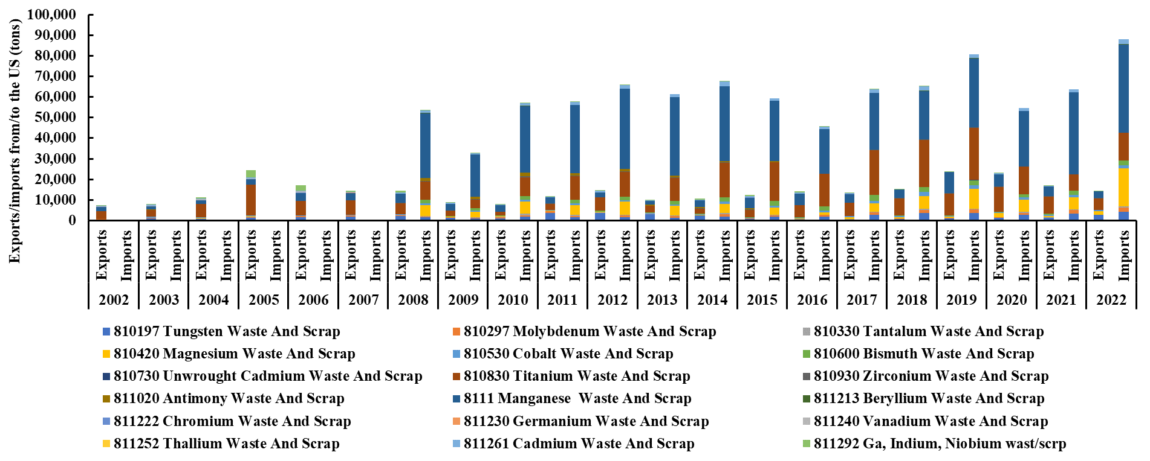
Figure S4B. Breakdown of other metals categories.

Supplementary materials, S6: Average annual US production and consumption volume of primary commodities vs. Average annual US production volume of secondary commodities.
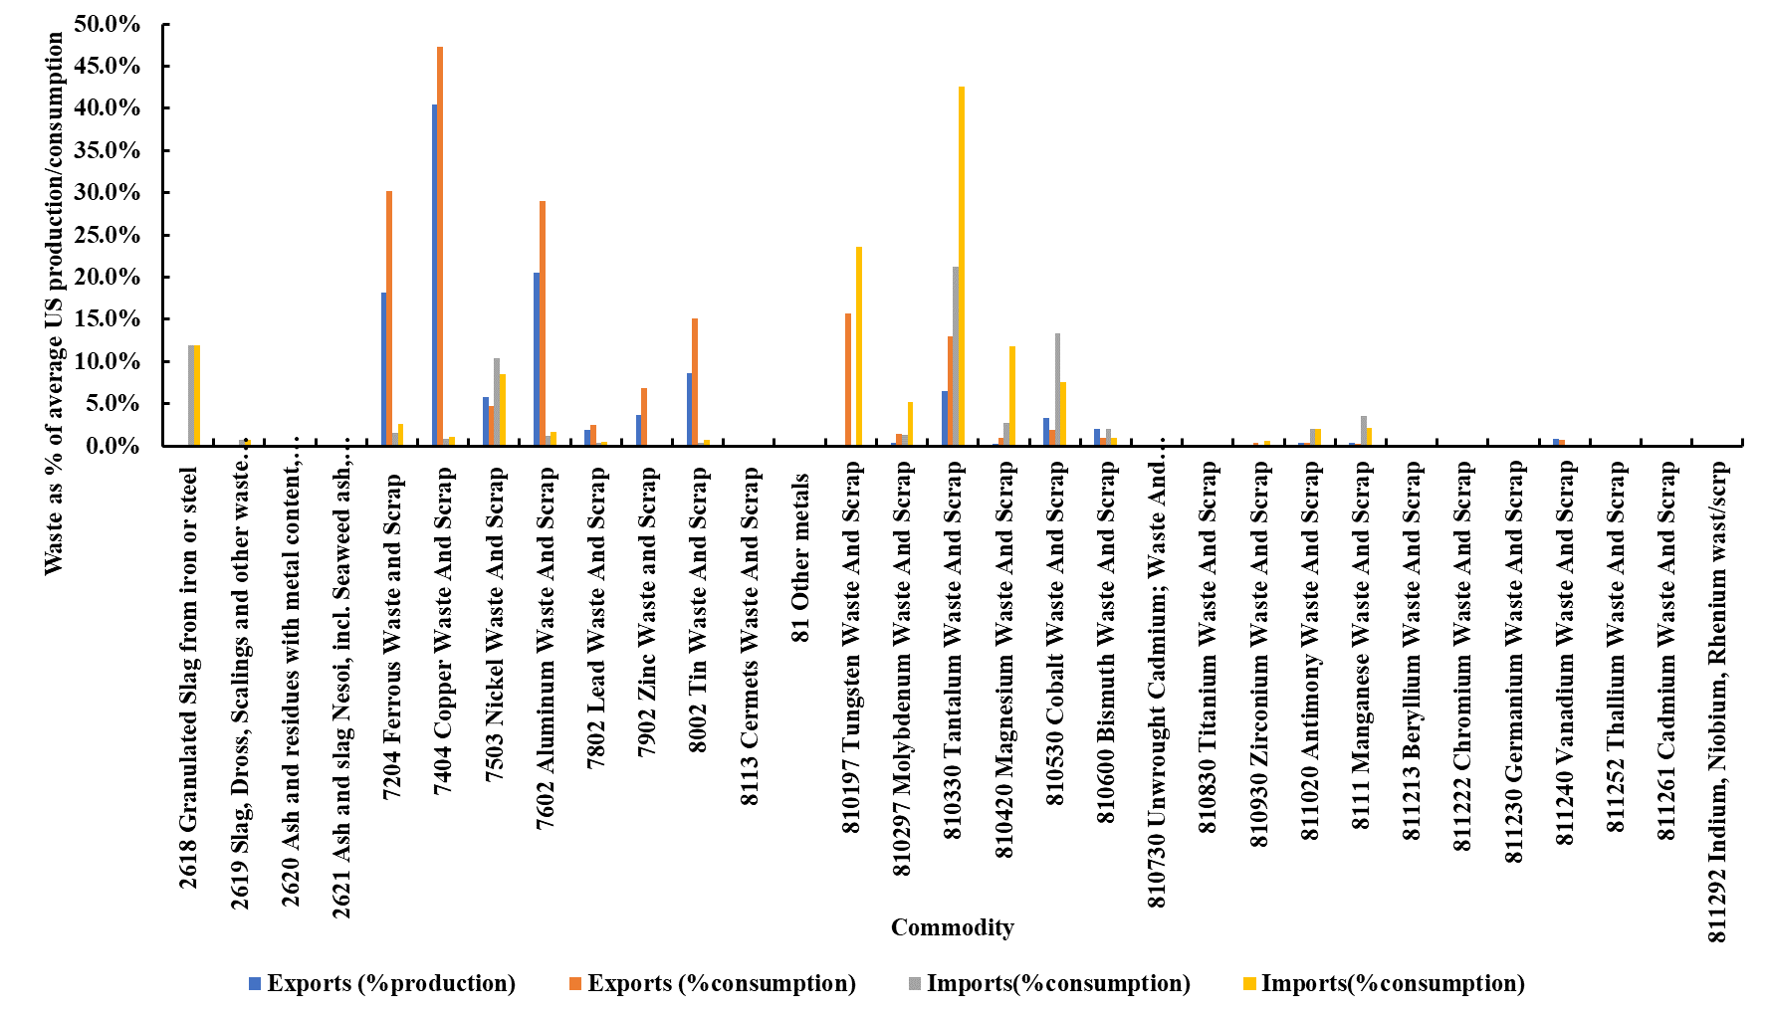
Figure S6.1. Average annual US production and consumption volume of primary commodities vs. Average annual US production volume of secondary commodities.

Supplementary materials, S7: Network analysis of: a) specific commodities exports from 2002-2022, and b) specific commodities imports from 2008-2022.
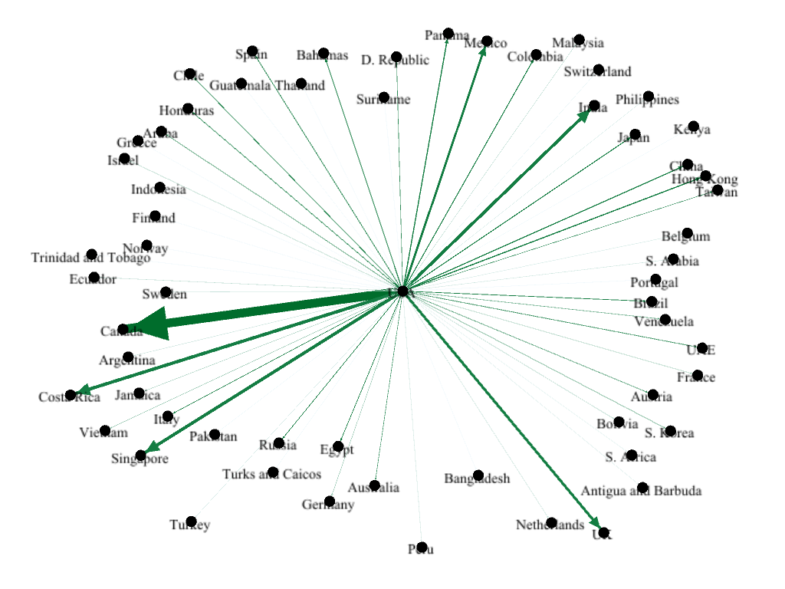

  - 2618 Granulated Slag from iron or steel exports. 46 countries are responsible for over 99% of exports. Range 11 tons, Switzerland, to 31,200 tons (Canada).
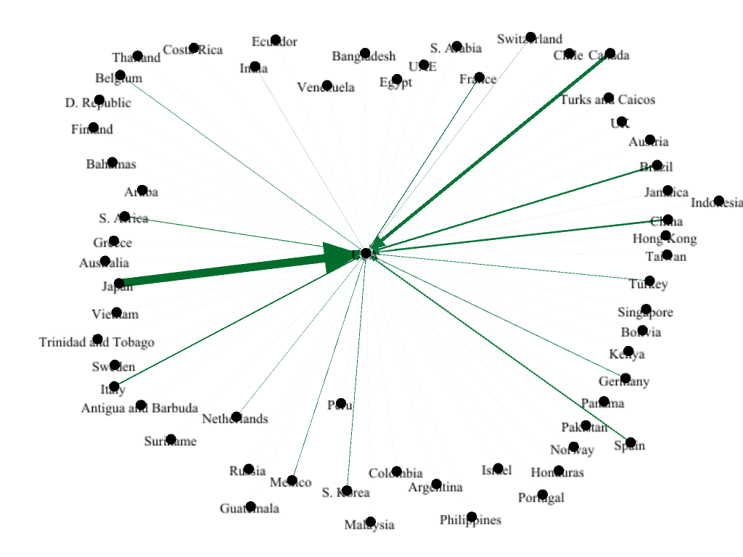
  - 2618 Granulated Slag from iron or steel imports. 23 countries responsible for over 99% of exports. Range 1.7 tons, UK, to 12.5 million tons (Japan).

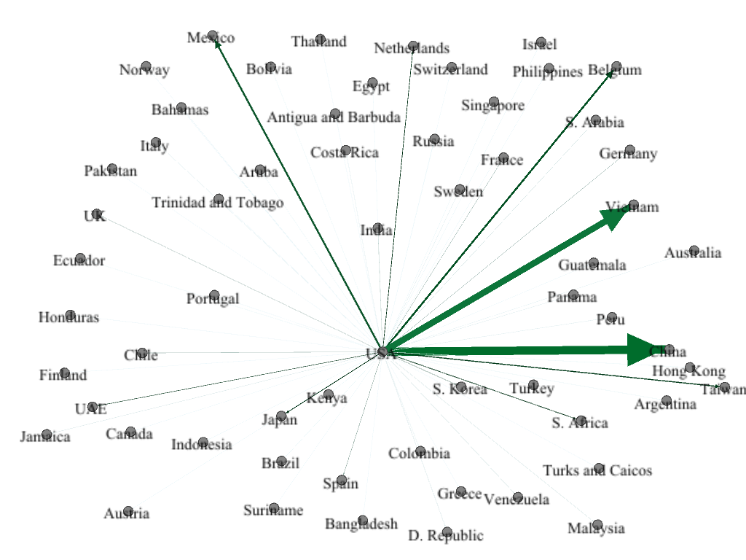
  - 2619 Slag, Dross, Scaling and other waste from iron or steel Exports. 39 countries have exported and contributed in total to over 99% of total exports. Range between 2.5 tons (Israel) and about 236,000 tons (China).

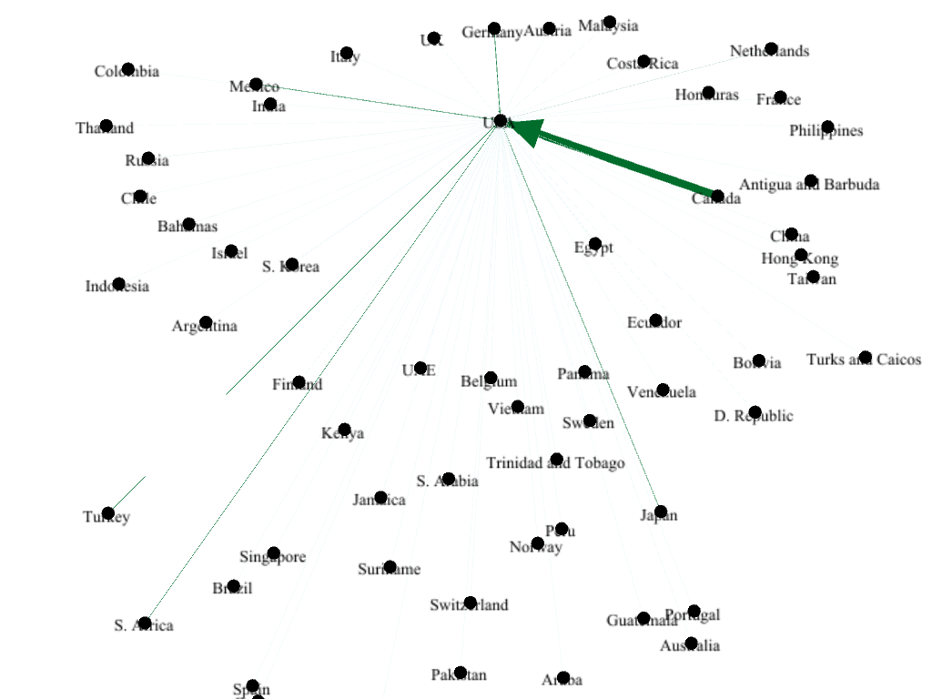

  - 2619 Slag, Dross, Scaling and other waste from iron or steel Imports. 21 countries responsible for over 99% of imports. Range from 0.1 tons (Malaysia) to about 1.5 million tons (Canada)

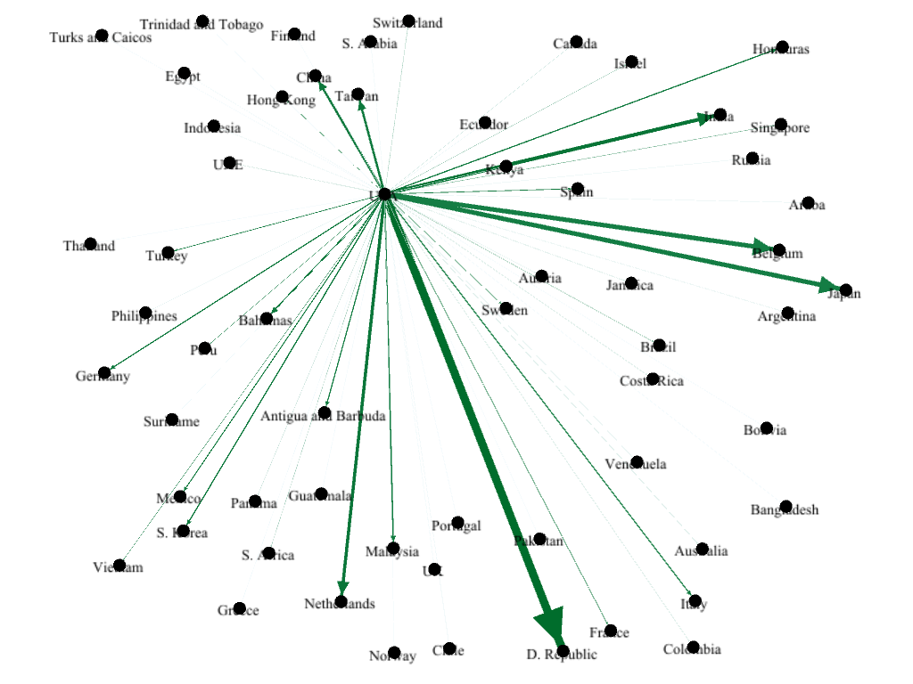
  - 2620 Ash and residues with metal content, excl. iron or steel Exports. 46 countries. Range (44- Ecuador, 275,000- Dominican Republic)

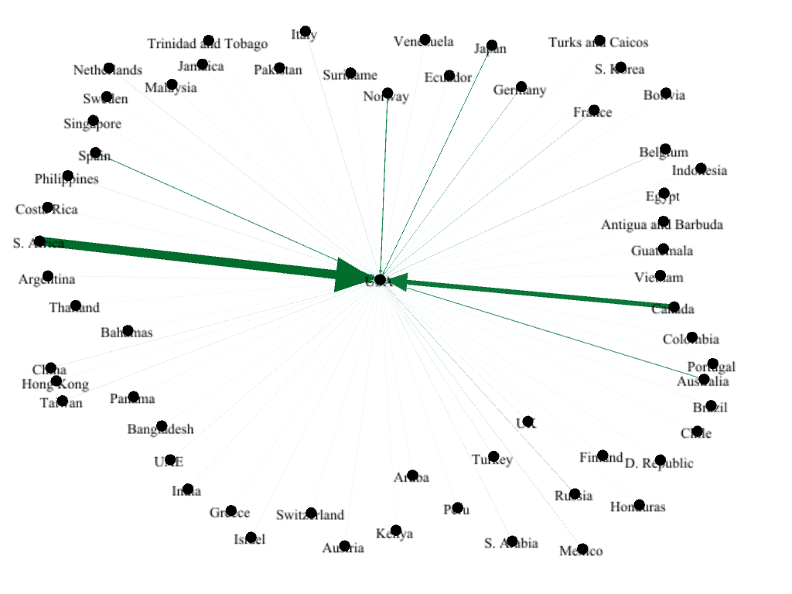
  - 2620 Ash and residues with metal content, excl. iron or steel Imports. 42 countries have exported and been responsible for over 99% of total imports. Range from 0.8 tons (Malaysia) to S. Africa (4.6 million tons).

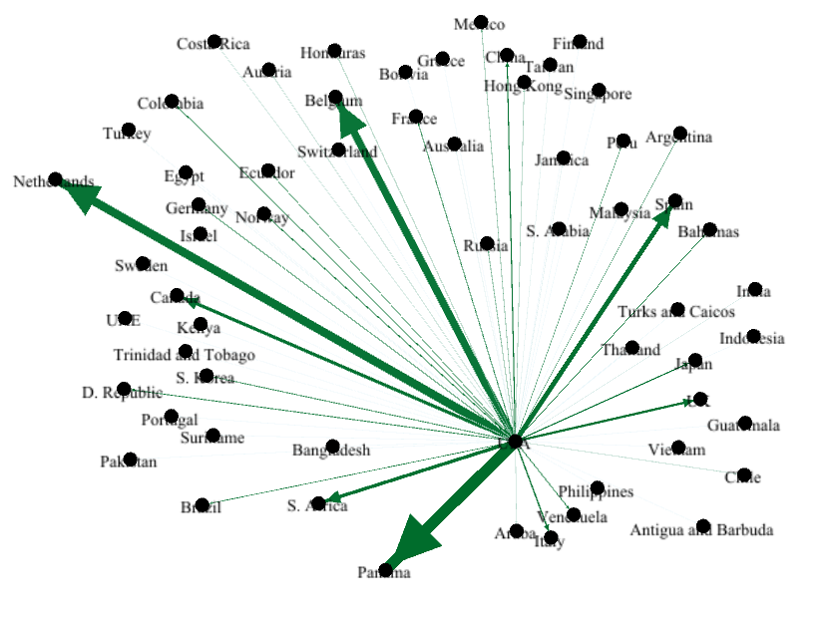
- 2621 Ash and slag Nesoi, incl. Seaweed ash, and Ash from municipal waste Exports. 35 countries. Range, 19 tons, Turkey, to 165,000 tons (Panama)

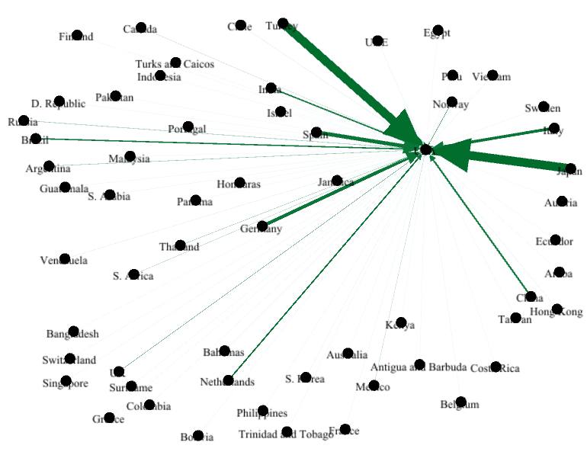

- 2621 Ash and slag Nesoi, incl. Seaweed ash, and Ash from municipal waste Imports. 29 countries. Range 17.5 tons, Sweden, to about 2.4 million tons, Japan.

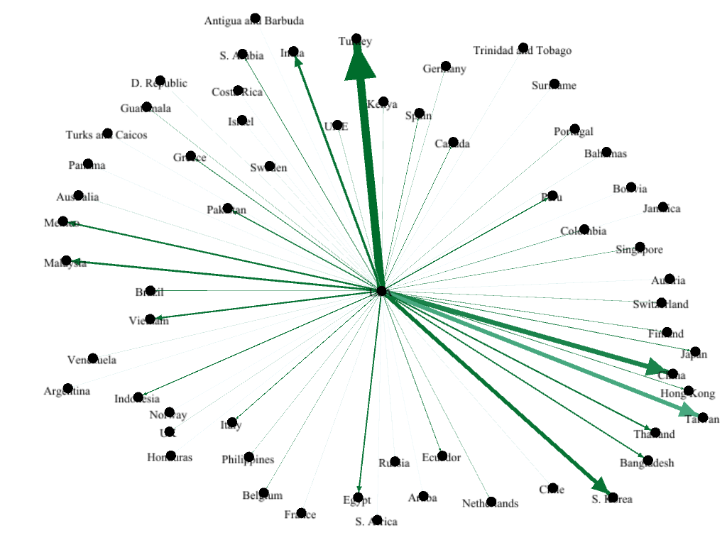
- 7204 Ferrous Waste and Scrap Exports. 310 tons Antigua and Barbuda; 73 million tons, Turkey. 57 countries.

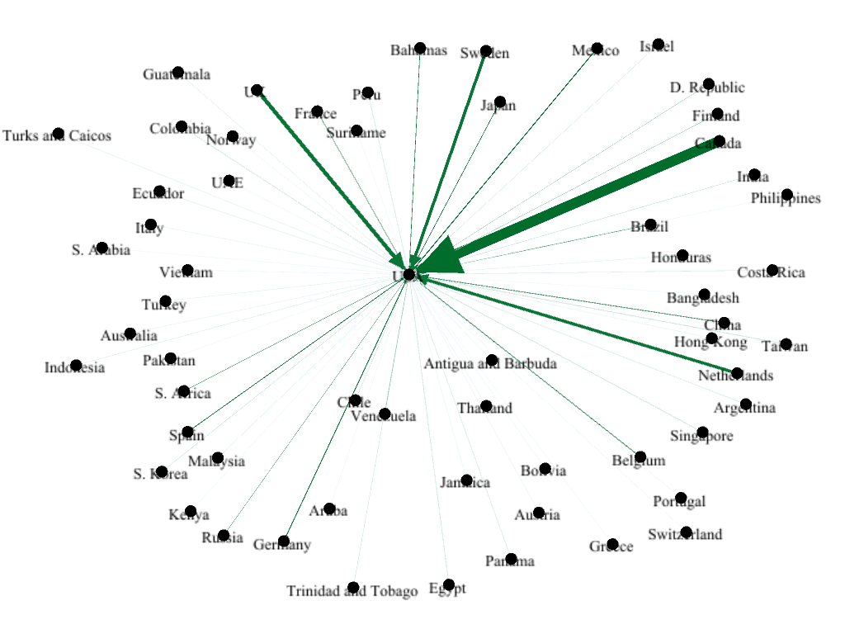
- 7204 Ferrous Waste and Scrap Imports. 55 countries. 9 million, Canada; 5 tons Vietnam.

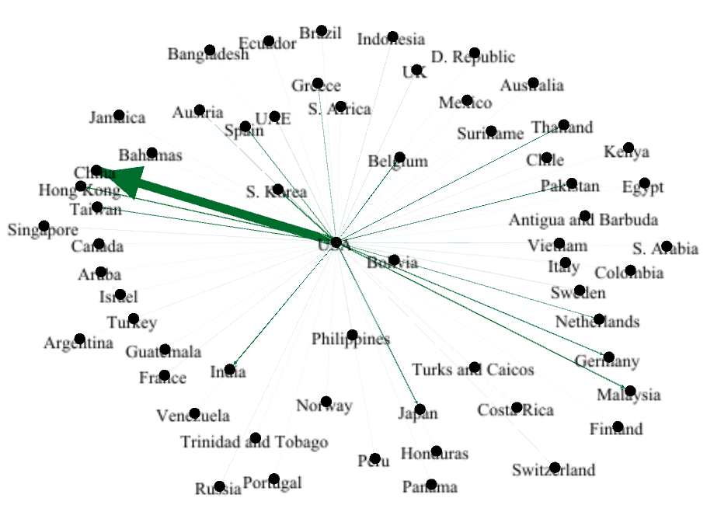
- 7404 Copper Waste and Scrap Exports. 4 tons, Antigua and Barbuda, to 11.6 million tons, China. 52 countries.
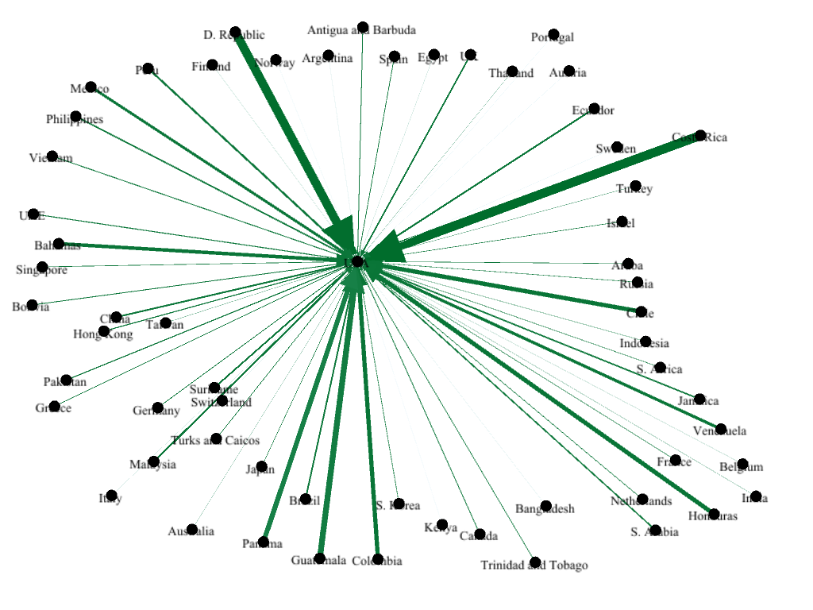
- 7404 Copper Waste and Scrap Imports. 2 tons, Sweden, about 32,000 tons, Costa Rica. 55 countries.

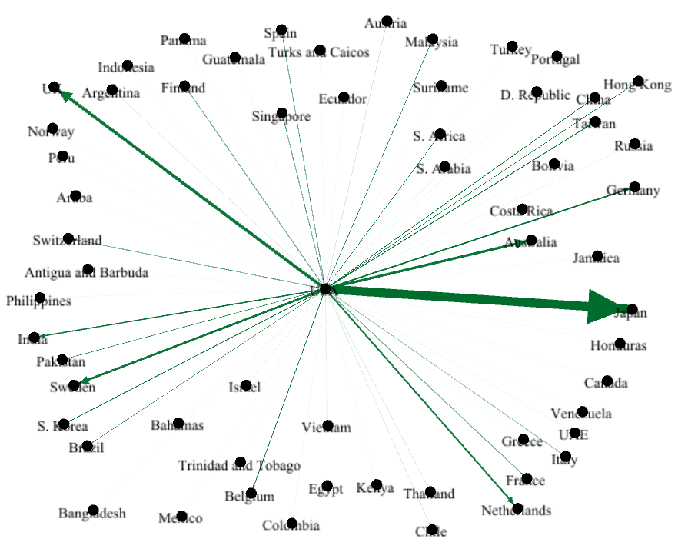

- 7503 Nickel Waste and Scrap Exports. 1 ton Mexico, to about 95,000 tons Japan. 36 countries.

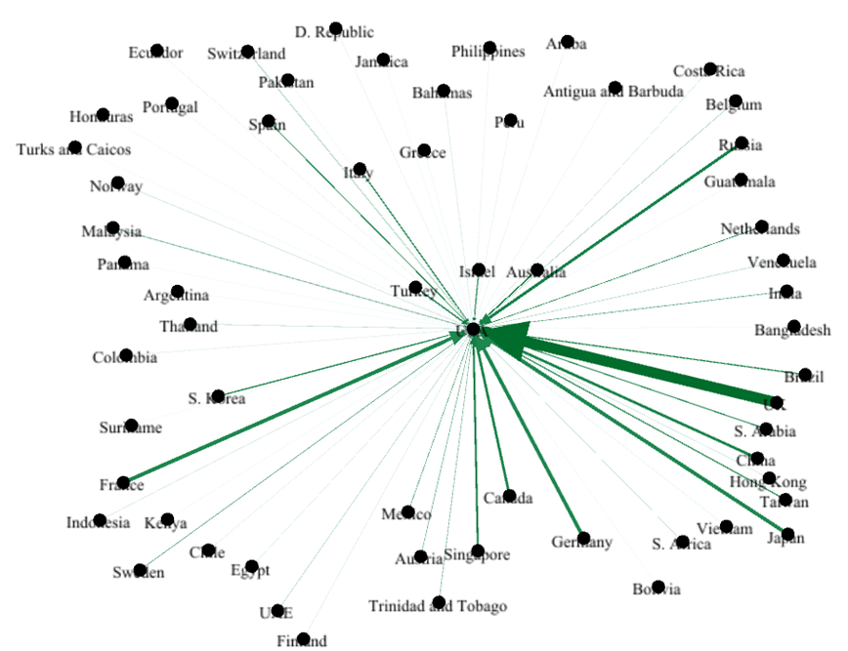
- 7503 Nickel Waste and Scrap Imports. 1.5 tons, Honduras, about 80,400 tons, UK. 52 countries.

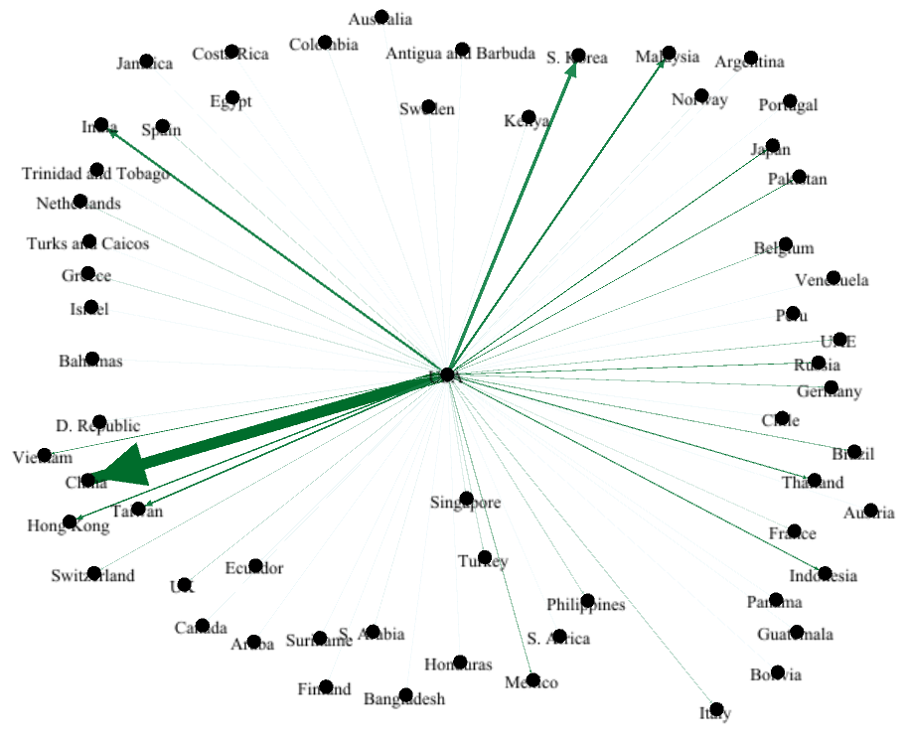

- 7602 Aluminum Waste and Scrap Exports. 9 tons Turks and Caicos, to 14.7 million tons, China. 55 countries.

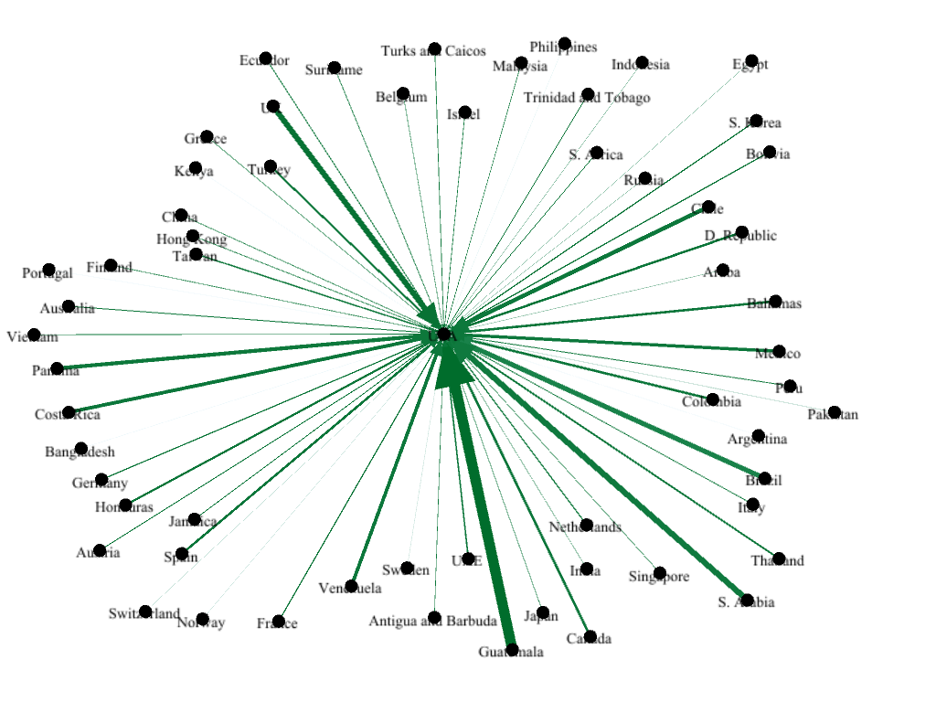

- 7602 Aluminum Waste and Scrap Imports. 23 tons, Philippines, to about 157,000 tons, Guatemala. 55 countries.

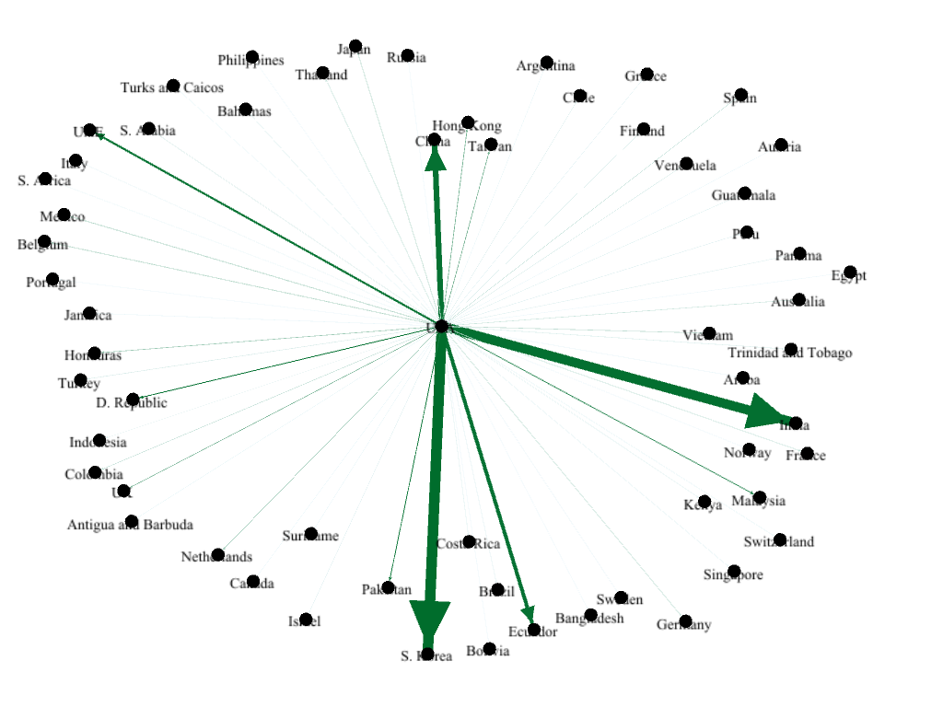

    - 7802 Lead Waste and Scrap Exports. 1 ton S. Africa, to about 270,000 tons, S. Korea. 50 countries.

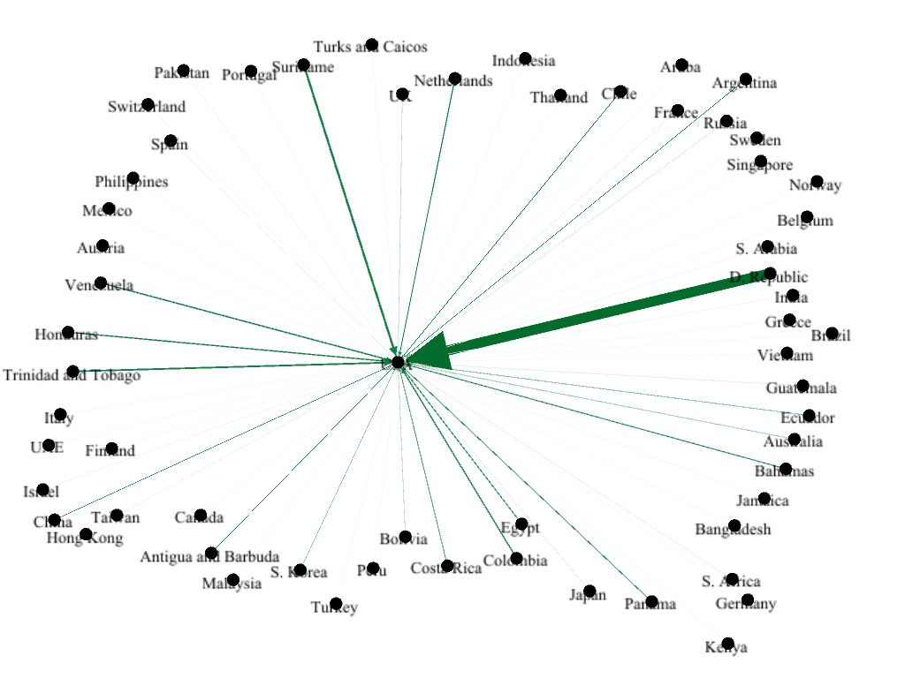

    - 7802 Lead Waste and Scrap Imports. 3 tons Turks and Caicos, to about 58,000 tons D. Republic. 33 countries.

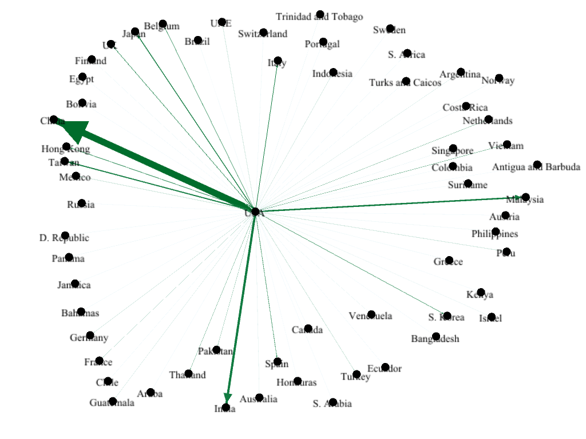

- 7902 Zinc Waste and Scrap Exports. 4 tons, Bahamas, 710,000 tons, China. 40 countries.

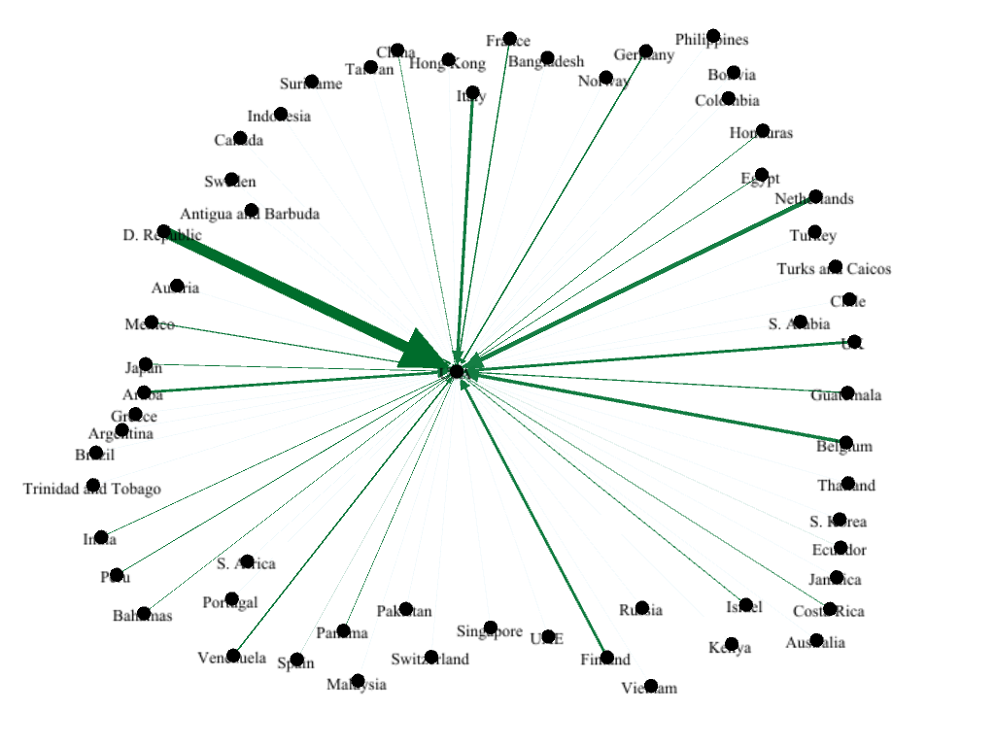
- 7902 Zinc Waste and Scrap Imports. 1 ton, Ecuador, to 2,000 tons, D. Republic. 24 countries.

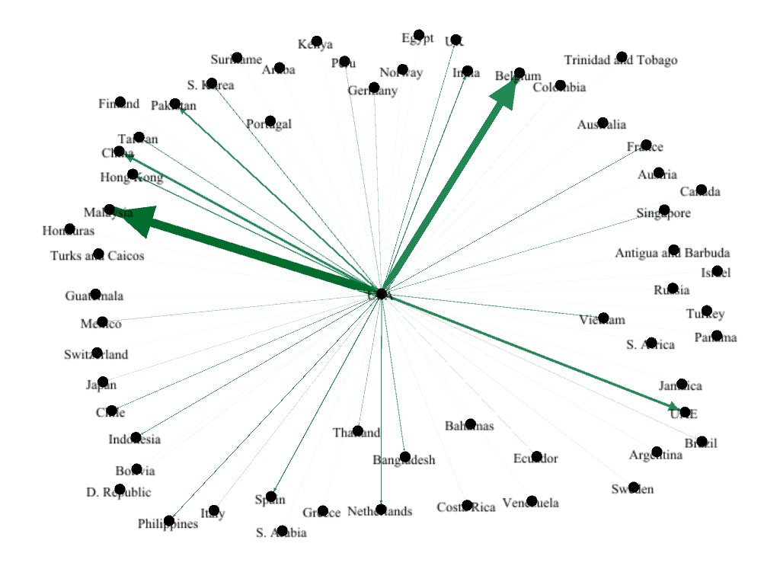

- 8002 Tin Waste and Scrap Exports. 0.5 tons, Jamaica, to 52,000 tons, Malaysia. 37 countries.

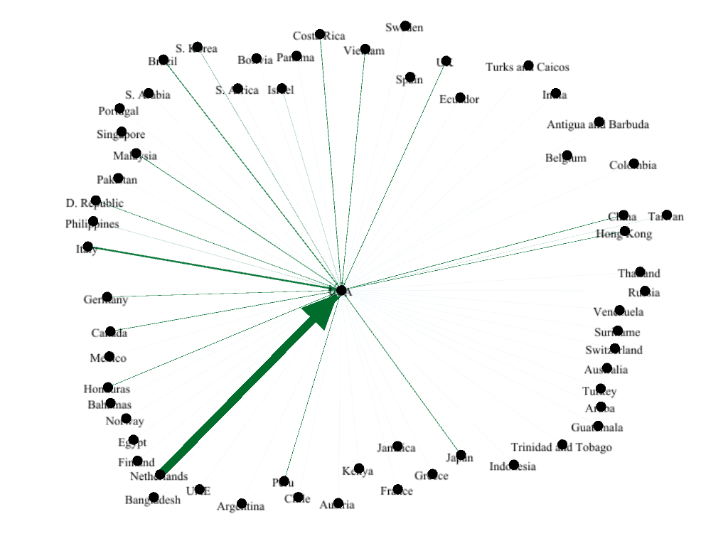
- 8002 Tin Waste and Scrap Imports. 2 tons, Taiwan; about 2,000 tons Netherlands. 19 countries.

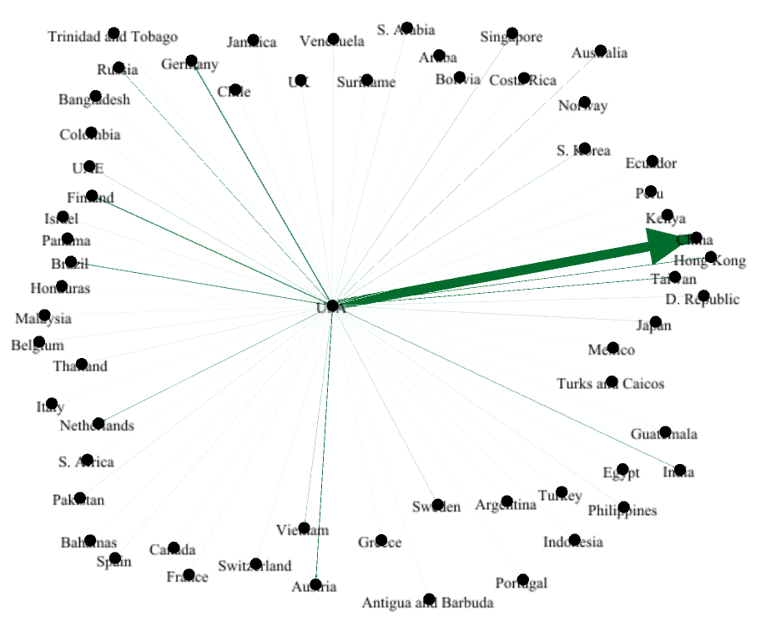

- 8113 Cermets Waste Exports. 0.1 tons, Mexico, to 50,300 tons, China. 44 countries.

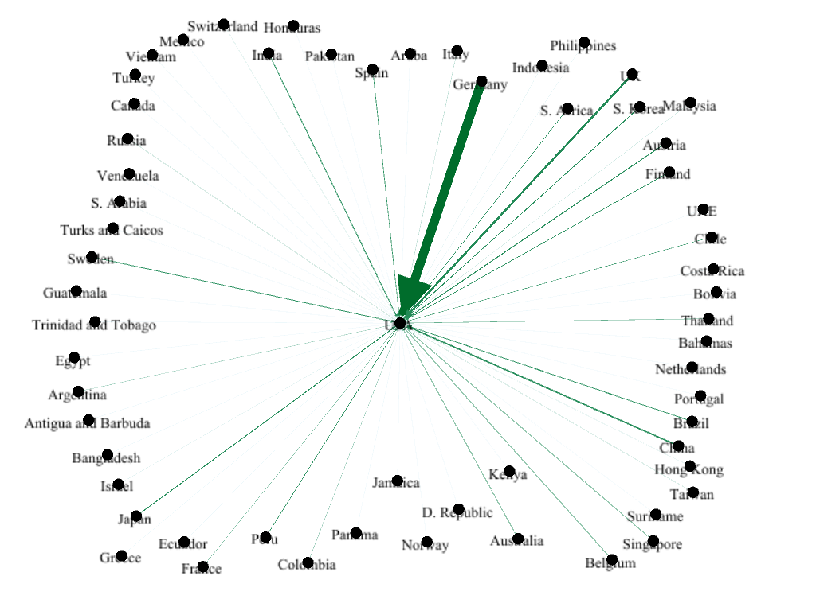

- 8113 Cermets Waste Imports. 33 countries. 0.2 tons, Netherlands, to 14,800 tons, Germany.

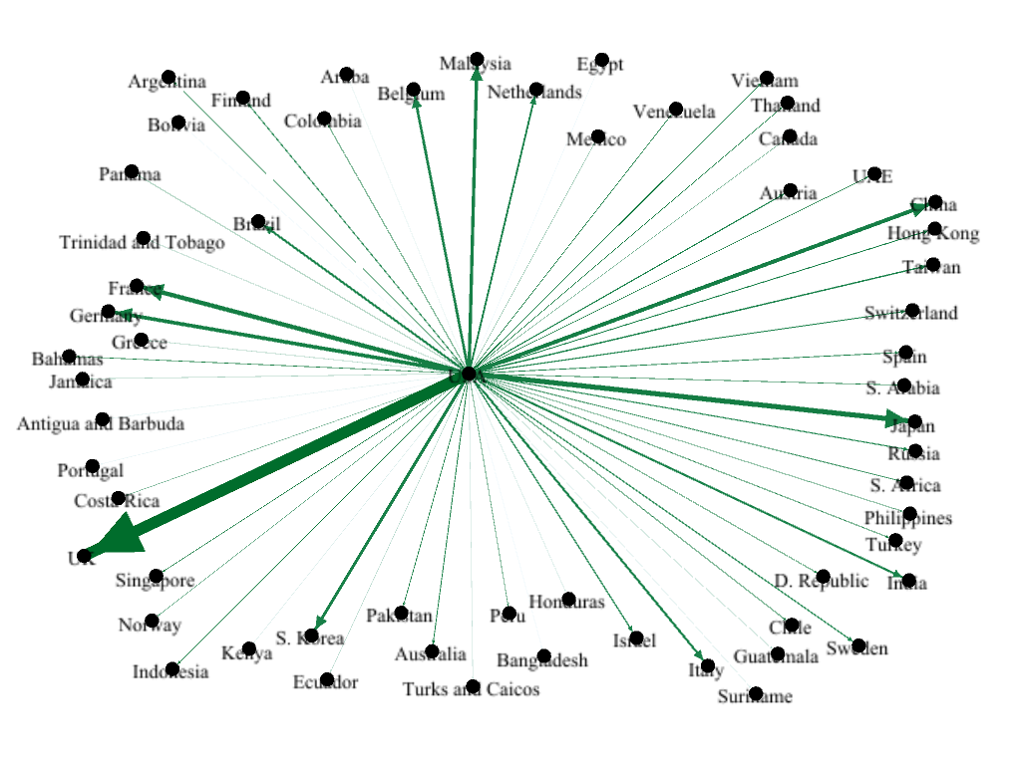

- 81 Other metals Exports. 11 tons Portugal, to about 64,000 tons, UK. 56 countries.

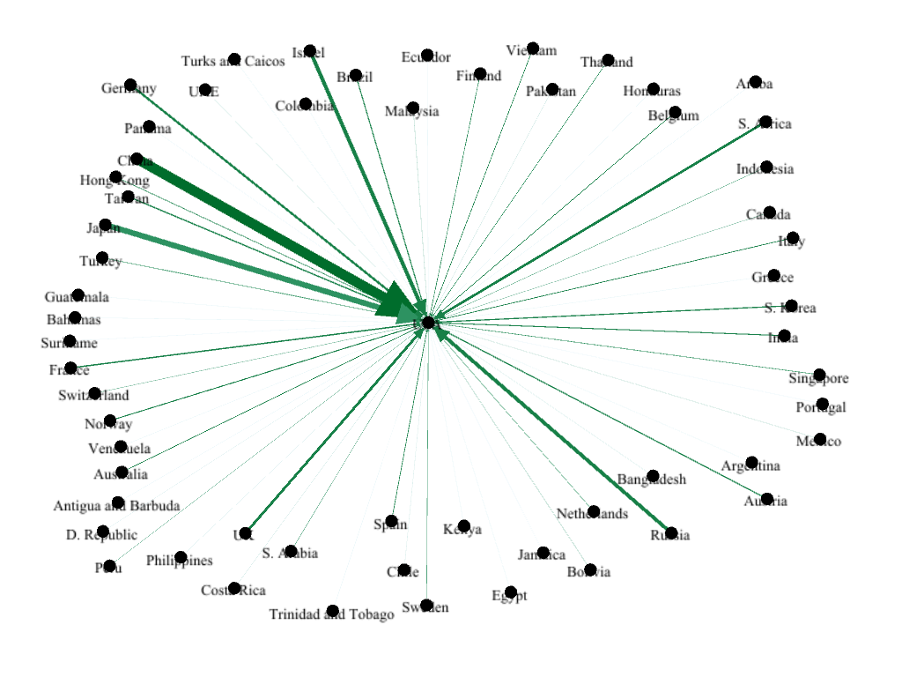
- 81 Other metals Imports. 0.2 tons, Ecuador, to 155,000 tons China. 54 countries.

Supplementary materials, S8: Detailed MFA of average recovery efficiencies of processing the commodities considered in this study.
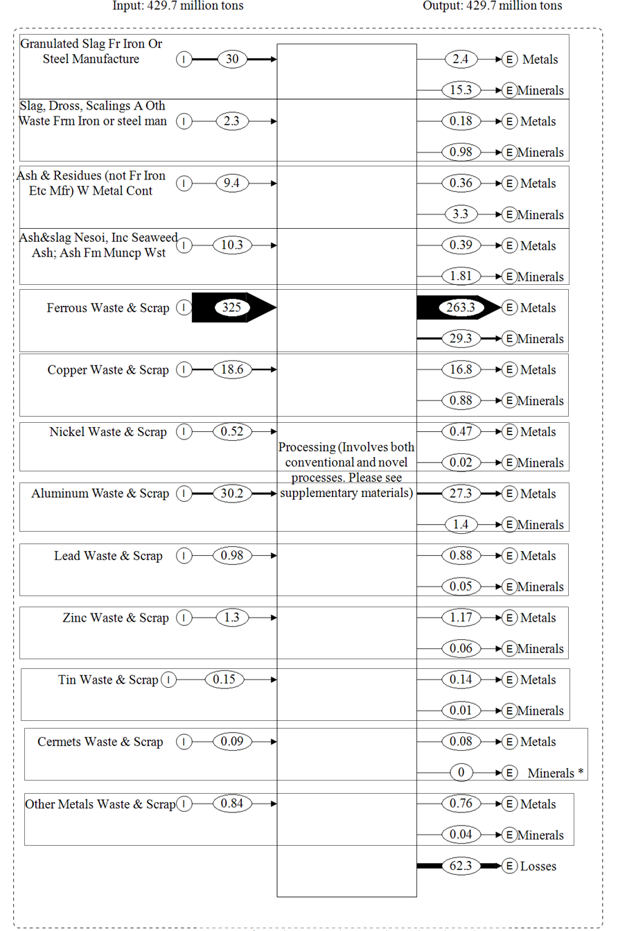
*Minerals produced from cermet waste and scrap is <0.01 million tons, so it was considered negligible.
Figure S7A. MFA of metal wastes and scrap, slag, ash, and residues considered in the analysis. Units are in millions of tons. Output data in the MFA include the average values obtained from the assessment of different recovery processes.

