Supplementary materials

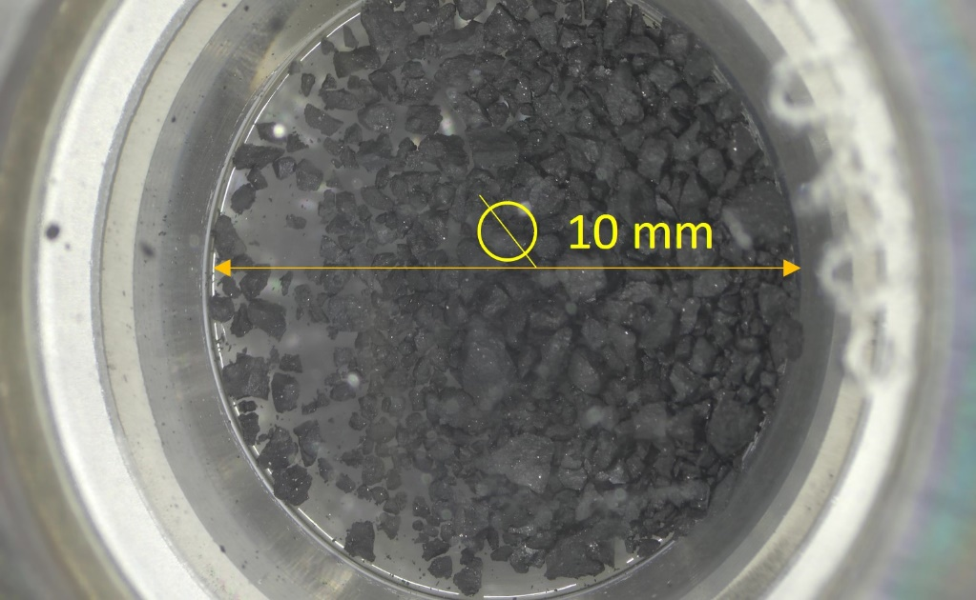
Figure S1. Picture of sample A0219. The other analysed Ryugu samples look similar.

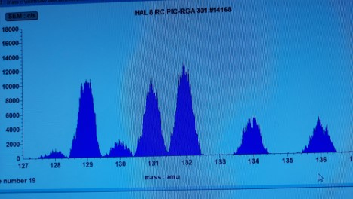
Figure S2. Mass spectrum of air Xe. The amount of Xe is about 2x10⁻¹¹ cm³ STP.

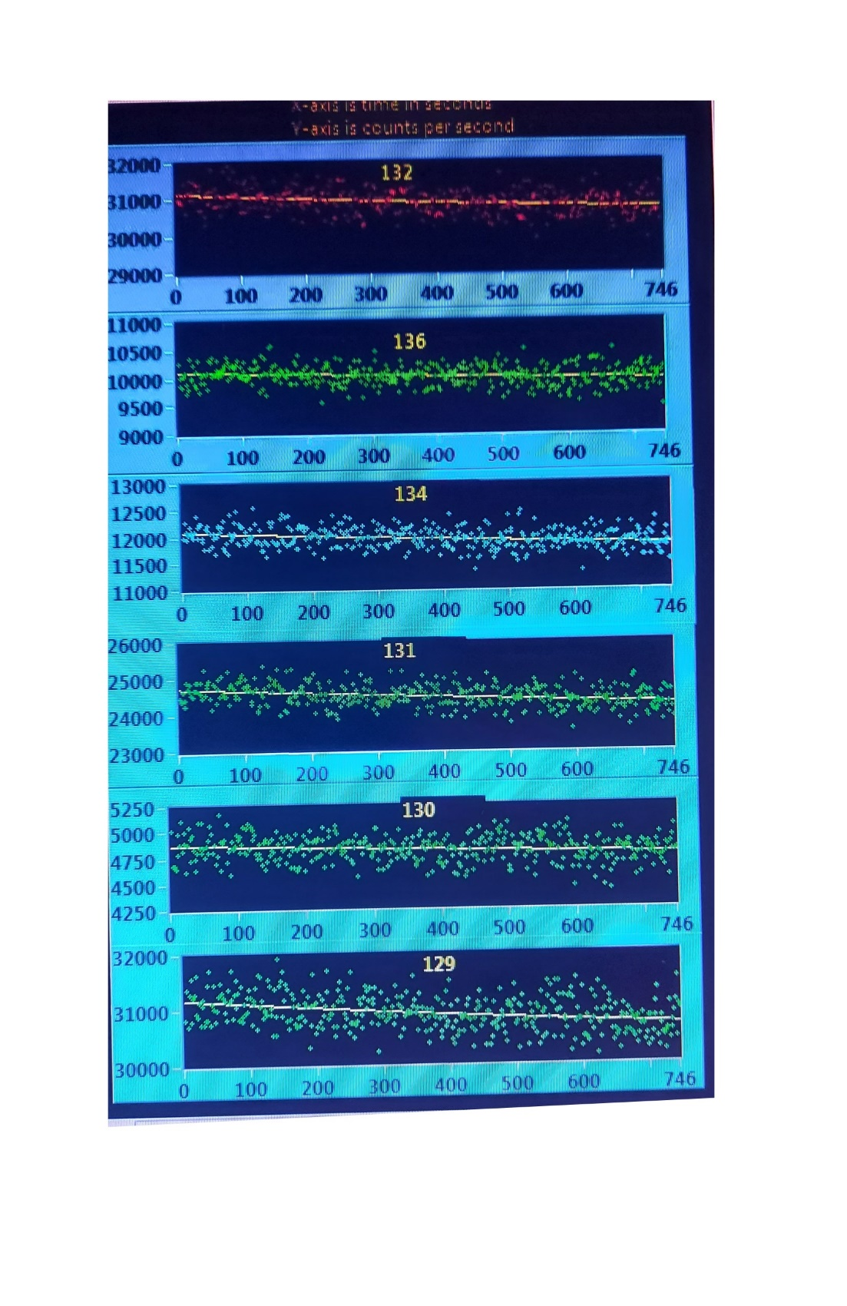
Figure S3. Xe peak intensities (cps) variations depending on time (s).

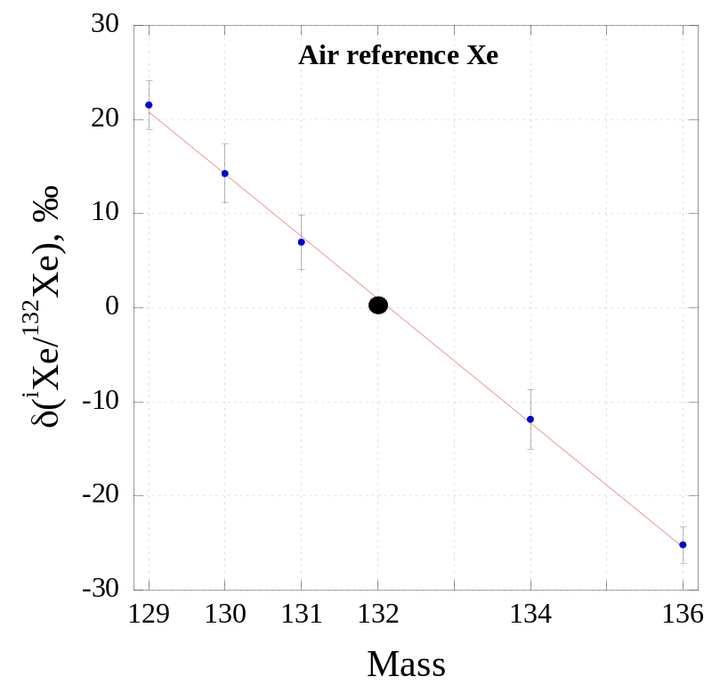
Figure S4. Mass discrimination of air Xe in the quadrupole mass spectrometer.

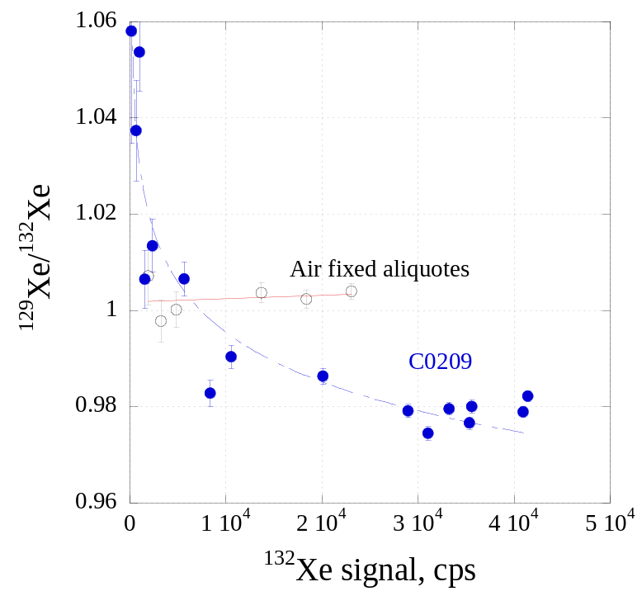
Figure S5. ¹²⁹Xe/¹³²Xe ratio variations depending on the amount of Xe in the quadrupole mass spectrometer for air reference (open cercles) and for temperature steps of the sample C0209 (filled cercles). Since air Xe does not show significant variations in the isotope ration on the amount of Xe, the variations for the sample are due to mixing of isotopically different components.

