Online-only Content
Time-dependent displacement of commensal skin microbes by pathogens at the site of colorectal surgery

Authors:
Jennifer Holder-Murray MD^{1,2}, Andrew Yeh MD², Matthew B. Rogers PhD², Brian Firek MS², Brandon Mahler¹, David Medich MD^{1,2}, James Celebrezze MD^{1,2}, Michael J. Morowitz MD^{2,3}

¹ Division of Colon & Rectal Surgery, University of Pittsburgh Medical Center, Pittsburgh, PA
² Department of Surgery, School of Medicine, University of Pittsburgh, Pittsburgh, Pennsylvania
³ Division of Pediatric General and Thoracic Surgery, UPMC Children's Hospital of Pittsburgh, University of Pittsburgh Medical Center, Pittsburgh, Pennsylvania

Corresponding Author: Michael Morowitz, MD
Mailing Address: UPMC Children’s Hospital of Pittsburgh
4401 Penn Avenue
Pittsburgh, PA 15224

Email Address: michael.morowitz@chp.edu

eMethods
Sample Collection and Preparation
At preoperative clinic visits, skin swab samples were obtained of the abdomen and chest wall using a BD BBL Culture Swab EZ premoistened with sterile 0.15 M NaCl / 0.1% Tween 20. For abdomen samples, a 2 x 2 cm area of skin was swabbed at the anticipated location of incisions for specimen extraction (periumbilical area for patients undergoing right colectomy and lower midline for patients undergoing total or left colectomy or proctectomy). On the chest wall, a 2 x 2 cm area of sternum was swabbed. Samples were stored at 4°C and ultimately transferred to -80°C until subsequent DNA extraction.

At surgery, rectal swabs were obtained by inserting the same type of premoistened swab 2 to 4 cm past the anal sphincter and rotated three times. A chest swab was obtained prior to the abdominal preparation in the manner described above. Abdominal skin swabs were obtained before and after abdominal preparation. At surgery, after the surgeon opened the extraction incision for ultimate specimen removal, subcutaneous adipose tissue in the wound was immediately swabbed. When the colon specimen was removed, the specimen was opened and a swab of the intestinal mucosa and/or a luminal sample was obtained. Just before closing the skin of the extraction incision and following subcutaneous irrigation, another swab of subcutaneous fat was obtained.

During the postoperative hospitalization, chest and abdomen swabs were obtained on most days. Additionally, stool samples and samples of ileostomy effluent were collected when possible by bedside nurses. Postoperative rectal swabs were obtained from some subjects when no fecal samples were obtained. If a subject required an incision to be opened during the postoperative period, swabs of the wound and/or drainage were collected. At postoperative clinic visits, swabs of the abdominal and chest skin were again obtained.

Bacterial DNA extraction and sequencing
Microbial DNA was extracted from all samples using the PowerSoil DNA Isolation kit (MO BIO Laboratories, Carlsbad, CA). Bacterial 16S rRNA gene sequences were amplified and sequenced on the Illumina MiSeq platform with fusion primers adapted for the Illumina MiSeq that target the V4 region (515F and 806R primers). Samples were sequenced with blank extraction and no-template added PCR controls at the University of Illinois Biotechnology Center. Due to the limited ability of V4 region primers to distinguish Propionibacterium from other genera¹, we quantified Propionibacterium acnes recA genes using the genesig Standard Kit for Propionibacterium acnes (Primerdesign, Ltd., Plymouth Meeting, PA, USA) on an Applied Biosystems 7900HT Fast Real-Time PCR System (ThermoFisher Scientific, Waltham, MA, USA) at the University of Pittsburgh HSCRF Genomics Research Core according to manufacturer’s specifications.

Computational Analysis
OTUs were predicted using an open OTU picking strategy implemented in the QIIME1 package using the Greengenes database as a reference. Samples with < 500 reads were excluded from downstream analysis, and the OTU table was rarefied to 500 counts per sample for diversity analyses.

Alpha diversity and beta diversity analyses were performed using the Vegan and Phyloseq R libraries. Alpha diversities were calculated as observed OTUs, and beta-diversity distances were caculated using the weighted UniFrac metric. Differential abundance predictions of taxa were performed using DeSEQ, ANCOM and LefSE at the family level rank between pre-visit samples and postoperative samples. Relative abundance of predictions that agreed between two out of three of the methods were plotted over time using the ggplot2 R library.

eReferences
1. Meisel JS, Hannigan GD, Tyldsley AS, et al. Skin microbiome surveys are strongly influenced by experimental design. J Invest Dermatol. 2016;0(0). doi:10.1016/j.jid.2016.01.016

eFigure 1. Alpha diversity comparisons (observed species) between abdominal skin swab samples and fecal or ileostomy samples.
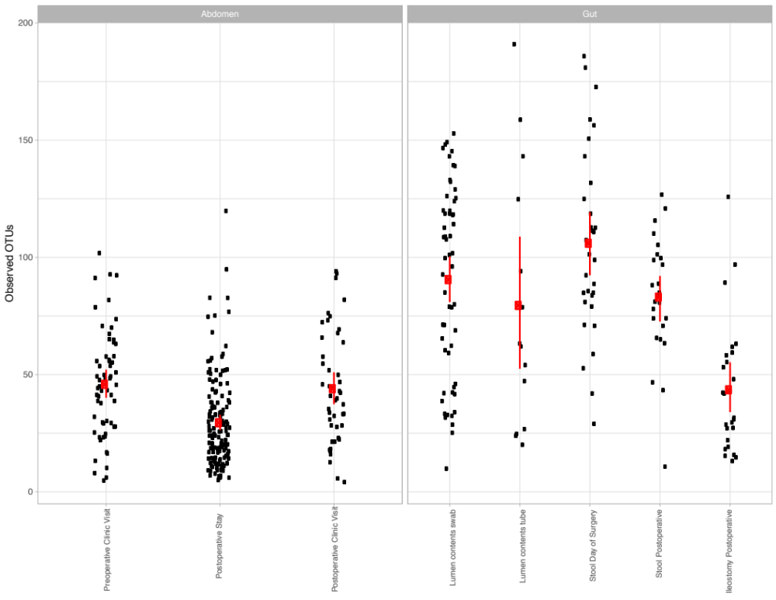

eFigure 2. Microbial diversity within swabs of subcutaneous fat within the surgical incision. A) Shown are the numbers of observed OTUs in swabs of the subcutaneous fat collected either at the time of incision (START) or at the time of closure (FINISH). B) Average weighted UniFrac distances between all subcutaneous fat swabs (START) and all swabs of luminal fecal contents (left), and distances between fat swabs only with luminal contents from the same subject. C) Average weighted UniFrac distances between all subcutaneous fat swabs (FINISH) and all swabs of luminal fecal contents (left), and distances between fat swabs only with luminal contents from the same subject.

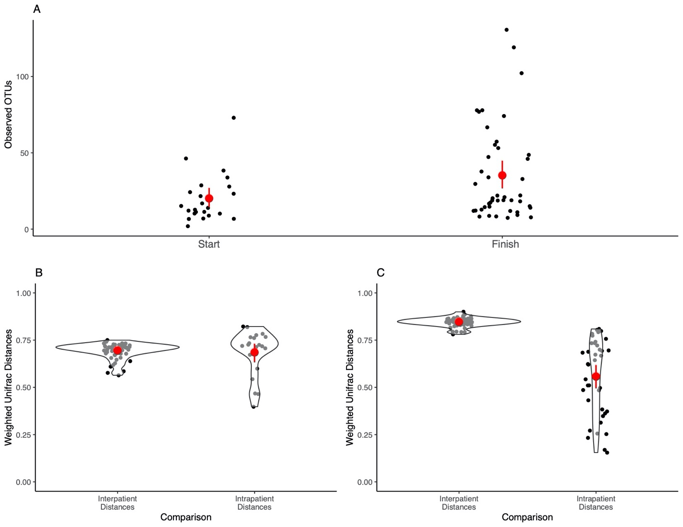

eFigure 3. Taxonomic profile of patient 8, showing increased Enterococcus on day 4 of hospital stay, as well as in ileostomy swabs from the same period, and later swabs from the wound site.

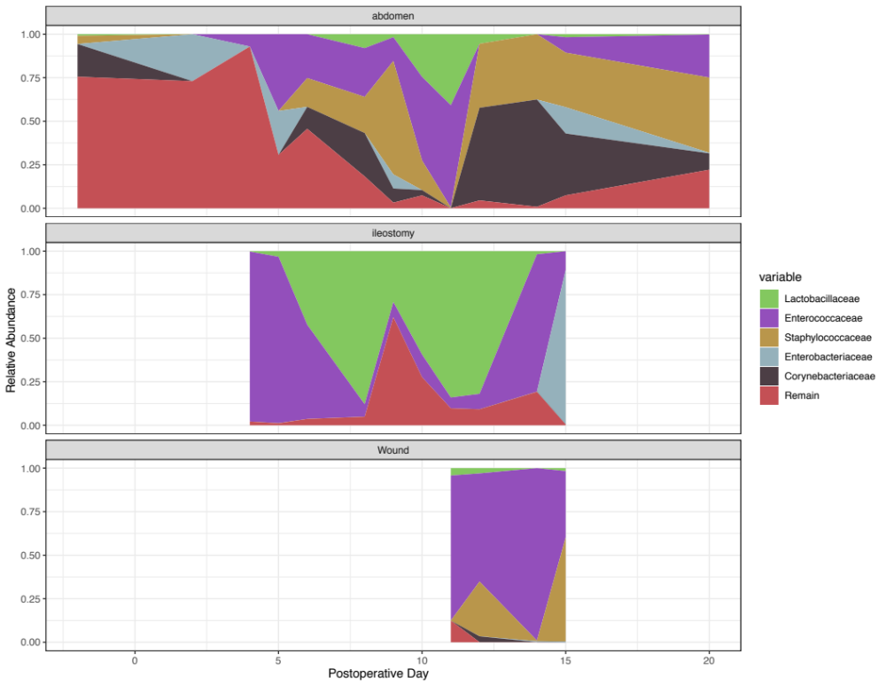

eTable 1. List of samples collected and analyzed in this study.
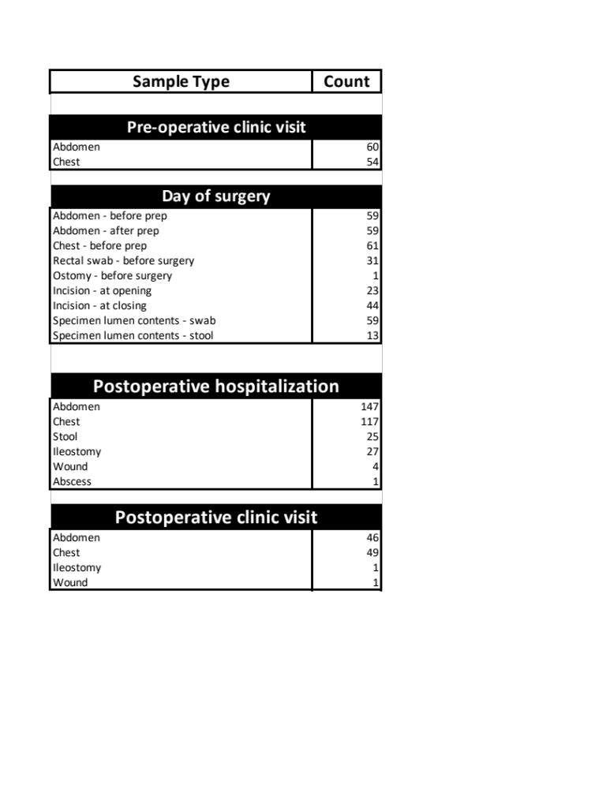
eTable 2. Details of bacterial families whose abundance varies significantly in the perioperative period, as described in primary text. Results from three statistical packages are shown. Shading in green or red represents increase or decrease in abundance, respectively.
Bacterial families within skin swabs at the surgical incision site that vary in abundance from the preoperative clinic visit and the inpatient postoperative hospital stay.
ANCON | LEFSE | DESEQ
- | - | Bacteroidaceae
Corynebacteriaceae | Corynebacteriaceae | Corynebacteriaceae
- | Enterobacteriaceae | Enterobacteriaceae
- | - | Enterococcaceae
- | - | Lachnospiraceae
Micrococcaceae | Micrococcaceae | Micrococcaceae
Moraxellaceae | - | Moraxellaceae
- | - | Pseudomonadaceae
- | - | Rhodobacteraceae
- | Streptococcaceae | -
Tissierellaceae | Tissierellaceae | Tissierellaceae
Bacterial families within subcutaneous fat swabs in the surgical incision that vary in abundance from the start of the operation to the end of the operation (wound closure).
ANCOM | LEFSE | DESEQ
- | - | Alcaligenaceae
Bacteroidaceae | Bacteroidaceae | Bacteroidaceae
- | Lachnospiraceae | Lachnospiraceae
- | - | Porphyromonadaceae
- | Neisseriaceae | -
- | Ruminococcaceae | -

