Supplementary Information
Plant and Soil
Supporting Information for
Reduced belowground allocation of freshly assimilated C contributes to negative plant-soil feedback in successive winter wheat rotations
Nikolaos Kaloterakis¹, Sirgit Kummer¹, Samuel Le Gall¹, Youri Rothfuss¹, Rüdiger Reichel¹, Nicolas Brüggemann¹
¹Institute of Bio- and Geosciences, Agrosphere (IBG-3), Forschungszentrum Jülich GmbH, 52428 Jülich, Germany
* corresponding author: n.kaloterakis@fz-juelich.de; nikoskaloter@gmail.com
Contents of this file
Figures S1-S3
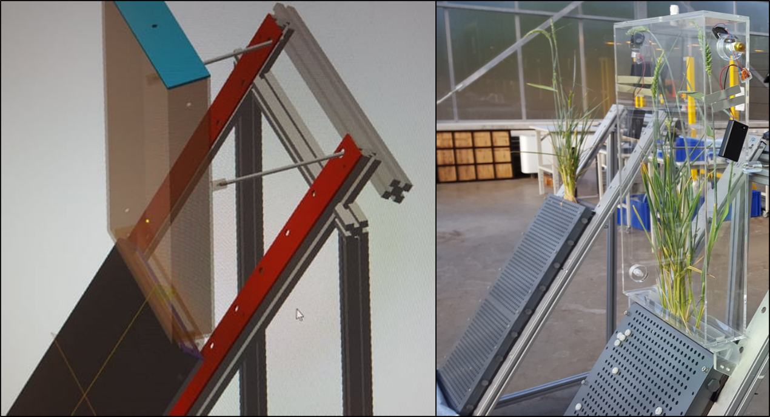
Fig. S1. Left: Visual illustration of the plant-labeling chamber used for the 13CO2 pulse labeling. Right: The chamber fitted onto the rhizotron.
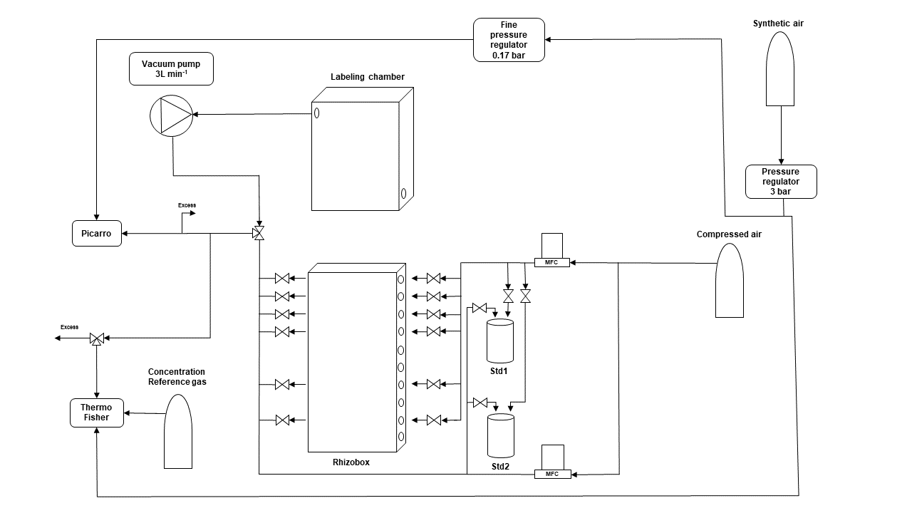
Fig. S2. Schematic representation of the experimental setup for sampling CO₂ and water vapor at different soil depths of the rhizotron, the plant-labeling chamber and from the two standards (500 ‰ H₂¹⁸O and D₂O enriched standard (Std)1 and depleted Std2). Adjusted from Rothfuss et al. (2015). The setup consisted of two valve stands each supporting six 3/2-way valves (Bürkert GmbH and Co. KG, Ingelfingen, Germany) with brass and stainless steel connections (Swagelok, Düsseldorf, Germany) suitable for creating airtight conditions when connected to the gas permeable tubing. Dry synthetic air (20.5% O₂, 79.5% N₂; Air Liquide, Düsseldorf, Germany) was directed to the isotope-specific analyzers. A vacuum pump with a needle valve was connected to the outlet of the plant chamber fitted onto the rhizotron and pumped air from the chamber interior to the isotope-specific analyzers at a rate of 3 L min⁻¹. Synthetic air could be directed either to the valves connected to the side ports of the rhizotron, to the isotope standard vessels prepared as per Rothfuss et al. (2013) or to isotope-specific analyzers. Two pressure regulators were used to control pressure (1 bar, 5 ml min⁻¹, Distrelec Deutschland GmbH, Bremen, Germany) and mass flow controllers (MFC) (Bronkhorst Deutschland Nord GmbH, Kamen, Germany) were used to control airflow.
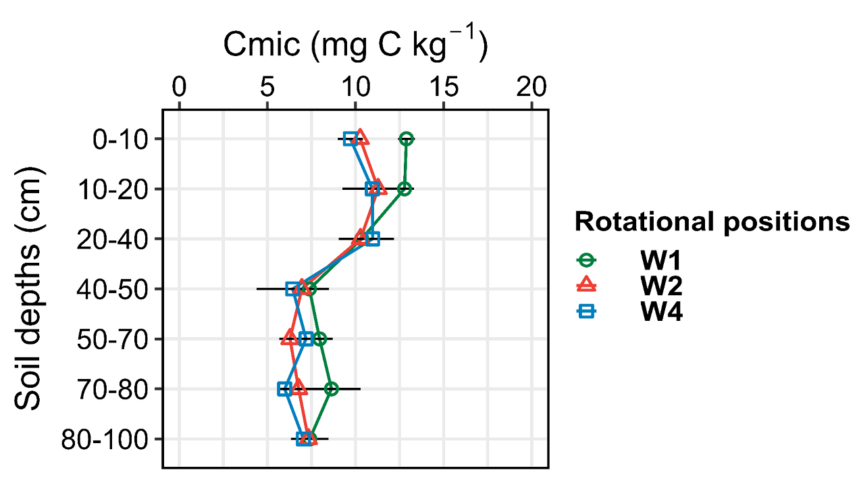
Fig. S3. Microbial biomass C (C_{mic}) of in three rotational position of winter wheat at grain ripening stage (BBCH 92). W1 = first wheat, W2 = second wheat, and W4 = fourth wheat after oilseed rape.

