Supplemental Figures

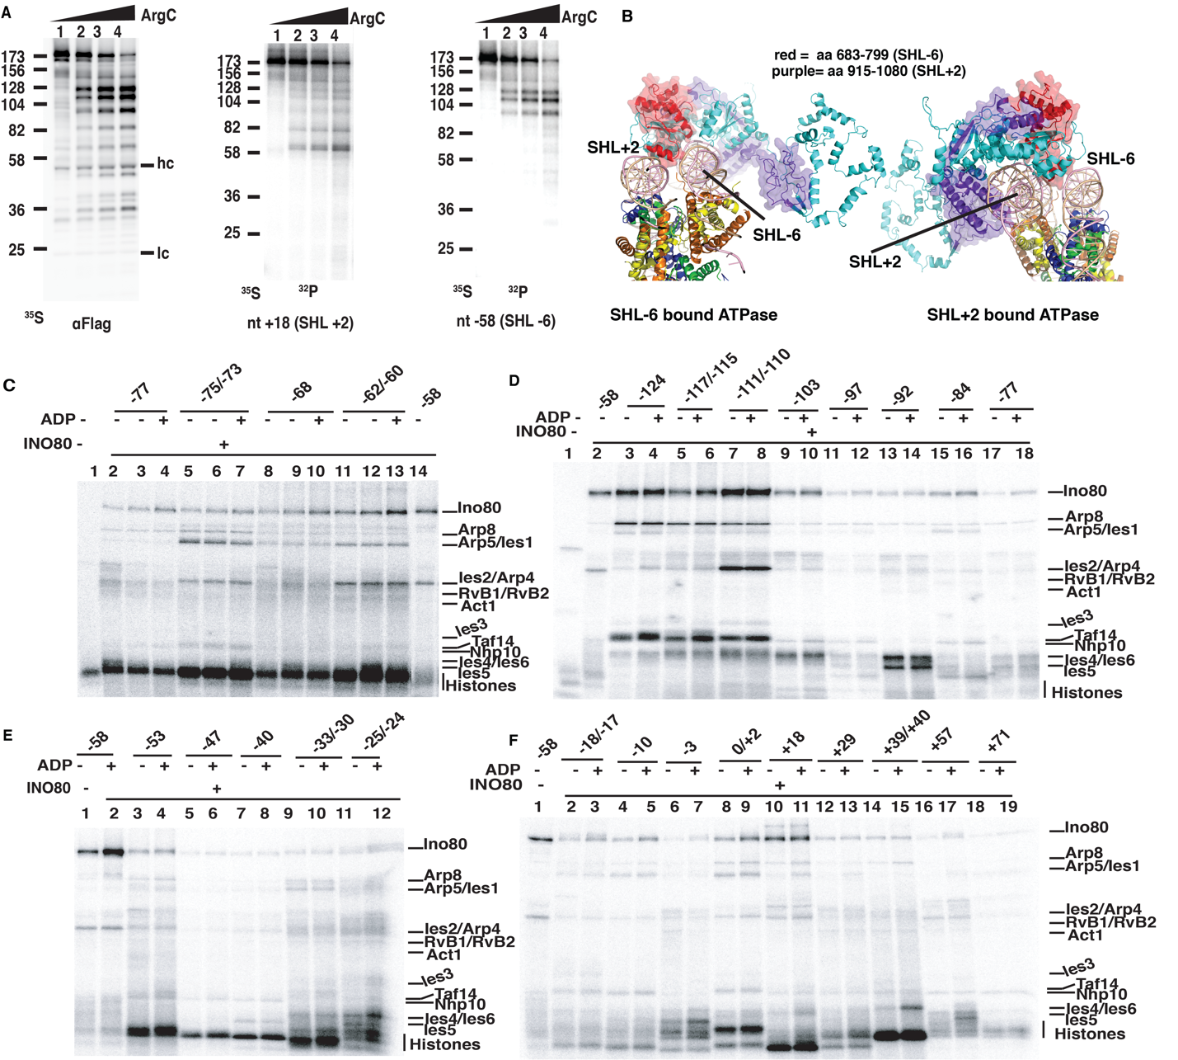
Supplementary Figure 1: Mapping INO80 interactions with extranucleosomal and nucleosomal DNA by DNA photocrosslinking and peptide mapping (A) Ino80 is crosslinked and radiolabeled with [³²P] at nt+18 and -58, cleaved with ArgC protease and resolved on a 4-20% SDS-PAGE. Shown is the phosphorimages of these gels and on the left side are shown where the custom-synthesized [³⁵S] peptide molecular weight markers migrated. In the immunoblot ‘hc’ and ‘lc’ indicate, respectively, the antibody heavy and light chains. (B) Two models of INO80 bound to nucleosomes at either SHL-6 or SHL+2 positions are shown with the crosslinked region highlighted in purple when crosslinked at nt+18 or red when crosslinked at nt -58. (C-F) Full 4-20% SDS-PAGE gel images of the DNA crosslinking patterns of INO80 are shown.

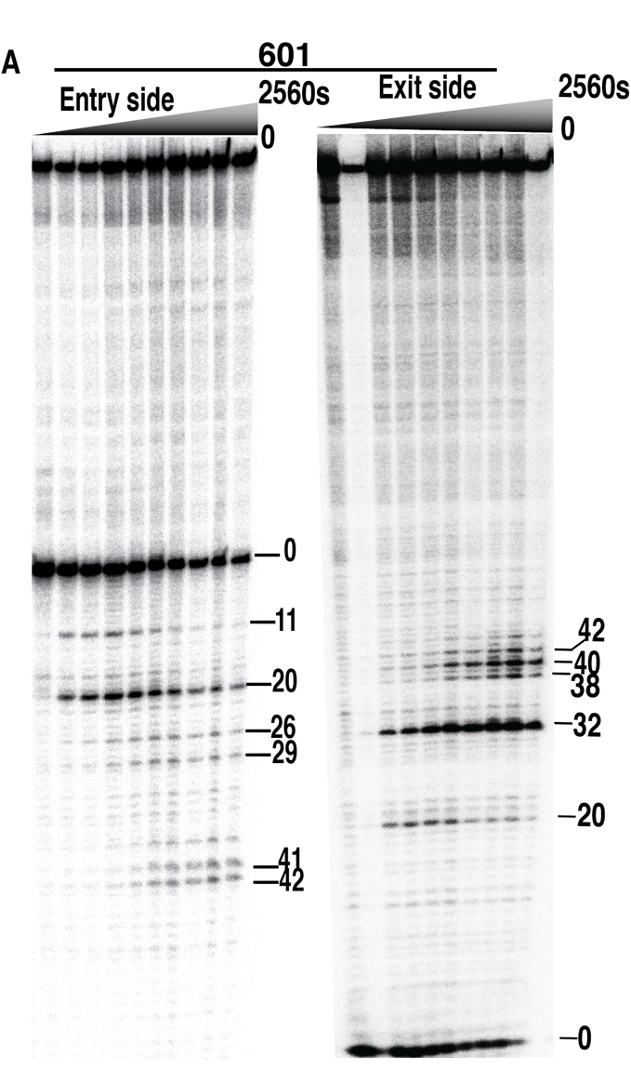
Supplementary Figure 2: DNA displaced is restricted to the entry side of nucleosomes and is not dependent on the extent of DNA movement at the entry side.
DNA movement on the histone octamer surface of nucleosomes was tracked from the entry and exit side of 601 nucleosomes using modified residue 53 of H2B. The sites in DNA that are crosslinked by the modified histone and subsequently cleaved are determined by resolving the cleaved radiolabeled DNA on an 8% denaturing polyacrylamide gel followed by phosphorimaging.

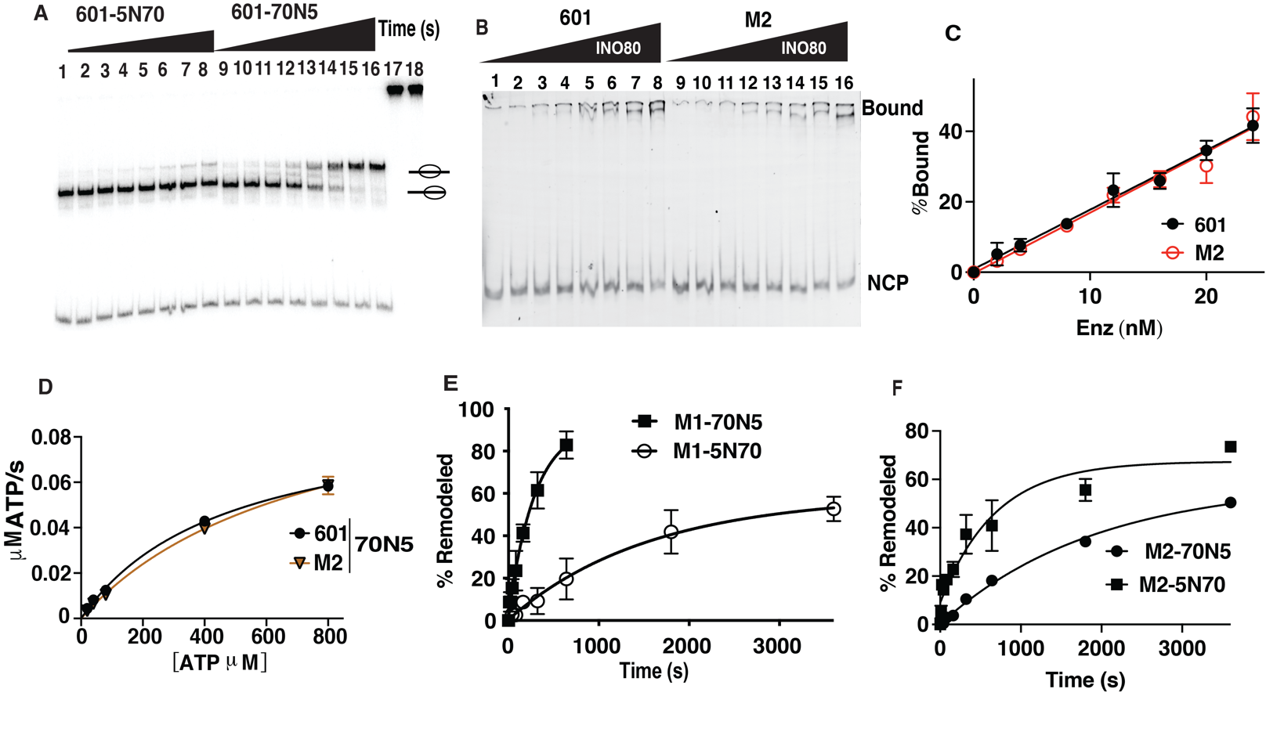
Supplementary Figure 3: DNA sequence at the H2A-H2B region is critical for INO80 mobilization of nucleosomes
(A) Nucleosome mobilization by INO80 is assessed by native electrophoretic mobility shift assays (EMSA) with 601 5N70 (lanes 1-8) and 70N5 (lanes 9-16) nucleosomes. Nucleosomes are saturated with INO80 (lanes 17 and 18) and remodeled with 80 μM ATP at 30°C for 0, 10, 20, 40, 80, 160, 320, and 640s. (B) INO80 binding assays for 601 vs M2 70N5 nucleosomes (40 nM) are determined by EMSA with 0-24 nM INO80. (C). The binding data in (B) is plotted with INO80 concentration versus the percent of nucleosomes bound. (D) Michaelis-Menten analysis was performed for 601 and M2 nucleosomes with 20, 40, 80, 400, 800 µM of ATP and 10 nm INO80 and 50 nM nucleosomes. Shown is ATP concentration plotted versus the rate of ATP hydrolyzed (refer to Table 2). (E-F) The plots show the rates of remodeling 5N70 and 70N5 nucleosomes assembled on (E) M1 and (F) M2 DNA. Remodeling and ATPase assays were performed in triplicates and error bars denote ±s.d.

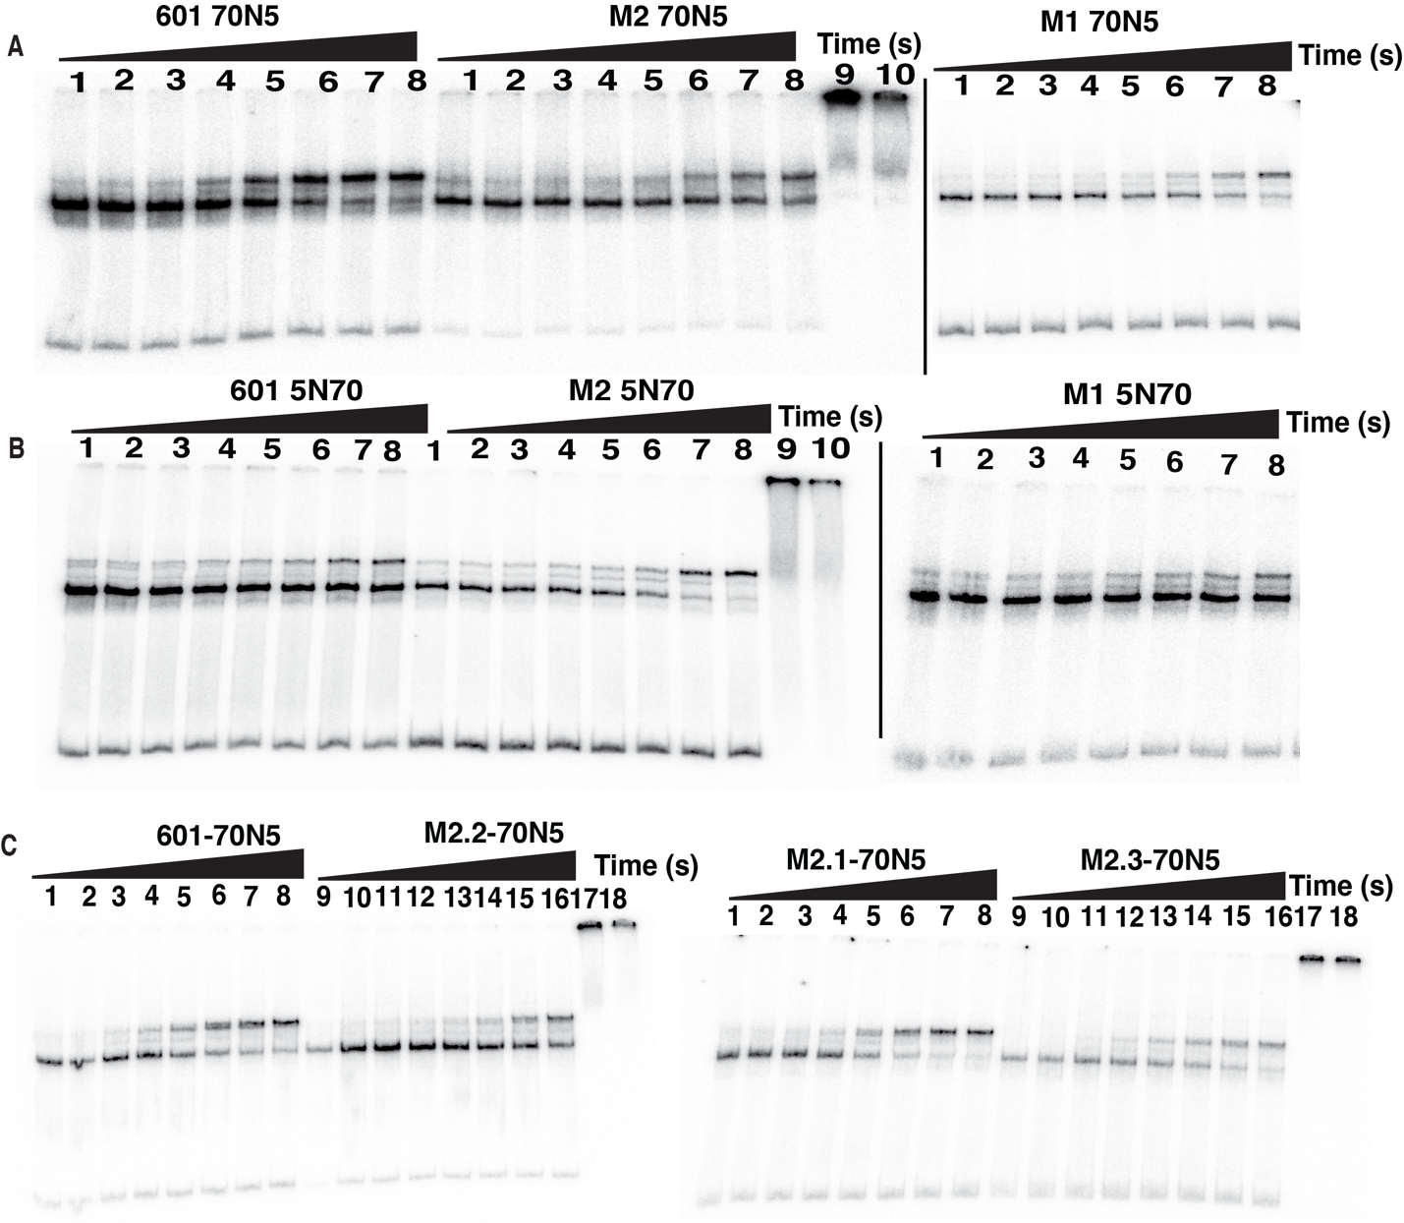

Supplementary Figure 4: The DNA sequence bound by the ATPase domain at SHL-6 is critical for INO80 remodeling. (A-B) Full gel images of the nucleosome mobilization assay for (A) 70N5 and (B) 5N70 nucleosomes assembled with 601, M1 and M2 DNA. The time points for 5N70 nucleosomes are 0, 40, 80, 160, 320, 640, 1800, 3600s (lanes 1–8) and 70N5 are 0, 10,20, 40, 80, 160, 320, 640s (lanes 1–8) assembled with M1 DNA. The reaction times with M2 70N5 and 5N70 nucleosomes are 0, 40, 80, 160, 320, 640, 1800, 3600s (lanes 1–8). (C) Representative gel images are shown for nucleosome mobilization assays with 601, M2.1, M2.2, and M2.3 70N5 nucleosomes. Nucleosomes were remodeled with saturating INO80 for 0, 10, 20, 40, 80, 160, 320, 640s.

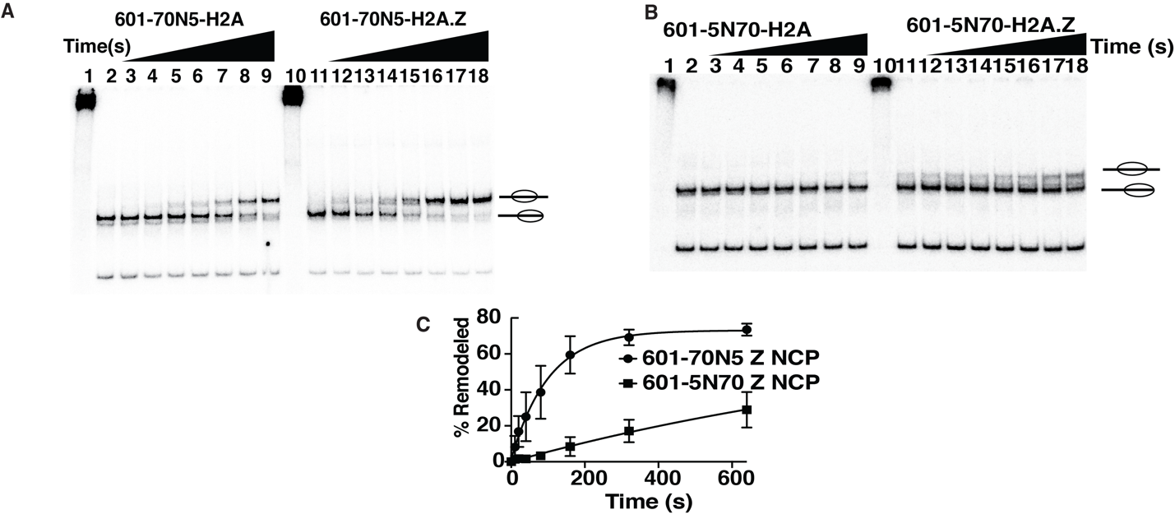
Supplementary Figure 5: DNA sequence specificity is conserved when INO80 remodels H2A.Z containing nucleosomes.
(A-B) Remodeling assays are shown for H2A and H2A.Z containing (A) 70N5 and (B) 5N70 nucleosomes saturated with INO80 and 80 μM ATP at 30°C for 0, 10, 20, 40, 80, 160, 320, and 640s using EMSA. (C) The data from (A-B) is plotted with reaction time versus the percent of nucleosomes mobilized. Three technical replicates were done, and error bars denote ±s.d.

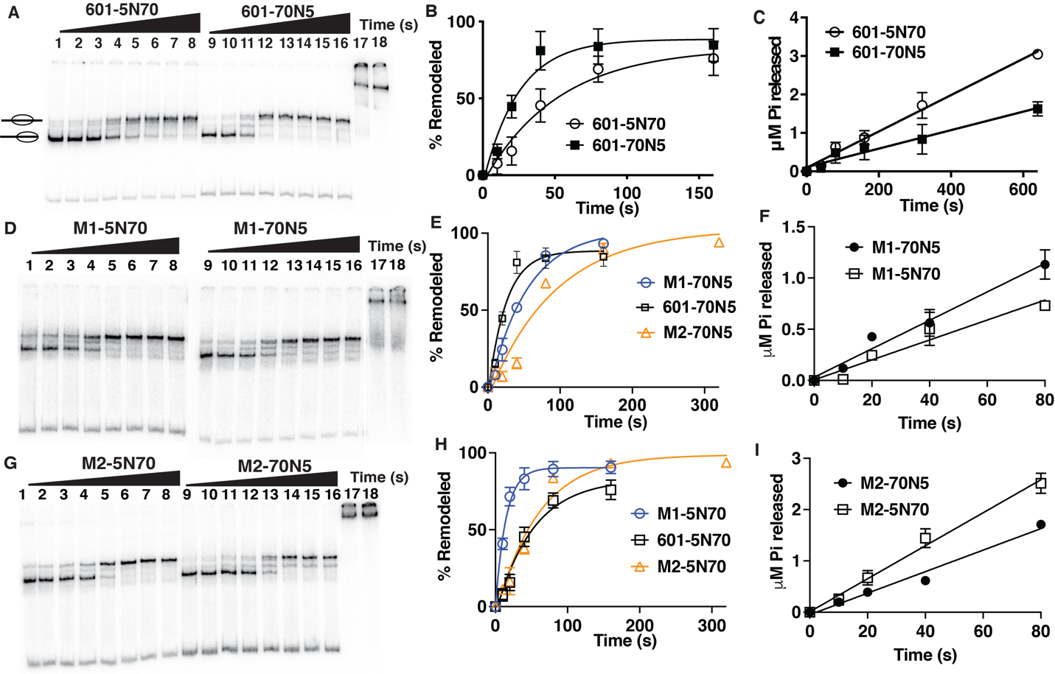

Supplementary Figure 6: ISW2 does not have the same DNA specificity as INO80.
(A,D,G) Both 5N70 (lanes 1–8) and 70N5 (lanes 9–16) nucleosomes of (A) 601, (D) M1 or (G) M2 are remodeled by ISW2 and assessed by EMSA. Nucleosomes are saturated with ISW2 (lanes 17 & 18) and remodeled with 10 μM ATP at 30°C for 0, 10, 20, 40, 80, 160, 320, and 640s. (B, E, H) Data from respectively (A), (D), and (G) are plotted, showing the rates these nucleosomes are remodeled by INO80. (C,F,I) The rates of ATP hydrolysis determined using thin-layer chromatography and are plotted for (C) 601, (F) M1 and (I) M2 nucleosomes. Experiments were done with three technical replicates and error bars denote ±s.d.

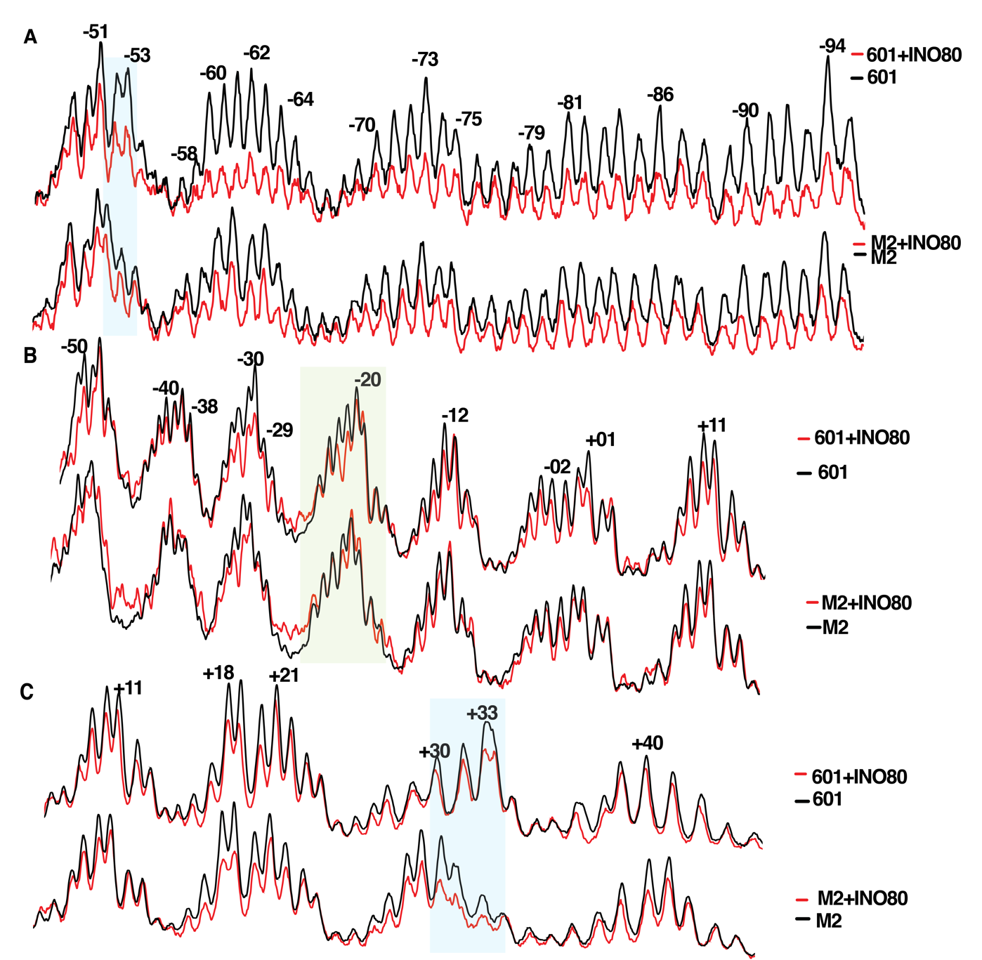
Supplementary Figure 7. DNA sequence at the H2A-H2B dimer impacts INO80 binding to nucleosomal DNA.
(A-C) The interactions of INO80 with 601 and M2 70N5 nucleosomes is probed by DNA footprinting at the entry sides of (A) upper and (B) lower DNA strands and (C) on the lower strand at the exit side. Black lines are nucleosomes only and red lines are nucleosomes with INO80 and with or without ATP analog added. Highlights are the same as in Supplementary Figure 6.

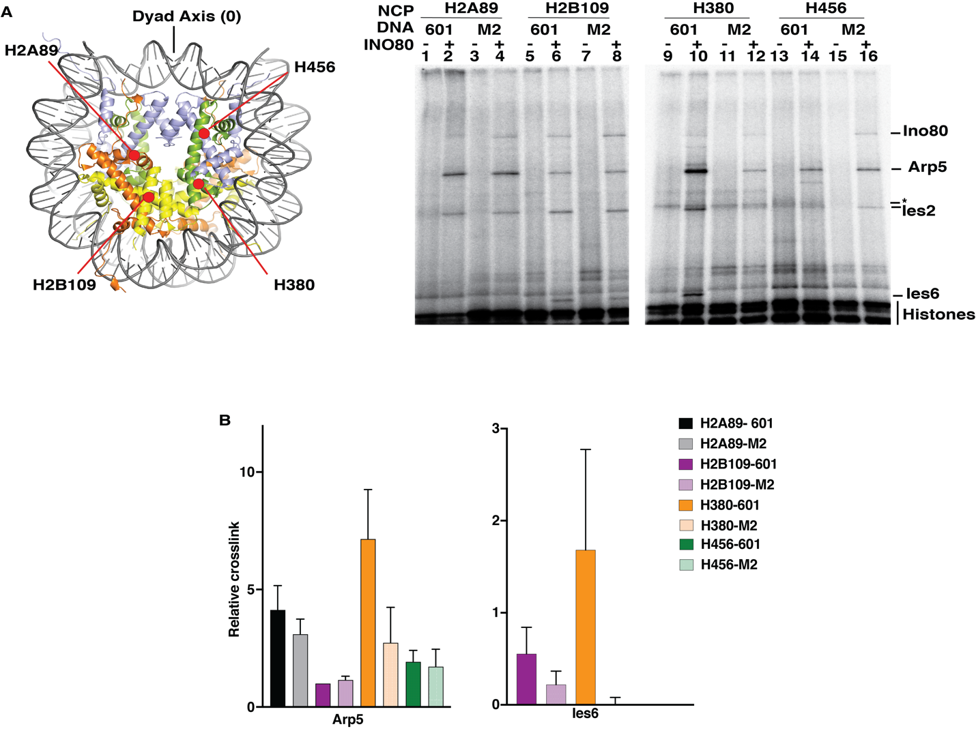
Supplementary Figure 8: Binding of Arp5 to the histone octamer are altered by the DNA sequence bound to the proximal H2A-H2B dimer.
(A) The interactions of INO80 with the histone octamer when bound to M2 and 601 70N5 nucleosomes are probed by site-directed histone crosslinking. A total of 4 histone sites are probed as shown in the schematic. The subunits crosslinked to histone sites and radiolabeled are determined by SDS-PAGE and phosphorimaging as shown. (B) The signal of the crosslinked INO80 subunits is quantitated and plotted as shown and the crosslinking patterns of 601 and M2 nucleosomes are compared. A total of 3 technical replicates were performed and error bars denote ± s.d.

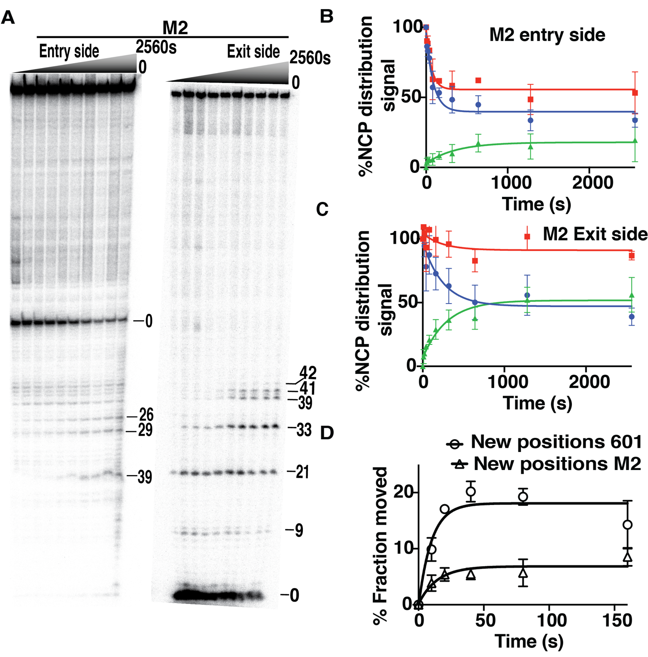
Supplementary Figure 9. Initial DNA translocation on the exit side is not DNA sequence sensitive
(A) DNA movement on the histone octamer surface of nucleosomes was tracked from the entry and exit side of M2 70N5 nucleosomes using modified residue 53 of H2B. The sites of DNA cleaved by crosslinking are determined by resolving the labeled DNA on an 8% denaturing polyacrylamide gel and phosphorimaging as shown. (B-C) The extent of DNA being displaced from the (B) entry and (C) exit sides of 601 and M2 nucleosome are shown with blue indicating the percent loss of the starting position on the entry side, green showing gain of the total new DNA position and red being the sum of both in order to determine the loss of DNA contact with this region of H2B. (D) The amount of total DNA being moved to new positions by INO80 on the entry side is shown for 601 and M2 70N5 nucleosomes. All these experiments are done with 3 independent replicates and error bars show ± s.d.

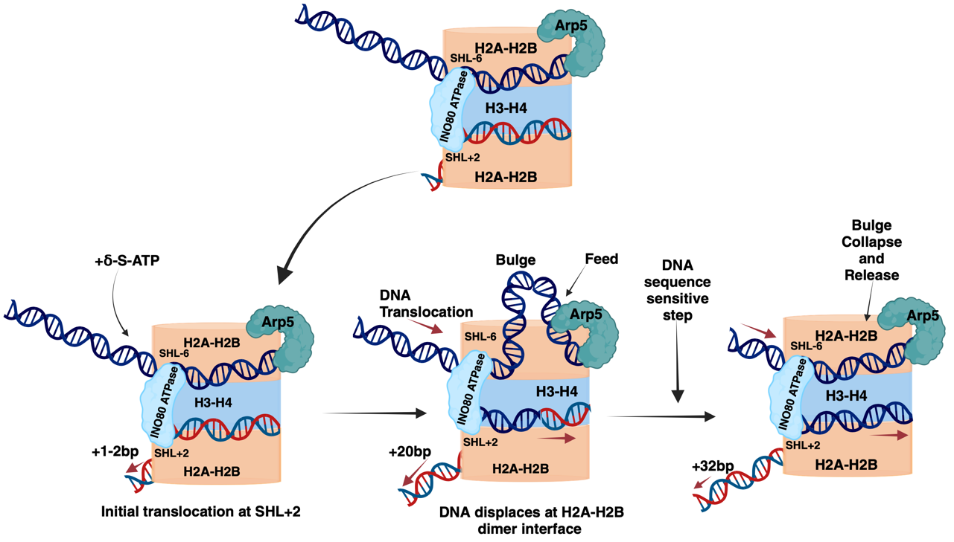
Supplementary Figure 10. Revised model of DNA translocation by INO80.
The ATPase domain of INO80 contacts both SHL-6 and SHL+2, effectively bridging the two superhelical locations in nucleosomes, and DNA translocation of the ATPase domain occurs at SHL+2. INO80 first moves DNA 20 bp on only the exit side of nucleosomes, coupled with INO80 displacing DNA near the entry side where H2A-H2B binds. After moving 20 bp on the exit side, DNA translocation is blocked by the ‘gatekeeper’ Arp5. Movement of an additional 12 bp on exit side occurs after DNA is displaced from the entry side, as indicated by the bulge collapse, and this additional movement is dependent on the DNA sequence at the H2A-H2B dimer interface.

