Table S1 Abiotic factors measured in this study. SAL, TEMP, TN, AN, NN, TP, TC, OC, HUM, DNA_C, PS, MMT, and MMP represented salinity, sediment temperature, total nitrogen, ammonium nitrogen, nitrate nitrogen, total phosphorus, total carbon, organic carbon, humidity, concentration of DNA extracted from per g sediments, particle size, monthly mean air temperature, and monthly mean precipitation, respectively.
Sample  Name | SAL  (‰) | TEMP  (℃) | TN  (g/kg) | AN  (mg/kg) | NN  (mg/kg) | TP  (g/kg) | TC  (g/kg) | OC  (g/kg) | pH | HUM  (%) | DNA_C  (ng/μl/g soils) | PS  (mm) | MMT  (℃) | MMP  (mm)
TLG_6_surf | 19.3 | 29.3 | 0.315 | 54 | 16.2 | 0.127 | 3.4 | 2.92 | 8.23 | 15.9 | 28.3 | 0.82 | 28 | 9.9
TLG_6_sub | 20.1 | 28.5 | 0.165 | 37.5 | 10.6 | 0.107 | 1.4 | 1.18 | 7.85 | 13.5 | 8.3 | 0.67 | 28 | 9.9
YLW_6_surf | 10.7 | 27.5 | 2.88 | 85.8 | 23.9 | 0.945 | 27.2 | 24.1 | 6.41 | 47 | 108.9 | 0.020 | 28 | 9.9
YLW_6_sub | 10.5 | 28 | 0.401 | 55.8 | 17.6 | 0.266 | 1.01 | 0.59 | 7.07 | 15.6 | 6.3 | 0.54 | 28 | 9.9
SYH_6_surf | 5.0 | 27.3 | 0.343 | 58.5 | 16.5 | 0.174 | 1.01 | 0.89 | 7.53 | 28.2 | 17.1 | 0.18 | 28 | 9.9
SYH_6_sub | 5.0 | 29.5 | 0.239 | 49.2 | 15.4 | 0.158 | 2.17 | 1.54 | 8.49 | 15 | 10.7 | 0.16 | 28 | 9.9
TLG_3_surf | 30.7 | 25.3 | 1.01 | 48.3 | 14.9 | 0.232 | 5.4 | 5.24 | 8.44 | 20.6 | 37.6 | 0.53 | 25 | 0.7
TLG_3_sub | 29 | 24.7 | 1.31 | 46.5 | 11.7 | 0.25 | 6.1 | 5.6 | 7.72 | 18.7 | 13.5 | 0.53 | 25 | 0.7
YLW_3_surf | 15 | 24.4 | 1.58 | 63.6 | 18.4 | 0.852 | 8.8 | 8.58 | 7.86 | 20.9 | 60.7 | 0.23 | 25 | 0.7
YLW_3_sub | 15 | 24.5 | 1.08 | 86.7 | 21 | 0.303 | 2.7 | 2.58 | 7.71 | 15.3 | 12.5 | 0.39 | 25 | 0.7
SYH_3_surf | 25 | 25.5 | 1.28 | 37.5 | 14.4 | 0.737 | 4 | 1.95 | 7.66 | 24.1 | 37.1 | 0.17 | 25 | 0.7
SYH_3_sub | 25 | 26.2 | 1.18 | 52.2 | 16.1 | 0.49 | 8.3 | 3.28 | 7.78 | 24.6 | 11.2 | 0.17 | 25 | 0.7
TLG_9_surf | 20.3 | 28.3 | 0.386 | 57.8 | 23.6 | 0.145 | 5.7 | 0.87 | 7.01 | 17.98 | 25.5 | 0.68 | 28 | 10.1
TLG_9_sub | 20.1 | 29.2 | 0.304 | 51.6 | 20.3 | 0.14 | 3.3 | 0.56 | 8.67 | 14.47 | 13.9 | 0.52 | 28 | 10.1
YLW_9_surf | 1 | 27.3 | 3.07 | 188 | 44.2 | 1 | 17.6 | 5.6 | 6.51 | 47.14 | 30.8 | 0.032 | 28 | 10.1
YLW_9_sub | 1 | 28.3 | 0.142 | 39.8 | 13.2 | 0.106 | 2.4 | 0.5 | 8.96 | 17.98 | 10.4 | 0.63 | 28 | 10.1
SYH_9_surf | 2 | 27.2 | 0.41 | 66.7 | 25.6 | 0.321 | 2.9 | 0.62 | 7.96 | 22.87 | 30.7 | 0.23 | 28 | 10.1
SYH_9_sub | 2 | 28.8 | 0.418 | 69.8 | 27 | 0.391 | 1.9 | 0.84 | 8.66 | 24.93 | 10.1 | 0.19 | 28 | 10.1
TLG_12_surf | 21 | 15.5 | 0.146 | 19.6 | 17.8 | 0.896 | 7.5 | 4.6 | 7.14 | 17.12 | 22.6 | 0.61 | 22 | 0.4
TLG_12_sub | 19.2 | 18.2 | 0.155 | 5.7 | 12.8 | 0.14 | 5.3 | 3.29 | 6.77 | 14.94 | 11.2 | 0.67 | 22 | 0.4
SYH_12_surf | 20 | 19.2 | 0.594 | 42.7 | 15.9 | 0.27 | 5 | 4.29 | 7.28 | 27.35 | 30.8 | 0.19 | 22 | 0.4
SYH_12_sub | 20 | 23.5 | 0.153 | 6.7 | 18.1 | 0.156 | 2.4 | 2.18 | 8.27 | 23.1 | 17.1 | 0.18 | 22 | 0.4

Table S3 Variance inflation factors (VIF) analysis to remove the factors possessed heavy collinearity with other factors. VIF values more than 10 were removed until all the rest of factors with the VIF values less than 10. After the calculation, TN, NN, TC, and MMP were removed.
 | SAL | TEMP | TN | AN | NN | TP | TC | OC | pH | HUM | PS | MMT | MMP
VIF value （Before） | 4.95 | 27.12 | 56.072 | 21.612 | 18.11 | 5.43 | 28.27 | 12.63 | 3.47 | 11.35 | 5.44 | 49.42 | 49.46
VIF value （After） | 4.59 | 7.22 | (Removed) | 4.062 | (Removed) | 2.94 | (Removed) | 2.73 | 2.63 | 7.08 | 4.66 | 9.39 | (Removed)

Fig. S1 Pearson correlation of abiotic factors. The lower part of this figure shows the scatter plot of the values between any two factors, and the upper part shows the correlation between any two factors. “*” and “**” in the upper part represent the p values ≤ 0.05 and ≤ 0.01, respectively (SAL, salinity; TEMP, sediment temperature; TN, total nitrogen; AN, ammonium nitrogen; NN, nitrate nitrogen; TP, total phosphorus; TC, total carbon; OC, organic carbon; HUM, humidity; DNA_C, concentration of DNA extracted from per gram of sediments; PS, particle size; MMT, monthly mean air temperature; MMP, monthly mean precipitation)

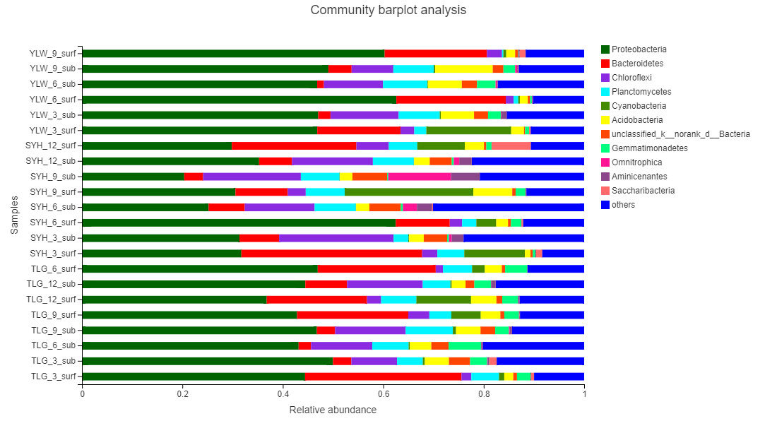
Fig. S2 Bacterial community component at phylum level.

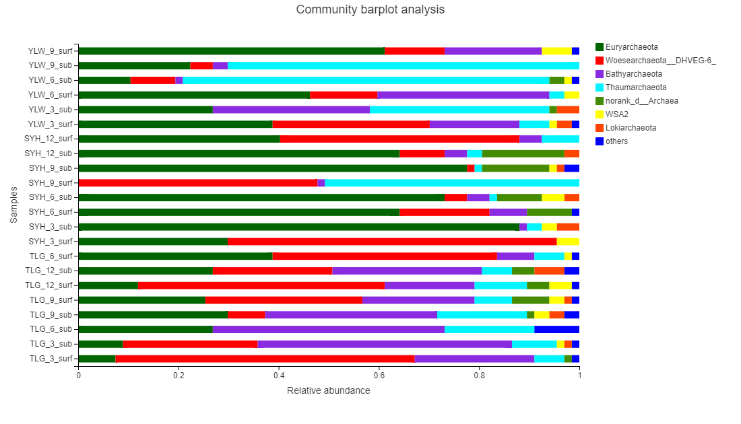
Fig. S3 Archaeal community component at phylum level.

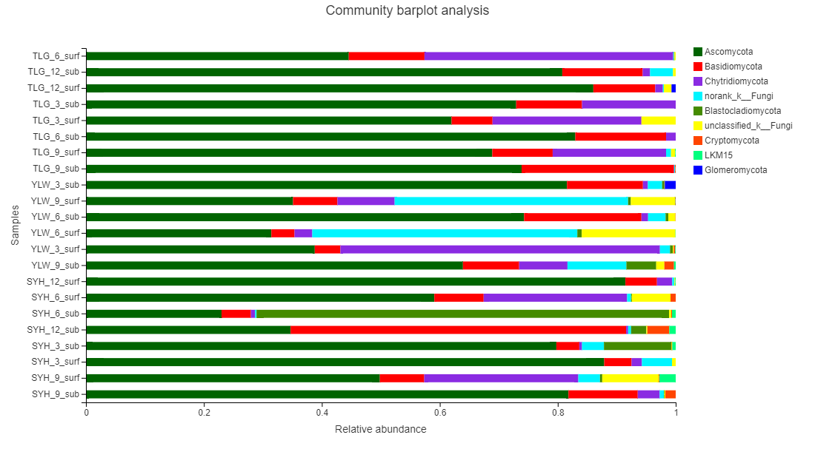
Fig. S3 Fungal community component at phylum level.

Fig. S4 Spatiotemporal impacts on the alpha-diversity of bacterial community. The impacts of location, depth and season on the alpha-diversity of bacterial community were shown in A-D, E-H, and I-L, respectively; The indexes of Shannon (A, E, and I), Simpson (B, F, and J), ACE (C, G, and K), and Chao (D, H, and L) of bacterial community from different spatiotemporal dimensions were shown. Results showed that the depth significantly affected (Anova, p ≤ 0.05) the diversity (based on Shannon and Simpson indexes) and abundance (based on ACE and Chao indexes) of bacterial community. Significant difference was not found in the samples from different locations and seasons. TLG, Tielu Bay; YLW, Yalong Bay; SYH, Sanya River.
Fig. S5 Spatiotemporal impacts on the alpha-diversity of archaeal community. The impacts of location, depth and season on the alpha-diversity of archaeal community were shown in A-D, E-H, and I-L, respectively; The indexes of Shannon (A, E, and I), Simpson (B, F, and J), ACE (C, G, and K), and Chao (D, H, and L) of archaeal community from different spatiotemporal dimensions were shown. Results showed that the location significantly affected (Anova, p ≤ 0.05) the diversity (based on Shannon and Simpson indexes) and abundance (based on ACE and Chao indexes) of archaeal community. Significant difference was not found in the samples from different depths and seasons.

Fig. S6 Spatiotemporal impacts on the alpha-diversity of fungal community. The impacts of location, depth and season on the alpha-diversity of fungal community were shown in A-D, E-H, and I-L, respectively; The indexes of Shannon (A, E, and I), Simpson (B, F, and J), ACE (C, G, and K), and Chao (D, H, and L) of fungal community from different spatiotemporal dimensions were shown. Results showed that the location and depth significantly affected (Anova, p ≤ 0.05) the abundance (based on ACE and Chao indexes) of fungal community. Significant difference was not found in the samples from different seasons.

Fig. S7 Legends of LEfSe results for bacterial (A), archaeal (B), and fungal (C) communities on phylum level.

Fig. S8 Linear equations of abiotic factors fitted with PC1 value from principal component analysis for bacterial community. The significant factors for bacterial community, including SAL, AN, TP, OC, pH, HUM, and PS, were individually fitted with PC1 value. Results showed that PS possessed the highest R², indicating that PS was the key abiotic factor for shaping the bacterial community in mangrove sediments.
Fig. S9 Linear equations of abiotic factors fitted with PC1 value from principal component analysis for archaeal community. The significant factors for archaeal community, including SAL, TEMP, HUM, and PS, were individually fitted with PC1 value. Results showed that PS possessed the highest R², indicating that PS was the key abiotic factor for shaping the archaeal community in mangrove sediments.

Fig. S10 Linear equations of abiotic factors fitted with PC1 value from principal component analysis for fungal community. The significant factors for fungal community, including SAL, TEMP, HUM, and PS, were individually fitted with PC1 value. Results showed that PS possessed the highest R², indicating that PS was the key abiotic factor for shaping the fungal community in mangrove sediments.
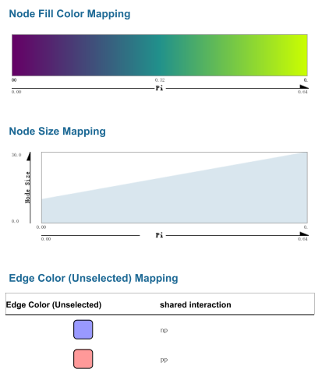
Fig. S11 Legend for the Cytoscape network of bacterial community from SYH samples.
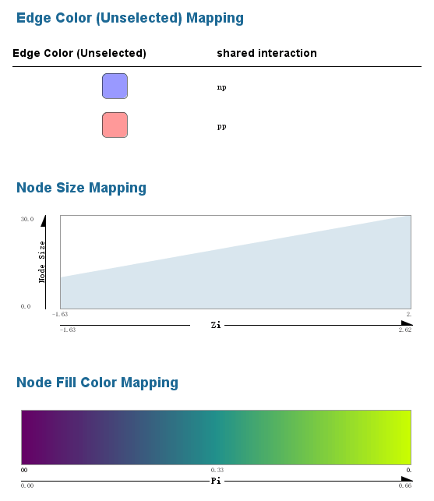
Fig. S12 Legend for the Cytoscape network of bacterial community from TLG samples.
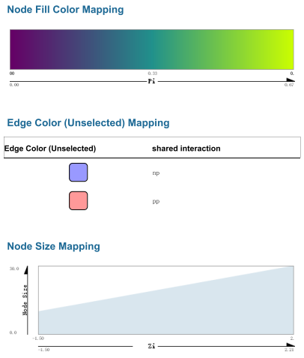
Fig. S13 Legend for the Cytoscape network of bacterial community from YLW samples.

