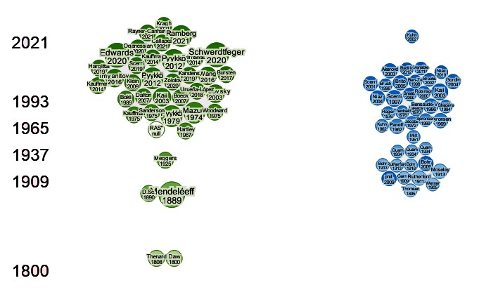
Appendix A
Figure A Literature review mapping

