Most monogenic disorders are caused by mutations altering protein folding free energy
Preeti Pandey¹ and Emil Alexov^{1,*}
¹ Department of Physics and Astronomy, Clemson University, Clemson, SC 29634
* Correspondence: Corresponding author email: ealexov@clemson.edu

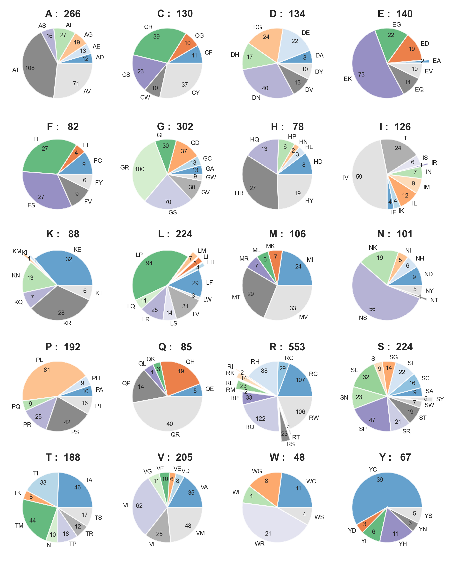

Figure S1a. Pie-chart summarising count of different amino acid mutations in the Monogenic Disorder Dataset 1 (no likely cases). In each subplot, the title shows the count of wild-type amino acids in the whole dataset, and the two-letter label of every pie-chart denotes the one-letter codes of the wild-type and mutant amino acid pair, respectively.
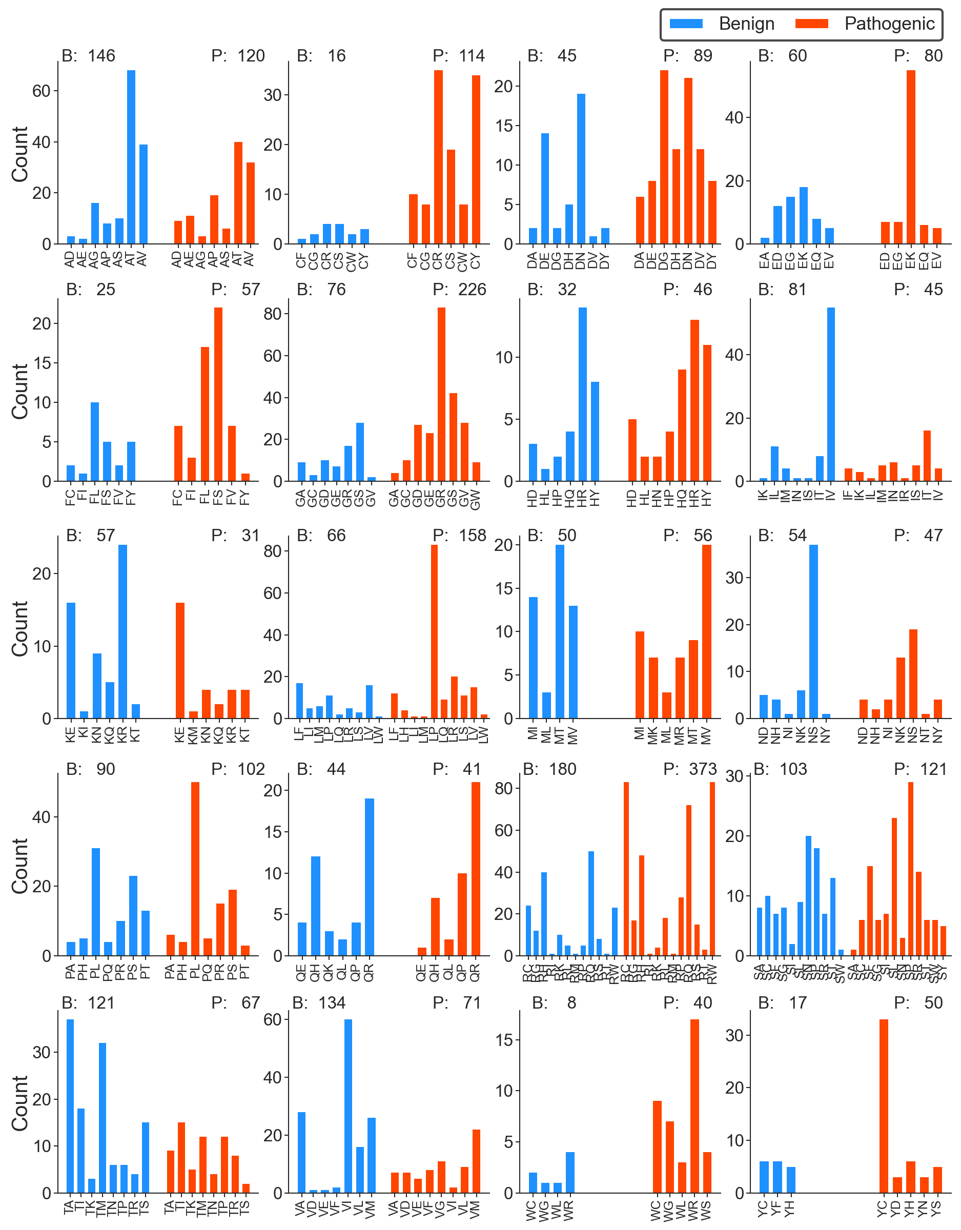

Figure S1b. Bar plots summarising count of benign and pathogenic mutations in the Monogenic Disorder Dataset 1 (no likely cases). The two-letter label of every bar denotes the one-letter codes of the wild-type and mutant amino acid pairs, respectively. B denotes benign and P denotes pathogenic mutations.

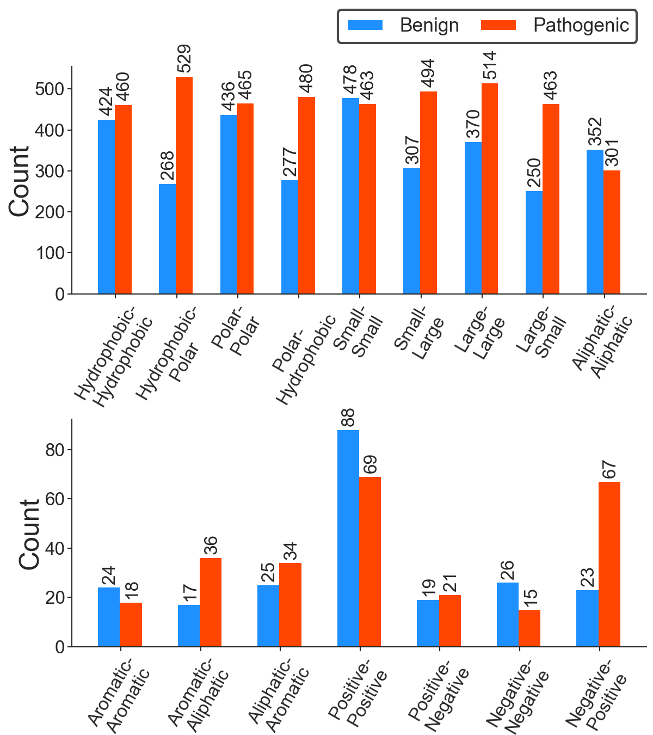

Figure S1c. Benign vs. pathogenic mutations assigned according to the property of amino acid mutation in the Monogenic Disorder Dataset 1 (no likely cases). The two-word label in the bar plot represents the chemical nature of the wild-type and mutant residues pairs, respectively. The amino acids according to their chemical properties are categorised as follows: Ala, Cys, Gly, Ile, Leu, Met, Phe, Pro, Trp, and Val are categorised as hydrophobic. Asp, Glu, Lys, Arg, His, Asn, Gln, Ser, Thr, and Tyr are categorised as polar. His, Phe, Trp, and Tyr as aromatic. Ala, ILe, Lys, Leu, Met, Pro, and Val as aliphatic. His, Lys, Arg as positive. Asp, and Glu as negative. Ala, Cys, Gly, Ser, Asn, Asp, Pro, Thr, and Val as small. And Arg, Gln, Glu, His, ILe, Leu, Lys, Met, Phe, Trp, and Tyr as large amino acids.

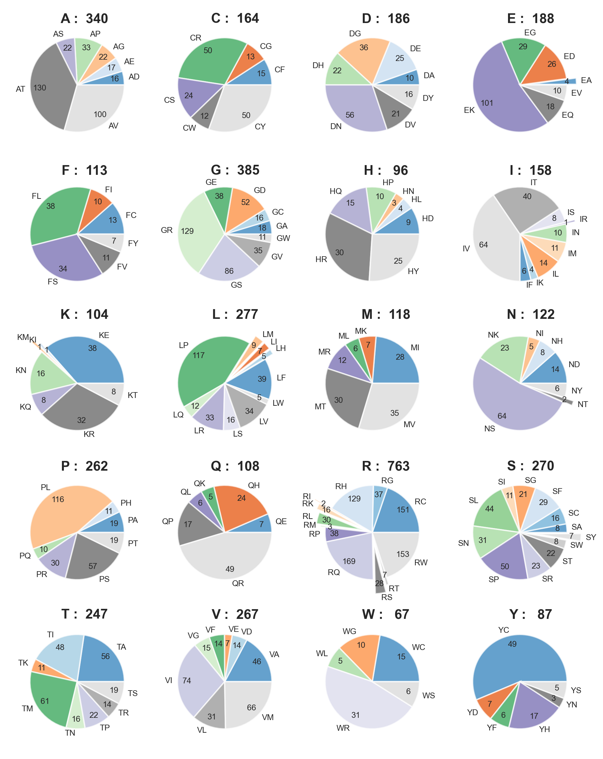
Figure S1d. Pie-chart summarising count of different amino acid mutations in the Monogenic Disorder Dataset 2 (including likely cases). In each subplot, the title shows the count of wild-type amino acids in the whole dataset, and the two-letter label of every pie-chart denotes the one-letter codes of the wild-type and mutant amino acid pair, respectively.
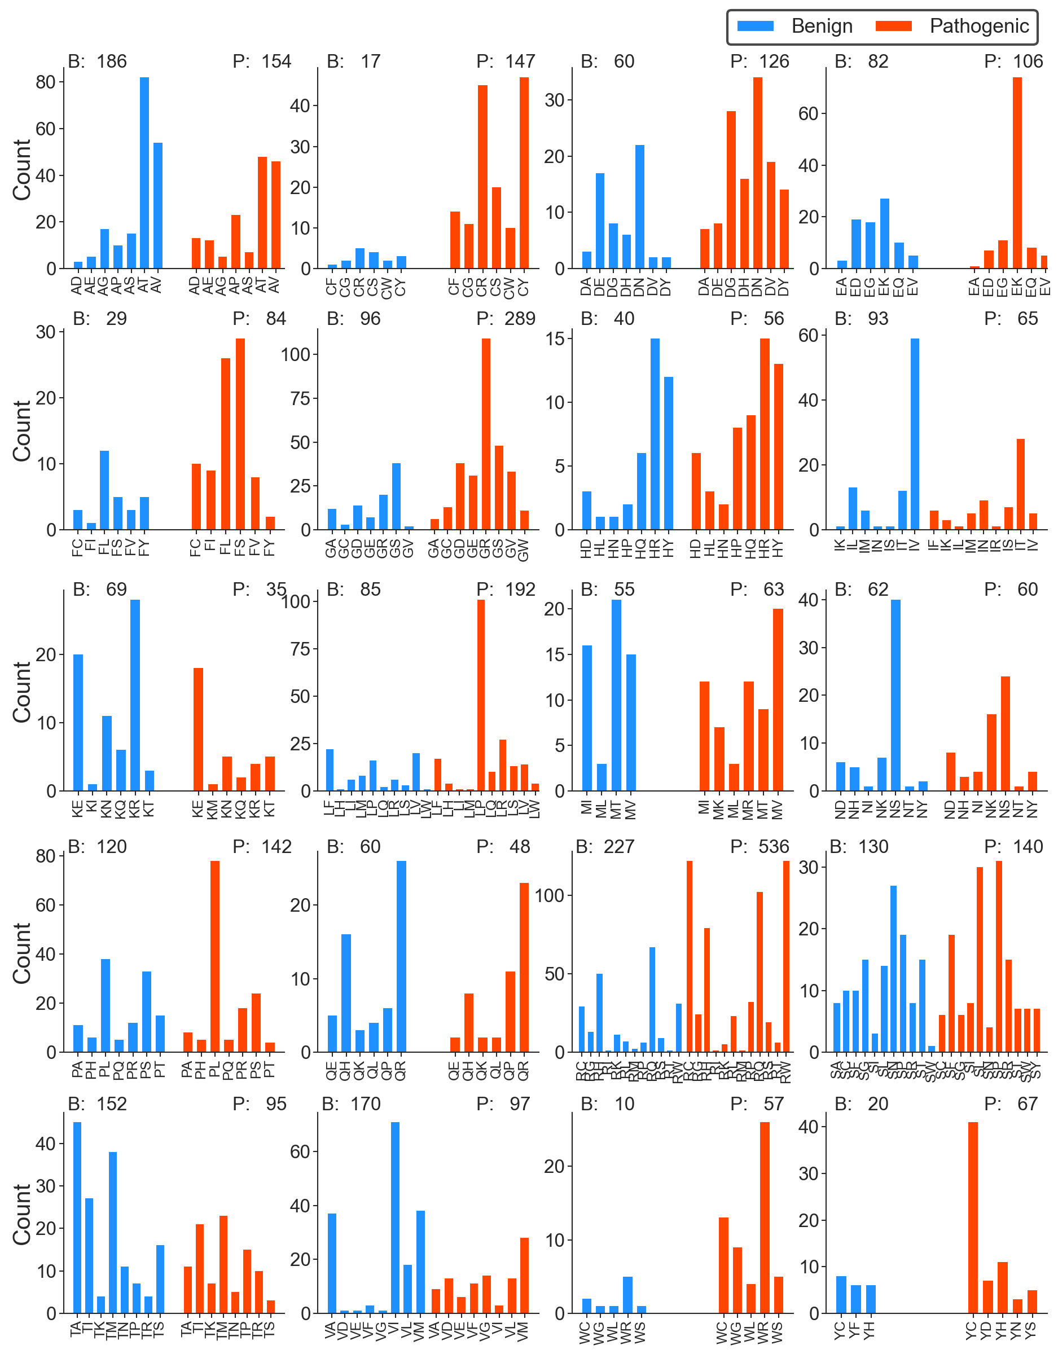
Figure S2e. Bar plots summarising count of benign and pathogenic mutations in the Monogenic Disorder Dataset 2 (including likely cases). The two-letter label of every bar denotes the one-letter codes of the wild-type and mutant amino acid pairs, respectively. B denotes benign and P denotes pathogenic mutations.
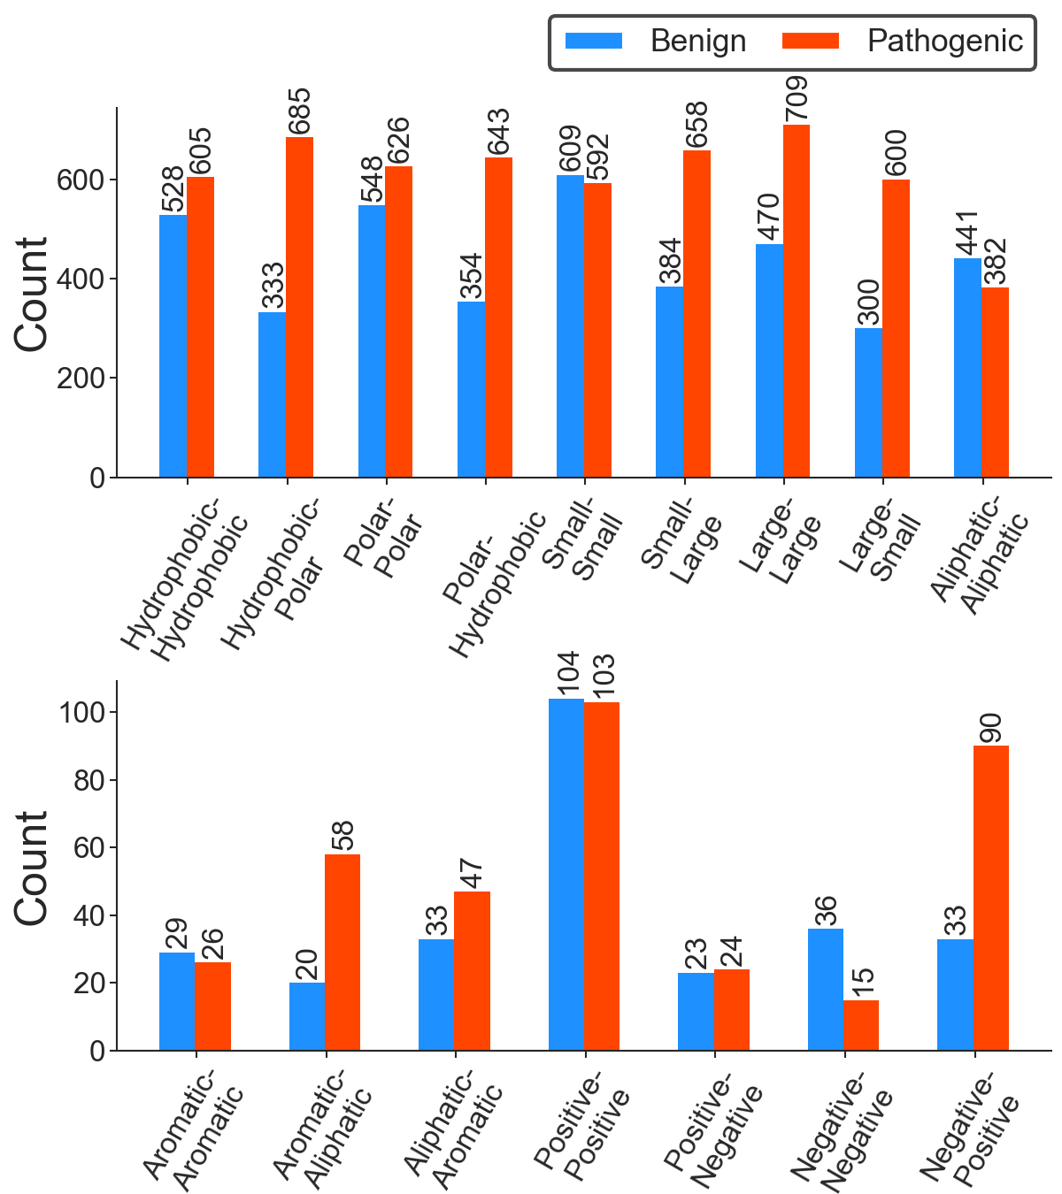

Figure S2f. Benign vs. pathogenic mutations assigned according to the property of amino acid mutation in the Monogenic Disorder Dataset 2 (including likely cases). The two-word label in the bar plot represents the chemical nature of the wild-type and mutant residues pairs, respectively. The amino acids according to their chemical properties are categorised as follows: Ala, Cys, Gly, Ile, Leu, Met, Phe, Pro, Trp, and Val are categorised as hydrophobic. Asp, Glu, Lys, Arg, His, Asn, Gln, Ser, Thr, and Tyr are categorised as polar. His, Phe, Trp, and Tyr as aromatic. Ala, ILe, Lys, Leu, Met, Pro, and Val as aliphatic. His, Lys, Arg as positive. Asp, and Glu as negative. Ala, Cys, Gly, Ser, Asn, Asp, Pro, Thr, and Val as small. And Arg, Gln, Glu, His, ILe, Leu, Lys, Met, Phe, Trp, and Tyr as large amino acids.

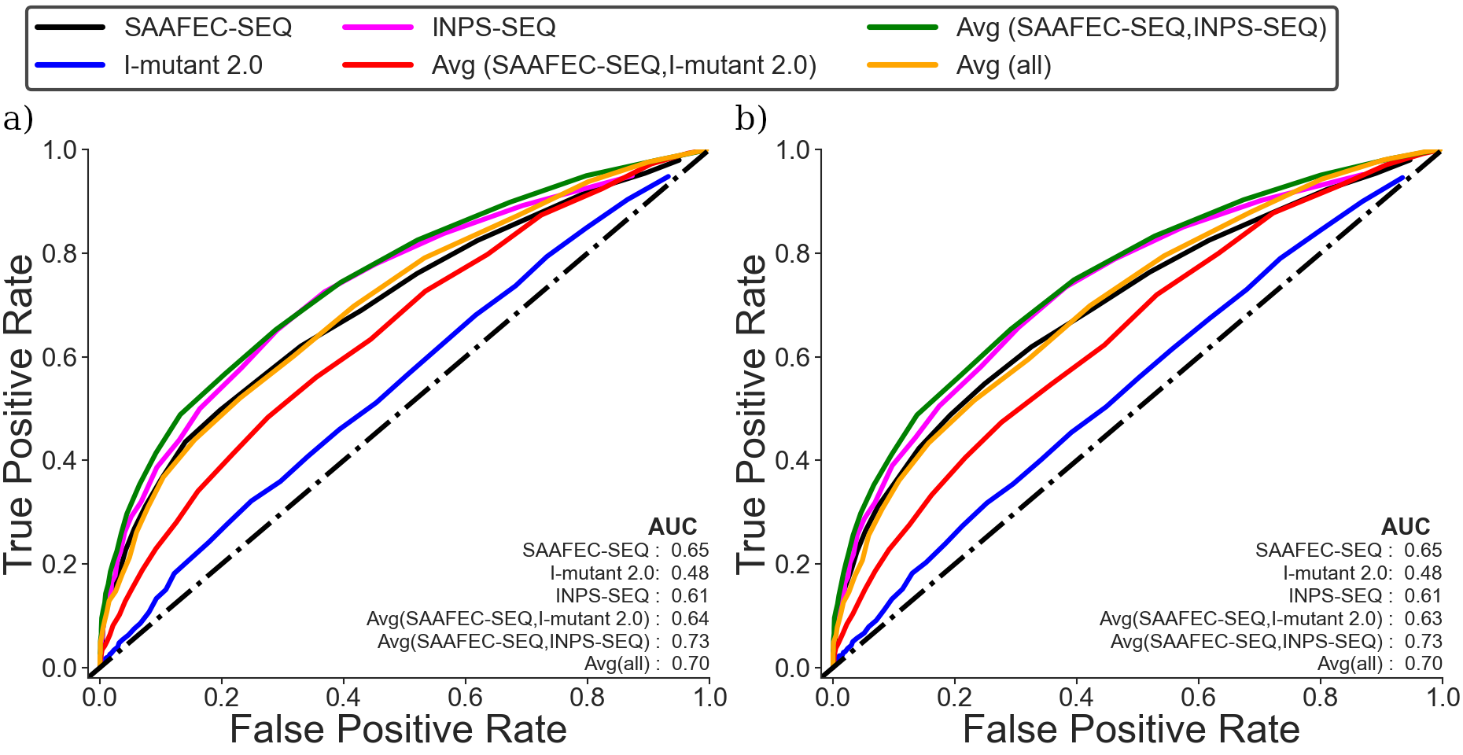

Figure S2. ROC curve for monogenic disorder dataset using absolute ΔΔ G values. (a) Monogenic Disorder Dataset 1 (no likely cases) (b) Monogenic Disorder Dataset 2 (including likely cases).
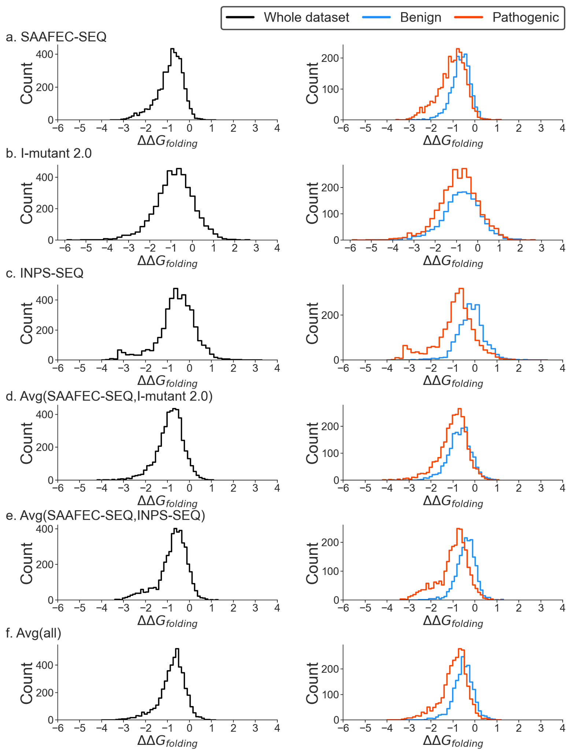
Figure S3. Distribution of change in folding free energy using different predictors using Monogenic Disorder Dataset 2 (including likely cases).

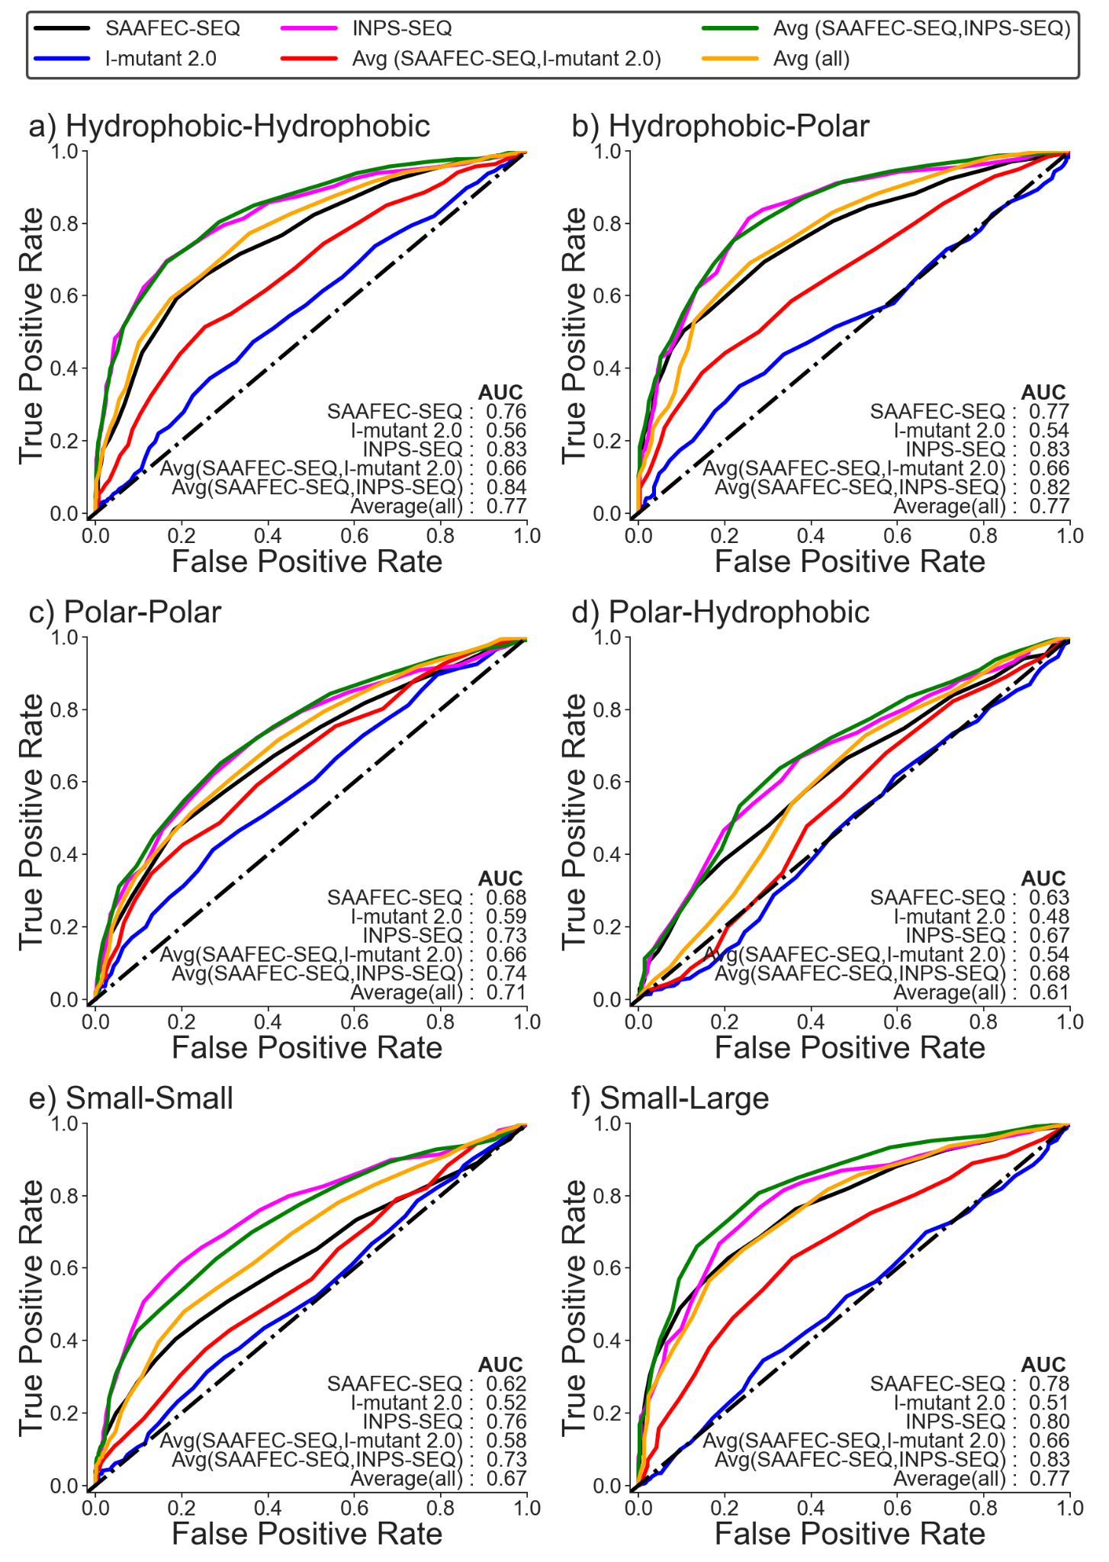
Figure S4a. ROC curve for Monogenic Disorder Dataset 2 (including likely cases) for different categories of amino acid mutations. The amino acids according to their chemical properties are categorised as follows: Ala, Cys, Gly, Ile, Leu, Met, Phe, Pro, Trp, and Val are categorised as hydrophobic. Asp, Glu, Lys, Arg, His, Asn, Gln, Ser, Thr, and Tyr are categorised as polar. His, Phe, Trp, and Tyr as aromatic. Ala, ILe, Lys, Leu, Met, Pro, and Val as aliphatic. His, Lys, Arg as positive. Asp, and Glu as negative. Ala, Cys, Gly, Ser, Asn, Asp, Pro, Thr, and Val as small. And Arg, Gln, Glu, His, ILe, Leu, Lys, Met, Phe, Trp, and Tyr as large amino acids.

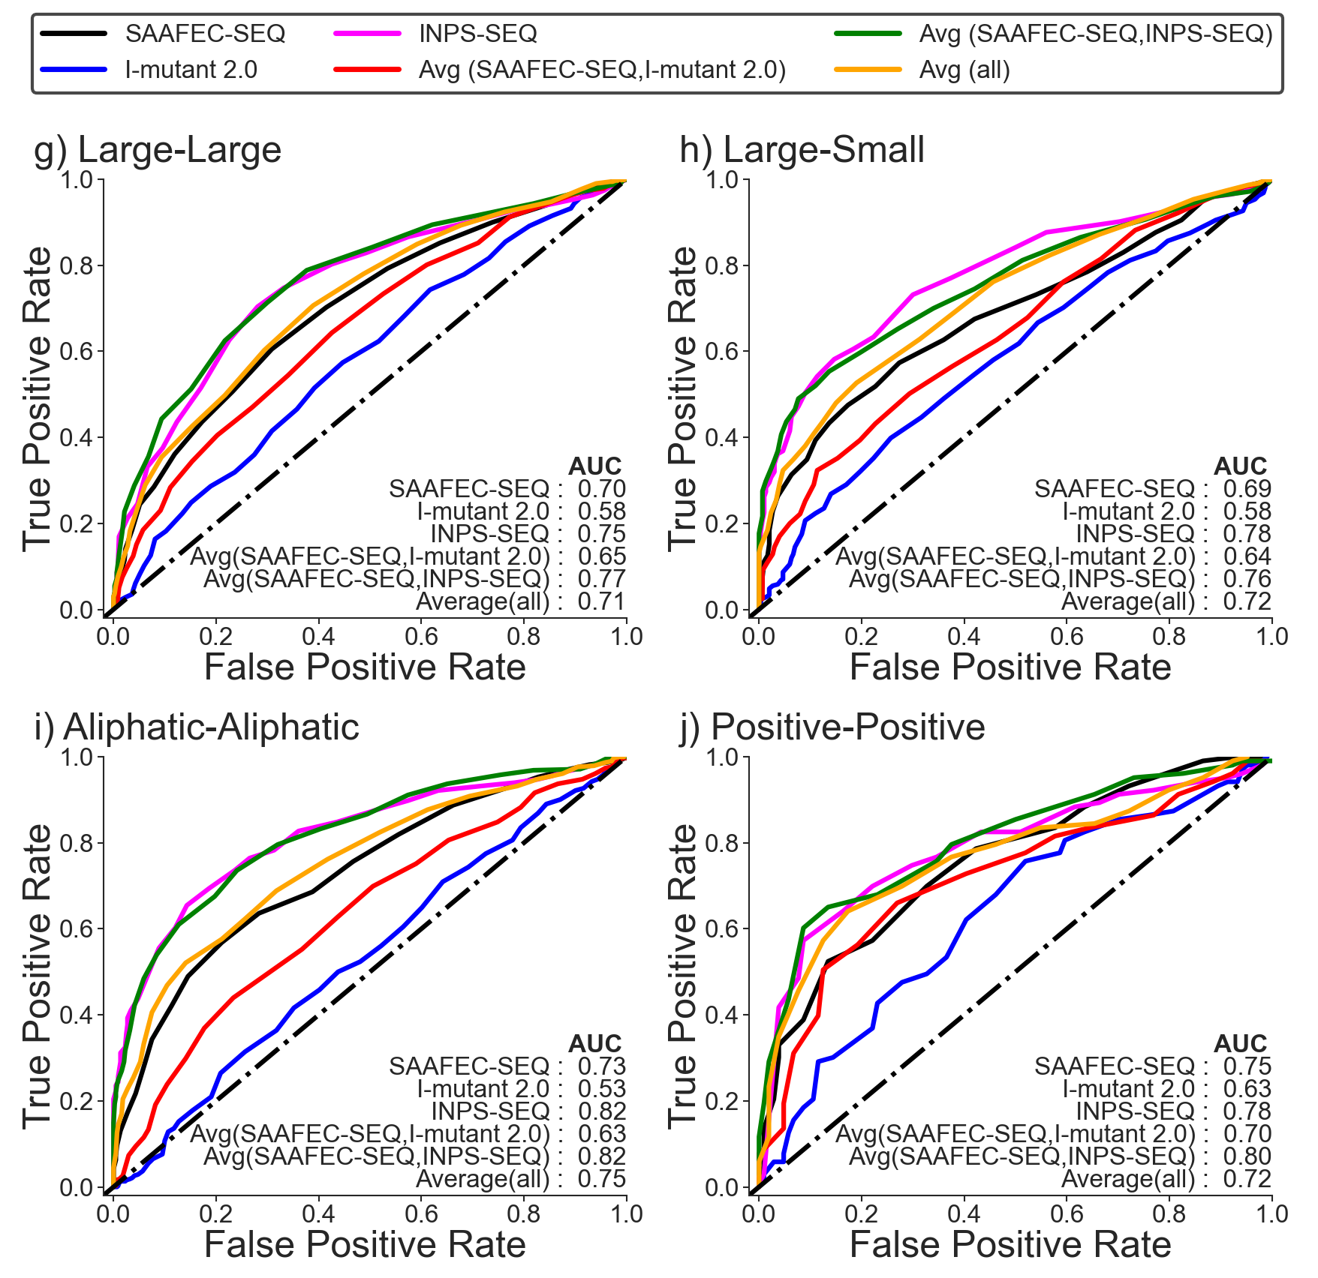
Figure S4b. ROC curve for Monogenic Disorder Dataset 2 (including likely cases) for different categories of amino acid mutations. The amino acids according to their chemical properties are categorized as follows: Ala, Cys, Gly, Ile, Leu, Met, Phe, Pro, Trp, and Val are categorised as hydrophobic. Asp, Glu, Lys, Arg, His, Asn, Gln, Ser, Thr, and Tyr are categorised as polar. His, Phe, Trp, and Tyr as aromatic. Ala, ILe, Lys, Leu, Met, Pro, and Val as aliphatic. His, Lys, Arg as positive. Asp, and Glu as negative. Ala, Cys, Gly, Ser, Asn, Asp, Pro, Thr, and Val as small. And Arg, Gln, Glu, His, ILe, Leu, Lys, Met, Phe, Trp, and Tyr as large amino acids.

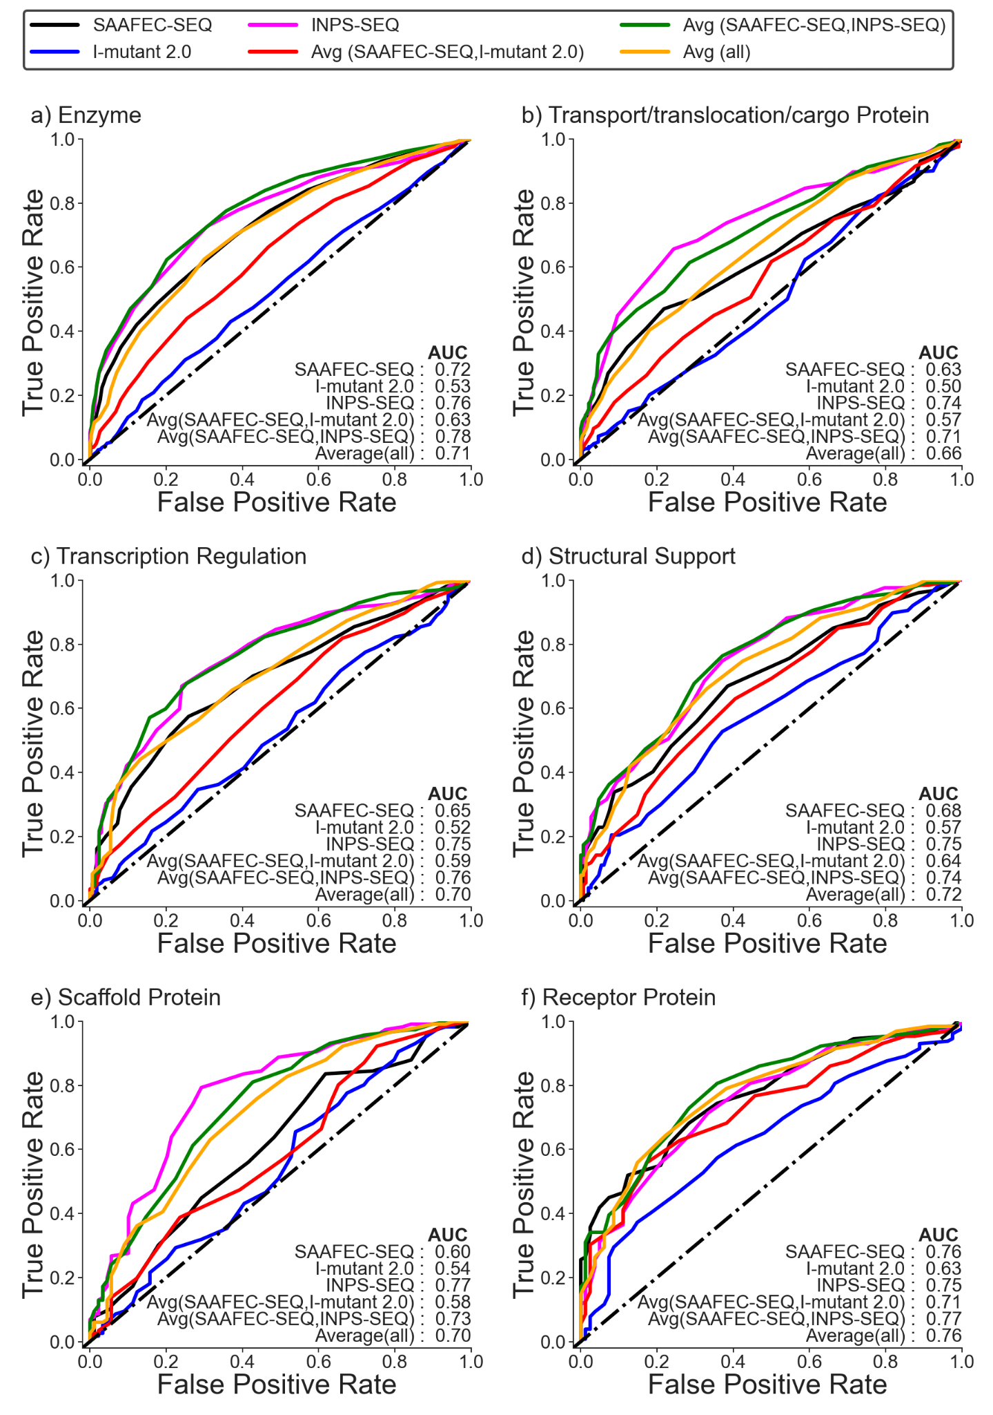
Figure S5a. ROC curve for Monogenic Disorder Dataset 2 (including likely cases) for different functional categories.
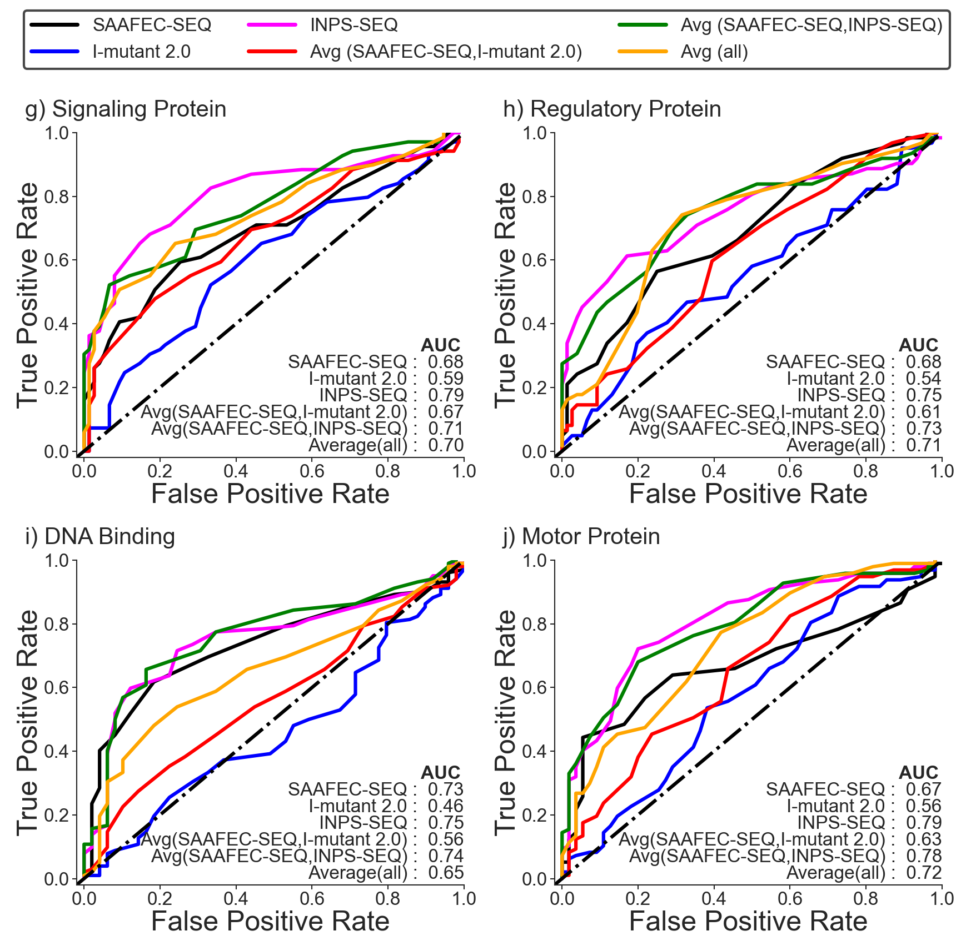
Figure S5b. ROC curve for Monogenic Disorder Dataset 2 (including likely cases) for different functional categories.

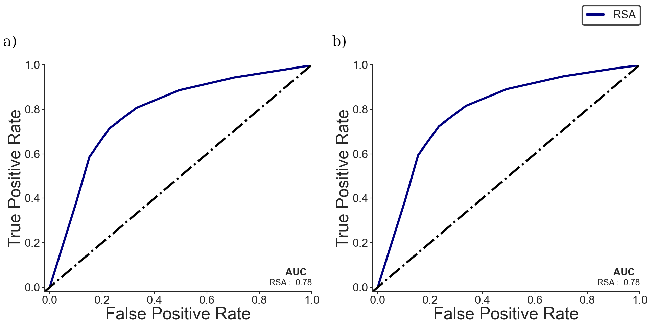
Figure S6. ROC curve for monogenic disorder dataset using Relative Surface Area (RSA) of amino acid. (a) Monogenic Disorder Dataset 1 (no likely cases) (b) Monogenic Disorder Dataset 2 (including likely cases).

Supplementary Tables

Table S1. Total number of amino acid mutations based on chemical nature of amino acid mutations in monogenic disorder database.

Se. No. | Type of amino acid mutation | Dataset 1 |  |  | Dataset 2
Se. No. | Type of amino acid mutation | Benign | Pathogenic | Total | Benign | Pathogenic | Total
1. | Hydrophobic-Hydrophobic | 424 | 460 | 884 | 528 | 605 | 1133
2. | Hydrophobic-Polar | 268 | 529 | 797 | 333 | 685 | 1018
3. | Polar-Polar | 436 | 465 | 901 | 548 | 626 | 1174
4. | Polar-Hydrophobic | 277 | 480 | 757 | 354 | 643 | 997
5. | Small-Small | 478 | 463 | 941 | 609 | 592 | 1201
6. | Small-Large | 307 | 494 | 801 | 384 | 658 | 1042
7. | Large-Large | 370 | 514 | 884 | 470 | 709 | 1179
8. | Large-Small | 250 | 463 | 713 | 300 | 600 | 900
9. | Aliphatic-Aliphatic | 352 | 301 | 653 | 441 | 382 | 823
10. | Aliphatic-Aromatic | 25 | 34 | 59 | 33 | 47 | 80
11. | Aromatic-Aromatic | 24 | 18 | 42 | 29 | 26 | 55
12. | Aromatic-Aliphatic | 17 | 36 | 53 | 20 | 58 | 78
13. | Positive-Positive | 88 | 69 | 157 | 104 | 103 | 207
14. | Positive-Negative | 19 | 21 | 40 | 23 | 24 | 47
15. | Negative-Negative | 26 | 15 | 41 | 36 | 15 | 51
16. | Negative-Positive | 23 | 67 | 90 | 33 | 90 | 123

Table S2. Total number of amino acid mutations based on functional annotation of proteins in monogenic disorder database.

Se. No. | Functional Class | No. of entries in Dataset 1 | No. of entries in Dataset 2
1. | Enzyme | 1295 | 1646
2. | Transport/translocation/cargo Protein | 445 | 570
3. | Transcription Regulation | 343 | 420
4. | Structural Support | 224 | 275
5. | Scaffold Protein | 152 | 205
6. | Receptor Protein | 141 | 210
7. | Signalling Protein | 128 | 144
8. | Regulatory Protein | 112 | 138
9. | DNA Binding | 90 | 151
10. | Motor Protein | 87 | 152
11. | Secretory Proteins | 74 | 80
12. | Adhesion Protein | 66 | 87
13. | Chaperons | 66 | 74
14. | Membrane Protein | 32 | 40
15. | RNA Binding | 31 | 50
16. | Antigen-Antibody | 14 | 18
17. | Miscellaneous | 39 | 62

