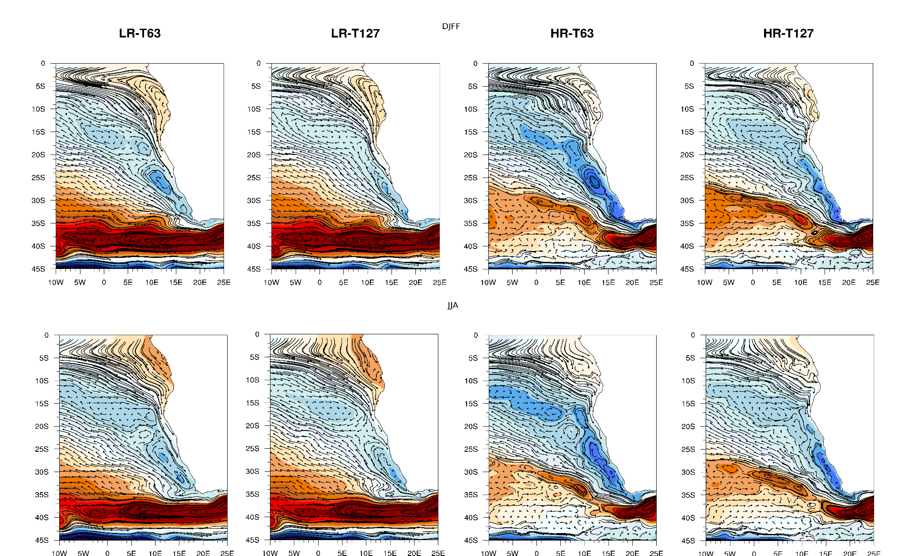
Fig. S1. Geostrophic circulation in the future

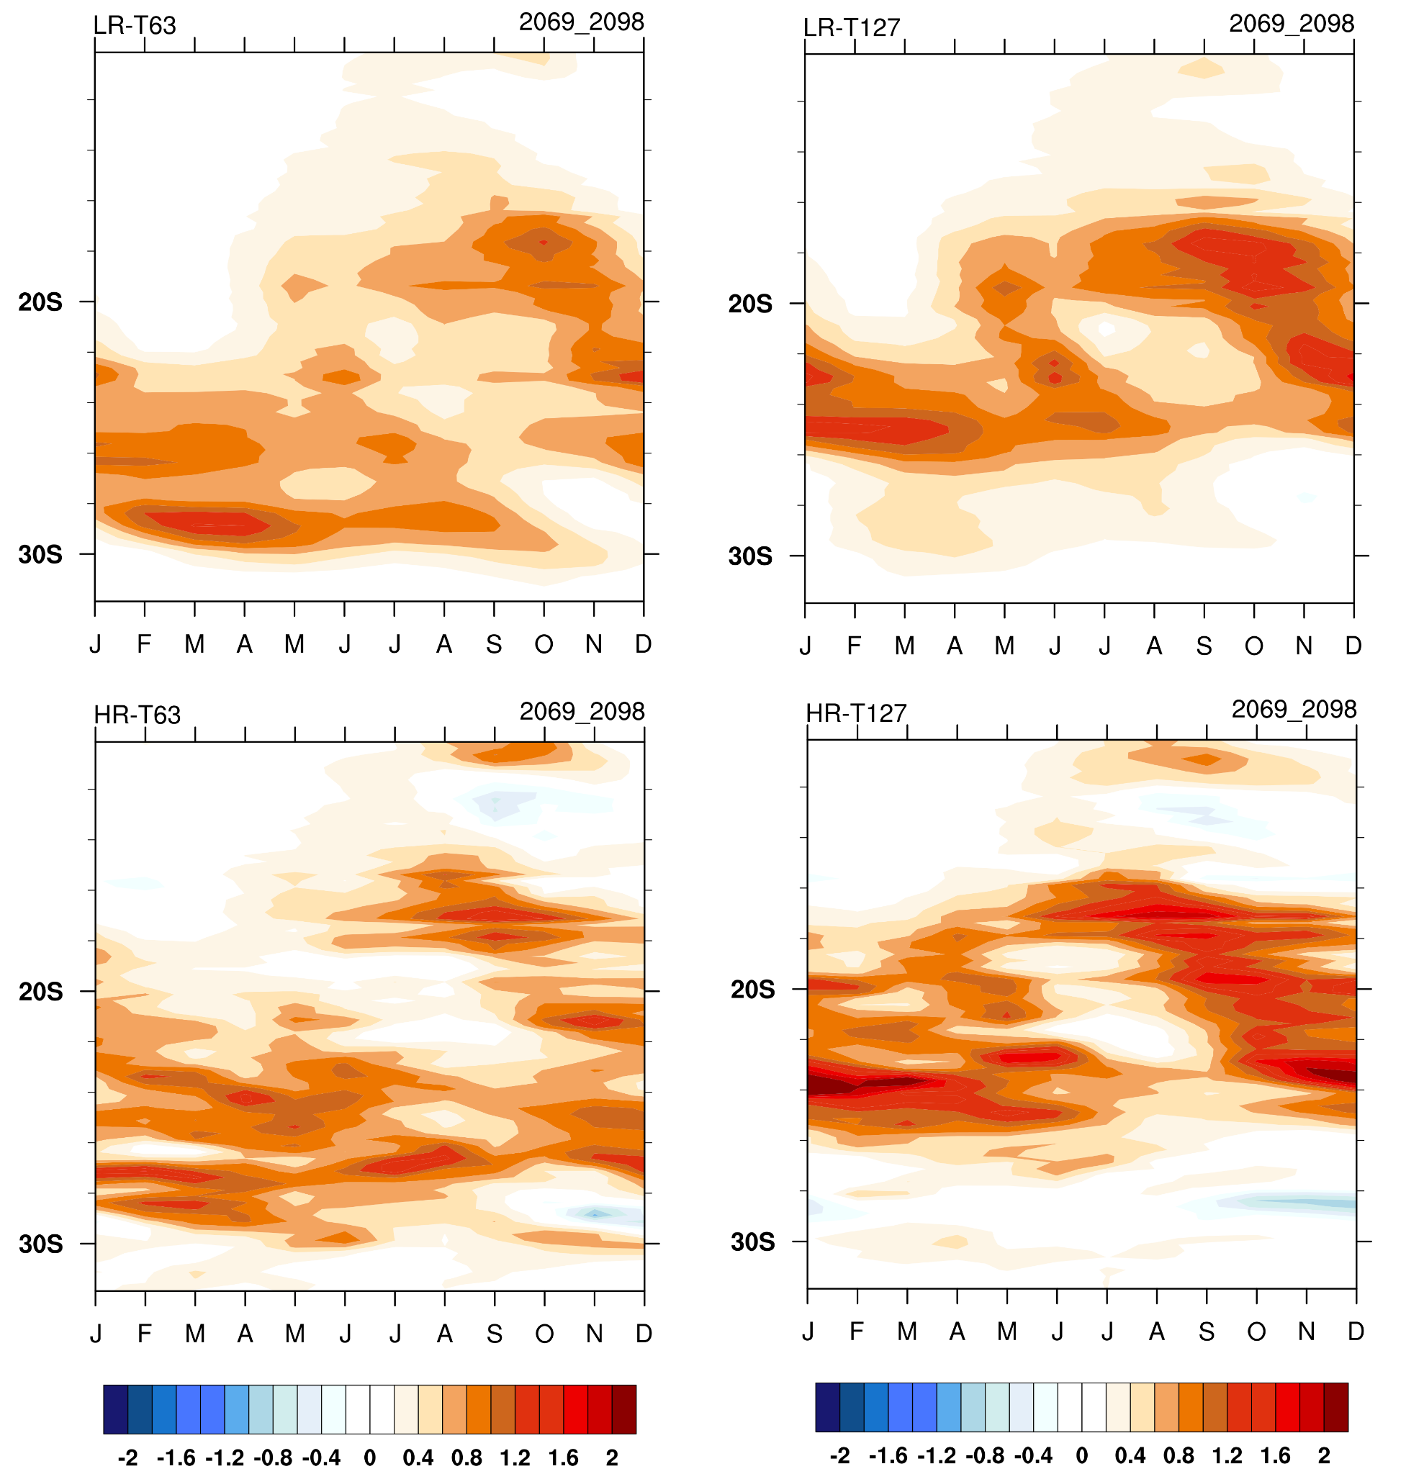
Fig. S2. Seasonal cycle of the meridional gradient of SST (°C/105 m) averaged over 11°–14° E to 10°–32° S. These are computed from the four simulations for the 2069–2098 time period

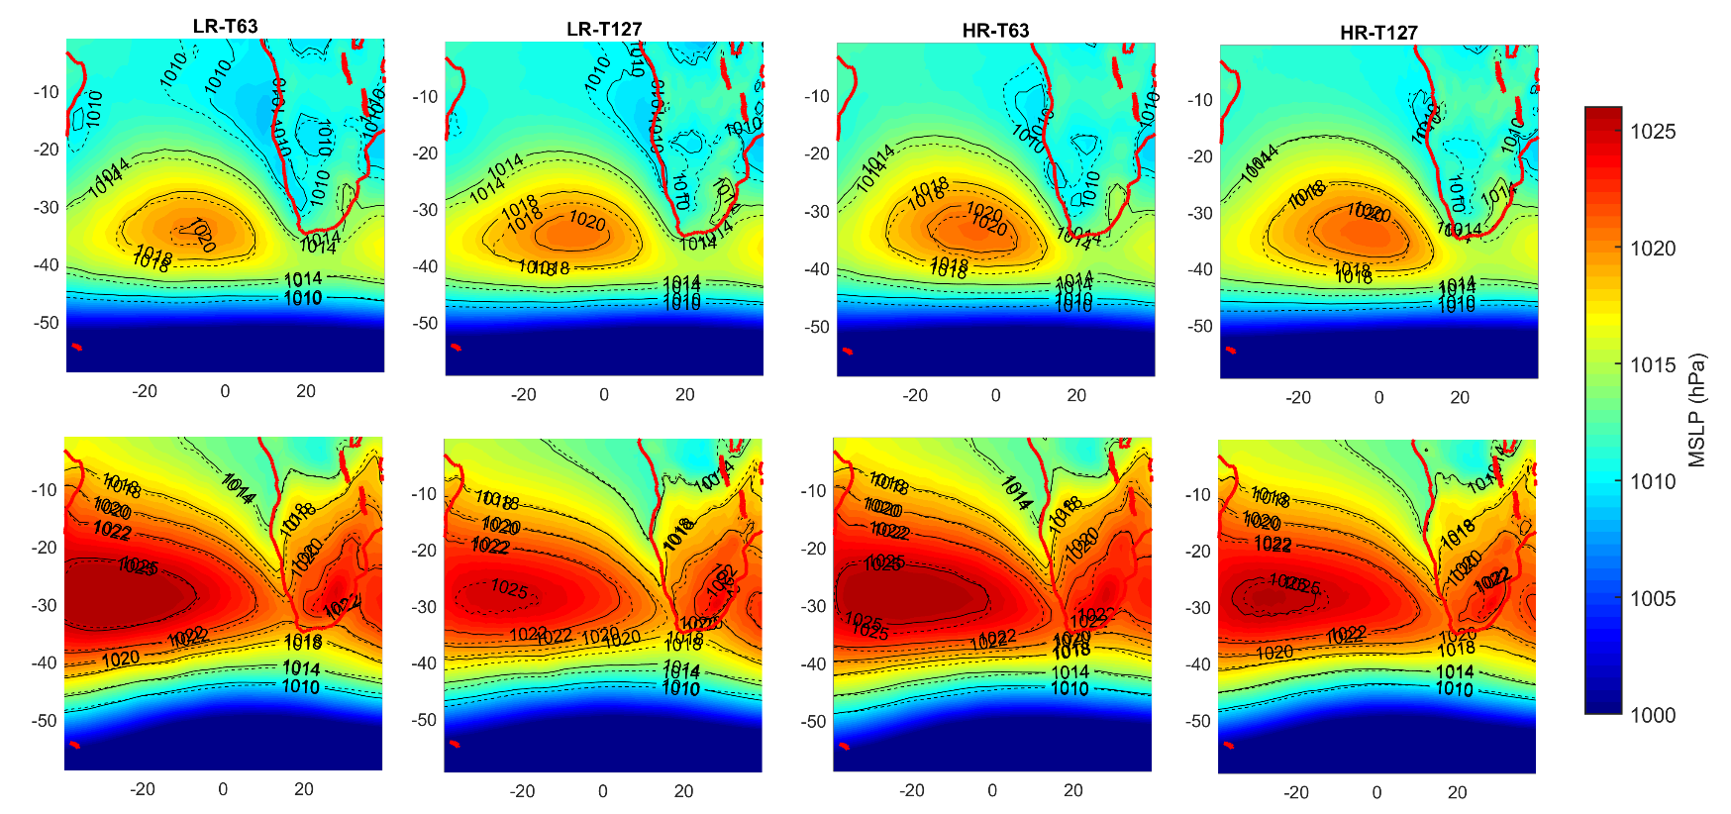
Fig. S3 Mean sea level pressure (MSLP) for the historical simulation (1976-2005) from the four simulations. The isobars are presented for both the historical (continuous black line) and RCP8.5 (dashed black line) simulations.

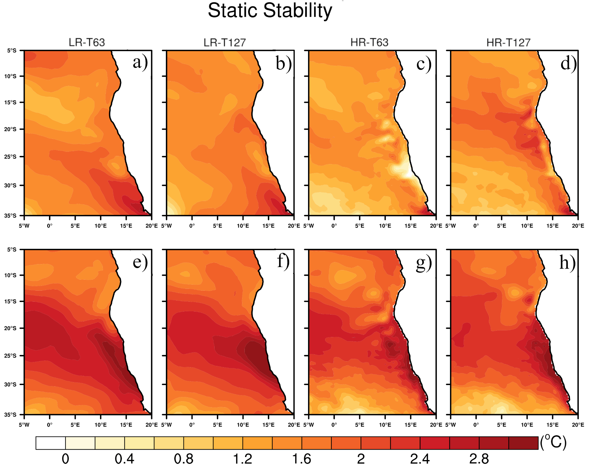
Fig. S4. Static stability parameter changes for DJF (panels a-d) and JJA (panels e-h)

