Appendices

Appendix 1
Figure 5 – Evolution of the studied variables, Morocco 1990-2018
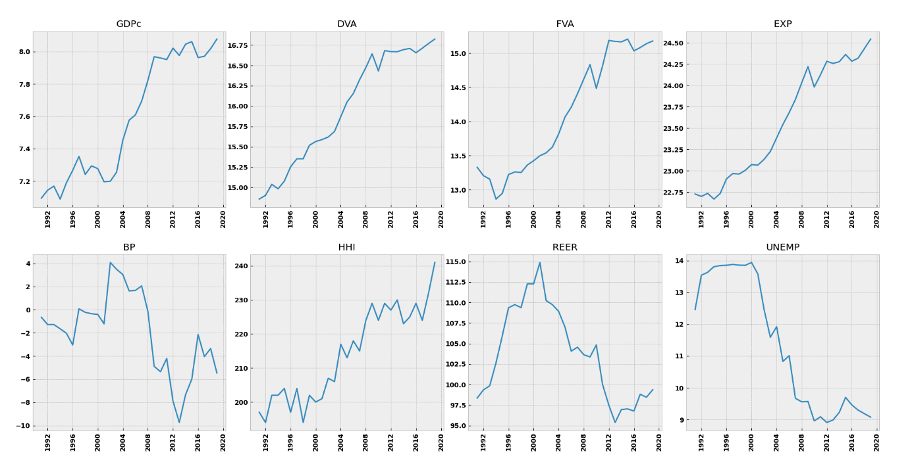

Appendix 2
Table 3 – Estimation of the impact of integration in GVCs on unemployment in Morocco, 1990-2018
$$Δ Log{\left(UNEMP\right)}_{t}$$ | Coef. | Std Error | z | P-value
ec1 | -1.363 | 1.422 | -0.958 | 0.338
$$Δ Log{\left(GDPc\right)}_{t-1}$$ | 2.3137 | 1.591 | 1.454 | 0.146
$Δ Log{\left(DVA\right)}_{t-1}$ | 1.2453 | 1.549 | 0.804 | 0.421
$Δ Log{\left(FVA\right)}_{t-1}$ | -0.3212 | 1.220 | -0.263 | 0.792
$Δ Log{\left(EXP\right)}_{t-1}$ | -2.0331 | 2.316 | -0.878 | 0.380
$Δ BP_{t-1}$ | 0.0059 | 0.047 | 0.126 | 0.900
$Δ HHI_{t-1}$ | -0.0328 | 0.017 | -1.960 | 0.050
$Δ REER_{t-1}$ | -0.0002 | 0.044 | -0.004 | 0.997
$Δ UNEMP_{t-1}$ | 0.0711 | 0.172 | 0.413 | 0.679
TREND | 0.0140 | 0.019 | 0.732 | 0.464

Appendix 3
Figure 6 – Evolution of the unemployment rate, Morocco 1999-2018
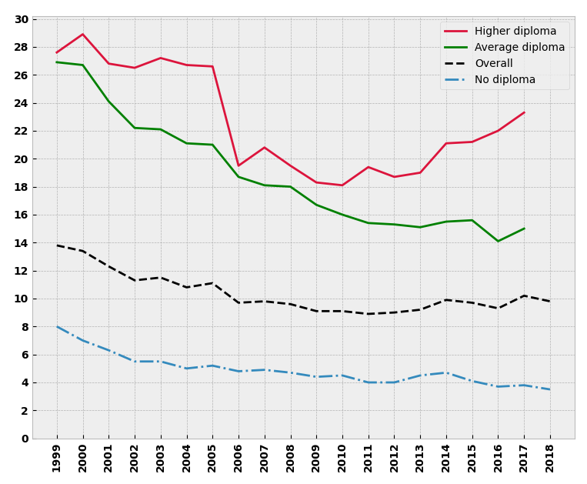
Source : HCP, Morocco

Appendix 4
Figure 7 – Correlation of the studied variables pairwise based on Domestic Value Added, Morocco
