Trimetazidine Attenuates Ischemia/Reperfusion-Induced Myocardial Ferroptosis by Modulating the Sirt3/Nrf2-GSH System and Reducing Mitochondrial Oxidative Stress
Mingyue Tan ^{1,†}, Yunfei Yin ^{1,†}, Weixiang Chen ^{1,†} ,Yifeng Jin ¹, Jun Zhang ¹,
Yue Zhang ¹, Lei Zhang¹, Tingbo Jiang ^{1,}*, Bin Jiang ^{1,}*, Hongxia Li ^{1,}*

Name and address of the institution:
¹ Department of Cardiology, The First Affiliated Hospital of Soochow University, 188 Shizi Street, Suzhou, Jiangsu 215006, P. R. China.

Corresponding authors:
Hongxia Li
Department of Cardiology, The First Affiliated Hospital of Soochow University, 188 Shizi Street, Suzhou, Jiangsu 215006, P. R. China. E-mail: shrimp@suda.edu.cn
Bin Jiang
Department of Cardiology, The First Affiliated Hospital of Soochow University, 188 Shizi Street, Suzhou, Jiangsu 215006, P. R. China. E-mail: jbin@suda.edu.cn
Tingbo Jiang
Department of Cardiology, The First Affiliated Hospital of Soochow University, 188 Shizi Street, Suzhou, Jiangsu 215006, P. R. China. E-mail: 18906201122@189.cn
†These authors contributed equally to this work.

Running Title: Trimetazidine modulates ferroptosis to attenuate I/R-mediated myocardial injury.

Figure S1
Fig S1. Grouping of cell experiments. Cells were randomly divided into the following groups: (i) Control: cells were pretreated with complete medium supplemented with DMSO (1:1000) for 12 hours and then replaced with normal medium. (ii) A/R+DMSO: cells were pretreated with complete medium added with DMSO (1:1000) for 12 hours and then starved in glucose-free medium containing 2% FBS for 4 hours before constructing the A/R injury model using the method described above; (iii) A/R+TMZ: cells were pretreated with complete medium spiked with TMZ (10 μM) for 12 hours. The cells were then starved in glucose-free medium containing 2% FBS for 4 hours, and then the A/R injury model was constructed; (iv) A/R+TMZ+RSL3: cells were pretreated with complete medium spiked with TMZ (10 μM) and RLS3 (100 nM) for 12 hours and then starved in glucose-free medium containing 2% FBS for 4 hours, and then the A/R injury model. (v) A/R+TMZ+Sirt3 siRNA: Cells were pretreated with SIRT3-specific siRNA, followed by pretreatment with complete medium spiked with TMZ (10 μM) for 12 hours, followed by starvation of cells and construction of the A/R model. The detailed experimental.

Figure S2
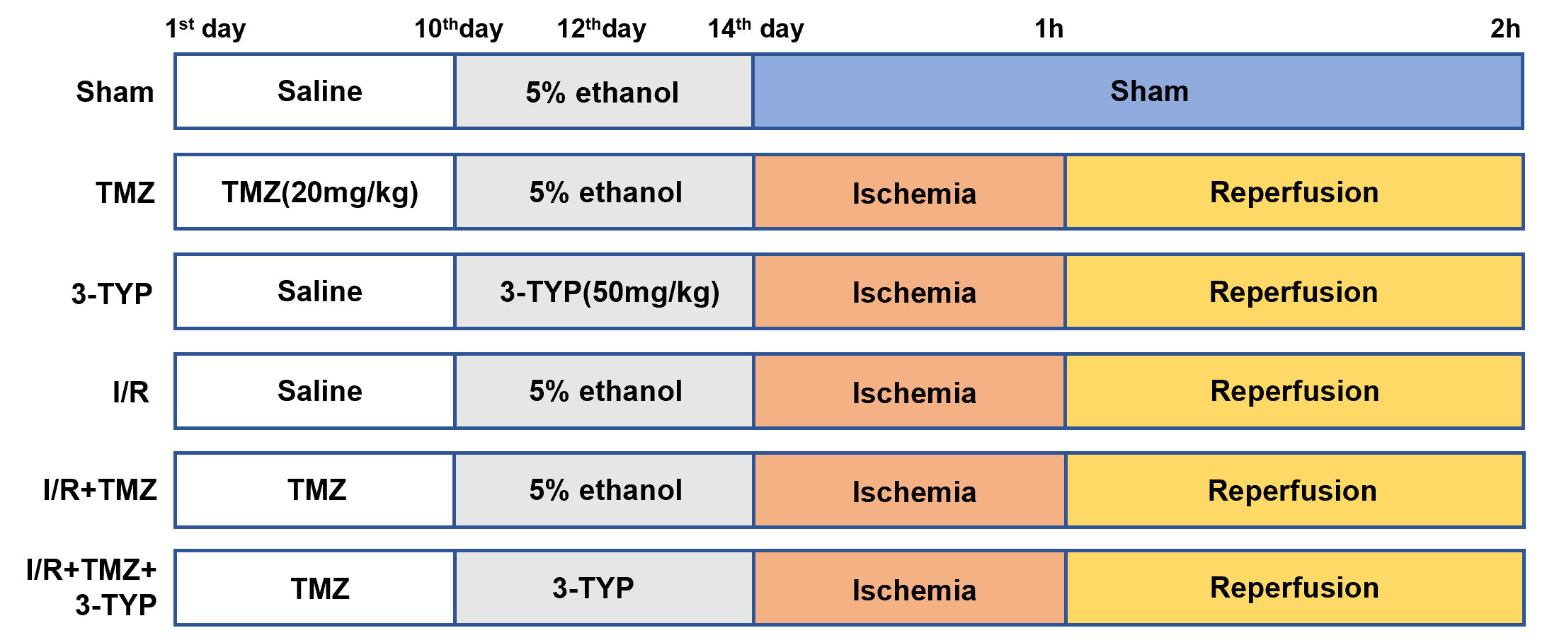
Fig S2. Grouping of animal experiments. The rats were randomly divided into 6 groups: (i) Sham group: rats were treated with saline 1ml on days 1-14 and 5% ethanol 1ml (by gavage) on days 10, 12, and 14, then the rats underwent sham surgery. (ii) TMZ group: rats were treated with trimetazidine hydrochloride (20mg/kg) on days 1-14 and 5% ethanol 1ml (by gavage) on days 10, 12, and 14, followed by sham surgery; (iii)3-TYP group: rats were treated with saline 1ml on days 1-14 and 3-TYP ( 50mg/Kg, dissolved in 5% ethanol at 50°C in a water bath protected from light) on days 10, 12, and 14 by gavage, followed by sham surgery; (iii) I/R group: rats were treated with 1ml of saline on days 1-14 and 1ml of 5% ethanol (by gavage) on days 10, 12 and 14, followed by MI/R surgery. (v) I/R+TMZ group: rats were treated with trimetazidine hydrochloride (20 mg/kg) and 1 ml of 5% ethanol (by gavage) on days 10, 12, and 14, followed by MI/R surgery; (vi) I/R+TMZ+3-TYP group: rats were treated with trimetazidine hydrochloride (20 mg/kg) on days 1-14 and 3-TYP (50mg/Kg) by gavage on days 10, 12 and 14, then rats underwent MI/R surgery.

Figure S3
Fig S3. RLS3 induces H9C2 and NRCM damage. (a) Effect of different concentrations of RLS3 administration for 12h on H9C2 cells survival was detected by CCK-8(n=10 per group). ***p < 0.001, ****p < 0.0001 vs 0 nM group; (b) Effect of different concentrations of RLS3 administered for 12 hours on the survival of NRCMs.
Figure S4
Fig S4. Efficiency of si-Sirt3 interference with Sirt3 expression in H9C2 and 3-TYP eliminated the inhibitory effect of TMZ on ferroptosis. (a and b) Western blot analysis showing protein levels of Sirt3 in H9C2 after administration of four different si-Sirt3 (n = 3 per group). *p < 0.05, **p < 0.01 vs si-Sirt3-NC. (c) Quantification of gene levels of Sirt3 in H9C2s after administration of four different si-Sirt3 (n = 3 per group). **p < 0.01, ***p < 0.001, ****p < 0.0001 vs si-Sirt3-NC. (d) Effect of different concentrations of 3-TYP administration for 12h on H9C2 cells survival was detected by CCK-8(n=10 per group). *p < 0.05, ***p < 0.001, ****p < 0.0001 vs 0 μM. (e) the content of ferrous and mitochondrial ROS was measured using FerroOrange dye/ Mito SOX in H9c2 cells after 3-TYP stimulation. Scale bars represent 100 µm. (f) Quantification of Fe²⁺ fluorescence intensity and (g) quantification of mitochondrial ROS fluorescence intensity(n = 6 per group). (h and i) Western blot analysis showed that the protein levels of GPX4, SLC7A11 in H9C2 after the administration of 3-TYP (n =3 per group). *P < 0.05; **P < 0.01; ****P < 0.0001; ns represent not significant.
Figure S5
Figure S5. TMZ and 3-TYP have no toxic effects on rat heart. (a). Typical ECG segments in the basic state after 10 min of ligation and reperfusion for 20 min. (b) Representative echocardiographic images for sham group, TMZ group, and 3-TYP group. (c) Cardiac ultrasound results of rats included EF (%), FS (%). (d) Representative HE-stained images of heart tissue sections. Scale bars represent 200 µm and 50 µm respectively. (e) Representative images of Evans Blue/TTC staining for sham group, TMZ group, and 3-TYP group.

