Supplementary methods, figures, and tables

Trichoderma-induced restructuring of the cucumber rhizosphere microbiome and the effect of a synthetic, cross-kingdom microbial community on Fusarium wilt disease and growth in cucumber

Manman Zhang^{1, 2, 3, 4, 6}, Rui Wang^{1, 2, 3, 6}, Raja Asad Ali Khan^{1, 2, 3, 6}, Xin Zhan^{1, 2, 3}, Sen Ren^{1, 2, 3}, Haonan Jiang^{1, 2, 3}, Yinggu Wu^{1, 2, 3}, Fanxing Yang^{1, 2, 3}, Xiaoli Yu^{1, 2, 3} & Tong Liu^{1,2,3,5*}

¹ School of Breeding and Multiplication (Sanya Institute of Breeding and Multiplication), Hainan University, YaZhou 572024, China. ² Key Laboratory of Green Prevention and Control of Tropical Diseases and Pests, Ministry of Education (School of Tropical Agriculture and Forestry), Hainan University, Haikou 570228, China. ³ School of Tropical Agriculture and Forestry（School of Agricultural and Rural, School of Rural Revitalization), Hainan University, Danzhou 571700, China. ⁴ School of Life Sciences, Hainan University, Haikou 570228, China. ⁵ Engineering Center of Agricultural Microbial Preparation Research and Development of Hainan, Hainan University, Haikou 570000, PR China. ⁶These authors contributed equally: Manman Zhang, Rui Wang, Raja Asad Ali Khan. e-mail: liutongamy@sina.com

Supplementary method
The total DNA of Soil samples of different treatments in continuous cropping experiments was extracted and amplified by Beijing Bmiec Company (Beijing, China). The hypervariable region (V3-V4) of bacterial 16S rRNA (Ali et al., 2020) was amplified using primer pairs (F 5'-ACTCCTACGGGAGGCAGCA-3' and R 5'-GGACTACHVGGGTWTCTAAT-3'), while the fungal ITS2 (Mesnage et al., 2022) region was amplified using primer pairs (F 5'-GCATCGATGAAGAACGCAGC-3', R 5'-TCCTCCGCTTATTGATATGC-3'). After amplification, the original data (raw data) were obtained by sequencing.Then merging and quality checking, low-abundance noise was removed from the raw data (Bolyen et al., 2019), and OTU (Operational Taxonomic Unit) clustering and species taxonomic classification were performed based on 97% similarity (Edgar, 2013). USEARCH (Edgar, 2010) and VSEARCH tools (Rognes et al., 2016) were used to remove chimeras and erroneous sequences generated during PCR amplification to obtain valid data. Qiime2 was used to calculate alpha (Shannon and Chao1) and beta diversity based on the minimum number of sequences in the sample (Bolyen et al., 2019). Analysis of variance (ANOVA) was used to analyze the α diversity index and OUT numbers of different samples. The differential genera and OTUs in different treatments were identified, and the results were visualized using the circlize package (Krzywinski et al., 2009) in R.
The total DNA of Soil samples treated with B11 or TB11 was extracted and amplified by Beijing NovaSeq Technology Co., Ltd. (Beijing, China). AGAGTTTGATCCT-GGCTCAG and R: GNTACCTTGTTACGACTT (Li et al., 2021) was used as the primer to amplify the V1-V9 region of bacterial 16S. After purification, the amplification products were mixed to construct the SMRT Bell library (Pootakham et al., 2017), and then sequenced on the PacBio platform. CCS (Generate Highly Accurate Single-Molecule Consensus Reads) was used to correct the data to obtain Raw reads. Simple Sequence repeats (SSRS) in Raw reads were filtered and primers were removed to obtain Clean-reads. Clean-reads were clustered by OTUs (Operational Taxonomic Units) according to 97% Identity (Edgar, 2013). The mothur (Schloss et al., 2009), Silva (Quast et al., 2013) database was used to annotate the representative sequence of OTUs, and the threshold was set to 0.8 during the annotation process.
References:
Ali, A., Ghani, M. I., Haiyan, D., Iqbal, M., Cheng, Z., & Cai, Z. (2020). Garlic substrate induces cucumber growth development and decreases fusarium wilt through regulation of soil microbial community structure and diversity in replanted disturbed soil. International Journal of Molecular Sciences, 21(17), 1–20. https://doi.org/10.3390/ijms21176008
Bolyen, E., Rideout, J. R., Dillon, M. R., Bokulich, N. A., Abnet, C. C., Al-Ghalith, G. A., Alexander, H., Alm, E. J., Arumugam, M., Asnicar, F., Bai, Y., Bisanz, J. E., Bittinger, K., Brejnrod, A., Brislawn, C. J., Brown, C. T., Callahan, B. J., Caraballo-Rodríguez, A. M., Chase, J., … Caporaso, J. G. (2019). Reproducible, interactive, scalable and extensible microbiome data science using QIIME 2. In Nature Biotechnology (Vol. 37, Issue 8, pp. 852–857). Nature Publishing Group. https://doi.org/10.1038/s41587-019-0209-9
Edgar, R. C. (2010). Search and clustering orders of magnitude faster than BLAST. Bioinformatics, 26(19), 2460–2461. https://doi.org/10.1093/bioinformatics/btq461
Edgar, R. C. (2013). UPARSE: Highly accurate OTU sequences from microbial amplicon reads. Nature Methods, 10(10), 996–998. https://doi.org/10.1038/nmeth.2604
Krzywinski, M., Schein, J., Birol, I., Connors, J., Gascoyne, R., Horsman, D., Jones, S. J., & Marra, M. A. (2009). Circos: An information aesthetic for comparative genomics. Genome Research, 19(9), 1639–1645. https://doi.org/10.1101/gr.092759.109
Li, Z., Bai, X., Jiao, S., Li, Y., Li, P., Yang, Y., Zhang, H., & Wei, G. (2021). A simplified synthetic community rescues Astragalus mongholicus from root rot disease by activating plant-induced systemic resistance. Microbiome, 9(1). https://doi.org/10.1186/s40168-021-01169-9
Mesnage, R., Panzacchi, S., Bourne, E., Mein, C. A., Perry, M. J., Hu, J., Chen, J., Mandrioli, D., Belpoggi, F., & Antoniou, M. N. (2022). Glyphosate and its formulations Roundup Bioflow and RangerPro alter bacterial and fungal community composition in the rat caecum microbiome. Frontiers in Microbiology, 13. https://doi.org/10.3389/fmicb.2022.888853
Pootakham, W., Mhuantong, W., Yoocha, T., Putchim, L., Sonthirod, C., Naktang, C., Thongtham, N., & Tangphatsornruang, S. (2017). High resolution profiling of coral-associated bacterial communities using full-length 16S rRNA sequence data from PacBio SMRT sequencing system. Scientific Reports, 7(1). https://doi.org/10.1038/s41598-017-03139-4
Quast, C., Pruesse, E., Yilmaz, P., Gerken, J., Schweer, T., Yarza, P., Peplies, J., & Glöckner, F. O. (2013). The SILVA ribosomal RNA gene database project: Improved data processing and web-based tools. Nucleic Acids Research, 41(D1). https://doi.org/10.1093/nar/gks1219
Rognes, T., Flouri, T., Nichols, B., Quince, C., & Mahé, F. (2016). VSEARCH: A versatile open source tool for metagenomics. PeerJ, 2016(10). https://doi.org/10.7717/peerj.2584
Schloss, P. D., Westcott, S. L., Ryabin, T., Hall, J. R., Hartmann, M., Hollister, E. B., Lesniewski, R. A., Oakley, B. B., Parks, D. H., Robinson, C. J., Sahl, J. W., Stres, B., Thallinger, G. G., Van Horn, D. J., & Weber, C. F. (2009). Introducing mothur: Open-source, platform-independent, community-supported software for describing and comparing microbial communities. Applied and Environmental Microbiology, 75(23), 7537–7541. https://doi.org/10.1128/AEM.01541-09

Supplementary Figure
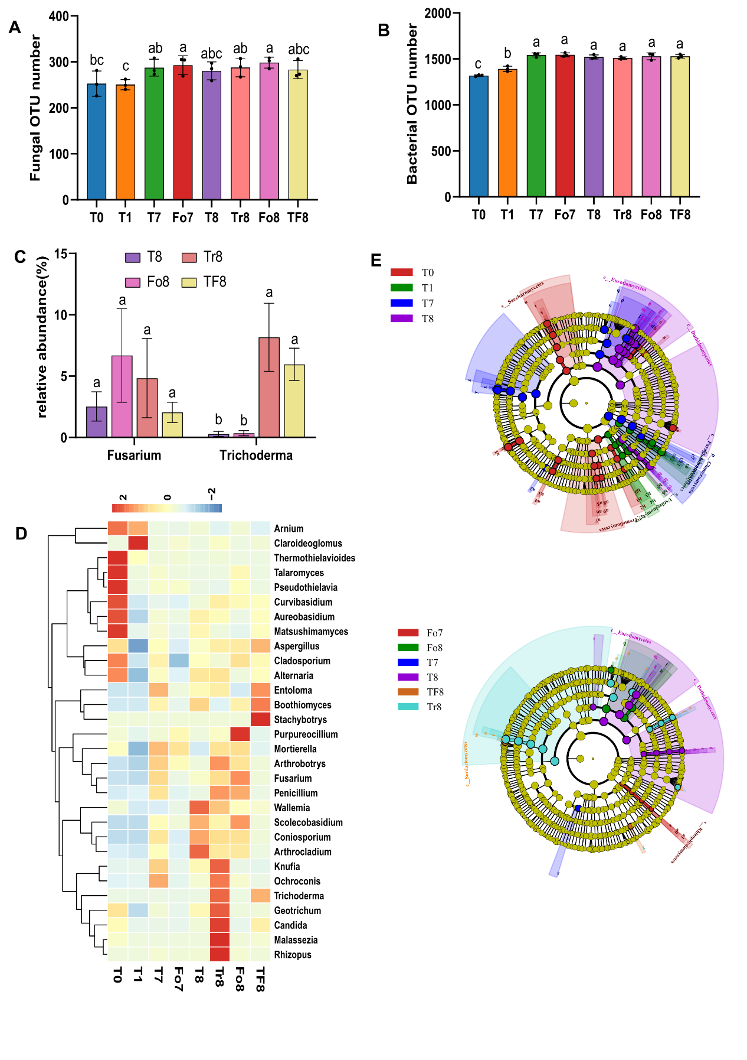
Supplementary Fig. 1. Changes of microbial community structure in continuous cropping experiments. (A-B) The OTU numbers of fungi(A) and bacteria(B). (C) Abundance of Trichoderma and Fusarium in the eighth crop soil. (D) Heat map of the bacterial community composition with cluster analysis. (E) Least discriminant analysis (LDA) effect size taxonomic cladogram comparing bacteria from different soil samples. The different classification levels are presented from the inside to the outside. The different treatment groups are designated as; control – sterile water treatment (T), T. asperellum FJ035 treatment (Tr), F. oxysporum SCCFo1 treatment (Fo), and SCCFo1+FJ035 treatment (TF). Numbers following a treatment indicate the number of planting cycles (1-11), SCCFO1-10⁵ spores /g soil, and FJ035-10⁶ spores /g soil. Quantitative data represent the means ± SE (n = 4). Different lowercase letters above the bars indicate a significant difference (p < 0.05) between treatment groups as determined by ANOVA.

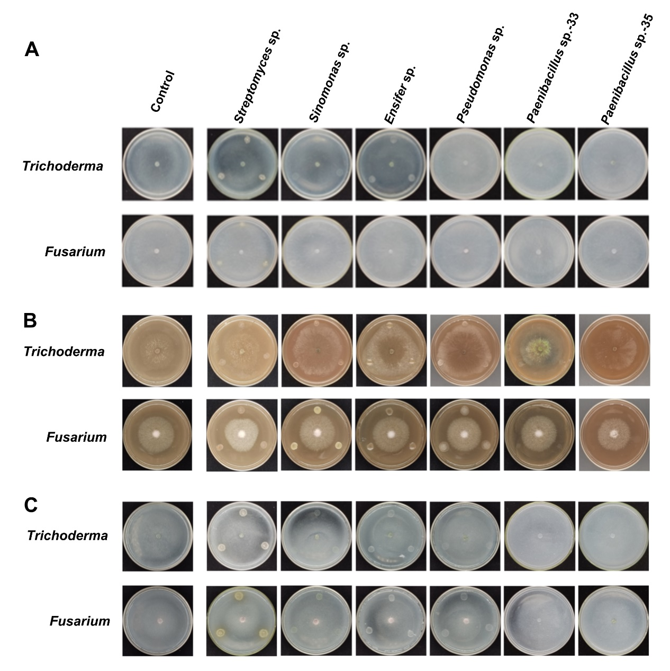
Supplementary Fig. 2. The nutritional competition of simplified bacteria with Trichoderma asperellum FJ035 and Fusarium oxysporum SCCFo1 in insoluble nutrient medium. (A-C) the effect of bacterial solution on the growth of FJ035 and SCCFo1 in potassium feldspar (A), insoluble phosphate (B) and nitrogen-free medium (C).

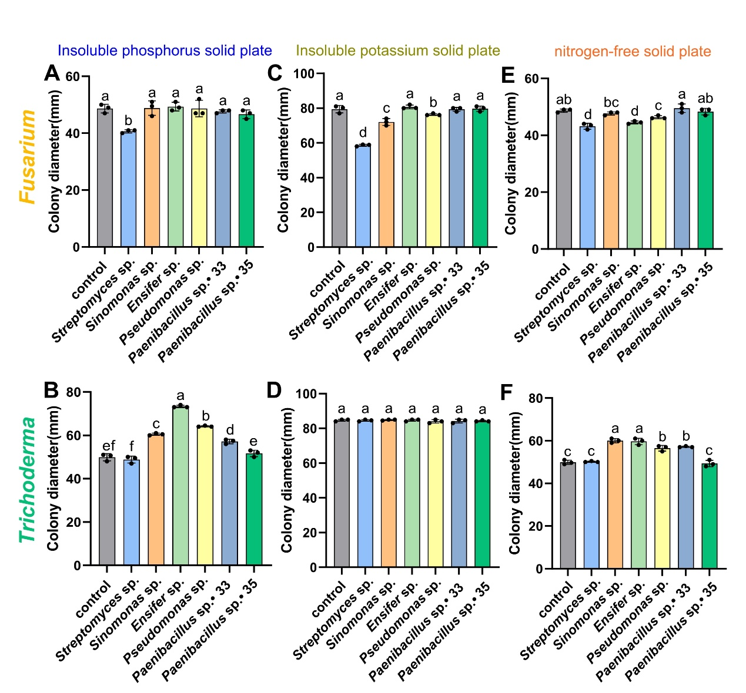
Supplementary Fig. 3. Colony size of Trichoderma asperellum FJ035 and Fusarium oxysporum SCCFo1 in insoluble nutrient antagonistic plate (P < 0.05). (A-B) colony size of SCCFo1 (A) and FJ035 (B) when confronted with bacterial liquid in insoluble phosphate medium. (C-D) colony size of SCCFo1 (C) and FJ035 (D) in potash feldspar medium when confronted with bacterial solution. E-F: colony size of SCCFo1 (E) and FJ035 (F) when confronted with bacterial liquid in nitrogen-free medium. Quantitative data represent the means ± SE (n = 3). Different lowercase letters above the bars indicate a significant difference (p < 0.05) between the measured parameter in the different bacterial strains comprising the simplified synthetic bacterial community as determined by ANOVA.

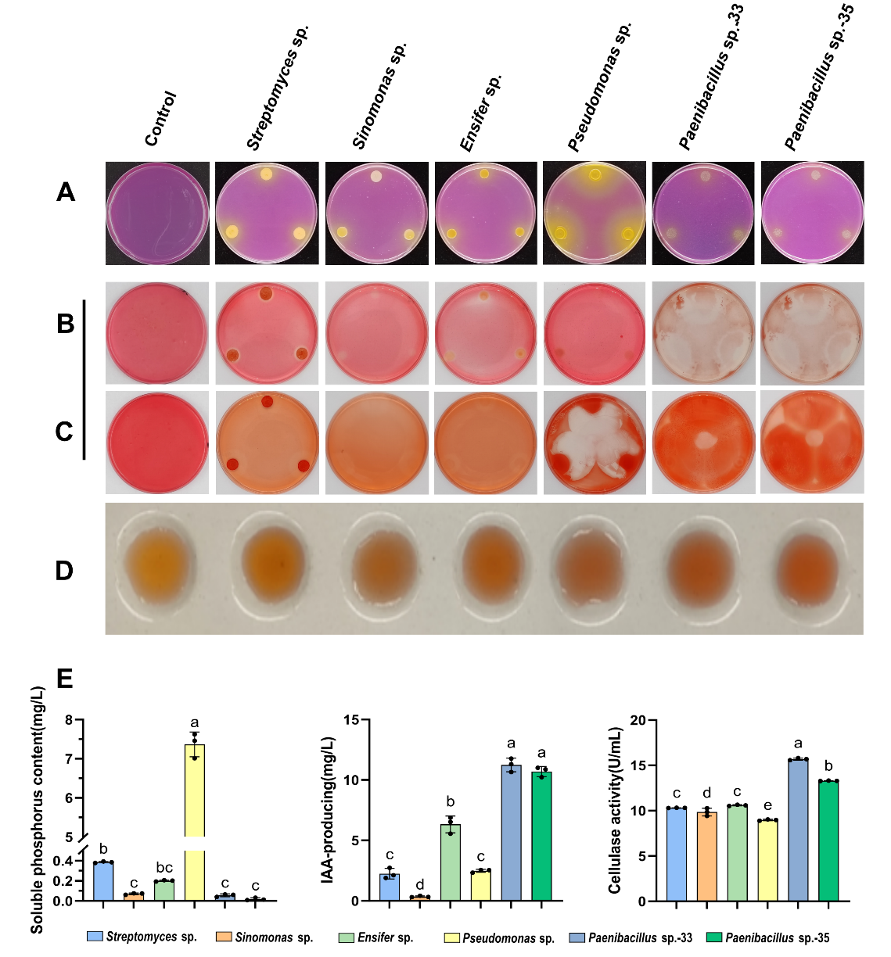
Supplementary Fig. 4. Growth promoting attributes of the six bacterial strains comprising the simplified synthetic bacterial community. A: Colony color development in modified SRSM medium. B-C: Staining of CMC-Na medium at 24h (B) and 48h (C) after inoculation. D: Color development indicating IAA production. E: Quantitative assessment of phosphate solubilization, IAA production, and cellulase production by the different bacterial strains. Quantitative data represent the means ± SE (n = 3). Different lowercase letters above the bars indicate a significant difference (p < 0.05) between the measured parameter in the different bacterial strains comprising the simplified synthetic bacterial community as determined by ANOVA.

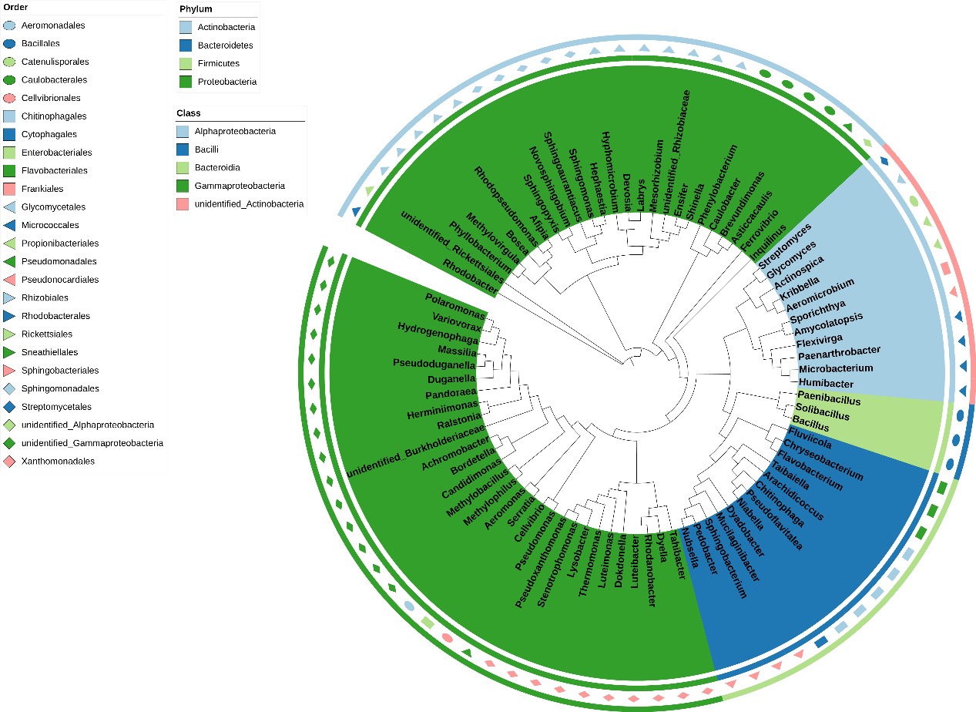
Supplementary Fig. 5. Genus of core bacteria of cucumber rhizosphere.

Supplementary Table
Supplementary Table 1 Soil sample collection time nodes
Sample name | Time nodes | Description
T0 | before cucumber planting | clear water treatment
T1 | after the first crop was completed and before SCCFo1 inoculation | second crop was inoculated with SCCFo1+ clear water treatment
T7 | after the seventh harvest and before treated of FJ035 | clear water treatment
Fo7 | after the seventh harvest and before treated of FJ035 | second crop was inoculated with SCCFo1+ clear water treatment
T8 | after the 8th harvest | clear water treatment
Tr8 | after the 8th harvest | second crop was inoculated with SCCFo1+ eighth crop was inoculated with FJ035+ clear water treatment
Fo8 | after the 8th harvest | second crop was inoculated with SCCFo1+ clear water treatment
TF8 | after the 8th harvest | second crop was inoculated with SCCFo1+ eighth crop was inoculated with FJ035+ clear water treatment

Supplementary Table 2 Sequences for primers used in quantitative real-time RT-PCR.
Gene/number | Primer sequence (5'–3')
Streptomyces sp. | F: TACCTCACCGACTTCGGGTGTT
 | R: GGATAGCGTCAAATCATCATAC
Sinomonas sp. | F: GCTGATCTGCGATTACTAGCGTC
 | R: ATGTCTTGGGCTTCACGCA
Ensifer sp. | F: GCTGATCATCCTCTCAGACAA
 | R: AGAACGAACGCTGGCGTAA
Pseudomonas sp. | F: ATGAAGCAGGTGGCCTTCTC
 | R: AGCTTGTGCTCGACGTTGTA
Paenibacillus sp. | F: GAAGTCGTAACAAGGTAGCCGTAG
 | R: AACCGTCAGTCTCCGCTACTT
SOD | F: ATTGTAGATAACCAGATTCCTCTTAGCGGC
 | R: GGAGTAAGACCGACAACACCACA
CAT | F: AACCCAACCCAAAATCCCA
 | R: TCTAATAGCCTCCTCTTCCAGCA
POD | F: CAGGAAGGAGGGATGGTTT
 | R: TGGTGTTAGGTTCACTGTTGGA
NPR-1 | F: TTACTGATTAAGGGCAAGAAGGCC
 | R: AAAGTTCACAAAGAGCAGGATGG
LOX-1 | F: AAGGTTTGCCTGTCCCAAGA
 | R: TGAGTACTGGATTAACTCCAGCCAA
LOX2 | F: CCTAAGAGCAAACTTGACCCA
 | R: CAATGCCTCAGCAACTGTAAG
EIN2 | F: ACAAAAGGGGCACCAGC
 | R: CCAACTCTCAGTAGAAGGCAA
EIN-3 | F: TCCTGATTCTTGCCCGCCT
 | R: GGTTGGTTTCCTCTTTCGCATA
GH3 | F: TCCTCACCAGTTCTGGGACA
 | R: GTACTGGACGAGCCACCAAA
SAUR | F: TTTAGGGCATCCGGCGTTT
 | R: GGACTCTGTGGACGGTGTG
ARR9 | F: GTTATGGCTGCCGATTCCCA
 | R: TCGAAGCCAGTCATTCCAGG

Supplementary Table 3 Sequencing results of 61 isolated and cultured bacteria
Order | Strain number | Closest relative species | Gene bank  number | Maximum similarity (%)
1 | B1-1 | Sinomonas atrocyanea strain NSB-27 | KR010184.1 | 100.00
2 | B1-2 | Streptomyces panayensis strain 42 | MF462944.1 | 100.00
3 | B1-3 | Streptomyces griseorubiginosus strain RBS 11 | MN826180.1 | 100.00
4 | B1-7 | Nocardia nova strain 60 | MH910164.1 | 100.00
5 | B1-8 | Dyella ginsengisoli strain Gsoil 3046 | NR_041370.1 | 100.00
6 | B1-9 | Ensifer adhaerens strain JS1020 Soil 9_F3Ptero | KX507144.1 | 100.00
7 | B1-10 | Cupriavidus laharis strain CCUG53908T | FN597609.1 | 99.56
8 | B1-11 | Arthrobacter alkaliphilus strain NIOT-ASA1-6 | MW874641.1 | 99.40
9 | B1-12 | Bacillus proteolyticus strain T11-14 | OM062575.1 | 100.00
10 | B1-15 | Bacillus wiedmannii strain J8BS6 | MT415981.1 | 100.00
11 | B1-16 | Pseudomonas nitritireducens strain NRB021 | MK542927.1 | 99.91
12 | B1-17 | Stenotrophomonas pavanii strain OsEnb_PLM_S11 | MN889300.1 | 100.00
13 | B1-19 | Chryseobacterium lactis strain KNU-AS17 | KT945035.1 | 100.00
14 | B1-20 | Pseudomonas nitroreducens strain BF-R40 | KY292456.1 | 100.00
15 | B1-21 | Arthrobacter alkaliphilus strain NIOT-ASA1-6 | MW874641.1 | 99.36
16 | B1-22 | Pseudomonas nitroreducens strain Atecer20 | MT386127.1 | 100.00
17 | B1-23 | Lysinibacillus macroides strain SKC-16 | MT218365.1 | 100.00
18 | B1-24 | Bacillus proteolyticus strain T11-14 | OM062575.1 | 100.00
19 | B1-25 | Pseudomonas nitroreducens strain Atecer2Q | MT386127.1 | 100.00
20 | B1-26 | Lysinibacillus macroides strain SKC-16 | MT218365.1 | 100.00
21 | B1-28 | Pseudomonas nitritireducens strain NRB021 | MK542927.1 | 99.10
22 | B1-29 | Bacillus proteolyticus strain T11-14 | OM062575.1 | 100.00
23 | B1-30 | Rhodococcus hoagii CS402 | LC552072.1 | 100.00
24 | B1-32 | Pseudomonas nitroreducens strain BF-R40 | KY292456.1 | 100.00
25 | B1-33 | Paenibacillus alvei strain DIB76/BCS12 | MK835674.1 | 100.00
26 | B1-34 | Cupriavidus laharis strain CCUG53908T | FN597609.1 | 99.73
27 | B1-35 | Paenibacillus alvei strain m291a | MF187632.1 | 100.00
28 | B1-36 | Burkholderia vietnamiensis strain P34 | MT431190.1 | 100.00
29 | B1-37 | Sinomonas atrocyanea strain NSB-27 | KR010184.1 | 99.83
30 | R1-2 | Beijerinckia fluminensis strain NAC54 | MK872339.1 | 100.00
31 | R1-3 | Stenotrophomonas pavanii strain OsEnb_PLM_S11 | MN889300.1 | 100.00
32 | R1-5 | Enterobacter ludwigii strain AN4 | MT557020.1 | 100.00
33 | R1-6 | Sphingobacterium multivorum strain DW-18 | EU240955.1 | 99.32
34 | R1-10 | Chryseobacterium culicis strain JY-9-4R | MZ636644.1 | 100.00
35 | B3-3 | Priestia koreensis strain NES-CTC-3 | MF079292.1 | 100.00
36 | B4-1 | Fictibacillus phosphorivorans strain Ca7TT97 | MN543875.1 | 100.00
37 | R2-1 | Pseudomonas alcaliphila W04 | LC333758.1 | 100.00
38 | R2-2 | Priestia aryabhattai strain TCV | OM992226.1 | 100.00
39 | R2-3 | Pseudomonas taiwanensis strain PsTW DMC 234 | CP030750.1 | 100.00
40 | R2-4 | Arthrobacter alkaliphilus strain NIOT-ASA1-6 | MW874641.1 | 99.45
41 | R2-5 | Chryseobacterium lactis strain KNU-AS17 | KT945035.1 | 100.00
42 | R2-6 | Paenibacillus illinoisensis strain P13VS | MT308774.1 | 100.00
43 | R2-7 | Acinetobacter baumannii strain AB5116 | CP091173.1 | 100.00
44 | R2-8 | Paenibacillus cucumis Kampfer et al. 2016 strain AP115T.110 | MN543868.1 | 99.84
45 | R2-9 | Mammaliicoccus sciuri strain TY-42 | MT550814.1 | 100.00
46 | R2-11 | Flavobacterium endoglycinae strain BB8 | MW722792.1 | 99.90
47 | R2-12 | Staphylococcus sciuri strain TY-42 | MT550814.1 | 100.00
48 | R2-13 | Brucella intermedia strain F5_AM | MT373519.1 | 100.00
49 | R2-14 | Microbacterium foliorum strain P30 | MT487621.1 | 100.00
50 | R2-15 | Brachybacterium paraconglomeratum strain RCB922 | KT261134.1 | 99.83
51 | B2-1 | Bacillus cereus strain DS-2 | ON005108.1 | 100.00
52 | B2-4 | Stenotrophomonas maltophilia strain IMER-B3-10 | FJ772079.1 | 100.00
53 | B2-8 | Paenibacillus polymyxa strain HY96-2 | CP025957.1 | 99.92
54 | B2-9 | Priestia aryabhattai strain NWPZ-6 | MT184818.1 | 100.00
55 | S1-2 | Staphylococcus saprophyticus strain UTI-045 | CP054831.1 | 100.00
56 | S1-3 | Brevibacterium sediminis strain YZGP507 | MN931294.1 | 100.00
57 | S1-4 | Stenotrophomonas maltophilia strain ISMMS3 | CP011010.1 | 99.92
58 | L1-2 | Priestia aryabhattai strain TCV | OM992226.1 | 100.00
59 | L1-3 | Bacillus infantis strain EB68 | MH130351.1 | 100.00
60 | L1-4 | Bacillus infantis strain WTB98 | MK241868.1 | 100.00
61 | L1-5 | Microbacterium arborescens strain OsEnb_PLM_L71 | MN889287.1 | 100.00

Supplementary Table 4. Construction of Cross-kingdom synthetic microbiota
synthetic microbiota | bacterial genus name | FJ035
B4 | Streptomyces；Stenotrophomonas；Acinetobacter；Ensife | -
TB4 | Streptomyces；Stenotrophomonas；Acinetobacter；Ensife | +
B11 | Streptomyces；Stenotrophomonas；Acinetobacter；Ensife；Chryseobacterium；Sinomonas；Bacillus；Paenibacillus；Pseudomonas；Flavobacterium；Microbacterium | -
TB11 | Streptomyces；Stenotrophomonas；Acinetobacter；Ensife；Chryseobacterium；Sinomonas；Bacillus；Paenibacillus；Pseudomonas；Flavobacterium；Microbacterium | +

Supplementary Table 5. Gene functions related to plant growth promotion in six bacterial strains
Function | Number | Ref_ID
Tryptophan 2-monooxygenase | Streptomyces sp. | WP_120053002.1
Tryptophan 2-monooxygenase | Pseudomonas sp. | WP_081516818.1
Monoamine oxidase | Streptomyces sp. | WP_062030312.1；WP_062032968.1
Monoamine oxidase | Pseudomonas sp. | WP_085640726.1；WP_085640729.1；WP_015478873.1；PJI48291.1；WP_119693177.1
Aldehyde dehydrogenase | Streptomyces sp. | WP_062233437.1；WP_079069824.1；WP_062026329.1；WP_062032048.1；WP_120052877.1；WP_062033504.1；WP_048580965.1；WP_062235407.1；WP_062235935.1；WP_020141259.1；WP_062028406.1；WP_062238833.1
Aldehyde dehydrogenase | Sinomonas sp. | ASN51320.1；WP_026556224.1；ASN53432.1；ASN51038.1；ASN53725.1；ASN54092.1；ASN53483.1
Aldehyde dehydrogenase | Ensifer sp. | WP_126090168.1；WP_093234440.1；WP_034788758.1；WP_112946678.1；WP_065371966.1；WP_065374727.1；WP_113553117.1；WP_053251695.1；WP_090295209.1；WP_113736930.1；WP_097594045.1；WP_112714765.1；WP_104668513.1
Aldehyde dehydrogenase | Pseudomonas sp. | WP_054907139.1；WP_017521705.1；WP_081519750.1；WP_017519720.1；WP_015479543.1；WP_015475099.1；WP_017516723.1；WP_081517211.1；WP_045207664.1；WP_085722908.1
Aldehyde dehydrogenase | Paenibacillus sp. B1-33 | GAV13948.1；WP_005550650.1；WP_005547633.1
Aldehyde dehydrogenase | Paenibacillus sp. B1-35 | WP_005550650.1；WP_005547633.1
Nitrile hydratase | Streptomyces sp. | WP_020138997.1；WP_079070210.1；WP_062031408.1
Nitrile hydratase | Ensifer sp. | WP_104663154.1；WP_077960572.1；WP_057253624.1
1-aminocyclopropane-1-carboxylate deaminase | Streptomyces sp. | WP_062236737.1；WP_060905203.1；WP_062024131.1
1-aminocyclopropane-1-carboxylate deaminase | Ensifer sp. | WP_097611546.1
1-aminocyclopropane-1-carboxylate deaminase | Pseudomonas sp. | WP_015478044.1
Lrp/AsnC family transcriptional regulator | Streptomyces sp. | WP_030323663.1；WP_020137395.1；WP_062026186.1；WP_028810110.1；WP_030316437.1；WP_062026432.1；WP_062026720.1；WP_020138156.1；WP_020138123.1；WP_062237792.1；WP_030321076.1；WP_020140604.1；WP_020135971.1；WP_060905204.1；AYC38481.1
Lrp/AsnC family transcriptional regulator | Ensifer sp. | WP_034806518.1；WP_057253242.1；WP_093234395.1；WP_065374885.1；WP_113514308.1；WP_065777795.1；WP_065374567.1；WP_110881011.1；WP_057255347.1；WP_113536736.1；WP_043613515.1；WP_093234572.1；WP_065372995.1；WP_057248156.1；WP_065774359.1；WP_065375464.1；WP_113538403.1；WP_043619168.1；WP_043614769.1；WP_043614306.1；WP_113539425.1；WP_093235941.1；WP_065776695.1；WP_112717883.1；WP_113082058.1；WP_057254733.1；WP_057255972.1
Lrp/AsnC family transcriptional regulator | Pseudomonas sp. | WP_015479539.1；WP_015477424.1；WP_024762520.1；WP_085626668.1；WP_081520044.1；WP_088420635.1；WP_015476969.1；WP_045209541.1；WP_015475470.1
Lrp/AsnC family transcriptional regulator | Paenibacillus sp. B1-33 | WP_005549754.1；WP_005549146.1；WP_005543654.1；WP_005548508.1
Lrp/AsnC family transcriptional regulator | Paenibacillus sp. B1-35 | WP_005549754.1；WP_005549146.1；WP_005543654.1；WP_005548508.1
Quinoprotein glucose dehydrogenase | Streptomyces sp. | AYC38332.1
Quinoprotein glucose dehydrogenase | Ensifer sp | WP_089044045.1
Quinoprotein glucose dehydrogenase | Pseudomonas sp. | WP_015475075.1
Pyrroloquinoline-quinone | Streptomyces sp. | WP_079069789.1；WP_037714908.1；WP_062029630.1；
Pyrroloquinoline-quinone | Ensifer sp | WP_113576812.1
Pyrroloquinoline-quinone | Pseudomonas sp. | WP_088421457.1
Pyrroloquinoline quinone precursor peptide PqqA | Ensifer sp. | WP_113104284.1
Pyrroloquinoline quinone precursor peptide PqqA | Pseudomonas sp. | WP_081519756.1
Pyrroloquinoline quinone biosynthesis protein PqqB | Ensifer sp. | WP_113566630.1
Pyrroloquinoline quinone biosynthesis protein PqqB | Pseudomonas sp. | PJI46100.1
Pyrroloquinoline quinone synthase PqqC | Pseudomonas sp. | WP_088421457.1
Pyrroloquinoline quinone biosynthesis peptide chaperone PqqD | Ensifer sp. | WP_058327752.1
Pyrroloquinoline quinone biosynthesis peptide chaperone PqqD | Pseudomonas sp. | WP_045217977.1
Pyrroloquinoline quinone biosynthesis protein PqqE | Ensifer sp. | WP_112407958.1
Pyrroloquinoline quinone biosynthesis protein PqqE | Pseudomonas sp. | WP_081519756.1
Beta-glucosidase | Streptomyces sp. | AYC41372.1；WP_062235814.1；WP_120050800.1；AYC35979.1；WP_062033714.1
Beta-glucosidase | Sinomonas sp. | ASN52697.1
Beta-glucosidase | Ensifer sp. | WP_060581261.1
endoglucanase | Streptomyces sp. | WP_062030399.1；AYC42743.1；KUM68560.1；WP_120054139.1；WP_120054140.1；WP_062032929.1；WP_120050882.1；WP_120053969.1
Exoglucanase | Streptomyces sp. | WP_120049879.1；WP_062239466.1；WP_120049881.1；WP_062021605.1；WP_120050424.1；WP_062237809.1
Exoglucanase | Paenibacillus sp. B1-33 | WP_005550851.1
Exoglucanase | Paenibacillus sp. B1-35 | WP_005550851.1

Supplementary Table6. Analysis of plant growth-promoting ability of 6 strains of simplified bacteria based on genome function
Strain | IAA synthetic pathway | ACC  Deaminase and transcriptional regulatory factors | Phospholytic enzyme | Cellulase
Streptomyces sp. | IAM, TAM, IAN | +; Lrp/AsnC | glucose dehydrogenase;  PQQ; - | β-glucosidase;  endoglucanase;  Exoglucanase
Sinomonas sp. | TAM | -;- | -; -; - | β-glucosidase; -; -
Ensifer sp. | TAM, IAN | +; Lrp/AsnC | glucose dehydrogenase;  PQQ; PqqABDE | β-glucosidase; -; -
Pseudomonas sp. | IAM, TAM | +; Lrp/AsnC | glucose dehydrogenase;  PQQ; PqqABCDE | -; -; -
Paenibacillus sp. B1-33 | TAM | -; Lrp/AsnC | -;-;- | -; -; Exoglucanase
Paenibacillus sp. B1-35 | TAM | -; Lrp/AsnC | -; -; - | -; -; Exoglucanase

