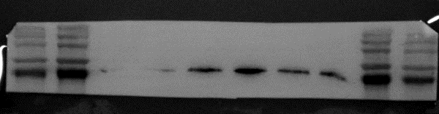
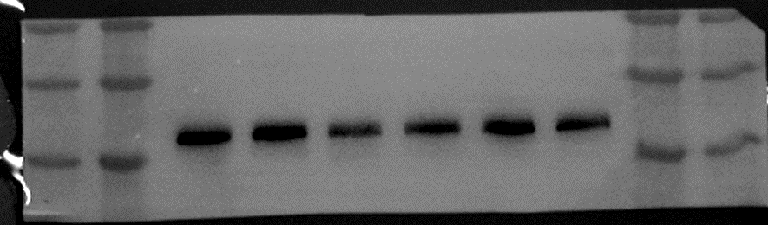
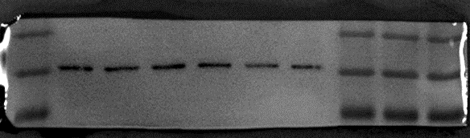
Supplementary Data 1. Original images of the Western blot analysis
37kDa(GAPDH)
35kDa
45kDa
60kDa
91kDa (PDE4D)
75kDa
100kDa
140kDa
Ang II
Control
25kDa
45kDa
35kDa
Figure 1B

Control
Ang II

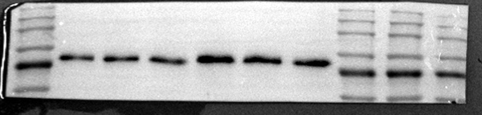
100kDa
60kDa
75kDa
91kDa(PDE4D)

37kDa(GAPDH)

Figure 4A
Ang II
Control
37kDa(GAPDH)
25kDa
35kDa
45kDa
75kDa
100kDa

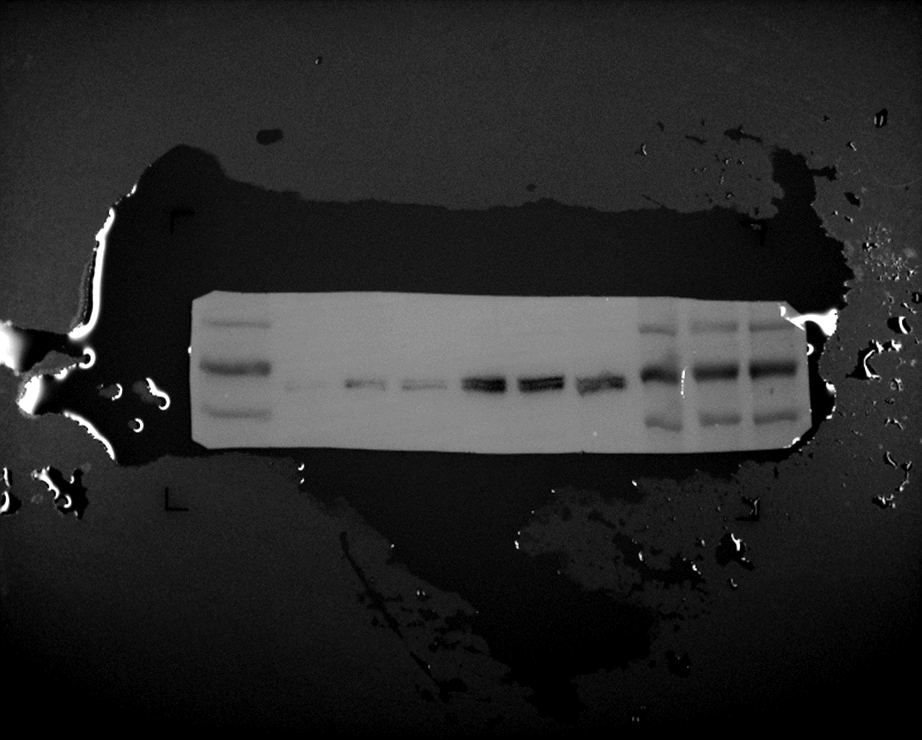
91kDa(PDE4D)
60kDa

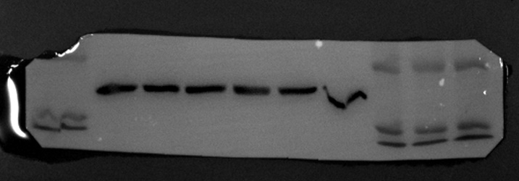

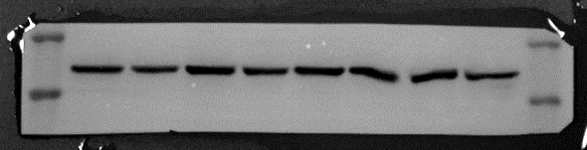
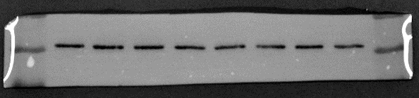
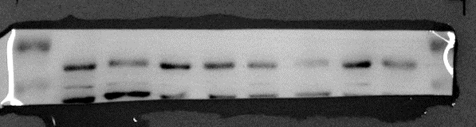
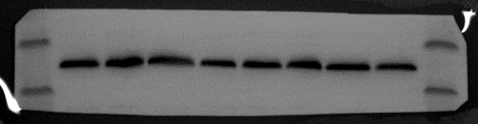
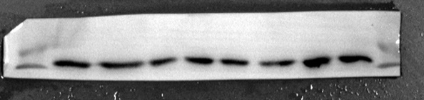
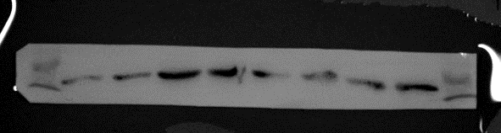
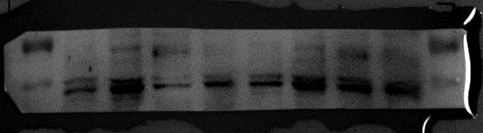
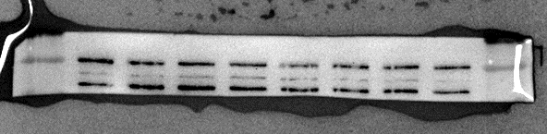
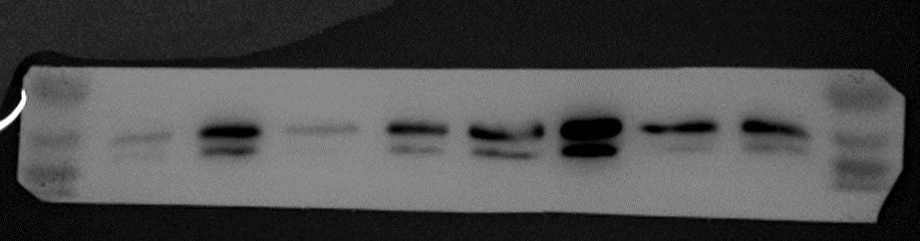
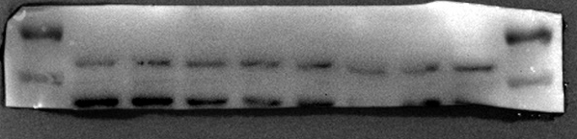
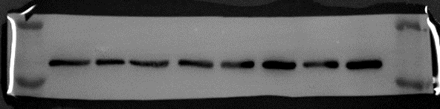
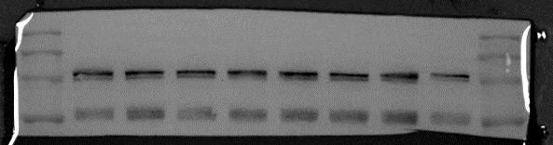
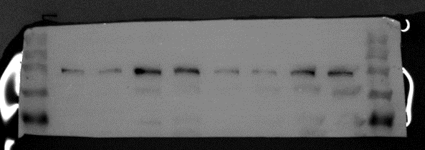
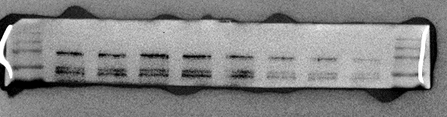
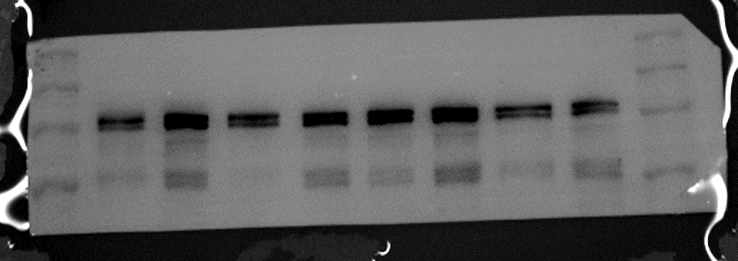
Si-PDE4D - - + + - - + +
37kDa(GAPDH)
37kDa(GAPDH)
18kDa(MLC)
18kDa(MLC)
15kDa
20kDa
18kDa(pMLC)
18kDa(pMLC)
60kDa
62kDa(AMPK)
62kDa(AMPK)
62kDa(pAMPK)
62kDa(pAMPK)
35kDa
45kDa
35kDa
45kDa
15kDa
20kDa
15kDa
20kDa
15kDa
20kDa
Ang II - + - + - + - +
60kDa
75kDa
60kDa
75kDa
60kDa
75kDa
75kDa
Figure 4F upper and lower panels (pAMPK, AMPK, pMLC and MLC)
37kDa(GAPDH)
35kDa
45kDa
180kDa
100kDa
140kDa(MYPT1)
100kDa
140kDa(pMYPT1)
180kDa
Si-PDE4D - - + + - - + +
Ang II - + - + - + - +
37kDa(GAPDH)
140kDa(MYPT1)
100kDa
180kDa
180kDa
140kDa(pMYPT1)
75kDa
100kDa
Figure 4F middle panels (pMYPT1 and MYPT1)

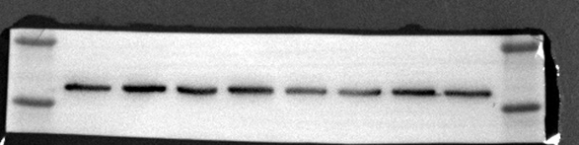
45kDa
35kDa

Figure 5B middle panels (pMYPT1 and MYPT1)
37kDa(GAPDH)
18kDa(MLC)
20kDa
15kDa
15kDa
180kDa
37kDa(GAPDH)
45kDa
PDE4D^{SMC-/-}+Ang II
PDE4D^{SMC-/-}+saline
PDE4D^{flox/flox}+saline
PDE4D^{flox/flox}+Ang II
PDE4D^{SMC-/-}+saline
PDE4D^{flox/flox}+saline
PDE4D^{flox/flox}+Ang II
PDE4D^{SMC-/-}+Ang II

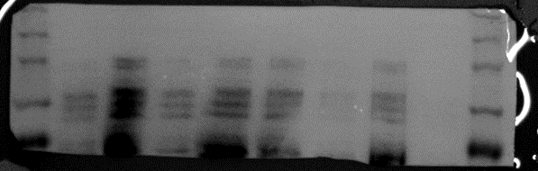
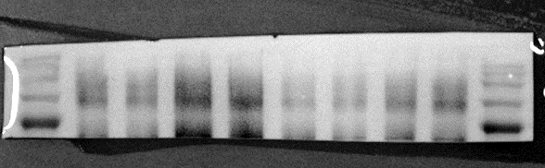
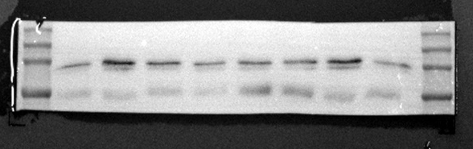
180kDa
140kDa(pMYPT1)
100kDa
140kDa(pMYPT1)
100kDa
75kDa
75kDa
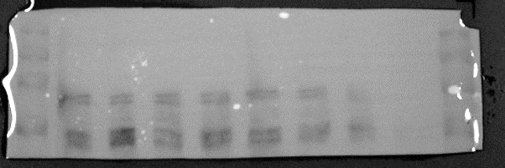
180kDa
180kDa
140kDa(MYPT1)
140kDa(MYPT1)
100kDa
100kDa

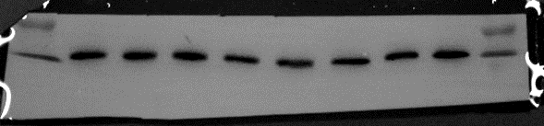
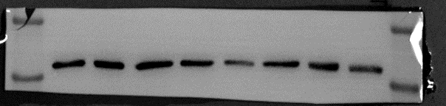
45kDa
37kDa(GAPDH)
35kDa
35kDa

Figure 5B upper and lower panels (pAMPK, AMPK, pMLC and MLC)

PDE4D^{SMC-/-}+Ang II
PDE4D^{SMC-/-}+saline
PDE4D^{flox/flox}+Ang II
PDE4D^{flox/flox}+saline
PDE4D^{SMC-/-}+Ang II
PDE4D^{SMC-/-}+saline
PDE4D^{flox/flox}+Ang II
PDE4D^{flox/flox}+saline

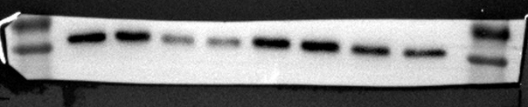
75kDa
62kDa(pAMPK)
75kDa
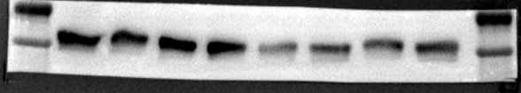
62kDa(pAMPK)
60kDa
60kDa

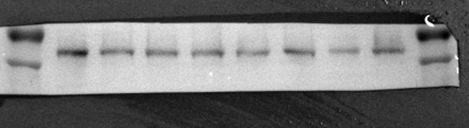
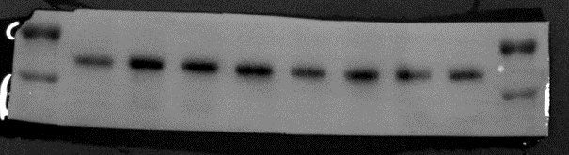
75kDa
75kDa
60kDa
62kDa(AMPK)
60kDa
62kDa(AMPK)

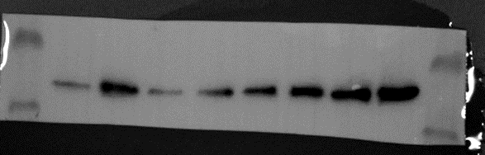
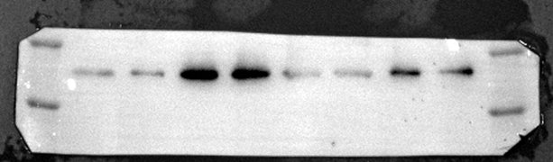
20kDa
18kDa(pMLC)
18kDa(pMLC)
15kDa
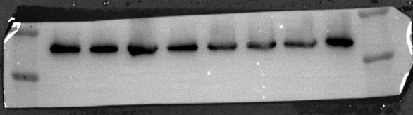
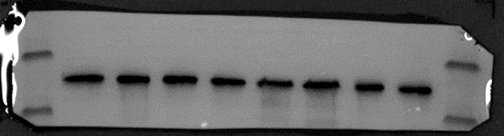
20kDa
18kDa(MLC)
20kDa
15kDa

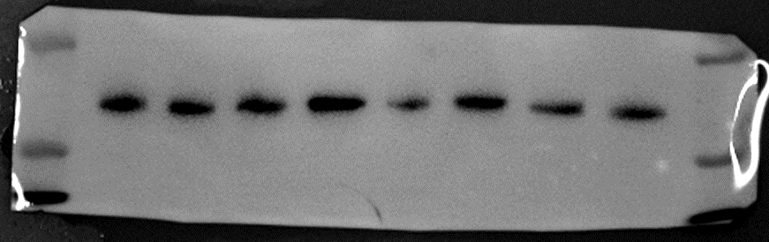
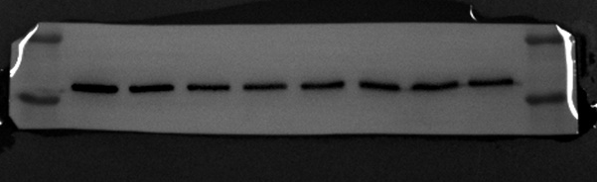
37kDa(GAPDH)
45kDa
45kDa
35kDa
35kDa

Supplementary Figure 2B, D
Tek-Cre
200bp
403bp
400bp
200bp
Control
PDE4D^{EC-/-}
PDE4D^{flox/flox}
Control
Tagln-Cre
PDE4D^{SMC-/-}
PDE4D^{flox/flox}

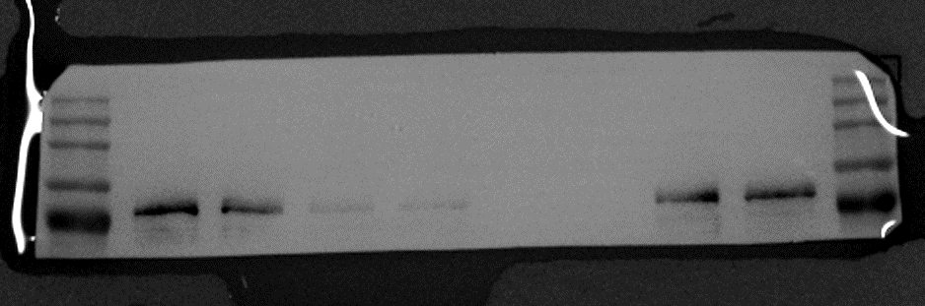
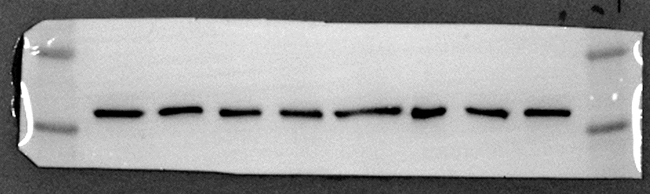
PDE4D^{EC-/-}
PDE4D^{flox/flox}
Supplementary Figure 2C

140kDa
91kDa(PDE4D)
100kDa
75kDa

37kDa(GAPDH)
45kDa
35kDa

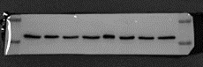
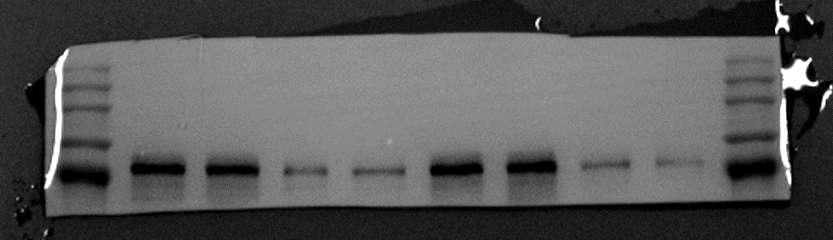
75kDa
100kDa
91kDa(PDE4D)
140kDa
37kDa(GAPDH)
35kDa
45kDa
PDE4D^{SMC-/-}
PDE4D^{flox/flox}
Supplementary Figure 2E

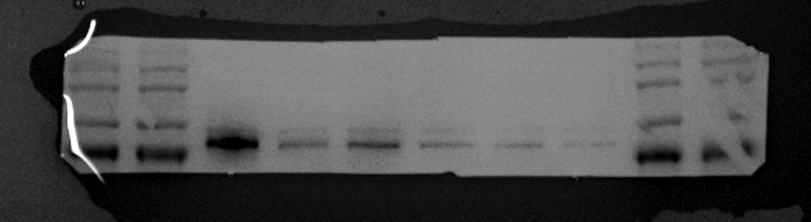
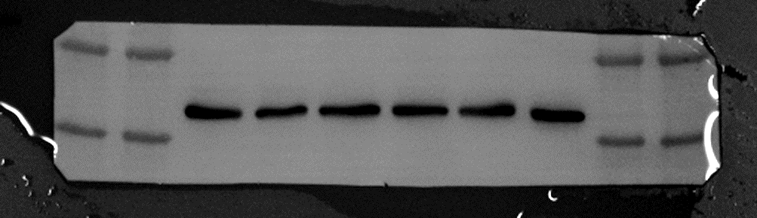
37kDa(GAPDH)
91kDa(PDE4D)
45kDa
35kDa
75kDa
100kDa
140kDa
Si-PDE4D
Si-PDE4D
Si-control
Si-PDE4D
Supplementary Figure 3A
Si-control
Si-control

