Supplementary information for: Modeling cassava root system architecture and the underlying dynamics in shoot-root carbon allocation
Nattharat Punyasu¹, Jittrawan Thaiprsit³, Saowalak kalapanulak^{1,3}, Treenut Saithong^{1,3*}, Johannes A. Postma^{1,2*}

Affiliations:
1) Bioinformatics and Systems Biology Program, School of Bioresources and Technology, and School of Information Technology, King Mongkut’s University of Technology Thonburi (Bang Khun Thian), Bangkok, Thailand
2) Institute for Plant Sciences (IBG2), Forschungszentrum Jülich, Jülich, Germany
3) Center for Agricultural Systems Biology (CASB), Systems Biology and Bioinformatics Research Group, Pilot Plant Development and Training Institute, King Mongkut’s University of Technology Thonburi (Bang Khun Thian), Bangkok, Thailand

* Corresponding author:
E-mail address: j.postma@fz-juelich.de (J.A., Postma)
E-mail address: treenut.sai@kmutt.ac.th (T., Saithong)

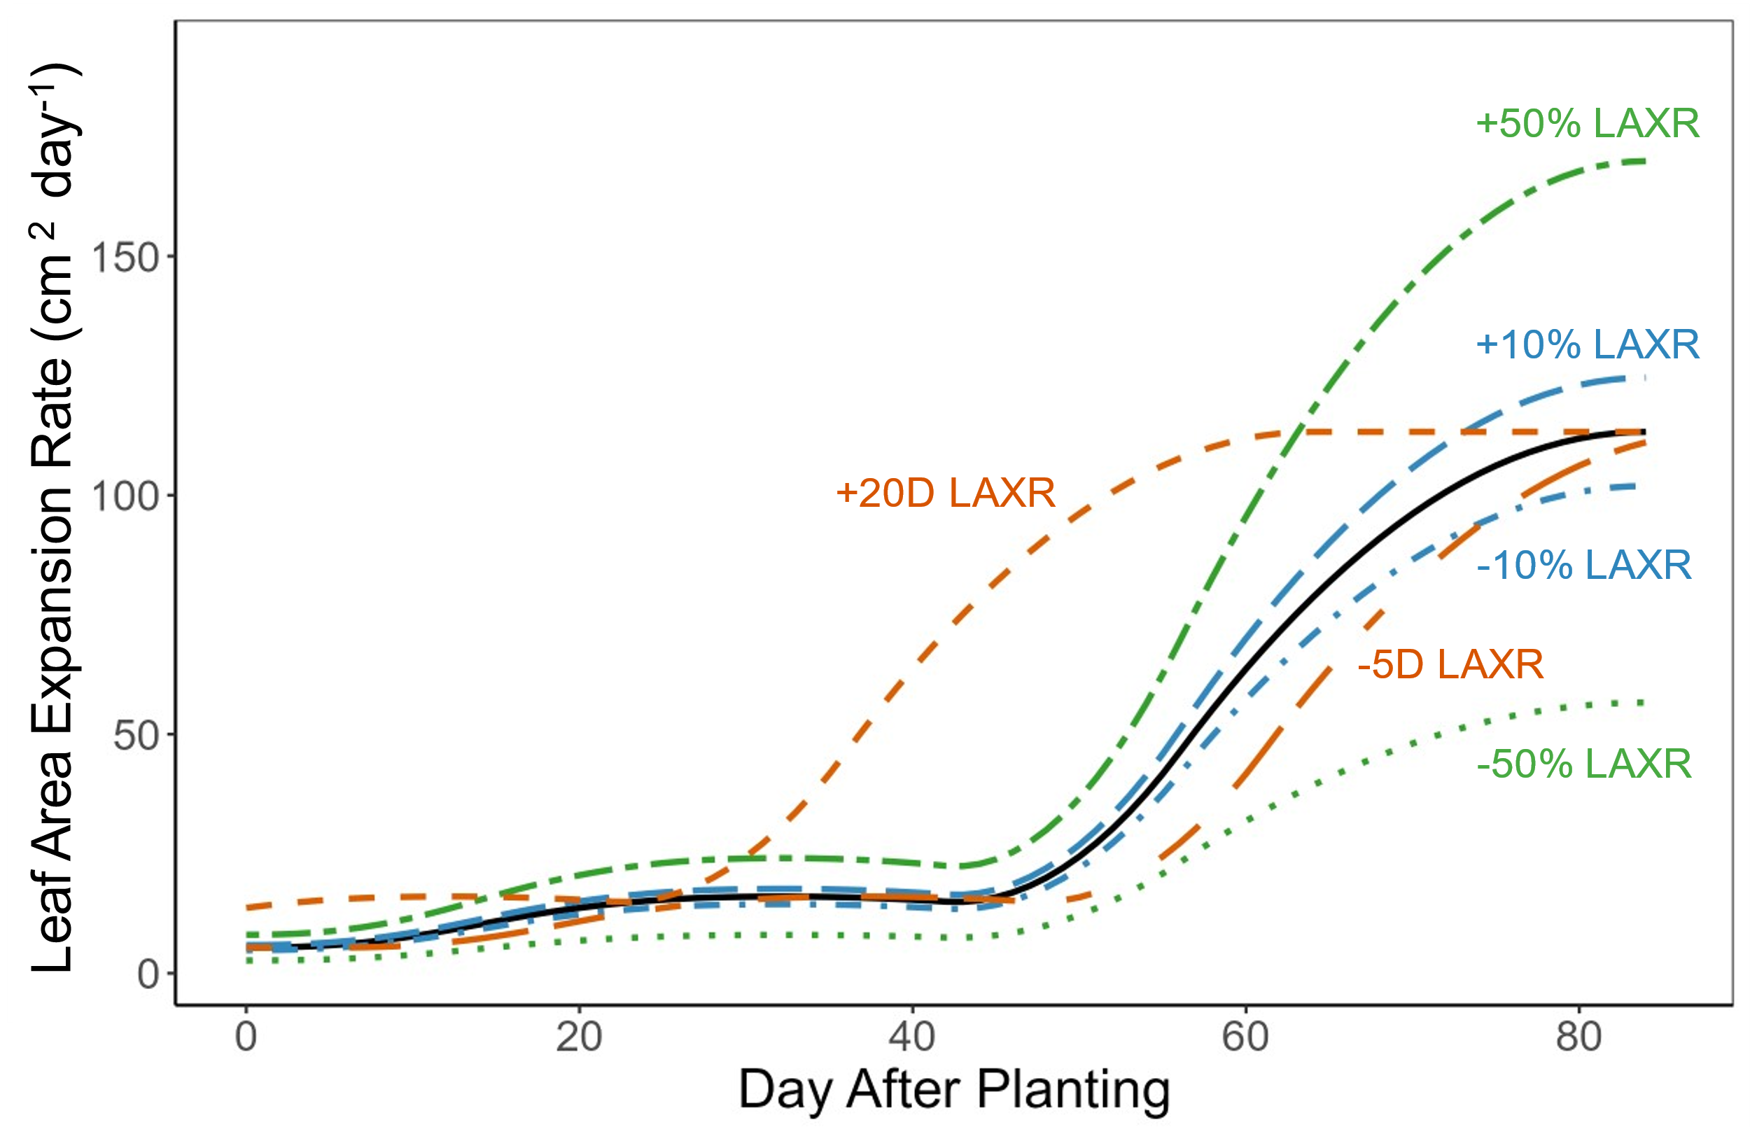

Fig. S1 Scenarios of leaf area expansion rate (LAXR). The black line shows LAXR from the experiment. The LAXR was perturbed in both increased and decreased, with variations of +/- 10% and +/- 50%, as well as shifting LAXR by +20/-5 days to represent rapid and slow-growing patterns (see Materials and Methods).

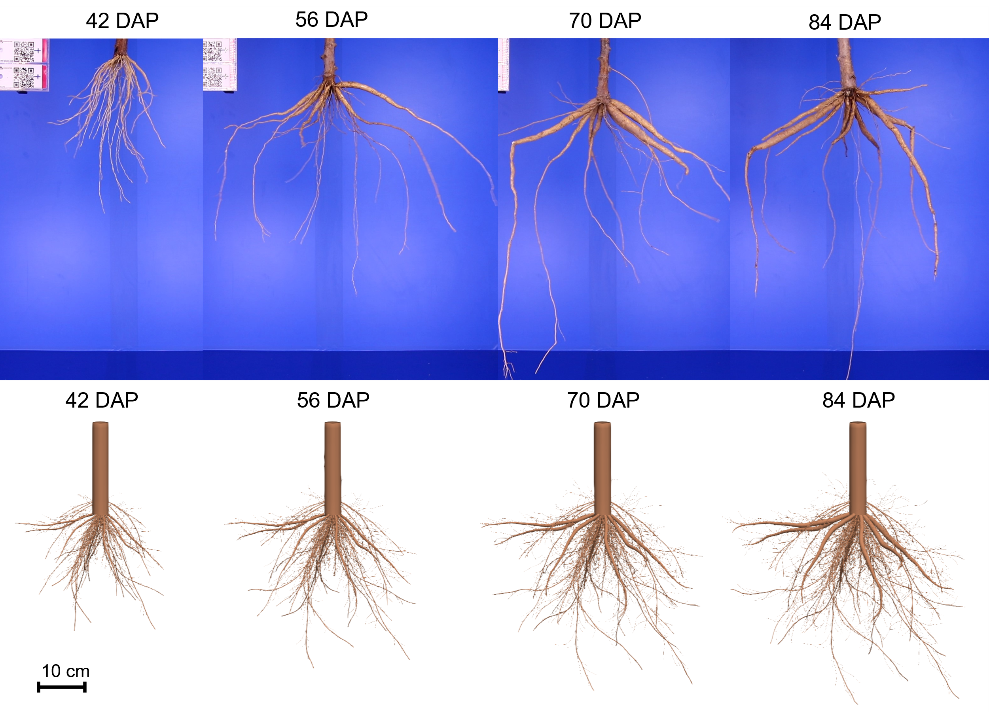

Fig. S2 The sampling (upper panel) and simulated (lower panel) cassava root systems across the growth stages from establishment to storage root formation. Simulated root systems are rendered at the same scale as the imaged root systems. The excavated root systems were taken from different cassava plants. The photographs are available under CC license at DOI 10.5281/zenodo.5883369.

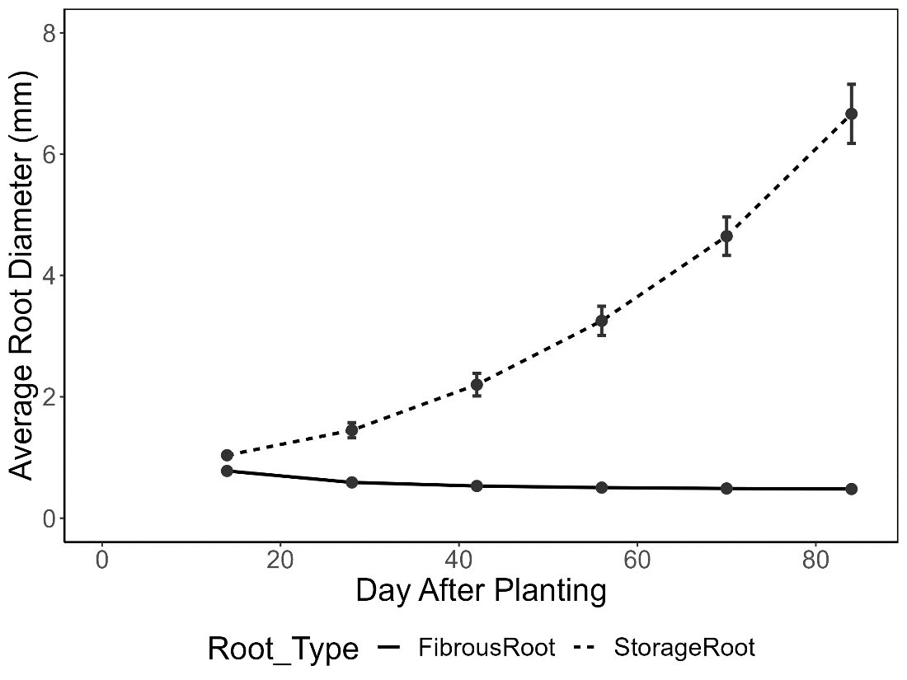
Fig. S3 Average root diameter (sampling density every ~1 cm) for fibrous roots (including adventitious roots and fine lateral roots; bold line) and storage roots (dashed line). The error bars represent the standard deviation across simulations with 6, 7, and 8 storage roots, with three replications for each case.

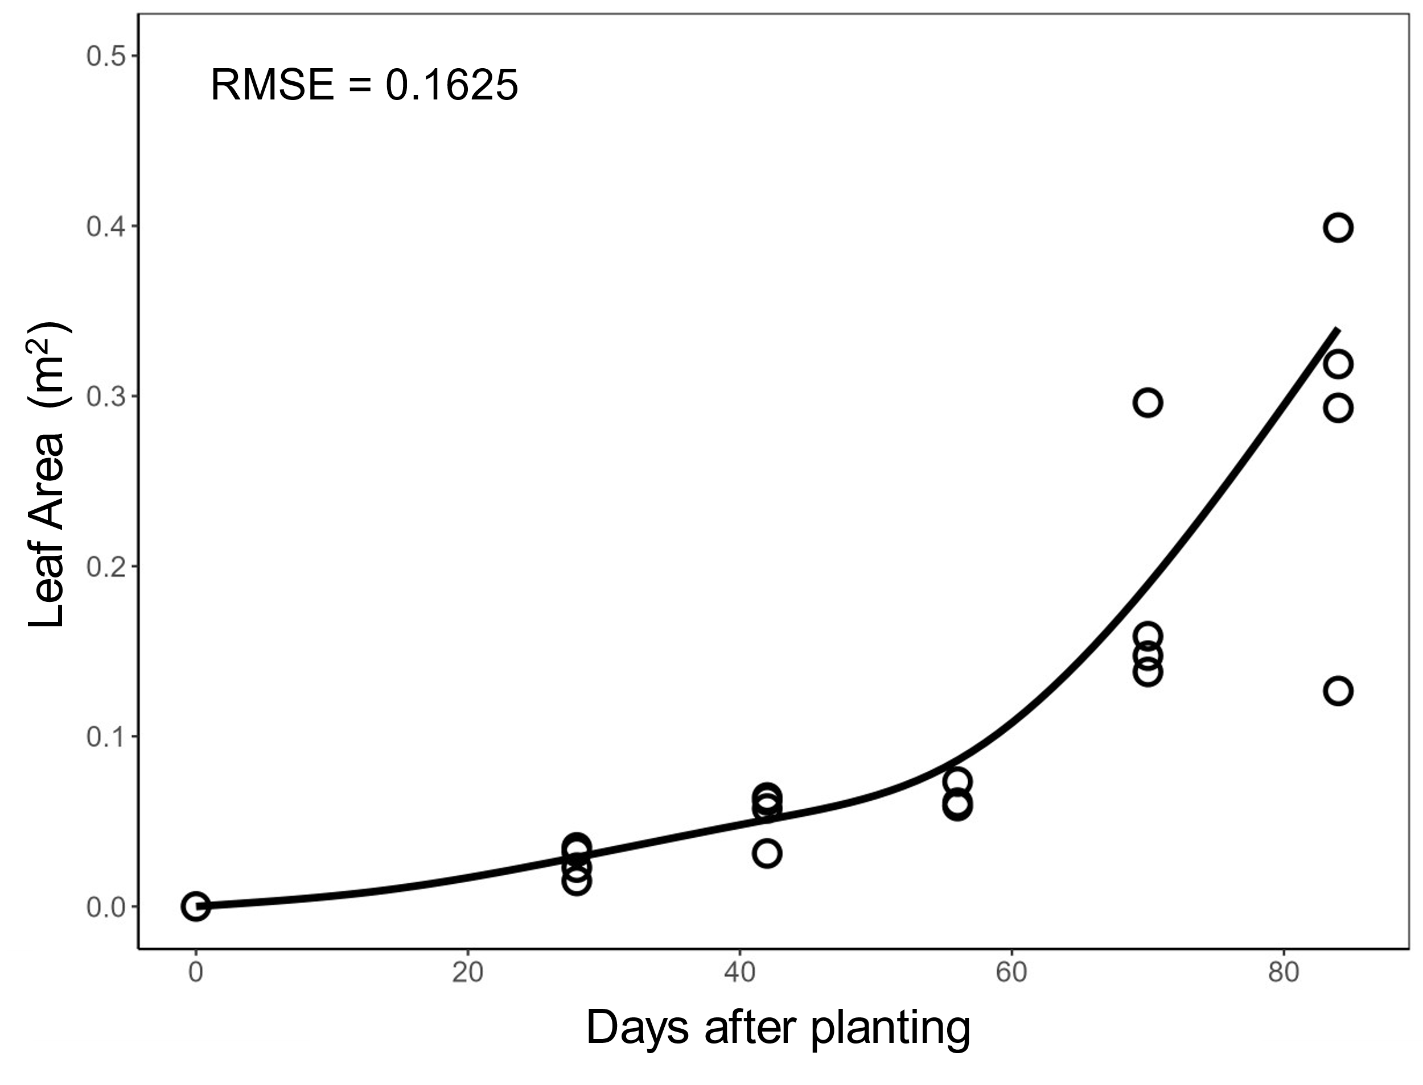
Fig. S4 Simulation of leaf area (m²) over time compared to experimental data (dots, n=5).

