Supplementary Information

3D printed Microfluidic Valve on PCB for Flow Control Applications using Liquid Metal

Ahmed Hamza , Anagha Navale, Qingchuan Song , Sagar Bhagwat , Pegah Pezeshkpour* and Bastian E. Rapp
Laboratory of Process Technology, NeptunLab, Department of Microsystem Engineering (IMTEK), University of Freiburg, 79110 Freiburg im Breisgau, Germany.

*Corresponding author. E-mail: Pegah.Pezeshkpour@neptunlab.org

Supplementary Information

Aligning the PCB on the printer head could be challenging due to the need a precise adjustment of the PCB with the design during printing. After calibrating the Z-position of the Printer, the center of the design would be shifted from the center of the printer head. To solve this problem, a calibration design as shown in Fig. S 1, was printed first on the printer head to set the borders of the printable area and to align the electrodes in the middle.
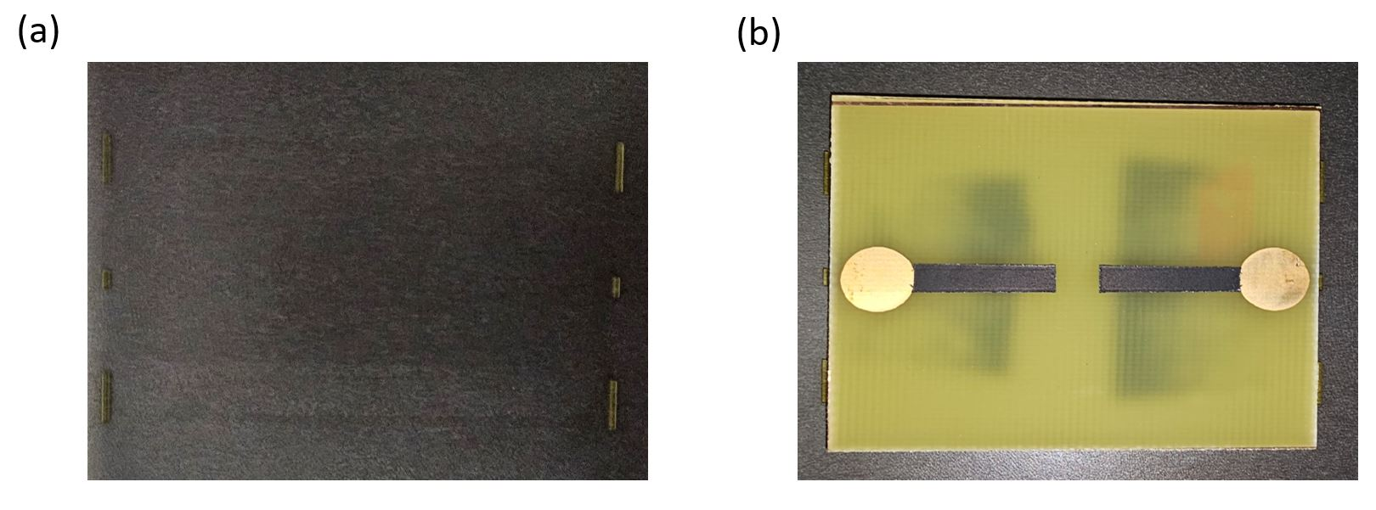
Fig. S 1 a Alignment design printed on the printer head. b The fixed PCB on the printer head

As shown in Fig. S 2a, a wave generator was used to supply a square wave pattern to move the Galinstan valve. Fig. S 2b shows the 2 cross-section views of the microfluidic chip design and its connection with the carbon electrodes.
Waveform Generator
Fig. S 2 a The experimental setup used for the LM valve. b Schematic cross-section views of the microfluidic chip on PCB

