Table 1 Eigenvectors and eigenvalues for the principal components (PC1, PC2, PC3, and PC4) derived from the variants: RRE, RSE, Cd concentrations in root and shoot (Cd/r and Cd/s), and relative MDA, H₂O₂, SOD, and APX in root and shoot (MDA/r, MDA/s, H₂O₂/r, H₂O₂/s, SOD/r, SOD/s, APX/r, and APX/s)

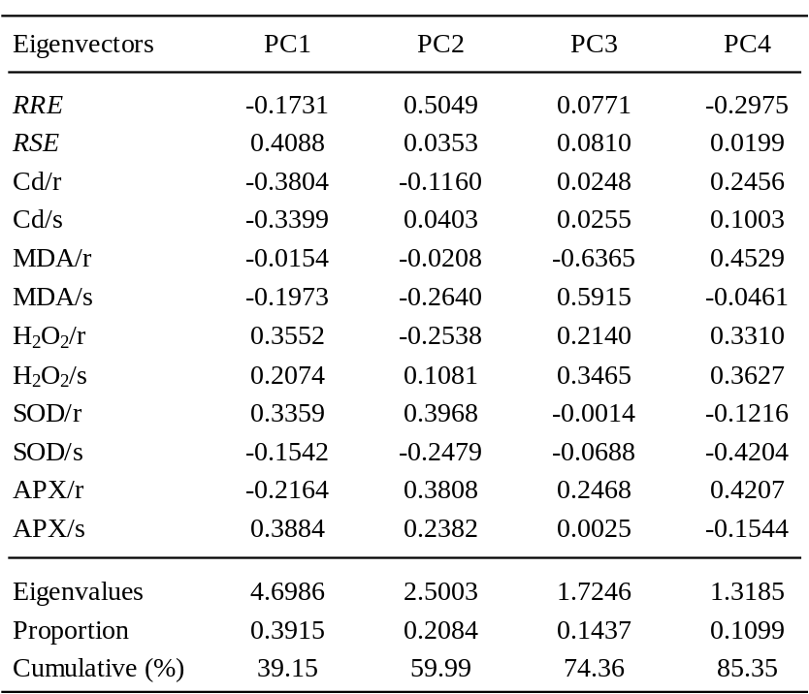

Table 2 Genotypic variations in the translocation factor (TF) values for the selected physiological traits, malondialdehyde (MDA), H₂O₂, superoxide dismutase (SOD), and ascorbate peroxidase (APX), and in the tendency index (TI) values for the Cd treatment relative to a check (CK) among the rice cultivars

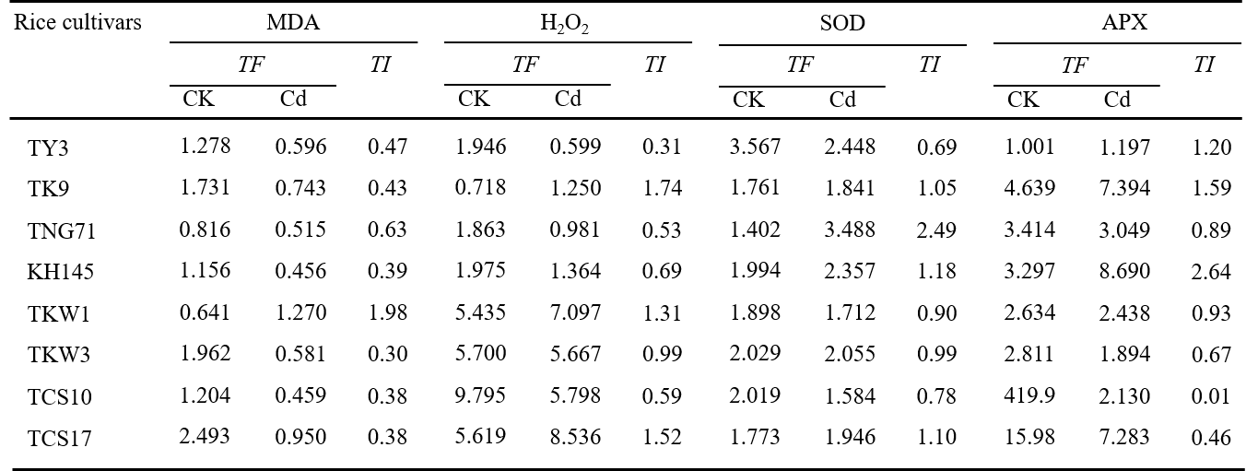

Table 3 Correlation coefficients between the plant growth factors, relative root elongation (RRE) and relative shoot extension (RSE), and the plant Cd concentrations in root and shoot versus the tendency index (TI) values of physiological traits, superoxide dismutase (SOD), ascorbate peroxidase (APX), H₂O₂, and malondialdehyde (MDA). The bold font highlights the significance at p<0.1

