Supplemental material to:

Hitchhiking actions: Erroneous saccade co-execution is independent of stimulus-response translation ease

Jens Kürten¹, Tim Raettig¹¹, and Lynn Huestegge¹
¹ University of Würzburg

Figure S1
Error rates as a function of stimulus mode and error type
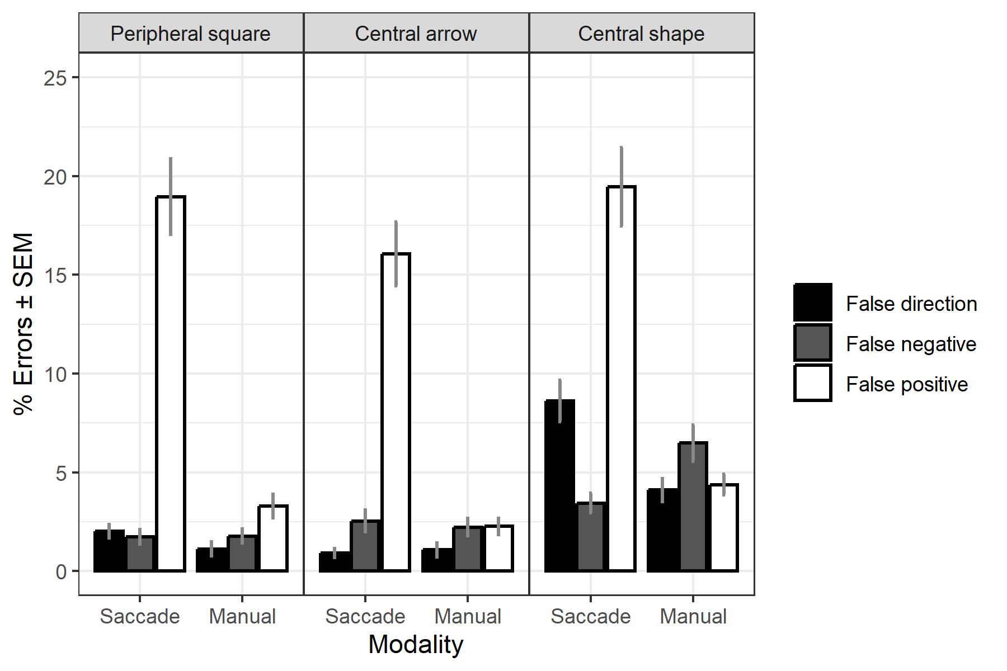
Note. ERs (%) of both response modalities (saccade, manual) as a function of stimulus mode (peripheral square, central arrow, central shape) and error type (false direction, false negative, false positive, false positive and false direction), calculated from all trials in which a certain error type could occur. False-positive error rates are thus based on 60 trials per modality and stimulus mode, false-negative error rates are based on 120 trials per modality and stimulus mode, and false-direction errors are based on 180 trials per modality and stimulus mode. Error bars represent the standard error of the mean (SEM).

Figure S2
Distribution of inter-response intervals in intended and erroneous dual actions in single manual trials
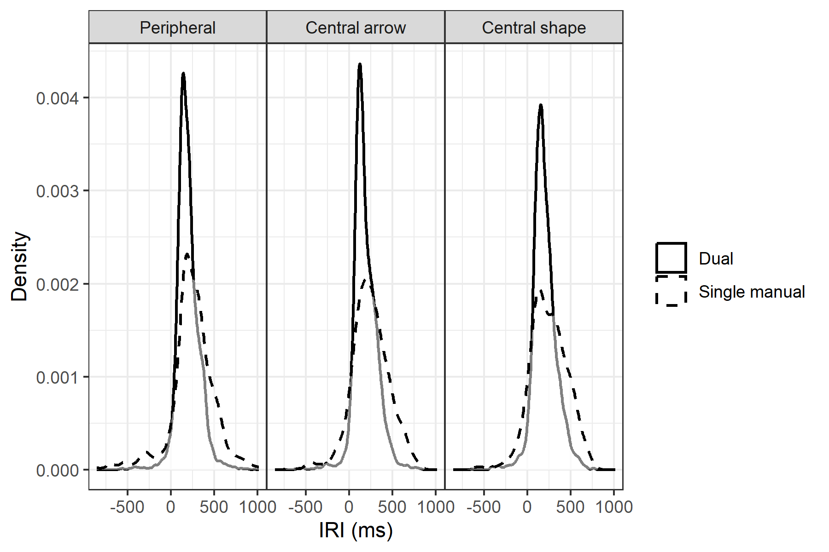
Note. Distribution of inter-response intervals (IRIs) in ms in dual-action trials (solid lines), and in single manual trials with a false-positive saccade and a manual response (broken lines). Positive values indicate that the saccade was executed before the key press, negative values indicate that the key press was executed before the saccade.

Figure S3
Sequential effects on inhibitory failures
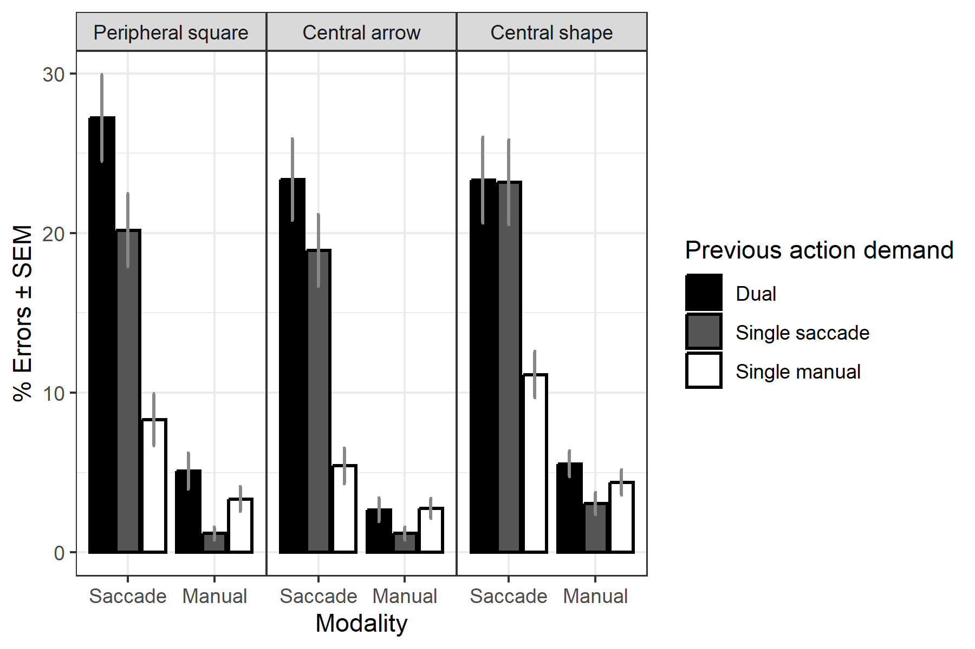
Note. False positive error rates (%) in the saccade modality (single manual trials) and the manual modality (single saccade trials) as a function of previous action demand (bars) and stimulus mode (panels). The mean trial count was > 18.23 in all cells.

Figure S4
Percentage of warranted and erroneous dual actions with both component actions in the same direction
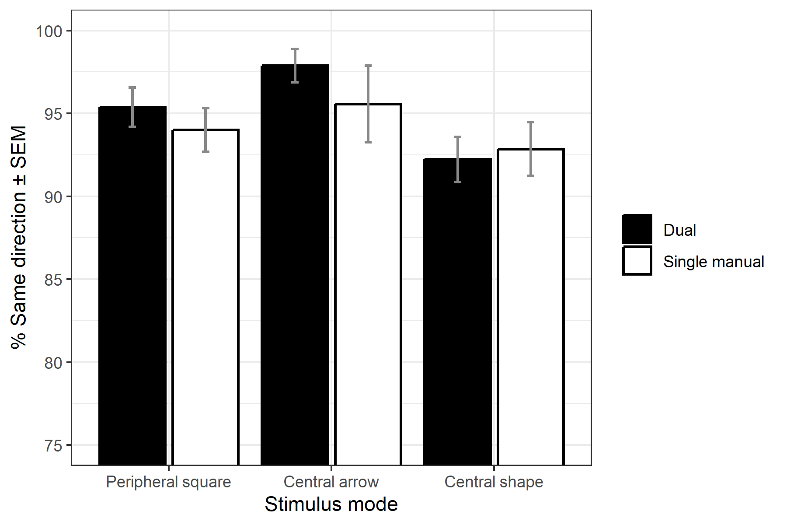
Note. Percentage of dual-action trials and single manual trials with the (false-positive) saccade and a manual response with both actions carried out in the same direction (both left or both right). The mean trial count in the single manual condition was 9.98 (SD = 7.65), 8.30 (SD = 6.41), and 8.52 (SD = 7.21) with the peripheral square, the central arrow, and the central shape respectively. Error bars represent the standard error of the mean (SEM).

