Appendix 1. The OHCA occurrence layer by heat-map analysis of OHCA occurrence location from 2013 to 2016 in Seoul
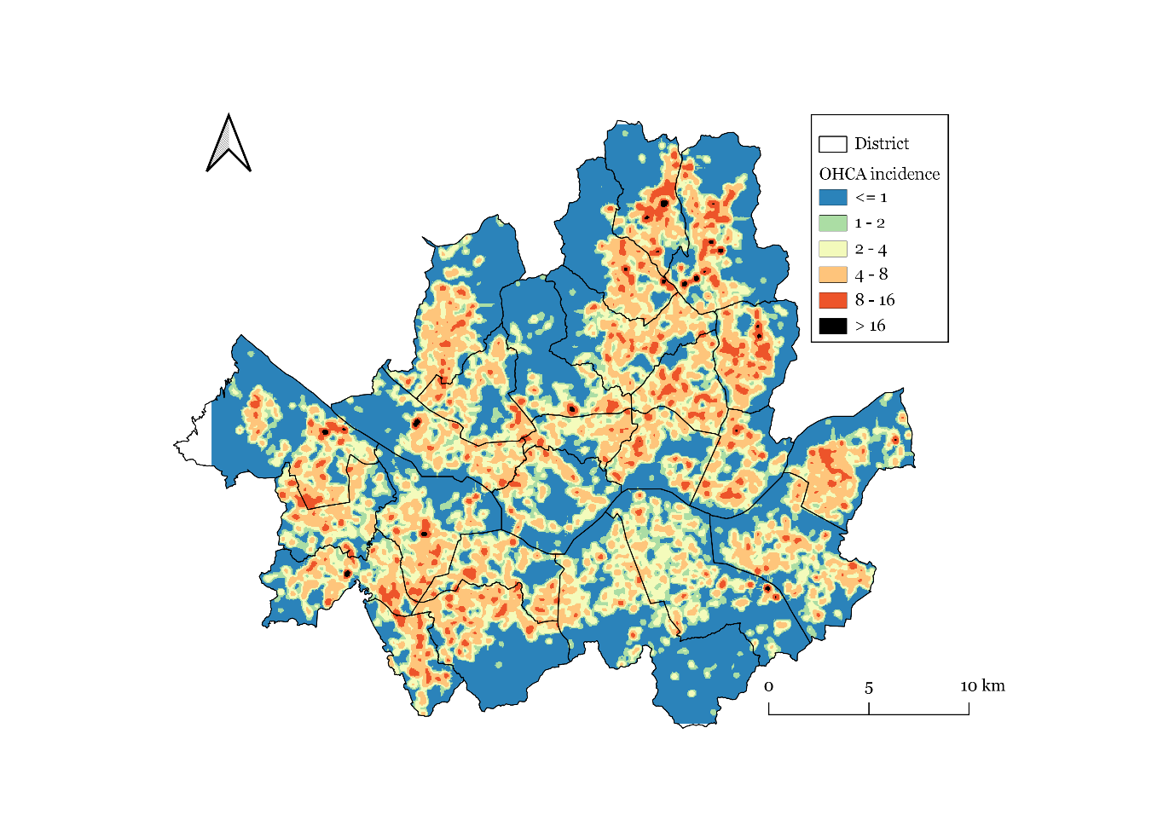

Appendix 2. Mean EMS call to scene arrival time and location of 116 fire stations from 2013 to 2016 in Seoul
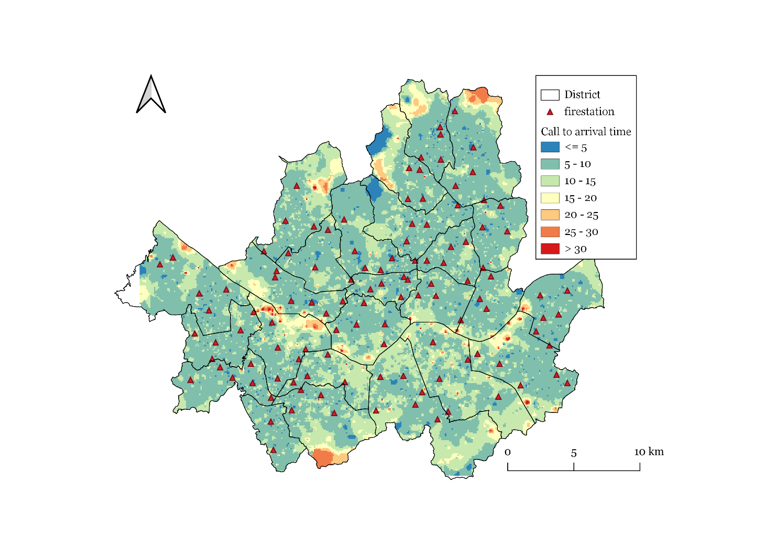

Appendix 3. Optimal location of UAV-AED stations using the genetic algorithm
