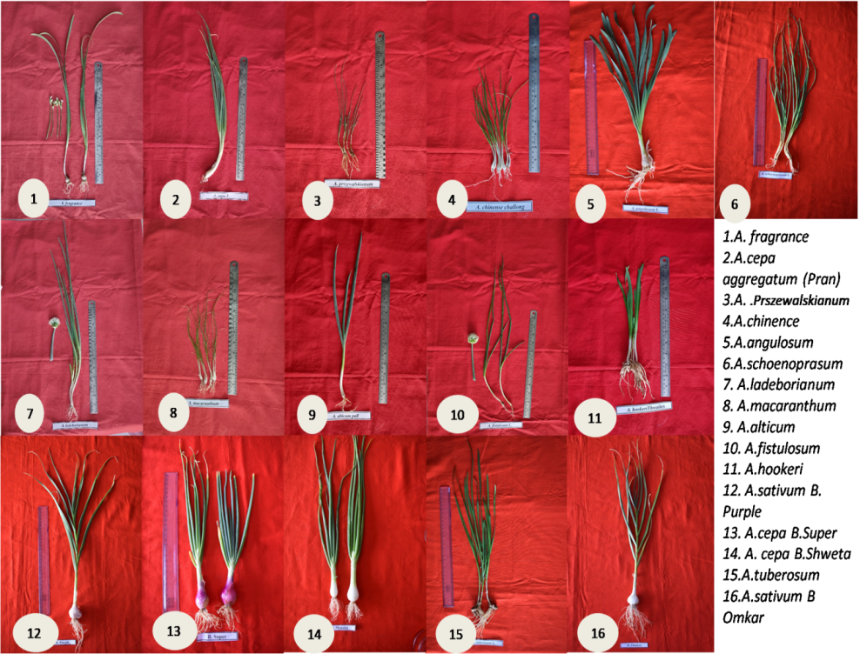
Supplementary Fig 1. Different Allium species used for morphological characterization on leaf style, leaf width, leaf height, leaf waxiness, plant height, inflorescence related traits (umble shape, floret density, flower colour, pollen colour etc.) and pseudo-stem parameters including bulging habit

Supplementary Table 1. General classification of traits based on quality differences and quantitative values of Allium species found in India
Traits | 1 | 2 | 3 | 4
Tiller per plant | Low (< 10) | Medium (10-30) | Moderately high (30 -100) | High ( > 100)
Plant height(cm) | Short (< 20cm) | Medium (20-50 cm) | Long ( > 50 cm)
No of leaves per plant | Low (< 20) | Medium (20-50) | Moderately high (50 -100) | High ( > 100)
Leaf width (mm) | Narrow (< 5 mm) | Medium (5-10mm) | Broad (>10mm)
Leaf length(cm) | Short(< 20 cm) | Medium (20-50cm) | Long (>50cm)
Leaf shape | Flat | Hollow
Leaf colour | Light green | Green | Dark green
Foliage attitude | Prostrate | Intermediate | Erect
Leaf waxiness | Weak | Medium | Strong
Pseudo-stem diameter | Narrow (< 5 mm) | Medium (5-10 mm) | Strong ( >10 mm)
Time of flowering | Early () | Mediate () | Late ()
Inflorescence shape | Cone | Spherical | Semi spherical
Inflorescence density | Sparse (<100) | Dense ( >100 )
Inflorescence colour | White | Lavender
Inflorescence fragrance | Light | Medium | Strong
Inflorescence size | Small | Medium | Large
Flower number in umbel | Few (6-10) | Many ( < 30)
Anther colour | Yellow | Green | Brown
Scape direction | Erect | Indirect
Scape diameter | Narrow | Medium | Broad
Scape length | Short () | Partial () | Long ()

