Supplementary Information for

Janus icosahedral particles: amorphization driven by three-dimensional atomic misfit and edge dislocation compensation
Zhen Sun^{1,3}, Yao Zhang^{1,3}, Zezhou Li¹, Xuanxuan Du¹, Zhiheng Xie¹, Yiheng Dai¹, Colin Ophus², Jihan Zhou¹
¹Beijing National Laboratory for Molecular Sciences, Center for Integrated Spectroscopy, College of Chemistry and Molecular Engineering, Peking University; Beijing, 100871, China.
²National Center for Electron Microscopy, Molecular Foundry, Lawrence Berkeley National Laboratory, Berkeley, CA 94720, USA.
³These authors contributed equally to this work.
Correspondence and requests for materials should be addressed to J. Z. (email:
jhzhou@pku.edu.cn)
This PDF file includes Supplementary Tables 1-7 and Supplementary Figs. 1-16.
Other Supplementary Materials for this manuscript include Supplementary Movies 1-2.

Supplementary Table 1 | Data collection, processing, reconstruction, refinement and statistic.
 | ICNP-1 | ICNP-2 |  | ICNP-3
Data Collection and Processing
Voltage (kV) | 300 |  | 300 |  | 300
Convergence semi-angle (mrad) | 30.0 |  | 30.0 |  | 30.0
Detector inner angle (mrad) | 39.4 |  | 39.4 |  | 39.4
Detector outer angle (mrad) | 200 |  | 200 |  | 200
Pixel size (Å) | 0.343 |  | 0.343 |  | 0.343
Scanning current ( pA) | 30 |  | 15 |  | 15
Number of projections | 55 | 56 |  | 58
Tilt range ( °) | -74.0  69.0 | -76.0  76.0 |  | -73.5  76
Electron dose ( 105 e-/Å2) | 5.2 | 2.7 |  | 2.8
Reconstruction
Algorithm | RESIRE
Oversampling ratio | 4 |  | 4 |  | 4
Number of iterations | 200 |  | 200 |  | 200
Refinement
R (%)a | 0.0765 | 0.0836 |  | 0.0789
Statistics
# of atoms
Total | 3643 | 4108 |  | 4711
Au | 2186 | 2145 |  | 2296
Pd | 1457 | 1963 |  | 2415

ª The R-factor is defined by , where is the back projection of the reconstruction volume at angle θ, b_{θ} {x,y} is the real projection image at angle θ, and N is the number of projections.

Supplementary Table 2 | The atom number of twenty tetrahedra-like domains of ICNP-1

 | Domain | Atom number (serial number) |  |  |  |  |  | Averaged number
C5 side | Class 1 | 448 (1) | 386 (2) | 459 (3) | 318 (4) |  |  | 403
C5 side | Class 2 | 313 (5) | 263 (6) | 356 (7) | 299 (8) | 281 (9) | 239 (10) | 292
C5’ side | Class 3 | 218 (11) | 200 (12) | 190 (13) | 142 (14) | 155 (15) | 247 (16) | 192
C5’ side | Class 4 | 165 (17) | 135 (18) | 167 (19) | 163 (20) |  |  | 158

Supplementary Table 3 | The atom number of twenty tetrahedra-like domains of ICNP-2

 | Domain | Atom number (serial number) |  |  |  |  |  | Averaged number
C5 side | Class 1 | 303 (1) | 334 (2) | 295 (3) | 292 (4) |  |  | 306
C5 side | Class 2 | 348 (5) | 275 (6) | 287 (7) | 269 (8) | 233 (9) | 290 (10) | 284
C5’ side | Class 3 | 252 (11) | 267 (12) | 271 (13) | 254 (14) | 284 (15) | 233 (16) | 260
C5’ side | Class 4 | 239 (17) | 262 (18) | 263 (19) | 323 (20) |  |  | 272

Supplementary Table 4 | The solid angle of twenty tetrahedra-like domains of ICNP-1

 | Domain | Solid angle (serial number) |  |  |  |  |  | Averaged angle
C5’ side | Class 1 | 50.6° (20) |  |  |  |  |  | 50.6°
C5’ side | Class 2 | 39.6° (17) |  | 40.5° (18) |  | 39.6° (19) |  | 39.9°
C5’ side | Class 3 | 36.4° (11) | 32.7° (12) | 35.2° (13) | 35.3° (14) | 34.7° (15) | 35.8° (16) | 35.0°
C5 side | Class 4 | 33.8° (5) | 36.4° (6) | 34.4° (7) | 35.0° (8) | 34.0° (9) | 35.4° (10) | 34.8°
C5 side | Class 5 | 33.3° (2) |  | 32.3° (3) |  | 32.9° (4) |  | 32.8°
C5 side | Class 6 | 32.4° (1) |  |  |  |  |  | 32.4°

Supplementary Table 5 | The solid angle of twenty tetrahedra-like domains of ICNP-2

 | Domain | Solid angle (Serial number) |  |  |  |  |  | Averaged angle
C5’ side | Class 1 | 45.9° (20) |  |  |  |  |  | 45.9°
C5’ side | Class 2 | 37.9° (17) |  | 42.7° (18) |  | 38.0° (19) |  | 39.5°
C5’ side | Class 3 | 36.9° (11) | 39.0° (12) | 34.3° (13) | 33.7° (14) | 33.2° (15) | 35.6° (16) | 35.4°
C5 side | Class 4 | 35.1° (5) | 35.6° (6) | 33.8° (7) | 33.3° (8) | 34.4° (9) | 36.3° (10) | 34.8°
C5 side | Class 5 | 34.4° (2) |  | 33.1° (3) |  | 33.6° (4) |  | 33.7°
C5 side | Class 6 | 33.1° (1) |  |  |  |  |  | 33.1°

Supplementary Table 6 | The packing efficiency of twenty tetrahedra-like domains of ICNP-1

 | Domain | Packing efficiency (serial number) |  |  |  |  |  | Averaged packing efficiency
C5 side | Class 1 | 69.7 (1) | 72.7 (2) | 70.5 (3) | 72.4 (4) |  |  | 71.3
C5 side | Class 2 | 67.3 (5) | 72.3 (6) | 72.0 (7) | 67.9 (8) | 70.9 (9) | 71.4 (10) | 70.3
C5’ side | Class 3 | 66.9 (11) | 71.2 (12) | 73 (13) | 69.5 (14) | 72.2 (15) | 71.9 (16) | 70.8
C5’ side | Class 4 | 71.2 (17) | 70.4 (18) | 63.4 (19) | 62.3 (20) |  |  | 66.8

Supplementary Table 7 | The packing efficiency of twenty tetrahedra-like domains of ICNP-2

 | Domain | Packing efficiency (serial number) |  |  |  |  |  | Averaged packing efficiency
C5 side | Class 1 | 68.6 (1) | 66.3 (2) | 69.7 (3) | 62.1 (4) |  |  | 66.7
C5 side | Class 2 | 68.7 (5) | 65.3 (6) | 69.9 (7) | 67.4 (8) | 61.8 (9) | 67.9 (10) | 66.8
C5’ side | Class 3 | 64.7 (11) | 67.6 (12) | 68.1 (13) | 64.2 (14) | 71.4 (15) | 68.6 (16) | 67.4
C5’ side | Class 4 | 67.2 (17) | 69.7 (18) | 71.2 (19) | 66.6 (20) |  |  | 68.7

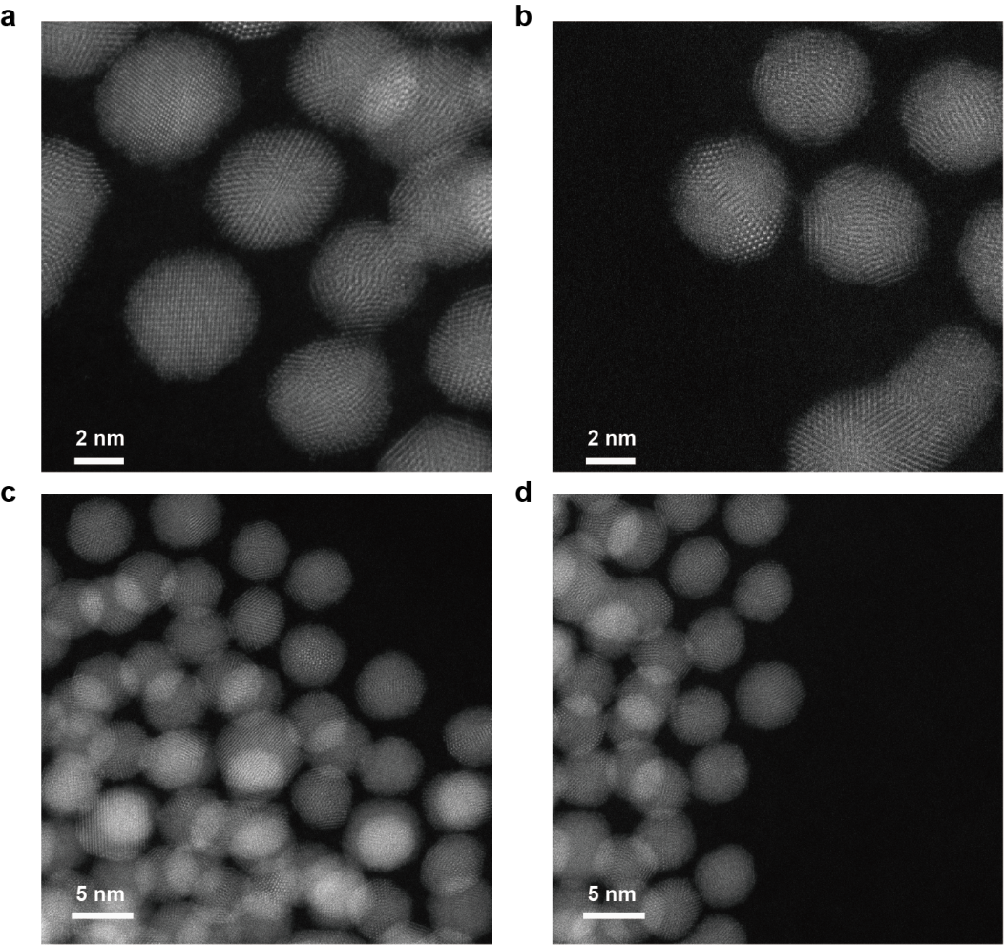

Supplementary Fig. 1 | The scanning transmission electron microscopy (STEM) images show the multiply twinned particles (MTPs). MTPs exhibit various features, including fivefold twinning boundaries, stacking faults, and randomly-orientated polycrystalline grains.

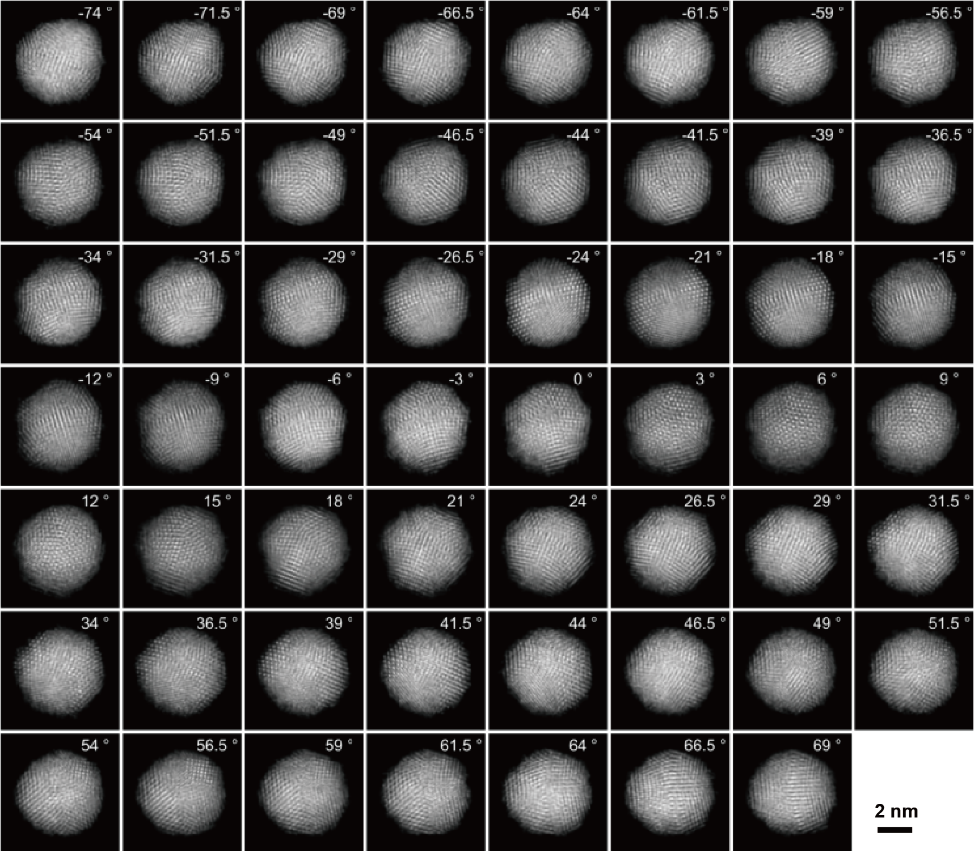

Supplementary Fig. 2 | Tomographic tilting series of ICNP-1. 55 ADF-STEM images with a tilt range from −74.0º to +69.0º.

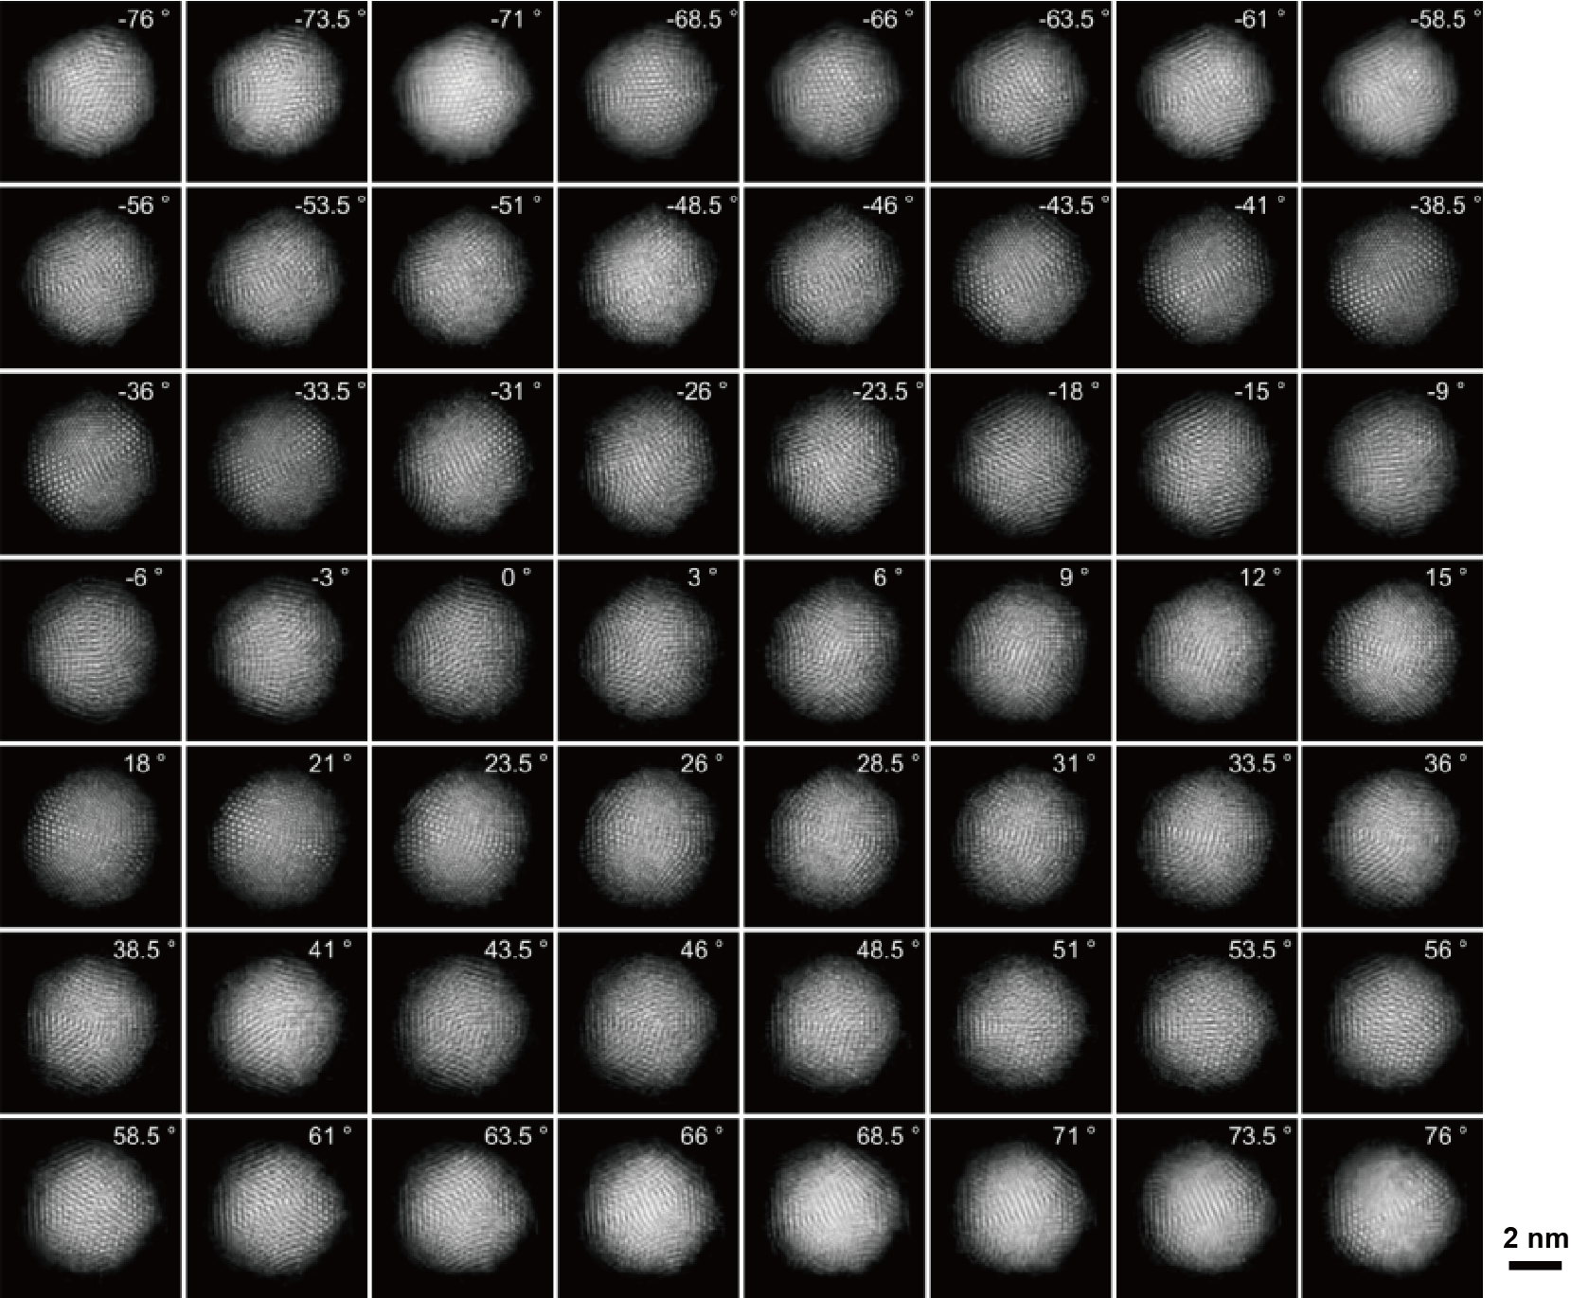

Supplementary Fig. 3 | Tomographic tilting series of ICNP-2. 56 ADF-STEM images with a tilt range from −76.0º to +76.0º.

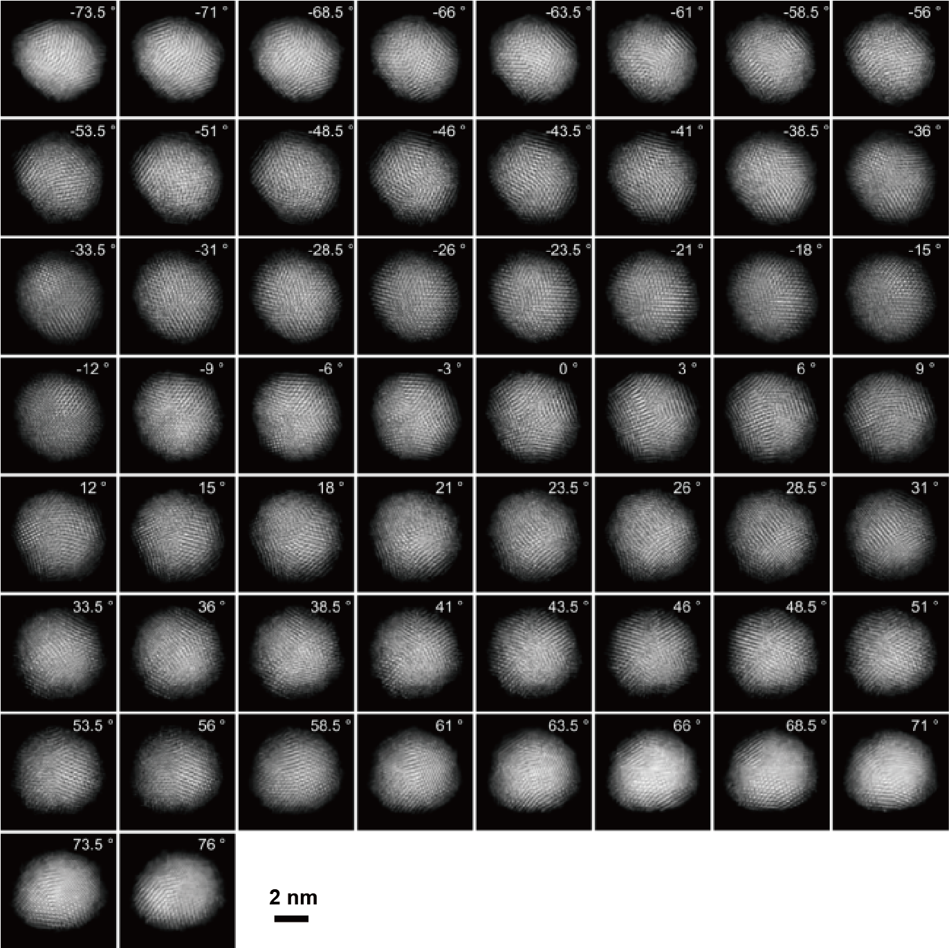

Supplementary Fig. 4 | Tomographic tilting series of ICNP-3. 58 ADF-STEM images with a tilt range from −73.5º to +76.0º.

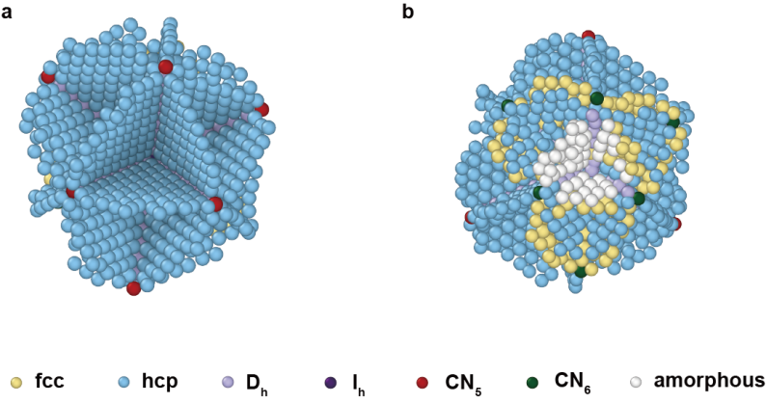

Supplementary Fig. 5 | 3D atomic structures of the grain boundaries in ICNP-1 viewed from two distinct angles.

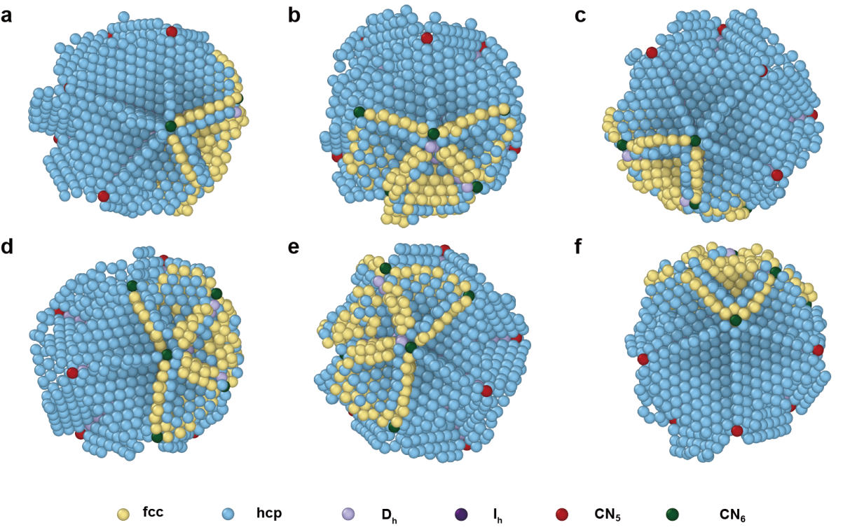

Supplementary Fig. 6 | The top view of six C5’ axes and grain boundaries of ICNP-1.

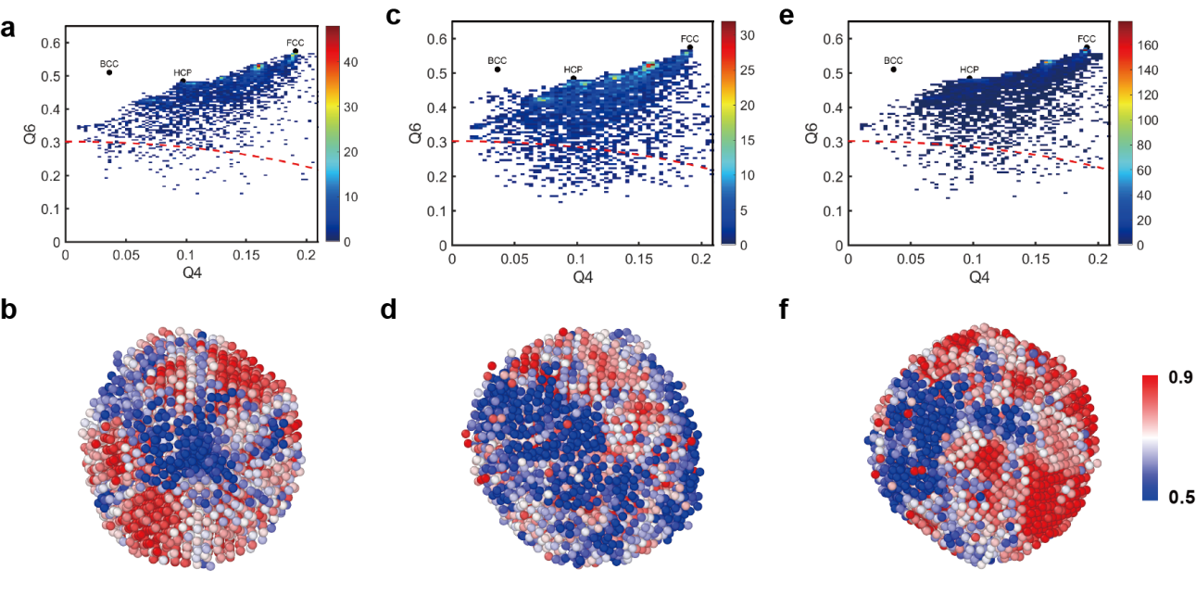

Supplementary Fig. 7 | Local BOO parameters of all the atoms in ICNP-1 (a), ICNP-2 (c) and ICNP-3 (e). The distribution of local BOO parameter of all the atoms in ICNP 1, 2 and 3 are shown in (b), (d) and (f), respectively.

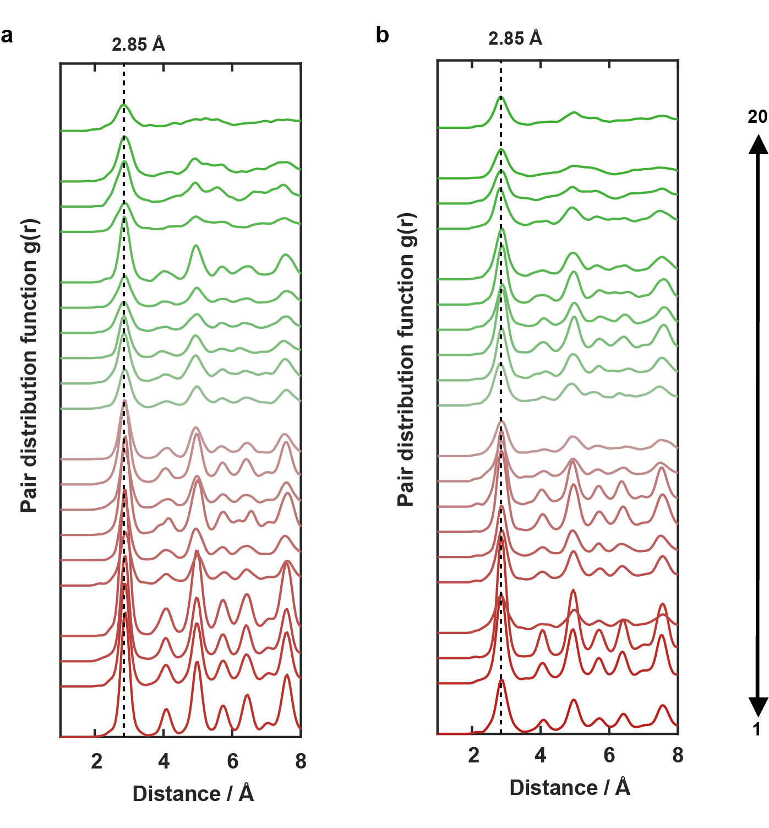

Supplementary Fig. 8 | Pair distribution functions (PDF) of twenty tetrahedral domains of ICNP-1 (a) and ICNP-2 (b). The PDF of tetrahedra from C5 side and C5’ side are marked in red and green, respectively. The order from bottom to top are the order from tetrahedral domain 1 to 20.

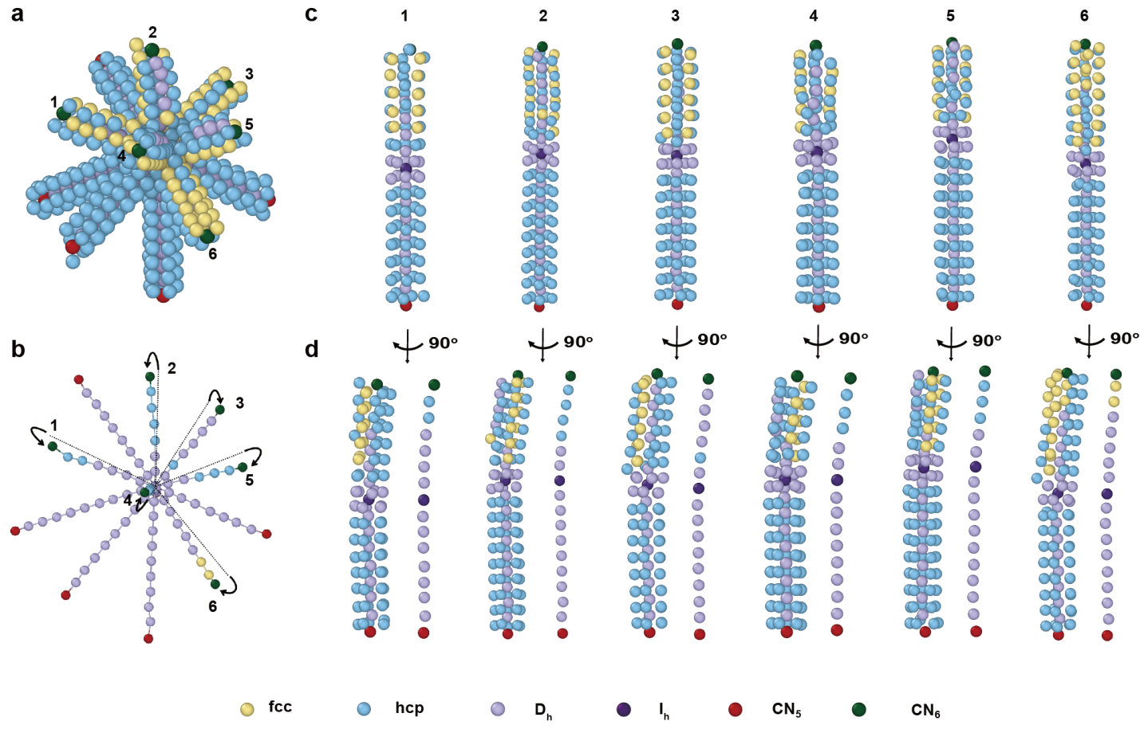

Supplementary Fig. 9 | The coordination environment of all twelve axes (six C5 axis and six C5’ axis) in ICNP-1. (a) All twelve axes and the coordinated atomic columns in ICNP-1. (b) The twelve axes (six C5 axes and six C5’ axes) in ICNP-1. (c) The front view of each group of C5 and C5’ axes and the coordinated atomic columns in ICNP-1. (d) The side view of each groups of C5 and C5’ axes and their coordinated atomic columns. The axial atom columns are shown besides. The ending atoms are colored with red or green intentionally to distinguish C5 and C5’ axes.

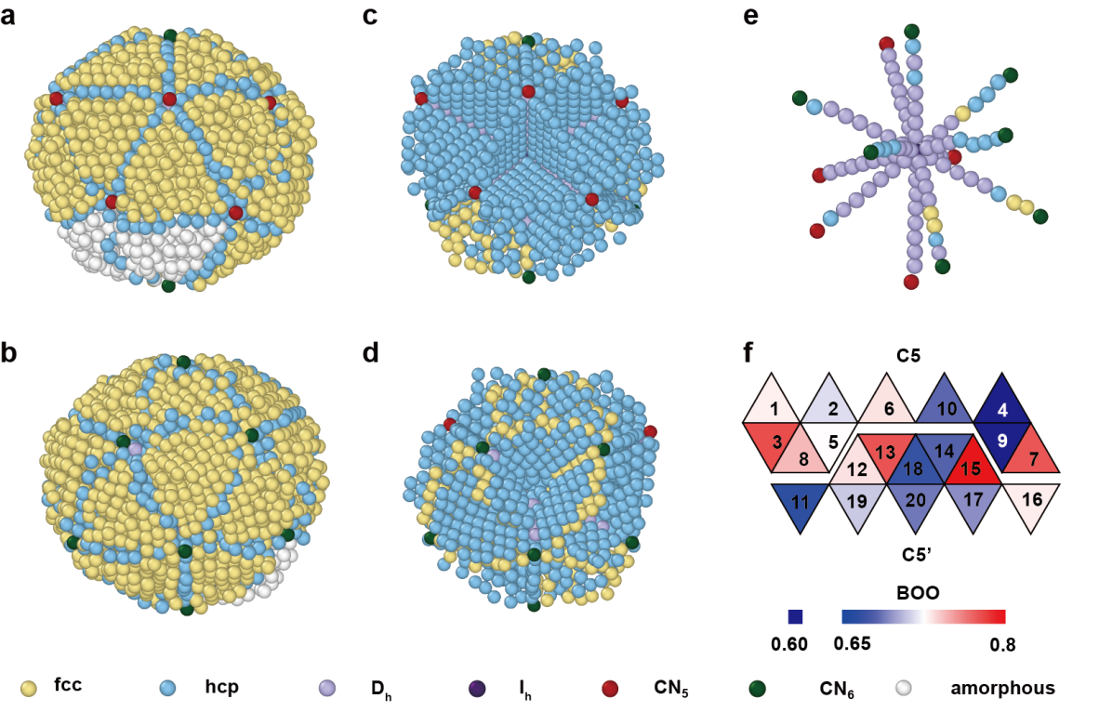
Supplementary Fig. 10 | 3D atomic structure, fivefold axes and BOO parameter of ICNP-2. (a, b) 3D atomic structure of ICNP-2 viewed from two distinct angles. Two tetrahedral domains at the interface between C5 and C5’ sides become amorphous. (c, d) The grain boundaries of ICNP-2 viewed from two distinct angles. (e) The twelve axes (five C5 and seven C5’ axes) in ICNP-2. (f) Unwrapped surfaces of twenty domains (each tetrahedral domain has been assigned a number) of ICNP-2 with averaged normalized BOO parameters separated from the C5 and C5’ side.

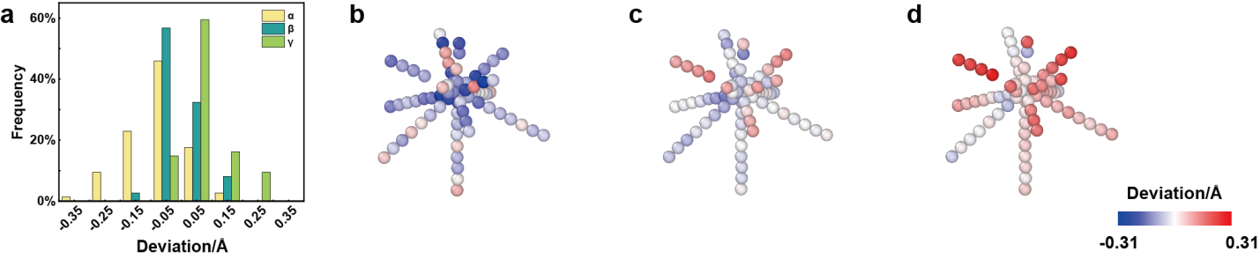
Supplementary Fig. 11 | The distribution of bond length of α, β, γ in ICNP-1. (a) The global distribution of deviations from the standard Au-Au bond length of α, β, γ in ICNP-1. (b-d) The deviations of bond length of α, β, γ, by subtracting the standard Au-Au bond length (2.88 Å), assigned to each D_{h} type atom in ICNP-1.

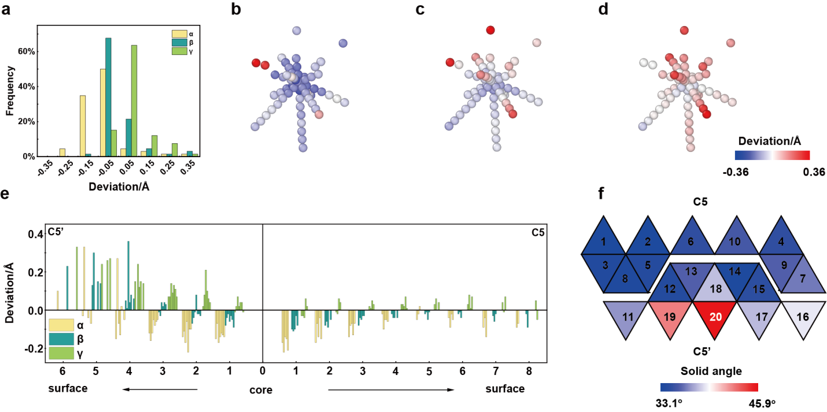

Supplementary Fig. 12 | The distinct structural characteristics distinguishing the C5 side and the C5’ side within ICNP-2. (a) The global distribution of deviations from standard Au-Au bond length of α, β, γ in ICNP-2. (b-d) The deviations of bond length of α, β, γ, by subtracting standard Au-Au bond length (2.88 Å), assigned to each D_{h} type atom in ICNP-2. (e) The deviations of bond length of α, β, and γ from the outer surface of C5’ axes to the outer surface of C5 axes in ICNP-2. (f) Unwrapped surfaces of twenty domains of ICNP-2 with of solid angles in both C5 and C5’ sides.

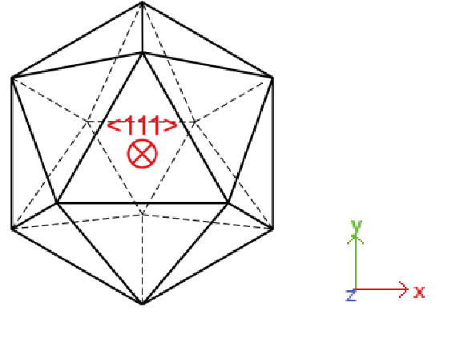
Supplementary Fig. 13 | Illustration of Z-direction in strain tensor calculation.

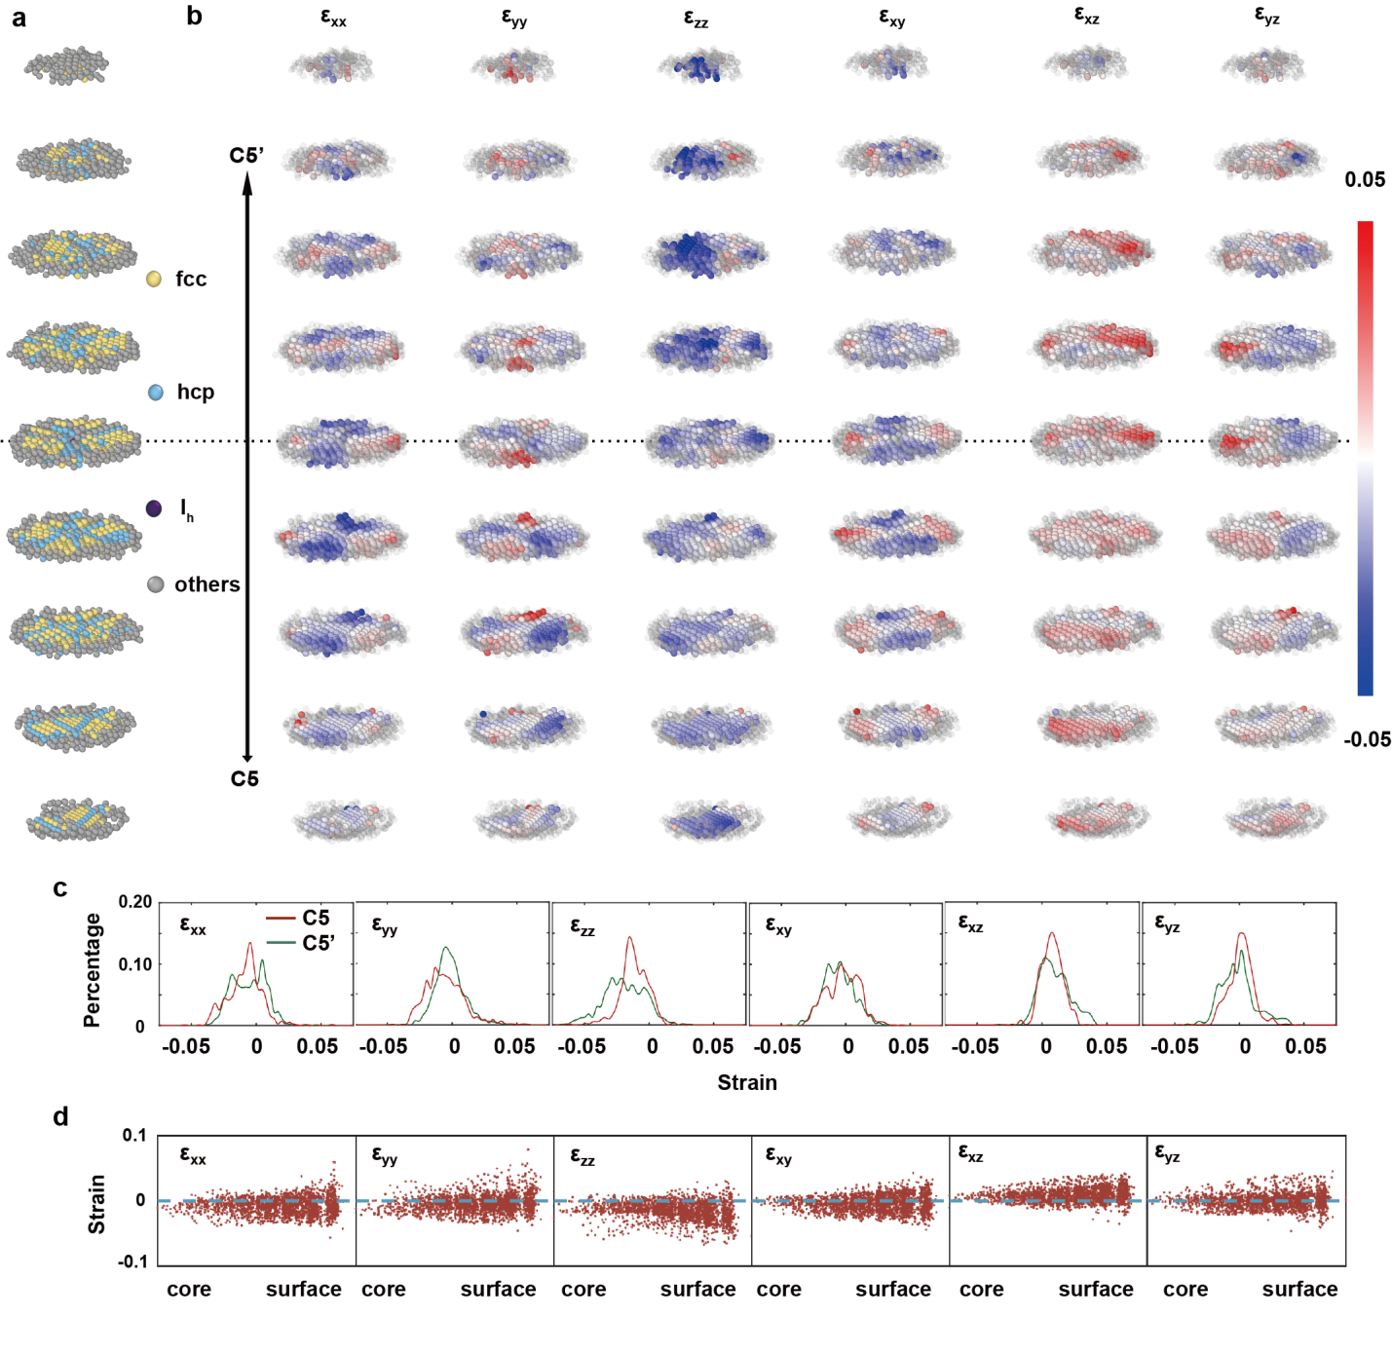
Supplementary Fig. 14 | The full strain tensor distributions of ICNP-2. (a) Atoms in ICNP-2 used to determine the 3D strain tensor, where the atoms in grey from the amorphous domains and the surfaces are excluded for strain measurement. The Z-axis is determined parallel to the perpendicular direction of the {111} planes shown in Supplementary Fig. 13. (b) Maps of the six components of the full strain tensor, with the same block-like distribution as crystal domains in (a). The grey atoms show where the strain tensor can not be determined due to the lack of reference lattice. (c) The histogram of six components of the full strain tensor on both C5 and C5’ sides. (d) Scatter plot of six components of the full strain tensor vs. distance from core to surface, with gradual increase and more scattered distribution.

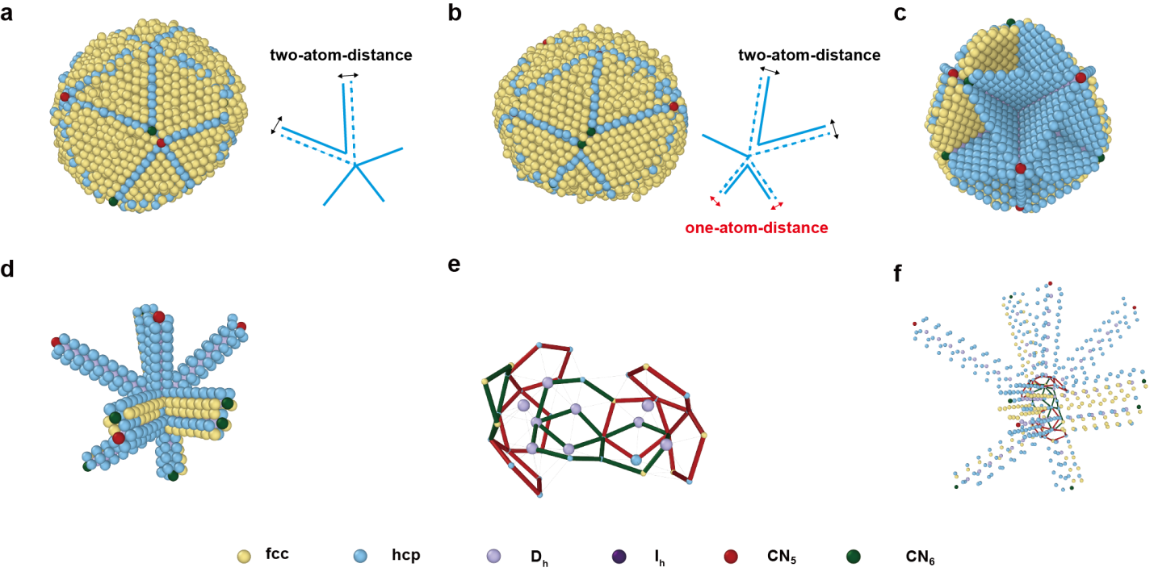
Supplementary Fig. 15 | 3D atomic structure of ICNP-3. (a, b) The morphology of twin axes with C5+C5’ (a) and C5’+C5’ (b). Insets depict the slipping distance of the hcp grain boundary. (c) The grain boundaries of ICNP-3 viewed from the icosahedra-like side. (d) The eight axes, including three fivefold (C5) axes, three pseudo fivefold (C5’) axes and two sets of twin axes. (e) The disordered boundary formed with fivefold and sixfold skeletons, marked as red and green respectively. (f) The combination of eight axes and disordered boundary, showing how the axes end in the a disordered boundary domain.

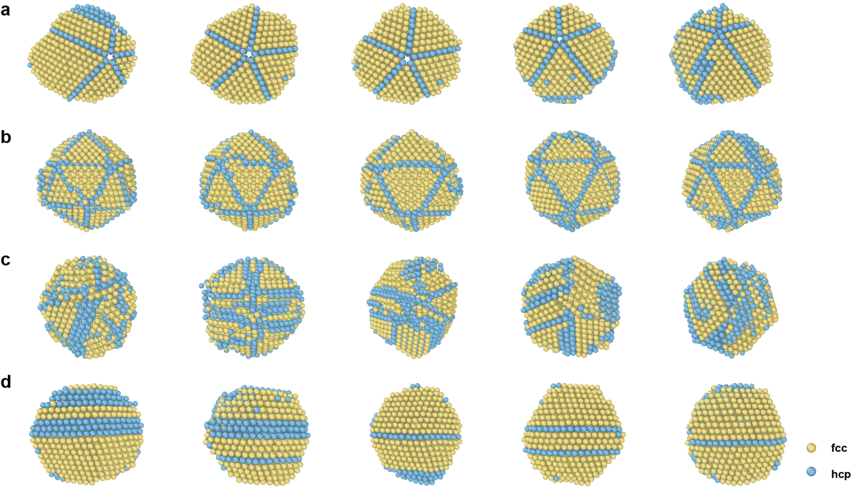

Supplementary Fig. 16 | The typical four types of annealed gold nanoparticles with different morphologies. (a) Decahedron (DH). (b) Icosahedron (IH). (c) Polycrystal (PC). (d) Crystals with stacking fault (SF). All the particles are displayed with fcc and hcp crystal structure, atoms with other types of structure are not showed.

