Supporting Information
Pd-skin tuned by rare earth rich sublayer for high performance methanol resistance oxygen reduction reaction
Felix Kwofie^{#a,b}, Jinfan Chen^{#c}, Ying Zhang^{d}, Yujing Liu^{e}, Yang Yang^{f}, Yang Li^{a,b}, Zhenjiang He^{a,b}, Yunjiao Li^{a,b}, Feixiang Wu^{a,b}, Yi Cheng^{a,b*}, Shuangyin Wang^{g}
ª Hunan Provincial Key Laboratory of Nonferrous Value-added Metallurgy, Central South University, Changsha, 410083, China.
^{b} Engineering Research Center of the Ministry of Education for Advanced Battery Materials, Central South University, Changsha, 410083, China.
^{c} Institute of Materials, China Academy of Engineering Physics, P.O. Box 9071, No. 9, Jiangyou, Sichuan 621907, China.
^{d} National Engineering Research Center of Green Recycling for Strategic Metal Resources, Institute of Process, Engineering, Chinese Academy of Sciences, Beijing 100190, China.
^{e} Institute of Metals, College of Material Science and Engineering, Changsha University of Science & Technology, 960, 2nd Section, Wanjiali RD (S), Changsha, Hunan 410004, China.
^{f} State Key Laboratory for Mechanical Behavior of Materials, Xi’an Jiaotong University, Xi’an 710049, China.
^{g} State Key Laboratory of Chem/Bio-Sensing and Chemometrics, Provincial Hunan Key Laboratory for Graphene Materials and Devices, College of Chemistry and Chemical Engineering, Hunan University, Changsha, 410082, China.

Methods
Materials
Palladium (II) acetylacetone (C₁₀H₁₄O₄Pd, Pd 34.9%, A.R.), sodium chloride (NaCl, 99.5%, A.R.), and RE metal nitrate, erbium (III) nitrate pentahydrate (ErN₃O₉.5H₂O, 99.9%, A.R.) were all obtained from Macklin Company. The commercial Pt/C catalysts were supplied by Johnson Matthey (60 wt% for Pt content, supplied as JM Pt/C), carbon black (Vulcan XC-72) by Cabot, magnesium (Mg, 99.9%, A.R.), and magnesium chloride (MgCl_{2,} 99.9%, A.R., anhydrous) were purchased from Aladdin Company. Methanol (CH₃OH) and isopropanol (C₃H₈O) were obtained from Sinopharm Chemical Reagent Co., Ltd. (Shanghai, China).10 wt.% Nafion by Sigma–Aldrich and polyvinyl propylamine (PEI, 99%) by Innochem Technology Co., Ltd. (Beijing, China). All the chemicals were used without further purification.
Pretreatment of the carbon material
Polyethyleneimine (PEI) was employed as a functionalizing agent. PEI has been classified as a popular amino-rich, highly hydrophilic cationic polyelectrolyte for fuel cell applications¹. The procedure for PEI functionalization of the carbon was carried out based on our previous studies; here, the Zeta potential of the PEI-C was 20 mV, whiles the loading of PEI wrapped onto the pristine carbon was 3 wt. %.¹ Besides, the weight loss of the functionalized carbon material began at ~250 ͦ C due to the decomposition of PEI, compared to 550 ͦ C for the pristine carbon. Briefly, the PEI functionalization of the carbon materials is as follows: 0.4 g pristine carbon black (Vulcan XC-72) was sonicated for 2 hours in 800 mL Milli-Q water containing 0.5 wt. % PEI; the dispersion was stirred overnight before filtration through a nylon membrane and washed multiple times to remove excess PEI. The as-received solid was then dried for 24 hours at 71 °C in a vacuum oven. The obtained product was denoted as PEI-C.

Synthesis of Carbon-Supported Pd–Er and Pd Electrocatalysts
The synthesis of the PdEr with 20% loading of Pd was conducted via the molten salt synthesis (MSS) route. Specifically, an anhydrous magnesium reduction method coupled with argon/hydrogen annealing was employed. Typically, 30 mg of the PEI-C was dispersed in DI water for 2hrs. Next, the dispersed sample was mixed with an approximate amount of an ethanol solution of erbium nitrate and Pd precursor, followed by stirring into a slurry form. Then after, the obtained slurry samples were freeze-dried for 48 hours. Then, an approximate amount of NaCl was added to the samples and ground to be homogeneous. Finally, the uniformly mixed samples were mixed with an appropriate amount of anhydrous MgCl₂ and Mg before annealing under an Ar/H environment.
Firstly, argon was injected to eliminate the air in the furnace, and then hydrogen was injected to run the program to raise the temperature to 700 ℃ at a heating rate of 5 ºC min⁻¹; the temperature was kept at 750 ºC for 1 hour for the products to cool naturally to ambient temperature and was finally removed from the furnace. Next, the products, including byproducts and excess reactants such as Na, Mg, and Cl⁻, were leached in acetic acid, ultrasonicated, and washed multiple times with Milli-Q water before being separated and dried overnight to obtain the final PdEr product. Finally, Pd on carbon was prepared following the same conditions except that rare earth was not added; Pd/C and Pt/C served as benchmark catalysts.
Physical Characterization
The X-ray diffraction (XRD) patterns of the prepared samples were recorded using an X-ray diffractometer (RIGAKU SMART LAB, Tokyo, Japan) with Cu Ka (λ=1.5406 Å) at 40 kV and 40 mA. In all measurements, the step size was 0.02°, with a scan rate of 5.0 ͦ C min⁻¹. The transmission electron microscopy (TEM) and transmission electron microscopy (TEM) analysis were done using TEM Tecnai G2 F20) equipped with an energy-dispersive X-ray spectrometer (EDS) detector. An FEI Titan G2, 60-300 microscope with an image spherical aberration (Cs) corrector running at 300 kV was used to conduct the HRTEM analysis. In order to acquire the HAADF photographs and elemental mapping data, we used the STEM mode on an FEI Titan Themis G1 equipped with twin aberration correctors and four EDS detectors, each with a 30 mm² active area for detecting EDS signals. X-ray photoelectron spectroscopy (XPS) measurements were performed on an XPS apparatus (ESCALAB 250Xi, Thermo-VG Scientific Ltd.) using Mg-Kα radiation.
Because the crystal structure of Pd metal is cubic, the lattice parameters of the catalysts were calculated using the equation below:
$2d sin θ=nλ →dhkl =\frac{λ}{2sinθ}$ (1)
For a specific kind of crystal, we will have.
$\frac{1}{dhkl²}=\frac{h²+k²+l²}{a²+b²+c²}$ (2)
But for the simple cubic structure, it is known that all three sides lattice is the same; hence we can arrive at this equation:
$\frac{1}{dhkl²}=\frac{h²+k²+l²}{a²+b²+c²}$ (3)
From the above equation, we can finally deduce the formula for simple cubic crystal structures as stated below:
$\frac{1}{dhkl}=\frac{a²}{\sqrt{h²+k²+l²}}$ → $a=dhkl\sqrt{h²+k²+l²}$ (4)
Where n is the diffraction order, for first order (n=1), λ is the wavelength of X-ray used (Kα1 of Cu target,1.5406 Å), d is the interplanar spacing in angstrom(Å), θ is the angle between incident X-ray and the corresponding crystal face, h, k, and l are the Miller indices. A is the lattice parameter of the Pd catalyst.
Furthermore, the crystallite sizes of the prepared sample were evaluated using Debye–Scherrer formula ²:
D=$\frac{Kλ}{βhklCOSθhkl}$ (5)
where D is the average diameter in nm, K is the Scherer's constant (0.89), λ is the wavelength of X-ray used (Kα1 of Cu target,1.5406 Å), β_{hkl} is the half-width of the diffraction maximum (FWHM) corresponding to diffraction peak (111) in radian, COS_{θhkl} is the Bragg diffraction angle (peak position) in radian.
Electrochemical characterization
ORR performance measurement
The catalyst slurry was prepared by ultrasonically dispersing 2 mg of the prepared catalysts in a solution containing 4 mL of ethanol + isopropanol + Nafion mixture for 30 mins. The yielded homogenous catalyst ink was used to prepare the working electrode. Then, 11 μ L of the ink was precisely dropped on the glassy carbon electrode surface with a pipet for the electrochemical tests, making the loading of Pd or Pt is 5.6 μg cm⁻². Electrochemical tests were acquired in a standard three-electrode configuration with Gamry Workstation at room temperature (20 ℃). The reference and counter electrodes were an Ag/AgCl (3 M KCl) electrode and graphite rod. The working electrode was glassy carbon RDE with a geometric area of 0.196 cm². All measured potentials were converted to reversible hydrogen electrode (RHE) using the following equation³:
E_{RHE} = E_{Ag/AgCl}+0.059 V× pH.
The cyclic voltammetry (CV) experiments were obtained in N₂₋ saturated 0.1M HClO₄ from 0.08 to 1.1 V vs. RHE at a scan rate of 50 mV s⁻¹. The ORR measurements were done using linear scan voltammetry curves in were obtained in O₂-saturated 0.1 M HClO₄ solutions with rotation rates ranging from 400 to 2000 rpm and a sweep rate of 10 mV s⁻¹. Tafel plots were acquired at a scan rate of 1 mV s⁻¹ to achieve a steady state. For each catalyst, the kinetic current was normalized to only Pd (or Pt) loading to generate mass and specific activities at 0.90 V versus RHE.
The ECSA calculation method
From charges associated with underpotentially deposited H (H_{upd}) and Cu (Cu_{upd}) and the Pd oxide reduction, the ECSAs of studied samples were calculated. The Coulombic charge for hydrogen desorption (Q.H.) was used to quantify the ECSA of the Pt/C catalyst on the electrodes, supposing a charge transfer rate of 210 µC cm⁻² on the Pt surface using the equation:
$aECSA=\frac{Q_{H}}{{CD}_{HUPD}}$ (6)
$ECSA=\frac{aECSA}{M_{pt} }$ (7)
where Q_{.H.} denotes the charge exchanged during hydrogen adsorption on a catalyst's surface (µC), CD_{HUPD}: is the charge density of underpotentially deposited H (HUPD), ~210 µC cm⁻² for Pt, M_{Pt}: is the absolute Pt loading (µg_{Pt}), and ECSA:m² g_{Pt}⁻¹ ⁴.
Meanwhile, the ESCA of Pd-based catalysts was estimated by integrating the charge density (420 µC cm⁻²) associated with surface Pd oxide reduction as determined by CV curves in N₂-saturated 0.1M HClO₄, according to the equation:
ECSA=$\frac{Q}{0.420 ×Wpd}$ (8)
where Q denotes the coulombic charge acquired by integrating the Pd-O reduction region, and W_{Pd} signifies the weight of Pd loaded on the electrode surface ⁵.
Regarding the Cu stripping test, N₂-saturated solutions of 5 mM CuSO₄ and 0.1 M HClO₄ were utilized as electrolytes. In order to attain a Cu_{upd} monolayer⁶, the voltage was initially kept at 0.3 V vs. RHE for 100 s. Afterward, CVs were recorded from 0.3 V to 1.0 V at 20 mV s¹. Background CVs were measured in N₂-saturated 0.1M HClO₄ at 20 mV s⁻¹ and subtracted from the ECSAs to arrive at the result, cconsidering a charge density of 470 C cm⁻².
Accelerated durability tests, Methanol resistance tests, and EIS measurements
To ascertain the stability of the catalysts, an accelerated durability tests (ADT) were conducted with potential sweep cycles ranging from 0.6 to 1.1 V vs. RHE for 5000 at scanning speed of 100 mV s⁻¹ in Ar-saturated 0.1 M HClO₃ electrolyte. The methanol resistance tests of the prepared catalysts were studied in O₂-saturated 0.1 M HClO₄ electrolytes with different methanol concentrations. In addition, electrochemical impedance spectroscopy (EIS) data were recorded at a cell voltage of 0.4 V in the 100 kHz to 0.01 Hz frequency range using Gamry Workstation. For comparison, the commercial Pt/C and Pd/C were used as the baseline catalysts, and the same procedures described above were applied to the electrochemical measurements.
Koutecky-Levich equation
The electron transfer number per oxygen molecule is calculated using the Koutecky–Levich equation as follow:⁷
$\frac{1}{J}=\frac{1}{JK}$+$\frac{1}{JL}$ =$\frac{1}{JK}$+$\frac{1}{Bω1/2}$ (9)
where J means the measured current density, J_{.L.,} and J_{.K.} denote the limiting and kinetic current density, respectively, (rmp) represents the electrode rotational velocity, and B signifies Levich slope as follows:
$B=0.2nF$A$D^{2/3}ω^{1/2}ν^{-1/6}$C (10)
where constant 0.2 is applied when the velocity of rotation is in rpm, F is the Faraday constant (96 485 C mol⁻¹), A is the electrode area (cm²), D is the diffusion coefficient, ω is the angular rotation rate of the electrode (rad/s) and v is the kinetic viscosity of the electrolyte (1.01× 10⁻² cm² s⁻¹)⁸.
MEA fabrication and DMFCs test
The membrane-electrode assemblies (MEAs) with an active area of 4 cm²
were fabricated by sandwiching the Nafion 115 membranes between two pieces of gas diffusion
electrodes with PtRu/C (1 mg_{Pt} cm⁻²) anode and PdEr (1 mg_{Pd} cm⁻²) cathode. For comparison, a MEA were prepared using PtRu/C (1 mg_{Pt} cm⁻²) anode and Pt/C (1 mg_{Pt} cm⁻²) cathode. The catalysts inks were prepared by mixing with water, isopropanol, and a 5 wt% Nafion solution with the addition of 15% PTFE. All catalyst inks were applied directly to a microporous gas diffusion layer through ultrasonic spray. Hot-pressing was done for 100 s at 120 °C and 1 M Pa. The DMFC were tested using a Fuel Cell Test System (850e Multi-range, Scribner Associate Co.) at 80 °C with humidified O₂ flowing at a rate of 0.1 L min⁻¹ and anode fuel being passed at 1.0 mL min⁻¹.
DFT model calculations
Density functional theory (DFT) calculations were performed with the Pwscf module implemented in the Quantum Espresso package (Version 6.0.0) based on plane-wave coupled with pseudopotentials⁹. A four-layer Pd (111) metal surface with 16 Å vacuum space along perpendicular to the surface was constructed to model the reactive slab. Ultrasoft pseudopotentials were selected for DFT calculations to treat the interactions between core electrons and nuclei. Kinetic energy cutoff for wavefunctions and charge density were set as 50 and 400 Ry, respectively, as suggested by the pseudopotential input files, and a grid mesh of 4x4x1 was chosen for k-point sampling in reciprocal spaces. Electron exchange-correlated was treated at a generalized gradient approximation (GGA) level with Perdew-Becke-Erzenhof (PBE) functional¹⁰, and Geometry optimization was assumed to converge when atomic forces were less than 0.03 eV/Å. The four-electron ORR pathways in acidic media were considered¹¹, and the electrochemical model developed by Nørskov et al.^{12, 13} was adopted to treat the chemical potentials of proton and electron.
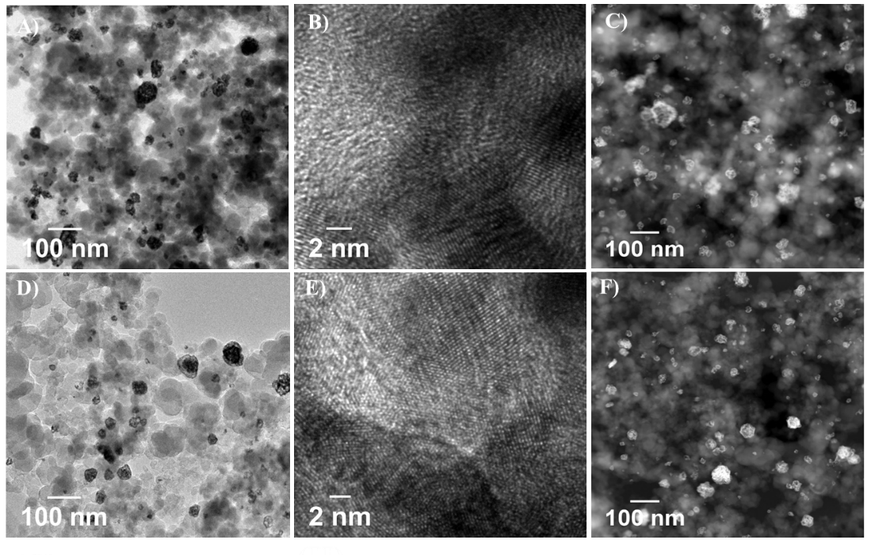
Fig. S1 | Characterization of the A-C) PdEr and B-F) Pd/C catalyst.

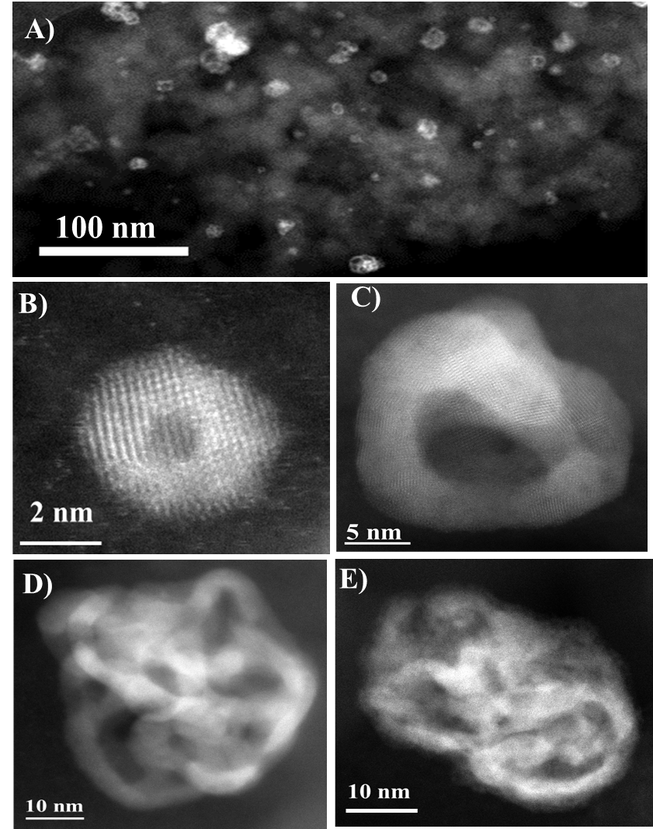
Fig. S2 | AC-STEM characterization of the prepared PdEr alloy. A) STEM images; B-E) AC-STEM images of the PdEr alloy.

Fig. S3 | STEM-EDS mapping of PdEr nanoparticle before acid wash.

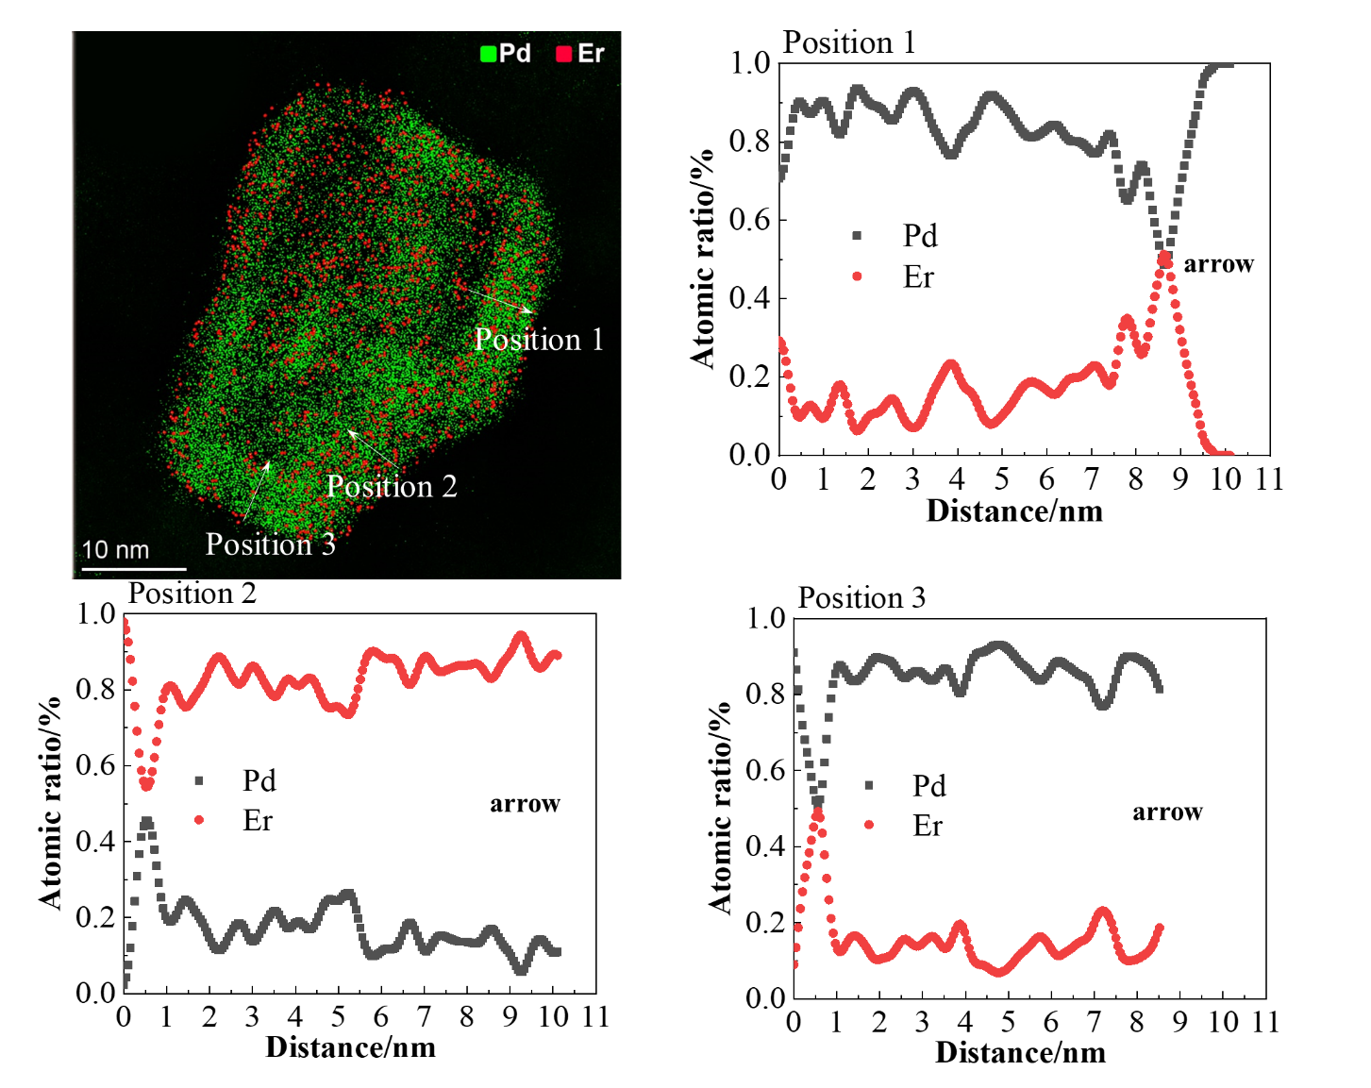
Fig. S4 | STEM-EDS mapping profiles of NPs deposited on carbon by capturing the Pd-L (~ keV) and Er-L (~ keV) lines, and corresponding linear scan analysis at position 1, 2, 3.

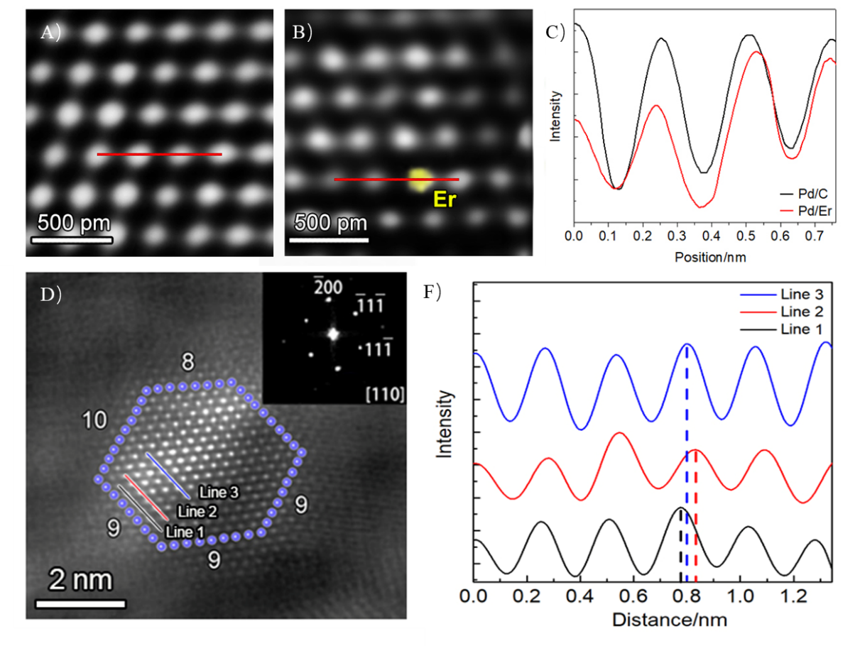
Fig. S5 | AC-STEM characterization of A) Pd/C and B) PdEr at atomic scale and C) its corresponding lattice structures in the inner layer of Pd and PdEr; D) the atomic structure shows a crystal unit of PdEr and F) the corresponding lattice structure shows the outer layer, sublayer and the inner layer lattice structures.

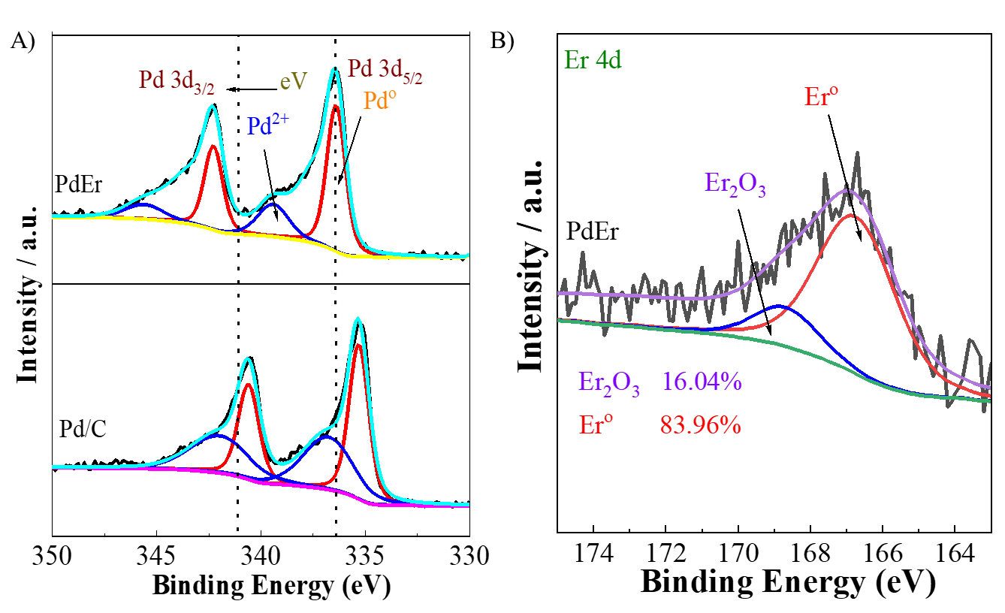
Fig.S6 | XPS spectra of PdEr alloy. A) Pd 3d and B) Er 4d.

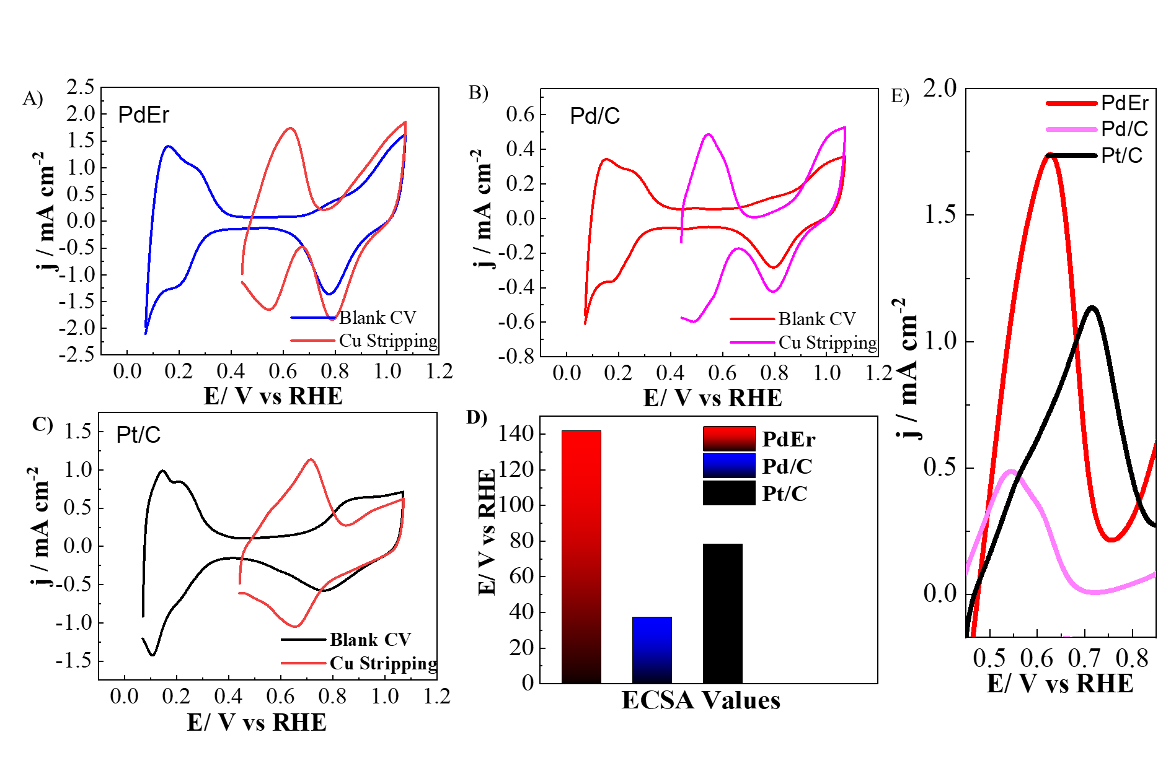
Fig. S7 | CV voltammetry of prepared samples. Cu stripping voltammograms on A) PdEr, B) Pd/C, C) Pt/C in 0.1 M HClO₄ + 5 mM CuSO₄ saturated with argon measured at 20mV s⁻¹ alongside their corresponding background CVs obtained at the same scan rate without CuSO₄, and D) the bar charts of the ECSA values, E) the enlarged CV curves of Cu stripping voltammograms shows the comparison of PdEr, Pd/C and Pt/C.

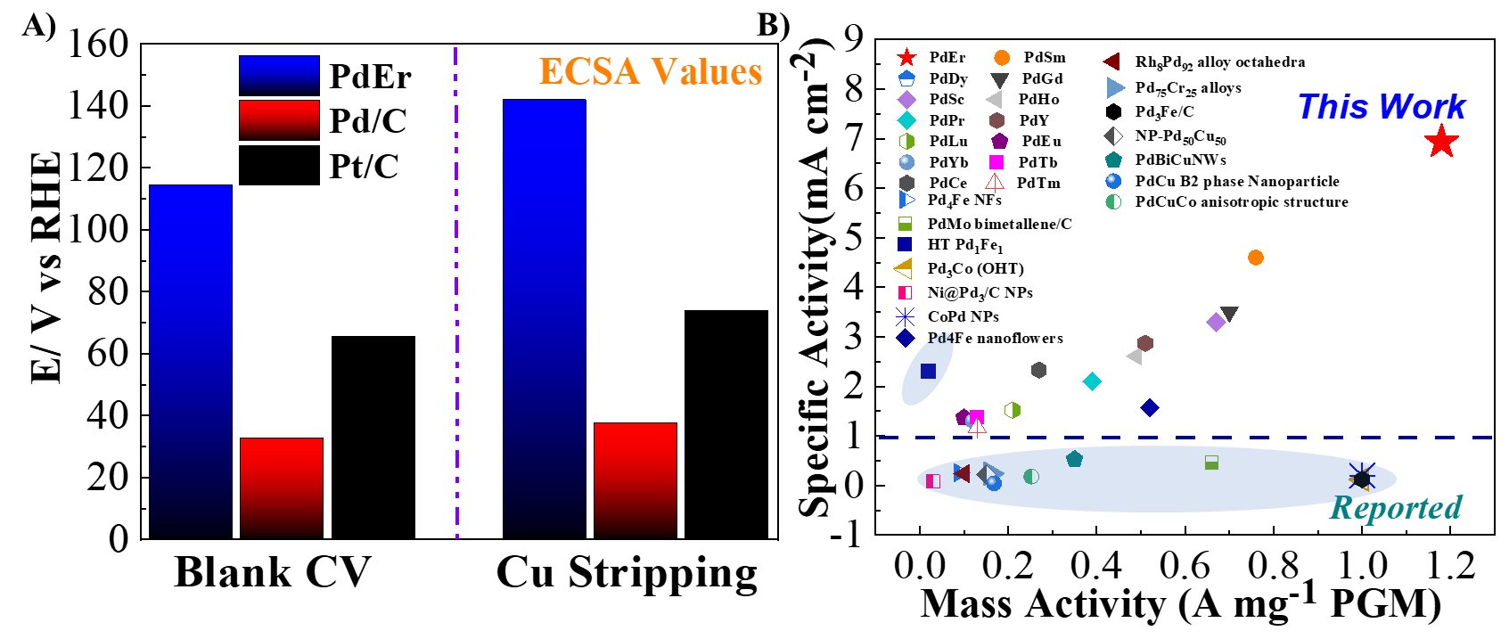
Fig. S8 | A) Comparison of ECSA values of PdEr, Pd/C, and Pt/C catalysts using Cu stripping and HUPD/ Pd oxide reduction methods in an acid electrolyte. B) ORR performance of all as-prepared catalysts compared with recently reported Pd-based ORR catalysts in acidic media.

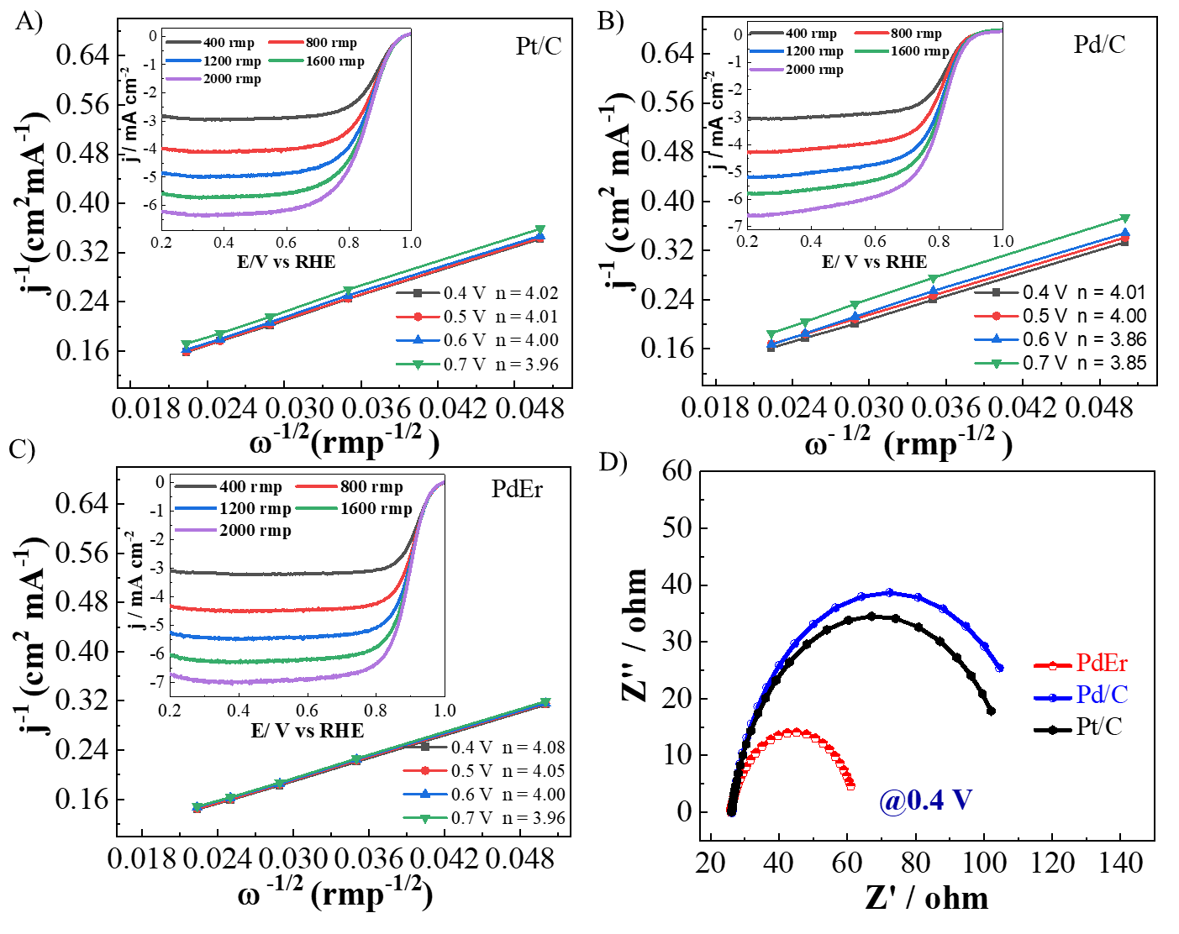
Fig. S9 | Koutecky–Levich plots of the studied catalysts at potentials 0.4 V, 0.5 V, 0.6 V, and 0.7 V. A) Pt/C, B) Pd/C, and C) PdEr. Insert: show their corresponding ORR LSV curves at varied rotation rates registered in O₂ saturated 0.1 M HClO₄ solution at a scan rate of 10 mV s⁻¹. D) EIS of Pt/C, Pd/C, and PdEr in O₂ saturated 0.1M HClO₄ at 0.4 V.
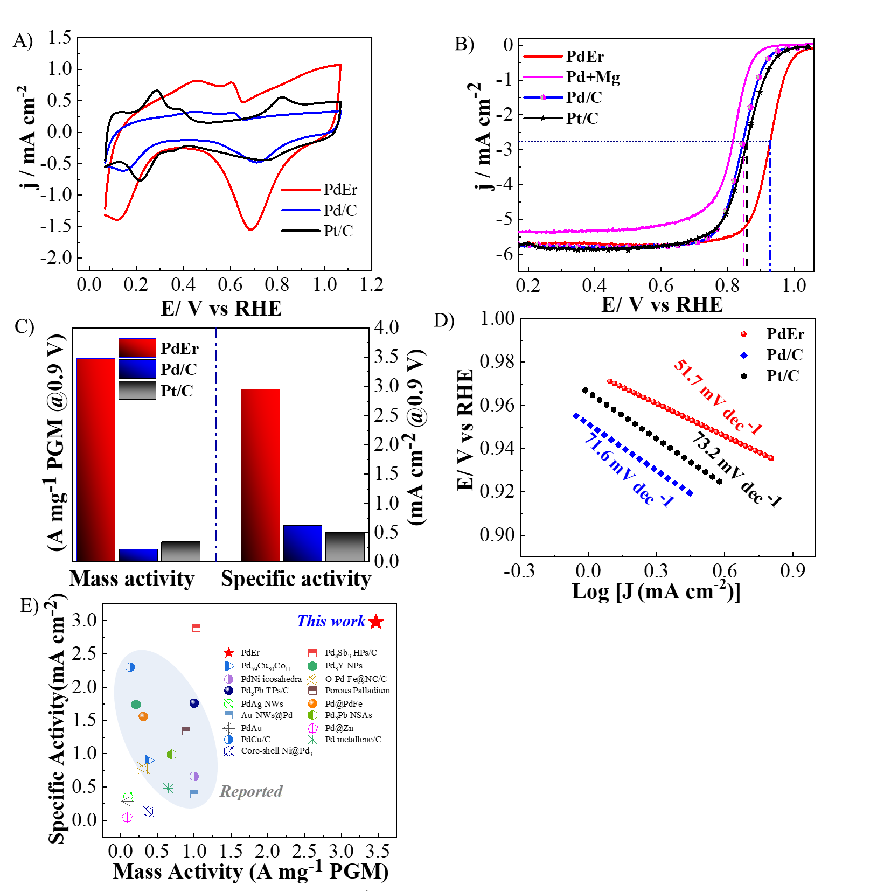
Fig.S10 | ORR performance of studied catalysts in alkaline conditions. A) CV curves in N₂- saturated 0.1M KOH with a rotating speed of 1600 rpm, from 0.08 V to 1.1 V vs RHE at a scan rate of 50 mV s⁻¹; B) ORR polarization curves (IR-corrected) in 0.1 M KOH solutions with rotation rates of 1600 rpm and a sweep rate of 10 mV s⁻¹; C) The mass and specific activities in 0.1M KOH at 0.9 V versus RHE; D) Tafel plots recorded in O₂-saturated 0.1M KOH; E) The ORR performance of PdEr catalyst compared with recently reported Pd-based ORR catalysts in alkaline conditions.

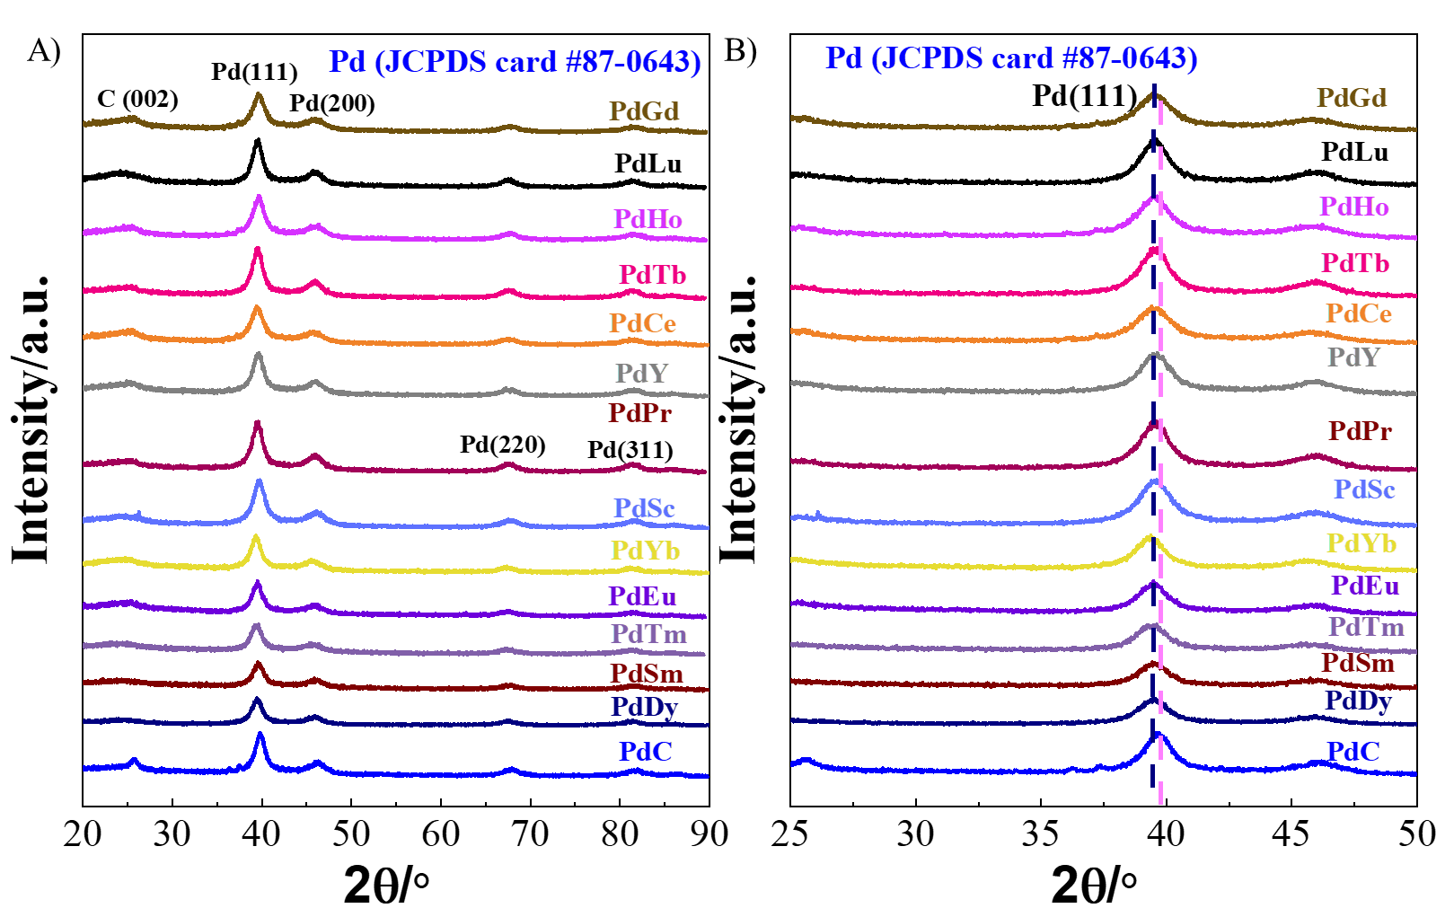
Fig.S11 | A). The XRD patterns obtained for the Pd-RE catalysts; B) Corresponding enlarged region of the XRD patterns.
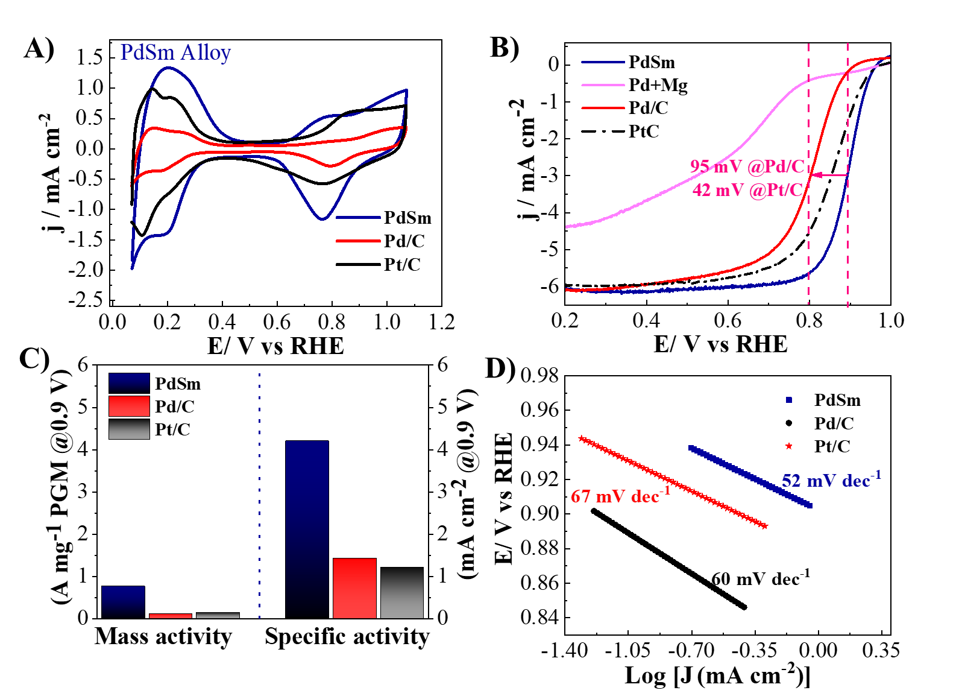
Fig. S12 | Electrochemical performance of PdSm catalysts in acidic conditions. A) Cyclic voltammetry (CV) curves in N₂- saturated 0.1M HClO₄ with a rotating speed of 1600 rpm, from 0.08 V to 1.1 V vs RHE at a scan rate of 50 mV s⁻¹; B) ORR polarization curves (LSV; IR-corrected) in 0.1 M HClO₄ solutions with rotation rates of 1600 rpm and a sweep rate of 10 mV s⁻¹; C) The mass and specific activities in 0.1 M HClO₄ at 0.9 V versus RHE; D) Tafel plots recorded in O₂ saturated 0.1M HClO₄.

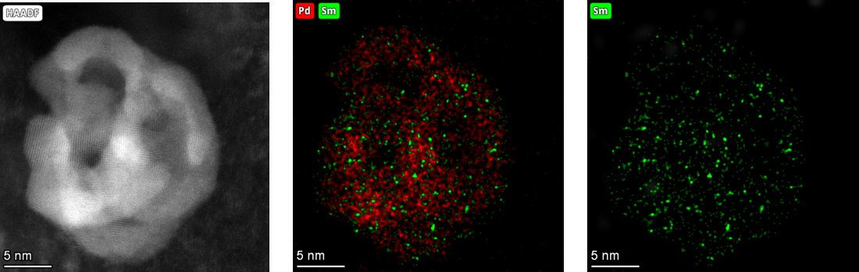
Fig. S13| AC-STEM-EDS mapping image of PdSm-nanoparticle.

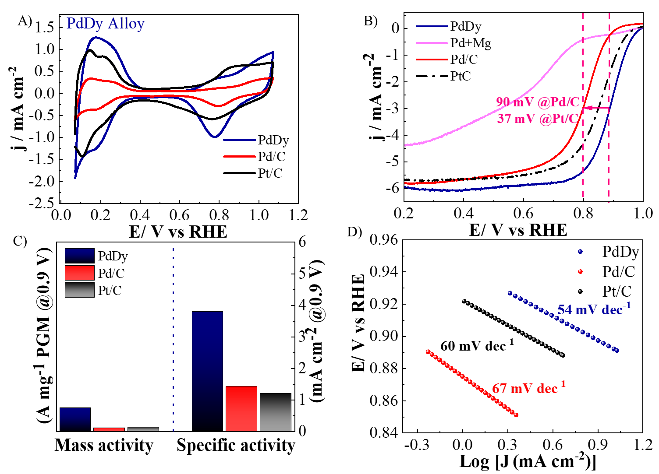
Fig. S14 | Electrochemical performance of PdDy catalysts in acidic conditions. A) Cyclic voltammetry (CV) curves in N₂- saturated 0.1M HClO₄ at a scan rate of 50 mV s⁻¹; B) ORR polarization curves (IR-corrected) in O₂-saturated 0.1 M HClO₄ solutions with rotation rates of 1600 rpm and a sweep rate of 10 mV s⁻¹; C) The mass and specific activities at 0.9 V vs RHE; D) Tafel plots recorded in O₂-saturated 0.1M HClO₄.
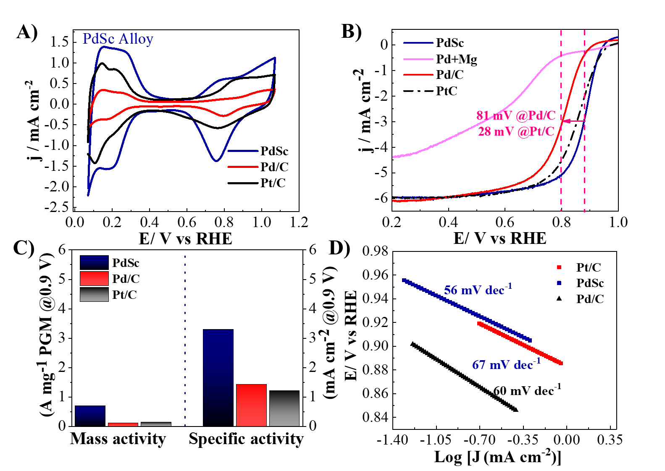
Fig. S15 | Electrochemical performance of PdSc catalysts in acidic conditions. A) Cyclic voltammetry (CV) curves in N₂-saturated 0.1M HClO₄ at a scan rate of 50 mV s⁻¹. B) ORR polarization curves (IR-corrected) in O₂-saturated 0.1 M HClO₄ solutions with rotation rates of 1600 rpm and a sweep rate of 10 mV s⁻¹. C) The mass and specific activities at 0.9 V versus RHE. D) Tafel plots recorded in O₂-saturated 0.1M HClO₄.
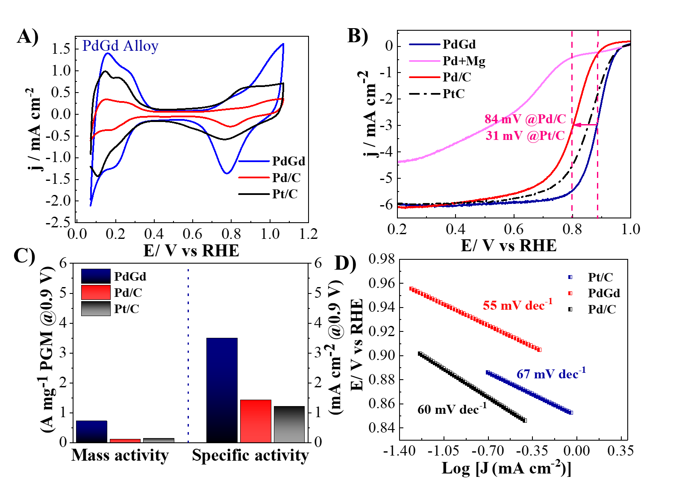
Fig. S16 | Electrochemical performance of PdGd catalysts in acidic conditions. A) Cyclic voltammetry (CV) curves in N₂- saturated 0.1M HClO₄ at a scan rate of 50 mV s⁻¹; B) ORR polarization curves (IR-corrected) in 0.1 M HClO₄ solutions with rotation rates of 1600 rpm and a sweep rate of 10 mV s⁻¹; C) The mass and specific activities in 0.1M HClO₄ at 0.9 V versus RHE; D) Tafel plots recorded in O₂-saturated 0.1M HClO₄.
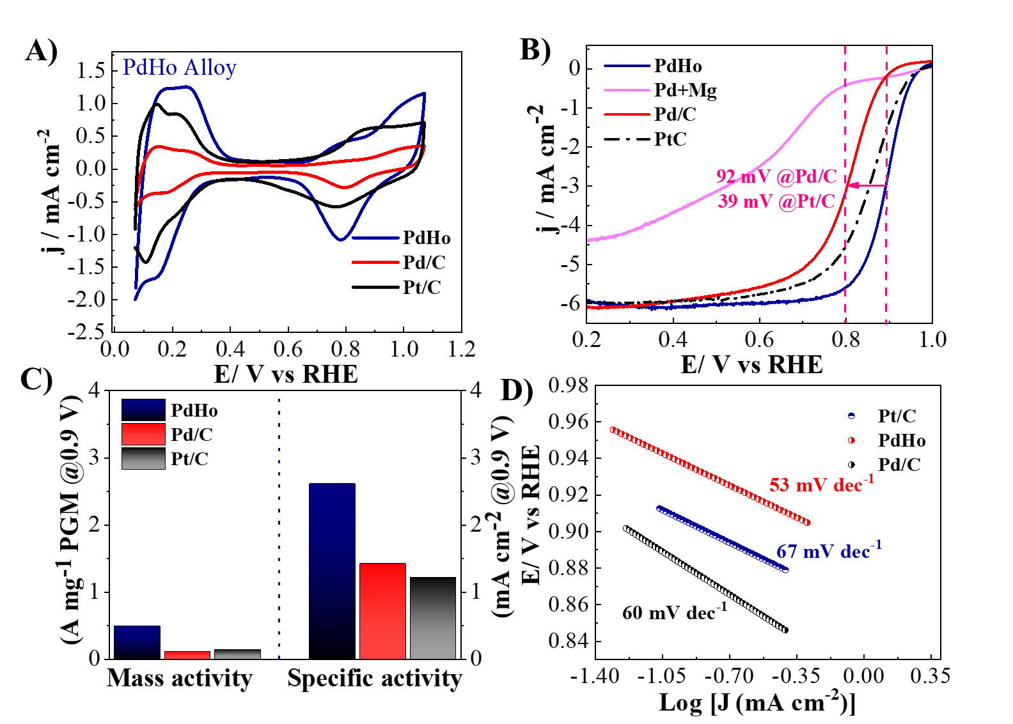
Fig. S17 | Electrochemical performance of PdHo catalysts in acidic conditions. A) Cyclic voltammetry (CV) curves in N₂-saturated 0.1M HClO₄ at a scan rate of 50 mV s⁻¹; B) ORR polarization curves (IR-corrected) in O₂-saturated 0.1 M HClO₄ solutions with rotation rates of 1600 rpm and a sweep rate of 10 mV s⁻¹; C) The mass and specific activities in 0.1M HClO₄ at 0.9 V versus RHE; D) Tafel plots recorded in O₂-saturated 0.1M HClO₄.
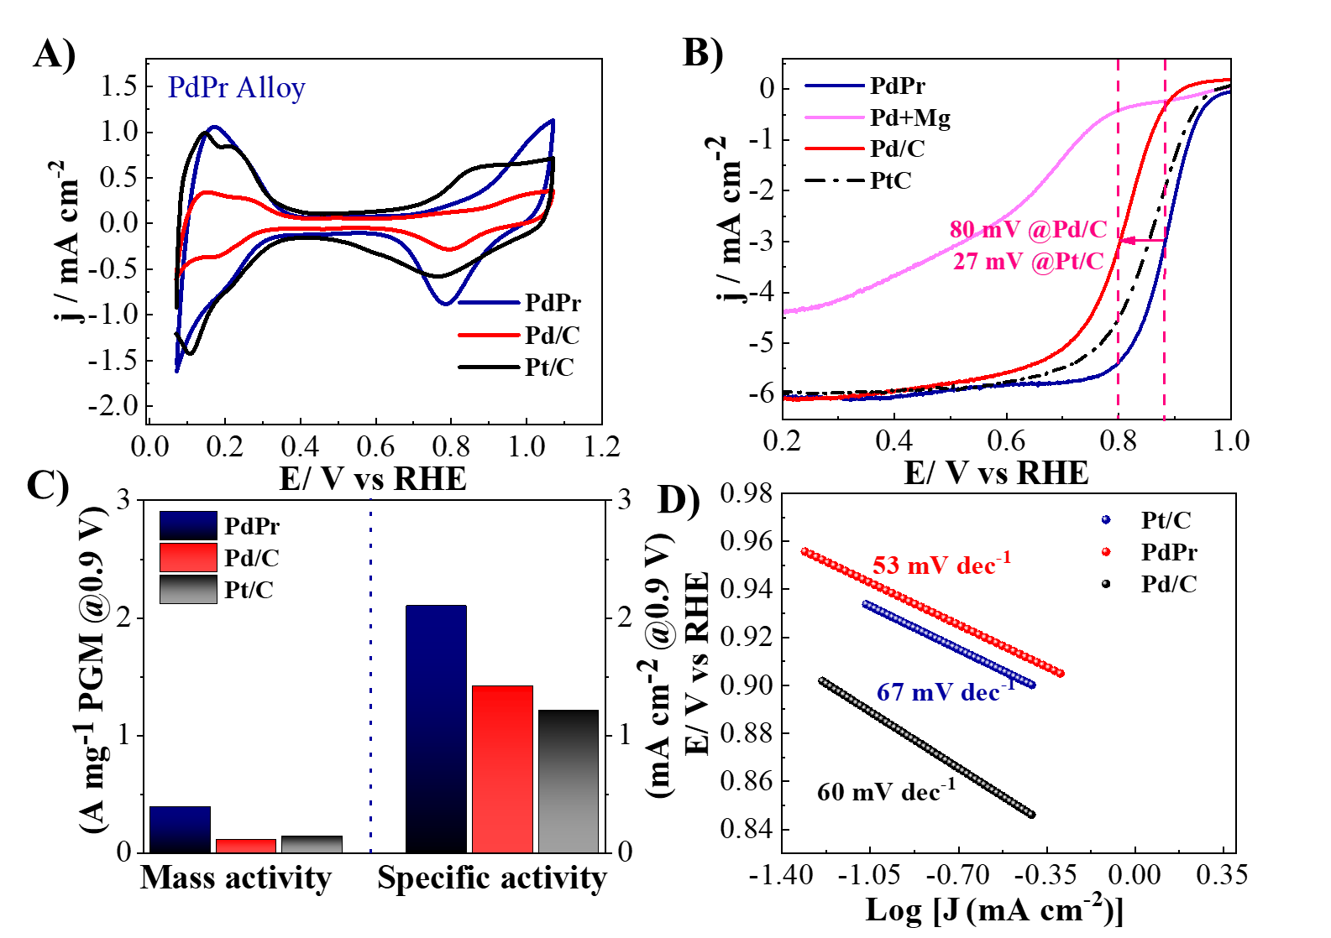
Fig. S18 | Electrochemical performance of PdPr catalysts in acidic conditions. A) Cyclic voltammetry (CV) curves in N₂-saturated 0.1M HClO₄ at a scan rate of 50 mV s⁻¹; B) ORR polarization curves (IR-corrected) in 0.1 M HClO₄ solutions with rotation rates of 1600 rpm and a sweep rate of 10 mV s⁻¹; C) The mass and specific activities in 0.1M HClO₄ at 0.9 V versus RHE; D) Tafel plots recorded in O₂ saturated 0.1M HClO₄.
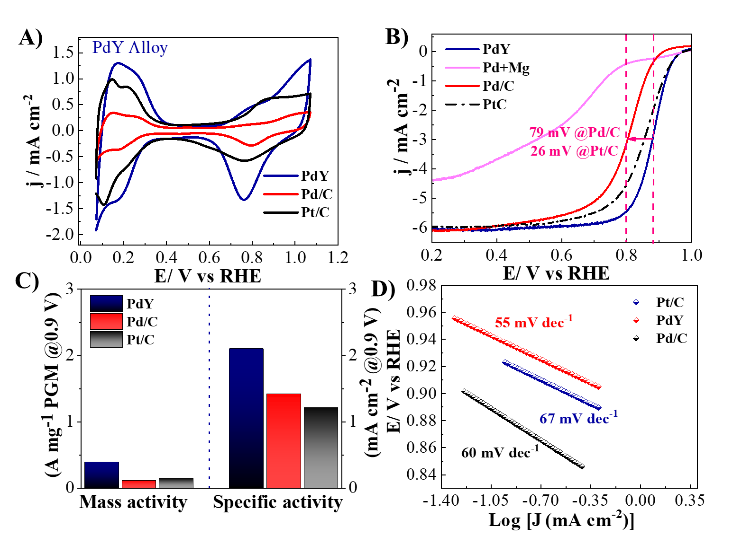
Fig. S19 | Electrochemical performance of PdY catalysts in acidic conditions. A) Cyclic voltammetry (CV) curves in N₂- saturated 0.1M HClO₄ at a scan rate of 50 mV s⁻¹; B) ORR polarization curves (IR-corrected) in 0.1 M HClO₄ solutions with rotation rates of 1600 rpm and a sweep rate of 10 mV s⁻¹; C) The mass and specific activities at 0.9 V versus RHE; D) Tafel plots recorded in O₂-saturated 0.1M HClO₄.
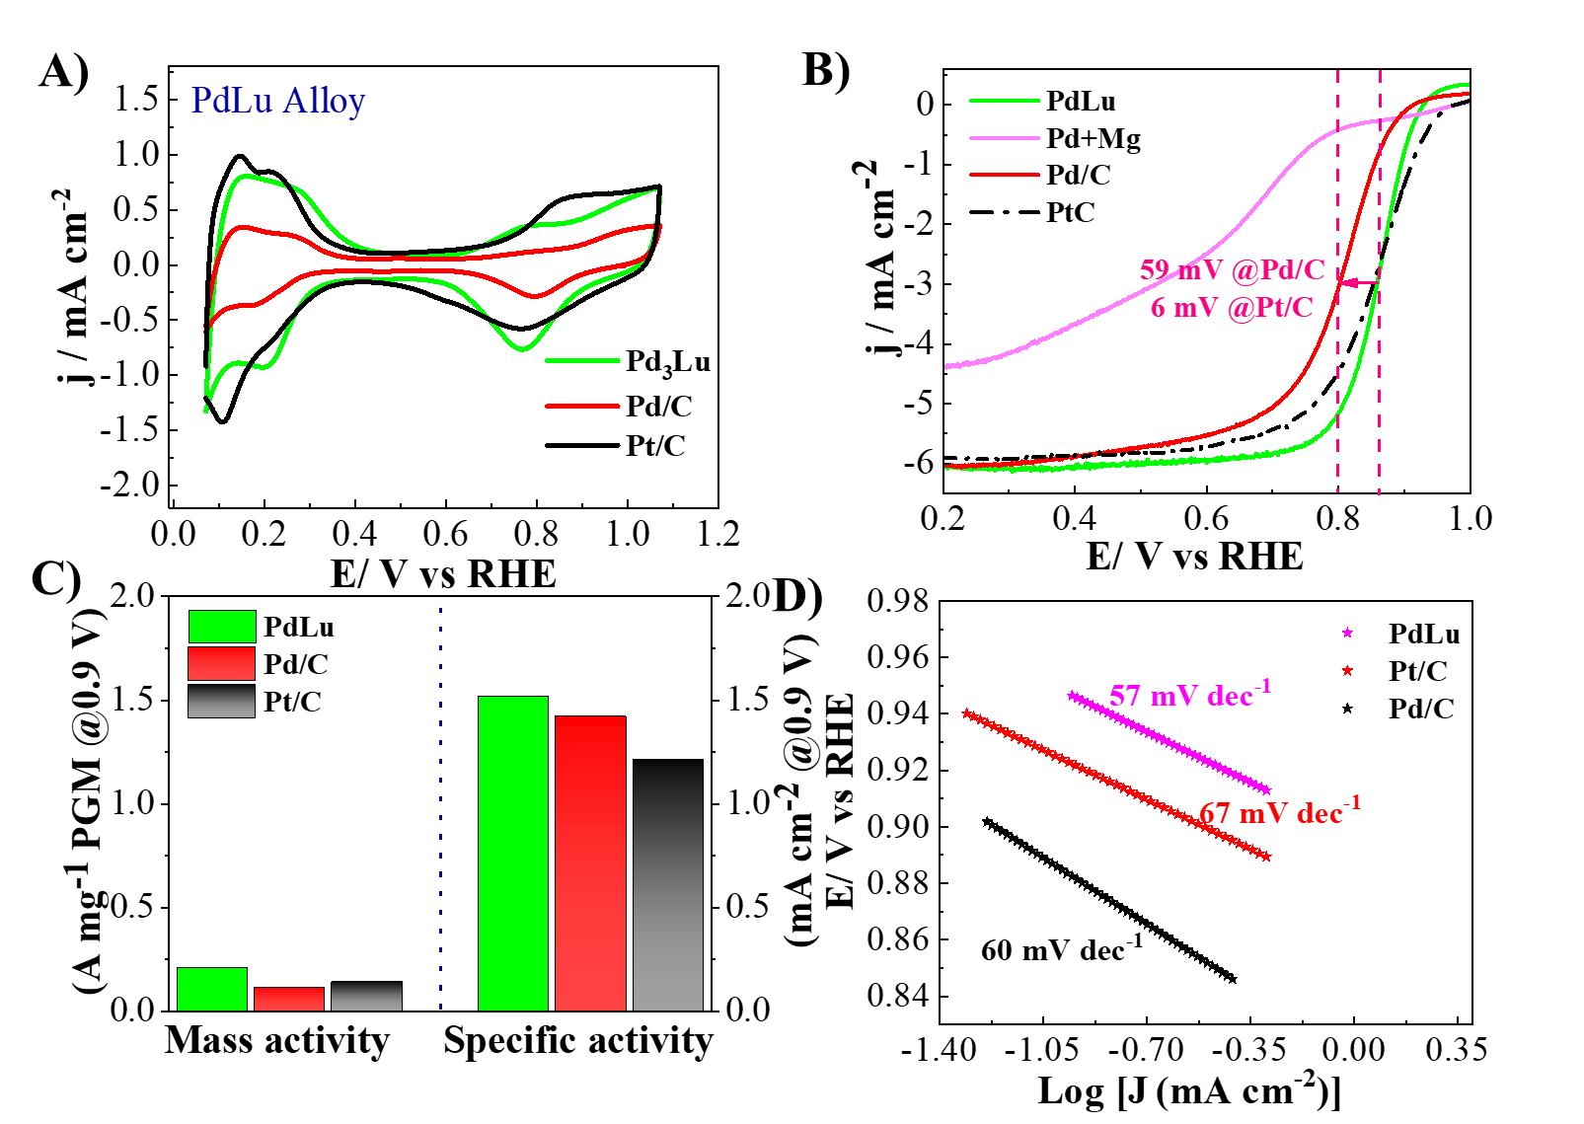
Fig. S20 | Electrochemical performance of PdLu catalysts in acidic conditions. A) Cyclic voltammetry (CV) curves in N₂- saturated 0.1M HClO₄ at a scan rate of 50 mV s⁻¹; B) ORR polarization curves (IR-corrected) in 0.1 M HClO₄ solutions with rotation rates of 1600 rpm and a sweep rate of 10 mV s⁻¹; C) The mass and specific activities at 0.9 V versus RHE. (D) Tafel plots recorded in O₂-saturated 0.1M HClO₄.
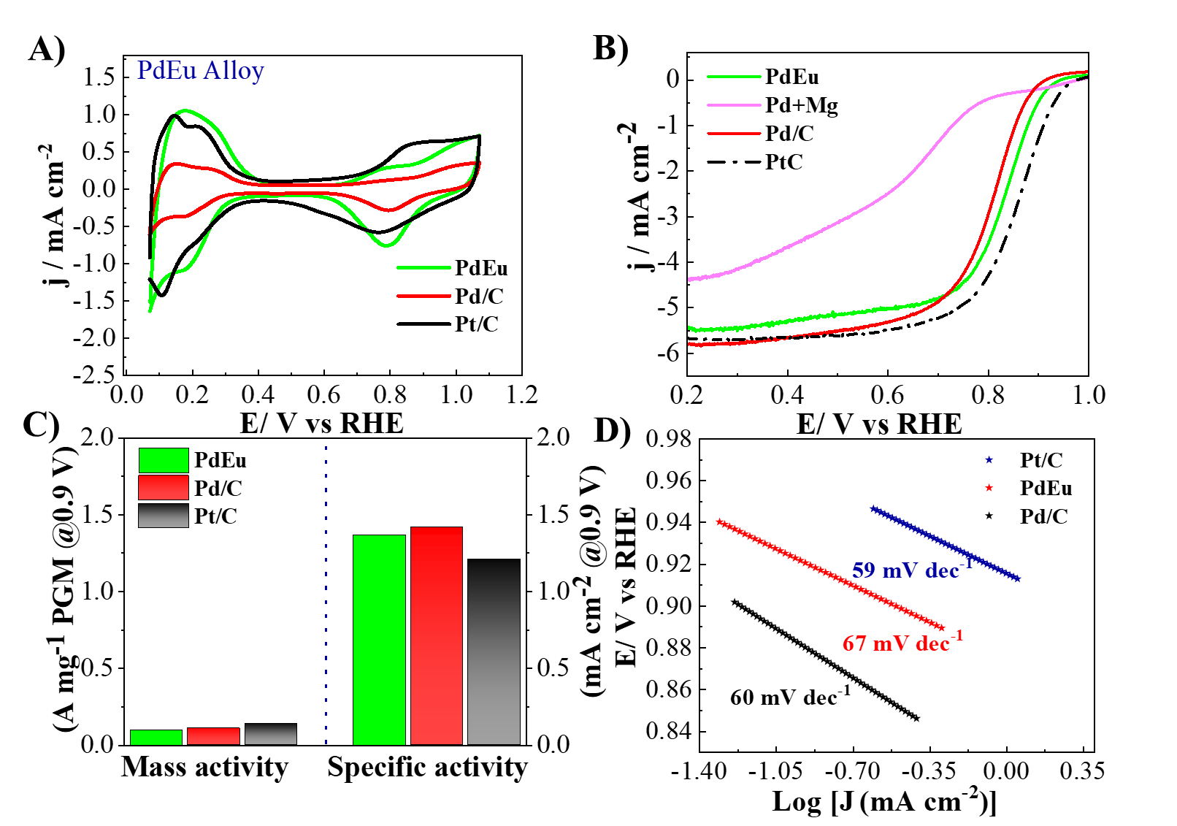
Fig. S21 | Electrochemical performance of PdEu catalysts in acidic conditions. A) Cyclic voltammetry (CV) curves in N₂- saturated 0.1M HClO₄ at a scan rate of 50 mV s⁻¹; B) ORR polarization curves (IR-corrected) in 0.1 M HClO₄ solutions with rotation rates of 1600 rpm and a sweep rate of 10 mV s⁻¹; C) The mass and specific activities at 0.9 V versus RHE; D) Tafel plots recorded in O₂-saturated 0.1M HClO₄.
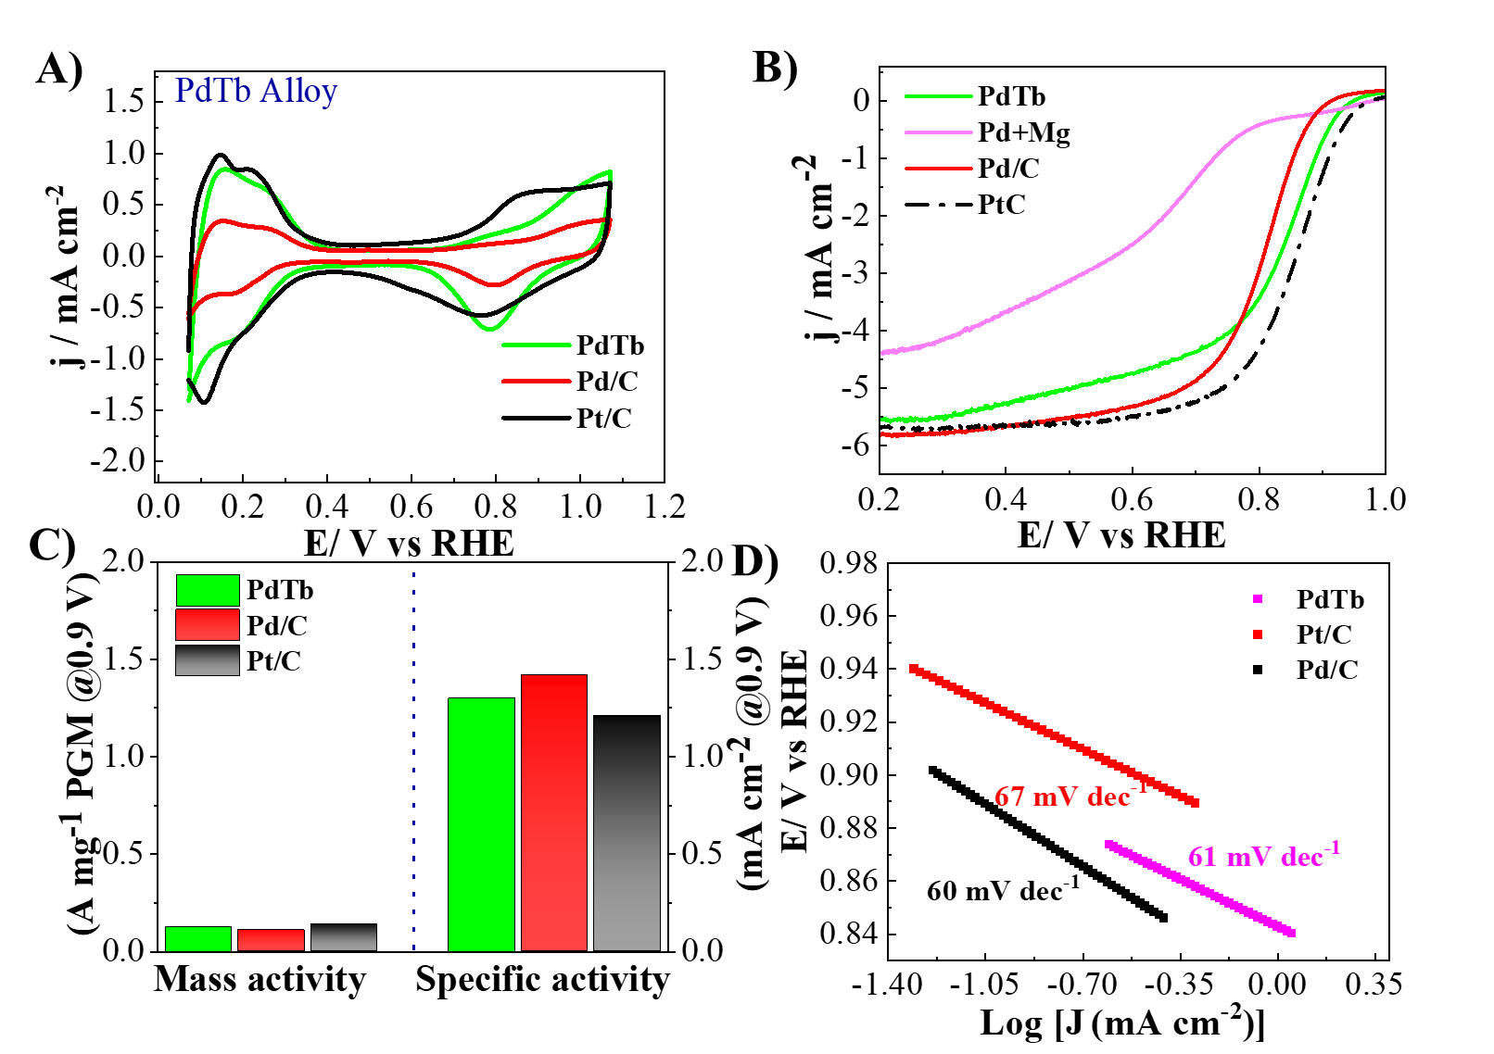
Fig. S22 | Electrochemical performance of PdYb catalysts in acidic conditions. A) Cyclic voltammetry (CV) curves in N₂-saturated 0.1M HClO₄ at a scan rate of 50 mV s⁻¹; B) ORR polarization curves (IR-corrected) in O₂-0.1 M HClO₄ solutions with rotation rates of 1600 rpm and a sweep rate of 10 mV s⁻¹; C) The mass and specific activities in 0.1M HClO₄ at 0.9 V vs RHE; D) Tafel plots recorded in O₂-saturated 0.1M HClO₄.
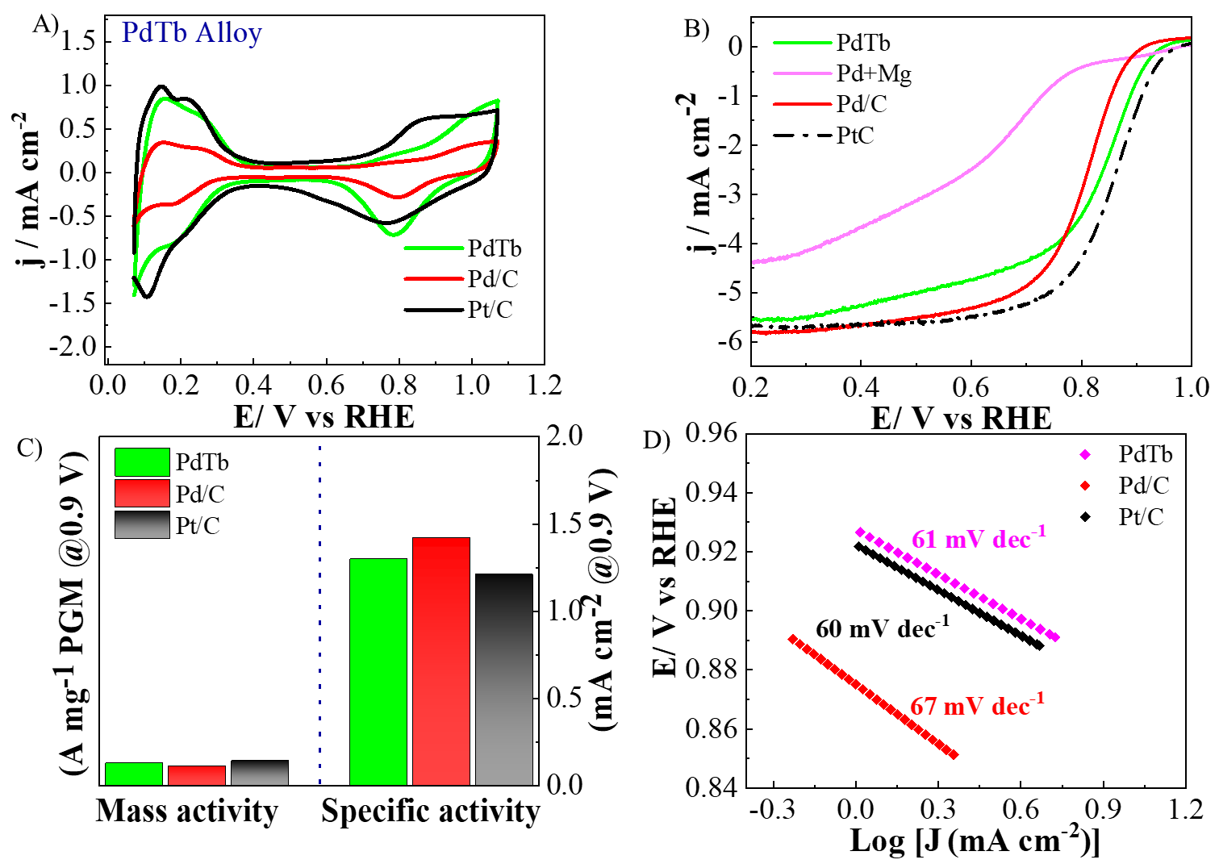
Fig. S23 | Electrochemical performance of PdTb catalysts in acidic conditions. A) Cyclic voltammetry (CV) curves in N₂- saturated 0.1M HClO₄ at a scan rate of 50 mV s⁻¹; B) ORR polarization curves (IR-corrected) in 0.1 M HClO₄ solutions with rotation rates of 1600 rpm and a sweep rate of 10 mV s⁻¹; C) The mass and specific activities at 0.9 V vs RHE; D) Tafel plots recorded in O₂-saturated 0.1M HClO₄.
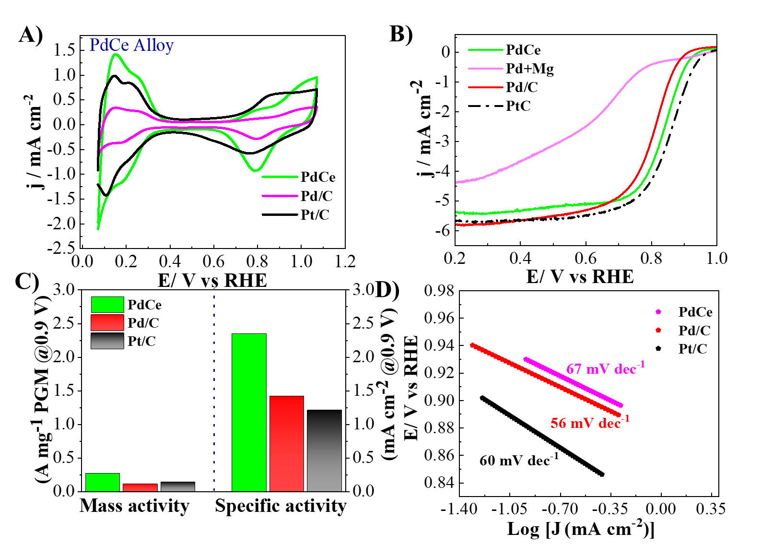
Fig. S24 | Electrochemical performance of PdCe catalysts in acidic conditions. A) Cyclic voltammetry (CV) curves in N₂- saturated 0.1M HClO₄ at a scan rate of 50 mV s⁻¹; B) ORR polarization curves (IR-corrected) in 0.1 M HClO₄ solutions with rotation rates of 1600 rpm and a sweep rate of 10 mV s⁻¹; C) The mass and specific activities at 0.9 V versus RHE; D) Tafel plots recorded in O₂-saturated 0.1M HClO₄.

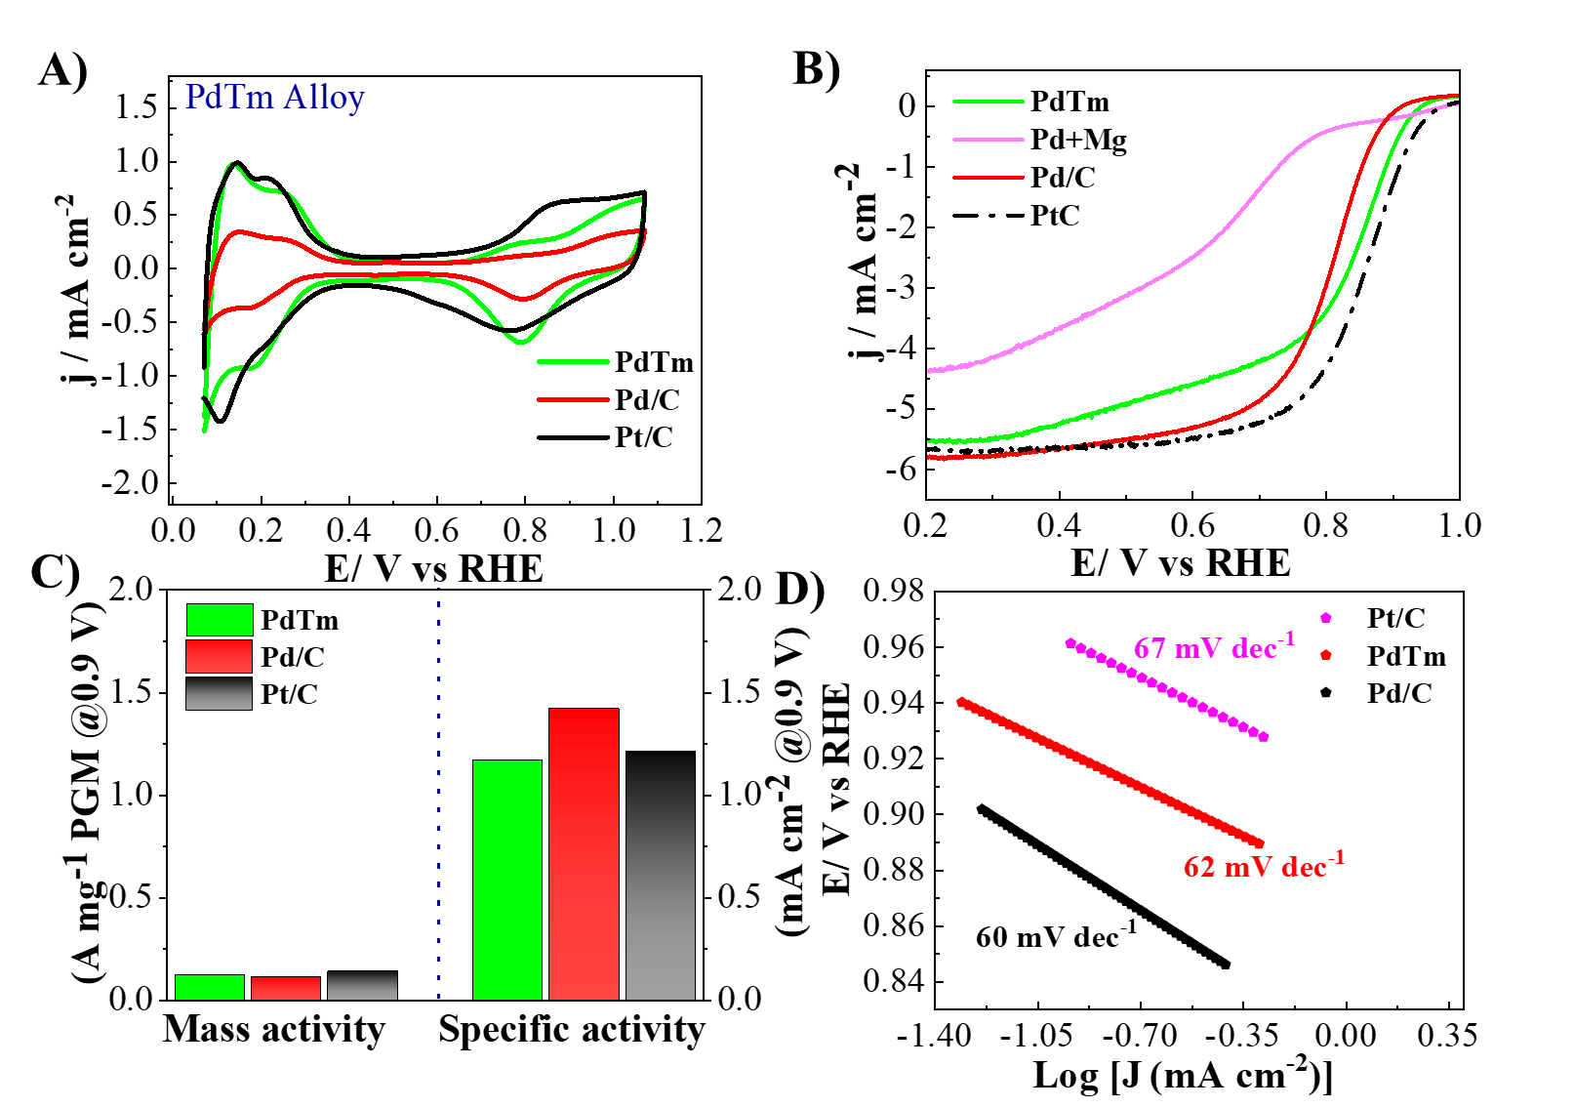
Fig. S25 | Electrochemical performance of PdTm catalysts in acidic conditions. A) Cyclic voltammetry (CV) curves in N₂-saturated 0.1M HClO₄ at a scan rate of 50 mV s⁻¹; B) ORR polarization curves (IR-corrected) in O₂-saturated 0.1 M HClO₄ solutions with rotation rates of 1600 rpm and a sweep rate of 10 mV s⁻¹; C) The mass and specific activities at 0.9 V vs RHE; D) Tafel plots recorded in O₂-saturated 0.1M HClO₄.

Fig. S26 | Reaction profiles and reaction sites. Free energy diagrams of ORR steps on Pt(111), Pd(111) and PdEr(111) surfaces. Atom color scheme: Palladium-blue green, Rare-earth atom-green, Oxygen-red, Hydrogen-white.

Table S1 | The calculated results of the lattice parameters and crystalline sizes of the PdRE alloys and the Pd/C.
Catalysts | 2θ/º | Sinθ | d-spacing (Å) | lattice constant (Å) | Crystalline Size (nm)
PdEr | 39.43 | 0.337 | 2.283 | 3.960 | 4.54
PdSm | 39.40 | 0.337 | 2.285 | 3.958 | 4.54
PdDy | 39.39 | 0.337 | 2.286 | 3.959 | 4.54
PdSc | 39.38 | 0.337 | 2.286 | 3.960 | 4.55
PdGd | 39.37 | 0.336 | 2.287 | 3.962 | 4.54
PdHo | 39.37 | 0.336 | 2.287 | 3.962 | 4.55
PdPr | 39.36 | 0.337 | 2.288 | 3.963 | 4.54
PdY | 39.38 | 0.337 | 2.286 | 3.960 | 4.55
PdLu | 39.36 | 0.337 | 2.288 | 3.963 | 4.56
PdEu | 39.36 | 0.337 | 2.288 | 3.963 | 4.56
PdCe | 39.36 | 0.337 | 2.288 | 3.963 | 4.55
PdTm | 39.37 | 0.336 | 2.287 | 3.962 | 4.56
PdYb | 39.35 | 0.337 | 2.288 | 3.964 | 4.56
PdTb | 39.35 | 0.337 | 2.288 | 3.964 | 4.56
Pd | 39.8 | 0.340 | 2.263 | 3.920 | 6.30

Table S2 | Binding energies and relative concentrations of Pd 3d and Er 4d species from XPS studies.
 | Species | Relative Concentrations (%)
 |  | PdEr | Pd/C
 | Pd⁰ | 72.32 | 65.10
Pd²⁺ |  | 27.68 | 34.90
 | Binding energies(eV)
 | Pd 3d_{5/2} | 335.8  338.5 | 335.3  336.0
 | Pd 3d_{3/2} | 341.0  344.0 | 340.6  341.8

Table S3 | ORR performance of Pd-RE alloys, Pd/Cand commercial Pt/C catalysts
Catalyst | Half-wave  potential  (V) | ECSA  (m²g⁻¹ PGM) | Mass activity  (Am g⁻¹PGM  @0.9 V) | Specific activity  (mA cm⁻²@0.9 V) | Tafel  mV dec⁻¹
PdEr | 0.901 | 141.8 | 1.18 | 6.93 | 50
PdSm | 0.896 | 100.3 | 0.76 | 4.6 | 52
PdDy | 0.892 | 98.0 | 0.73 | 3.8 | 54
PdSc | 0.882 | 87.7 | 0.67 | 3.3 | 56
PdGd | 0.885 | 91.9 | 0.70 | 3.5 | 55
PdHo | 0.893 | 79.4 | 0.49 | 2.61 | 53
PdPr | 0.881 | 73.5 | 0.39 | 2.10 | 53
PdY | 0.880 | 82.3 | 0.51 | 2.87 | 55
PdLu | 0.860 | 65.6 | 0.21 | 1.52 | 57
PdEu | 0.830 | 64.1 | 0.1 | 1.37 | 59
PdYb | 0.827 | 61.9 | 0.12 | 1.30 | 64
PdTb | 0.832 | 60.6 | 0.13 | 1.37 | 61
PdCe | 0.840 | 83.5 | 0.27 | 2.33 | 56
PdTm | 0.832 | 50.91 | 0.13 | 1.17 | 65
Pd/C | 0.801 | 37.3 | 0.075 | 1.21 | 67
Pt/C | 0.854 | 73.7 | 0.16 | 1.42 | 60

Table S4 | The ORR performance of the PdEr catalyst compared with control catalysts in this study and other reported high-performance ORR catalysts in acidic electrolytes.
Catalyst | Mass activity  (A mg⁻¹ PGM @0.9 V) | Specific activity  (mA cm⁻² @0.9 V) | E_{1/2}(V) | Scan rate  mV s⁻¹ | References
PdEr | 1.18 | 6.93 | 0.901 | 10 | This work
Pd/C | 0.11 | 1.42 | 0.801 | 10 | This work
Pt/C | 0.14 | 1.21 | 0.854 | 10 | This work
Pd₄Fe NFs | 0.09 | 0.26 | 0.833 | 20 | Chem. Commun. 2018, 54 7058-7061
Pd₄Fe NFs | 0.06 | 0.16 | 0.821 | 10 | Chem. Commun. 2018, 54 7058-7061
PdMo bimetallene/C | 0.66 | ~0.46 | N/A | 20 | Nature.2019, 574, 81–85
HT Pd₁Fe₁ | ~ 0.160 | ~ 2.30 | 0.92 | 5 | J. Power Sources.2016, 303,234- 242
O-Pd₃Fe/C | N/A | N/A | 0.767 | 5 | J. Electrochem. Soc. 2015 163, F132
Pd₃Co (OHT) | 0.131 | 0.12 | 0.86 | 20 | J. Electroanal. Chem. 2014, 712 ,223-229
Ni@Pd₃/C NPs | 0.03 | 0.08 | 0.87 | 5 | J. Mater. Chem. A.2017, 5,9233-9240
Pd₃Co | N/A | 0.09 | 0.848 | 10 | J. Electroanal. Chem. 2014, 712 ,223-229
Pd₄Fe nanoflowers | 0.52 | 1.57 | 0.833 | 20 | Chem. Commun. 2018, 54, 7058–7061
Pd₄IrY_{0.1}/C | N/A | N/A | 0.626 | 5 | Catal. Today.2021, 359,106-111
Rh₈Pd9₂ alloy octahedra | 0.10 | 0.24 | N/A | 10 | Nanoscale.2015, 7, 301–307
Pd₇₅Cr₂₅ alloys | 0.16 | 0.24 | N/A | 10 | Nano Energy.2014, 8,214-222
Pd/CDC | N/A | 0.06 | ~0.800 | 10 | ChemElectroChem .2020, 7 7 ,546-554
NP-Pd₅₀Cu₅₀ | 0.15 | 0.22 | NA | 10 | Int. J. Hydrogen,  Energy.2013, 38,10029–10038
Pd/GC-Fe₂MoC | ~0.15 | NA | 0.86 V | 5 | Appl. Catal. B 2015, 165 ,636-641.
Pd Cube | NA | 0.31 | 0.86 V | 10 | J. Phys. Chem. C 2013, 117, 8, 4172–4180
Pd Octa | NA | 0.03 | NA | 10 | Chem. Commun., 2011, 47, 6566-6568
CoPd NPs | 0.15 | 0.20 | NA | 10 | Chem. Asian J. 2013, 8, 2721-2728
Pd₃Fe/C | 0.121 | 0.121 | 0.84 | 20 | J. Electroanal. Chem.2011, 658,25-32
PdCoNi/C | N.A. | 0.388 | NA | 10 | ChemElectroChem.2014,1, 1359-1369
Au (900)-PdFe (900)/C | ~0.3 | NA | NA | 5 | ChemistrySelect 2018, 3, 6399 – 6405
Note: All the ORR measurements were performed at room temperature in O₂ -saturated 0.1 M HClO₄ solution with a rotation rate of 1600 rpm. Carbide-derived carbon (CDC), N/A: not available.

Table S5 | The comparison half-wave potentials resenting the MeOH resistance properties of the PdEr catalyst against the reference catalysts Pd/C and Pt/C.
Parameters/Catalysts | E_{1/2} @ MeOH Poisoning
MeOH Conc. (M) | 0.1 | 0.2 | 0.5 | 1 | 2
PdEr | 0.893 | 0.889 | 0.888 | 0.871 | 0.855
Pd/C | 0.787 | 0.785 | 0.771 | 0.752 | 0.711
Pt/C | 0.671 | 0.661 | 0.621 | 0.604 | 0.601

Table S6 | The ORR performance of the PdEr and other reported high-performance ORR catalysts in alkaline electrolyte
Catalyst | Mass activity  (A mg⁻¹ PGM @0.9 V) | Specific activity  (mA cm⁻² @0.9 V) | E_{1/2}(V) | Scan rate  mV s⁻¹ | References
PdEr | 3.47 | 2.98 | 0.931 | 10 | This work
Pd/C | 0.22 | 0.37 | 0.844 | 10 | This work
Pt/C | 0.32 | 0.42 | 0.859 | 10 | This work
Pd₈Sb₃ HPs/C | 1.03 | 2.89 | 0.92 | 2 | Adv. Mater. 2022, 34, 2202333
Pd metallene/C | 0.65 | 0.48 | 0.89 | 20 | Nat. Commun. 2019, 574, 81
Palladium nanocubes/C | 0.101 | N/A | 0.84 | 10 | Electrochem. Commun. 2016, 64, 9
Ag@Pd/MW  NTs | 0.157 | N/A | 0.75 | 5 | Appl. Catal. B: Enviro. 2013, 138, 285
8.8 wt.%  Pd@MnO₂/C | 0.42 | N/A | 0.810 | 10 | J. Power Sources 2011, 196, 4491
Core-shell Ni@Pd₃ | 0.38 | 0.13 | ~0.86 | 5 | J. Mater. Chem. A 2017, 5, 9233
Pd-B/C | N/A | 0.170 | 0.883 | 10 | J. Phys. Chem. C 2017, 121, 3416
Pd₅₉Cu₃₀Co₁₁  Nanodendrite | 0.38 | 0.90 | 0.91 | 10 | Nat. Commun. 2018,  9, 3702
Pd₃Y NPs | 0.21 | 1.74 | 0.88 | 20 | Electrochim. Acta  2019, 320, 134563
PdNi icosahedra | 0.22 | 0.66 | 0.89 | 10 | Sci. Adv. 2018, 4,  eaap8817
O-Pd-Fe@NC/C | 0.32 | 0.78 | ~0.91 | 10 | Nano Res. 2020, 13, 2365-2370
Pd₃Pb TPs/C | 0.56 | 1.76 | N/A | 10 | Chem 4, 359-371
Porous Palladium  Metallene | 0.892 | 1.34 | ~0.90 | 10 | Angew. Chem. Int.2021,60,2
PdAg NWs | 0.103 | 0.36 | ~0.90 | 10 | Nanoscale 2020, 12, 5368-5373
Pd@PdFe | 0.310 | 1.560 | N/A | 10 | Nano Lett. 2020, 20, 1403-1409
Au-NWs@Pd | 0.295 | 0.398 | 0.9 | 10 | ACS Catal. 2018, 8, 11287-11295
Pd₃Pb NSAs | 0.697 | 0.989 | N/A | 10 | ACS Catal. 2018, 8, 4569-4575
PdAu | 0.101 | 0.289 | 0.83 | 10 | J. Energy Chem.  2020, 40, 217-223
Pd@Zn | 0.090 | 0.044 | 0.82 | 10 | J. Catal. 2020, 382, 181-191
PdCu/C | 0.130 | 2.30 | 0.89 | 10 | J. Am. Chem. Soc.  2020, 142, 3980-3988
Note: All the contrastive ORR measurements were performed at room temperature in O₂ -an saturated 0.1 M KOH solution with a rotation rate of 1600 rpm. N/A: not available

References
1. Cheng, Y.; Jiang, S. P., Highly effective and CO-tolerant PtRu electrocatalysts supported on poly(ethyleneimine) functionalized carbon nanotubes for direct methanol fuel cells. Electrochimica Acta 2013, 99, 124-132.
2. Hanifah, M. F. R.; Jaafar, J.; Othman, M. H. D.; Ismail, A. F.; Rahman, M. A.; Yusof, N.; Aziz, F.; Rahman, N. A. A., One-pot synthesis of efficient reduced graphene oxide supported binary Pt-Pd alloy nanoparticles as superior electro-catalyst and its electro-catalytic performance toward methanol electro-oxidation reaction in direct methanol fuel cell. J. Alloys Compd. 2019, 793, 232-246.
3. Luo, M.; Zhao, Z.; Zhang, Y.; Sun, Y.; Xing, Y.; Lv, F.; Yang, Y.; Zhang, X.; Hwang, S.; Qin, Y.; Ma, J. Y.; Lin, F.; Su, D.; Lu, G.; Guo, S., PdMo bimetallene for oxygen reduction catalysis. Nature 2019, 574 (7776), 81-85.
4. Xia, Y.-F.; Guo, P.; Li, J.-Z.; Zhao, L.; Sui, X.-L.; Wang, Y.; Wang, Z.-B., How to appropriately assess the oxygen reduction reaction activity of platinum group metal catalysts with rotating disk electrode. iScience 2021, 24 (9), 103024.
5. Wang, Y.; He, Q.; Ding, K.; Wei, H.; Guo, J.; Wang, Q.; O'Connor, R.; Huang, X.; Luo, Z.; Shen, T. D.; Wei, S.; Guo, Z., Multiwalled Carbon Nanotubes Composited with Palladium Nanocatalysts for Highly Efficient Ethanol Oxidation. Journal of The Electrochemical Society 2015, 162 (7), F755-F763.
6. Okada, J.; Inukai, J.; Itaya, K., Underpotential and bulk deposition of copper on Pd(111) in sulfuric acid solution studied by in situ scanning tunneling microscopy. Physical Chemistry Chemical Physics 2001, 3 (16), 3297-3302.
7. Mohanraju, K.; Cindrella, L., Impact of alloying and lattice strain on ORR activity of Pt and Pd based ternary alloys with Fe and Co for proton exchange membrane fuel cell applications. RSC Advances 2014, 4 (23), 11939-11947.
8. Zhong, X.; Qin, Y.; Chen, X.; Xu, W.; Zhuang, G.; Li, X.; Wang, J., PtPd alloy embedded in nitrogen-rich graphene nanopores: High-performance bifunctional electrocatalysts for hydrogen evolution and oxygen reduction. Carbon 2017, 114, 740-748.
9. Giannozzi, P.; Baroni, S.; Bonini, N.; Calandra, M.; Car, R.; Cavazzoni, C.; Ceresoli, D.; Chiarotti, G. L.; Cococcioni, M.; Dabo, I.; Dal Corso, A.; de Gironcoli, S.; Fabris, S.; Fratesi, G.; Gebauer, R.; Gerstmann, U.; Gougoussis, C.; Kokalj, A.; Lazzeri, M.; Martin-Samos, L.; Marzari, N.; Mauri, F.; Mazzarello, R.; Paolini, S.; Pasquarello, A.; Paulatto, L.; Sbraccia, C.; Scandolo, S.; Sclauzero, G.; Seitsonen, A. P.; Smogunov, A.; Umari, P.; Wentzcovitch, R. M., QUANTUM ESPRESSO: a modular and open-source software project for quantum simulations of materials. Journal of Physics: Condensed Matter 2009, 21 (39), 395502.
10. Perdew, J. P.; Burke, K.; Ernzerhof, M., Generalized Gradient Approximation Made Simple. Physical Review Letters 1996, 77 (18), 3865-3868.
11. Kim, S. K.; Shin, K.; Henkelman, G., Stability of Pt Skin Intermetallic Core Catalysts and Adsorption Properties for the Oxygen Reduction Reaction. The Journal of Physical Chemistry C 2021, 125 (6), 3527-3534.
12. Nørskov, J. K.; Rossmeisl, J.; Logadottir, A.; Lindqvist, L.; Kitchin, J. R.; Bligaard, T.; Jónsson, H., Origin of the Overpotential for Oxygen Reduction at a Fuel-Cell Cathode. The Journal of Physical Chemistry B 2004, 108 (46), 17886-17892.
13. Man, I. C.; Su, H.-Y.; Calle-Vallejo, F.; Hansen, H. A.; Martínez, J. I.; Inoglu, N. G.; Kitchin, J.; Jaramillo, T. F.; Nørskov, J. K.; Rossmeisl, J., Universality in Oxygen Evolution Electrocatalysis on Oxide Surfaces. ChemCatChem 2011, 3 (7), 1159-1165.

