Parameters | Bond Length (Å) |  | Parameters | Bond Angle (º)
Parameters | Theoretical Value | Experimental Value | Parameters | Theoretical Value | Experimental Value
C₁₂ O₂₄ | 1.419 | 1.422 | C₁₁ C₁₂ C₁₃ | 111.219 | 111.9
C₂₆ O₂₈ | 1.264 | 1.266 | C₁₂ O₂₄ H₂₅ | 105.438 | 107
C₂₆ O₂₇ | 1.316 | 1.27 | O₂₇ C₂₆ O₂₈ | 124.141 | 122.3
C₃₇ C₃₈ | 1.416 | 1.402 | O₈₁ C₃₈ C₃₇ | 121.174 | 115.6
C₃₇ O₈₃ | 1.389 | 1.369 | C₃₈ C₃₇ O₈₃ | 115.738 | 114.8
C₃₈ O₈₁ | 1.394 | 1.379 | O₈₂ C₆₅ N₇₈ | 123.409 | 122.1
C₆₅ O₈₂ | 1.218 | 1.225 | C₄₂ N₇₈ C₇₆ | 109.374 | 108.6
C₆₉ O₈₀ | 1.465 | 1.430 | C₆₉ O₈₀ C₇₁ | 116.107 | 115.7
C₅₄ N₇₉ | 1.499 | 1.499 | C₄₆ N₇₉ C₅₁ | 107.993 | 107.6
C₇₁ C₇₄ | 1.506 | 1.503 | C₄₆ N₇₉ C₅₄ | 113.759 | 112.9
C₇₆ N₇₈ | 1.493 | 1.496 | C₅₁ N₇₉ C₅₄ | 113.272 | 112.8
Table.S1 Selected Bond length and Bond Angles of BBA.

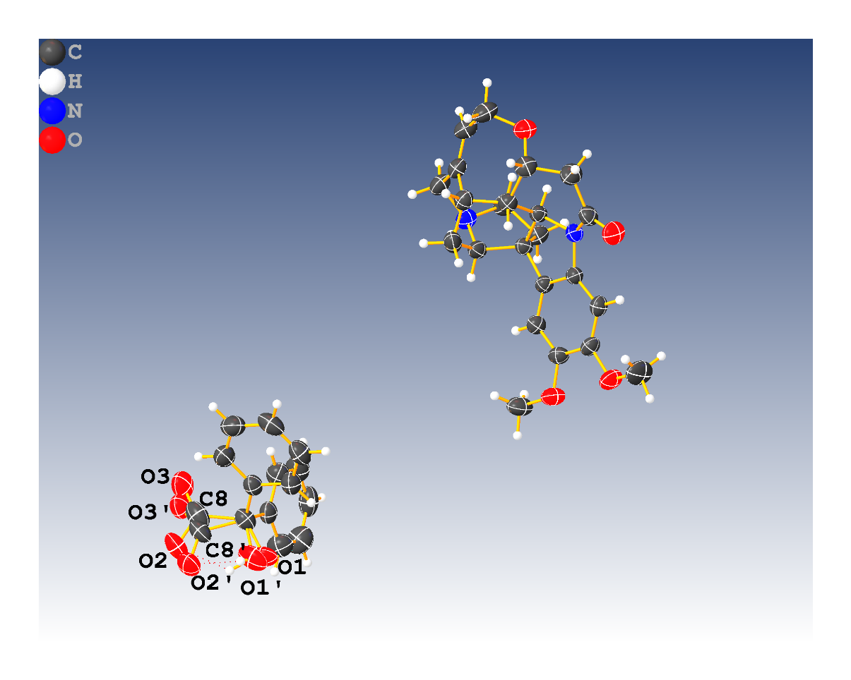
Fig.S1 The disordered atoms at C(8), O(1), O(2) and O(3) were positioned with chemical occupancies 0.45:0.55.

