Supplementary material

Article title: Weather forecast using WRFg at 2 km resolution over two provinces in northwestern Panama
Journal name: Climate Dynamics

Author name: Josue BATISTA, Reinhardt PINZON

Table S1. Specifications of the HPC-GPU system (called IBEROGUN) used to perform the DDS. NVIDIA (2023).
SYSTEM SPECIFICATIONS

Brand | NVIDIA
Model | DGX-A100
GPUs | 8x NVIDIA A100 Tensor Core GPUs
GPU Memory | 320 GB total
Performance | 5 petaFLOPS AI / 10 petaOPS INT8
NVIDIA NVSwitches | 6
System Power Usage | 6.5 kW max
CPU | Dual AMD Rome 7742, 128 cores total, 2.25 GHz (base), 3.4 GHz (max boost)
System Memory | 1 TB
Software | Ubuntu Linux OS
NVIDIA A100 TENSOR CORE GPU SPECIFICATIONS

FP64 | 9.7 TFLOPS
FP64 Tensor Core | 19.5 TFLOPS
FP32 | 19.5 TFLOPS
Tensor Float 32 (TF32) | 312 TFLOPS (With sparsity)
BFLOAT16 Tensor Core | 624 TFLOPS (With sparsity)
FP16 Tensor Core | 624 TFLOPS (With sparsity)
INT8 Tensor Core | 1248 TOPS (With sparsity)
GPU Memory | 40GB HBM2
GPU Memory Bandwidth | 1,555GB/s
Max Thermal Design Power (TDP) | 400W
Multi-Instance GPU | Up to 7 MIGs @ 5GB
Form Factor | SXM
Interconnect | NVLink: 600GB/s / PCIe Gen4: 64GB/s
Server Options | NVIDIA HGX TM A100-Partner and NVIDIA-Certified Systems with 4,8, or 16 GPUs NVIDIA DGX TM A100 with 8 GPUs

Text S1. GFS features
This section shows general model information (Table S2), standard pressure levels (Table S3) and the variables (Table S4) included in the GFS model used to obtain high resolution precipitation and temperature forecasts for the western region of Panama.
The most recent version of the GFS is version 16.3 (EMC, 2022), this was put into operational operation on November 29, 2022, however, the chosen meteorological events (hurricane ETA and IOTA) occurred during 2020 and in that period the GFS model corresponded to version 15.3, additional characteristics of the version used are shown in Table S2.
The latest GFS operational forecast files can be downloaded from the following address:
https://nomads.ncep.noaa.gov/
To obtain forecasts for past dates you can visit the link below, in the section "Data on NCEI Servers → GFS Forecasts (GFS Model)". Global forecasts with 0.5° resolution can be downloaded from that link.
https://www.ncei.noaa.gov/products/weather-climate-models/global-forecast

Table S2. General information from the GFS weather forecast used.
Model | GFS-atmosphere
Version | 15.3
Spatial resolution | 0.5°
Temporal resolution | 3 hour
Number of vertical layers | 64
Number of standard pressure levels | 34
Maximum forecast period¹ | 384 hour
Forecast update time | 0000, 0600, 1200 y 1800 UTC (published 4 times a day). The GFS outputs at 0000 UTC were used to generate the simulations.

Table S3. General information from the GFS weather forecast used.
GFS model | Height / pascals [Pa]
Standard pressure levels | 100000, 97500, 95000, 92500, 90000, 85000, 80000, 75000, 70000, 65000, 60000, 55000, 50000, 45000, 40000, 35000, 30000, 25000, 20000, 15000, 10000, 7000, 5000, 4000, 3000, 2000, 1500, 1000, 700, 500, 300, 200, 100, 40

Table S4. Description, code and measurement units of the atmospheric variables included in the GFS model version 15.3.

Code | Description
no4LFTXsfc | surface Best (4 layer) Lifted Index [K]
no5WAVH500mb | 500 mb 5-Wave Geopotential Height [gpm]
ABSVprs | (1000 975 950 925 900.. 30 20 15 10 40) Absolute Vorticity [1/s]
APTMP2m | 2 m above ground Apparent Temperature [K]
CAPEsfc | surface Convective Available Potential Energy [J/kg]
CAPE180_0mb | 180-0 mb above ground Convective Available Potential Energy [J/kg]
CAPE255_0mb | 255-0 mb above ground Convective Available Potential Energy [J/kg]
CFRZRsfc | surface Categorical Freezing Rain [-]
CICEPsfc | surface Categorical Ice Pellets [-]
CINsfc | surface Convective Inhibition [J/kg]
CIN180_0mb | 180-0 mb above ground Convective Inhibition [J/kg]
CIN255_0mb | 255-0 mb above ground Convective Inhibition [J/kg]
CLMRprs | (1000 975 950 925 900.. 250 200 150 100 50) Cloud Mixing Ratio [kg/kg]
CLMRhy1 | 1 hybrid level Cloud Mixing Ratio [kg/kg]
CPOFPsfc | surface Percent frozen precipitation [%]
CRAINsfc | surface Categorical Rain [-]
CSNOWsfc | surface Categorical Snow [-]
CWATclm | entire atmosphere (considered as a single layer) Cloud Water [kg/m^2]
DPT2m | 2 m above ground Dew Point Temperature [K]
DZDTprs | (1000 975 950 925 900.. 300 250 200 150 100) Vertical Velocity (Geometric) [m/s]
FLDCPsfc | surface Field Capacity [Fraction]
GRLEprs | (1000 975 950 925 900.. 250 200 150 100 50) Graupel [kg/kg]
GRLEhy1 | 1 hybrid level Graupel [kg/kg]
GUSTsfc | surface Wind Speed (Gust) [m/s]
HGTsfc | surface Geopotential Height [gpm]
HGTprs | (1000 975 950 925 900.. 5 3 2 1 40) Geopotential Height [gpm]
HGT2pv | PV=2e-06 (Km^2/kg/s) surface Geopotential Height [gpm]
HGTneg2pv | PV=-2e-06 (Km^2/kg/s) surface Geopotential Height [gpm]
HGTtop0C | highest tropospheric freezing level Geopotential Height [gpm]
HGT0C | 0C isotherm Geopotential Height [gpm]
HGTmwl | max wind Geopotential Height [gpm]
HGTtrop | tropopause Geopotential Height [gpm]
HINDEXsfc | surface Haines Index [Numeric]
HLCY3000_0m | 3000-0 m above ground Storm Relative Helicity [m^2/s^2]
HPBLsfc | surface Planetary Boundary Layer Height [m]
ICAHTmwl | max wind ICAO Standard Atmosphere Reference Height [m]
ICAHTtrop | tropopause ICAO Standard Atmosphere Reference Height [m]
ICECsfc | surface Ice Cover [Proportion]
ICEG_10m | 10 m above mean sea level Ice Growth Rate [m/s]
ICMRprs | (1000 975 950 925 900.. 250 200 150 100 50) Ice Water Mixing Ratio [kg/kg]
ICMRhy1 | 1 hybrid level Ice Water Mixing Ratio [kg/kg]
LANDsfc | surface Land Cover (0=sea, 1=land) [Proportion]
LANDNsfc | surface Land-sea coverage (nearest neighbor) [land=1,sea=0] [-]
LFTXsfc | surface Surface Lifted Index [K]
MSLETmsl | mean sea level MSLP (Eta model reduction) [Pa]
O3MRprs | (1000 850 700 500 400.. 5 3 2 1 40) Ozone Mixing Ratio [kg/kg]
PLPL255_0mb | 255-0 mb above ground Pressure of level from which parcel was lifted [Pa]
POTsig995 | 0.995 sigma level Potential Temperature [K]
PRATEsfc | surface Precipitation Rate [kg/m^2/s]
PRESsfc | surface Pressure [Pa]
PRES80m | 80 m above ground Pressure [Pa]
PRES2pv | PV=2e-06 (Km^2/kg/s) surface Pressure [Pa]
PRESneg2pv | PV=-2e-06 (Km^2/kg/s) surface Pressure [Pa]
PRESmwl | max wind Pressure [Pa]
PREStrop | tropopause Pressure [Pa]
PRMSLmsl | mean sea level Pressure Reduced to MSL [Pa]
PWATclm | entire atmosphere (considered as a single layer) Precipitable Water [kg/m^2]
REFCclm | entire atmosphere Composite reflectivity [dB]
RHprs | (1000 975 950 925 900.. 7 5 3 2 1) Relative Humidity [%]
RH2m | 2 m above ground Relative Humidity [%]
RHsg330_1000 | 0.33-1 sigma layer Relative Humidity [%]
RHsg440_1000 | 0.44-1 sigma layer Relative Humidity [%]
RHsg720_940 | 0.72-0.94 sigma layer Relative Humidity [%]
RHsg440_720 | 0.44-0.72 sigma layer Relative Humidity [%]
RHsig995 | 0.995 sigma level Relative Humidity [%]
RH30_0mb | 30-0 mb above ground Relative Humidity [%]
RHclm | entire atmosphere (considered as a single layer) Relative Humidity [%]
RHtop0C | highest tropospheric freezing level Relative Humidity [%]
RH0C | 0C isotherm Relative Humidity [%]
RWMRprs | (1000 975 950 925 900.. 250 200 150 100 50) Rain Mixing Ratio [kg/kg]
RWMRhy1 | 1 hybrid level Rain Mixing Ratio [kg/kg]
SNMRprs | (1000 975 950 925 900.. 250 200 150 100 50) Snow Mixing Ratio [kg/kg]
SNMRhy1 | 1 hybrid level Snow Mixing Ratio [kg/kg]
SNODsfc | surface Snow Depth [m]
SOILW0_10cm | 0-0.1 m below ground Volumetric Soil Moisture Content [Fraction]
SOILW10_40cm | 0.1-0.4 m below ground Volumetric Soil Moisture Content [Fraction]
SOILW40_100cm | 0.4-1 m below ground Volumetric Soil Moisture Content [Fraction]
SOILW100_200cm | 1-2 m below ground Volumetric Soil Moisture Content [Fraction]
SPFH2m | 2 m above ground Specific Humidity [kg/kg]
SPFH80m | 80 m above ground Specific Humidity [kg/kg]
SPFH30_0mb | 30-0 mb above ground Specific Humidity [kg/kg]
SUNSDsfc | surface Sunshine Duration [s]
TCDCprs | (1000 975 950 925 900.. 250 200 150 100 50) Total Cloud Cover [%]
TMPsfc | surface Temperature [K]
TMPprs | (1000 975 950 925 900.. 5 3 2 1 40) Temperature [K]
TMP_1829m | 1829 m above mean sea level Temperature [K]
TMP_2743m | 2743 m above mean sea level Temperature [K]
TMP_3658m | 3658 m above mean sea level Temperature [K]
TMP2m | 2 m above ground Temperature [K]
TMP80m | 80 m above ground Temperature [K]
TMP100m | 100 m above ground Temperature [K]
TMPsig995 | 0.995 sigma level Temperature [K]
TMP30_0mb | 30-0 mb above ground Temperature [K]
TMP2pv | PV=2e-06 (Km^2/kg/s) surface Temperature [K]
TMPneg2pv | PV=-2e-06 (Km^2/kg/s) surface Temperature [K]
TMPmwl | max wind Temperature [K]
TMPtrop | tropopause Temperature [K]
TOZNEclm | entire atmosphere (considered as a single layer) Total Ozone [DU]
TSOIL0_10cm | 0-0.1 m below ground Soil Temperature [K]
TSOIL10_40cm | 0.1-0.4 m below ground Soil Temperature [K]
TSOIL40_100cm | 0.4-1 m below ground Soil Temperature [K]
TSOIL100_200cm | 1-2 m below ground Soil Temperature [K]
UGRDprs | (1000 975 950 925 900.. 7 5 3 2 1) U-Component of Wind [m/s]
UGRD_1829m | 1829 m above mean sea level U-Component of Wind [m/s]
UGRD_2743m | 2743 m above mean sea level U-Component of Wind [m/s]
UGRD_3658m | 3658 m above mean sea level U-Component of Wind [m/s]
UGRD10m | 10 m above ground U-Component of Wind [m/s]
UGRD20m | 20 m above ground U-Component of Wind [m/s]
UGRD30m | 30 m above ground U-Component of Wind [m/s]
UGRD40m | 40 m above ground U-Component of Wind [m/s]
UGRD50m | 50 m above ground U-Component of Wind [m/s]
UGRD80m | 80 m above ground U-Component of Wind [m/s]
UGRD100m | 100 m above ground U-Component of Wind [m/s]
UGRDsig995 | 0.995 sigma level U-Component of Wind [m/s]
UGRD30_0mb | 30-0 mb above ground U-Component of Wind [m/s]
UGRD2pv | PV=2e-06 (Km^2/kg/s) surface U-Component of Wind [m/s]
UGRDneg2pv | PV=-2e-06 (Km^2/kg/s) surface U-Component of Wind [m/s]
UGRDpbl | planetary boundary layer U-Component of Wind [m/s]
UGRDmwl | max wind U-Component of Wind [m/s]
UGRDtrop | tropopause U-Component of Wind [m/s]
USTM6000_0m | 6000-0 m above ground U-Component Storm Motion [m/s]
VGRDprs | (1000 975 950 925 900.. 7 5 3 2 1) V-Component of Wind [m/s]
VGRD_1829m | 1829 m above mean sea level V-Component of Wind [m/s]
VGRD_2743m | 2743 m above mean sea level V-Component of Wind [m/s]
VGRD_3658m | 3658 m above mean sea level V-Component of Wind [m/s]
VGRD10m | 10 m above ground V-Component of Wind [m/s]
VGRD20m | 20 m above ground V-Component of Wind [m/s]
VGRD30m | 30 m above ground V-Component of Wind [m/s]
VGRD40m | 40 m above ground V-Component of Wind [m/s]
VGRD50m | 50 m above ground V-Component of Wind [m/s]
VGRD80m | 80 m above ground V-Component of Wind [m/s]
VGRD100m | 100 m above ground V-Component of Wind [m/s]
VGRDsig995 | 0.995 sigma level V-Component of Wind [m/s]
VGRD30_0mb | 30-0 mb above ground V-Component of Wind [m/s]
VGRD2pv | PV=2e-06 (Km^2/kg/s) surface V-Component of Wind [m/s]
VGRDneg2pv | PV=-2e-06 (Km^2/kg/s) surface V-Component of Wind [m/s]
VGRDpbl | planetary boundary layer V-Component of Wind [m/s]
VGRDmwl | max wind V-Component of Wind [m/s]
VGRDtrop | tropopause V-Component of Wind [m/s]
VISsfc | surface Visibility [m]
VRATEpbl | planetary boundary layer Ventilation Rate [m^2/s]
VSTM6000_0m | 6000-0 m above ground V-Component Storm Motion [m/s]
VVELprs | (1000 975 950 925 900.. 300 250 200 150 100) Vertical Velocity (Pressure) [Pa/s]
VVELsig995 | 0.995 sigma level Vertical Velocity (Pressure) [Pa/s]
VWSH2pv | PV=2e-06 (Km^2/kg/s) surface Vertical Speed Shear [1/s]
VWSHneg2pv | PV=-2e-06 (Km^2/kg/s) surface Vertical Speed Shear [1/s]
VWSHtrop | tropopause Vertical Speed Shear [1/s]
WEASDsfc | surface Water Equivalent of Accumulated Snow Depth [kg/m^2]
WILTsfc | surface Wilting Point [Fraction]

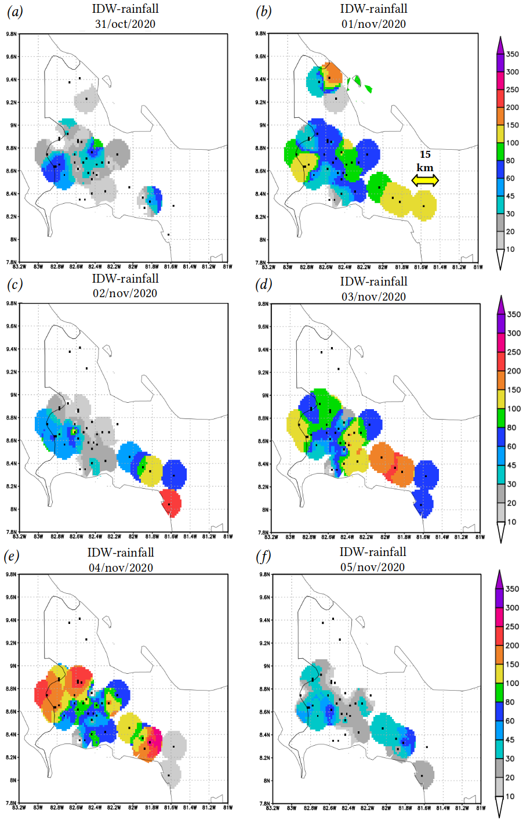
Fig. S1. Interpolated daily precipitation in millimeters [mm] from the IMHPA weather station network for the days of the ETA event.

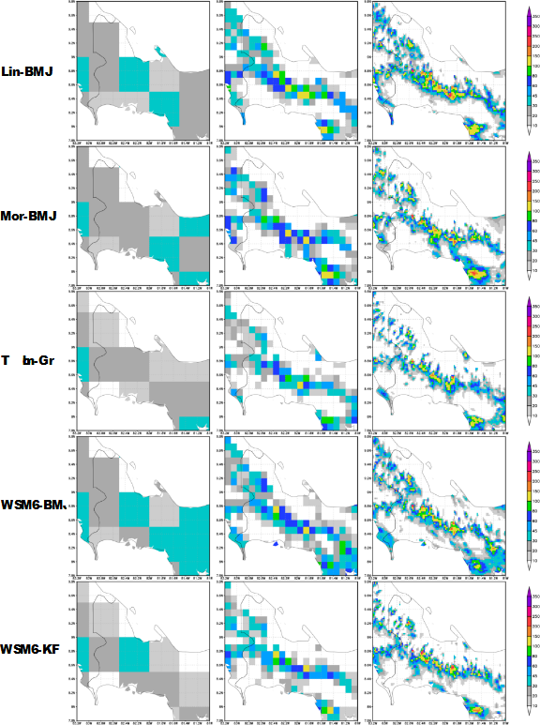
Fig. S2. Daily precipitation in millimeters [mm] predicted at 24 hours for 31/Oct/2020 from the different MPS-CPS arrays with resolutions of 56 km (left), 11 km (center) and 2 km (right).
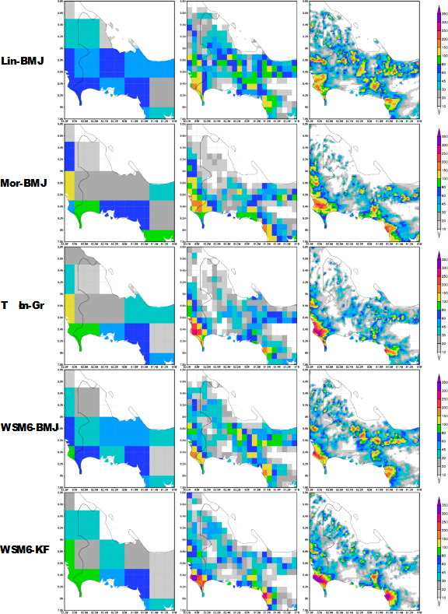
Fig. S3. Daily precipitation in millimeters [mm] predicted at 24 hours for 01/Nov/2020 from the different MPS-CPS arrays with resolutions of 56 km (left), 11 km (center) and 2 km (right).
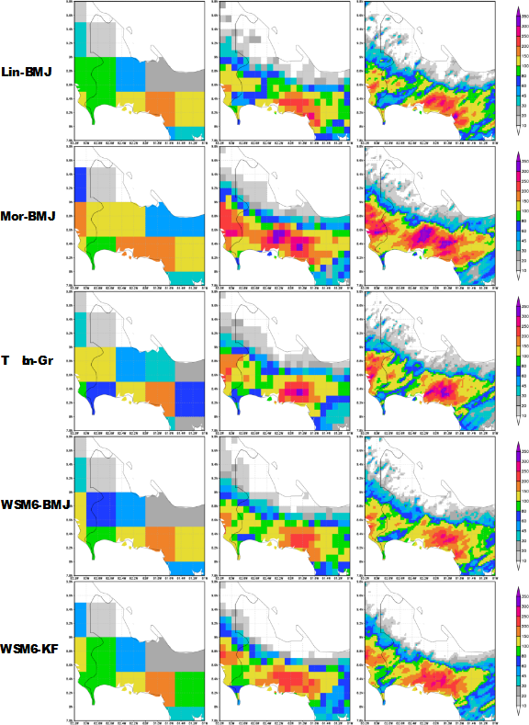
Fig. S4. Daily precipitation in millimeters [mm] predicted at 24 hours for 02/Nov/2020 from the different MPS-CPS arrays with resolutions of 56 km (left), 11 km (center) and 2 km (right).
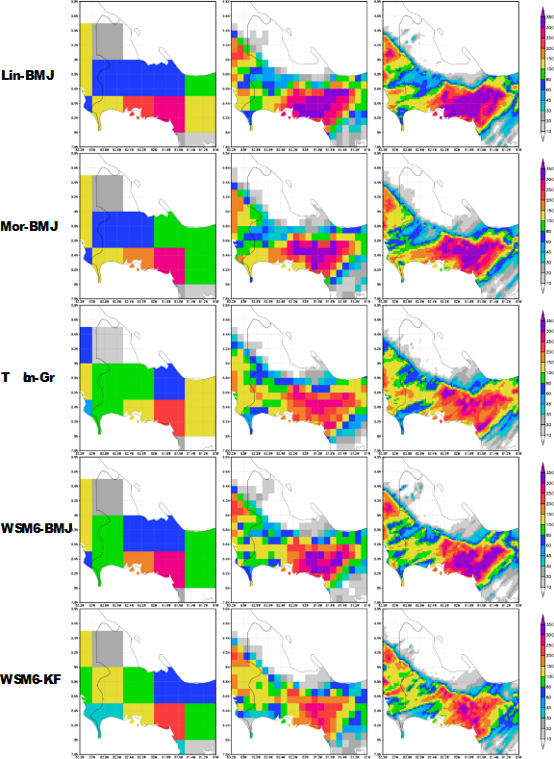
Fig. S5. Daily precipitation in millimeters [mm] predicted at 24 hours for 03/Nov/2020 from the different MPS-CPS arrays with resolutions of 56 km (left), 11 km (center) and 2 km (right).
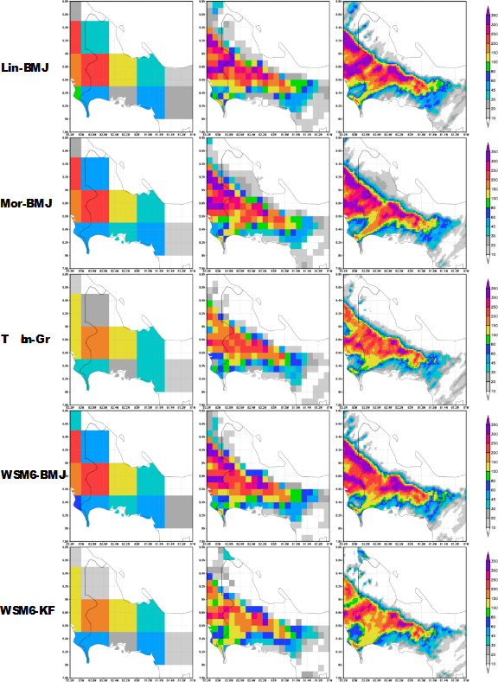
Fig. S6. Daily precipitation in millimeters [mm] predicted at 24 hours for 04/Nov/2020 from the different MPS-CPS arrays with resolutions of 56 km (left), 11 km (center) and 2 km (right).
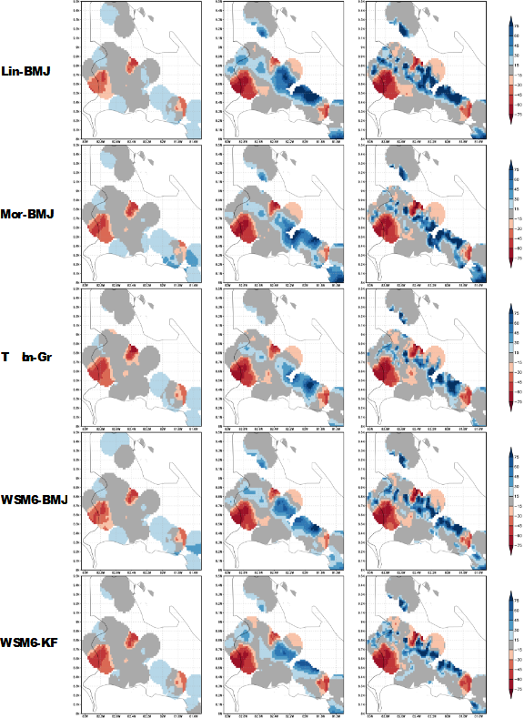
Fig. S7. Difference in millimeters [mm] of 24-hour DDS-predicted and interpolated rainfall on 31/Oct/2020 for the different MPS-CPS arrays with resolutions of 56 km (left), 11 km (center) and 2 km (right).
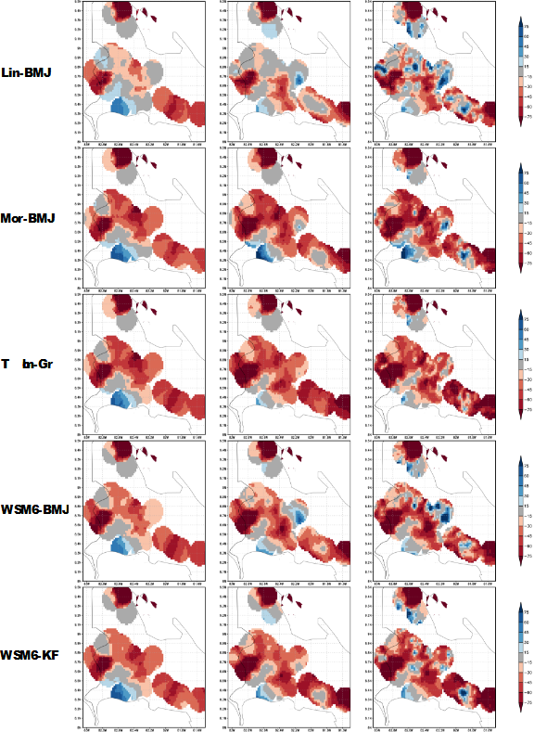
Fig. S8. Difference in millimeters [mm] of DDS 24-hour predicted and interpolated precipitation on 01/Nov/2020 for the different MPS-CPS arrays with resolutions of 56 km (left), 11 km (center) and 2 km (right).

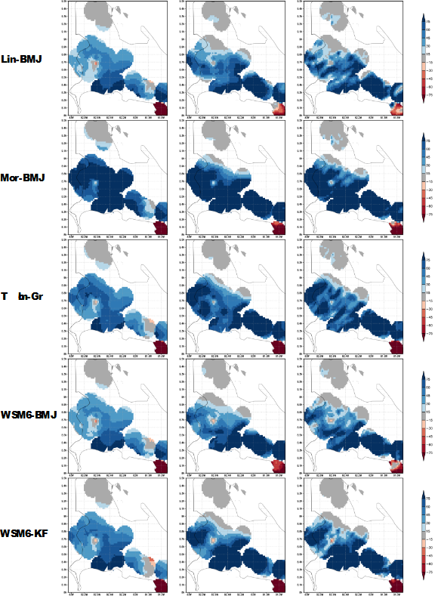
Fig. S9. Difference in millimeters [mm] of DDS 24-hour predicted and interpolated rainfall on 02/Nov/2020 for the different MPS-CPS arrays with resolutions of 56 km (left), 11 km (center) and 2 km (right).

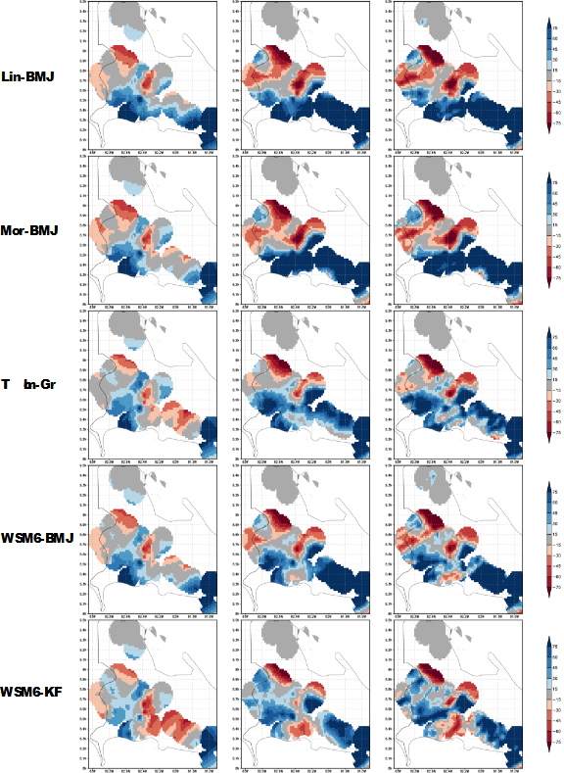
Fig. S10. Difference in millimeters [mm] of DDS 24-hour predicted and interpolated precipitation on 03/Nov/2020 for the different MPS-CPS arrays with resolutions of 56 km (left), 11 km (center) and 2 km (right).

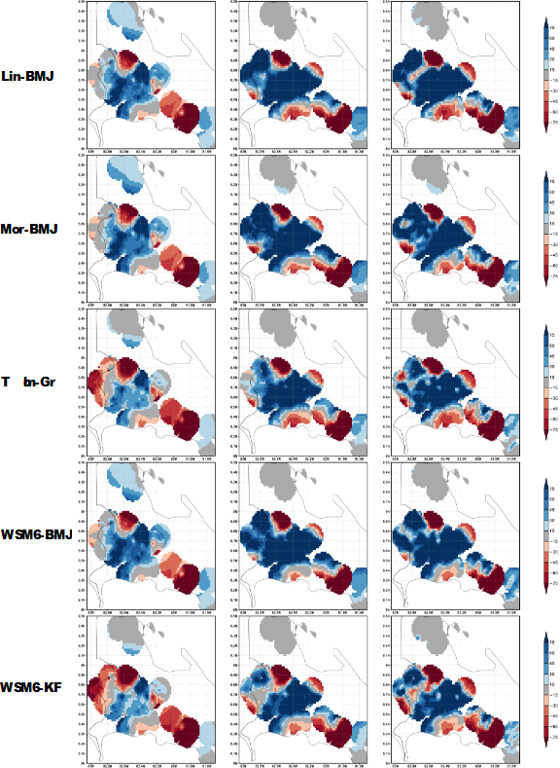
Fig. S11. Difference in millimeters [mm] of DDS 24-hour predicted and interpolated rainfall on 04/Nov/2020 for the different MPS-CPS arrays with resolutions of 56 km (left), 11 km (center) and 2 km (right).

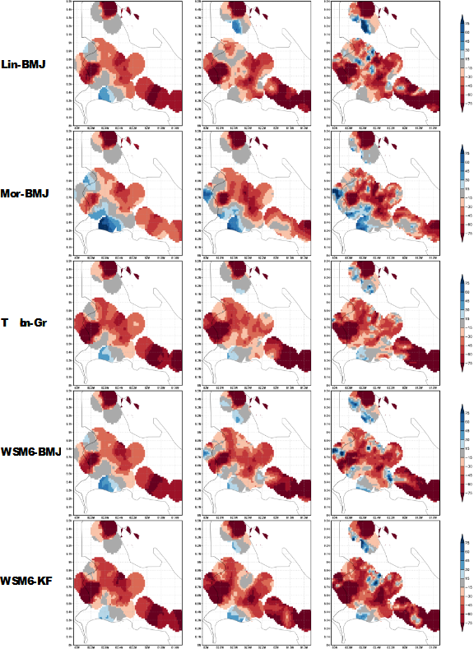
Fig. S12. Difference in millimeters [mm] of DDS 48-hour predicted and interpolated precipitation on 01/Nov/2020 for the different MPS-CPS arrays with resolutions of 56 km (left), 11 km (center) and 2 km (right).

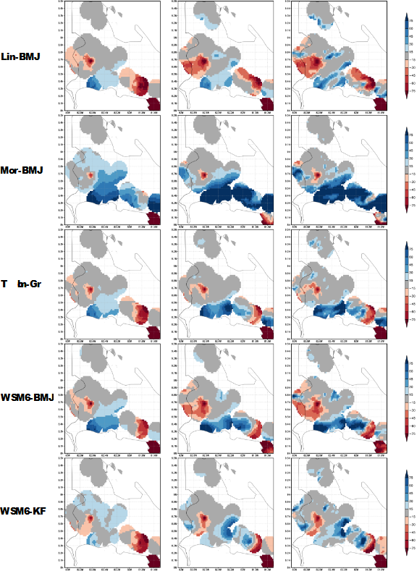
Fig. S13. Difference in millimeters [mm] of DDS 48-hour predicted and interpolated precipitation on 02/Nov/2020 for the different MPS-CPS arrays with resolutions of 56 km (left), 11 km (center) and 2 km (right).

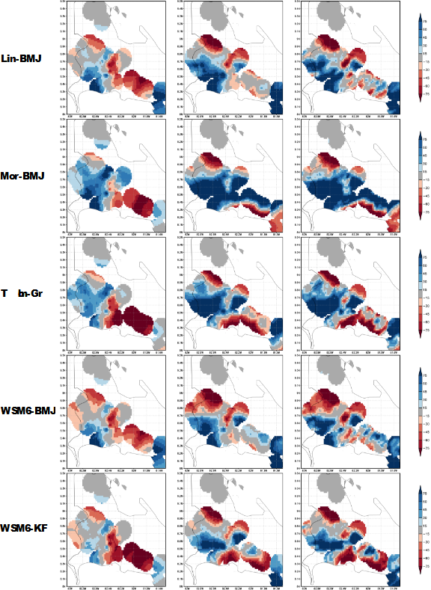
Fig. S14. Difference in millimeters [mm] of DDS 48-hour predicted and interpolated precipitation on 03/Nov/2020 for the different MPS-CPS arrays with resolutions of 56 km (left), 11 km (center) and 2 km (right).

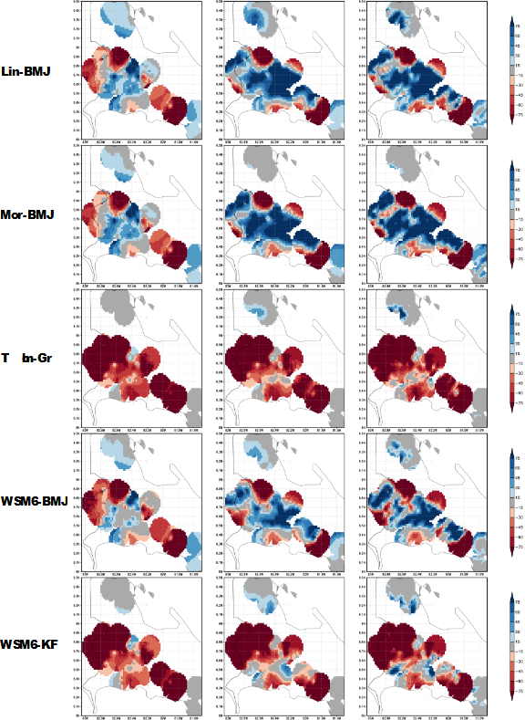
Fig. S15. Difference in millimeters [mm] of DDS 48-hour predicted and interpolated rainfall on 04/Nov/2020 for the different MPS-CPS arrays with resolutions of 56 km (left), 11 km (center) and 2 km (right).

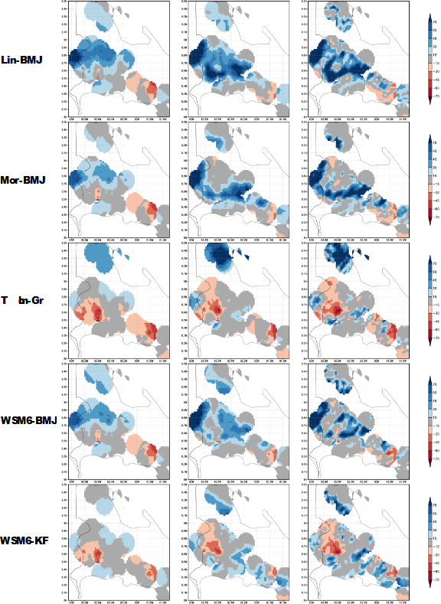
Fig. S16. Difference in millimeters [mm] of DDS 48-hour predicted and interpolated precipitation on 05/Nov/2020 for the different MPS-CPS arrays with resolutions of 56 km (left), 11 km (center) and 2 km (right).

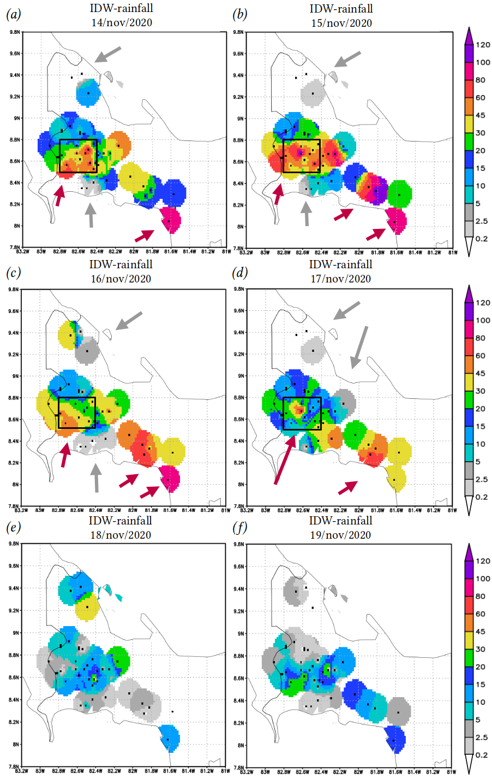
Fig. S17. Interpolated daily precipitation in millimeters [mm] from the IMHPA weather station network for the days of the IOTA event. Precipitation maxima are indicated with magenta arrows and minima with gray arrows.

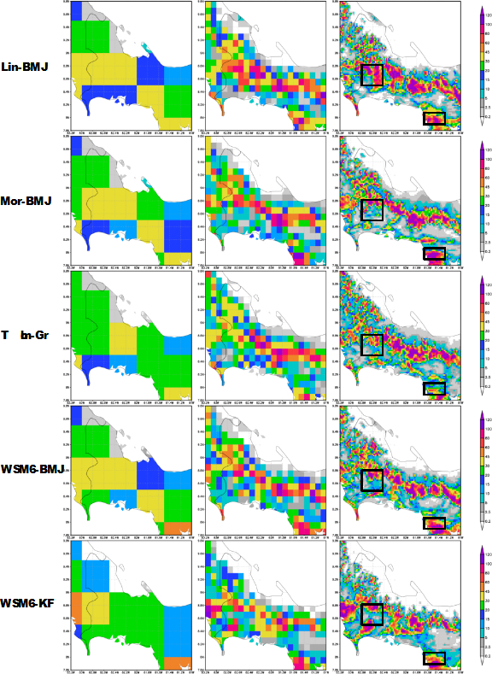
Fig. S18. Daily precipitation in millimeters [mm] predicted at 24 hours for 14/Nov/2020 from the different MPS-CPS arrays with resolutions of 56 km (left), 11 km (center) and 2 km (right).
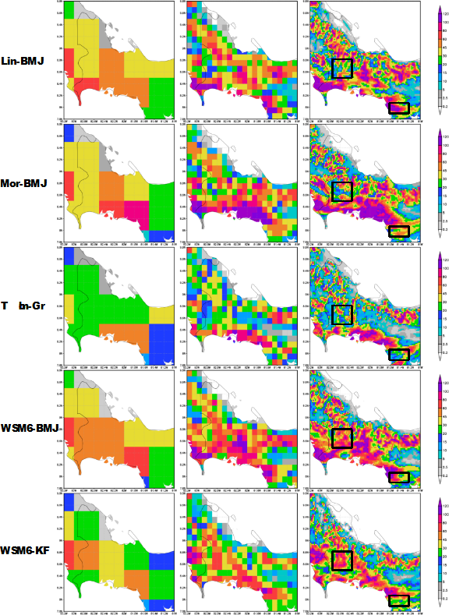
Fig. S19. Daily precipitation in millimeters [mm] predicted at 24 hours for 15/Nov/2020 from the different MPS-CPS arrays with resolutions of 56 km (left), 11 km (center) and 2 km (right).

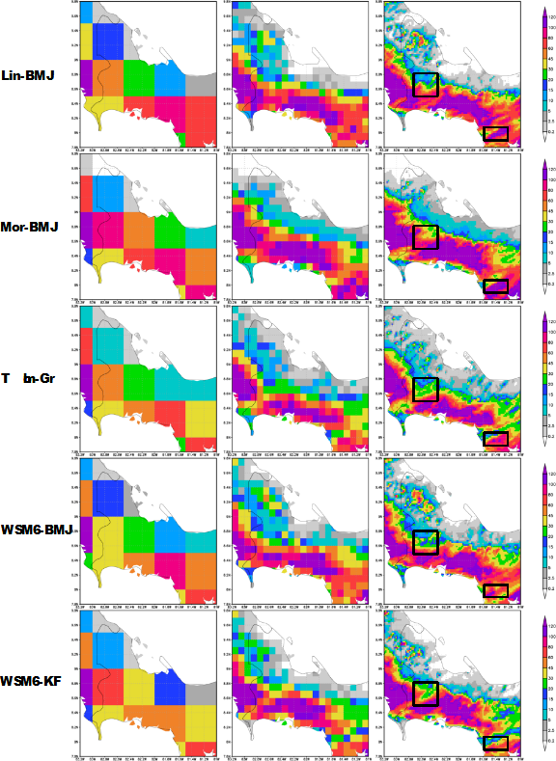
Fig. S20. Daily precipitation in millimeters [mm] predicted at 24 hours for 16/Nov/2020 from the different MPS-CPS arrays with resolutions of 56 km (left), 11 km (center) and 2 km (right).
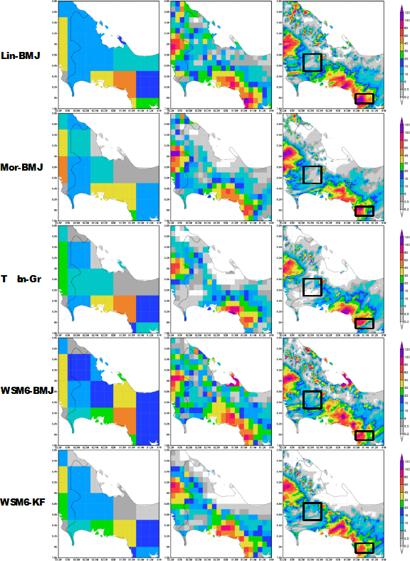
Fig. S21. Daily precipitation in millimeters [mm] predicted at 24 hours for 17/Nov/2020 from the different MPS-CPS arrays with resolutions of 56 km (left), 11 km (center) and 2 km (right).

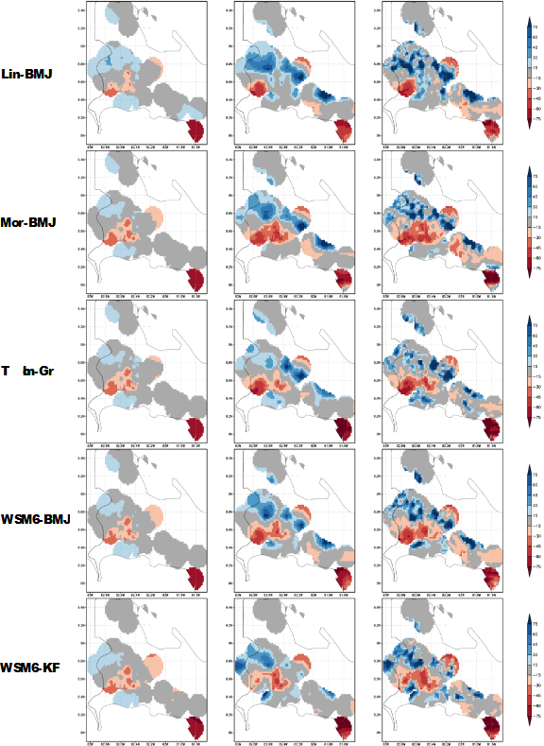
Fig. S22. Difference in millimeters [mm] of DDS 24-hour predicted and interpolated rainfall on 14/Nov/2020 for the different MPS-CPS arrays with resolutions of 56 km (left), 11 km (center) and 2 km (right).

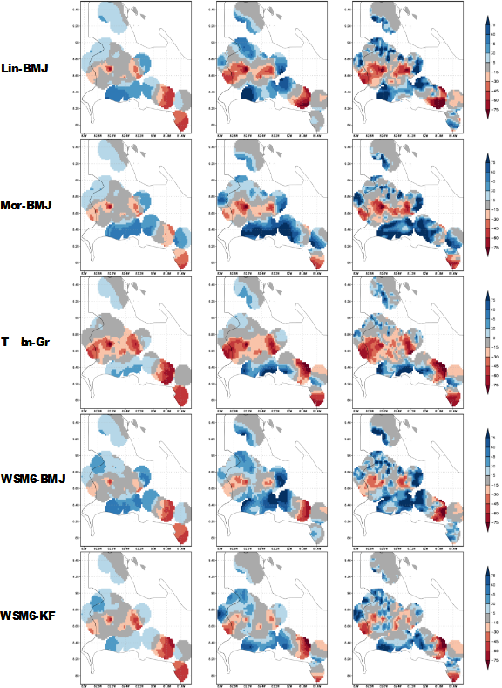
Fig. S23. Difference in millimeters [mm] of DDS 24-hour predicted and interpolated precipitation on 15/Nov/2020 for the different MPS-CPS arrays with resolutions of 56 km (left), 11 km (center) and 2 km (right).
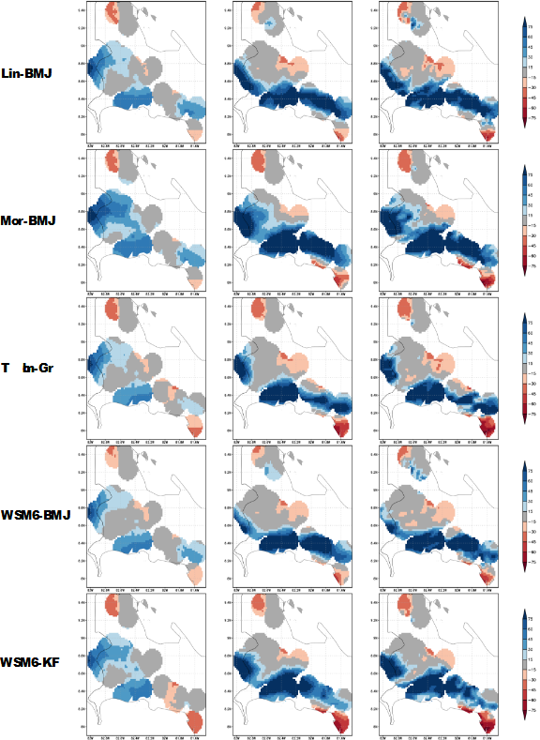
Fig. S24. Difference in millimeters [mm] of DDS 24-hour predicted and interpolated precipitation on 16/Nov/2020 for the different MPS-CPS arrays with resolutions of 56 km (left), 11 km (center) and 2 km (right).

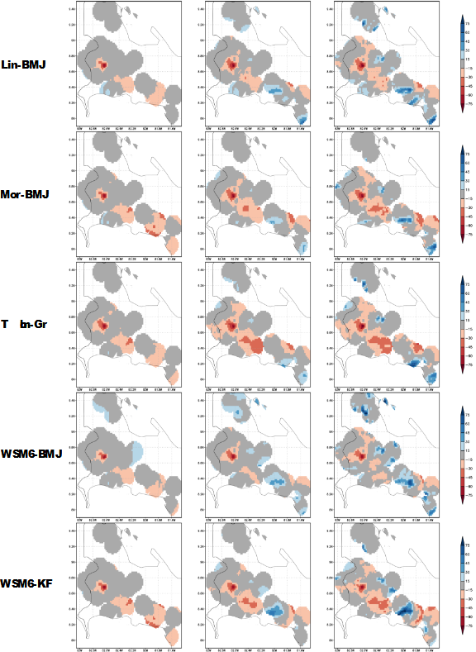
Fig. S25. Difference in millimeters [mm] of DDS 24-hour predicted and interpolated rainfall on 17/Nov/2020 for the different MPS-CPS arrays with resolutions of 56 km (left), 11 km (center) and 2 km (right).

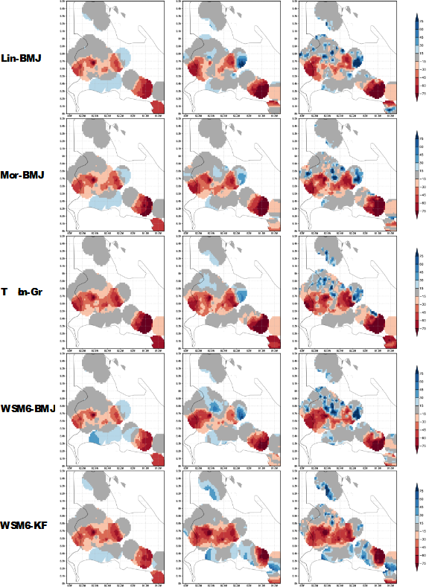
Fig. S26. Difference in millimeters [mm] of DDS 48-hour predicted and interpolated precipitation on 15/Nov/2020 for the different MPS-CPS arrays with resolutions of 56 km (left), 11 km (center) and 2 km (right).

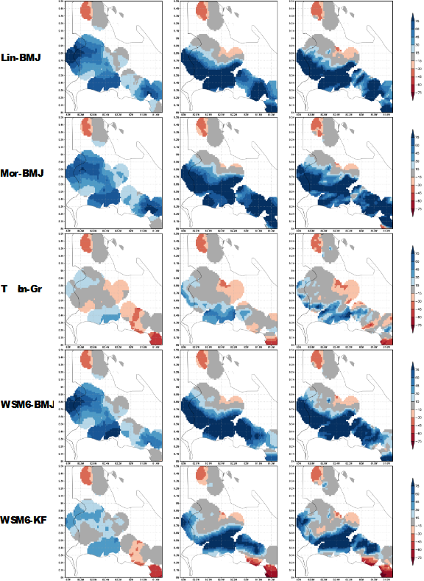
Fig. S27. Difference in millimeters [mm] of DDS 48-hour predicted and interpolated precipitation on 16/Nov/2020 for the different MPS-CPS arrays with resolutions of 56 km (left), 11 km (center) and 2 km (right).

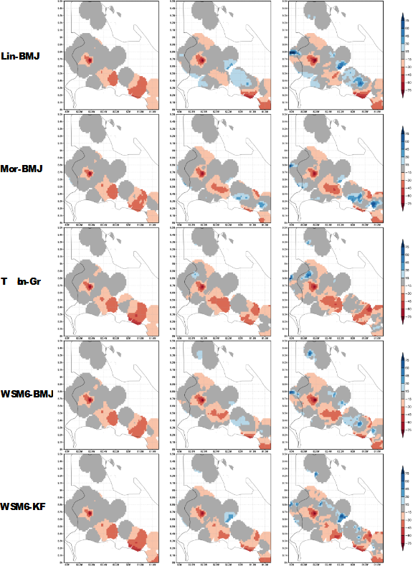
Fig. S28. Difference in millimeters [mm] of DDS 48-hour predicted and interpolated rainfall on 17/Nov/2020 for the different MPS-CPS arrays with resolutions of 56 km (left), 11 km (center) and 2 km (right).

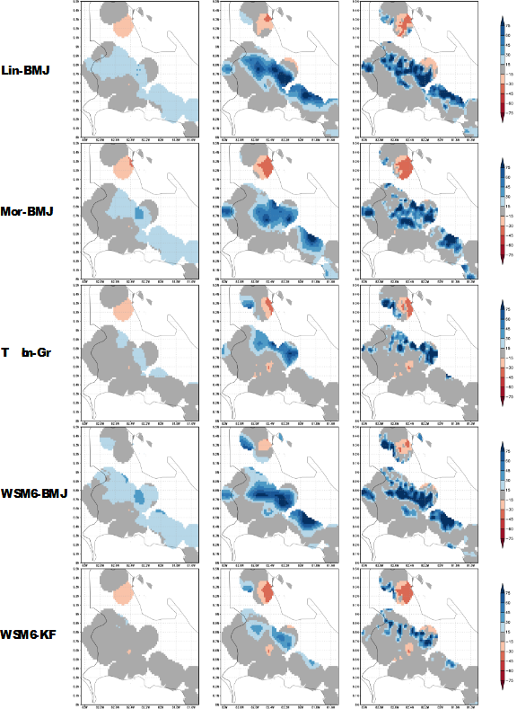
Fig. S29. Difference in millimeters [mm] of DDS 48-hour predicted and interpolated precipitation on 18/Nov/2020 for the different MPS-CPS arrays with resolutions of 56 km (left), 11 km (center) and 2 km (right).

References
Environmental Modeling Center (EMC). (2022). NCEP/EMC GFS v16.3 Operational Verification. Last visited 2023-06-25 de https://www.emc.ncep.noaa.gov/users/verification/global/gfs/ops/
NVIDIA (2023). NVIDIA A100 Tensor Core GPU. Cloud & Data Center. https://www.nvidia.com/en-us/data-center/a100/

GFS/GDAS changes since 1991. https://www.emc.ncep.noaa.gov/gmb/STATS/html/model_changes.html

