Supplementary information:
Observation of mammalian living cells with femtosecond single pulse illumination generated by a soft X-ray free electron laser

Satoru Egawa^{1,8#*}, Kai Sakurai^{2,3}, Yoko Takeo², Kyota Yoshinaga^{2,3}, Masashi Takei⁴, Shigeki Owada^{5,6}, Gota Yamaguchi⁶, Shunya Yokomae⁷, Hidekazu Mimura⁸, Yutaka Yamagata¹, Makina Yabashi^{5,6}, Mari Shimura^{6,9#}, and Takashi Kimura^{2#}

1 RIKEN Center for Advanced Photonics, 2-1 Hirosawa, Wako, Saitama 351-0198, Japan
2 The institute for Solid State Physics, The University of Tokyo, 5-1-5 Kashiwanoha, Kashiwa-shi, Chiba 277-8581, Japan
3 Department of Applied Physics, School of Engineering, The University of Tokyo, 7-3-1 Hongo, Bunkyo-ku, Tokyo 113-8656, Japan
4 Research Institute for Electronic Science, Hokkaido University, Kita 21, Nishi 10, Kita-ku, Sapporo 001-0021, Japan
5 Japan Synchrotron Radiation Research Institute (JASRI), 1-1-1 Kouto, Sayo-cho, Sayo-gun, Hyogo 679-5198, Japan
6 RIKEN SPring-8 Center, 1-1-1 Kouto, Sayo-cho, Sayo-gun, Hyogo 679-5198, Japan
7 Technology Center, Natsume Optical Corporation, 1200-29 Kawaji, Iida, Nagano 399-2431, Japan
8 Research Center for Advanced Science and Technology, The University of Tokyo, 4-6-1 Komaba, Meguro-ku, Tokyo, 153-8904, Japan
9 Research Institute, National Center for Global Health and Medicine, Tokyo 162-8655, Japan
#These three authors contributed equally.
*corresponding author
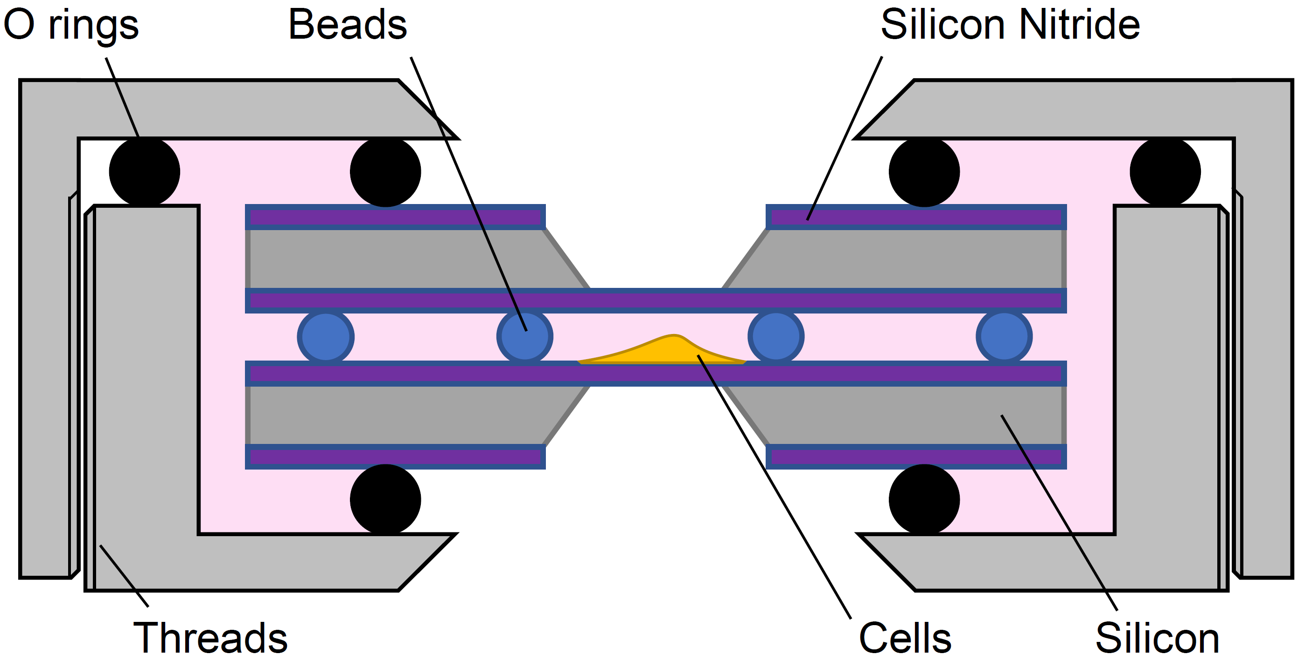
Supplementary Fig. 1. Schematic illustration of a liquid cell holder. Cells are plated on a 100-nm-thick silicon nitride window supported by a silicon chip. φ4.5 μm silica micro rods, serving as spacers, are spread on another chip of silicon nitride window. The two chips, with the cells, the spacers, and ~30 μL Ham’s F-12 medium are overlaid. The assembly is vacuum-sealed using o-rings and a metal housing.
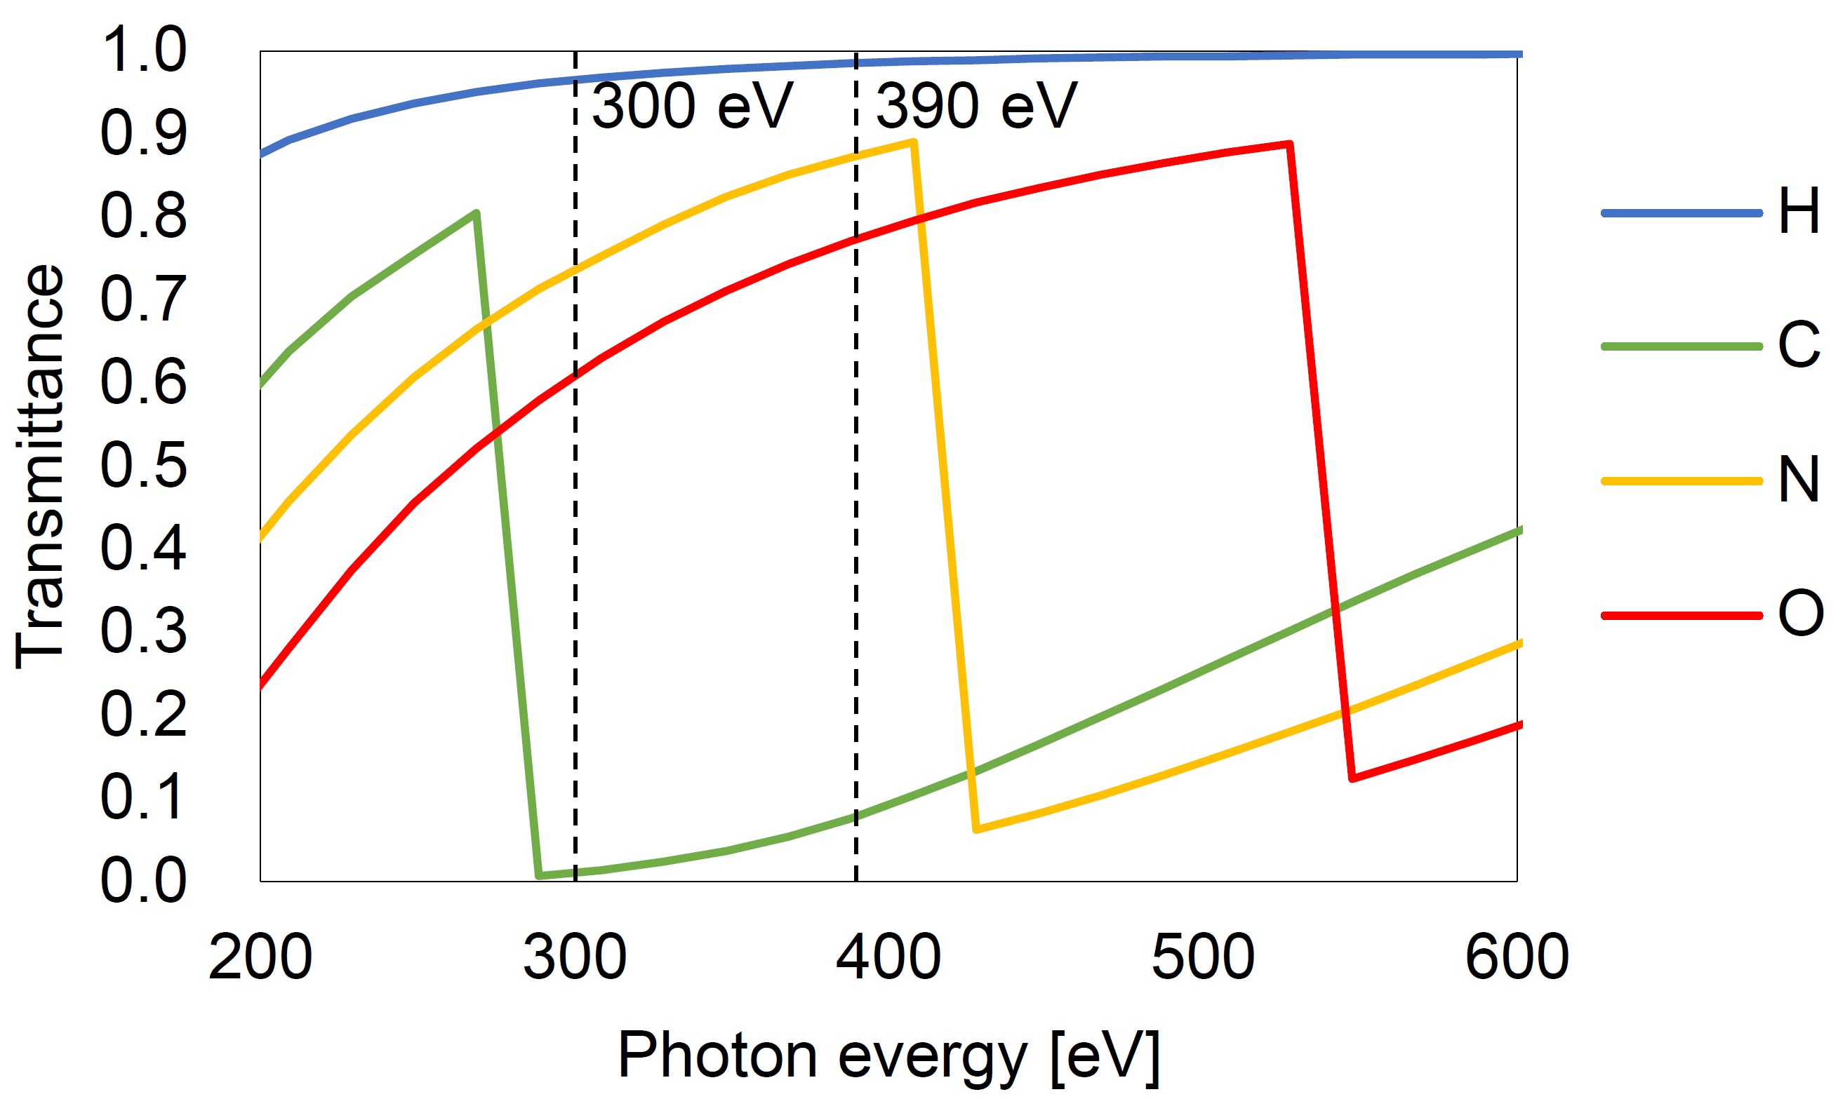
Supplementary Fig. 2. Photon energy dependence of soft X-ray transmittance against hydrogen, carbon, nitrogen, and oxygen¹. A density of 1.0 g/cm³ and thickness of 1.0 μm are assumed for each element. Dashed lines are at photon energies of 300 eV and 390 eV, which are employed in the observation of cells.
Supplementary Fig. 3. Soft X-ray images of CHO K-1 cells in culture medium captured at a photon energy of 390 eV. (a) Image of living cells captured by a single-shot exposure of an SXFEL pulse. Exposure time of the single shot corresponds to the pulse duration of an SXFEL pulse of ~30 fs. (b) The same cells, captured by 15-shot exposure of SXFEL pulses 43 s after the first single shot. Exposure time, 250 ms (15 pulses), (c) (d) Enlarged view at nuclear regions of (a) and (b). Notably, multiple linear carbon path-like structures extending between the central nucleolus and the nuclear membrane were found. Orange arrows in (c) point to carbon-dense regions at the nuclear membrane. Scale bar, 5 μm.
Supplementary Fig. 4. Soft X-ray images of CHO K-1 cells in culture medium at a photon energy of 390 eV. (a) (b) Cells captured by single-shot and multi-shot exposures of SXFEL pulses in Fig. 2. (c) (d) Enlarged view of the area framed by the orange dashed rectangle in (a) and (b). Multiple dark spots (<1 μm) were observed in the cytoplasm in a single-shot image in (c), which was confirmed by the multi-shot image with high contrast in (d). Similar spots were observed in approximately 20% of the cells we observed. Scale bar, 5 μm.
Supplementary Fig. 5. Soft X-ray image of a test chart at a photon energy of 390 eV. The white dashed circle corresponds to the resolution limit of the bar spacing of 230 nm. Scale bar, 5 μm.
Supplementary Fig. 6. Soft X-ray image of a CHO K-1 cell fixed with 2% paraformaldehyde (see Supplementary Method 1). The image was generated by stitching 11 individual frames, each obtained with 100 exposures of 330 eV soft X-ray pulses. Scale bar, 5 µm.

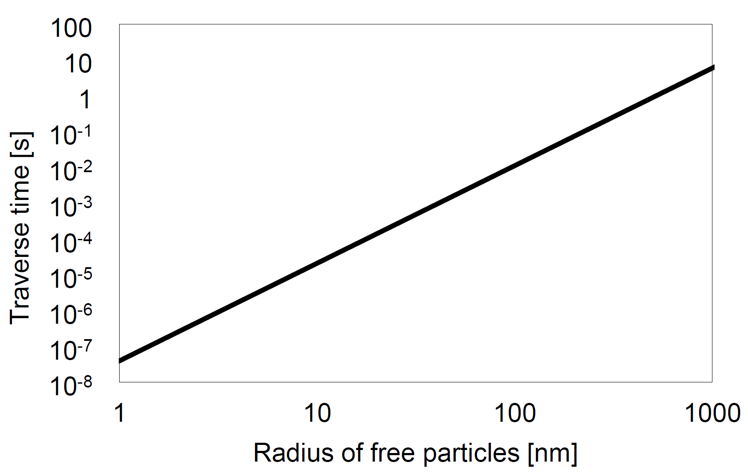
Supplementary Fig. 7. Time for which free biomolecules in culture medium traverse their own diameter by Brownian motion. The calculation is detailed in the Methods section. The temperature and viscosity of the culture medium is assumed to be 300 K and 1.0 mPa$∙$s, respectively.
Supplementary Fig. 8. Time-course soft X-ray images of CHO K-1 cells in culture medium at a photon energy of 300 eV (see Supplementary Method 2). (a) The 1st image was captured with a single-pulse exposure, while the 2nd image and beyond were taken with 100-pulse exposures (b-e). Displayed images are the 1st, 2nd, 10th, 20th, and 31st. Scale bar, 5 µm.
As exposure accumulates, a hazy pattern emerges in the cytoplasm, nucleus, and even outside the cells. The size of the cell, nucleus, and nucleolus-like structure with a high-signal-intensity seemed reduced. Previous literature reports that clear structural changes are observed in initially living cells at 10⁴ Gray², which is consistent with this experiment.

Supplementary Fig. 9. Frequency domain filtering for elimination of stripe pattern due to the distorted wavefront of the illumination. (a) Intensity distribution of the two-dimensional frequency domain filter. Frequency components in the black region are cut off, and those in the white region are preserved. (b) An image of cells before the frequency domain filter is applied. (c) An image of cells after the frequency domain filter is applied.

Supplementary Method 1: Preparation of paraformaldehyde-fixed cells
To compare the morphology of chemically fixed cells and living cells in culture medium, we observed paraformaldehyde-fixed CHO K-1 cells. The RBRC-RCB02859 CHO-K1 cell line was obtained from RIKEN Cell Bank of Japan (Tsukuba, Japan). Cells were maintained in Ham’s F-12 medium (Nakalai Tesque, Kyoto, Japan) supplemented with 10% heat-inactivated fetal calf serum (104387; Gibco, Grand Island, NY, USA). Cells were plated on a silicon nitride membrane supported by a silicon chip, which has 9 silicon nitride windows with 200 nm thickness, 150 μm x 500 μm size. The cells were treated with fluorescent yellow silica beads (120 nm diameter, 797871, Sigma Aldrich, St. Louis, MO, USA) at 83 μM, 37°C for overnight. It should be noted that fluorescent beads were introduced to the cells because the fixed cells used in this observation were originally prepared for another experiment involving visible light fluorescence observation. Soft X-ray images of a paraformaldehyde-fixed CHO K-1 cell without the fluorescent beads, observed by ptychographic phase retrieval, are also presented in our previous study³. After treatment, the cells were washed twice with phosphate-buffered saline (PBS (-)) (P-4417, Sigma-Aldrich, St. Louis, MO, USA) containing 10% FBS and then once with PBS (-). The cells were fixed with 2% paraformaldehyde (18814, ultra-pure EM grade; Polysciences, Inc., Warrington, PA, USA) in PBS (-) for 10 min. The plates were washed with PBS (-) once and Milli-Q water 3 times, air-dried, and stored in clean tubes.
Supplementary Fig. 6 shows an image of a paraformaldehyde-fixed CHO K-1 cell that was generated by stitching 11 image patches. Each image patch was captured by exposure of 100 shots of soft X-ray pulses at a photon energy of 330 eV.

Supplementary Method 2 Time-course observation of cells under repetitive exposure of soft X-ray pulses
We investigated the influence of soft X-ray damage on the structure of living cells by repeatedly irradiating them with soft X-rays and observing the changes over time. SXFEL pulses at a photon energy of 300 eV were used. The radiation dose applied to the cells per soft X-ray pulse was estimated to be 140 Gy. For estimation of the radiation dose, the energy of the incident pulse was converted to the radiation dose assuming that the thickness of the CHO K-1 cells is 4.5 μm and its density is 1.0 g/cm³.
Initially, cells were exposed to a single pulse, followed by 100 pulses of exposure every 13 seconds. Images of the cells at initial exposure, second exposure (first exposure in the multi-shot series), and at 10th, 20th, and 31st exposures are shown in Supplementary Fig. 9 a, b, c, d, e, respectively.

Supplementary References
- Henke, B. L., Gullikson, E. M. & Davis, J. C. X-Ray Interactions: Photoabsorption, Scattering, Transmission, and Reflection at E = 50-30,000 eV, Z = 1-92. At. Data Nucl. Data Tables 54, 181–342 (1993).
- Kirz, J., Jacobsen, C. & Howells, M. Soft X-ray microscopes and their biological applications. Q. Rev. Biophys. 28, 33–130 (1995).
3. Kimura, T. et al. Soft X-ray ptychography system using a Wolter mirror for achromatic illumination optics. Opt. Express 30, 26220–26228 (2022).

