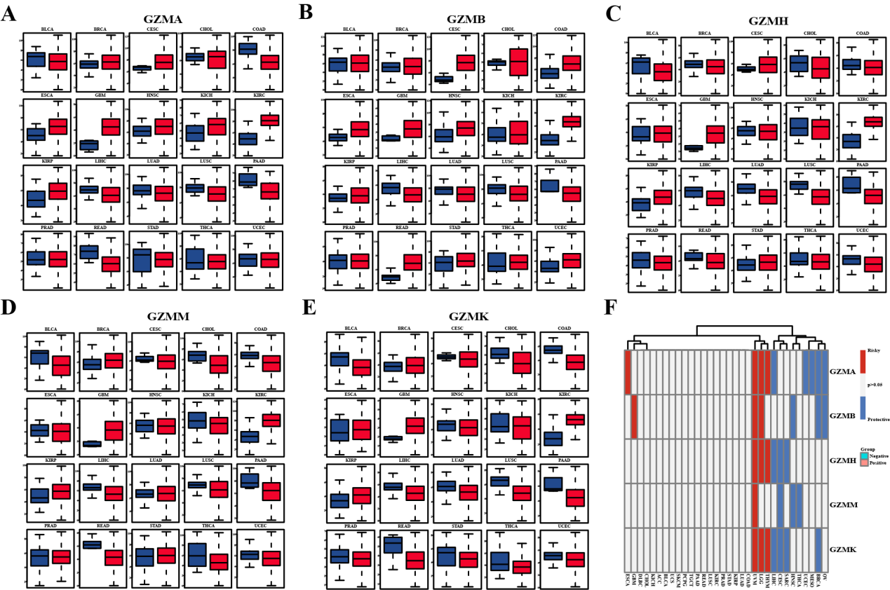
Figure S1: Expression Patterns and Prognostic Value of GZM Gene Family in Pan-cancer. (A-E) Box plots depict the expression distribution of GZMA, GZMB, GZMH, GZMM, and GZMK in tumor samples and normal samples within pan-cancer. (F) Prognostic value of the GZM gene family analyzed by the log-rank test. Red indicates a correlation between high expression of granulysin and poorer survival rate, while blue indicates a correlation with better survival rate.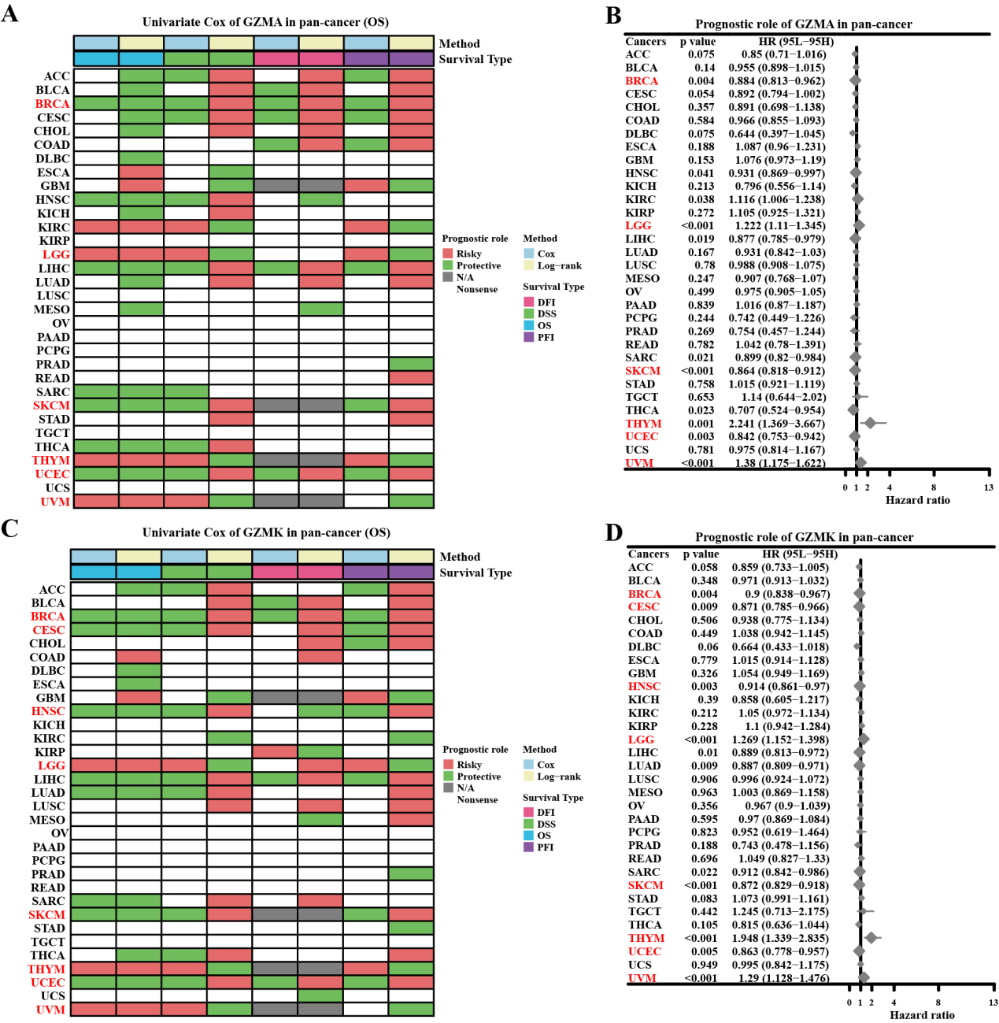
Figure S2: The association between GZMA, GZMK, and overall cancer survival. (A) The correlation between GZMA expression and overall survival (OS), disease-specific survival (DSS), disease-free interval (DFI), and progression-free interval (PFI) in cancer patients was assessed using univariate Cox regression and Kaplan-Meier models. Red color indicates that GZMA is a risk factor affecting the prognosis of cancer patients, while green color indicates a protective factor. Only results with P<0.05 are displayed. (B) The forest plot illustrates the prognostic role of GZMA in cancer using the univariate Cox regression method. Red color for cancer types represents statistically significant risk factors. (C) The correlation between GZMK expression and overall survival (OS), disease-specific survival (DSS), disease-free interval (DFI), and progression-free interval (PFI) in cancer patients was analyzed using univariate Cox regression and Kaplan-Meier models. Red color indicates that GZMK is a risk factor affecting the prognosis of cancer patients, while green color indicates a protective factor. Only results with P<0.05 are displayed. (D) The forest plot illustrates the prognostic role of GZMK in cancer using the univariate Cox regression method. Red color for cancer types represents statistically significant risk factors.
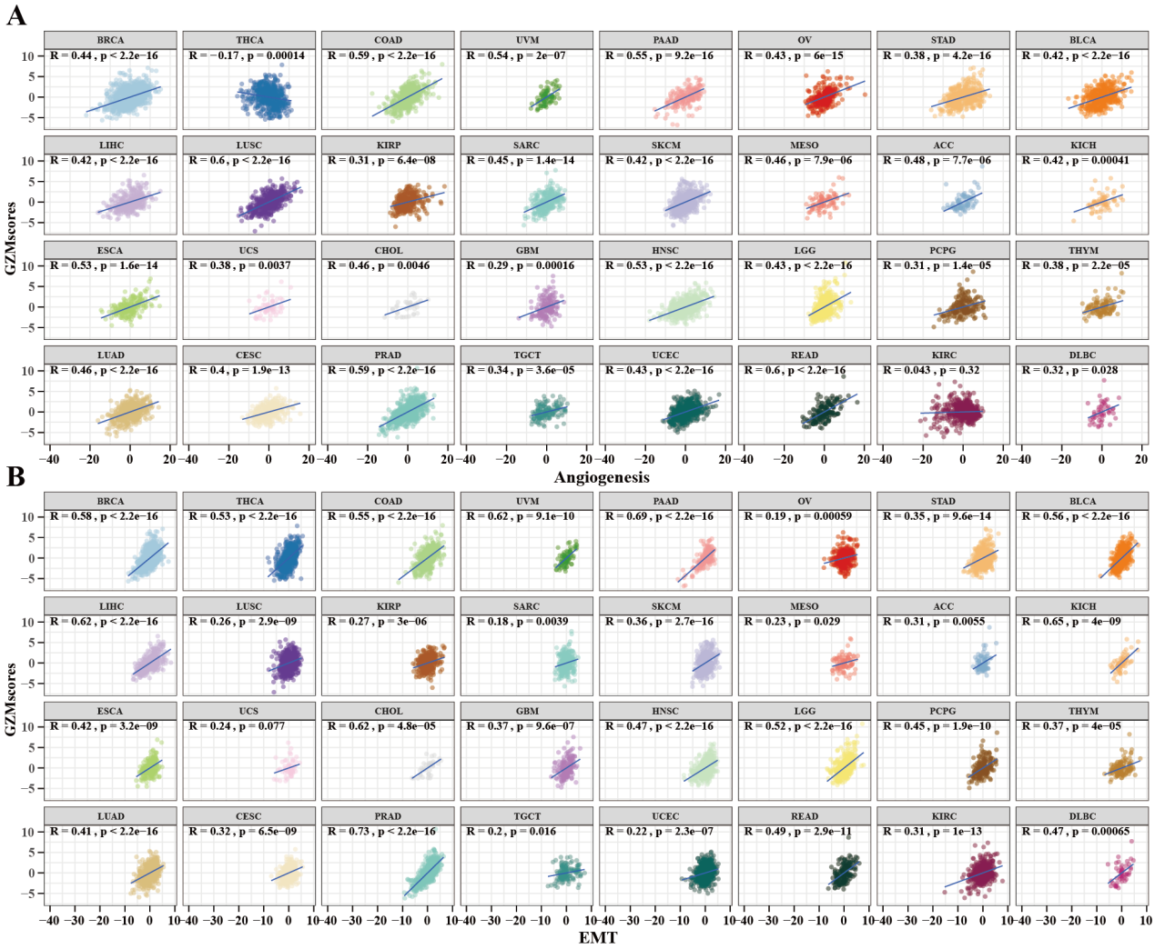
Figure S3: Correlation between GZMscores and malignant features of vascular generation and EMT in pan-cancer. (A) Correlation between GZM scores and malignant features of vascular generation in pan-cancer. (B) Correlation between GZM scores and malignant features of vascular generation in pan-cancer.
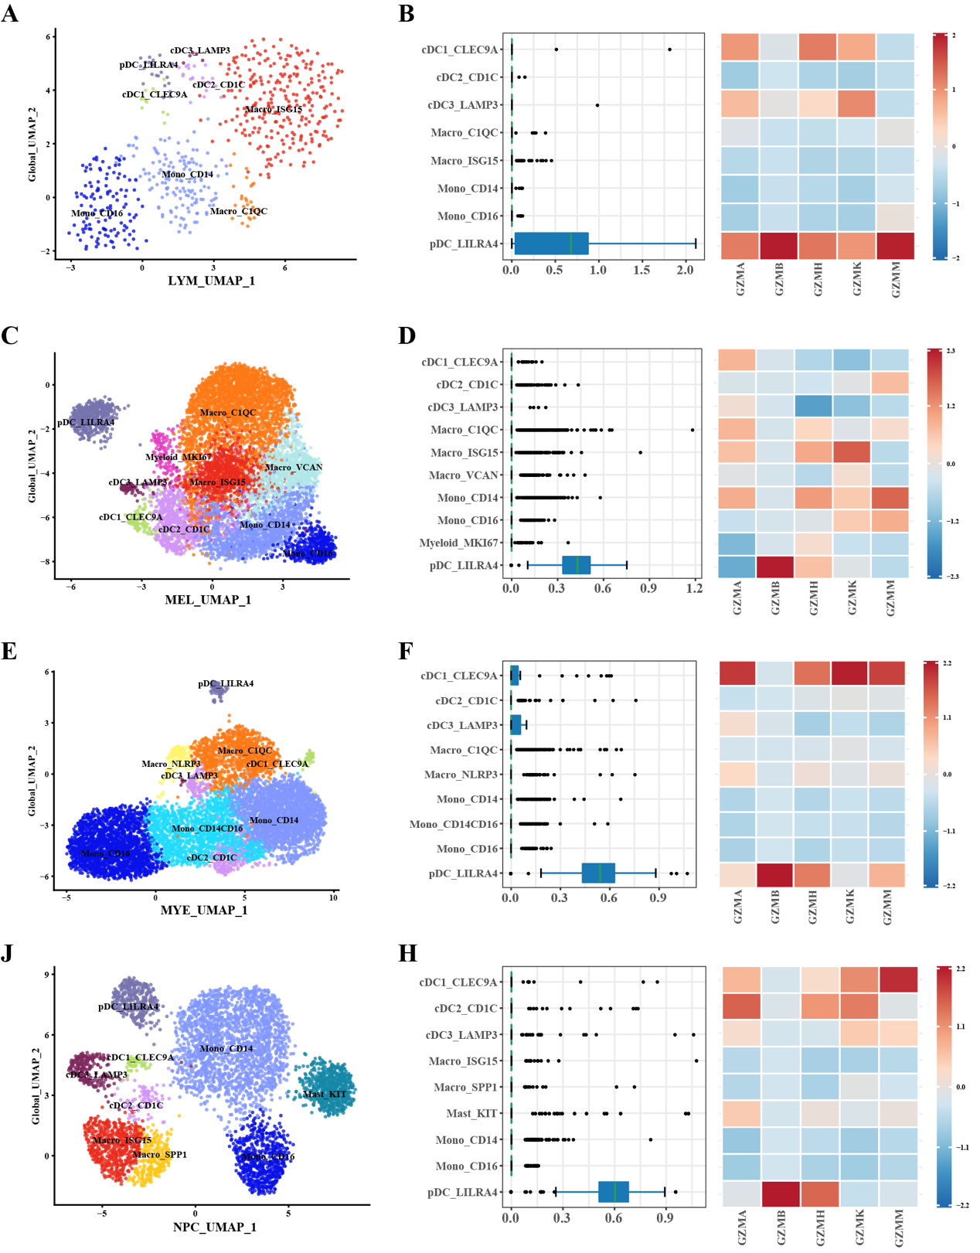
Figure S4: The expression of the GZM gene family in different cell subgroups within LYMPHOMA (LYM), MELANOMA (MEL), MYELOMA (MYE), and NASOPHARYNGEAL CARCINOMA (NPC) cancer tissues' myeloid cells. (A) UMAP visualization of cell subgroups in myeloid cells from LYM cancer tissues. (B) Heatmap illustrating the expression levels of the GZM gene family in myeloid cells from LYM. (C) UMAP visualization of cell subgroups in myeloid cells from MEL cancer tissues. (D) Heatmap illustrating the expression levels of the GZM gene family in myeloid cells from MEL. (E) UMAP visualization of cell subgroups in myeloid cells from MYE cancer tissues. (F) Heatmap illustrating the expression levels of the GZM gene family in myeloid cells from MYE. (G) UMAP visualization of cell subgroups in myeloid cells from NPC cancer tissues. (H) Heatmap illustrating the expression levels of the GZM gene family in myeloid cells from NPC.

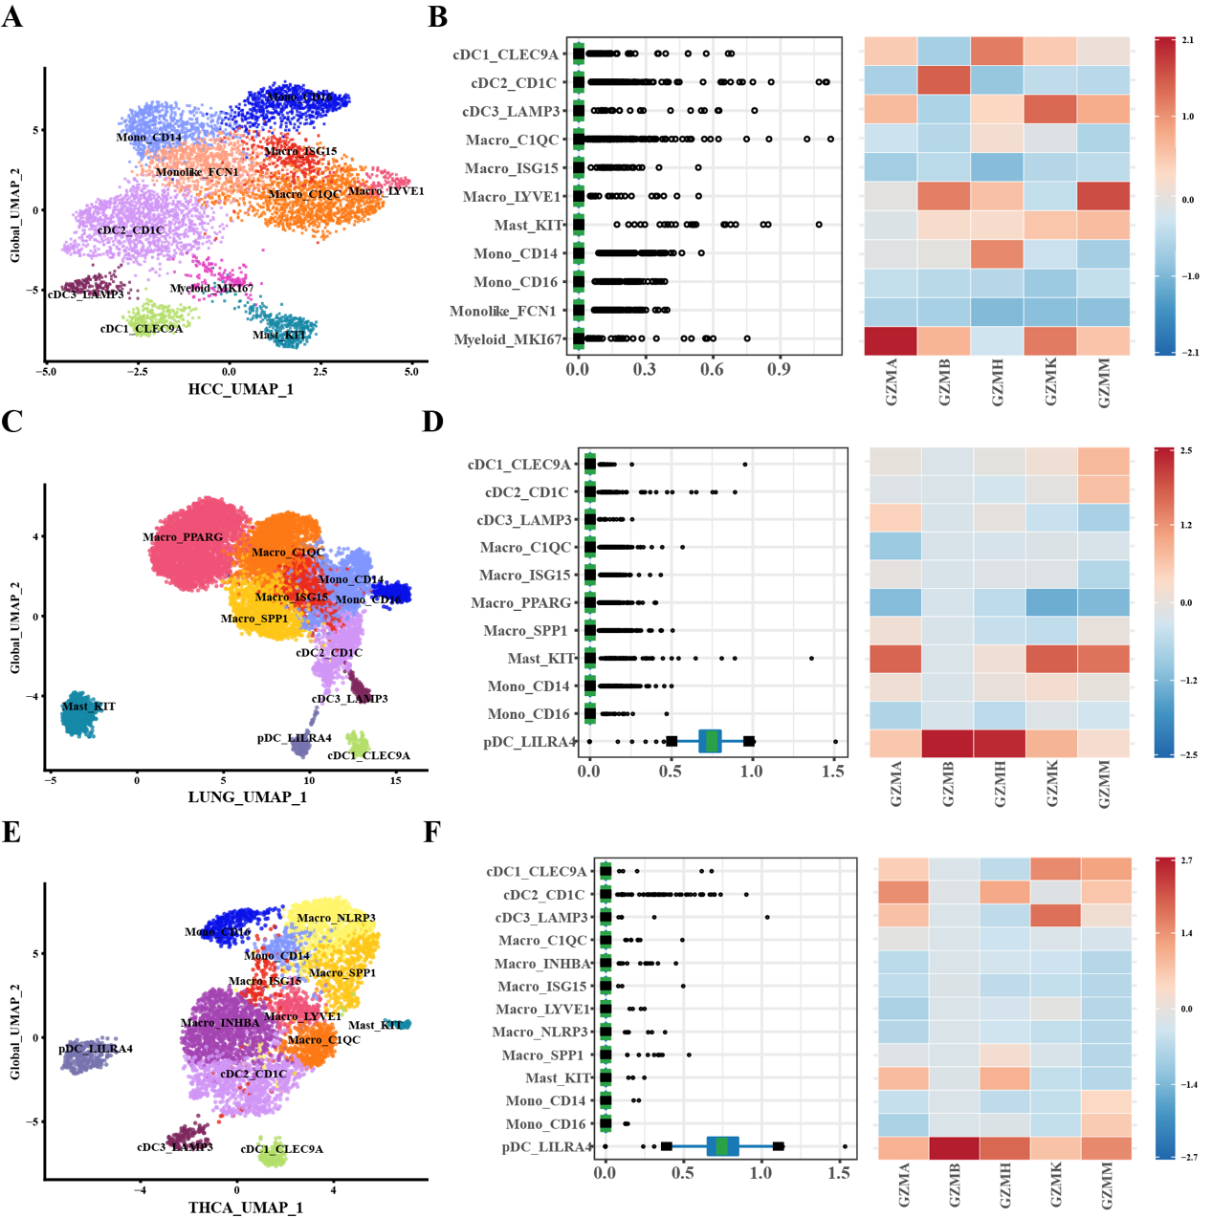
Figure S5: Depicts the expression of subpopulations of myeloid cells in HCC (hepatocellular carcinoma), lung cancer (LUNG), and thyroid carcinoma (THCA) tissues was analyzed for the GZM gene family. (A) UMAP visualization of myeloid cell subpopulations in HCC cancer tissue. (B) Heatmap illustrating the expression levels of the GZM gene family in myeloid cell subpopulations in HCC. (C) UMAP visualization of myeloid cell subpopulations in lung cancer tissue. (D) Heatmap illustrating the expression levels of the GZM gene family in myeloid cell subpopulations in lung cancer. (E) UMAP visualization of myeloid cell subpopulations in thyroid carcinoma tissue. (F) Heatmap illustrating the expression levels of the GZM gene family in myeloid cell subpopulations in thyroid carcinoma.
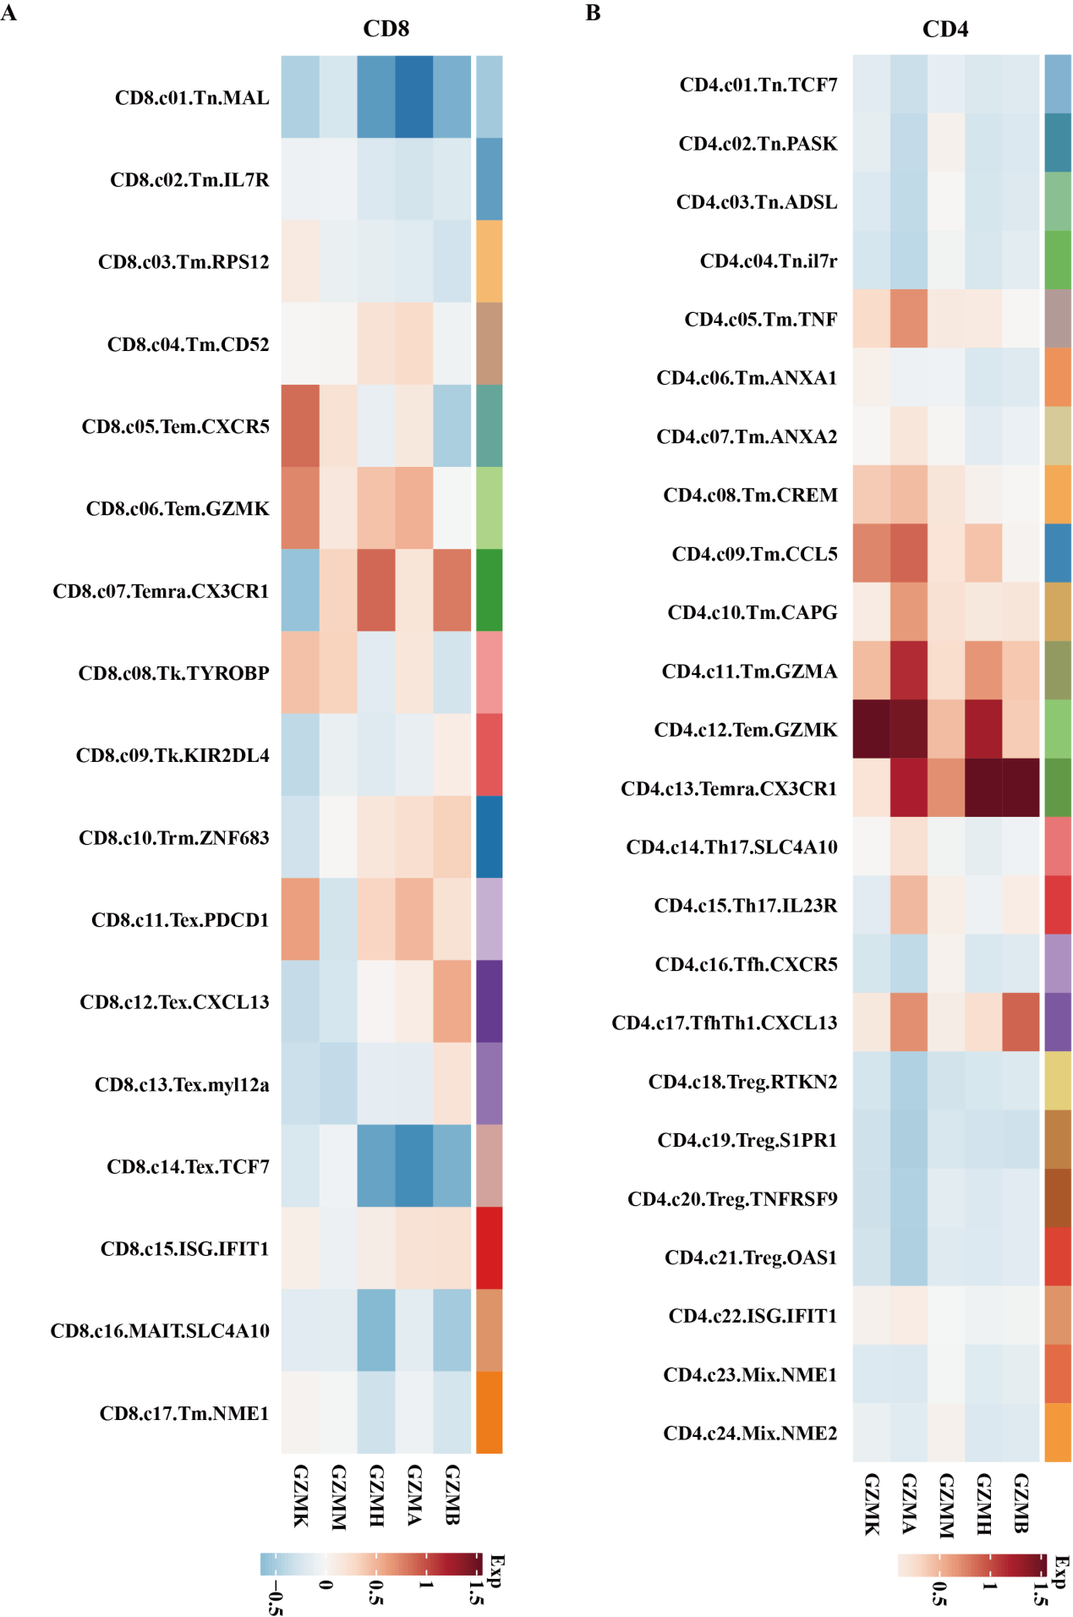
Figure S6: Depicts the expression of the GZM gene family in cellular subsets of CD8+ and CD4+ T cells in a generalized cancer context. Panel A shows the expression of the GZM gene family in cellular subsets of CD8+ T cells in generalized cancer. Panel B exhibits the expression of the GZM gene family in cellular subsets of CD4+ T cells in generalized cancer.

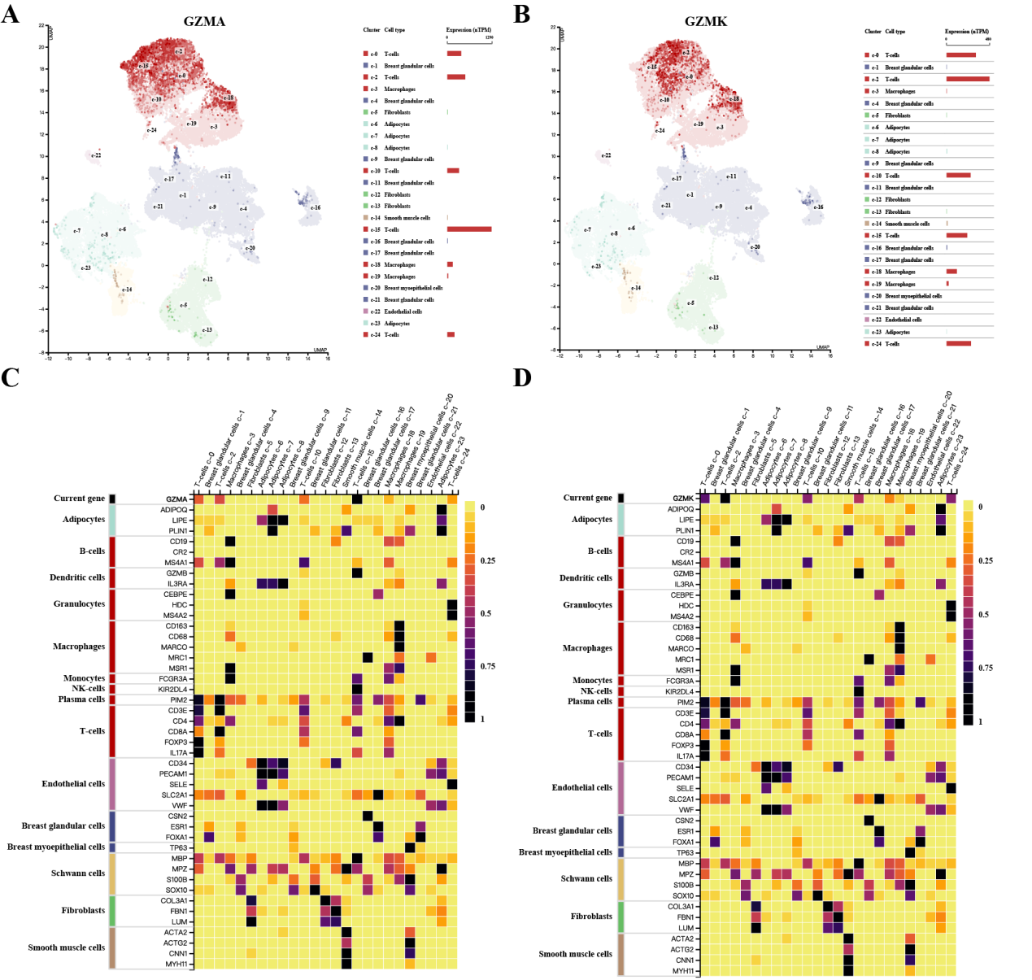
Figure S7: Depicts the RNA expression of GZMA and GZMK in identified single-cell type clusters in breast cancer. The expression of GZMA in various breast cancer tissues and cell clusters is visualized in (A) UMAP plot. The correlation between the expression of GZMA and cell markers in different cell clusters within breast cancer tissues is displayed in (B) bar plot. Both visualizations are based on analyses using The Human Protein Atlas database.

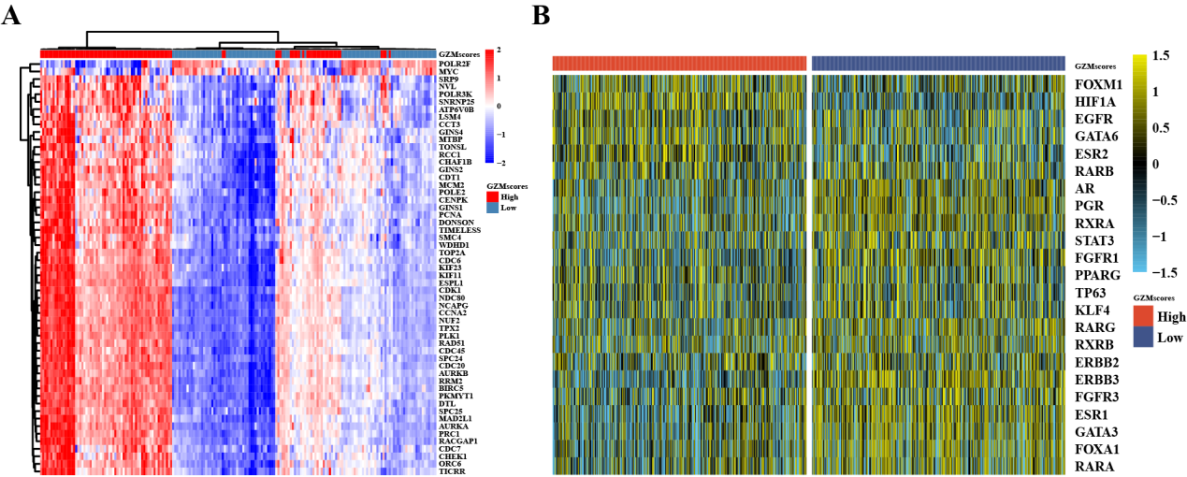
Figure S8: The identification of essential genes closely associated with GZMscores in breast cancer and the regulatory landscape of transcription factors in high and low GZMscores are depicted in FIGURE S8. (A) Heatmap showing significant differential gene expression in BRCA tumor tissue compared to paired normal tissue, as revealed by RNA sequencing data from TCGA. (B) Heatmap illustrating the regulatory activity profiles of 23 transcription factors.

