Supplementary Information
Effects of water level fluctuations on the trophic state of a connected lacustrine system (Southern Andes, Patagonia, Argentina): applicability of the CDOM method as a monitoring tool of eutrophication
Diamela Gianello^{1*}• Mariana Reissig¹ • Gonzalo L. Pérez¹ • Magalí Rechencq² • Lucía G. De Stefano¹ • Claudia Queimaliños¹
¹ GESAP (Grupo de Ecología de Sistemas Acuáticos a escala de Paisaje), Instituto de Investigaciones en Biodiversidad y Medioambiente (INIBIOMA), Universidad Nacional del Comahue, CONICET, Quintral 1250, Bariloche (8400), Argentina
² GEMaRI (Grupo de Evaluación y Manejo de Recursos Ícticos), Instituto de Investigaciones en Biodiversidad y Medioambiente (INIBIOMA), Universidad Nacional del Comahue, Quintral 1250, Bariloche (8400), Argentina

*Corresponding author: Diamela Gianello, gianellodiamela@comahue-conicet.gob.ar

Materials and Methods
Brief history about the study site
Prior to 1960, Lake Morenito was not considered as an independent waterbody since it constituted a large inner bay of Lake Moreno West, adjacent to the small bay sampled in the present study. However, the presence of an island of about 6 Ha at the mouth of this bay disrupted the water connection with the rest of the lake considering that the shallowness of the zone favored a profuse development of emergent macrophytes at both sides of the island (Fig. S1). In the summer of 1960, a dirt road of 220 m was built to reach the inhabited island by land, diminishing even more the connection between the bay and the deep part of the lake, mainly when the water level of the system is low during the dry season. A direct connection remains in the other side of the original island, where a channel was dredged through the aquatic vegetation allowing the navigation of small to median sized boats.

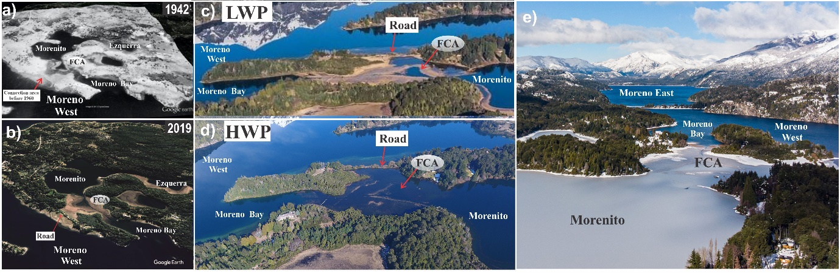Fig. S1: Historical (a) and current (b-e) images illustrating the connection between Morenito and Moreno West through the Floodable Connection Area (FCA) before (a) and after (b-e) road construction in 1960. a) Interconnected lacustrine system before road construction (image from Management Plan ME-UNR, 2016); b) Interconnected lacustrine system after road construction; c) Actual FCA during low water phase; d) Actual FCA during high water phase (image by Matías Etchart); e) freezing of Morenito and FCA during winter 2019.

The bathymetric survey
A predesigned course of equidistant transects was implemented to collect de hydroacoustic data with a Humminbird 999 CI HD Side Scan Sonar. This echosounder was equipped with a 200/455-kilohertz (kHz) 60°-180° dual-beam transducer The shorelines of the lakes during both low and high-water phases, were digitized using geographic information system (GIS) tools over Google Earth images from different seasons of the sampling year. The geo-referenced depth data and the shorelines were used to construct bathymetries by a local Kriging interpolation model built with the ArcGis Geostatistical Analyst tools.
The outcome of this data analysis was the creation of bathymetric maps to estimate the volume and morphometric characteristics of each lake by the GIS geometry polygon tools and empirical formulas. These maps were constructed using 0.3-meter isobaths for Ezquerra and FCA, and 1-meter isobaths for Morenito and Moreno Bay, respectively. The bathymetric maps and the GIS tools allow the estimation of slopes and the predictive map of submerged macrophytes, assuming that the plants can´t grow deeper than 4-meter depth and in areas with high slopes.
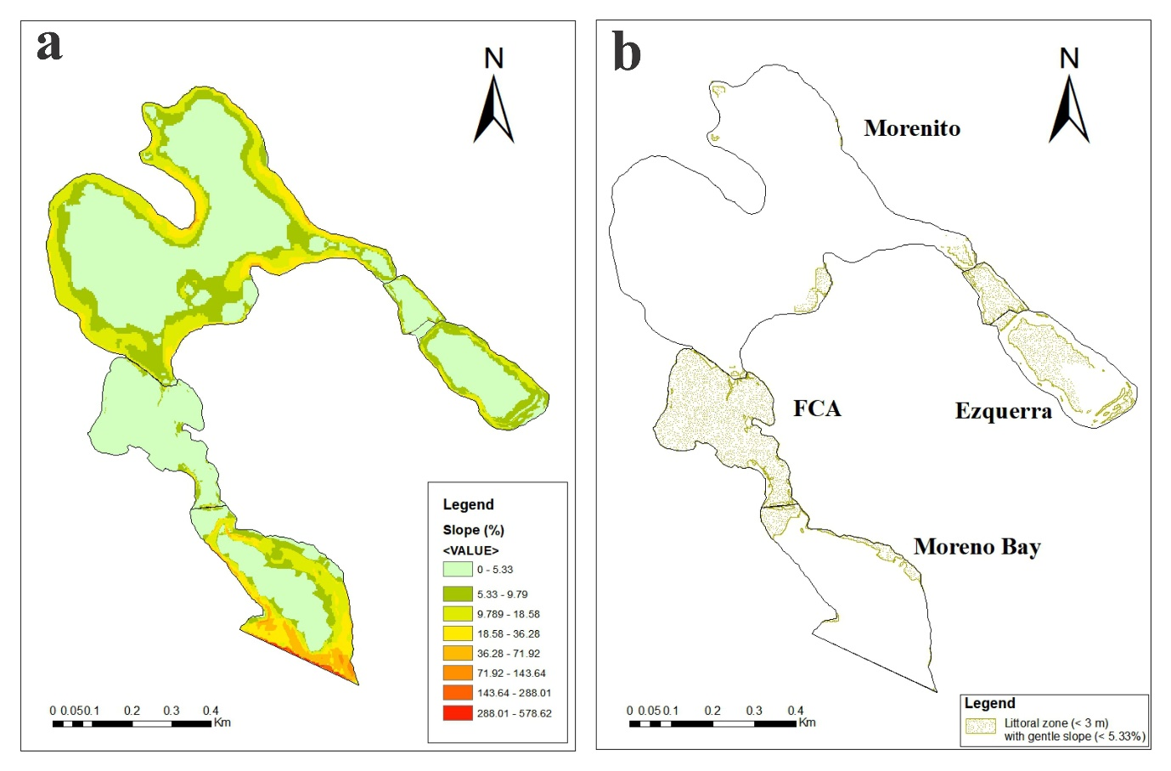
Fig. S2: a) Slope delimitation in the studied lakes b) predictive map of submerged macrophytes development area (littoral zone with gentle slope) (Source: own elaboration based on bathymetric information).
Table S1: Equations for calculating TSI according to Zhang et al. (2018) and Wei et al. (2019). Numbers in parentheses indicate the number of samples used in each calculation. TSI(Chla), TSI(TN), and TSI(TP), and TSI(SDD) indicate trophic state indexes in relation to Chla, TN, and TP and SDD, respectively.
TSI Zhang (140) | TSI Wei (180)
Eq. 1) TSI = 0.326 × TSI (Chla) + 0.219 × TSI (TN) + 0.230 × TSI (TP) + 0.225 × TSI (SDD) | Eq. 6) TSI = 0.421 × TSI (Chla) + 0.282 × TSI(TN) + 0.297 × TSI (TP)
Eq. 2) TSI (Chla) = 10 × (2.5 + 1.086 × 1nChla) | Eq. 7) TSI (Chla) = 10 × (2.5 + 1.086 × lnChla)
Eq. 3) TSI (TP) = 10 × (9.436 + 1.624 × 1nTP) | Eq. 8) TSI (TN) = 10 × (5.453 + 1.694 × lnTN)
Eq. 4) TSI (TN) = 10 × (5.453 + 1.694 × 1nTN) | Eq. 9) TSI (TP) = 10 × (9.436 + 1.624 × lnTP)
Eq. 5) TSI (SDD) = 10 × (5.118-1.94 × 1nSDD)

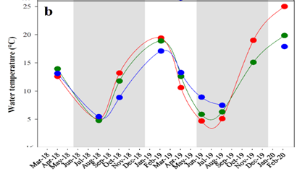
Fig. S3: Temporal dynamics of water temperature registered during the ice-free period: white sections (LWP, dry period); grey sections (HWP, wet period).

Fig. S4: Temporal dynamics of physicochemical parameters during the wet (grey sections) and dry (white sections) periods. a) Conductivity; b) Alkalinity; c) pH and d) DO.

Table S2: Results of the Kruskal–Wallis test comparing physiochemical parameters among lakes*: Ezquerra (E), Morenito (M), floodable connection area (FCA) and Moreno Bay (MB). Letters A, B, C, D indicate different homogeneous groups detected by pairwise comparison tests (Mann Dunn´s test). DO (dissolved oxygen); SDD (Secchi disk depth); TSS (total suspended solids); TP (total phosphorus); TN (total nitrogen); DOC (dissolved organic carbon); TSI (trophic state index).
Variable | n | statistic | df | p | p.signif | Homogeneous groups
 |  |  |  |  |  | E | M | FCA | MB
Temperature (°C) | 180 | 0.206 | 3 | 0.977 | ns | A | A | A | A
Conductivity (µS cm⁻¹) | 180 | 123.64 | 3 | 1.19E-26 | **** | A | A | A | B
Alkalinity (µeq L⁻¹) | 180 | 137.630 | 3 | 1.23E-29 | **** | A | AB | B | B
pH | 180 | 5.531 | 3 | 0.137 | ns | A | A | A | A
DO (mg⁻¹) | 180 | 2.747 | 3 | 0.432 | ns | A | A | A | A
DO saturation (%) | 180 | 2.749 | 3 | 0.432 | ns | A | A | A | A
TSS (mg L⁻¹) | 180 | 82.598 | 3 | 8.50E-18 | **** | A | A | A | B
SDD (m) | 180 | 103.548 | 2 | 3.27E-23 | **** | A | A | - | B
Chla (µg L⁻¹) | 180 | 56.959 | 3 | 2.62E-12 | **** | A | A | A | B
TP (µg L⁻¹) | 180 | 122.967 | 3 | 1.77E-26 | **** | A | A | A | B
TN (µg L⁻¹) | 180 | 139.691 | 3 | 4.41E-30 | **** | A | B | B | C
DOC (mg L⁻¹) | 180 | 149.136 | 3 | 4.05E-32 | **** | A | B | B | C
a₂₅₄ (m⁻¹) | 180 | 149.233 | 3 | 3.86E-32 | **** | A | B | B | C
a₃₅₅ (m⁻¹) | 180 | 151.332 | 3 | 1.36E-32 | **** | A | B | B | C
S₂₇₅₋₂₉₅ (nm⁻¹) | 180 | 131.055 | 3 | 3.20E-28 | **** | A | B | B | C
TSI | 180 | 146.418 | 3 | 1.56E-31 | **** | A | B | B | C
ns: p > 0.05, *: p <= 0.05, **: p <= 0.01, ***: p <= 0.001, ****: p <= 0.0001
*Considering that the assessed physiochemical and optical parameters showed low variability among the sampling sites within each lake and along the water column (statistical data not shown), the comparison among lakes was based on the mean values of these variables obtained for each lake and/or section in each sampling date

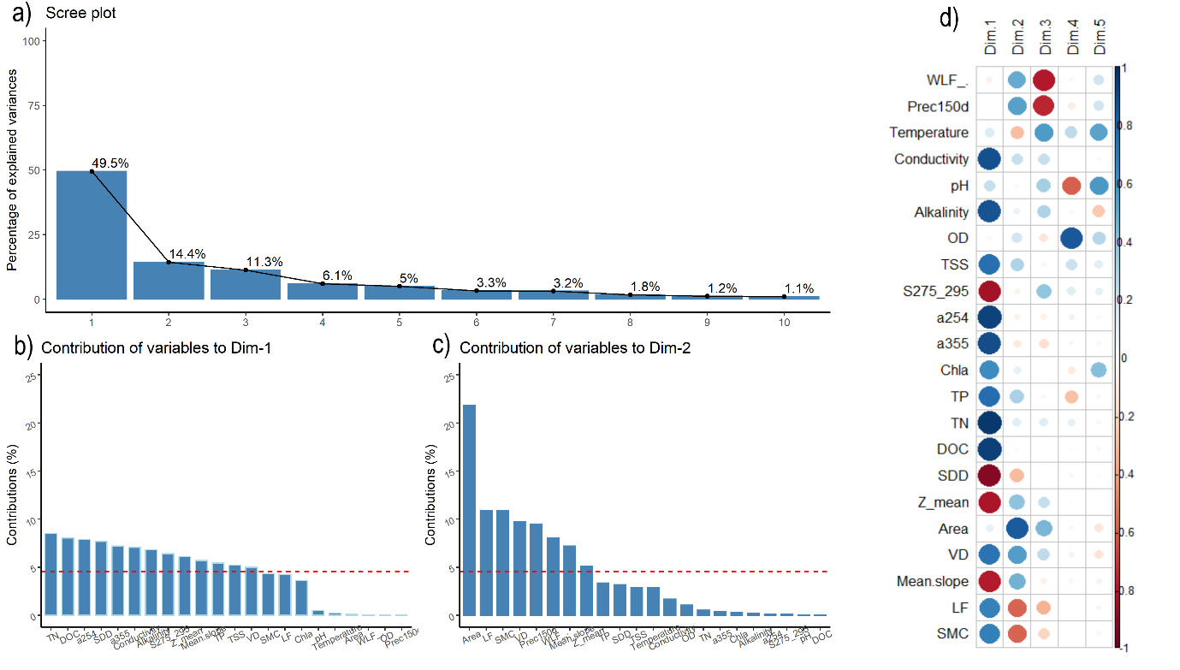
Fig. S5: a) Contribution of the axes to the PCA; b) contribution of the variables to Dim1; c) contribution of the variables to Dim2; d) correlations between variables and dimensions of the PCA.

Fig. S6: PCAs for each lake. a) Ezquerra, b) Morenito lake, c) FCA, d) Moreno Bay.
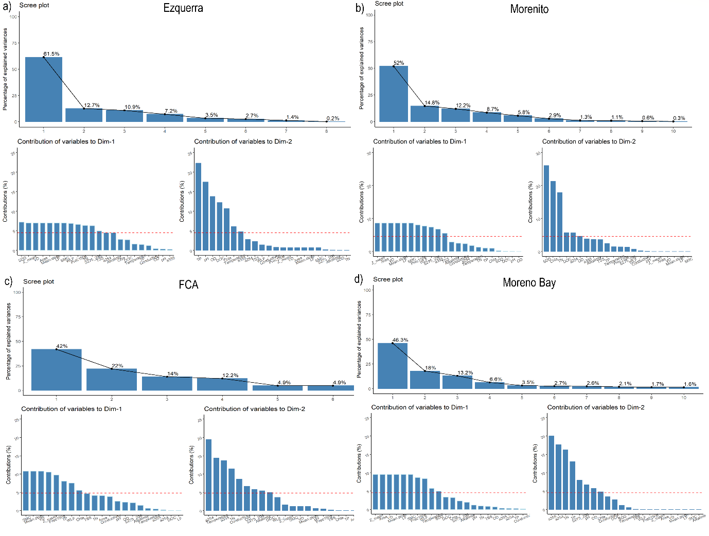
Fig. S7: Contributions of dimensions and variables to PCAs by lake. a) Ezquerra, b) Morenito, c) FCA, d) Moreno Bay.
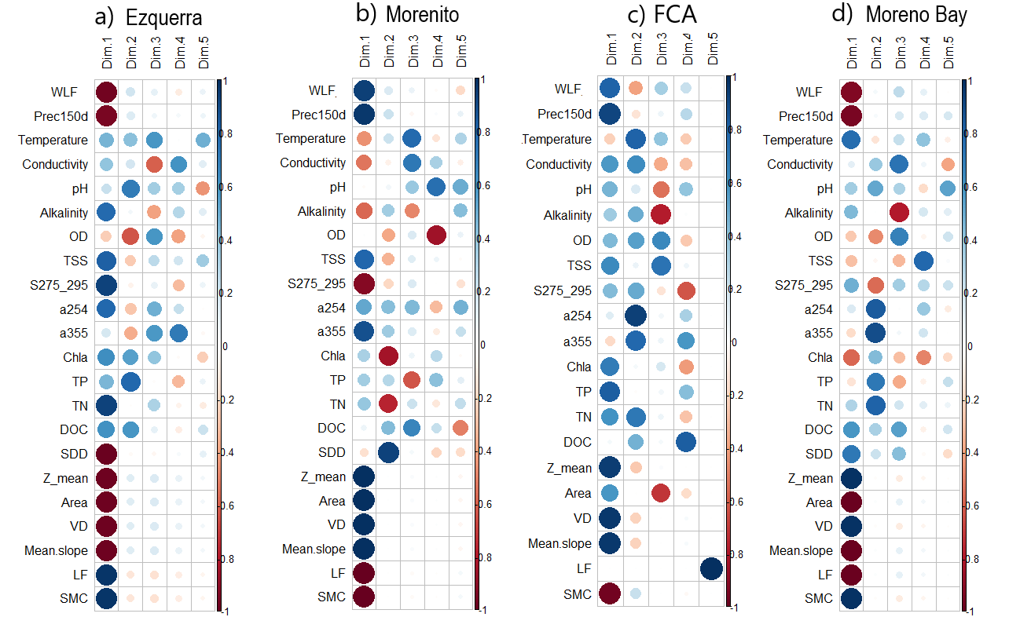
Fig. S8: Correlations between variables and dimensions of the PCAs per lake. a) Ezquerra, b) Morenito, c) FCA, d) Moreno Bay.
Table S3: Physiochemical and optical parameters of the studied lakes separated by hydrological periods. LWP: low water phase (dry season); HWP: high water phase (wet season). DO (dissolved oxygen); SDD (Secchi disk depth); TSS (total suspended solids); TP (total phosphorus); TN (total nitrogen); DOC (dissolved organic carbon); TSI (trophic state index). We evaluated whether there were significant differences between phases using the Wilcoxon test.
Physiochemical and optical parameters | Ezquerra |  |  |  |  | Morenito |  |  |  |  | FCA |  |  |  |  | Moreno Bay
Physiochemical and optical parameters | LWP |  | HWP |  |  | LWP |  | HWP |  |  | LWP |  | HWP |  |  | LWP |  | HWP
Physiochemical and optical parameters | Mean ± SD | Range | Mean ± SD | Range |  | Mean ± SD | Range | Mean ± SD | Range |  | Mean ± SD | Range | Mean ± SD | Range |  | Mean ± SD | Range | Mean ± SD | Range
Temperature (°C) | 14.45 ± 7.30 | 4.70 - 25.00 | 10.60 ± 6.13 | 5.10 - 19.00 | ns | 12.23 ± 5.12 | 5.60 - 21.10 | 9.5 - 4.25 | 4.80 - 15.10 | ** | 14.02 ± 6.42 | 5.00 - 21.60 | 10.35 ± 5.20 | 5.20 - 17.00 | ns | 14.06 ± 3.30 | 8.10 - 18.80 | 7.31 ± 1.37 | 5.3 - 9.1 | ****
Conductivity (µS cm⁻¹) | 73.97 ± 9.98 | 60.00 - 88.90 | 66.90 ± 6.56 | 60.00 - 76.40 | * | 72.06 ± 4.15 | 64.80 - 79.30 | 67.58 ± 3.67 | 61.90 - 74.30 | *** | 63.50 ± 13.20 | 48.30 - 80.20 | 67.97 ± 3.45 | 64.80 - 73.00 | ns | 36.95 ± 2.14 | 33.50 - 43.10 | 38.91 ± 3.76 | 35.60 - 45.00 | **
Alkalinity (µeq L⁻¹) | 1269 ± 90.03 | 1040 - 1360 | 998 ± 155.02 | 800 - 1200 | **** | 1088 ± 208.61 | 720 - 1360 | 875 ± 104.21 | 720 - 1120 | *** | 872 ± 133.06 | 720 - 1040 | 840 ± 111.09 | 640 - 1040 | ns | 553 ± 119.17 | 400 - 800 | 472 ± 46.66 | 400 - 560 | **
pH | 6.91 ± 0.47 | 6.41 - 7.86 | 6.87 ± 0.41 | 6.27 - 7.50 | ns | 6.98 ± 0.40 | 7.50 - 7.83 | 6.96 ± 0.35 | 6.28 - 7.47 | ns | 6.90 ± 0.40 | 6.31 - 7.62 | 6.96 ± 0.34 | 6.63 -7.41 | ns | 6.88 ± 0.32 | 6.10 - 7.38 | 6.64 ± 0.49 | 5.86 - 7.39 | *
DO (mg L⁻¹) | 9.01 ± 2.35 | 6.20 - 13.60 | 10.09 ± 1.99 | 6.90 - 12.40 | ns | 9.23 ± 1.95 | 5.60 - 12.40 | 10.17 ± 1.96 | 6.00 - 12.60 | * | 8.18 ± 1.27 | 6.70 - 9.80 | 10.40 ± 2.01 | 6.60 - 12.40 | ns | 8.26 ± 1.40 | 5.00 - 10.60 | 10.45 ± 1.49 | 6.90 - 12.50 | ****
DO saturation % | 91.89 ± 16.00 | 75.99 - 129.77 | 97.70 ± 12.25 | 81.72 - 119.02 | ns | 99.61 ± 17.15 | 75.07 - 131.51 | 98.71 ± 13.89 | 81.69 - 123.38 | ns | 95.11 ± 18. 45 | 73.97 - 125.49 | 106.47 ± 11.98 | 90.35 - 120.56 | ns | 92.46 ± 7.09 | 81.61 - 111.16 | 97.39 ± 6.44 | 85.42 - 109.90 | **
TSS (mg L⁻¹) | 1.13 ± 0.32 | 0.67 - 1.62 | 0.68 ± 0.11 | 0.53 - 0.86 | *** | 0.58 ± 0.12 | 0.33 - 0.86 | 0.90 ± 0.20 | 0.46 - 1.44 | **** | 0.47 ± 0.53 | 0.68 - 1.05 | 0.75 ± 0.26 | 0.35 - 1.01 | ns | 0.36 ± 0.44 | 0.01 - 2.78 | 0.39 ± 0.13 | 0.15 - 0.81 | **
SDD (m) |  | 2.2 |  | 3 | * | 6.51 ± 0.61 | 5.50 - 7.2 | 6.25 ± 1.27 | 4.50 - 8.00 | ns |  |  |  |  |  | 14.14 ± 1.75 | 12.00 - 17.00 | 12.12 ± 0.75 | 11.00 - 13.00 | ****
Chla (µg L⁻¹) | 2.62 ± 1.63 | 1.16 - 6.72 | 1.39 ± 0.42 | 0.88- 2.14 | ** | 1.33 ± 0.49 | 0.54 - 2.80 | 1.72 ± 0.77 | 0.53 - 2.94 | ns | 1.45 ± 0.67 | 0.55 - 2.40 | 1.82 ± 0.84 | 0.76 - 3.07 | ns | 0.78 ± 0.27 | 0.25 - 1.76 | 1.11 ± 0.45 | 0.41 - 1.81 | **
TP (µg L⁻¹) | 11.41 ± 3.56 | 6.01 - 18.14 | 8.98 ± 2.80 | 6.29 - 13.54 | ns | 9.72 ± 3.34 | 4.99 - 19.91 | 9.94 ± 2.93 | 5.82 - 16.80 | ns | 8.53 ±1.95 | 6.18 - 11.95 | 9.42 ± 3.34 | 4.16 - 13.43 | ns | 3.17 ± 1.43 | 1.19 - 7.32 | 3.38 ± 2.04 | 0.94 - 9.15 | ns
TN (µg L⁻¹) | 745.20 ± 99.08 | 578.10 - 943.50 | 503.30 ± 63.74 | 373.70 - 577.60 | **** | 452.90 ± 7.55 | 112.50 - 531.60 | 497.60 ± 54.01 | 374.60 - 606.50 | * | 444.70 ± 110.82 | 308.60 - 602.60 | 429.30 ± 113.2 | 208.40 - 528.10 | ns | 114.52 ± 25.41 | 70.98 - 218.56 | 113.89 ± 31.83 | 55.25 - 189.27 | ns
DOC (mg L⁻¹) | 6.17 ± 0.91 | 4.89 - 8.27 | 4.99 ± 1.50 | 3.73 - 7.46 | * | 2.68 ± 0.50 | 2.09 - 3.96 | 2.80 ± 0.73 | 2.14 - 4.21 | ns | 2.70 ± 0.54 | 2.12 - 3.73 | 2.72 ± 0.51 | 2.20 - 3.63 | ns | 0.60 ± 0.14 | 0.28 - 0.87 | 0.51 ± 0.05 | 0.44 - 0.74 | **
a₂₅₄ (m⁻¹) | 41.3 ± 3.56 | 34.54 - 44.55 | 36.10 ± 1.68 | 33.49 - 38.97 | ** | 13.18 ± 0.84 | 11.54 - 14.81 | 14.07 ± 0.74 | 12.41 - 17.99 | ** | 13.97 ± 2.54 | 10.17 - 17.99 | 11.9 ± 2.54 | 6.65 - 15.08 | ns | 1.88 ± 0.23 | 1.55 - 2.65 | 1.88 ± 0.27 | 1.47 - 3.11 | ns
a₃₅₅ (m⁻¹) | 8.30 ± 0.82 | 6.91 - 9.39 | 8.22 ± 0.36 | 7.70 - 9.00 | ns | 1.91 ± 0.16 | 1.70 - 2.31 | 2.49 ± 0.21 | 2.07 - 2.76 | **** | 2.62 ± 0.40 | 2.03 - 3.29 | 2.16 ± 0.55 | 1.28 - 2.73 | ns | 0.24 ± 0.12 | 0.15 - 0.42 | 0.27 ± 0.07 | 0.16 - 0.54 | *
S₂₇₅₋₂₉₅ (nm⁻¹) | 0.019 ± 0.001 | 0.017 - 0.021 | 0.016 ± 0.001 | 0.015 - 0.019 | *** | 0.023 ± 0.001 | 0.022 - 0.028 | 0.020 ± 0.0009 | 0.019 - 0.023 | *** | 0.019 ± 0.0018 | 0.016 - 0.022 | 0.019 ± 0.001 | 0.019 - 0.020 | ns | 0.027 ± 0.002 | 0.022 - 0.033 | 0.027 ± 0.001 | 0.022 - 0.029 | ***
TSI | 33.89 ± 3.31 | 30.34 - 40.72 | 28.97 - 1.81 | 26.02 - 31.68 | **** | 25.18 ± 2.11 | 20.00 - 28.84 | 27.11 ± 3.11 | 21.22 - 32.12 | * | 22.89 ± 2.89 | 18.49 - 27.38 | 24.31 ± 4.10 | 16.17 - 29.06 | ns | 10.44 ± 2.38 | 5.27 - 16.49 | 11.96 ± 3.80 | 4.64 - 18.33 | ns
ns: p > 0.05, *: p <= 0.05, **: p <= 0.01, ***: p <= 0.001, ****: p <= 0.0001

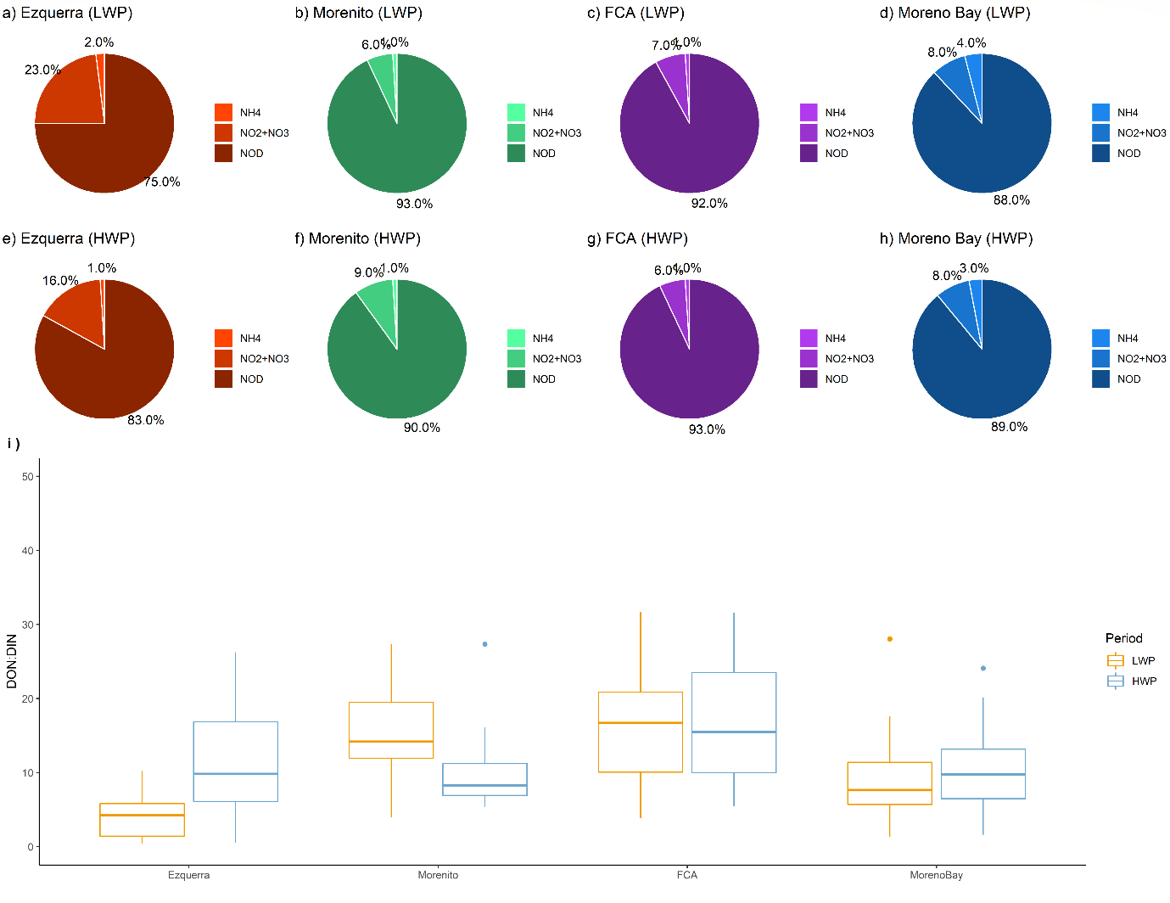
Fig. S9: a-d) Percentage contribution of organic and inorganic N fractions in LWP. e-h) Percentage contribution of organic and inorganic N fractions in HWP. i) DON:DIN ratio boxplot in LWP and HWP.

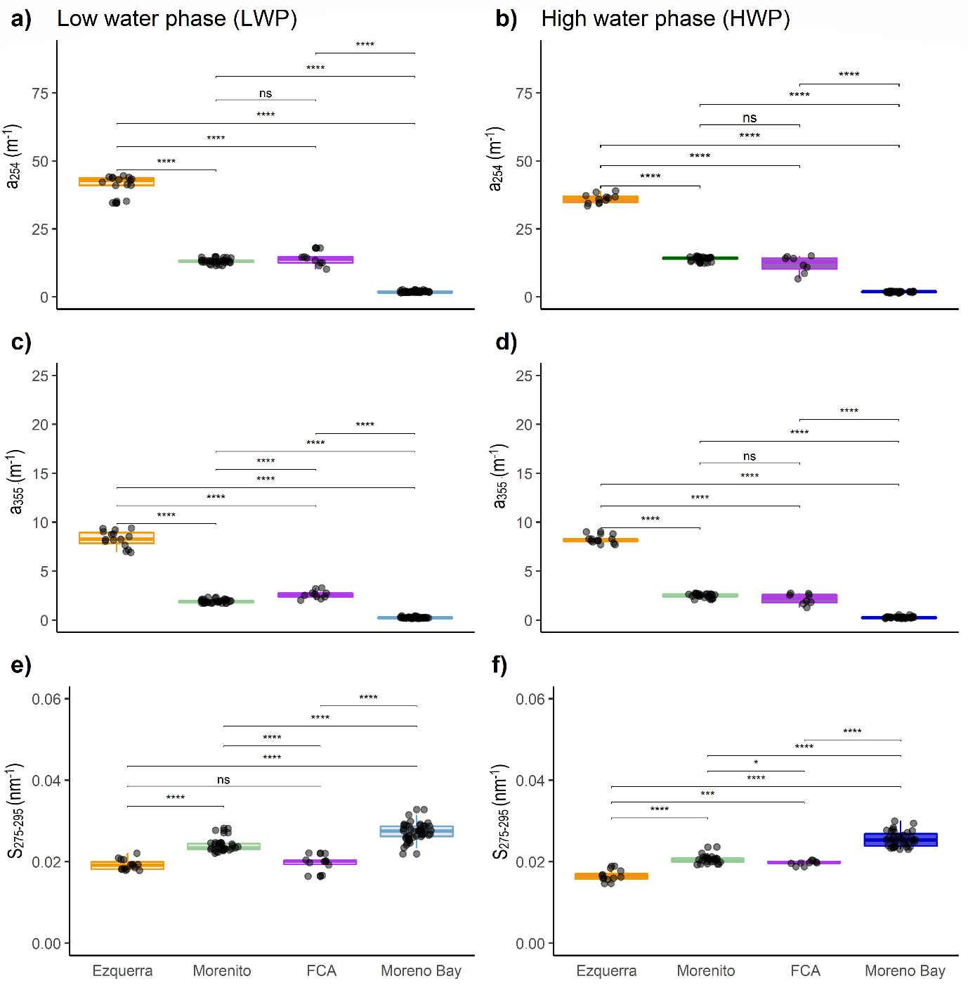
Fig. S10: Comparisons among lakes in LWP and HWP for the following variables: a, b) a₂₅₄ m^{-1;} c, d) a₃₅₅ m⁻¹ and e, f) S_{275-295.}

Table S4: Linear Regression Models for TSI and optical variables (a₂₅₄; a₃₅₅) across entire dataset and separated by hydrological periods. LWP: low water phase (dry season); HWP: high water phase (wet season).
Linear Regression Models |  | TSI vs ln a₂₅₄ (m⁻¹) |  |  |  |  | TSI vs ln a₃₅₅ (m⁻¹)
Linear Regression Models | n | y-intercept | Slope | R² | RMSE | p | y-intercept | Slope | R² | RMSE | p
All data | 180 | 6.79 | 7.05 | 0.89 | 2.95 | *** | 19.91 | 6.15 | 0.87 | 3.11 | ***
LWP | 100 | 5.67 | 7.48 | 0.93 | 2.40 | *** | 19.95 | 6.54 | 0.91 | 2.72 | ***
HWP | 80 | 8.20 | 6.50 | 0.83 | 3.38 | *** | 19.92 | 5.66 | 0.82 | 3.43 | ***
***: p <= 0.001

