Supplementary Figure 1. Forest plot of MR estimates for the 20 druggable genes in the validation cohort. The 20 druggable genes were identified as target genes in the training cohort. CI, confidence interval; OR, odds ratio.
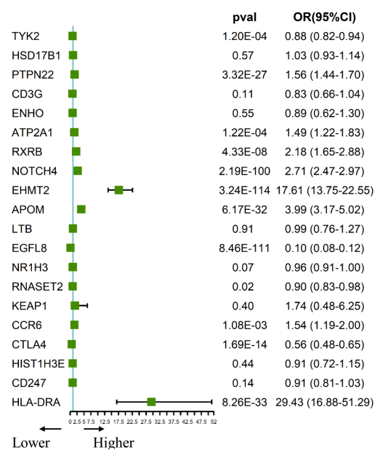

Supplementary Figure 2. Protein-protein interaction network among the current RA drug targets and the final therapeutic target genes. CTLA4 and CCR6 were identified as the final therapeutic targets, while the other genes represented the targets of current RA drugs.
