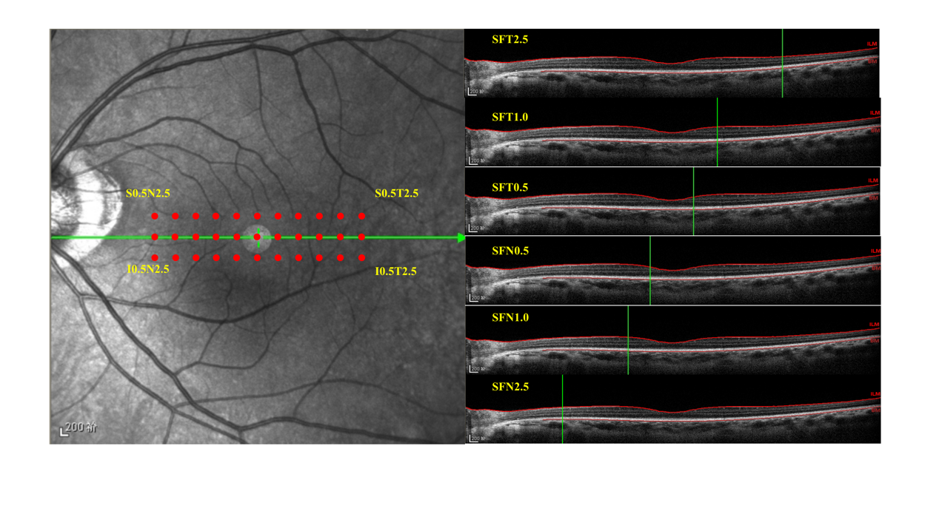
Sup Fig. 1 Schematic diagram depicting the enhanced depth-imaging optical coherence tomography (OCT) method for measuring choroidal thickness. A shows 3 scan lines of 33 points covering the superior, inferior, temporal and nasal quadrants. These measurements were taken at 500 μm intervals starting from fovea to 2.5 mm nasally and 2.5 mm temporally. B. Cross-sectional image of the measurement point between SFN2.5 and SFT2.5.
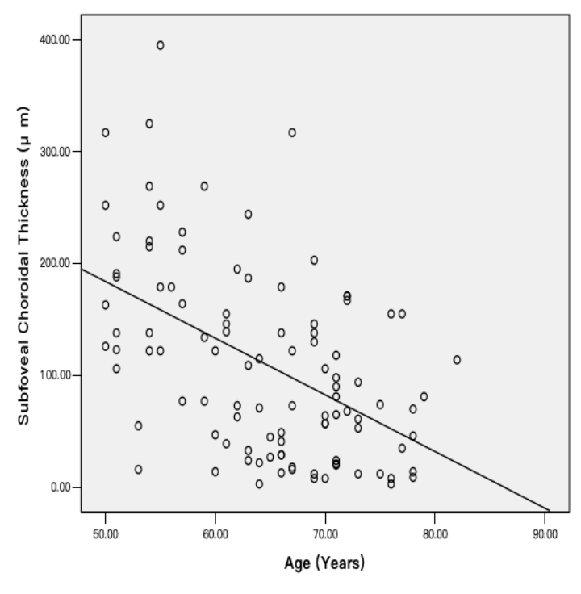
Sup Fig. 2 Scatterplot showing the distribution of subfoveal choroidal thickness (as measured by enhanced depth imaging of spectral domain optical coherence tomography) versus age in highly myopic eyes (P<0.001; Y = -5.1X +437.2; R²= 0.25)
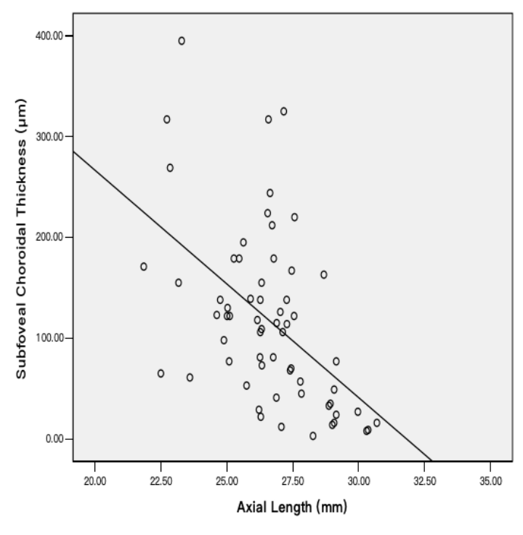
Sup Fig. 3 Scatterplot showing the distribution of subfoveal choroidal thickness (as measured by enhanced depth imaging of spectral domain optical coherence tomography) versus axial length in highly myopic eyes (P<0.001; Y = -22.6X +717.9; R²= 0.26)
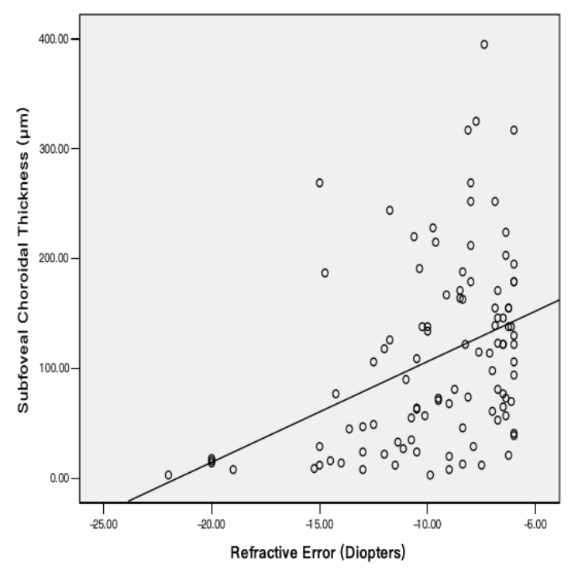
Sup Fig. 4 Scatterplot showing the distribution of subfoveal choroidal thickness (as measured by enhanced depth imaging of spectral domain optical coherence tomography) versus refractive error in highly myopic eyes (P<0.001; Y= 9.2 X+ 198.2; R²=0.15)

