Supplementary Material

Table S1. Maternal clinical and biochemical parameters in normal pregnancies

Parameters | Units | NGT
n |  | 10
age | years | 29.7 ± 5.6 (27.7-31.6)
Height | m | 1.60 ± 0.1 (1.57-1.61)
Weight (3T) | Kg | 82.9 ± 9.5 (77.7-87.5)
BMI (3T) | Kg/m² | 32.5 ± 5.8 (29.4-35.9)
Basal Glycaemia (1T) | mg/dl | 81.1 ± 5.5 (78.7-83.7)
Basal Glycaemia (2T) | mg/dl | 82.5 ± 0.9 (81.3-82.9)
Glycaemia 2h post 75 g (2T) | mg/dl | 109.0 ± 9.6 (101.2-114.4)
Maternal thyroid hormone profile in Third Trimester
TSH | mIU/L | 2.0 ± 0.4 (1.9-2.3)
FT4 | ng/dl | 0.8 ± 0.1 (0.7-0.9)
TT4 | µg/ml | 11.0 ± 1.7 (10.1-12.3)
TT3 | ng/ml | 1.7 ± 0.2 (1.6-1.8)
NTG: Normal tolerance glucose; BMI: Body Mass Index; 2T: Second trimester; 3T: Third Trimester; TSH: Thyroid Stimulating Hormone; FT4: Free Thyroxine: TT4: Total Thyroxine; TT3: Total triiodothyronine. Data correspond to mean ± S.D (IC 95%).

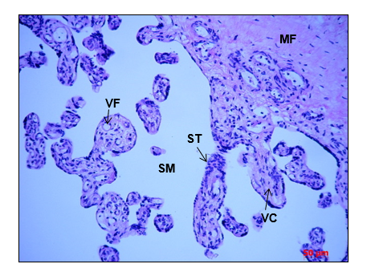

Fig S1. Evaluation of human placental explant tissue integrity. After 12 hours of culture, human placental explants were fixed in paraformaldehyde 4%, embedded in paraffin and sectioned at 4 µm. Tissue integrity was evaluated with hematoxylin-eosin staining, showing conserved placental histological structures. VF: Fetal vessel; SM: Maternal blood; ST: Syncytiotrophoblast; VC: Chorionic villi; MF: Fetal mesenchyme. Red bar: 50 µm. N = 3 per group

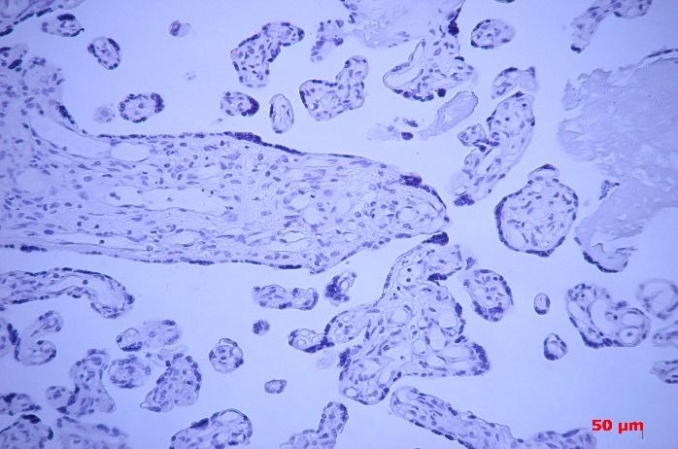

Fig S2. Negative control for deiodinase IHQ. Pig IgG diluted 1:100 was utilized instead of primary antibody anti-deiodinases. The rest of the process was followed as described. There was no sign of positive immunostaining. Red bar: 50 µm. N = 3 per group

