Supplementary Information

N-Iodopyridinium Cations: Kinetic Trapping as Sulfonate Complexes

Rakesh Puttreddy, Parveen Kumar, and Kari Rissanen

University of Jyvaskyla, Department of Chemistry, Survontie 9 B, 40014 Jyväskylä, Finland

Table of Contents
1. General Information S2
2. X-ray Crystallography S3
3. DFT Studies S12
4. Solution NMR Data S27
5. References S29

The Supplementary Information file includes Supplementary Figures 1-15 and
Supplementary Tables 1-3.

General information

1.1 Synthetic and Spectroscopic Data
4-(Dimethylamino)pyridine (>99%), 4-methylpyridine (99%), 4-cyanopyridine (98%), silver(I) methylsulfonate and silver(I) para-toluenesulfonate were purchased from Sigma Aldrich, whereas Silver(I) n-heptanesulfonate was synthesized using the literature method.^{[1]} The elemental iodine (>99%) was purchased from TCI chemicals Europe. Acetonitrile (HPLC grade >99%) and n-pentane (HPLC grade >99%) were purchased from Honeywell. CD₃CN (D 99.80%, water <0.05%) sold in septum vial was purchased from Eurisotop. All reagents and solvents were used as purchased, with no further drying or purification. The ¹H and the ¹H-¹⁵N HMBC NMR spectra were recorded at -20 ºC on a Bruker Avance III 500 MHz instrument in CD₃CN. Chemical shifts are reported on the δ scale in ppm and residual solvent signal is calibrated to δ 1.94 ppm, and for ¹H-¹⁵N HMBC NMR to an external d₃-MeNO₂ standard.
1.2. General procedure for the synthesis of iodine complexes
A silicone rubber-insulated magnetic stirrer plate is placed inside the -24 ºC freezer. Precooled acetonitrile (-24 ºC) was added to 1.0 eq of pyridine and the mixture is stirred inside the -24 ºC freezer. At this point, 1.0 eq of silver salt was added and stirred for 3-4 min followed by 0.5-0.6 eq of finely grounded iodine (for more details, See Supplementary Table 1). The mixture was stirred (2-3 min) until the iodine grains are completely dissolved. The yellow silver(I) iodide precipitates were removed by filtration. Single crystals suitable for X-ray diffraction were produced by the vapour diffusion of n-pentane into an acetonitrile solution containing iodine complexes that were kept in a -24 ºC freezer. Hydrogen-bonded complexes ([Dmap-H]Tos, [4CNPy-H]Tos, and [4CNPy-H]Mes) were prepared by mixing 1:1 equivalents of pyridine with sulfonic acid in precooled acetonitrile (-24 ºC). The solutions were kept in a -24 ºC freezer to yield crystals for X-ray diffraction analysis.
Supplementary Figure 1. (above) Synthetic route to prepare silver(I), iodine(I) and hydrogen-bonded complexes. (Below) List of pyridines and sulfonates.

Supplementary Table 1. Stoichiometric information on the crystallization of iodine complexes
Complex | Pyridine | Silver(I) salt | Iodine | Solvent
[Dmap-I]Tos | 34.5 mg  (0.2824 mmol, 1.0 eq) | 78.8 mg  (0.2824 mmol, 1. 0eq) | 43.0 mg  (0.1694 mmol, 0.6 eq) | ACN (4 mL)  Pentane diffusion
[Dmap-I]Mes | 10.0 mg  (0.0818 mmol, 1.0eq) | 16.5 mg  (0.0818 mmol, 1.0 eq) | 12.4 mg  (0.0491 mmol, 0.6 eq) | ACN (2 mL)  Pentane diffusion
[4MePy-I]Tos | 55.4 mg  (0.5944 mmol, 1.0 eq) | 165.9 mg  (0.5944 mmol, 1.0 eq) | 101.1 mg  (0.3983 mmol, 0.67 eq) | ACN (4 mL)  Pentane diffusion
[4MePy-I]Mes | 70.1 mg  (0.7528 mmol, 1.0 eq) | 210.1 mg  (0.7528 mmol, 1.0 eq) | 114.6 mg  (0.4517 mmol, 0.6 eq) | ACN (4 mL)  pentane diffusion
[4CNPy-I]Tos | 80.0 mg  (0.7684 mmol, 1.0 eq) | 192.9 mg  (0.6916 mmol, 0.9 eq) | 105.3 mg  (0.4149 mmol, 0.6 eq) | ACN (4 mL)  Pentane diffusion
[4CNPy-I]Mes | 84.0 mg  (0.8068 mmol, 1.0 eq) | 225.9 mg  (0.8068 mmol, 1.0 eq) | 102.4 mg  (0.4034 mmol, 0.5 eq) | ACN (4 mL)  Pentane diffusion
[4CNPy-I]Heps | 61.0 mg  (0.5859 mmol, 1.0 eq) | 177.6 mg  (0.5859 mmol, 1.0 eq) | 80.3 mg  (0.3164 mmol, 0.54 eq) | ACN (4 mL)  Pentane diffusion

X-ray Crystallographic Studies
2.1. X-ray crystallography
The X-ray crystal structure data for [Dmap-I]Tos, [Dmap-I]Mes, [4MePy-I]Tos, [4MePy-I]Mes, [Dmap-I-Dmap]I₃, [4CNPy-I]Heps, [4CNPy-H]Tos, and [4CNPy-H]Mes were collected at 120 K, using an Rigaku SuperNova four-circle diffractometer equipped with an Hybrid Pixel Array Detector (detector type: HyPix-Arc 100) and Cu-K_{α} (λ = 1.54184 Å) radiation. Whereas the data for [4MePy₄Ag₂]Tos₂, [4CNPy₄Ag₂]Tos₂∙H₂O, [4CNPy₂Ag]Mes, [4CNPy₄Ag₂]Heps₂, [4CNPy-I]Tos, [4CNPy-I]Mes, [Dmap-I-Dmap]Heps, [4MePy-I-4MePy]I₅ and [Dmap-H]Tos were collected at 120 K using an XtaLAB Synergy R four-circle diffractometer equipped with an Hybrid Pixel Array Detector (detector type: HyPix-Arc 100). Diffraction source type is PhotonJet R (Cu, λ = 1.54184 Å) X-ray source. CrysAlisPro (version 1.171.42.89a) was used for the data collection and reduction, and the intensities were absorption corrected using a gaussian face index absorption correction method. All structures were solved by intrinsic phasing (SHELXT)^{[2]} and refined by full-matrix least squares on F² using the OLEX2^{[3]}, utilizing the SHELXL-2015 module.^{[4,5]} Anisotropic displacement parameters were assigned to non-H atoms and isotropic displacement parameters for all H atoms were constrained to multiples of the equivalent displacement parameters of their parent atoms with U_{iso}(H) = 1.2 U_{eq}(parent atom). In the hydrogen-bonded complexes, the N–H distances are fixed at 1.04 Å. The X-ray single crystal data and CCDC numbers of all new structures are included below. CCDC XXXX-XXXX contains the supplementary crystallographic data for this paper. These data can be obtained free of charge via http://www.ccdc.cam.ac.uk/conts/retrieving.html (or from the CCDC, 12 Union Road, Cambridge CB2 1EZ, UK; Fax: +44 1223 336033; E-mail: deposit@ccdc.cam.ac.uk).
Crystal data for [4MePy₄Ag₂]Tos₂: CCDC-2294109. C₃₈H₄₂Ag₂N₄O₆S₂, M = 930.61 g/mol, colorless block, 0.089 x 0.056 x 0.055 mm³, monoclinic, space group P2₁/n, a = 9.48181(5) Å, b = 11.83720(7) Å, c = 16.98475(10) Å, α = 90°, β = 90.0419(5) °, γ = 90°, V = 1906.336(18) Å³, Z = 2, D_{calc} = 1.621 gcm⁻³, F000 = 944, µ = 9.683 mm⁻¹, T = 120 K, θ_{max} = 66.746°, 32763 total reflections, 3353 with I_{o} > 2σ(I_{o}), R_{int} = 0.0196, 3375 data, 238 parameters, 0 restraints, GooF = 1.071, R₁ = 0.0160 and wR₂ = 0.0429 [Io > 2σ(Io)], R₂ = 0.0161 and wR₂ = 0.0430 (all reflections), 0.354<d∆ρ <-0.259 eÅ⁻³.
Crystal data for [4CNPy₄Ag₂]Tos₂∙H₂O: CCDC-2294110. C₇₆H₆₄Ag₄N₁₆O₁₄S₄, M = 1985.15 g/mol, colorless block, 0.084 x 0.079 x 0.056 mm³, triclinic, space group P-1, a = 10.95280(10) Å, b = 13.0889(2) Å, c = 14.7410(2) Å, α = 85.0290(10)°, β = 70.3170(10)°, γ = 77.2600(10)°, V = 1940.63(5) Å³, Z = 1, D_{calc} = 1.699 gcm⁻³, F000 = 996, µ = 9.614 mm⁻¹, T = 120 K, θ_{max} = 66.702°, 35545 total reflections, 6638 with I_{o} > 2σ(I_{o}), R_{int} = 0.0191, 6866 data, 519 parameters, 0 restraints, GooF = 1.037, R₁ = 0.0162 and wR₂ = 0.0414 [Io > 2σ(Io)], R₂ = 0.0169 and wR₂ = 0.0418 (all reflections), 0.283<d∆ρ <-0.372eÅ⁻³.
Crystal data for [4CNPy₂Ag]Mes: CCDC-2294111. C₁₃H₁₁AgN₄O₃S, M = 411.19 g/mol, colorless block, 0.095 x 0.058 x 0.036 mm³, monoclinic, space group P2₁/c, a = 8.81330(10) Å, b = 10.5312(2) Å, c = 16.1392(3) Å, α = 90°, β = 90.576(2)°, γ = 90°, V = 1497.88(4) Å³, Z = 4, D_{calc} = 1.823 gcm⁻³, F000 = 816, µ = 12.271 mm⁻¹, T = 120 K, θ_{max} = 66.671°, 14645 total reflections, 2536 with I_{o} > 2σ(I_{o}), R_{int} = 0.0328, 2650 data, 200 parameters, 0 restraints, GooF = 1.083, R₁ = 0.0302 and wR₂ = 0.0785 [Io > 2σ(Io)], R₂ = 0.0316 and wR₂ = 0.0797 (all reflections), 1.530<d∆ρ < -0.568 eÅ⁻³.
Crystal data for [4CNPy₄Ag₂]Heps₂: CCDC-2294112. C₃₈H₄₆Ag₂N₈O₆S₂, M = 990.69 g/mol, colorless block, 0.2 x 0.14 x 0.11 mm³, triclinic, space group P-1, a = 8.3444(2) Å, b = 10.8479(2) Å, c = 12.5798(3) Å, α = 99.107(2) °, β = 100.320(2)°, γ = 107.639(2)°, V = 1039.82(4) Å³, Z = 1, D_{calc} = 1.582 gcm⁻³, F000 = 504, µ = 8.943 mm⁻¹, T = 120 K, θ_{max} = 66.740°, 16458 total reflections, 3650 with I_{o} > 2σ(I_{o}), R_{int} = 0.0153, 3664 data, 254 parameters, 0 restraints, GooF = 1.093, R₁ = 0.0150 and wR₂ = 0.0386 [Io > 2σ(Io)], R₂ = 0.0152 and wR₂ = 0.0387 (all reflections), 0.305<d∆ρ <-0.307 eÅ⁻³.
Crystal data for [Dmap-I]Tos: CCDC-2294113. C₁₄H₁₇IN₂O₃S, M = 420.25 g/mol, colorless block, 0.159 x 0.113 x 0.069 mm³, monoclinic, space group P2₁/c, a = 8.72730(10) Å, b = 10.7508(2) Å, c = 17.4625(3) Å, α = 90°, β = 103.043(2) °, γ = 90°, V = 712.96(4) Å³, Z = 4, D_{calc} = 1.749 gcm⁻³, F000 = 832, µ = 17.090 mm⁻¹, T = 120 K, θ_{max} = 66.708°, 11442 total reflections, 2630 with I_{o} > 2σ(I_{o}), R_{int} = 0.0303, 2834 data, 193 parameters, 0 restraints, GooF = 1.043, R₁ = 0.0210 and wR₂ = 0.0520 [Io > 2σ(Io)], R₂ = 0.0226 and wR₂ = 0.0530 (all reflections), 0.349 <d∆ρ <-0.499 eÅ⁻³.
Crystal data for [Dmap-I]Mes: CCDC-2294114. C₈H₁₃IN₂O₃S, M = 344.16 g/mol, colorless block, 0.147 x 0.059 x 0.047 mm³, monoclinic, space group P2₁/c, a = 12.4543(3) Å, b = 10.3811(2) Å, c = 9.0638(2) Å, α = 90°, β = 93.366(2) °, γ = 90°, V = 1169.83(4) Å³, Z = 4, D_{calc} = 1.954 gcm⁻³, F000 = 672, µ = 23.133 mm⁻¹, T = 120 K, θ_{max} = 66.744°, 7565 total reflections, 2020 with I_{o} > 2σ(I_{o}), R_{int} = 0.0286, 2081 data, 139 parameters, 0 restraints, GooF = 1.053, R₁ = 0.0210 and wR₂ = 0.0534 [Io > 2σ(Io)], R₂ = 0.0217 and wR₂ = 0.0538 (all reflections), 0.674 <d∆ρ <-1.048 eÅ⁻³.
Crystal data for [4MePy-I]Tos: CCDC-2294115. C₁₃H₁₄INO₃S, M = 391.21 g/mol, colorless block, 0.13 x 0.049 x 0.021 mm³, monoclinic, space group P2₁/m, a = 6.5526(2) Å, b = 7.6753(3) Å, c = 14.1926(4) Å, α = 90°, β = 92.753(3) °, γ = 90°, V = 712.96(4) Å³, Z = 2, D_{calc} = 1.822 gcm⁻³, F000 = 384, µ = 19.056 mm⁻¹, T = 120 K, θ_{max} = 66.744°, 4682 total reflections, 1279 with I_{o} > 2σ(I_{o}), R_{int} = 0.0447, 1356 data, 144 parameters, 0 restraints, GooF = 1.126, R₁ = 0.0337 and wR₂ = 0.0879 [Io > 2σ(Io)], R₂ = 0.0359 and wR₂ = 0.0886 (all reflections), 0.834 <d∆ρ < -0.941 eÅ⁻³.
Crystal data for [4MePy-I]Mes: CCDC-2294116. C₇H₁₀INO₃S, M = 315.12 g/mol, colorless block, 0.07 x 0.032 x 0.021 mm³, orthorhombic, space group P2₁2₁2₁, a = 6.8158(2)Å, b = 8.4534(2)Å, c = 17.7150(4)Å, α = 90°, β = 90°, γ = 90°, V = 1020.68(4)Å³, Z = 4, D_{calc} = 2.051gcm⁻³, F000 = 608, µ = 26.410 mm⁻¹, T = 120 K, θ_{max} = 66.747°, 6566 total reflections, 1741 with I_{o} > 2σ(I_{o}), R_{int} = 0.0377, 1792 data, 120 parameters, 0 restraints, GooF = 1.064, R₁ = 0.0199 and wR₂ = 0.0430 [Io > 2σ(Io)], R₂ = 0.0205 and wR₂ = 0.0431 (all reflections), 0.563<d∆ρ <-0.396eÅ⁻³.
Crystal data for [4CNPy-I]Tos: CCDC-2294117. C₁₃H₁₁IN₂O₃S, M = 402.20 g/mol, colorless plate, 0.072 x 0.067 x 0.024 mm³, triclinic, space group P-1, a = 6.3951(2)Å, b = 7.6119(2)Å, c = 14.8771(5)Å, α = 97.461(3)°, β = 90.497(3)°, γ = 97.156(2)°, V = 712.25(4) Å³, Z = 2, D_{calc} = 1.875 gcm⁻³, F000 = 392, µ = 19.124 mm⁻¹, T = 120 K, θ_{max} = 66.725°, 8214 total reflections, 2409 with I_{o} > 2σ(I_{o}), R_{int} = 0.0325, 2515 data, 182 parameters, 0 restraints, GooF = 1.053, R₁ = 0.0251 and wR₂ = 0.0648 [Io > 2σ(Io)], R₂ = 0.0263 and wR₂ = 0.0655 (all reflections), 0.965<d∆ρ<-0.667eÅ⁻³.
Crystal data for [4CNPy-I]Mes: CCDC-2294118. C₇H₇IN₂O₃S, M = 326.11 g/mol, colorless block, 0.107 x 0.08 x 0.032 mm³, monoclinic, space group P2₁/c, a = 11.6849(2) Å, b = 5.49970(10) Å, c = 16.4022(2) Å, α = 90°, β = 104.545(2)°, γ = 90°, V = 1020.28(3) Å³, Z = 4, D_{calc} = 2.123 gcm⁻³, F000 = 624, µ = 26.488 mm⁻¹, T = 120 K, θ_{max} = 66.739°, 8869 total reflections, 1703 with I_{o} > 2σ(I_{o}), R_{int} = 0.0297, 1808 data, 128 parameters, 0 restraints, GooF = 1.090, R₁ = 0.0196 and wR₂ = 0.0515 [Io > 2σ(Io)], R₂ = 0.0208 and wR₂ = 0.0522 (all reflections), 0.573<d∆ρ <-0.479eÅ⁻³.
Crystal data for [4CNPy-I]Heps: CCDC-2294119. C₁₃H₁₉IN₂O₃S, M = 410.26 g/mol, colorless block, 0.078 x 0.052 x 0.024 mm³, monoclinic, space group P2₁/c, a = 18.4255(6) Å, b = 5.60400(10) Å, c = 16.8977(5) Å, α = 90°, β = 113.606(4)°, γ = 90°, V = 1598.79(9) Å³, Z = 4, D_{calc} = 1.704 gcm⁻³, F000 = 816, µ = 17.040 mm⁻¹, T = 120 K, θ_{max} = 66.743°, 28830 total reflections, 2732 with I_{o} > 2σ(I_{o}), R_{int} = 0.0568, 2837 data, 182 parameters, 0 restraints, GooF = 1.027, R₁ = 0.0220 and wR₂ = 0.0566 [Io > 2σ(Io)], R₂ = 0.0230 and wR₂ = 0.0571 (all reflections), 0.392<d∆ρ < -0.825eÅ⁻³.
Crystal data for [Dmap-I-Dmap]I₃: CCDC-2294120. C₁₄H₂₀I₄N₄, M = 751.94 g/mol, colorless block, 0.107 x 0.071 x 0.028 mm³, triclinic, space group Pccn, a = 6.818(4) Å, b = 9.165(7) Å, c = 17.622(4) Å, α = 89.14(4) °, β = 89.69(4) °, γ = 71.10(6) °, V = 1041.7(11) Å³, Z = 2, D_{calc} = 2.397 gcm⁻³, F000 = 688, µ = 46.993 mm⁻¹, T = 120 K, θ_{max} = 84.012 °, 8735 total reflections, 3708 with I_{o} > 2σ(I_{o}), R_{int} = twinned data, 3986 data, 203 parameters, 0 restraints, GooF = 1.824, R₁ 0.1288 and wR₂ = 0.3808 [Io > 2σ(Io)], R₂ = 0.1311 and wR₂ = 0 0.3838 (all reflections), 7.137 <d∆ρ <-3.164 e Å⁻³.
Crystal data for [Dmap-I-Dmap]Heps: CCDC-2294121. C₂₁H₃₅IN₄O₃S, M = 550.49 g/mol, colorless block, 0.193 x 0.136 x 0.038 mm³, monoclinic, space group P2₁/c, a = 8.29464(8)Å, b = 31.3463(3)Å, c = 37.1083(4)Å, α = 90°, β = 94.0938(9)°, γ = 90°, V = 9623.78(15) Å³, Z = 16, D_{calc} = 1.520 gcm⁻³, F000 = 4512, µ = 1.502 mm⁻¹, T = 120 K, θ_{max} = 66.749°, 103080 total reflections, 15050 with I_{o} > 2σ(I_{o}), R_{int} = 0.0412, 16964 data, 1101 parameters, 12 restraints, GooF = 1.045, R₁ = 0.0393 and wR₂ = 0.1011 [Io > 2σ(Io)], R₂ = 0.0436 and wR₂ = 0.1048 (all reflections), 4.334<d∆ρ <-0.343eÅ⁻³.
Crystal data for [4MePy-I-4MePy]I₅: CCDC-2294122. C₁₂H₁₄I₆N₂, M = 947.65 g/mol, red block, 0.124 x 0.095 x 0.056 mm³, orthorhombic, space group Pccn, a = 20.9964(3)Å, b = 16.48163(19)Å, c = 12.31496(17)Å, α = 90°, β = 90°, γ = 90°, V = 4261.66(9) Å³, Z = 8, D_{calc} = 2.954 gcm⁻³, F000 = 3344, µ = 68.637 mm⁻¹, T = 120 K, θ_{max} = 66.710°, 4337 total reflections, 3847 with I_{o} > 2σ(I_{o}), R_{int} = twin, 4337 data, 185 parameters, 0 restraints, GooF = 1.262, R₁ = 0.0515 and wR₂ = 0.1546 [Io > 2σ(Io)], R₂ = 0.0574 and wR₂ = 0.1584 (all reflections), 3.264<d∆ρ < -3.315eÅ⁻³.
Crystal data for [Dmap-H]Tos: CCDC-2294123. C₁₄H₁₈N₂O₃S, M = 294.36 g/mol, colorless block, 0.12 x 0.1 x 0.062 mm³, triclinic, space group P-1, a = 7.0280(3)Å, b = 8.1296(4)Å, c = 13.1100(6)Å, α = 72.873(4)°, β = 79.560(4)°, γ = 80.826(4)°, V = 699.47(6) Å³, Z = 2, D_{calc} = 1.398 gcm⁻³, F000 = 312, µ = 2.144 mm⁻¹, T = 120 K, θ_{max} = 66.734°, 9999 total reflections, 2402 with I_{o} > 2σ(I_{o}), R_{int} = 0.0194, 2477 data, 184 parameters, 0 restraints, GooF = 1.072, R₁ = 0.0301 and wR₂ = 0.0798 [Io > 2σ(Io)], R₂ = 0.0307 and wR₂ = 0.0801 (all reflections), 0.289<d∆ρ <-0.433eÅ⁻³.
Crystal data for [4CNPy-H]Tos: CCDC-2294124. C₁₃H₁₂N₂O₃S, M = 276.31 g/mol, colorless block, 0.12 x 0.1 x 0.071 mm³, orthorhombic, space group Pbca, a = 7.88490(10) Å, b = 11.42010(10) Å, c = 27.8681(2) Å, α = 90°, β = 90°, γ = 90°, V = 2509.42(4) Å³, Z = 8, D_{calc} = 1.463 gcm⁻³, F000 = 1152, µ = 2.361 mm⁻¹, T = 120 K, θ_{max} = 66.722°, 18300 total reflections, 2135 with I_{o} > 2σ(I_{o}), R_{int} = 0.0229, 2226 data, 173 parameters, 0 restraints, GooF = 1.035, R₁ = 0.0277 and wR₂ = 0.0740 [Io > 2σ(Io)], R₂ = 0.0288 and wR₂ = 0.0749 (all reflections), 0.263<d∆ρ < -0.435eÅ⁻³.
Crystal data for [4CNPy-H]Mes: CCDC-2294125. C₇H₈N₂O₃S, M = 200.21 g/mol, colorless block, 0.276 x 0.093 x 0.038 mm³, orthorhombic, space group P2₁2₁2₁, a = 5.19330(10) Å, b = 9.18190(10) Å, c = 18.6113(2) Å, α = 90°, β = 90°, γ = 90°, V = 887.88(2) Å³, Z = 4, D_{calc} = 1.498 gcm⁻³, F000 = 416, µ = 3.092 mm⁻¹, T = 120 K, θ_{max} = 66.725°, 5204 total reflections, 1533 with I_{o} > 2σ(I_{o}), R_{int} = 0.0176, 1570 data, 119 parameters, 0 restraints, GooF = 1.090, R₁ = 0.0219 and wR₂ = 0.0593 [Io > 2σ(Io)], R₂ = 0.0224 and wR₂ = 0.0595 (all reflections), 0.278<d∆ρ < -0.260eÅ⁻³.

Supplementary Table 2. X-ray and DFT XB parameters of N-iodopyridinium sulfonate complexes.
Code | N-I (Å) | I-O (Å) | R_{XB}ª of  I-O (Å) | N···O | S=O (Å) | S=O (Å) | S-O (Å) | S-C (Å) | N-I-O (°)
[DMAP-I]Tos | 2.142(2) | 2.339(2) | 0.668 | 4.480 | 1.445(2) | 1.442(2) | 1.493(2) | 1.773(2) | 178.0(1)
DFT | 2.126 | 2.374 | 0.678 | 4.496 | 1.449 | 1.449 | 1.495 | 1.768 | 177.0
XRD-DFT | +0.016 | -0.035 | -- | -0.016 | -0.004 | -0.007 | -0.002 | +0.005 | +1.00
[DMAP-I]Mes | 2.140(2) | 2.331(2) | 0.666 | 4.466 | 1.446(2) | 1.451(2) | 1.500(2) | 1.757(3) | 175.1(1)
DFT | 2.129 | 2.359 | 0.674 | 4.486 | 1.450 | 1.42 | 1.496 | 1.763 | 177.4
XRD-DFT | +0.011 | -0.028 | -- | -0.020 | -0.004 | -0.0031 | +0.004 | -0.006 | -2.3
DFT  [DMAP-I]Heps | 2.128 | 2.363 | 0.675 | 4.490 | 1.453 | 1.452 | 1.497 | 1.773 | 177.49
[4MePy-I]Tos | 2.142(4) | 2.358(5) | 0.674 | 4.477 | 1.448(7) | 1.449(7) | 1.519(3) | 1.775(4) | 168.3(2)
DFT | 2.165 | 2.295 | 0.656 | 4.458 | 1.447 | 1.447 | 1.504 | 1.766 | 176.8
XRD-DFT | -0.023 | +0.063 | -- | +0.019 | -0.001 | -0.002 | -0.015 | -0.009 | -8.5
[4MePy-I]Mes | 2.154(4) | 2.347(4) | 0.671 | 4.490 | 1.442(4) | 1.442(4) | 1.488(4) | 1.761(5) | 174.1(1)
DFT | 2.169 | 2.286 | 0.653 | 4.454 | 1.449 | 1.449 | 1.504 | 1.762 | 177.6
XRD-DFT | -0.015 | +0.061 | -- | +0.036 | -0.007 | -0.007 | -0.016 | -0.001 | -3.5
DFT  [4MePy-I]Heps | 2.179 | 2.278 | 0.651 | 4.456 | 1.450 | 1.451 | 1.507 | 1.772 | 177.38
[4CNPy-I]Tos | 2.187(3) | 2.303(2) | 0.658 | 4.482 | 1.439(2) | 1.440(2) | 1.506(2) | 1.766(3) | 175.5(1)
DFT | 2.204 | 2.243 | 0.641 | 4.445 | 1.444 | 1.446 | 1.512 | 1.764 | 177.3
XRD-DFT | -0.017 | +0.06 | -- | +0.035 | -0.001 | -0.006 | -0.006 | +0.002 | -1.8
[4CNPy-I]Mes | 2.199(2) | 2.274(2) | 0.650 | 4.468 | 1.441(2) | 1.451(2) | 1.517(2) | 1.762(3) | 178.2(1)
DFT | 2.211 | 2.234 | 0.638 | 4.444 | 1.446 | 1.447 | 1.514 | 1.761 | 177.2
XRD-DFT | -0.012 | +0.04 | -- | +0.024 | -0.005 | +0.004 | +0.003 | -0.001 | +1.0
[4CNPy-I]Heps | 2.195(2) | 2.282(2) | 0.652 | 4.461 | 1.441(2) | 1.448(2) | 1.516(2) | 1.772(4) | 173.9(1)
DFT | 2.211 | 2.227 | 0.636 | 4.437 | 1.448 | 1.445 | 1.516 | 1.772 | 177.8
XRD-DFT | -0.016 | +0.055 | -- | +0.024 | -0.007 | +0.003 | 0.0 | 0.0 | -3.9
ªR_{XB}, is defined as [R_{XB} = d_{XB}/(X_{vdw}+B_{vdw})], where d_{XB} [Å] is the distance between donor (X) and the acceptor atoms (B), X_{vdw} and B_{vdw} are vdW radii [Å] of the corresponding atoms; The vdW radii determined by Bondi were used to calculate R_{XB} values.

Supplementary Table 3. S-O Bond lengths analysis in [pyridine-H](sulfonate) (pyridine = Dmap, 4MePy, 4CNPy) X-ray crystal structures.
Code | Cation | Anion | S=O (Å) | S=O (Å) | S-O (involved in hydrogen bonding, Å)
this work | [DMAP-H] | Tos | 1.449(1) | 1.460(1) | 1.464(1)
LIVVIW | [4MePy-H] | Tos | 1.448(1) | 1.450(1) | 1.472(1)
LIVVIW01 | [4MePy-H] | Tos | 1.453(1) | 1.463(1) | 1.470(1)
this work | [4CNPy-H] | Tos | 1.447(1) | 1.453(1) | 1.472(1)
this work | [4CNPy-H] | Mes | 1.453(2) | 1.456(2) | 1.476(2)

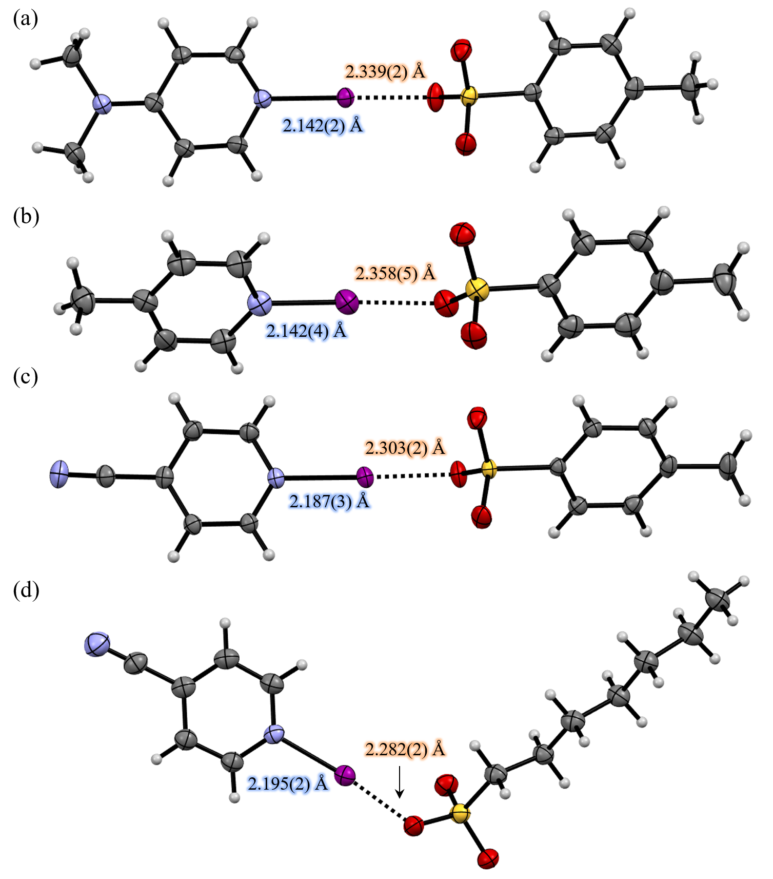
Supplementary Figure 2. X-ray crystal structures of (a) [Dmap-I]Tos, (b) [4MePy-I]Tos, (c) [4CNPy-I]Tos, and (d) [4CNPy-I]Heps with thermal displacement parameters at 50% probability level.

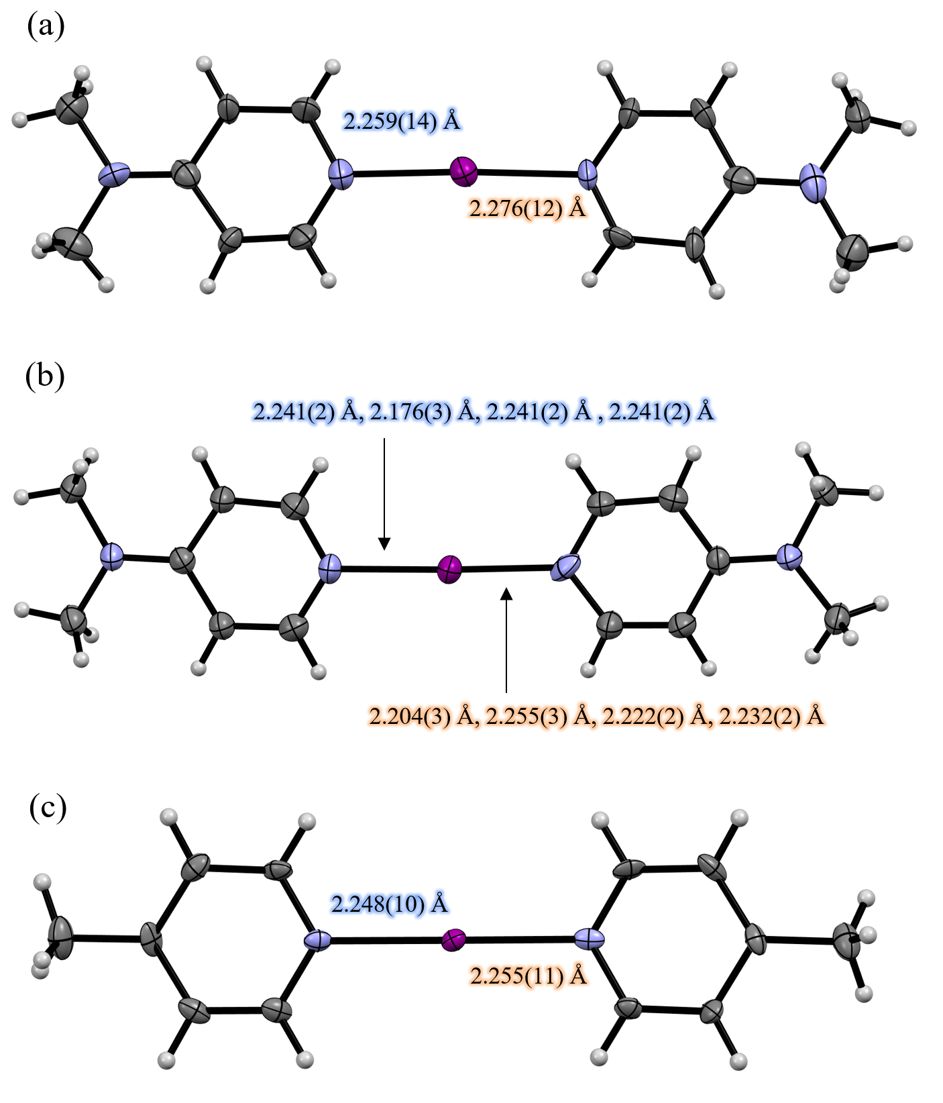
Supplementary Figure 3. X-ray crystal structures of (a) (Dmap-I-Dmap)I₃ (b) (Dmap-I-Dmap)Heps, and (c) (4MePy-I-4MePy)I₅ with thermal displacement parameters at 50% probability level. Anions are omitted for viewing clarity. Notes: (i) The asymmetric of (Dmap-I-Dmap)Heps contains four independent cations and heptanesulfonate anions. (ii) The asymmetric of (4MePy-I-4MePy)I₅ contains one (4MePy-I-4MePy) ion and two centrosymmetric I₅ˉ ions.
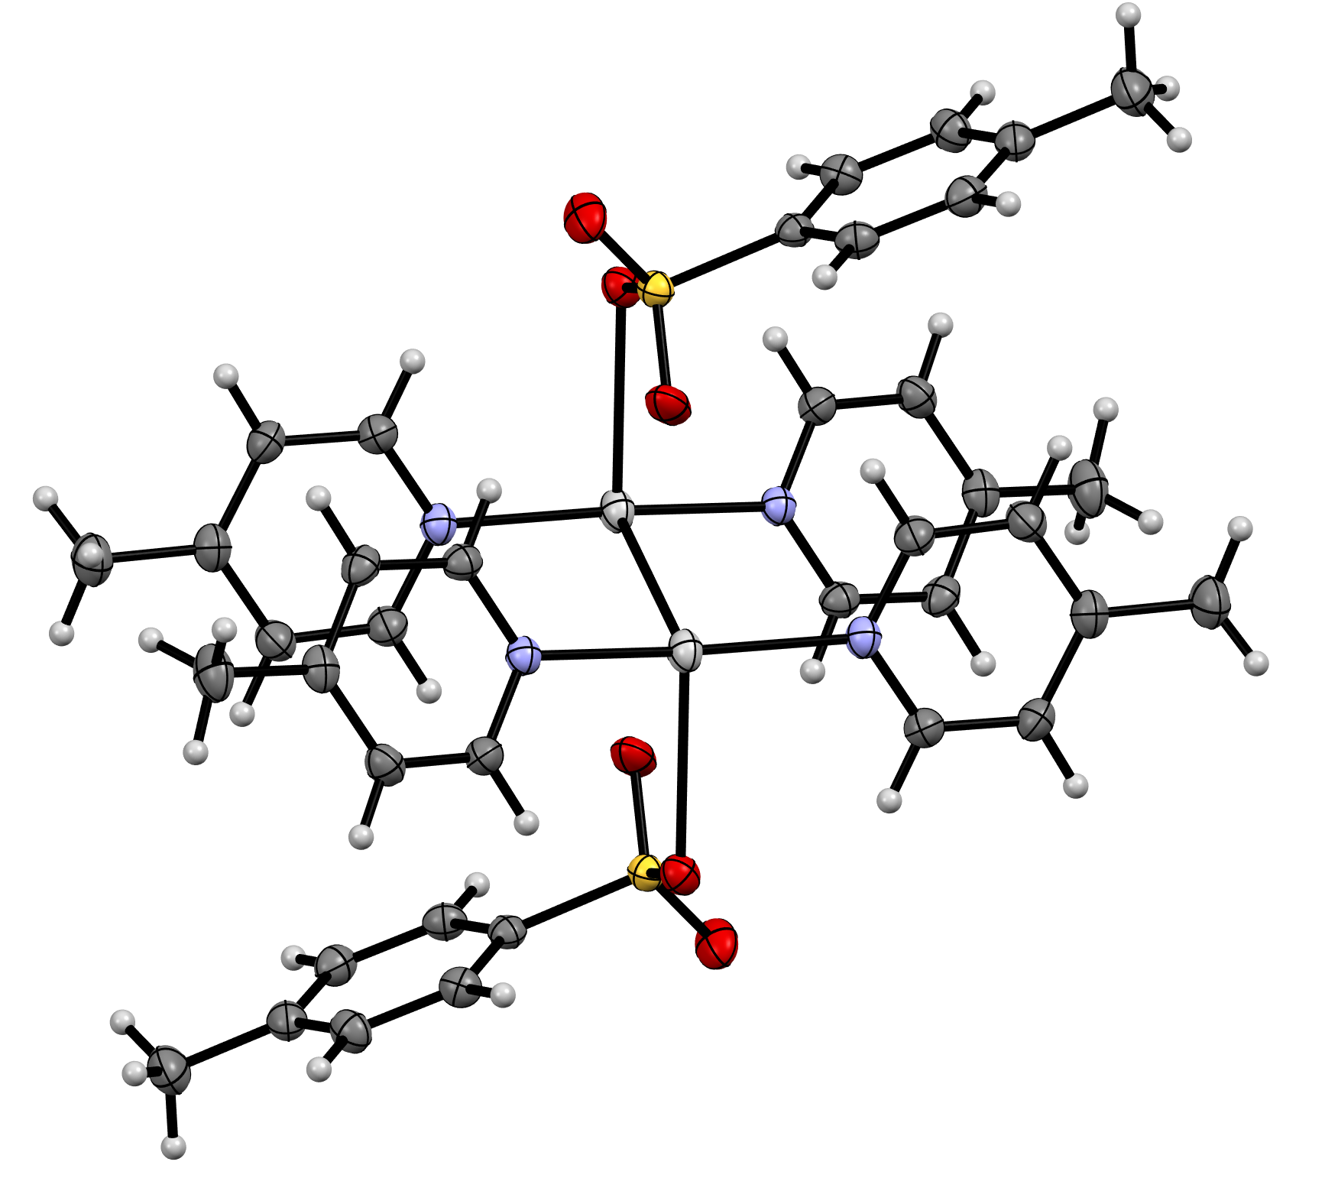
Supplementary Figure 4. X-ray crystal structure of [4MePy₄Ag₂]Tos₂ with thermal displacement parameters at 50% probability level.
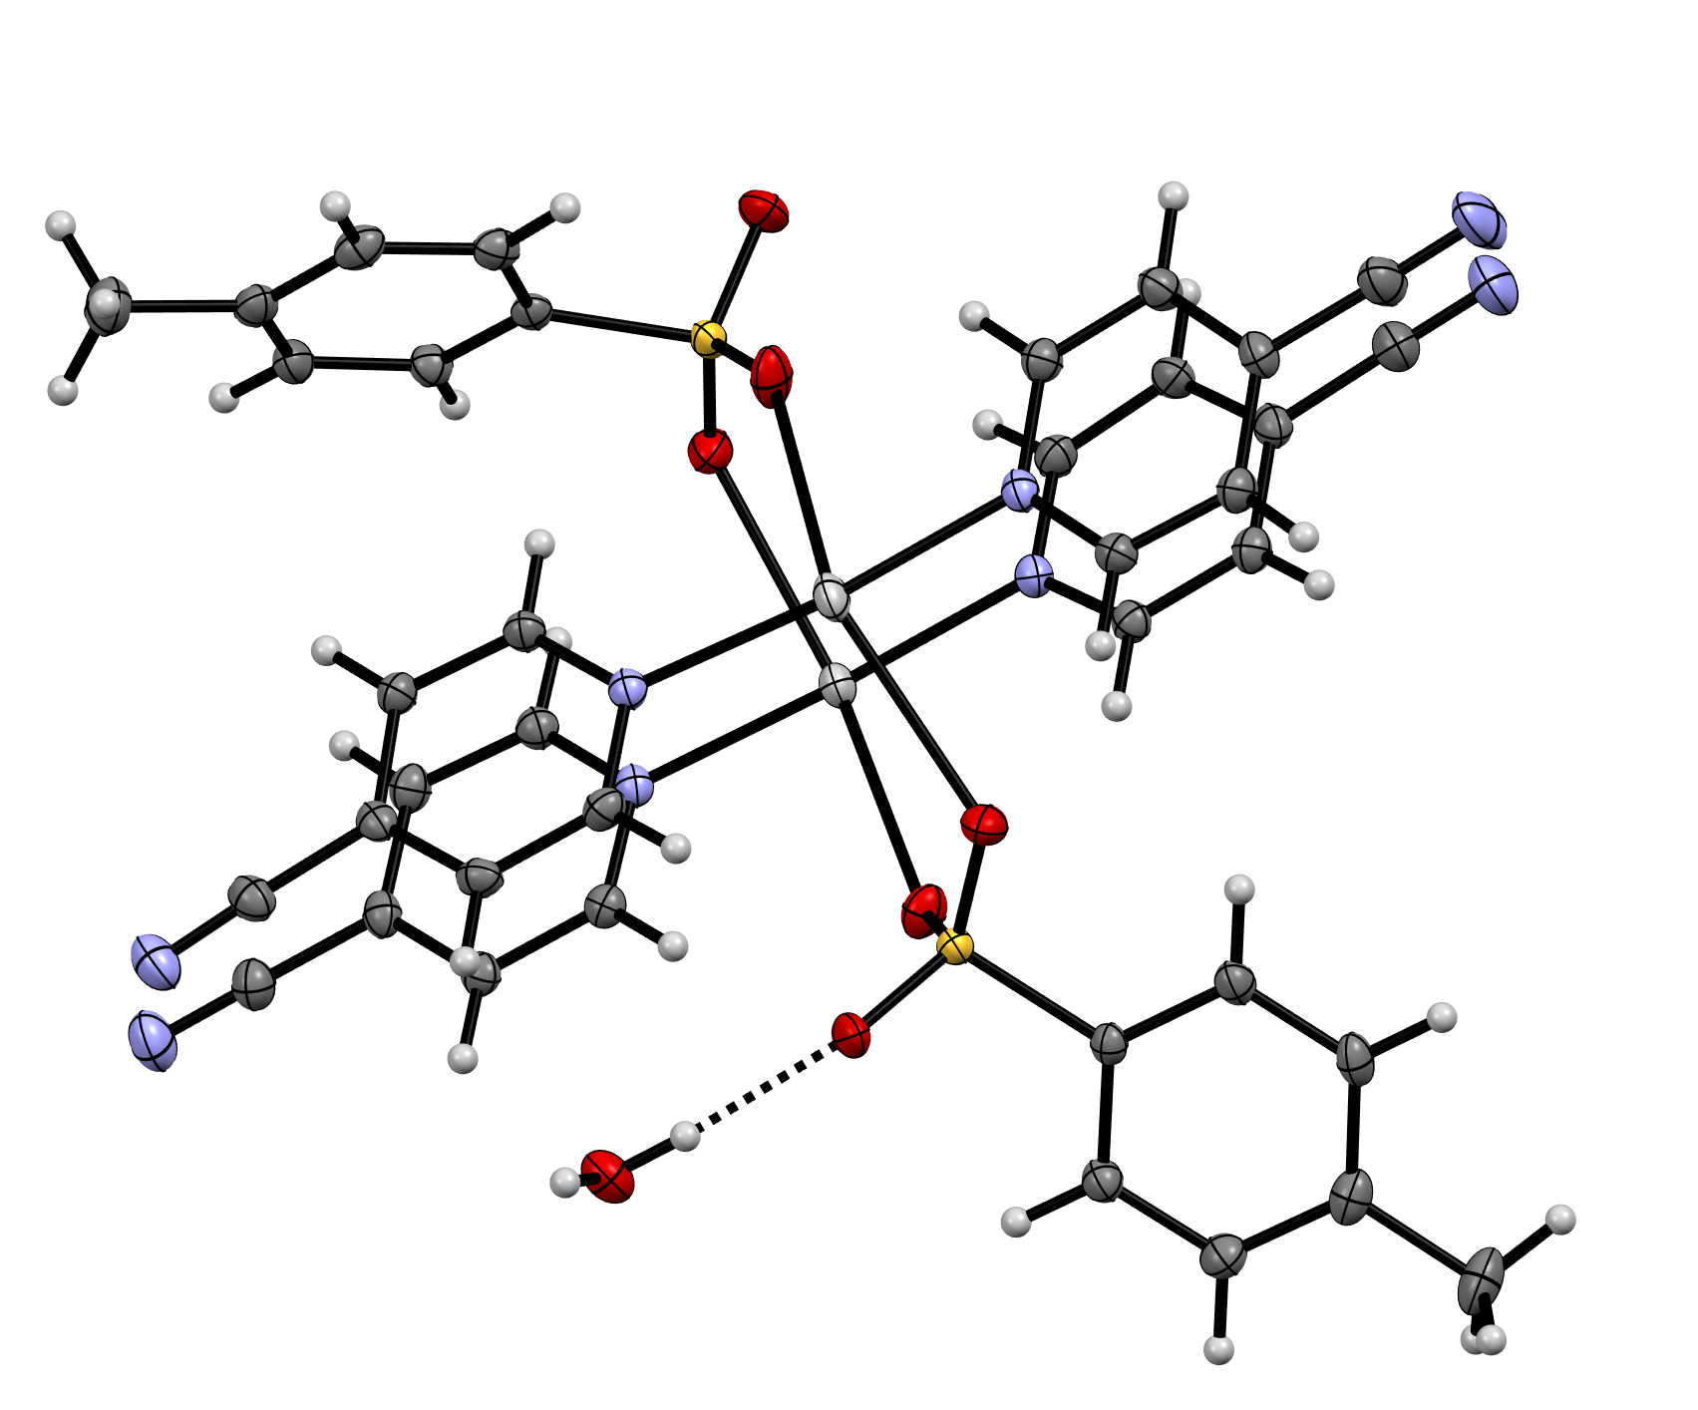
Supplementary Figure 5. X-ray crystal structure of [4CNPy₄Ag₂]Tos₂∙H₂O with thermal displacement parameters at 50% probability level. The black broken lines represent hydrogen bonding.
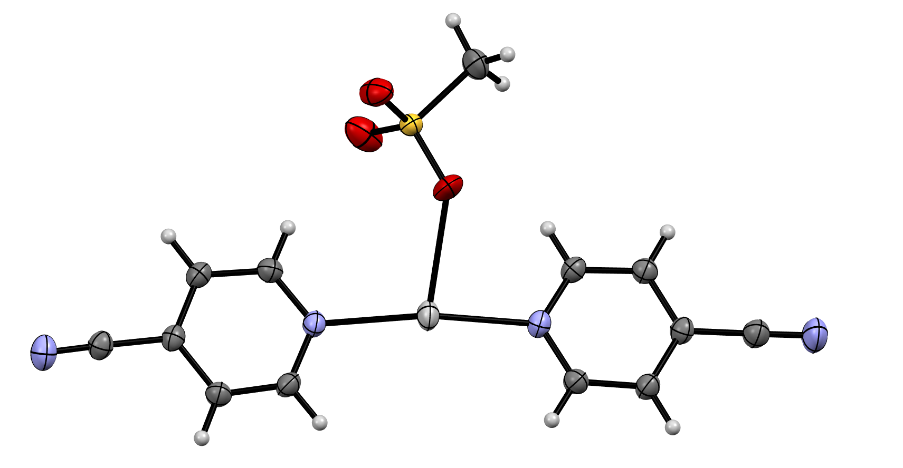
Supplementary Figure 6. X-ray crystal structure of [4CNPy₂Ag]Mes with thermal displacement parameters at 50% probability level.
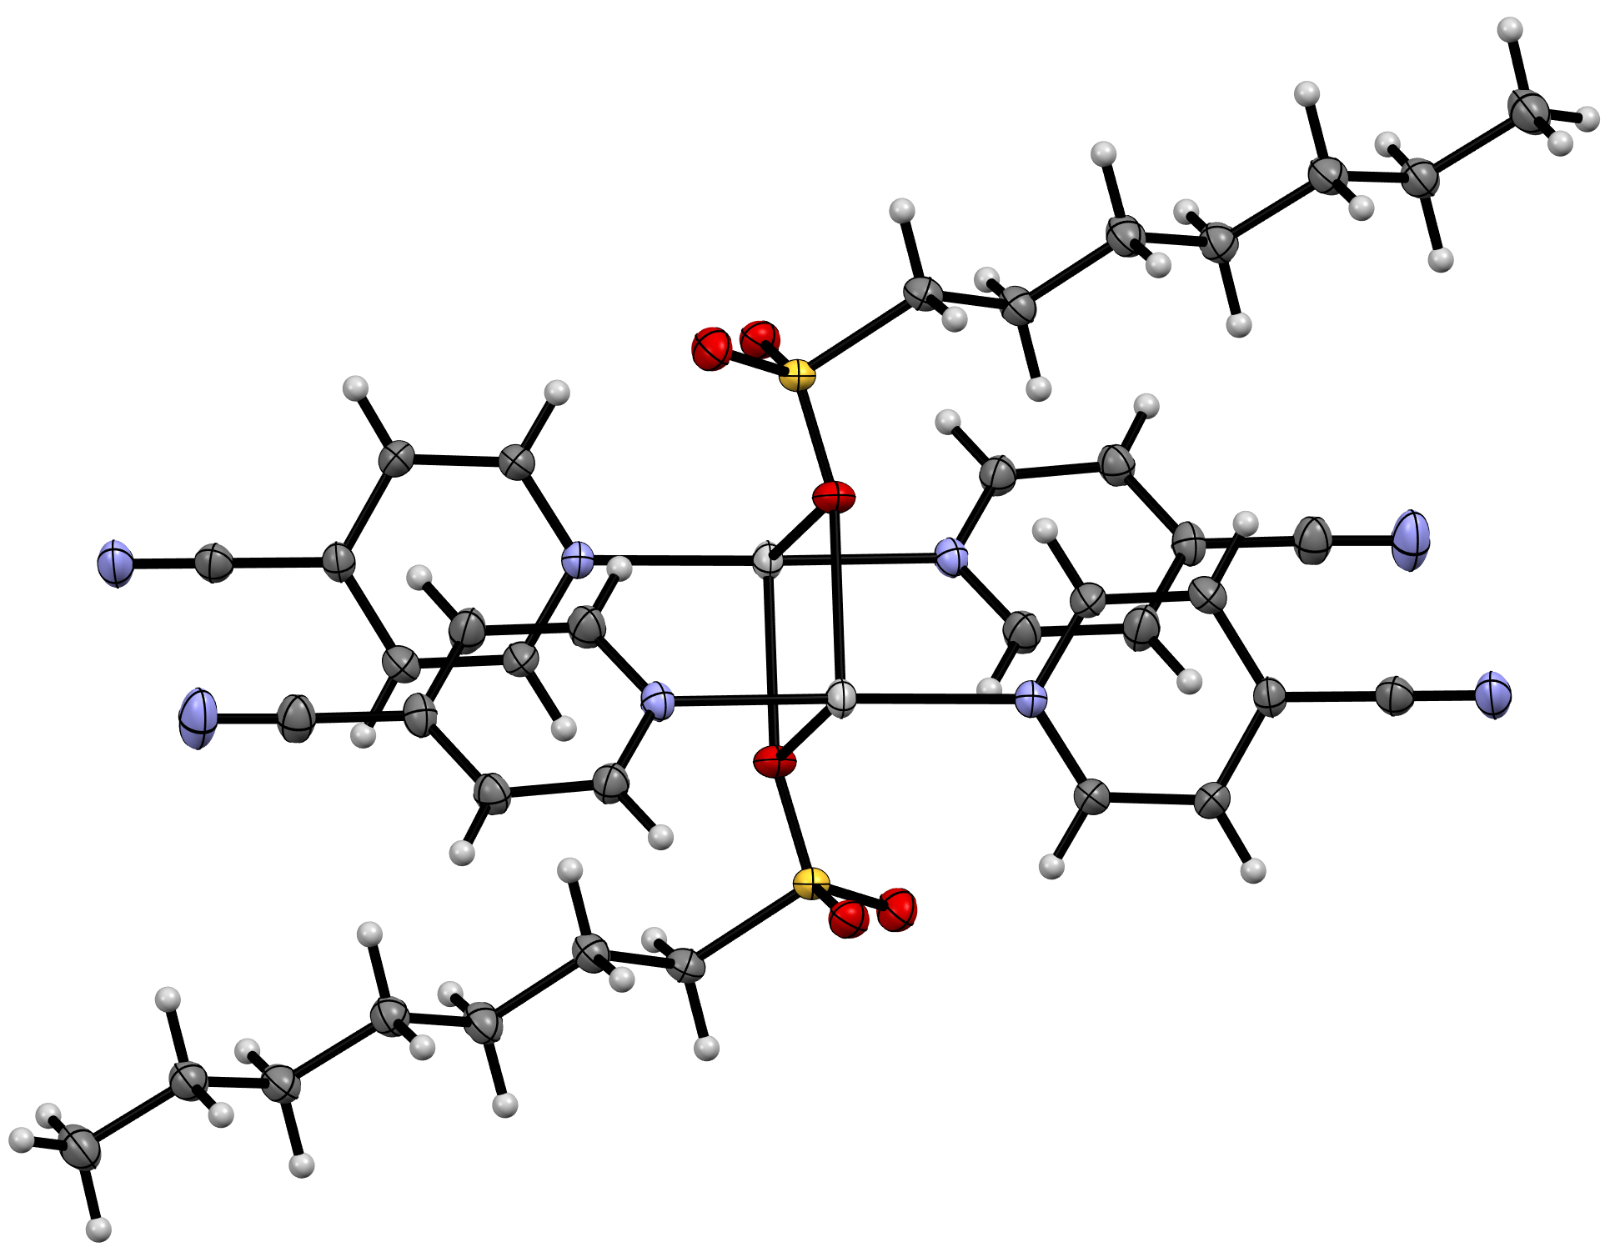
Supplementary Figure 7. X-ray crystal structure of [4CNPy₄Ag₂]Heps₂ with thermal displacement parameters at 50% probability level.

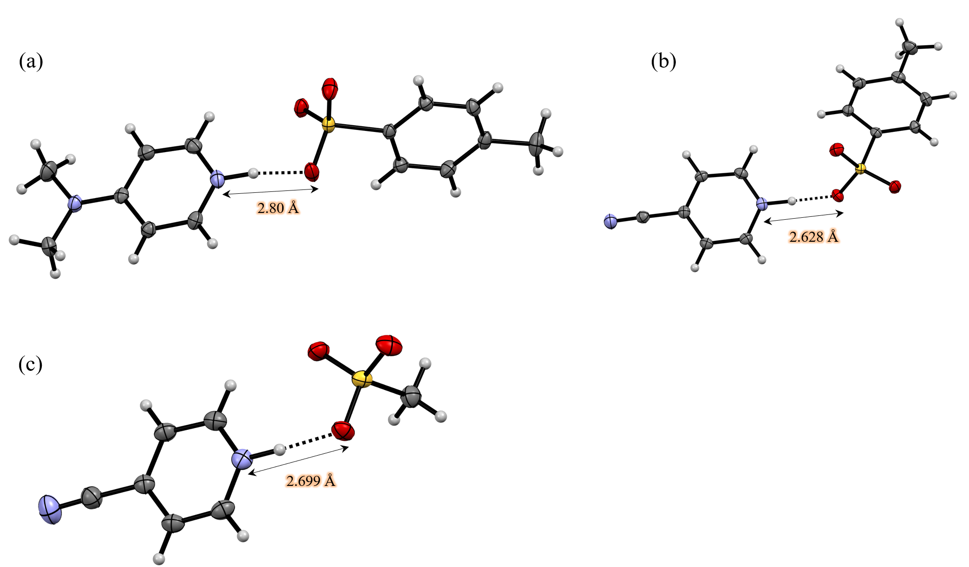
Supplementary Figure 8. X-ray crystal structure of (a) [Dmap-H]Tos, (b) [4CNPy-H]Tos, (c) [4CNPy-H]Mes with thermal displacement parameters at 50% probability level. Numbers below are N···O distances.
3. Computational Studies
3.1 General
The geometry calculations for the complexes were done at the M06-2X/def2-TZVP level of theory^{[6]} and the SPARTAN20 program^{[7]} with acetonitrile (dielectric = 37.50) as a solvent using conductor-like polarizable continuum model (C-PCM).^{[8,9]} The initial models were built using SPARTAN20 and optimized at the M06-2X/def2-TZVP level of theory. The DFT optimizations was started from the sulfonyl hypoiodites R-SO₃-I where the iodine is bonded to the SO₃ oxygen and the pyridine derivatives and the N···O distance was ca. 4.6 Å and the O–I···N angle ca. 170º.
The hexafluorophosphates were started from the preformed N-iodopyridinium cation and “free” PF₆ anion with I···F contact of ca. 2.4 Å. During the optimization the iodine atom moves from the SO₃ oxygen to the N-atom of the pyridine derivative, leading to the N-iodopyridinium sulfonate. In the hexafluorophosphate complexes, the N-iodopyridinium N–I distance shortens and the PF₆ anion moves further away from the iodine atom. The optimized structures and geometry parameters are shown in Figures S6 - S8.

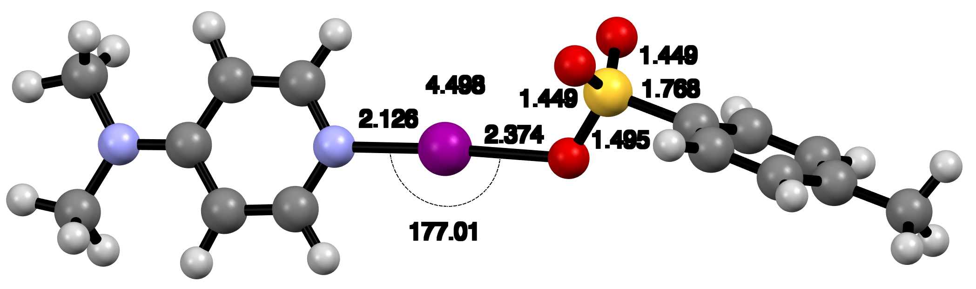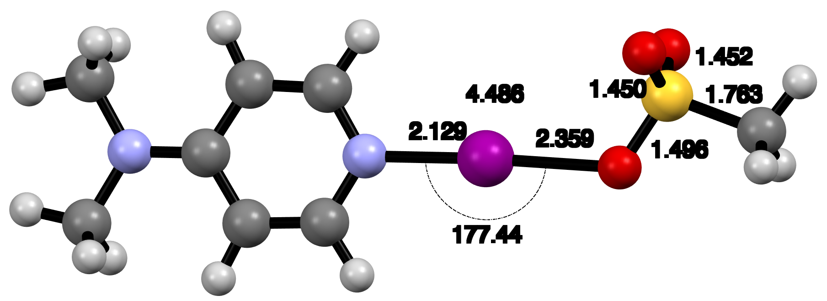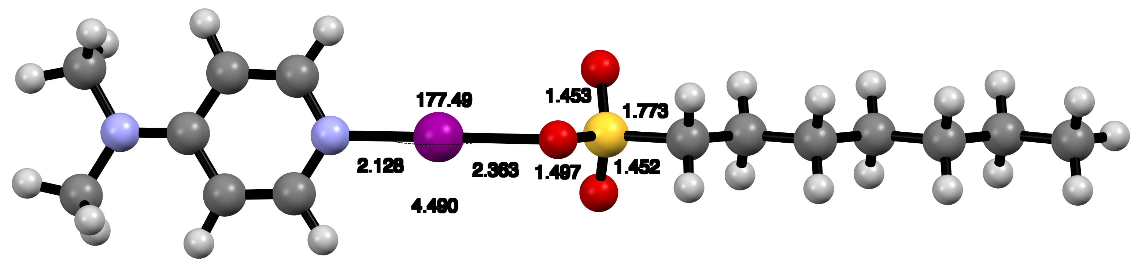
Supplementary Figure 9. The DFT optimized structures of [Dmap-I]Tos (top), [Dmap-I]Mes (middle) and [Dmap-I]Heps (bottom).

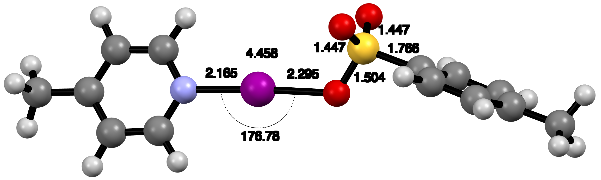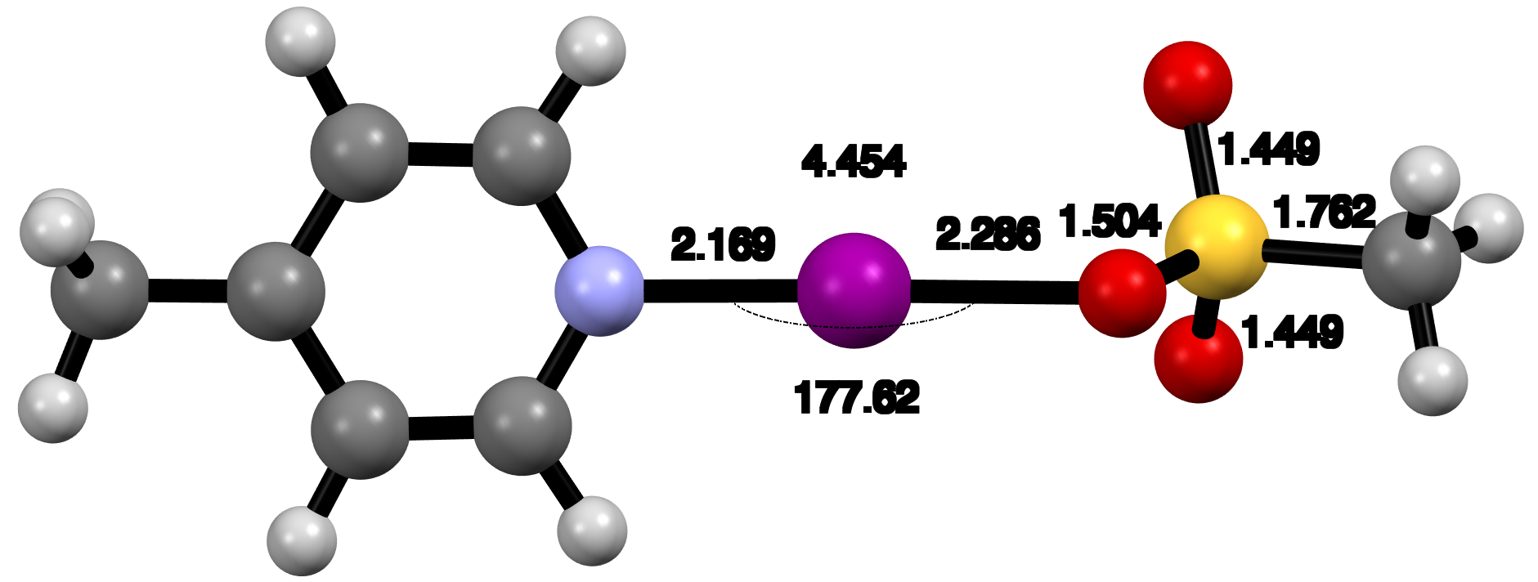
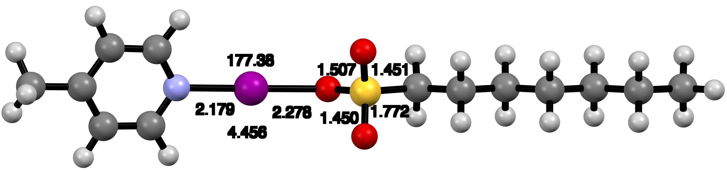
Supplementary Figure 10. The DFT optimized structures of [4MePy-I]Tos (top), [4MePy-I]Mes (middle) and [4MePy-I]Heps (bottom).
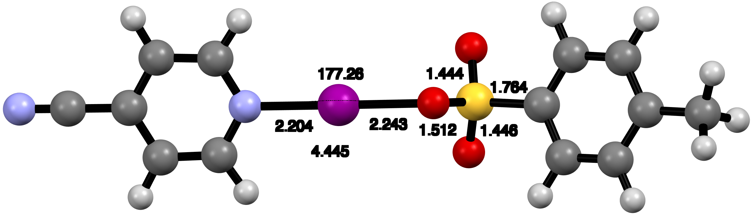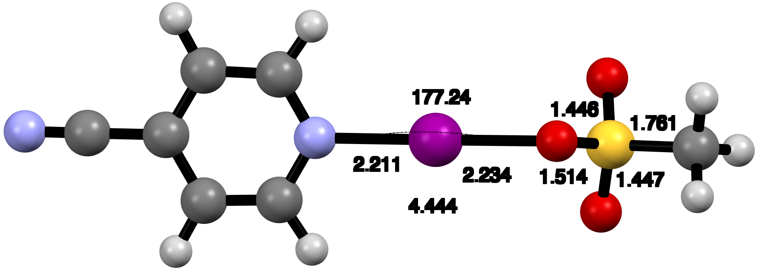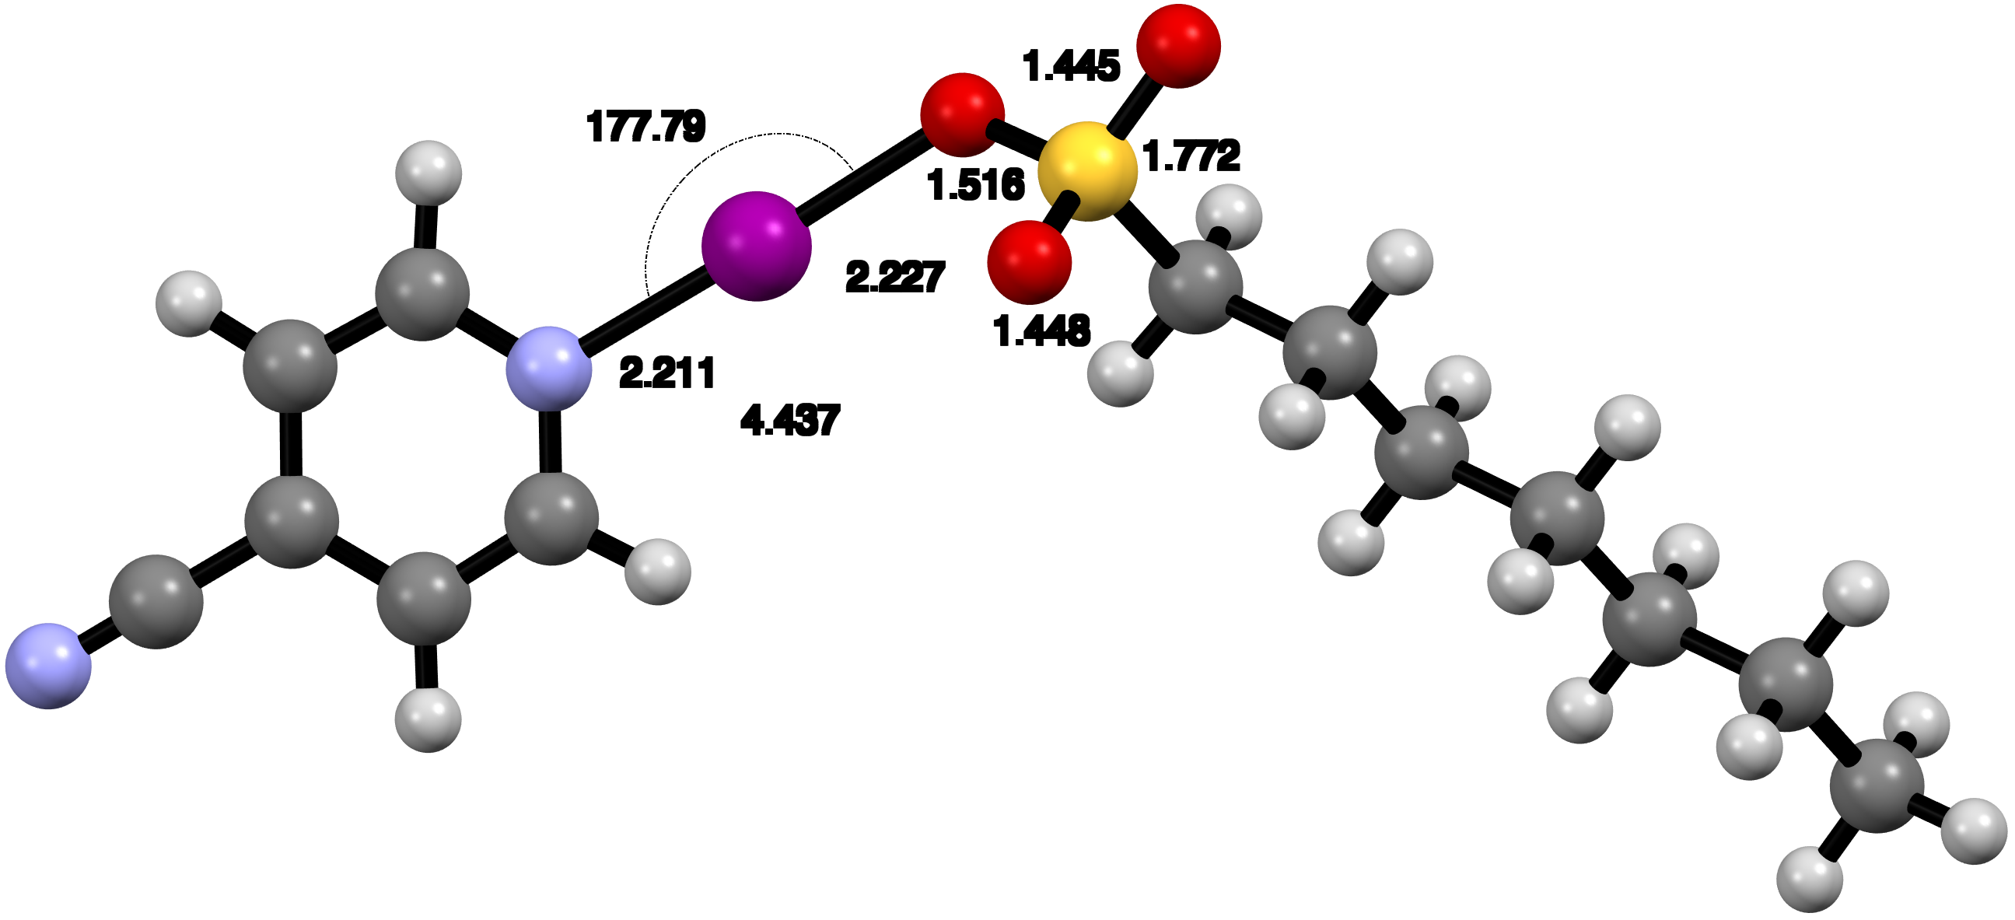
Supplementary Figure 11. The DFT optimized structures of [4CNPy-I]Tos (top), [4CNPy-I]Mes (middle) and [4CNPy-I]Heps (bottom).

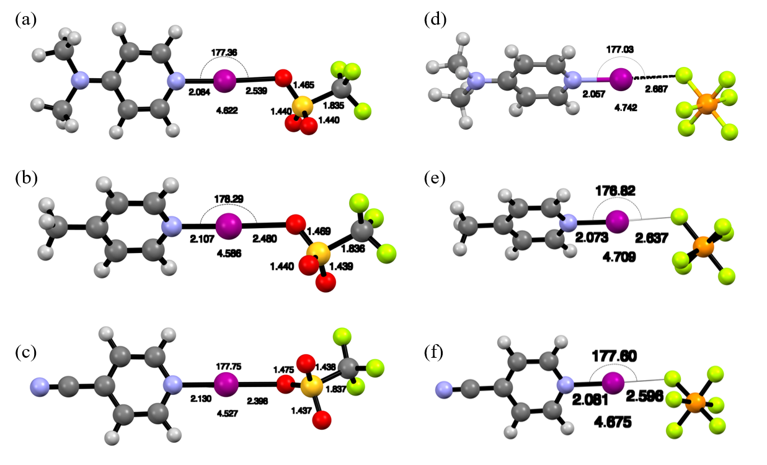
Supplementary Figure 12. The DFT optimized structures of [Dmap-I]Trif (a), [4MePy-I]Trif (b), [4CNPy-I]Trif (c), [Dmap-I]PF₆ (d), [4MePy-I]PF₆ (e) and [4CNPy-I]PF₆ (f).

3.2 Coordinates
[Dmap-I]Tos
H 0.618830 4.584395 2.464801
C 1.235171 4.121375 3.224318
C 2.827598 2.923198 5.156917
C 1.914769 2.945320 2.942613
C 1.360548 4.694589 4.481817
C 2.156955 4.107782 5.463224
C 2.712243 2.339850 3.905200
H 0.830942 5.613496 4.704360
H 3.240336 1.423642 3.673622
H 3.448712 2.453025 5.910391
S 1.732714 2.182453 1.357994
O 1.339641 3.213491 0.419066
O 2.982219 1.517887 1.045412
O 0.632970 1.193408 1.573900
I -0.101930 -0.187001 -0.212050
C 2.315045 4.749235 6.812584
H 3.198544 5.391734 6.824743
H 2.444073 3.996967 7.590057
H 1.451496 5.366615 7.057475
H 0.096059 -2.709757 -4.689329
C -0.548239 -2.542778 -3.840264
C -2.057129 -2.026040 -1.623718
C -1.829033 -3.148667 -3.745659
C -0.102200 -1.727289 -2.841146
N -0.838110 -1.464481 -1.743725
C -2.577222 -2.852609 -2.576221
H 0.870142 -1.256372 -2.893849
H -3.559254 -3.267653 -2.411999
H -2.610979 -1.788599 -0.725535
N -2.302359 -3.951124 -4.701377
C -1.499746 -4.235491 -5.882892
H -0.566191 -4.731173 -5.608978
H -1.265077 -3.316472 -6.423039
H -2.064123 -4.890247 -6.538426
C -3.617989 -4.560499 -4.559940
H -3.819164 -5.166250 -5.437103
H -4.392620 -3.796301 -4.477427
H -3.657640 -5.199659 -3.675820

[Dmap-I]Mes
O -3.319764 3.359392 0.424714
I -1.637762 1.713243 0.269156
S -4.483081 3.339210 -0.516489
O -4.055155 3.524202 -1.890838
O -5.316355 2.170674 -0.302768
C -5.416833 4.759431 -0.046404
H -4.792961 5.640514 -0.177069
H -5.716286 4.645986 0.992791
H -6.289414 4.806555 -0.694810
H -0.917693 -0.707310 -1.417930
C -0.082788 -0.705023 -0.729901
C 1.966562 -0.578936 1.071048
C 0.899096 -1.649736 -0.806218
N -0.070727 0.274015 0.194594
C 0.945238 0.326139 1.076803
C 1.983769 -1.624297 0.110057
H 0.824082 -2.404354 -1.573405
H 0.912963 1.129178 1.800981
H 2.744928 -0.475310 1.810526
N 2.962056 -2.531153 0.069738
C 4.060953 -2.465382 1.023851
H 4.751613 -3.276052 0.817312
H 3.695277 -2.568192 2.047380
H 4.595711 -1.517859 0.935323
C 2.938902 -3.589450 -0.930659
H 3.806444 -4.224658 -0.786423
H 2.972794 -3.172355 -1.939105
H 2.038433 -4.198472 -0.832256

[Dmap-I]Heps
S 0.363290 0.712289 0.475831
O 1.357319 0.862399 -0.572823
O 0.715272 -0.265072 1.490922
O -0.994001 0.440746 -0.094449
I -1.388435 -1.555687 -1.294778
H -1.406553 -4.592587 -5.437656
C -1.731265 -4.567749 -4.409246
C -2.494001 -4.344244 -1.796075
C -2.429074 -5.654657 -3.819700
C -1.461397 -3.450377 -3.673673
N -1.832324 -3.328955 -2.384717
C -2.804884 -5.495137 -2.460409
H -0.935169 -2.609356 -4.104573
H -3.334987 -6.267765 -1.926197
H -2.769842 -4.202641 -0.759713
C 0.162455 2.283041 1.274466
H -0.632995 2.145950 2.008483
H -0.185248 2.972103 0.503385
C 1.449460 2.769542 1.924048
H 2.225314 2.870744 1.161415
H 1.797786 2.025673 2.644870
C 1.244646 4.106740 2.627784
H 0.469215 3.997112 3.392675
H 0.871379 4.841617 1.907255
C 2.521100 4.632706 3.271476
H 3.292161 4.748844 2.502511
H 2.900607 3.890714 3.982062
C 2.320749 5.961236 3.989199
H 1.555236 5.841935 4.763701
H 1.930752 6.700240 3.280694
C 3.596995 6.500062 4.623813
H 4.358706 6.622610 3.848126
H 3.988038 5.758742 5.327083
C 3.378691 7.825410 5.342952
H 4.302382 8.199024 5.786888
H 2.641718 7.715185 6.141404
H 3.007199 8.583978 4.650537
N -2.717697 -6.763197 -4.505910
C -2.302458 -6.894076 -5.895877
H -1.218994 -6.799990 -5.986118
H -2.774788 -6.131648 -6.518607
H -2.597605 -7.873188 -6.257698
C -3.464685 -7.841743 -3.873254
H -2.909026 -8.262164 -3.032540
H -3.634341 -8.624279 -4.604953
H -4.430700 -7.484131 -3.512616

[4MePy-I]Tos
H 0.183616 3.856507 1.624601
C 0.809061 3.400933 2.381227
C 2.426848 2.220944 4.305281
C 1.511269 2.239568 2.093560
C 0.924862 3.968482 3.641843
C 1.733678 3.390781 4.618771
C 2.321526 1.642531 3.050697
H 0.378413 4.875799 3.870473
H 2.866580 0.738288 2.812358
H 3.057910 1.758749 5.055404
S 1.346713 1.487524 0.504589
O 0.948499 2.512991 -0.434754
O 2.592377 0.818015 0.196871
O 0.241394 0.490727 0.718455
I -0.469153 -0.847618 -1.004715
C 1.881494 4.027024 5.971516
H 2.762474 4.672692 5.990738
H 2.009682 3.272003 6.746604
H 1.014150 4.639724 6.213923
H -0.329621 -3.439477 -5.497773
C -0.955180 -3.246430 -4.636496
C -2.440926 -2.701601 -2.419387
C -2.216934 -3.828992 -4.524360
C -0.487452 -2.416355 -3.641967
N -1.226274 -2.153717 -2.556602
C -2.958799 -3.539248 -3.381706
H 0.486084 -1.947864 -3.693239
H -3.941331 -3.966504 -3.233955
H -2.986505 -2.454314 -1.518783
C -2.762255 -4.710001 -5.601770
H -1.960506 -5.226982 -6.126107
H -3.298831 -4.097323 -6.330425
H -3.462862 -5.436857 -5.194873

[4MePy-I]Mes
S 1.742456 3.407016 2.397416
O 2.726797 3.511425 1.339153
O 2.077188 2.462584 3.443769
O 0.372594 3.133569 1.836027
I -0.017503 1.206578 0.669692
H -0.079743 -1.863204 -3.506847
C -0.383752 -1.821955 -2.469285
C -1.105766 -1.610008 0.149453
C -1.041080 -2.898701 -1.872978
C -0.114509 -0.688883 -1.737303
N -0.473527 -0.594474 -0.448892
C -1.401861 -2.769786 -0.535133
H 0.392228 0.165983 -2.164246
H -1.914803 -3.569230 -0.018238
H -1.369214 -1.473576 1.189697
C 1.554126 4.996904 3.133278
H 2.515406 5.270103 3.564113
H 0.791506 4.929690 3.905362
H 1.264199 5.702804 2.358735
C -1.334942 -4.140509 -2.651961
H -0.400355 -4.616674 -2.954289
H -1.882364 -3.892013 -3.562112
H -1.917083 -4.847641 -2.065413

[4MePy-I]Heps
S 0.067407 -0.211130 -0.211186
O 0.955335 0.063655 -1.323876
O 0.536647 -1.242805 0.693720
O -1.328635 -0.512293 -0.692379
I -1.751237 -2.405993 -1.885142
H -3.045010 -5.080449 -6.143768
C -2.837752 -5.201240 -5.089054
C -2.307169 -5.384207 -2.421622
C -2.901527 -6.454859 -4.485609
C -2.511005 -4.092491 -4.338238
N -2.250912 -4.192026 -3.028984
C -2.628316 -6.526773 -3.120219
H -2.454293 -3.102727 -4.771354
H -2.668147 -7.471507 -2.594681
H -2.091171 -5.400153 -1.361783
C -0.158690 1.285302 0.711703
H -0.892293 1.053529 1.485096
H -0.593481 2.003643 0.015522
C 1.146310 1.796436 1.304926
H 1.869960 1.962120 0.503143
H 1.566094 1.038946 1.971285
C 0.929327 3.094769 2.074637
H 0.196760 2.925872 2.870447
H 0.495662 3.843605 1.404127
C 2.216592 3.641763 2.678073
H 2.950116 3.801703 1.880624
H 2.647722 2.893130 3.351172
C 2.007382 4.944672 3.438790
H 1.272569 4.784750 4.235535
H 1.574017 5.691461 2.764472
C 3.290448 5.500865 4.044035
H 4.024155 5.657065 3.247522
H 3.720683 4.755158 4.719199
C 3.063953 6.806190 4.796405
H 3.991378 7.191365 5.222170
H 2.352233 6.663607 5.612581
H 2.656582 7.569959 4.130342
C -3.227782 -7.684849 -5.272840
H -2.299808 -8.183916 -5.562882
H -3.777020 -7.436711 -6.179138
H -3.807086 -8.385433 -4.672771

[4CNPy-I]Tos
H 1.617891 3.502763 -0.132691
C 1.268500 3.461373 0.890597
C 0.376401 3.332308 3.517993
C 1.072213 2.235275 1.508838
C 1.015431 4.625471 1.601634
C 0.568457 4.579177 2.920672
C 0.625666 2.160948 2.821990
H 1.166734 5.585944 1.123726
H 0.479713 1.196877 3.291854
H 0.026920 3.280866 4.542441
C 0.325365 5.843131 3.694457
H 1.216322 6.112428 4.266439
H -0.494278 5.717805 4.401544
H 0.094732 6.673130 3.027673
S 1.350885 0.745111 0.607324
O 2.234371 1.039859 -0.497100
O 1.819522 -0.264202 1.529655
O -0.036273 0.405006 0.110577
I -0.380500 -1.490086 -1.038866
H -1.365724 -4.274197 -5.338543
C -1.245886 -4.358521 -4.268385
C -0.927379 -4.490251 -1.549588
C -1.361094 -5.580376 -3.615528
C -0.969207 -3.239391 -3.510872
N -0.817254 -3.319904 -2.185683
C -1.200202 -5.654911 -2.236854
H -0.865218 -2.260596 -3.958305
H -1.284611 -6.591998 -1.706058
H -0.792885 -4.480644 -0.476574
C -1.647083 -6.771828 -4.370072
N -1.871528 -7.720570 -4.972295

[4CNPy-I]Mes
O -1.987881 2.440168 0.305962
I -0.473648 0.833405 0.271992
S -3.121643 2.403879 -0.705181
O -2.618653 2.611850 -2.043635
O -3.929793 1.219982 -0.522715
C -4.073400 3.809914 -0.240140
H -3.447022 4.694346 -0.325424
H -4.420025 3.669343 0.780638
H -4.913604 3.863378 -0.929922
H 0.220203 -1.688384 -1.338941
C 1.035517 -1.731973 -0.629072
C 3.042932 -1.709688 1.232082
C 1.976025 -2.741234 -0.665547
N 1.090927 -0.761946 0.287029
C 2.064107 -0.736998 1.200073
C 2.991913 -2.724011 0.282424
H 1.913442 -3.517198 -1.414711
H 2.047973 0.077764 1.911628
H 3.822160 -1.673701 1.979905
C 3.992030 -3.757256 0.281794
N 4.788438 -4.581640 0.281761

[4CNPy-I]Heps
S 1.361562 -1.711190 -2.076213
O 0.273187 -1.199207 -2.881204
O 2.640823 -1.812736 -2.740889
O 1.008140 -3.063560 -1.491716
I -1.064524 -3.620097 -0.897702
H -4.982577 -7.000434 -0.160760
C -4.712399 -5.959778 -0.055031
C -3.950908 -3.338282 0.185334
C -5.611448 -5.018854 0.434271
C -3.449766 -5.530738 -0.408002
N -3.093642 -4.248688 -0.286056
C -5.231811 -3.687631 0.560116
H -2.705418 -6.212476 -0.796243
H -5.911272 -2.938093 0.938649
H -3.594751 -2.319592 0.256371
C -6.939601 -5.422863 0.812378
N -7.997808 -5.742438 1.114780
C 1.550997 -0.654073 -0.666876
H 2.313610 -1.120518 -0.041212
H 0.595751 -0.680686 -0.138037
C 1.935245 0.763560 -1.065195
H 1.171965 1.172532 -1.731616
H 2.874570 0.740380 -1.623251
C 2.087617 1.666668 0.153637
H 2.841339 1.244893 0.826336
H 1.145575 1.685320 0.711101
C 2.483210 3.088510 -0.223529
H 1.732433 3.503372 -0.904602
H 3.426483 3.064651 -0.779750
C 2.632254 4.007647 0.981673
H 3.379829 3.590852 1.665558
H 1.687656 4.034763 1.536101
C 3.033975 5.428415 0.604766
H 2.288924 5.840726 -0.082360
H 3.979134 5.398881 0.054299
C 3.174356 6.339883 1.817284
H 3.465458 7.350715 1.528513
H 3.930771 5.955430 2.504990
H 2.231060 6.404737 2.364087

[DMAP-I]Trif

S 2.707942 3.602613 3.505917
O 2.824932 4.593022 2.467083
O 3.841225 2.732055 3.685616
O 1.414039 2.916847 3.538281
I 0.648075 1.339681 1.702479
H 0.832439 -1.190713 -2.722671
C 0.201977 -1.032714 -1.861624
C -1.275703 -0.539212 0.385404
C -1.067151 -1.661013 -1.739789
C 0.654503 -0.204950 -0.878641
N -0.068817 0.047435 0.233365
C -1.795173 -1.378445 -0.552986
H 1.615222 0.285436 -0.952689
H -2.764527 -1.812758 -0.365407
H -1.814012 -0.308736 1.294144
N -1.546781 -2.468669 -2.683864
C -0.771563 -2.728932 -3.890253
H 0.177329 -3.209414 -3.645108
H -0.569526 -1.800893 -4.427951
H -1.342072 -3.388485 -4.535199
C -2.853123 -3.093674 -2.519394
H -3.063337 -3.698567 -3.394815
H -3.634418 -2.338270 -2.419374
H -2.866732 -3.735771 -1.637039
C 2.639098 4.580444 5.058117
F 3.764609 5.272276 5.212602
F 2.489395 3.784837 6.112559
F 1.622149 5.436569 5.031238

[4MePy-I]Trif

H -2.056666 -0.211284 -3.496694
C -1.151865 0.041414 -2.960440
C 1.076928 0.652373 -1.508915
C 0.013304 0.387965 -3.644076
C -1.164382 0.013076 -1.586221
N -0.061075 0.316206 -0.883262
C 1.139178 0.694622 -2.882647
H -2.046255 -0.251626 -1.020116
H 2.073661 0.964953 -3.355322
H 1.928494 0.881455 -0.883744
I -0.108841 0.251399 1.221704
C 0.041495 0.449950 -5.136198
H 1.059182 0.373971 -5.513460
H -0.373862 1.406440 -5.462963
H -0.571524 -0.340408 -5.567304
S 0.511154 -0.765685 4.501038
O 0.305416 -2.118713 4.053897
O 1.859990 -0.401052 4.842138
O -0.196054 0.241970 3.699507
C -0.398998 -0.663732 6.091611
F 0.111646 -1.530037 6.961893
F -0.305536 0.556874 6.609632
F -1.685391 -0.950132 5.919942

[4CNPy-I]Trif

H -2.078244 -0.137329 -3.975143
C -1.171263 0.095017 -3.436288
C 1.089657 0.674572 -1.995004
C 0.000640 0.445772 -4.095350
C -1.158579 0.048791 -2.058563
N -0.045619 0.335242 -1.371009
C 1.149161 0.740291 -3.370450
H -2.036859 -0.216508 -1.487036
H 2.072888 1.015816 -3.858035
H 1.947393 0.892552 -1.374289
I -0.076956 0.258265 0.756754
S 0.545097 -0.733167 3.996133
O 0.360258 -2.092825 3.565922
O 1.878200 -0.343155 4.363727
O -0.153322 0.255792 3.153839
C -0.419771 -0.599404 5.552983
F 0.077666 -1.429813 6.463240
F -0.364212 0.636982 6.034422
F -1.692683 -0.915108 5.344563
C 0.026564 0.507763 -5.533006
N 0.049983 0.560454 -6.677409

[DMAP-I]PF₆

H -1.688304 -1.033639 -2.077668
C -0.834753 -0.654257 -1.537869
C 1.255321 0.273197 -0.031180
C 0.301799 -0.128102 -2.211903
C -0.870816 -0.691359 -0.178629
N 0.157611 -0.236372 0.573305
C 1.359704 0.341845 -1.385871
H -1.723063 -1.087001 0.355187
H 2.263185 0.758947 -1.802023
H 2.046790 0.622792 0.616504
I 0.055787 -0.329959 2.625070
P -0.874672 0.401439 6.290355
F -1.745443 1.342356 7.249272
F -2.122351 0.232558 5.289706
F -0.380944 1.680648 5.450324
F 0.014284 -0.557847 5.302444
F -1.346618 -0.901285 7.097949
F 0.395327 0.547168 7.258884
N 0.370881 -0.081659 -3.539231
C 1.554813 0.459592 -4.196005
H 2.441825 -0.120221 -3.935327
H 1.713568 1.500196 -3.908375
H 1.408912 0.413288 -5.269803
C -0.729490 -0.591424 -4.348674
H -0.475494 -0.472049 -5.396248
H -1.647931 -0.038626 -4.144206
H -0.899929 -1.650226 -4.145986

[4MePy-I]PF₆

H -1.552164 -0.974546 -3.112894
C -0.680460 -0.670349 -2.549577
C 1.464460 0.075365 -1.030727
C 0.507335 -0.325130 -3.195523
C -0.760787 -0.632512 -1.180415
N 0.303902 -0.263600 -0.445180
C 1.587690 0.050890 -2.399607
H -1.660463 -0.892732 -0.641934
H 2.536062 0.325653 -2.840895
H 2.277812 0.360552 -0.378929
I 0.147466 -0.227495 1.621889
P -0.955319 0.656394 5.161827
F -1.953490 1.552207 6.033075
F -2.138520 0.298135 4.133721
F -0.564568 1.927074 4.258597
F 0.069178 -0.260657 4.257924
F -1.316529 -0.641823 6.028691
F 0.257687 0.987382 6.155447
C 0.600775 -0.341551 -4.684662
H 1.636486 -0.331730 -5.015560
H 0.101268 0.543852 -5.085023
H 0.092179 -1.215380 -5.090243

[4CNPy-I]PF₆

H -1.515793 -0.993026 -3.574308
C -0.642579 -0.697615 -3.011253
C 1.533854 0.043662 -1.508623
C 0.549508 -0.352851 -3.636676
C -0.699948 -0.656164 -1.636011
N 0.375136 -0.291355 -0.920179
C 1.653784 0.021270 -2.880210
H -1.596030 -0.910701 -1.088843
H 2.592632 0.293344 -3.340158
H 2.353175 0.327448 -0.863909
I 0.240598 -0.241939 1.156191
C 0.641113 -0.384187 -5.071765
N 0.714567 -0.411169 -6.214737
P -0.900116 0.619469 4.672493
F -1.920484 1.472105 5.558941
F -2.058069 0.291015 3.606854
F -0.501542 1.924356 3.825772
F 0.152082 -0.256471 3.749731
F -1.264091 -0.715620 5.477647
F 0.292206 0.918428 5.699042

4. Solution ¹H-¹⁵N HMBC NMR
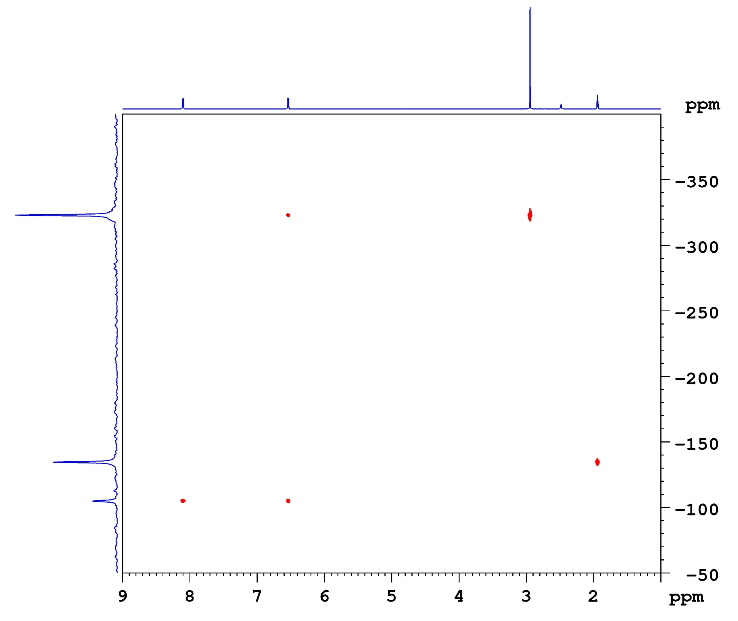

Supplementary Figure 13. The ¹H-¹⁵N HMBC spectrum of Dmap (CD₃CN, -20 °C).
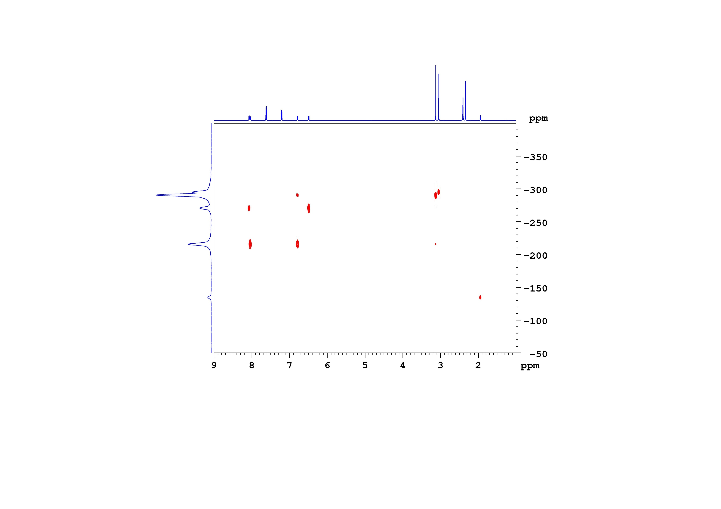
Pyridinic-N of (Dmap-I)Tos
Pyridinic-N of (Dmap-H)⁺
CD₃CN
Supplementary Figure 14. The ¹H-¹⁵N HMBC spectrum of [Dmap-I]Tos (CD₃CN, -20 °C).
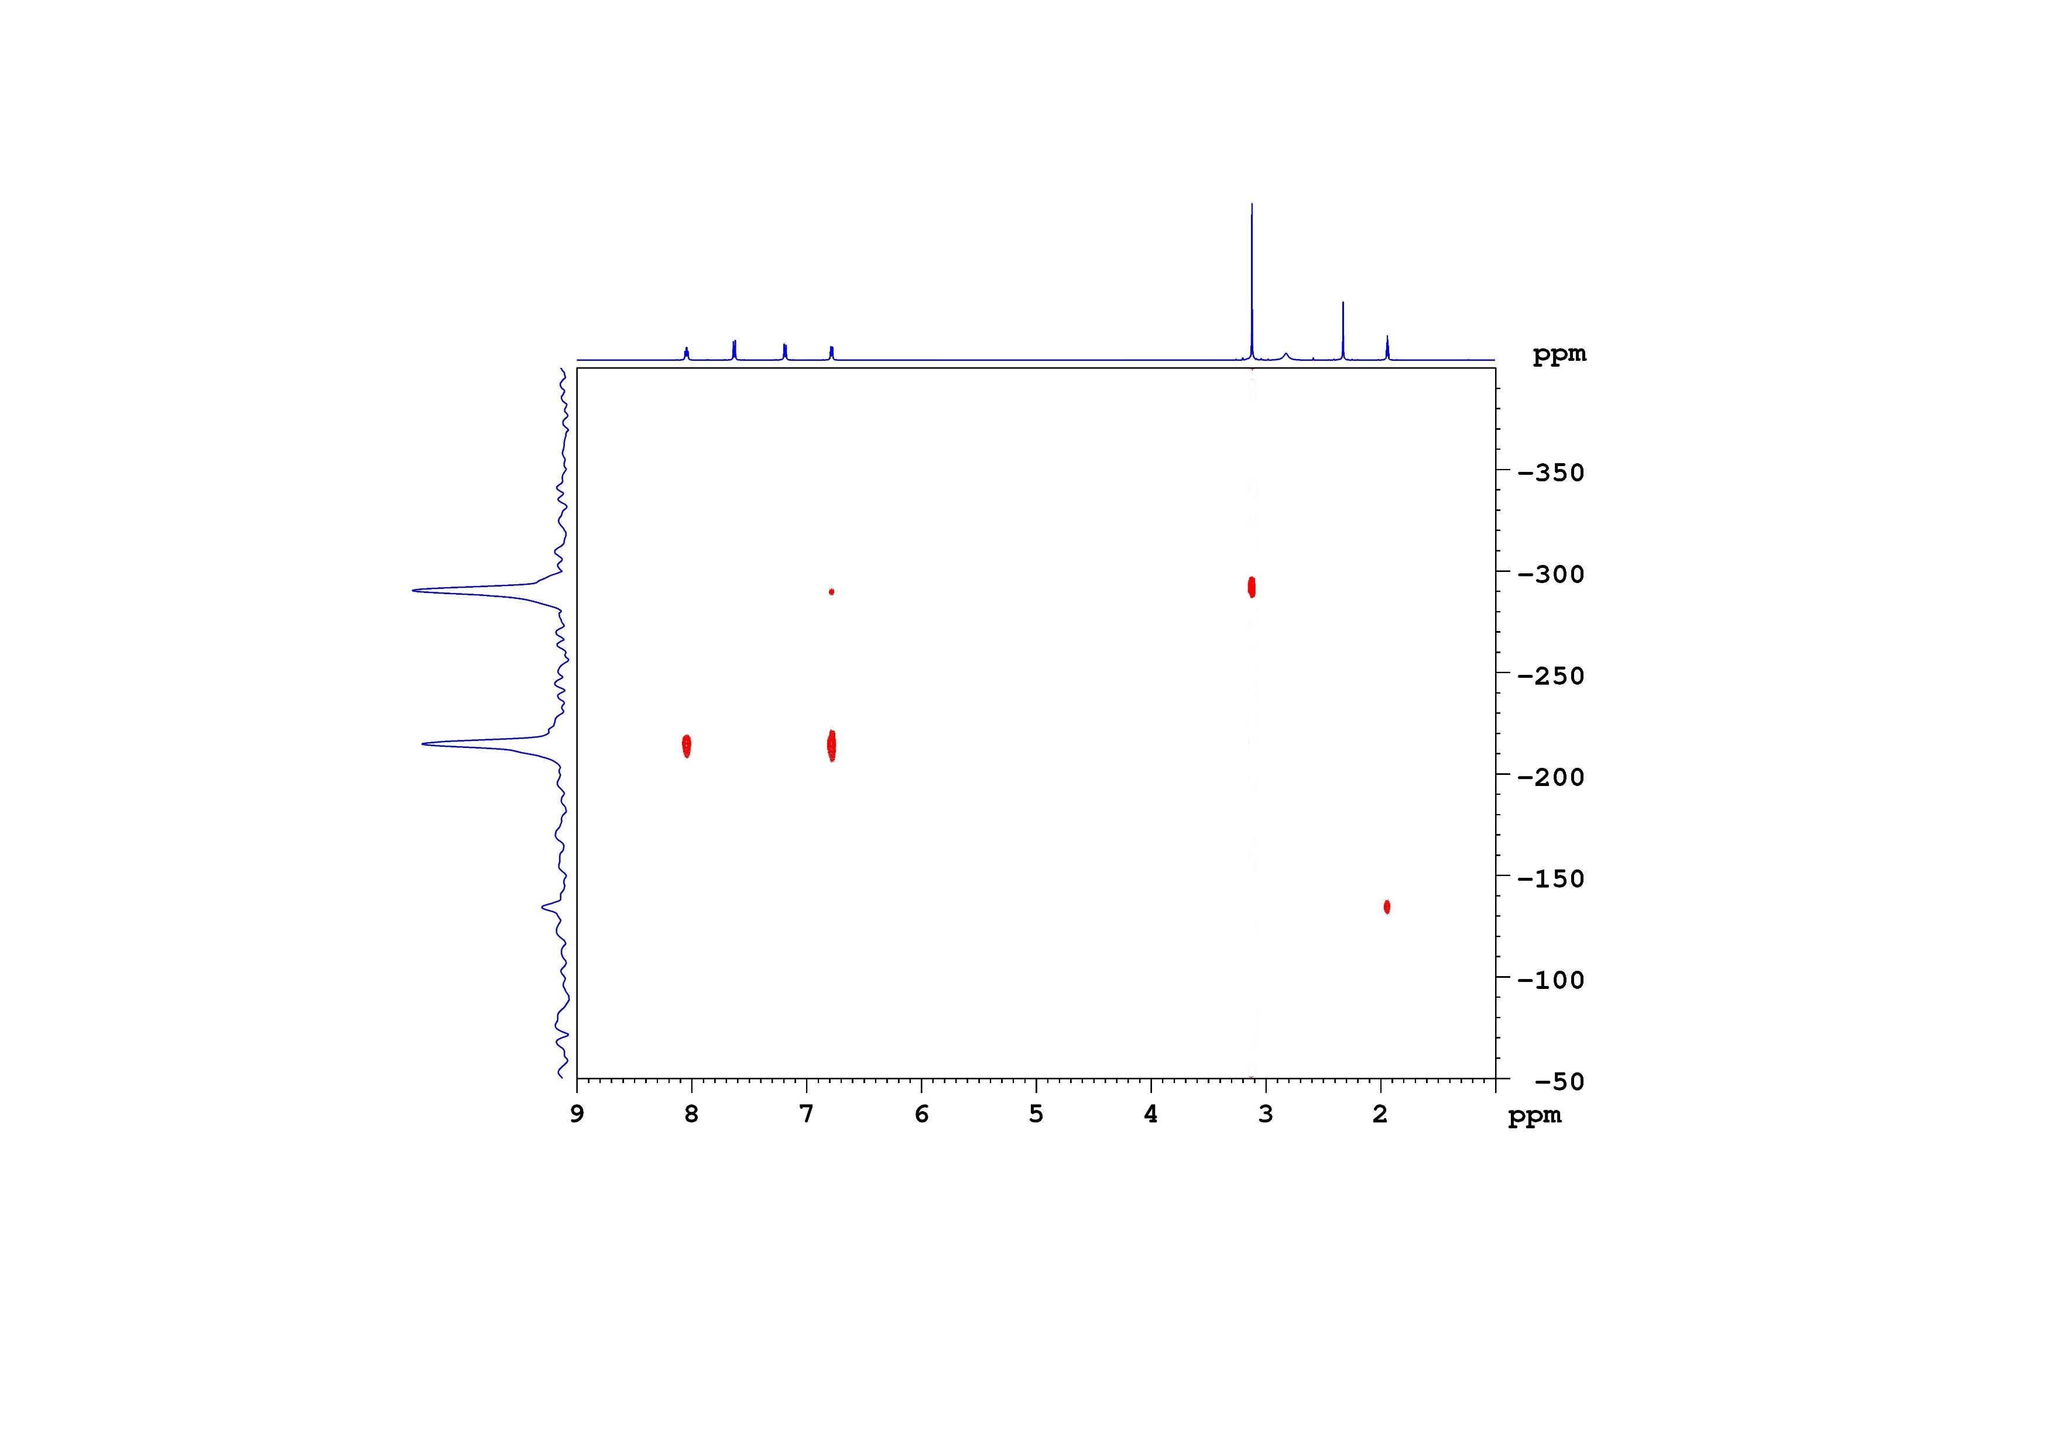
Supplementary Figure 15. The ¹H-¹⁵N HMBC spectrum of [Dmap-H]Tos (CD₃CN, -20 °C).

5. References
[1] Q. Dong, N. Li, R. Qiu, J. Wang, C. Guo, X. Xu, J Organomet Chem 2015, 799–800, 122–127.
[2] G. M. Sheldrick, Acta Crystallogr A 2015, 71, 3-8.
[3] O. V. Dolomanov, L. J. Bourhis, R. J. Gildea, J. A. K. Howard, H. Puschmann, J Appl Crystallogr 2009, 42, 339–341.
[4] G. M. Sheldrick, Acta Crystallogr A 2008, 64, 112–122.
[5] G. M. Sheldrick, Acta Crystallogr C Struct Chem 2015, 71, 3–8.
[6] Y. Zhao, D. G. Truhlar, Theor. Chem. Acc. 2008, 120, 215–241.
[7] S. K. P. E. Deppmeier, B. J. Driessen, A. J. Hehre, W. J. Hehre, T. S. Johnson, J. A. Ohlinger, “Spartan 18, build 1.4.8, Wavefunction Inc., 2018”.
[8] X. Zhang, J. M. Herbert, J. Phys. Chem. B 2014, 118, 7806–7817.
[9] A. W. Lange, J. M. Herbert, Chem. Phys. Lett. 2011, 509, 77–87.

