Supplementary Materials for Strength-ductility materials by engineering coherent interface at incoherent precipitates

Dongxin Mao,^{1†} Yuming Xie,^{1,2†} Xiangchen Meng,^{1,2†} Xiaotian Ma,² Zeyu Zhang,¹ Xiuwen Sun,¹ Long Wan,¹ Yongxian Huang^{1,2*}
¹State Key Laboratory of Advanced Welding and Joining, Harbin Institute of Technology, Harbin 150001, China
²Zhengzhou Research Institute, Harbin Institute of Technology, Zhengzhou 450000, China
‡These authors contributed equally to this work.
*Corresponding authors. Tel.: 86-451-86413951. E-mail: yxhuang@hit.edu.cn (Yongxian Huang).

- Table S1. Chemical composition of 2195 alloy
2195 powder | Cu | Li | Mg | Ag | Zr | Fe | Al
Mass percentage (wt.%) | 3.99 | 1.09 | 0.38 | 0.42 | 0.1 | 0.17 | Bal.
Atomic percentage (at.%) | 1.68 | 4.19 | 0.43 | 0.10 | 0.03 | 0.08 | Bal.

- Table S2. Crystallographic information of the phases
Phase type  crystallographic  information | plane | interplanar spacing(nm) | Angle between planes(°)
Al matrix | No.1:-1-1-1 | 2.3379 | No.1/2:109.47
Al matrix | No.2:-111 | 2.3379 | No.2/3:54.74
Al matrix | No.3:-200 | 2.0247 | No.1/3:54.74
Al₇Cu₂Fe | No.1:202 | 2.9145 | No.1/2:65.37
Al₇Cu₂Fe | No.2:21-4 | 2.2536 | No.2/3:27.99
Al₇Cu₂Fe | No.3:41-2 | 1.50489 | No.1/3:37.37
Al₂Cu | No.1:200 | 3.0327 | No.1/2:45.00
Al₂Cu | No.2:110 | 4.2889 | No.2/3:26.57
Al₂Cu | No.3:310 | 1.9180 | No.1/3:18.43
Al₃Zr | No.1:114 | 2.3701 | No.1/2:53.76
Al₃Zr | No.2:200 | 2.0045 | No.2/3:24.45
Al₃Zr | No.3:314 | 1.2165 | No.1/3:29.30
- Table S3. The measured/calculated spinodal decomposition wavelengths.
Different interface | Crystal plane | The measured wavelengths (nm) | The calculated wavelengths (nm)
Al-Al₂Cu interface | (111) | 1.337 | 1.197
Al-Al₇Cu₂Fe interface | (111) | 1.375 | 1.237

- Table S4. The disregistries δ between different interfaces.
Different interface | [uνw]_{Al} | d_{[uνw]Al} | [uνw]_{Al2Cu} | d_{[uνw]Al2Cu} | θ |  | δ_{i} | δ
Al-Al₂Cu | [111] | 2.225 | [200] | 2.887 |  | 19.18 | 27.21 | 34.5
Al-Al₂Cu | [200] | 1.963 | [110] | 4.140 |  | 10.20 | 53.33 | 34.5
Al-Al₂Cu | [111] | 2.225 | [020] | 2.887 |  | 2.86 | 23.03 | 34.5
Differed interface | [uνw]_{Al} | d_{[uνw]Al} | [uνw]_{Al7C2Fe} | d_{[uνw]Al7Cu2Fe} |  | θ | δ_{i} | δ
Al-Al₇Cu₂Fe | [111] | 2.225 | [0-16] | 2.223 |  | 0.64 | 0.08
Al-Al₇Cu₂Fe | [200] | 1.963 | [202] | 2.946 |  | 12.66 | 34.99 | 15.7
Al-Al₇Cu₂Fe | [111] | 2.225 | [21-4] | 2.275 |  | 25.61 | 11.81

- Designed experiments:
(Let Al-Cu sheets with and without Li undergo severe plastic deformation at the same time to see the microstructure change.)
The 2219 sheet (Al-Cu) and the 2195 sheet (Al-Cu-Li) were placed together tightly. The two sheets were undergone severe plastic deformation at the same time via specially designed tool. The phases in the 2219 sheet were the usually-seen coarse θ (Al-Cu) phases. In the 2195 plate, before the severe plastic deformation, the T₁ (Al-Cu-Li) phases were existed, shown in XRD (Fig. S1 E). After the severe plastic deformation, usually-seen needle-like T₁ (Al-Cu-Li) phases were missing instead by the spinodal decomposition structures and LPSO (Long Period Stacking Ordered) phases.
Spinodal decomposition structures and LPSO coexisted. LPSO, similar to spinodal decomposition structure, was usually formed in the alloy with low stacking fault energy like Mg. Its formation in the 2195 Al alloy (high stacking fault energy) was attributed to the partial stacking fault energy decrease induced by the severe plastic deformation. The coexistence of the spinodal decomposition structures/ordered structure and its formation process were the focus of the present investigation, which were discussed in detail in the “Microstructural evolution” part of the manuscript.
Such microstructures were in agreement with the results in the manuscript. It can be concluded that under the effect of severe plastic deformation, due to the reduction of local stacking fault energy in the 2195 alloy system, initial spinodal decomposition and LPSO structure tended to form, which was not an accidental phenomenon.
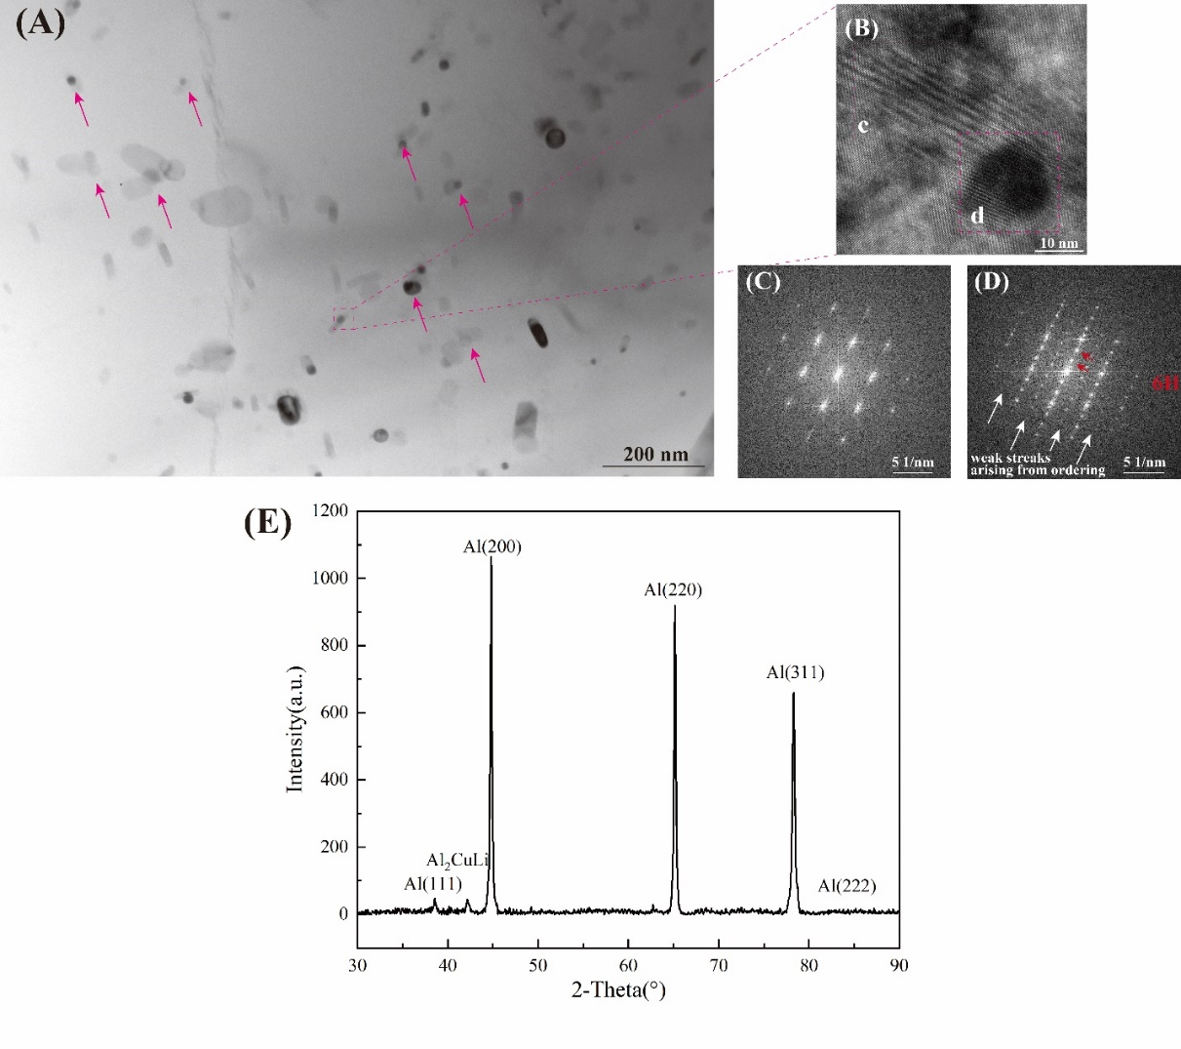
Fig. S1 TEM figure of the 2195 sheet. (A) Bright filed figure of the 2195 sheet. (B) The HR-TEM of the selected phase. (C) The selected area electron diffraction spot patterns of area c. (D) The selected area electron diffraction spot patterns of area d. (E) the XRD data of the 2195 sheet before the svere plastic deformation.

- The distribution of Al₂Cu/Al₇Cu₂Fe in commercial 2195 alloy and DDMed 2195 alloy
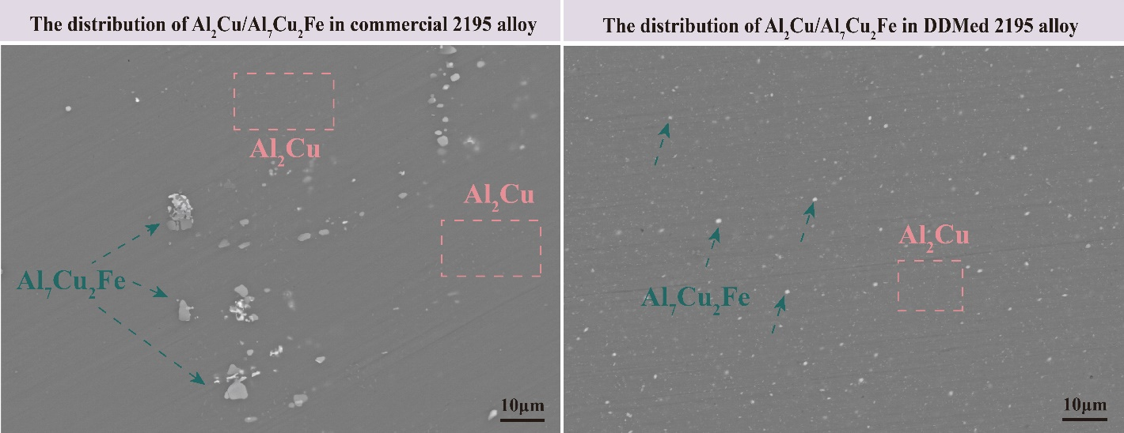
Fig. S2. The distribution of Al₂Cu/Al₇Cu₂Fe in commercial 2195 alloy and DDMed 2195 alloy via scanning electron microscope.
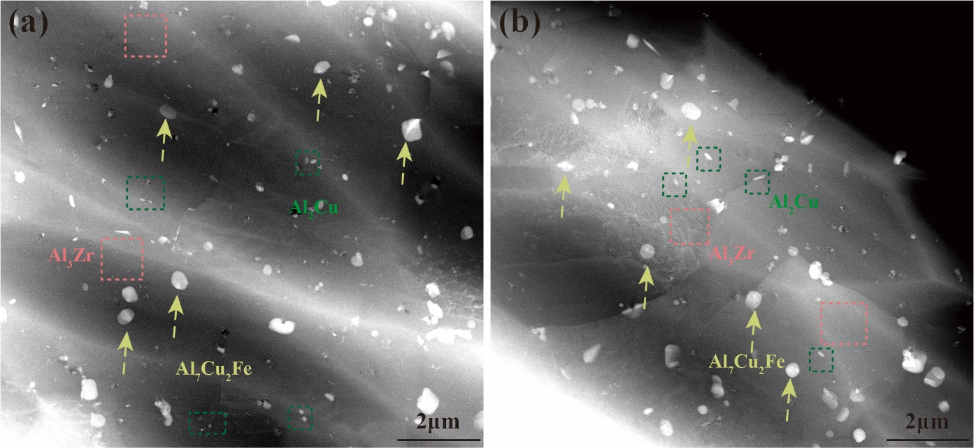
Fig. S3. The distribution of Al₂Cu/Al₇Cu₂Fe in commercial 2195 alloy and DDMed 2195 alloy via scanning transmission electron microscopy.

- The grain boundary and the taylor factor of the commercial 2195 alloy /DDMed 2195
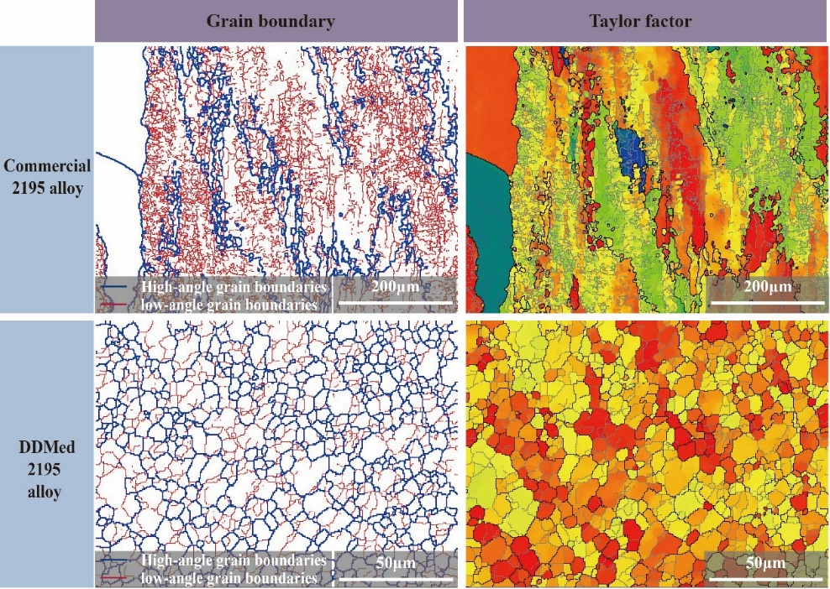
Fig. S4. The grain boundary and the taylor factor of the commercial 2195 alloy/DDMed 2195.
- The point-to-point/origin misorientation profile of typical grains in the DDMed 2195 alloy
The point-to-origin misorientation varies between approximately 0.0◦ and 1.0◦ and did not accumulate across the grain. Typical multi-peak distributions (Fig.S4b and S4c) within small grains were presented, which were attributed to the intragranular-distributed substructure. Such a phenomenon further clarified the typical characteristics of the DDM method with a high instantaneous plastic strain rate and its dominant continuous dynamic recrystallization mode¹.
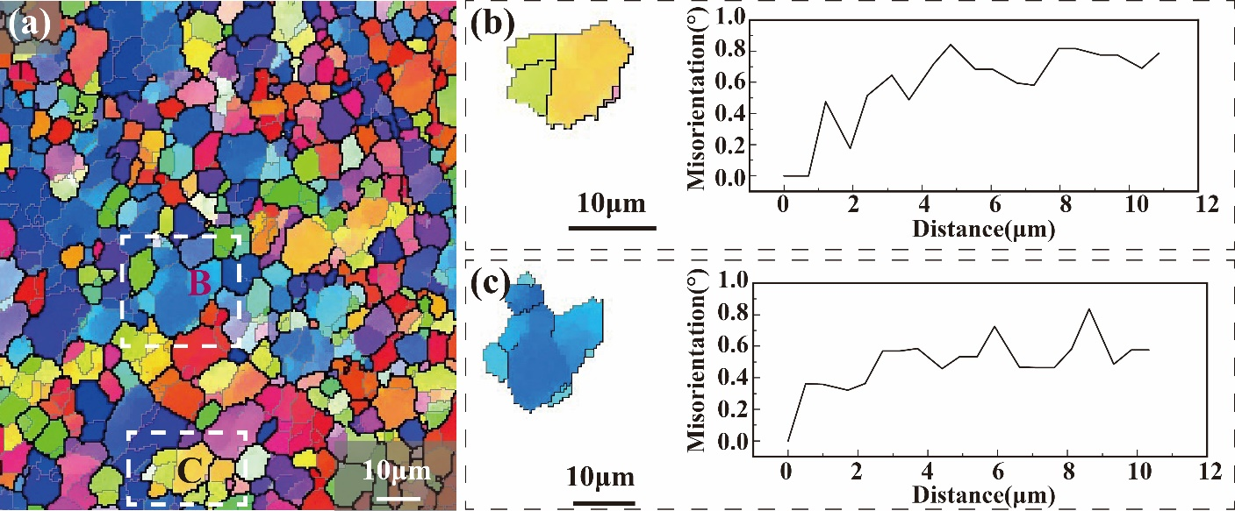
Fig. S5. The point-to-point/origin misorientation profile of typical grains in the DDMed 2195 alloy.
- The selected diffraction spots we used for all GPA analysis.
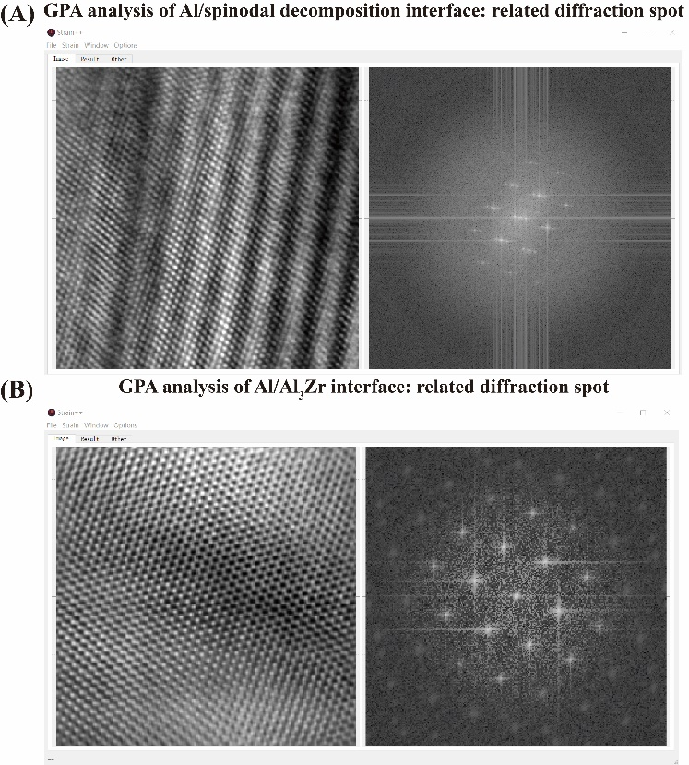
Fig. S6. The selected diffraction spots we used for all GPA analysis.

- Schematic of the DDM process and the related temperature-time curve
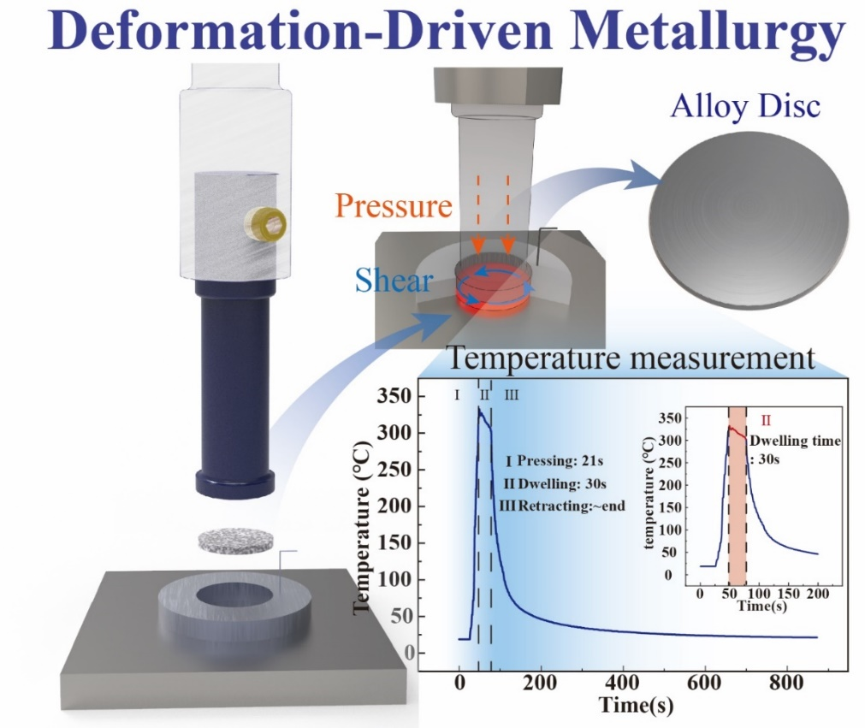
Fig. S7. Schematic of the DDM process and the temperature-time curve during the process.
- The elastic modulus of each crystal orientation of aluminum
The elastic modulus of each crystal orientation of aluminum can be calculated by the following equation²:
$Y_{<100>}=\left(C_{11}+2C_{12}\right)\left(C_{11}-C_{12}\right)/C_{11}$ (1)
$Y_{<110>}=(C_{11}+2C_{12})(C_{11}+6C_{44}-C_{12})/[2\left(C_{11}+2C_{44}+C_{12}\right)]$ (2)
$Y_{<111>}=6\left(C_{11}+2C_{12}\right)C_{44}/(C_{44}+C_{11}+2C_{12})$ (3)
The elastic modulus of <100>_{Al}, <110> _{Al}, <111> _{Al} were estimated as 98.7 GPa,110.0 GPa, and 114.0 GPa, respectively, from C₁₁=107.0 GPa, C₁₂=60.8 GPa, C₄₄=28.3 GPa.

- Movies

Movie S1.
The diffraction spots changing at the Al₂Cu/Al interface.

Movie S2.
The diffraction spots changing at the Al₇Cu₂Fe/Al interface.

Reference:
1. Jorge-Badiola, D., Iza-Mendia, A. & Gutiérrez, I. Study by EBSD of the development of the substructure in a hot deformed 304 stainless steel. Mater. Sci. Eng. A 394, 445–454 (2005).
2. Tang, Y. et al. Concurrent strengthening of ultrafine-grained age-hardenable Al-Mg alloy by means of high-pressure torsion and spinodal decomposition. Acta Mater. 131, 57–64 (2017).

