Decorating phenylalanine side-chains with triple labeled ¹³C/¹⁹F/²H isotope patterns
Giorgia Toscano,^{[a,c]} Julian Holzinger,^{[b]} Benjamin Nagl,^{[d]} Georg Kontaxis,^{[e]} Hanspeter Kählig,^{[d]} Robert Konrat^{[b]} and Roman J. Lichtenecker*^{[a,f]}
[a] G. Toscano, R.J. Lichtenecker
Christian Doppler Laboratory for High-Content Structural Biology and Biotechnology, Institute of Organic Chemistry, University of Vienna, Währingerstr. 38, 1090 Vienna, Austria.
E-mail: roman.lichtenecker@univie.ac.at
[b] J. Holzinger, R. Konrat
Christian Doppler Laboratory for High-Content Structural Biology and Biotechnology, Department of Structural and Computational Biology, Max Perutz Labs, University of Vienna, Campus Vienna Biocenter 5, 1030 Vienna, Austria.
[c] G. Toscano
University of Vienna, Vienna Doctoral School in Chemistry (DoSChem), Währinger Str. 42, 1090 Vienna, Austria.
[d] B. Nagl, H. Kählig
Institute of Organic Chemistry, University of Vienna, Währinger Str. 38, 1090 Vienna, Austria.
[e] G. Kontaxis
Max Perutz Laboratories, Department of Structural and Computational Biology, Campus Vienna Biocenter 5, 1030 Vienna, Austria.
[f] R.J. Lichtenecker
MAG-LAB, Karl-Farkas-Gasse 22, 1030 Vienna, Austria.

NMR of isotope labeled compounds

¹H NMR Compound 2

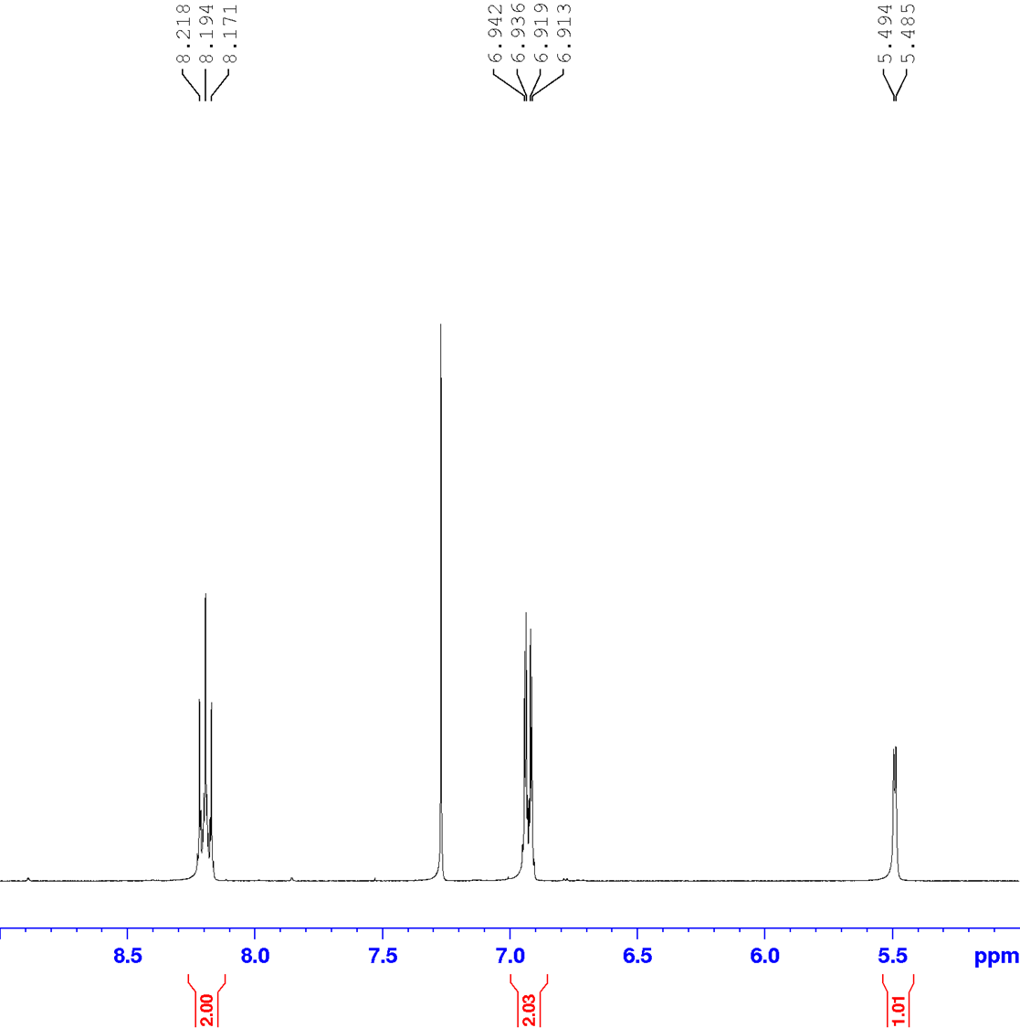

¹³C NMR Compound 2
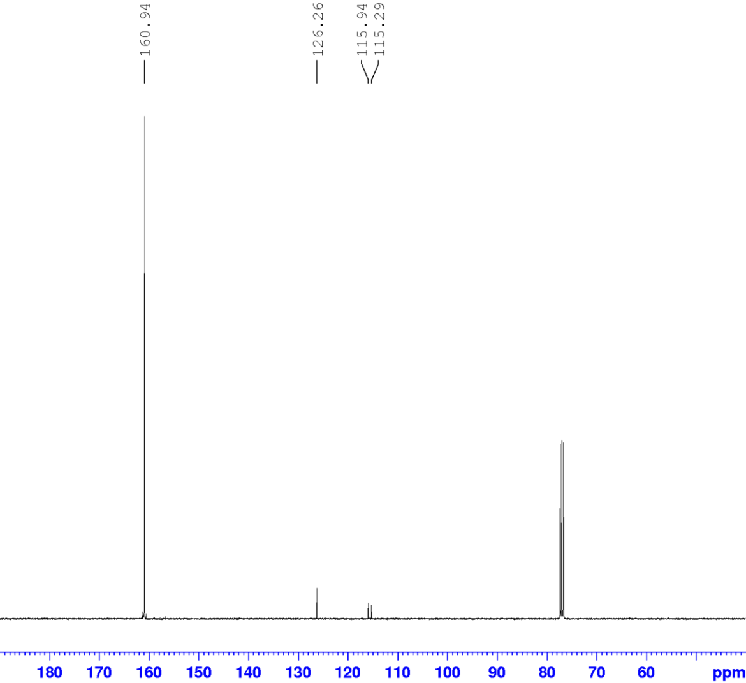

¹H NMR Compound 3
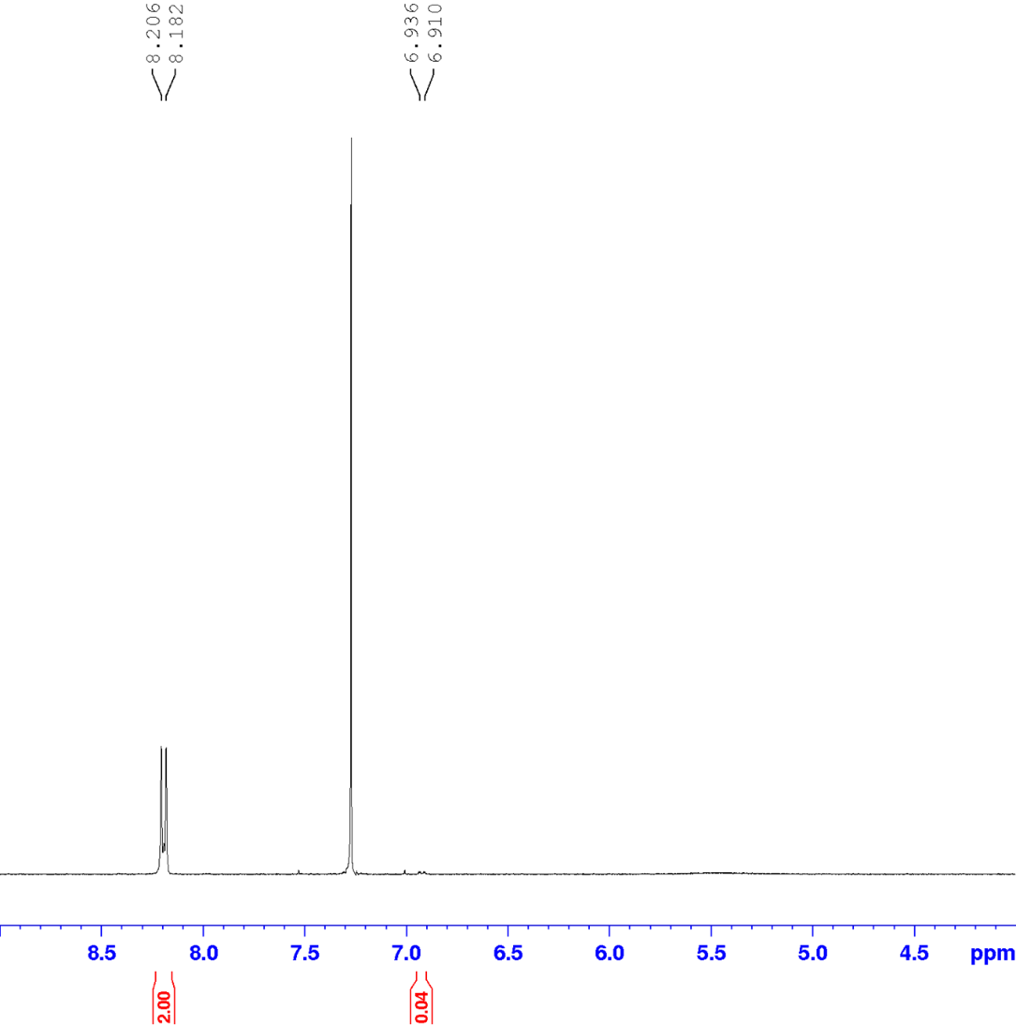

¹³C NMR Compound 3
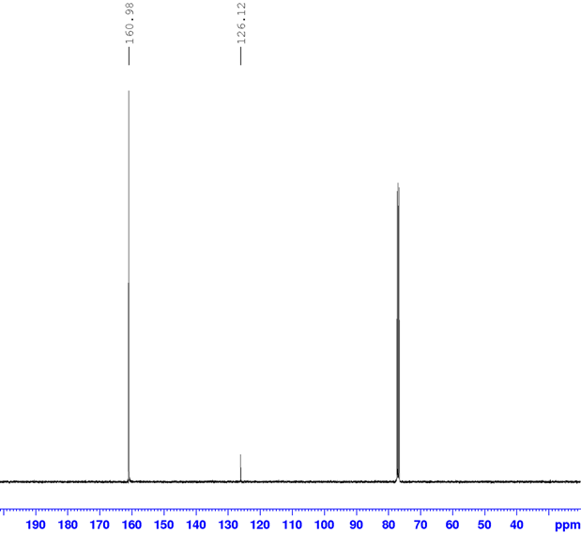

¹H NMR Compound 4
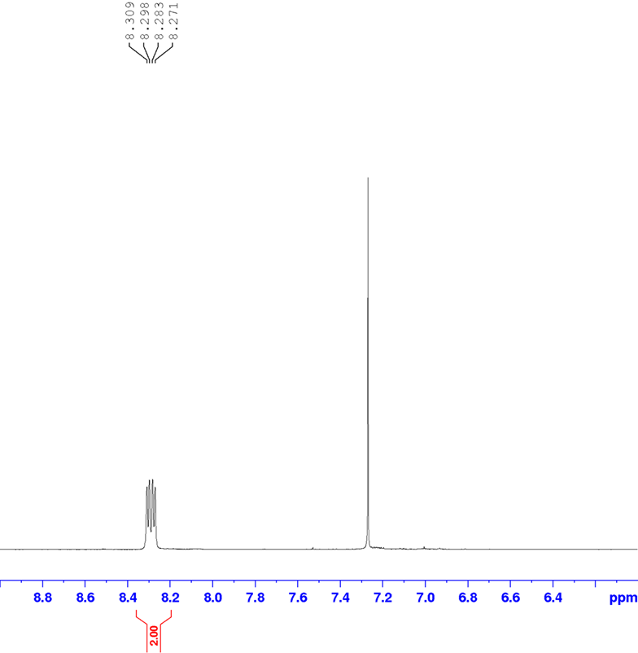

¹³C NMR Compound 4
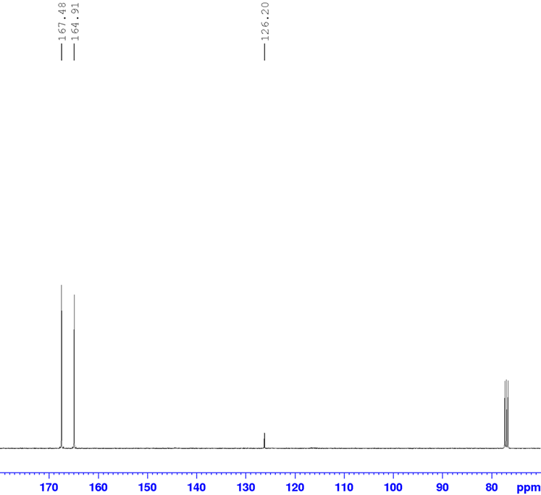

¹H NMR Compound 5

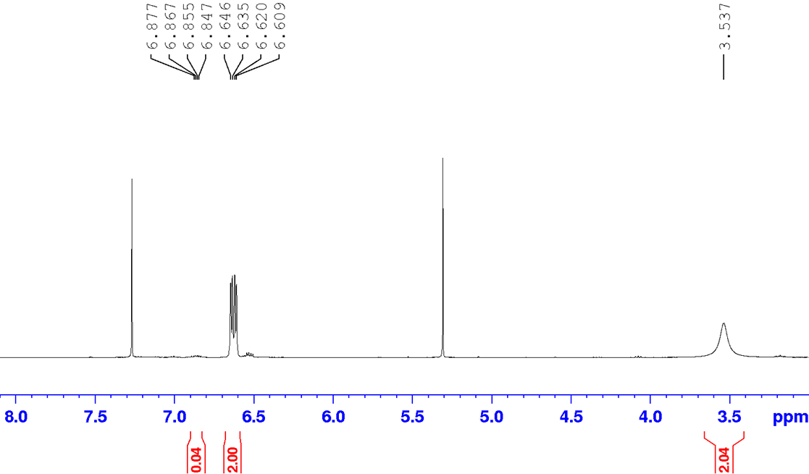

¹³C NMR Compound 5
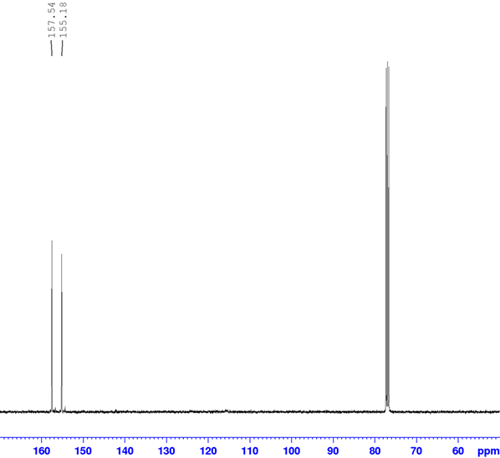

¹H NMR Compound 6
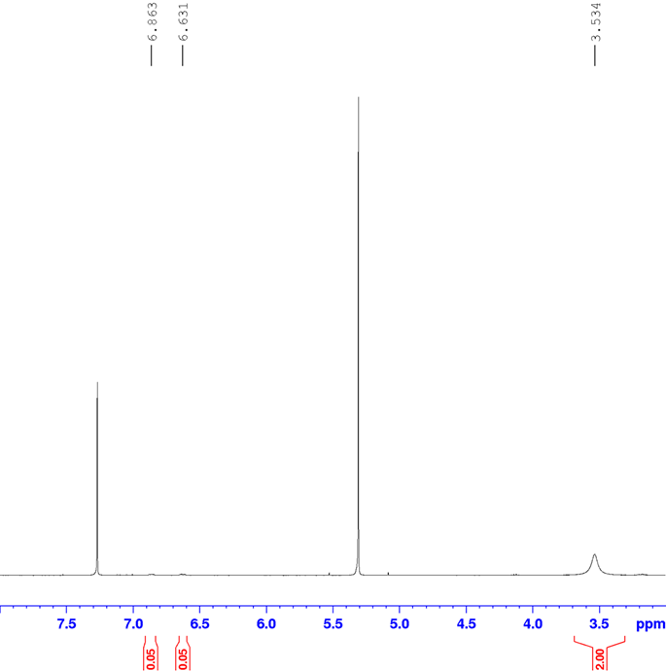

¹³C NMR Compound 6
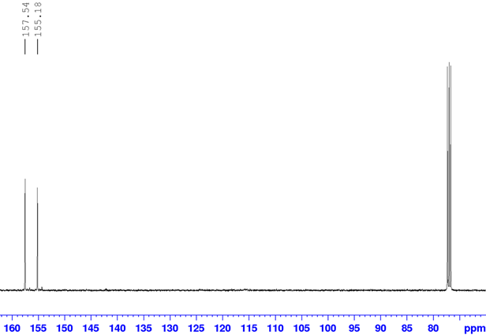

¹³C NMR Compound 7
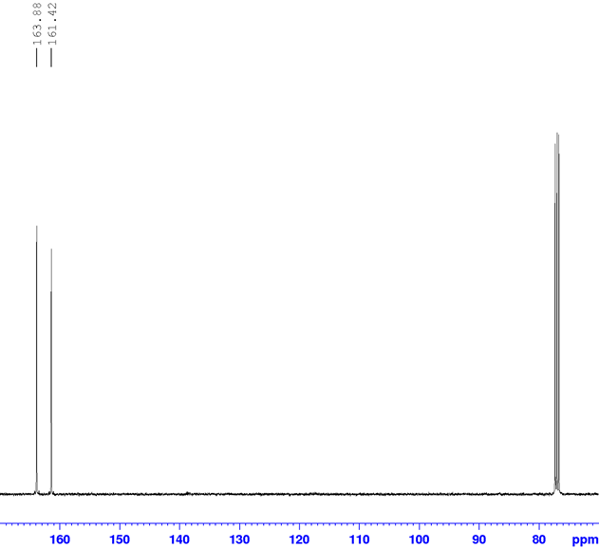

¹H NMR Compound 8
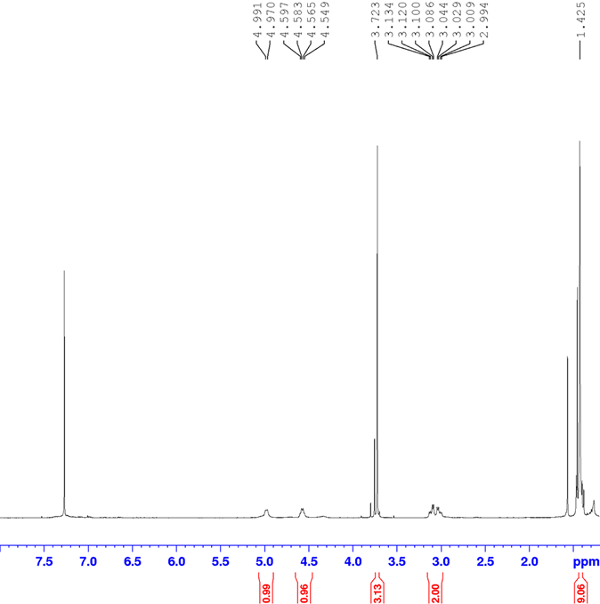

¹³C NMR Compound 8
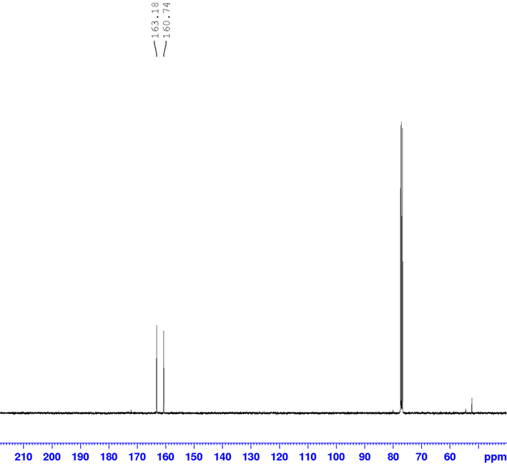

¹H NMR Compound 9
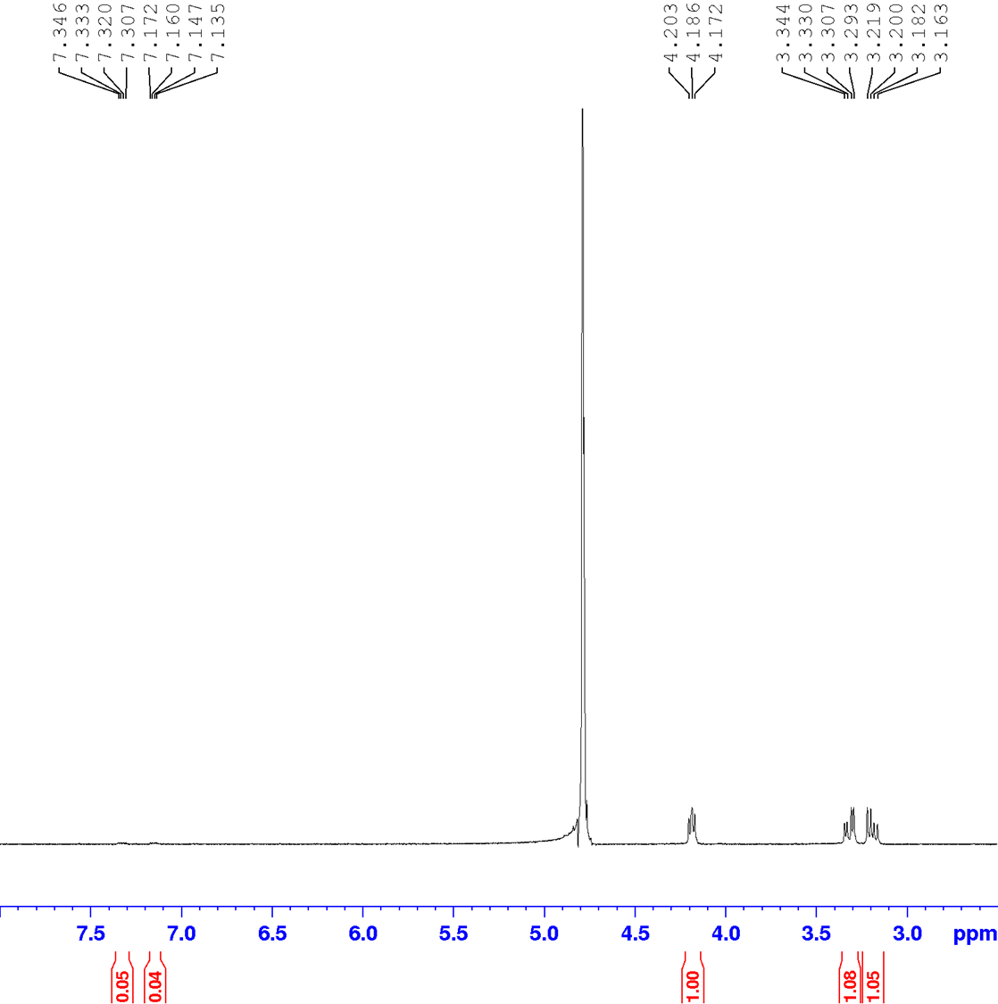

¹³C NMR Compound 9
