Scheme 1. Optimization of the reaction conditions.
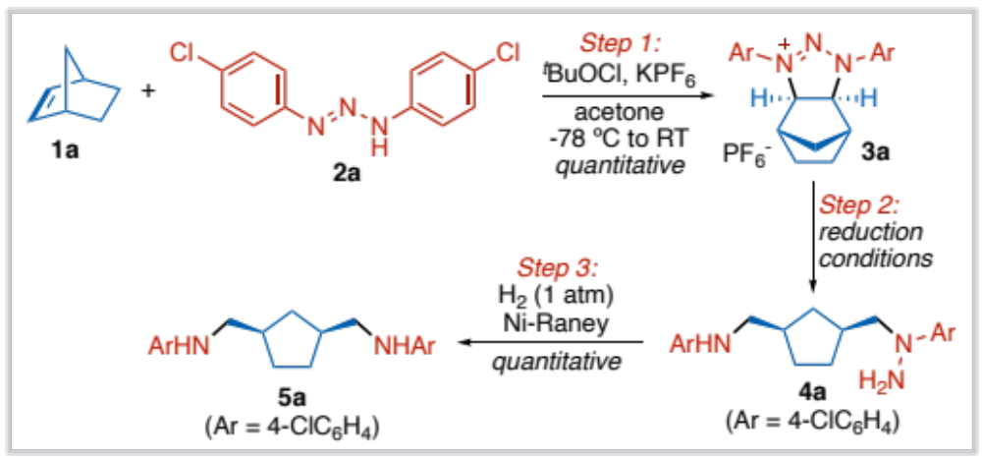

Scheme 2. A,B: unregular reactivity in the reaction and plausible mechanisms of the products` formation. C: unsuccessful alkenes.
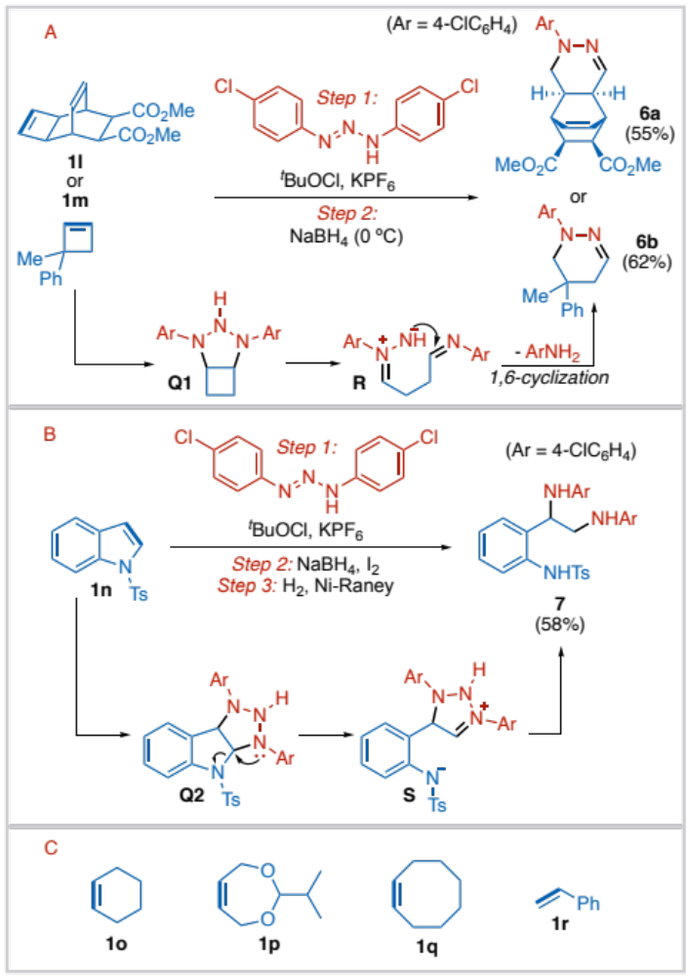

Reaction conditions for A: Step 1 – 1 (2 eq), 2 (1 eq), ^{t}BuOCl (1.5 eq), KPF₆ (2 eq), acetone (0.033M), –78 °C to RT; Step 2 – 3 (1 eq), NaBH₄ (5 eq), THF (0.1M), 0 °C.
Reaction conditions for B: Step 1 – 1 (2 eq), 2 (1 eq), ^{t}BuOCl (1.5 eq), KPF₆ (2 eq), acetone (0.033M), –78 °C to RT; Step 2 – 3 (1 eq), NaBH₄ (6 eq), I₂ (1 eq), THF (0.1M), RT; Step 3 – 4’ (1 eq), Ni-Raney (40 mg per 0.1 mmol of 4), H₂ (1 atm), MeOH (0.05M), RT.

Scheme 3. Plausible mechanism of the reaction.
