Table 1. Optimization of the reaction conditionsª (Step 2).
Entry | Reductant  (5 eq)^{b} | Solvent | Temperature  and time^{c} | Additives | Isolated yield of 4a (%)^{d}
1 | NaBH₄ | MeOH | 1) RT, 1 h  2) 90 °C, 2 h | - | 0
2 | NaBH₄ | THF | 1) RT, 15 min  2) 90 °C, 15 min | - | 81
3 | LiBH₄ | THF | 1) RT, 15 min  2) reflux, 10 min | - | 82
4 | LiAlH₄ | THF | 1) RT, 15 min  2) 90 °C, 15 min | - | 32
5 | PhSiH₃ | THF | 1) RT, 15 min  2) 90 °C, 2 h | CsF (5 eq)^{e} | 0
6 | NaBH₄ | toluene | 1) RT, 15 min  2) 90 °C, 2h | - | 0
7 | NaBH₄ | DMF | 1) 0 °C, 1 h  2) 90 °C, 2h | - | 0
8 | NaBH₄ | dioxane | 1) 0 °C, 1 h  2) 90 °C, 4h | - | 12
9 | NaBH₄ | Et₂O | 1) 0 °C, 1 h  2) reflux, 15h | - | 61
10 | NaBH₄ | THF | 1) RT, 15 min  2) reflux, 15 min | - | 81
11 | NaBH₄ | THF | 1) RT, 15 min  2) 40 °C, 1.5 h | - | 77
12 | NaBH₄ | THF | RT, 24 h | - | 75
13 | NaBH₄  (3 eq) | THF | 1) RT, 15 min  2) reflux, 15 min | - | 64
14 | NaBH₄  (6 eq) | THF | RT, 10 min | I₂ (1 eq)^{f} | 85
15 | NaBH₄  (6 eq) | THF | RT, 1.5 h | I₂ (0.2 eq) ^{f} | 81
16 | NaBH₄  (6 eq) | THF | RT, 5 min | BF₃×Et₂O  (1 eq) ^{f} | 72
ª Standard reaction conditions for Step 2: 3a (0.2 mmol), reductant, additive, solvent (0.1 M). ^{b} Unless otherwise stated. ^{c} The sequence and interval of reaction is indicated: 1) – nitrenium was premixed with reductant for specific period of time; 2) – the reaction mixture was heated up to indicated temperature for specific period of time. ^{d} Isolated yields are presented for two-step process. ^{e} CsF was premixed with PhSiH₃ for 10 minutes. ^{f} The additive was premixed with NaBH₄ at 0 °C for 5 minutes.

Table 2. Substrate scope of the reaction.
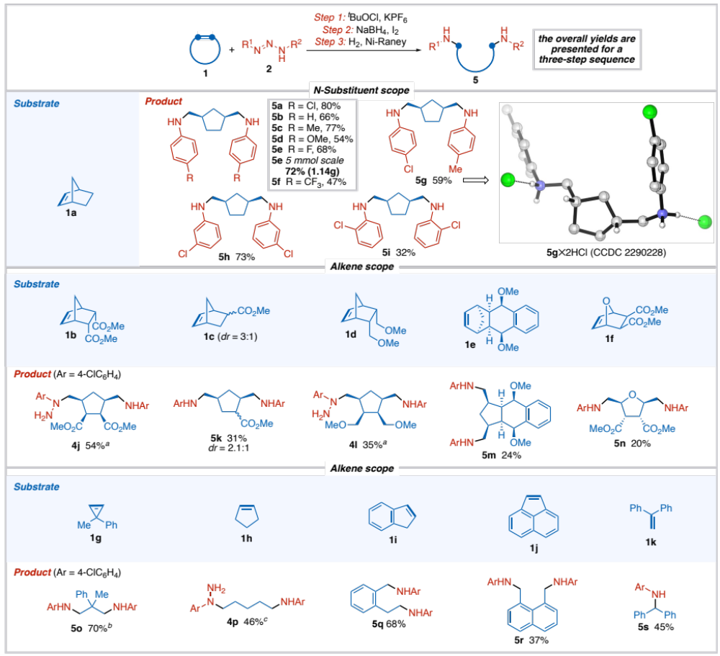
Reaction conditions: Step 1 – 1 (2 eq), 2 (1 eq), ^{t}BuOCl (1.1 eq), KPF₆ (2 eq), acetone (0.033M), –78 °C to RT; Step 2 – 3 (1 eq), NaBH₄ (6 eq), I₂ (1 eq), THF (0.1M), RT; Step 3 – 4 (1 eq), Ni-Raney (40 mg per 0.1 mmol of 4), H₂ (1 atm), MeOH (0.05M), RT; isolated yields are reported.
ª Step 3 was not used to isolate hydrazines 4j and 4l.
^{b} Step 3 was not needed: reaction mixture consisted only of diamine after Step 2.
^{c} Step 2 was performed with NaBH₄ (5 eq) at RT and reflux afterwards. Step 3 was not used to isolate hydrazine 4p.

