A Mathematical Model of U.S. COVID-19 Deaths, Incidence and Quarantine Adjusted Herd Immunity by Age
SUPPLEMENTAL MATERIALS
Methods
COVID-19 disease Incidence is difficult to quantify for several reasons including variability over time, variability across geographies, availability of testing, false positive/negative results, and asymptomatic disease. COVID-19 related Deaths are more of a known variable because all states report COVID-19 deaths and year-over-year comparative analysis provide additional confidence in quantifying incremental deaths attributed to COVID-19. Using COVID-19 IFR to estimate COVID-19 incidence removes the additional variability introduced by testing (availability, test rate, false positive/negatives, etc). COVID-19 incidence can be estimated from deaths using the Infection Fatality Ratio (IFR) which is “the number of individuals who die of the disease among all infected individuals (symptomatic and asymptomatic)” ⁽⁶⁾ such that deaths divided by IFR yields the incident population and, when divided by the total population, yields the incidence. Additionally, total population size multiplied by IFR yields the theoretical maximum number of deaths (assuming a 100% infection rate). Finally, since deaths are reported each week and by age group it is possible to estimate weekly COVID-19 incidence trends from age specific COVID-19 IFRs.
Infection Fatality Ratio (IFR)
Published estimates of COVID-19 IFR were used which included 10-year age stratifications for six regions in Europe during the early phases of the pandemic (through May 2020). ⁽⁷⁾ For the purposes of this analysis, IFRs averaged across the six European regions were “smoothed” to better align with CDC reported death age groupings. The total IFR averaged across the six EU regions and weighted by the U.S. population is 0.0144 (0.0110-0.0195) and are much higher for older adults. These IFR estimates are also referenced by the CDC as “best estimates” for scenario planning purposes. ⁽⁶⁾ However, the CDC scenario planning estimates significantly discount mortality among the 80+ age group. A meta-analysis of IFR (8) was also evaluated which suggested higher IFR for the 34-44 age group and lower IFR for older adults. The sensitivity of these IFRs indicate a lower fit to model and were therefore not used in this analysis but are shown for comparative purposes. (Figure 2-3)
Figure 2 Figure 3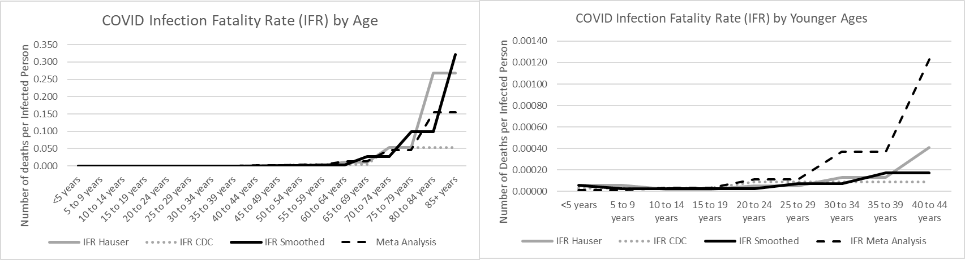

While IFR is generally assumed to be stable over time, the possibility that IFR could vary was also considered. Several variables were identified which could potentially impact IFR over time. ⁽¹⁾ Shift in the demographics (eg, age distribution) of individuals exposed over time could bias total population IFR. This analysis inherently controls for age. ⁽²⁾ Significant improvements in available treatments could improve survival rates and lower IFR. While data on COVID-19 IFR trends is sparse one analysis found that “COVID-19 isn’t getting less deadly” ⁽⁹⁾ while a systematic review and meta-analysis found that adjusted mortality fell ~54% from 31.4% in March to 14.4% in July and then stabilized. ⁽¹⁰⁾ ⁽¹¹⁾ This analysis assumes a 25% improvement in IFR from April to July (0% and 50% improvement sensitivity). ⁽³⁾ Novel circulating variants of COVID-19 could also impact IFR. While several novel strains have been recently found globally, novel strains are just appearing in the U.S. ⁽¹²⁾ No adjustments were made to IFR as it relates to novel strains’ impact on historic trends but impact on future outcomes is considered in the Caveats and Limitations section. ⁽⁴⁾ Finally, calculating cumulative incidence from deaths and IFR needs to account for the possibility of reinfection. Published clinical data suggests that “at least three immunological compartments was measurable in ~95% of subjects 5 to 8 months PSO [post-symptomatic onset], indicating that durable immunity against secondary COVID-19 disease is a possibility in most individuals” ⁽¹³⁾ and that “immune memory persists after mild COVID-19.” ⁽¹⁴⁾ Additionally, analysis from the Moderna mRNA phase III study suggest an 80% relative risk reduction of reinfection among placebo candidates with prior evidence of exposure relative to placebo candidates without prior evidence of exposure ⁽¹⁵⁾. As such, this analysis assumes no re-exposure risk in 95% of individuals previously exposed (80% and 90% sensitivity) with durability lasting for 18 months after prior disease exposure (6 and 12 month sensitivity).
When comparing total cumulative CDC reported deaths through February 13, 2021 to the modeled Maximum Projected Deaths by age (see MPD_{a} calculation below) using population weighted IFRs, actual deaths were slightly higher than MPD in the 35–44-year age group. As such, IFR was adjusted by 111% (0.0160 total weighted MPR) to yield a slightly higher MPD. Adjusted IFR is well within the confidence interval of Hauser, et al published IFR and was used as the base case assumption for the remainder of this analysis.
COVID-19 Incidence and Immunity
Population size by age group (P_{a}) ⁽¹⁶⁾ was multiplied by age specific IFR (IFR_{a}) to calculate the Theoretical Maximum Projected Deaths by age group (MPD_{a}) (assuming 100% of the population was infected).
MPD_{a} = P_{a} x IFR_{a}
Weekly reported deaths by age in period t (D_{at}) were divided by age specific IFR to estimate infected population in period t-1 (symptomatic and asymptomatic) (I_{at-1}). Infected population by age was then divided by the total population by age to calculate age specific infection rates (IR_{a}). Infected population by age was summed and divided by the total U.S. population (P_{T}) to determine total Infection Rate (IR_{T}).
I_{at-1} = D_{at} / IFR_{a}
IR_{a} = I_{a} / P_{a}
IR_{T} = (I_{a1}+I_{a2}+I_{a3}+I_{an})/P_{T}
Cumulative immunity by age (CIm_{a}), calculated by summing the incident population over time (_{t}), was adjusted to account for individuals susceptible to reinfections (S_{a}) by assuming 90% (80% & 95%) immunity and 52 (26 & 78) weeks of durable immunity.
CIm_{a} = ((I_{at1}+I_{at2}+I_{at3}+I_{atn}) x 90%) – CIm_{at-52}
Projected Deaths, Infections, & Immunity
COVID-19 weekly deaths by age were trended using polynomial regression of reported deaths from week ending September 12 to week ending December 5 (see Figures 4-6 for trends, equations and R₂ values). For ages <15 years there were few deaths, but calculations provided a reasonable approximation of directional trends.
Figures 4 Figure 5 Figure 6
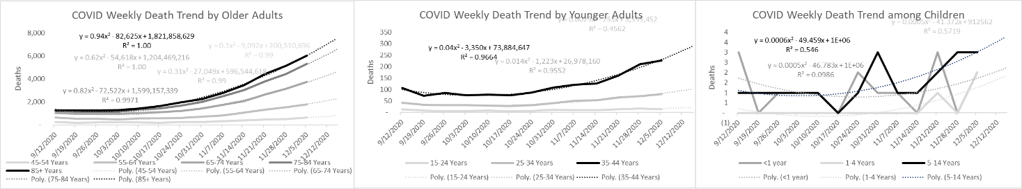
Projected infections and immunity were calculated from projected deaths using the same methodology as above. Age specific projected weekly infections were capped and drop to zero when cumulative incidence hit 100% of population infected (and MPD) (Figure 7)
If D_{atn} > MPD_{a} then 0 else D_{atn} = M_{a} x t_{n}^{^2} + M_{a} x t_{n} + C_{a} (where M = the coefficient, t= the X value & C = the constant)
Figure 7
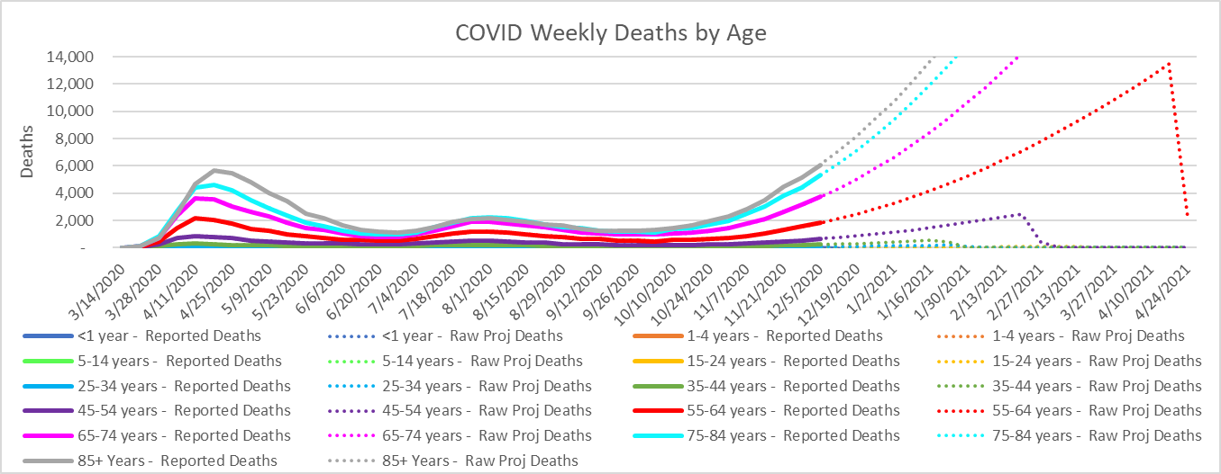
Trend Period
Cumulative Max Projected Deaths
Summing weekly infectious population and deaths across age groups (actual and projected) yielded the modeled impact of age adjusted IFR on total population infection (I_{T}) and death (D_{T}) trends.
I_{T}=I_{a1}+I_{a2}+I_{a3}+I_{an}
D_{T}=D_{a1}+D_{a2}+D_{an}
These trends (Raw Projected Deaths, Infections, and Immunity) do not yet consider adjustments for behavior (social distancing), herd immunity, quarantine adjusted herd immunity, vaccinations, impact of novel strains or any other intervention beyond achievement of Theoretical Maximum Projected Deaths.
Quarantine Adjusted Herd Immunity Impact
To quantify the heterogeneous relationship of social mixing on infections across age groups during quarantine, polynomial regression was used where total infections in period tn (I_{Ttn}) is the independent variable and age specific infections in period tn+1 (I_{atn+1}) is the dependent variable. This was calculated for each age group separately such that t = weekly trend period, x = total projected infected population, and y = age specific projected infected population. In traditional SEIR models, a lag period is used to account for the time between exposure, infection, and recovery. In this model, the time lag was assumed to be only 1 week with less sensitivity as the regression coefficient will adjust to account for the lag. Infections from week ending September 12 to week ending December 5 (same trend period as used to project Deaths and prior to the inflection in reported deaths) were used for all regression equations.
Using regression coefficients, a sequential time series analysis was used to calculate herd immunity adjusted infections for each age group (y) in period t_{n} which was then summed to generate total herd immunity adjusted infections (x) in period t_{n} which was then used to calculate herd immunity adjusted infections for each age group (y) in period t_{n+1} and so on. Infections multiplied by IFR yielded the Herd Projected Deaths. A Pearson Correlation between Reported Deaths and Quarantine Herd Immunity Adjusted Projected Deaths in the hold out period (December 6 - February 13) was used to evaluate the null hypothesis to determine if herd immunity contributed to the decline in deaths.
Vaccination Impact on Projected Deaths
To further test the hypothesis, Raw Projected Infections (RI) and Raw Projected Deaths (RD) were evaluated without the impact of herd immunity but considering actual and projected vaccines administered through the model period. CDC reported daily total first and second dose vaccine administrations ⁽¹⁷⁾ were grouped by week (D1 and D2). The first dose was assumed to confer 80% immunity (50% and 90% sensitivity) and the second dose an incremental 15% immunity (95% total efficacy, 90% and 95% sensitivity). The lag time from administration to prevention of death was assumed to be 4 weeks (2 and 6 sensitivity) considering lag time for efficacy to build as well as time from infection to death. First and second dose total administration distributions by age through February 24 was used as reported by the CDC (1) and applied across the model period. Total administrations through April 17 were projected to be just over 250 million which is 2.5 times greater than that promised by the Biden administration in his first 100 days. ^{(18) T}he impact of vaccine induced immunity (VIm) on vaccine adjusted deaths (VD) was calculated by age as follows.
VIm_{at} = D1_{at-4} x 80% + D2_{at-4} x (95%-80%)
VD_{a} = ((P_{a} – VIm_{a}) x (RI_{a}/P_{a})) x IFR_{a}
A Pearson Correlation between Reported Deaths and Vaccine Adjusted Projected Deaths in the hold out period (December 6 - February 13) was used to evaluate the null hypothesis to determine if vaccines contributed to the decline in deaths.
Sensitivity Analysis
The sensitivity on model predictability of Reported Deaths was evaluated across eight key variables including a low and high estimate for each and three scenarios (Raw Projected deaths, Herd Immunity Adjusted Deaths, Vaccine Adjusted Deaths). Variables tested included:
- two variables related to Infectious Fatality Rate (value and relative improvement over time),
- two variables on naturally acquired immunity (percent infected that achieve immunity and durability of immunity) and
- three variables on vaccines (efficacy after first dose, efficacy after second dose and lag time between vaccine administration and deaths prevented).
- One variable related to herd immunity (% infected prior to herd immunity)
Weekly data was stratified into four time periods.
- Week ending 2/1/20 thru 9/2/20: pre-model trend period (changes in weather, social distancing, and geographic spread of disease may have higher influence in infection and death trends),
- Week ending 9/12/20 thru 12/5/20: trend period used in all analysis include Reported Death trends and Herd Immunity coefficients,
- Week ending 12/12/20 thru 1/30/21: hold out period where modeled deaths were correlated to actual reported deaths,
- Week ending 2/6/21 thru 4/17/21: future time (actual reported deaths are not yet available).
None of the sensitivities improved predictability of the model. (Table 1 and Charts 18-20) Due to relatively low volume of individuals with immunity in the first six months of the pandemic and low levels of vaccinations to date, vaccine and immunity related sensitivities are underpowered to reasonably be expected to have an impact.
Table 1

Figure 18 Figure 19 Figure 20
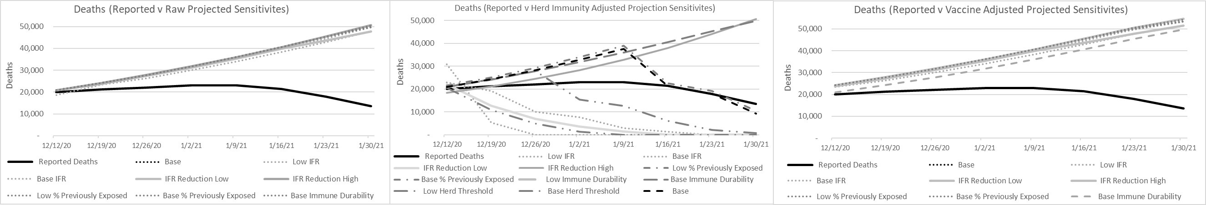

Caveats and Limitations
This analysis is not meant to determine the herd immunity threshold, IFR or cumulative immunity levels, but rather quantitatively describes the relational sensitivity between these variables and establishes boundaries when viewed in the context of known variables (eg. IFR or cumulative deaths). This model could benefit from further sensitivity analysis and monte carlo simulations to pressure test the relational sensitivity of key assumptions.
Predictive trends quantified in this analysis are relevant in the context of current/historical social distancing and mask wearing behaviors. As of this writing, older adults still have very low levels of naturally acquired immunity and vaccination and are therefore still “at high risk” of infection, morbidity, and mortality even in the context of herd immunity. Changes in social distancing policy and behaviors could shift herd immunity trend dynamics negatively.
Herd immunity analysis is also relevant in the context of current/historic COVID-19 strains in circulation. Future relative risk may be different if emerging genetic variants prove to have higher infectiousness and/or morbidity than historic variants. As of this publication new strains are believed to be more infectious but there is no strong evidence to support higher morbidity.
Age specific relative risks contextualized in this analysis are meant to represent population averages. Individuals may have higher or lower actual risk based on other risk factors. Additionally, herd immunity trends will not be able to drive infections down to the point of disease elimination. As such, individual risk may be significantly reduced due to herd immunity but not eliminated.
A relatively short period of time was used to project age specific death trends. Additionally, the number of deaths among individuals less than 15 years old were too thin to reliably trend and estimates of incidence for this age group are the least reliable for that reason. However, incidence among children should have nominal impact on predicted reported death trends.
This analysis does not consider the impact of changes in social distancing (around the holidays), weather patterns, political and social media influences on behavior as the underlying dynamics of epidemiology (IFR and herd immunity) can account for a significant portion of the variability in reported death trends.

