Synthesis and characterization of (E)-4-((anthracen-9-ylmethylene) amino)-N-(pyridin-2-yl) benzenesulfonamide and its metal complexes: Evaluation of potential against the colon cancer cell line COLO-205 and biological activity profiles
P. Jona¹*, P.S. Suja Pon Mini¹, N. Suman¹, S. Robinson¹, S. Amutha¹ and P. Ram Kumar²*

¹Department of Chemistry, Francis Xavier Engineering College, Vannarpet, Tirunelveli- 627003
²Department of Chemistry, Lord Jegannath College of Engineering and Technology, Nagercoil, Kanyakumari 629402, India
Corresponding authors E-mail: jona@francisxavier.ac.in (P. Jona)
dr.ramchem93@gmail.com (P. Ram Kumar)
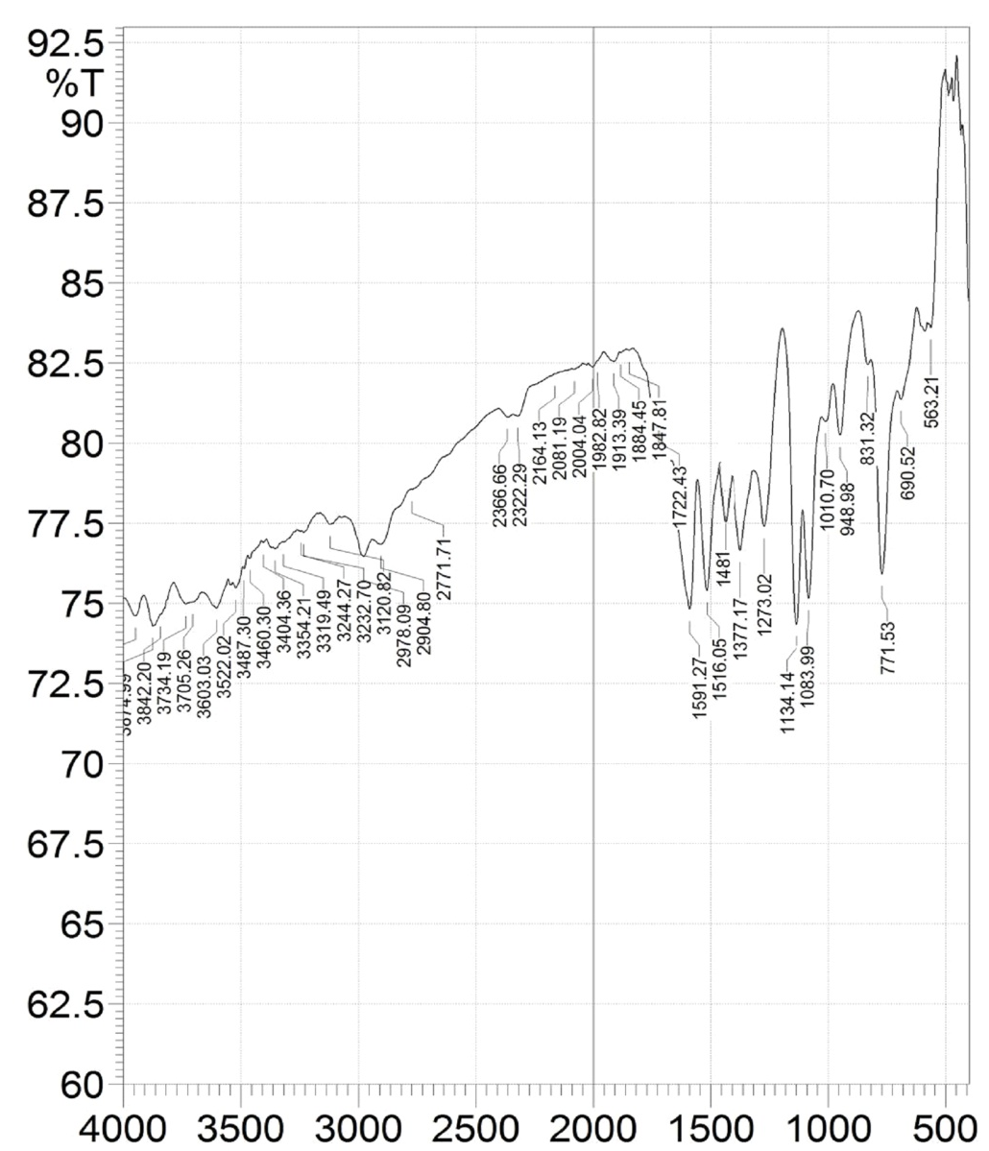
Fig. S1 FT-IR spectrum of the Schiff base ligand (SPA)

Fig. S2 FT-IR spectrum of [Mn(SPA)₂ (NO₃)₂] complex

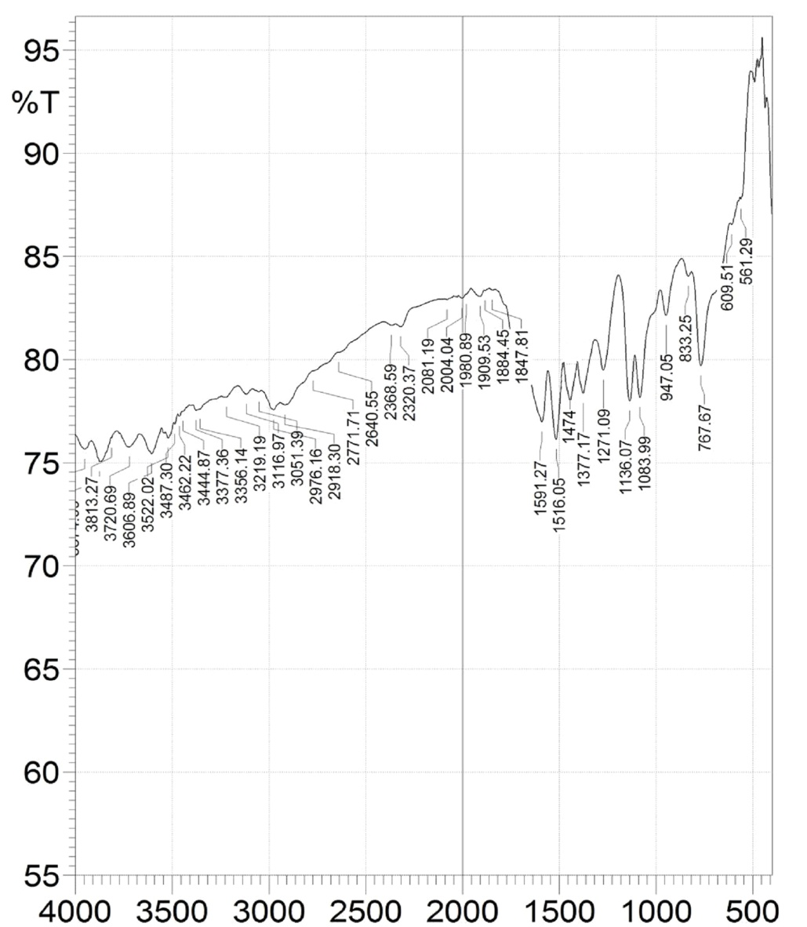
Fig. S3 FT-IR spectrum of [Co(SPA)₂(NO₃)₂] complex

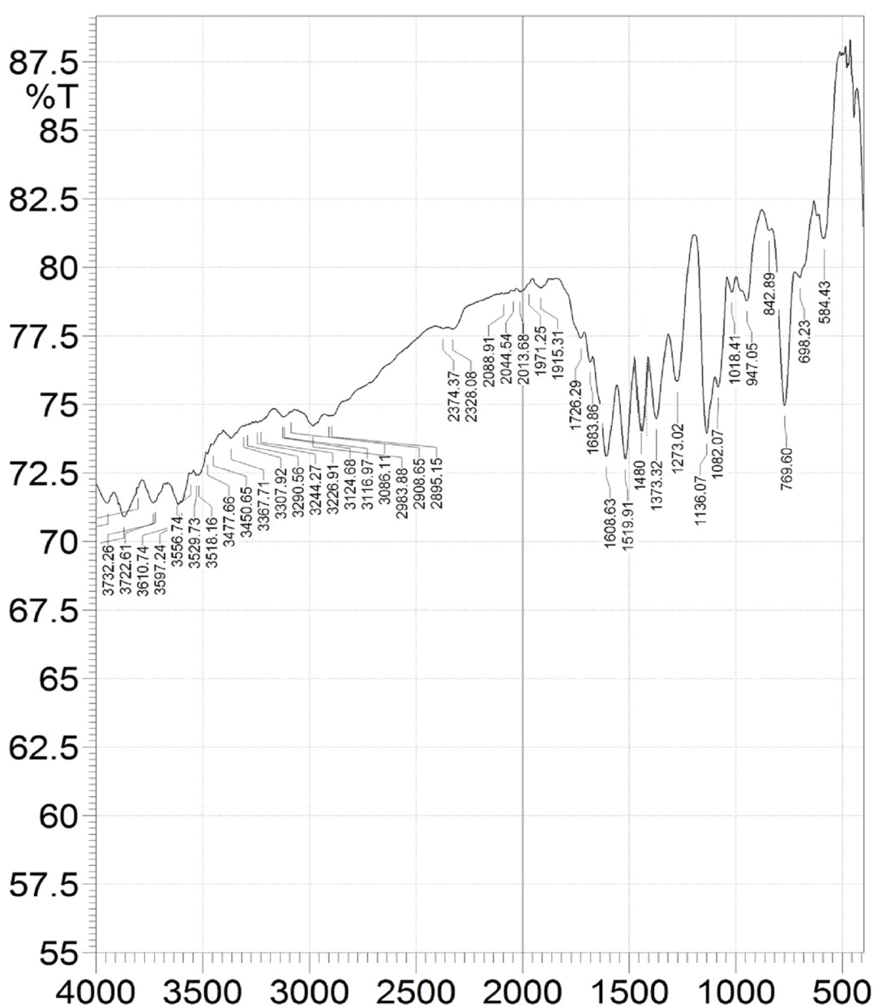
Fig. S4 FT-IR spectrum of [Ni(SPA)₂(NO₃)₂] complex

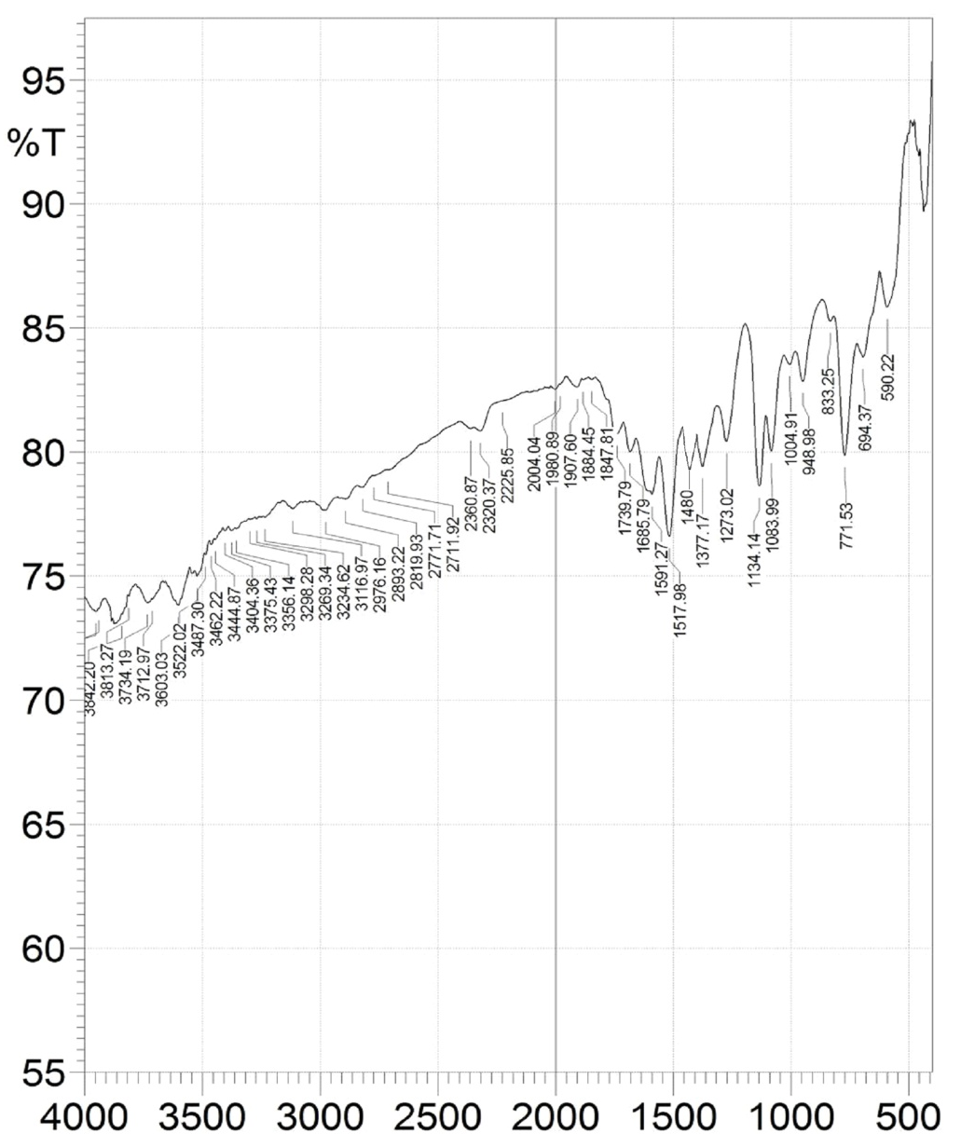
Fig. S5 FT-IR spectrum of [Cu(SPA)₂(NO₃)₂] complex

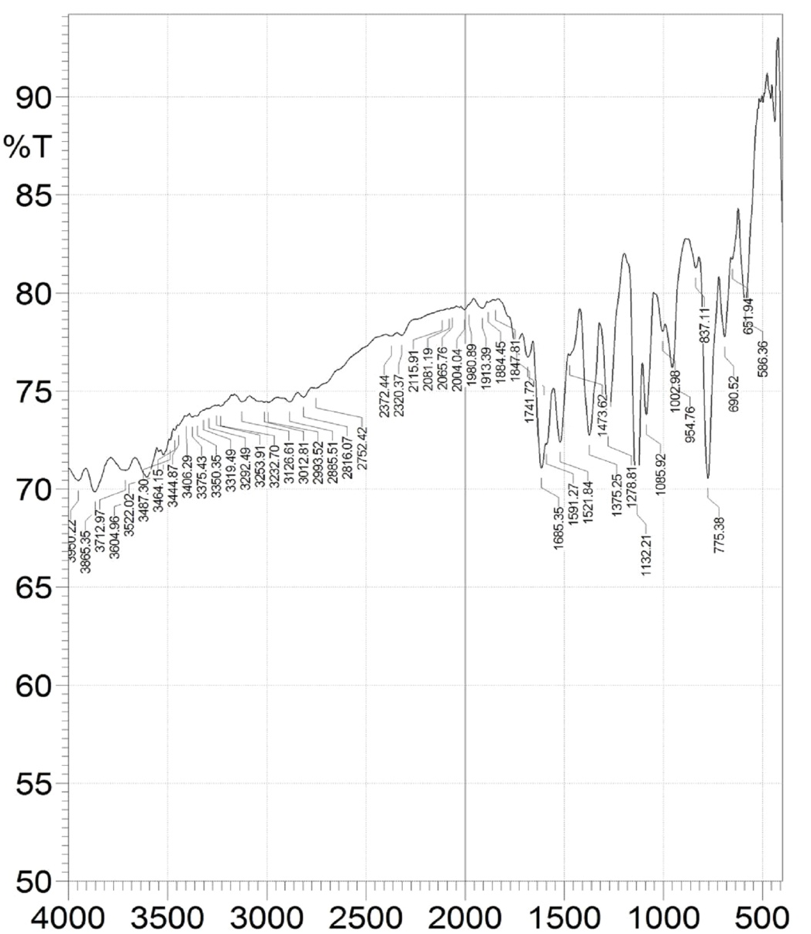
Fig. S6 FT-IR spectrum of [Zn(SPA)₂(NO₃)₂] complex

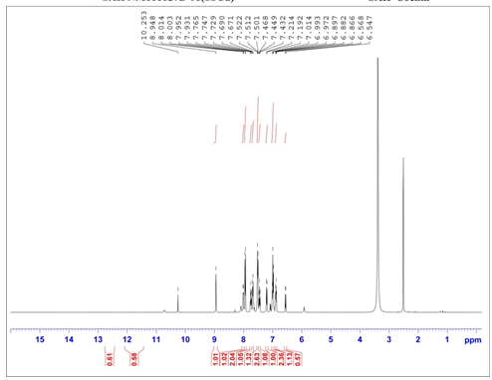

Fig. S7 NMR spectrum of Schiff base ligand (SPA)

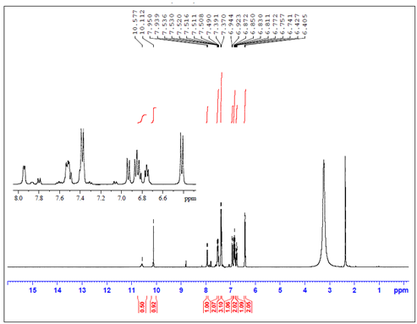

Fig. S8 NMR spectrum of [Zn(SPA)₂(NO₃)₂] complex

Fig. S9 Diffractogram of Schiff base ligand (SPA)
Fig. 10 Diffractogram of [Zn(SPA)₂(NO₃)₂]

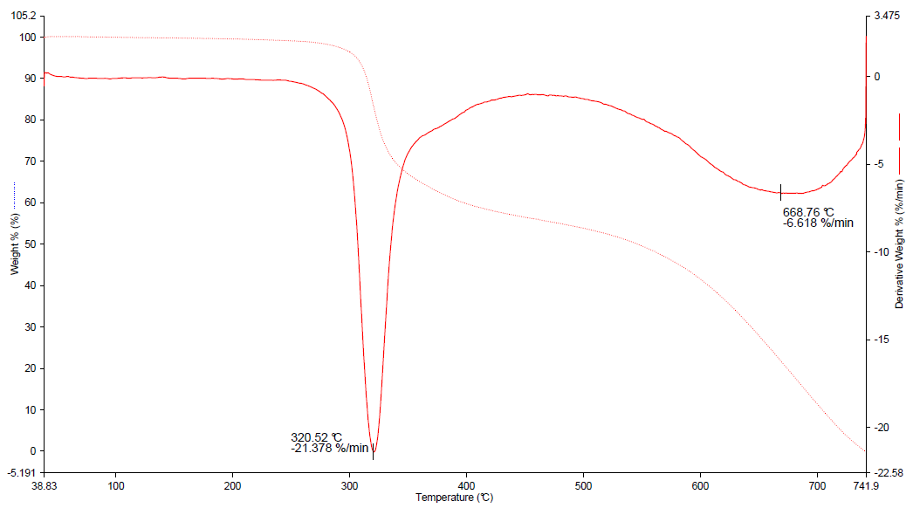
Fig. 11 TGA and DTA curves of [Zn(SPA)₂₍NO₃)₂] complex

