Estimating alcohol and tobacco consumption of university students and urban population in Ho Chi Minh city by wastewater-based epidemiology
Do Thi Thuy Quyen ^{a*}, Tran Thi Yen Nhi ^{b}, Nguyen Thi Thanh Nhon ª, To Thi Hien ª

ª Deparment of Environmental Engineering, Faculty of Environment, Vietnam National University, Ho Chi Minh City - University of Science, Vietnam
^{b} Department of Analytical Chemistry, Faculty of Chemistry, Vietnam National University, Ho Chi Minh City - University of Science, Vietnam
*Corresponding author:
Do Thi Thuy Quyen doquyen111@gmail.com; dttquyen@hcmus.edu.vn
Current address: 227 Nguyen Van Cu Street, Ward 4, District 5, Ho Chi Minh city, Vietnam 72711
Short description of the muncipal wastewater treatment system in Ho Chi Minh city:
To better understand the result, it might be useful to understand the characteristics of municipal wastewater treatment system in Ho Chi Minh city. 90 percent of households using septic tanks as a means of on-site treatment. Black water (from toilet) is collected and retained in the septic tank for 1 – 3 days before it overflow to river through the city drainage system. The untreated greywater including bathroom, kitchen, laundry, however, is discharged to drainage system directly. About 21.2 percent of the total wastewater daily discharge of Ho Chi Minh City (approximately 370,624 m³) was further treated at three operational WWTPs and other small scale treatment facilities (Phan Anh, 2019). The urban sampling site in this study is the largest WWTP of the city. Contrast to single household, large buildings with many occupants (dormitories, apartment etc.) are regulated to incorporate centralized advanced wastewater treatment systems.

Phan Anh. (2019). Vietnam dumps almost all urban wastewater untreated into the environment. VN Express International. https://e.vnexpress.net/news/news/vietnam-dumps-almost-all-urban-wastewater-untreated-into-the-environment-3993043.html#:~:text=Ho%20Chi%20Minh%20City%2C%20meanwhile,of%20its%20total%20daily%20discharge.

Table S1. Details of sampling sites and sampling periods
STP | Type | Average flow (m³/day) | Population served | Sampling period
A | (Urban city residence) | 210,685 | 637,080 | 2-15 April, 2023
B | (University town residence) | 1,920 | 16,287 | 11-22 May, 2023
In urban catchments, the wastewater flow was measured as total amount daily. As for the wastewater flow in university town, the value is provided by the technical staff at the STP.
Table S2. The average concentration of ethylsulfate (EtS), cotinine (COT) in wastewater and estimated daily intake of alcohol and tobacco (Mean±SD). The value is the average of all daytime and nighttime samples.
STP | No of sample |  | EtS (μg/L) | COT (μg/L)
A (Urban) | 24 | 1.5 ± 0.2 |  | 3.5 ± 0.37
B (U-town) | 28 | 1.5 ± 0.28 |  | 3.6 ± 0.69

Table S3. Solvent program of liquid chromatography method
Time (min) | Flow (ml/min) | Solvent A (%) | Solvent B (%)
0.00 | 0.2 | 90 | 10
2.00 | 0.2 | 90 | 10
2.50 | 0.2 | 10 | 90
5.00 | 0.2 | 10 | 90
5.10 | 0.2 | 90 | 10
7.00 | 0.2 | 90 | 10

Mobile phase A:  10% MeOH and 0.1% formic acid;  Mobile phase B:  MeOH and 0.1% formic acid.  Flow rate: 0.2 mL min⁻¹  Column temperature was 40 °C  Injection volume was 10 μL  Total run time was 7 min. | 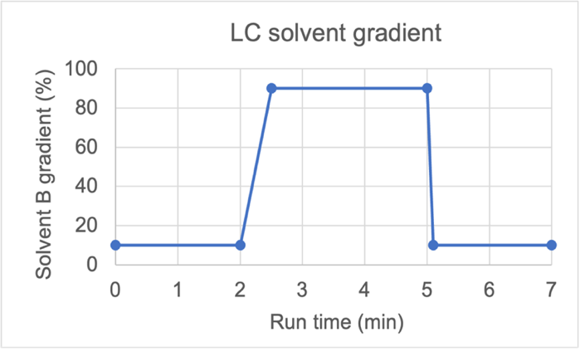
Table S4. Mass spectrometer parametes for EtS, COT analysis
Analytes | RT (min) | Q1 Mass (m/z) | Q3 Mass (m/z) | Dwell time (msec) | ESI | DP | EP | CE | CXP
EtS 1 | 0.77 | 125.1 | 80.2 | 250 | - | -80 | -7 | -44 | -20
EtS 2* | 0.77 | 125.1 | 96.9 | 250 | - | -80 | -7 | -22 | -20
EtS - d5 | 0.77 | 130.0 | 97.9 | 250 | - | -80 | -7 | -22 | -20
COT 1 | 2.0 | 177.0 | 80.2 | 250 | + | 120 | 10 | 38 | 20
COT 2 | 2.0 | 177.0 | 98 .1 | 250 | + | 120 | 10 | 28 | 20
COT - d3 | 2.0 | 180.0 | 100.1 | 250 | + | 120 | 10 | 26 | 20
Q1: precursor ion, Q3: product ion, RT: retention time; DP: declustering potential, EP: entrance potential, CE: collision energy, CXP: collision cell exit potential
Table S5. Laboratory report for ethyl sulfate, cotinine
Analytes | Calibration curve (μg/L) | Linearity | LOD  μg/L | LOQ  μg/L | Repeatability (%RSD)
Ethyl Sulfate | 0.1 - 50 | 0.9976 | 0.10 | 0.30 | 3.3
Cotinine | 0.1 - 50 | 0.9965 | 0.20 | 0.22 | 7.4

Note: LOD (Limit of detection) was calculated as 3 times of the standard deviation of 7 times injection of standard at concentration 0.877 μg/L.
LOQ was calculated as 3 times of LOD. Linearity is the r of calibration curve. Accuracy and precision were calculated with 7 times injection of the same sample.

