Mediterranean diet associated with lower frailty risk: a large cohort study of 21,643 women admitted to hospitals
Supplementary Methods
Supplementary Figure S1 A flowchart of participants for the UK Women’s Cohort Study
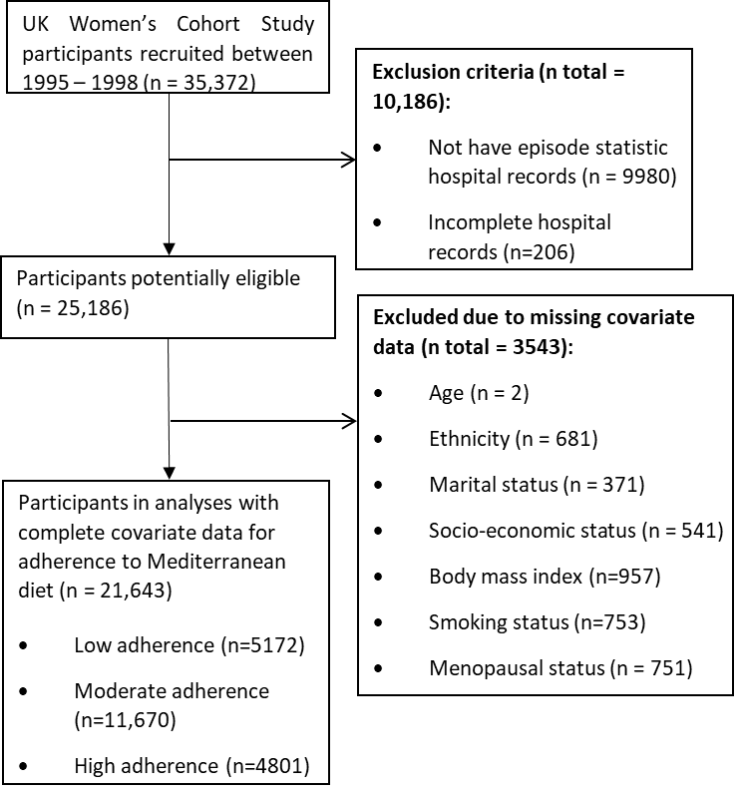
Supplementary Table S1 The cut-points of the Mediterranean diet score for each component in our study
 | Indicator values
Components | 1 | 0
Vegetables (g/day) | ≥283.1 | <283.1
Legumes (g/day) | ≥30.8 | <30.8
Fruit & nuts (g/day) | ≥271.5 | <271.5
Cereals (g/day) | ≥224.0 | <224.0
Fish (g/day) | ≥24.1 | <24.1
MUFA + PUFA: SFA ª | ≥1.0 | <1.0
Meat (g/day) | <42.1 | ≥42.1
Poultry (g/day) | <14.0 | ≥14.0
Dairy (g/day) | <98.0 | ≥98.0
Alcohol (g/day) | 5–25 | <5 or >25
ª Fatty acid ratio of monounsaturated plus polyunsaturated fatty acids to saturated fatty acids
Supplementary Table S2 Frailty related ICD-10 diagnostic codes derived from Gilbert et al. [1]
ICD Code | ICD Description | Points awarded |  | ICD Code | ICD Description | Points awarded
F00 | Dementia in Alzheimer's disease | 7·1 |  | E16 | Other disorders of pancreatic internal secretion | 1·4
G81 | Hemiplegia | 4·4 |  | R94 | Abnormal results of function studies | 1·4
G30 | Alzheimer's disease | 4·0 |  | N18 | Chronic renal failure | 1·4
I69 | Sequelae of cerebrovascular disease | 3·7 |  | R33 | Retention of urine | 1·3
R29 | Other symptoms and signs involving the nervous and musculoskeletal systems | 3·6 |  | R69 | Unknown and unspecified causes of morbidity | 1·3
N39 | Other disorders of urinary system (includes urinary tract infection and urinary incontinence) | 3·2 |  | N28 | Other disorders of kidney and ureter, not elsewhere classified | 1·3
F05 | Delirium, not induced by alcohol and other psychoactive substances | 3·2 |  | R32 | Unspecified urinary incontinence | 1·2
W19 | Unspecified fall | 3·2 |  | G31 | Other degenerative diseases of nervous system, not elsewhere classified | 1·2
S00 | Superficial injury of head | 3·2 |  | Y95 | Nosocomial condition | 1·2
R31 | Unspecified haematuria | 3·0 |  | S09 | Other and unspecified injuries of head | 1·2
B96 | "Other bacterial agents as the cause of diseases classified to other chapters" | 2·9 |  | R45 | Symptoms and signs involving emotional state | 1·2
R41 | "Other symptoms and signs involving cognitive functions and awareness" | 2·7 |  | G45 | Transient cerebral ischaemic attacks and related syndromes | 1·2
R26 | Abnormalities of gait and mobility | 2·6 |  | Z74 | Problems related to care-provider dependency | 1·1
I67 | Other cerebrovascular diseases | 2·6 |  | M79 | Other soft tissue disorders, not elsewhere classified | 1·1
R56 | Convulsions, not elsewhere classified | 2·6 |  | W06 | Fall involving bed | 1·1
R40 | Somnolence, stupor and coma | 2·5 |  | S01 | Open wound of head | 1·1
T83 | "Complications of genitourinary prosthetic devices, implants and grafts" | 2·4 |  | A04 | Other bacterial intestinal infections | 1·1
S06 | Intracranial injury | 2·4 |  | A09 | Diarrhoea and gastroenteritis of presumed infectious origin | 1·1
S42 | Fracture of shoulder and upper arm | 2·3 |  | J18 | Pneumonia, organism unspecified | 1·1
E87 | "Other disorders of fluid, electrolyte and acid base balance" | 2·3 |  | J69 | Pneumonitis due to solids and liquids | 1·0
M25 | Other joint disorders, not elsewhere classified | 2·3 |  | R47 | Speech disturbances, not elsewhere classified | 1·0
E86 | Volume depletion | 2·3 |  | E55 | Vitamin D deficiency | 1·0
R54 | Senility | 2·2 |  | Z93 | Artificial opening status | 1·0
Z50 | "Care involving use of rehabilitation procedures" | 2·1 |  | R02 | Gangrene, not elsewhere classified | 1·0
F03 | Unspecified dementia | 2·1 |  | R63 | Symptoms and signs concerning food and fluid intake | 0·9
W18 | Other fall on same level | 2·1 |  | H91 | Other hearing loss | 0·9
Z75 | "Problems related to medical facilities and other health care" | 2·0 |  | W10 | Fall on and from stairs and steps | 0·9
F01 | Vascular dementia | 2·0 |  | W01 | Fall on same level from slipping, tripping and stumbling | 0·9
S80 | Superficial injury of lower leg | 2·0 |  | E05 | Thyrotoxicosis [hyperthyroidism] | 0·9
L03 | Cellulitis | 2·0 |  | M41 | Scoliosis | 0·9
H54 | Blindness and low vision | 1·9 |  | R13 | Dysphagia | 0·8
E53 | Deficiency of other B group vitamins | 1·9 |  | Z99 | Dependence on enabling machines and devices | 0·8
Z60 | Problems related to social environment | 1·8 |  | U80 | Agent resistant to penicillin and related antibiotics | 0·8
G20 | Parkinson's disease | 1·8 |  | M80 | Osteoporosis with pathological fracture | 0·8
R55 | Syncope and collapse | 1·8 |  | K92 | Other diseases of digestive system | 0·8
S22 | Fracture of rib(s), sternum and thoracic spine | 1·8 |  | I63 | Cerebral Infarction | 0·8
K59 | Other functional intestinal disorders | 1·8 |  | N20 | Calculus of kidney and ureter | 0·7
N17 | Acute renal failure | 1·8 |  | F10 | Mental and behavioural disorders due to use of alcohol | 0·7
L89 | Decubitus ulcer | 1·7 |  | Y84 | Other medical procedures as the cause of abnormal reaction of the patient | 0·7
Z22 | Carrier of infectious disease | 1·7 |  | R00 | Abnormalities of heart beat | 0·7
B95 | Streptococcus and staphylococcus as the cause of diseases classified to other chapters | 1·7 |  | J22 | Unspecified acute lower respiratory infection | 0·7
L97 | Ulcer of lower limb, not elsewhere classified | 1·6 |  | Z73 | Problems related to life-management difficulty | 0·6
R44 | Other symptoms and signs involving general sensations and perceptions | 1·6 |  | R79 | Other abnormal findings of blood chemistry | 0·6
K26 | Duodenal ulcer | 1·6 |  | Z91 | Personal history of risk-factors, not elsewhere classified | 0·5
I95 | Hypotension | 1·6 |  | S51 | Open wound of forearm | 0·5
N19 | Unspecified renal failure | 1·6 |  | F32 | Depressive episode | 0·5
A41 | Other septicaemia | 1·6 |  | M48 | Spinal stenosis (secondary code only) | 0·5
Z87 | Personal history of other diseases and conditions | 1·5 |  | E83 | Disorders of mineral metabolism | 0·4
J96 | Respiratory failure, not elsewhere classified | 1·5 |  | M15 | Polyarthrosis | 0·4
X59 | Exposure to unspecified factor | 1·5 |  | D64 | Other anaemias | 0·4
M19 | Other arthrosis | 1·5 |  | L08 | Other local infections of skin and subcutaneous tissue | 0·4
G40 | Epilepsy | 1·5 |  | R11 | Nausea and vomiting | 0·3
M81 | Osteoporosis without pathological fracture | 1·4 |  | K52 | Other noninfective gastroenteritis and colitis | 0·3
S72 | Fracture of femur | 1·4 |  | R50 | Fever of unknown origin | 0·1
S32 | Fracture of lumbar spine and pelvis | 1·4

Dietary assessment
The baseline FFQ was compared against four-day weighed food diaries and a second FFQ collected at the same time as the diary, on 283 women 3 years after baseline. Whilst accepting that each tool type is measuring different aspects of diet, correlations between the two dietary assessment methods were comparable to those found in other studies; for example, the correlation coefficients between the FFQ and the four-day weighed food diaries were 0.39 for carbohydrate, 0.35 for fat, 0.43 for calcium and 0.62 for vitamin C [2,3]. The food intake frequency was converted into daily portions for each item (Table 4.1), followed by calculation for weight of each food consumed per day (gram/day, g/d) based on standard portion weights from the Food Standards Agency portion sizes book [4]. Energy and nutrient intakes of each food item were determined by multiplying the consumed food weight by the standard nutrient composition of foods derived from McCance & Widdowson's The Composition of Foods (5th Edition) [5]. Then energy and nutrient intakes per day were calculated by summing nutrient contents of each food item for each participant.
Any missing food frequency information was assumed that the missing item had not been consumed. In our study, nutrients provided by supplements were not included in the nutritional analysis.
Covariates in the fully-adjusted model
Covariates in the fully-adjusted model including baseline age (years, continuous); ethnicity (white, Asian, black, and other); marital status (married/living as married, separated/divorced, and single/widowed); socio-economic status (SES, professional/managerial, intermediate, and routine/manual); physical activity (low, moderate, and high levels); smoking status (never smoked, ex-smoker, and current smoker); alcohol consumption (g/d, continuous); body mass index (BMI, kg/m2, continuous); daily energy intake (MJ/d, continuous); and menopausal status (pre-menopausal, post-menopausal).
Most variables were undertaken by self-report at recruitment. SES was derived from the United Kingdom National Statistics-Socio-Economic Classification (NS-SEC) [6]. Physical activity was calculated based on a serial of questions about participants’ usual daily activities at baseline that were taken from the International Physical activity questionnaire (IPAQ) short form and categorized into three levels being low, moderate, and high, according to the official guidelines for data processing and analysis [7].
Reference
[1] Gilbert, T., et al., Development and validation of a Hospital Frailty Risk Score focusing on older people in acute care settings using electronic hospital records: an observational study. The Lancet, 2018. 391(10132): p. 1775-1782.
[2] Cade JE, Burley VJ, Greenwood DC. The UK Women's Cohort Study: comparison of vegetarians, fish-eaters and meat-eaters. Public Health Nutr 2004; 7: 871-878.
[3] Spence M, Cade J, Burley V, Greenwood D. Ability of the UK Women's Cohort Study Food Frequency Questionnaire to rank dietary intakes: a preliminary validation study. Proceedings-Nutrition Society of London; 2002; London: CABI Publishing; 1999; 2002. p. 117A.
[4] Food Standards Agency (FSA), Food Portion Sizes. London: The Stationary Office; 2002.
[5] B H, AA W, ID U, DH B, AA P, DAT S. McCance and Widdowson's the Composition of Foods, 5th. : London Royal Society of Chemistry and MAFF; 1991.
[6] The National Statistics Socio-Economic Classification User Manual Office for National Statistics. [Accessed on 5 August 2023]; Available online: https://www.ons.gov.uk/ons/guide-method/classifications/archived-standard-classifications/soc-and-sec-archive/the-national-statistics-socio-economic-classification--user-manual.pdf. 2005.
[7] Committee, I.R., Guidelines for data processing and analysis of the International Physical Activity Questionnaire (IPAQ)-short and long forms. http://www. ipaq. ki. se/scoring. pdf, 2005.

Supplementary Results
Figure S2 Associations of Mediterranean diet with clinical frailty risk within the whole or the age subgroups of UK Women’s Cohort Study with a stringent standard for frailty assessment
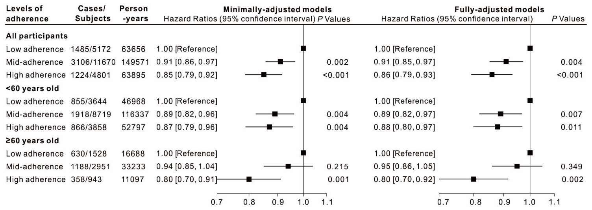
Age was adjusted in the minimally-adjusted model; Additionally, ethnicity, marital status, socioeconomic status, physical activity, body mass index, smoking status, alcohol consumption, total energy intake, and menopausal status were adjusted in the fully-adjusted model in the right panel of the figure.

Table S3 Subgroup analyses on associations between Mediterranean diet and frailty risk with a stringent standard for frailty assessment
Stratifying variable | Cases/subjects | Person-years | Hazard Ratio (95% Confidence Interval) | P*
Body Mass Index (BMI)
Normal-weight (BMI≤24.9 kg/m², N=13,648)
Low adherence | 752/2837 | 35959 | 1.00 (Reference)
Moderate adherence | 1849/7314 | 96027 | 0.92 (0.85, 1.01) | 0.068
High adherence | 890/3497 | 46871 | 0.92 (0.83, 1.02) | 0.097
Overweight (BMI>24.9 kg/m², N=7995)
Low adherence | 733/2335 | 27697 | 1.00 (Reference)
Moderate adherence | 1257/4356 | 53544 | 0.91 (0.83, 1.00) | 0.040
High adherence | 334/1304 | 17023 | 0.73 (0.64, 0.83) | <0.001
* Adjusted for age, ethnicity, marital status, socioeconomic status, physical activity, body mass index, smoking status, alcohol consumption, total energy intake, and menopausal status.

Table S4 Sensitivity analyses by excluding subjects with specific profiles on associations between Mediterranean diet and frailty risk with a stringent standard for frailty assessment
 | Cases/subjects | Person-years | Hazard Ratio (95% Confidence Interval) | P*
Fully-adjusted model
Low adherence | 1485/5172 | 63,656 | 1.00 (Reference)
Moderate adherence | 3106/11,670 | 149,571 | 0.91 (0.85, 0.97) | 0.004
High adherence | 1224/4801 | 63,895 | 0.86 (0.79, 0.93) | <0.001
Excluding subjects with < 3 years of follow-up (N=1812)
Low adherence | 1353/4677 | 62,808 | 1.00 (Reference)
Moderate adherence | 2813/10,706 | 147,863 | 0.90 (0.84, 0.96) | 0.001
High adherence | 1135/4448 | 63,242 | 0.85 (0.79, 0.93) | <0.001
Excluding subjects with over any three kinds of chronic diseases (N=1829)
Low adherence | 1323/4697 | 58,680 | 1.00 (Reference)
Moderate adherence | 2723/10,669 | 139,550 | 0.88 (0.82, 0.94) | <0.001
High adherence | 1112/4448 | 59,949 | 0.84 (0.78, 0.92) | <0.001
Excluding subjects on long-term treatment for illness (N=6899)
Low adherence | 886/3346 | 43,521 | 1.00 (Reference)
Moderate adherence | 1957/7916 | 106,927 | 0.91 (0.84, 0.98) | 0.019
High adherence | 844/3482 | 47,710 | 0.89 (0.80, 0.98) | 0.019
Excluding subjects with ≥1 year hormone replacement therapy (HRT) (N=4764)
Low adherence | 1096/3938 | 49,004 | 1.00 (Reference)
Moderate adherence | 2386/9111 | 117,479 | 0.93 (0.87, 1.00) | 0.058
High adherence | 952/3830 | 51,399 | 0.87 (0.79, 0.95) | 0.002
* Adjusted for age, ethnicity, marital status, socioeconomic status, physical activity, body mass index, smoking status, alcohol consumption, total energy intake, and menopausal status

