Supplementary Figures
Identification and immune landscape of sarcopenia-related molecular clusters in inflammatory bowel disease by machine learning
Chongkang Yue and Huiping Xue *
* Correspondence should be addressed to Prof. Huiping Xue MD, Ph.D. (E-mail: huiping_ xue@126.com; Tel:8613601902966)

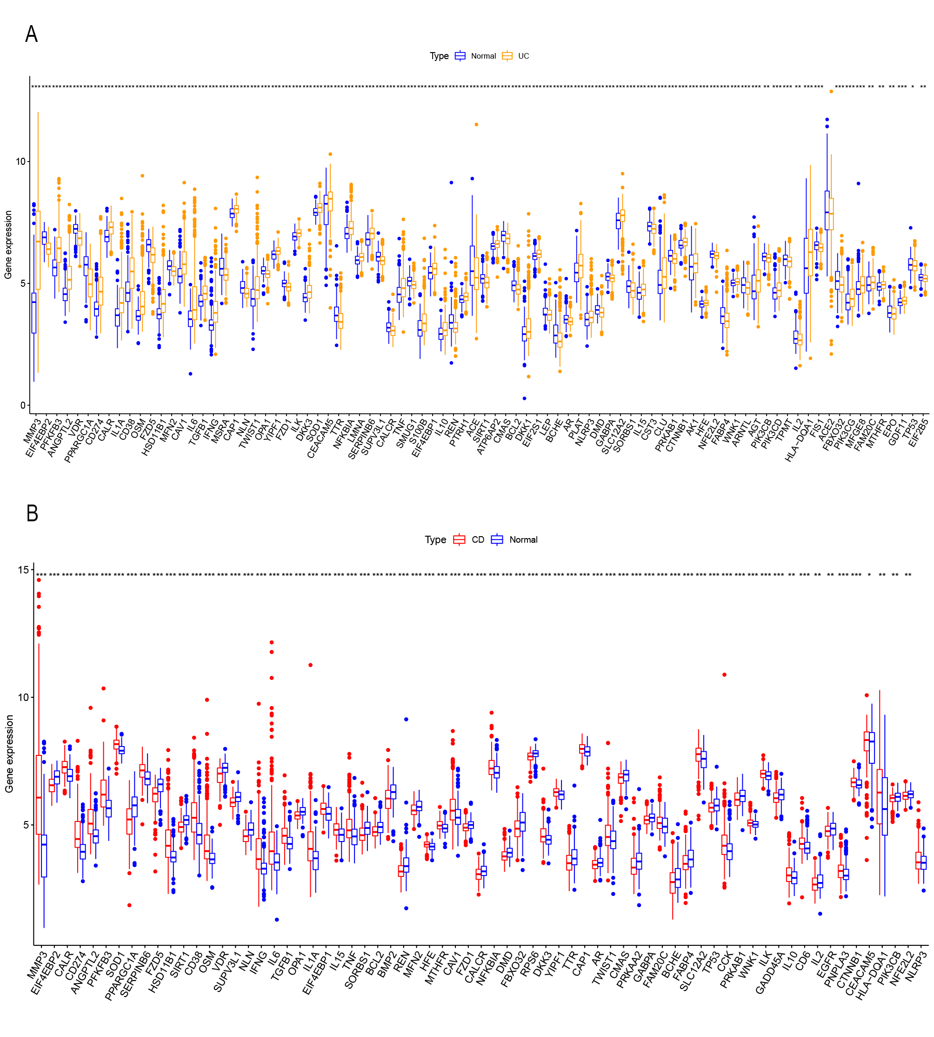

Figure S1. Differential expression patterns of DESRGs in IBD and normal tissues. (A) Boxplot showed the expression of 86 DESRGs in normal and UC tissues. (B) Boxplot showed the expression of 69 DESRGs in normal and CD tissues.

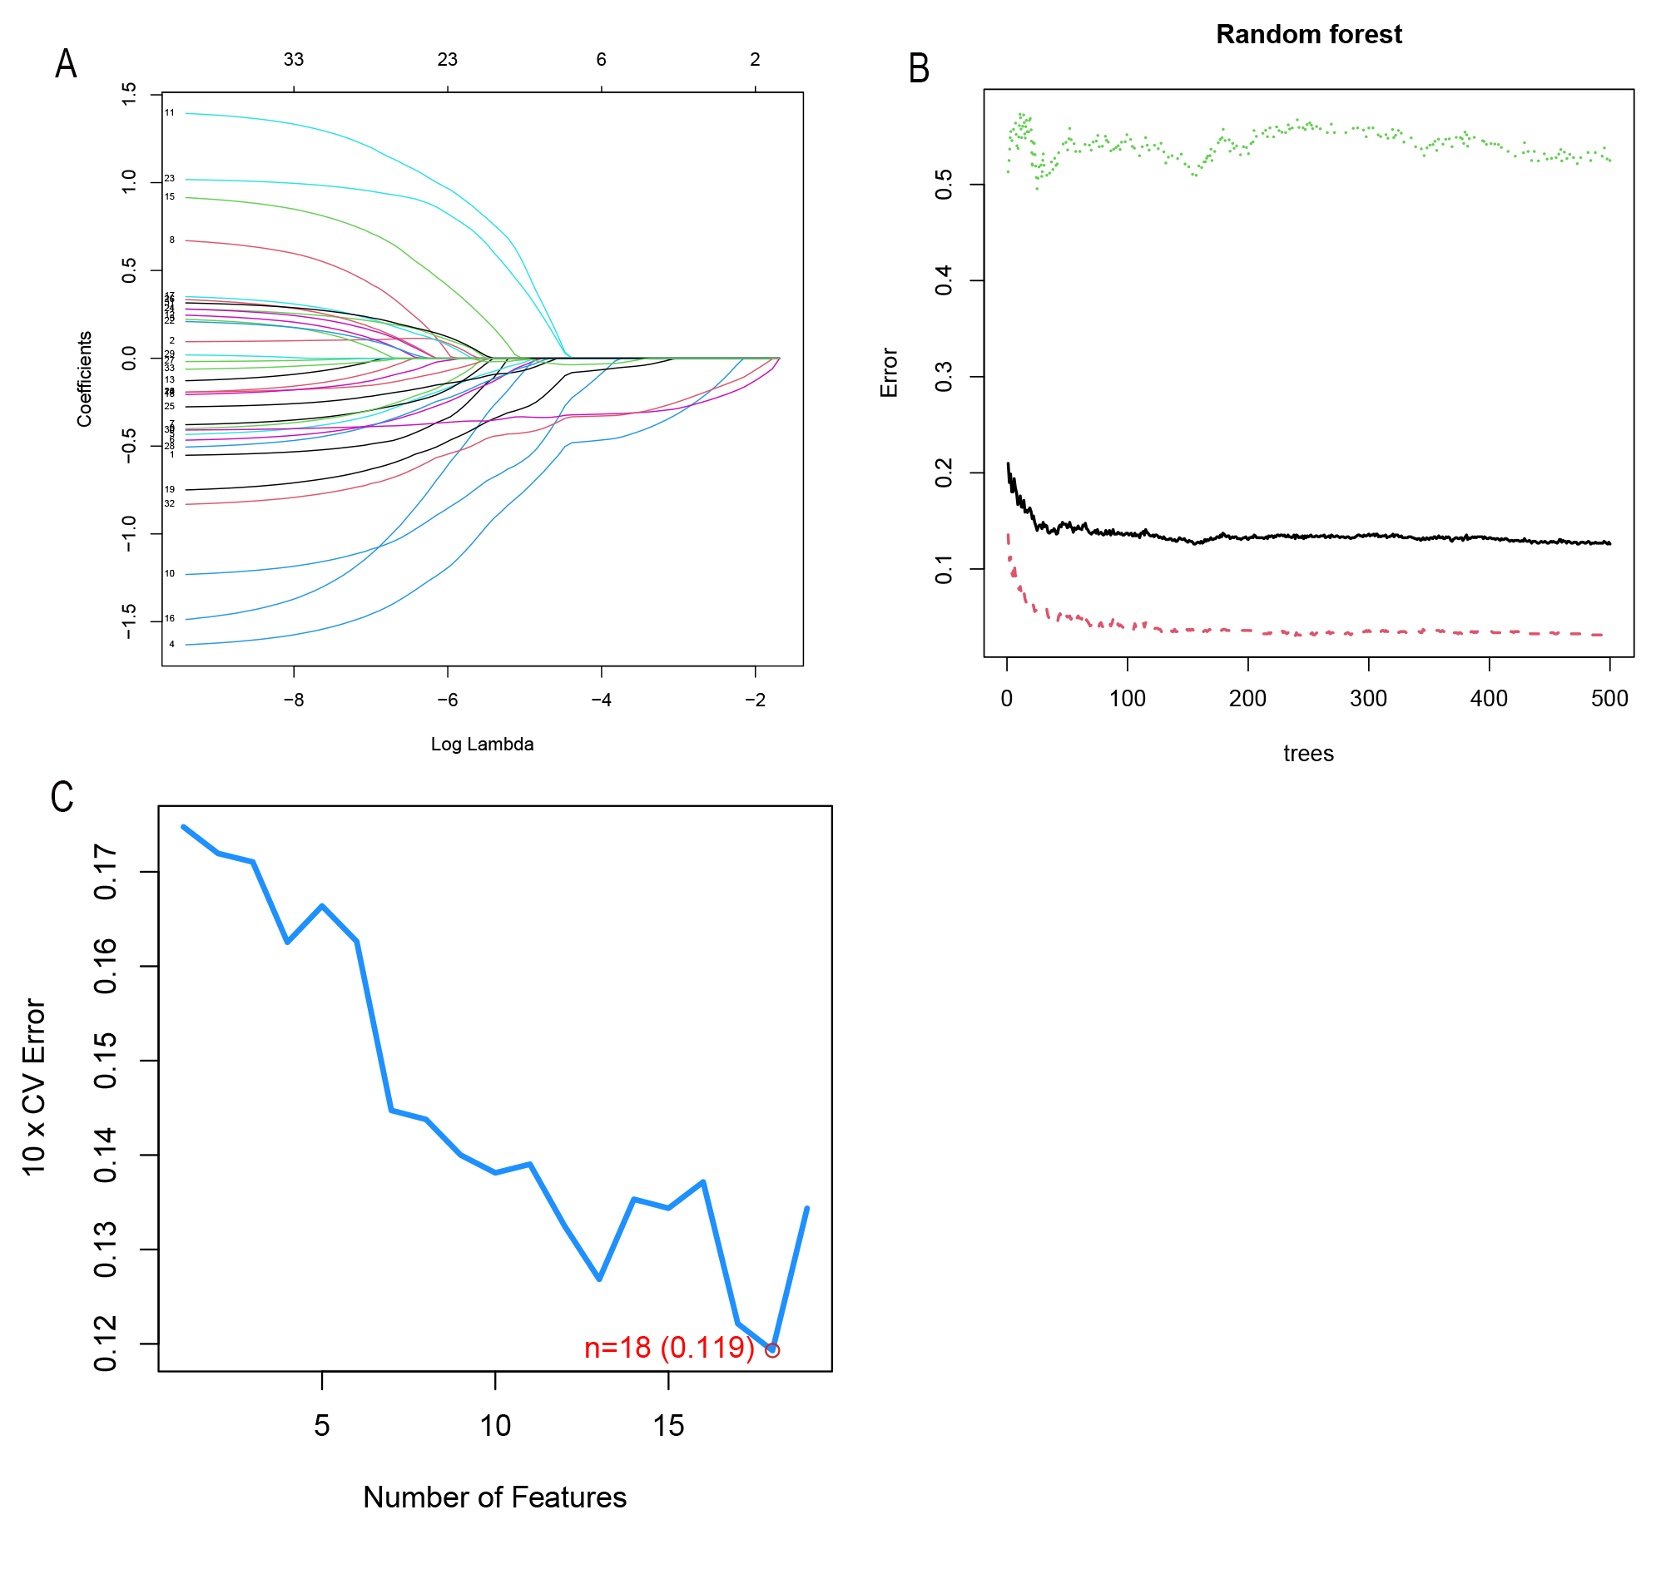

Figure S2. Screening characteristic genes by machine learning algorithms. (A) LASSO coefficient profiles of the 23 variables. (B) The influence of the number of decision trees on the error rate. The x-axis represents the number of decision trees, and the y-axis indicates the error rate. (C) The errors of the estimate generation for the SVM‐RFE algorithm.

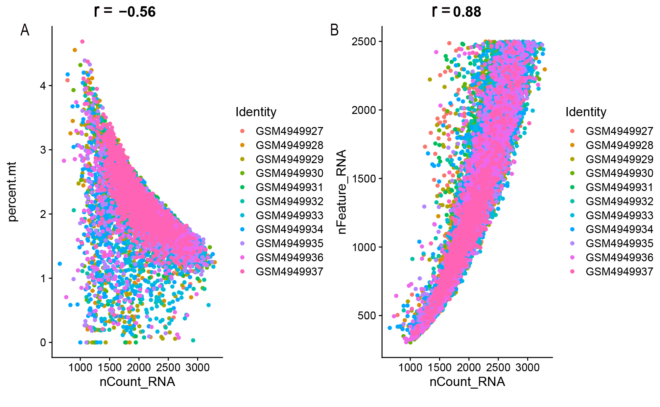

Figure S3. scRNA analysis of colon lamina propria immune cells in patients with active UC. (A) Correlation between genes and mitochondrial gene percentage in the sample. (B) Correlation between genes and counts in the sample.

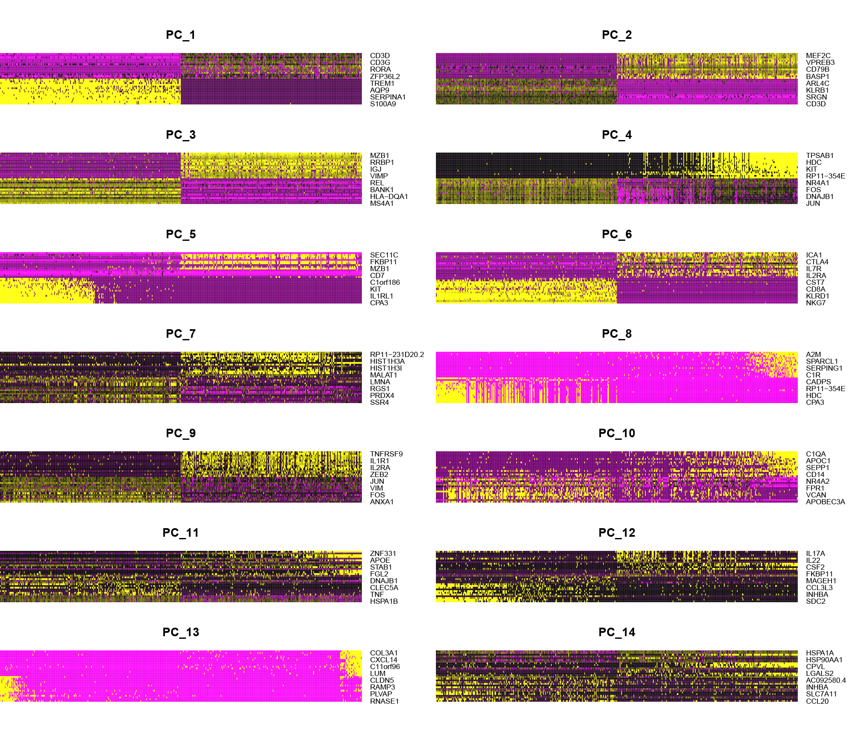
Figure S4. Heatmaps of the top 14 PCs with signature genes.

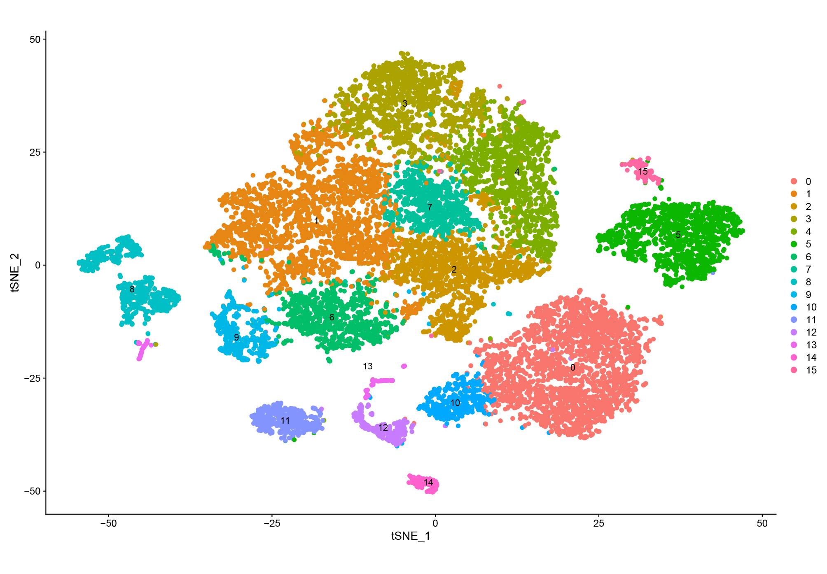

Figure S5. t-SNE projection of 15,316 immune cells, clustered into 15 clusters.

