Supplementary Information for
Rationally Micropatterned Antifogging Hydrogels Counteracting Extreme Condensation

Hyunchul Park^{1,+}, Cheuk Wing Edmond Lam¹, Iwan Haechler¹, Thomas M. Schutzius^{2,3,*}, Dimos Poulikakos^{1,*}
¹Laboratory of Thermodynamics in Emerging Technologies, Department of Mechanical and Process Engineering, ETH Zurich, Sonneggstrasse 3, CH-8092 Zurich, Switzerland
²Laboratory for Multiphase Thermofluidics and Surface Nanoengineering, Department of Mechanical and Process Engineering, ETH Zurich, Sonneggstrasse 3, CH-8092 Zurich, Switzerland
³Department of Mechanical Engineering, University of California at Berkeley, Berkeley, California 94720-1740, USA
*Correspondence e-mail: dpoulikakos@ethz.ch; thomschu@ethz.ch

This PDF file includes:

Supplementary Notes 1 to 5
Supplementary Figs. 1 to 7
Supplementary Videos 1 to 5
Supplementary References

-------------------------------------------
⁺Current address: Extreme Materials Research Center, Korea Institute of Science and Technology, Seoul 02792, Republic of Korea

Supplementary Note 1: Wetting criteria for designing microstructures

The critical contact angle, $θ_{c}$, was calculated using the formula (2) $θ_{c}=\cos^{-1}\left({\left(1-f_{s}\right)}/{\left(r-f_{s}\right)}\right)$, where the roughness factor, $r$, was determined as follows: $r=\frac{A}{A_{p}}=\frac{\frac{\sqrt{3}}{4}{\left(s+d\right)}^{2}+\frac{π}{2}dh}{\frac{\sqrt{3}}{4}{\left(s+d\right)}^{2}}=1+\frac{2πdh}{{\sqrt{3}\left(s+d\right)}^{2}}$. The parameters used in the calculation of $r$ were $s$, $d$, and $h$, representing the spacing, diameter, and height of the pillar, respectively. $A_{p}$ and $A$ denote the projected and actual surface areas, respectively. Additionally, the top solid area fraction of the liquid-solid interface was calculated as $f_{s}=\frac{A_{s}}{A_{p}}=\frac{\frac{π}{8}d^{2}}{\frac{\sqrt{3}}{4}{\left(s+d\right)}^{2}}=\frac{πd^{2}}{2\sqrt{3}{\left(s+d\right)}^{2}}$, where $A_{s}$ represents the projected solid surface area. The values of $d$, $s$, and $h$ were used to establish $r$ and $f_{s}$ were 30 µm. The resulting values for $r$ and $f_{s}$ were 1.91 and 0.23, respectively.

Supplementary Note 2: Stabilization of the incoming water flux by wicking

When a surface experiences extreme condensation conditions, it needs to efficiently spread incoming condensate by wicking, to rapidly form (and maintain) a thin, continuous water layer. We can determine if a surface can do this, by comparing the incoming water flux to the wicking rate from the microstructure. To this end, we measured the growth rate of condensing water volume, $V$, as a function of environmental temperature and found that it yielded a maximum value of $\frac{dV}{dt}≈11$ mm³ s⁻¹ at the most extreme condensation conditions we tested. This corresponds to an average heat flux of $Q_{avg}≈\frac{ρ_{w}∆H}{A_{proj}}\frac{dV}{dt}$ = 9 kW m⁻², where $∆H$ is the heat of condensation, ($∆H$ = 2.26 MJ kg⁻¹), $ρ_{w}$ is the density of liquid water ($ρ_{w}=997$ kg m⁻³), $A_{proj}$ is the projected area ($A_{proj}=w×l=$ 2.85 × 10⁻³ m²), $w$ and $l$ are the width and length of the micropatterned area (Supplementary Fig. 7), a relatively high value considering that no active cooling has been applied. In experiments, condensation occurs uniformly over the entire surface. To simplify our two-dimensional calculations, we assumed that incoming condensate will spread from a single edge to the opposing edge over the surface as an extreme scenario ($x$-direction in Supplementary Fig. 7). We determined the wicking rate using a model that balances capillary and viscous forces. Specifically, the model scales the wicking rate as (1) $\overset{˙}{V}=\frac{γ}{μ}\frac{h}{l}\frac{r-1}{r}A_{c}$ where $γ$ is the surface tension of liquid, $μ$ is the dynamic viscosity of liquid water, $r$ is the ratio of the actual surface area to the projected area, and $A_{c}$ is the cross-sectional area through which condensate passes between the micropillars and is calculated by $A_{c}=\frac{wh}{2}$ for simplicity. Substituting appropriate values ($w$ = 0.057 m; $l$ = 0.05 m; $h$ = 30 µm; $γ=$0.072 N m⁻¹; $μ=$0.0013 Pa s; $r$ = 1.91), we yielded the wicking rate of 13.5 mm³ s⁻¹, indicating that at extreme condensation conditions, that wicking rate is indeed higher than the incoming condensing flux of 11 mm³ s⁻¹. Therefore, the designed microstructure is capable of spreading liquid water with a high incoming water flux under our experimental conditions.

Supplementary Note 3: Diffusion and flow characteristics of water vapor

The dominance between diffusion and flow in the experimental conditions was determined through a scaling analysis based on the Peclet number, $Pe={Uh}/D$, where $U$ represents the flow velocity, $D$ is the diffusion coefficient of water vapor, and $h$ is the height of the pillar. This dimensionless number characterizes the relative importance of convective and diffusive transport in a given system. In the experiment, the chamber was installed in an environment with room temperature and 30% relative humidity. The vapor temperature range near the surface was 30–70 °C. In this given condition, $D$ ranged from 0.27 to 0.33 cm² s⁻¹ and the density of water vapor, $ρ_{v}$, was in the range of 0.03–0.18 kg m⁻³. To calculate the flow velocity of water vapor within the microstructure, the rate of condensation on the sample surface with the dimensions of 50 × 57 mm² was assumed to be the same as the flow rate of water vapor transported to the micropatterned surface. From the experiments, the condensation flux, $J_{c}$, was found to be in the range of 10⁻⁷–10⁻⁶ kg s⁻¹, and the projected area of void fraction on the surface, $A_{w}$, was 0.22 cm². The flow velocity, $U$, was calculated as $U={J_{c}}/{\left(ρ_{v}A_{w}\right)}$ in the range of 0.1–10 mm s⁻¹. Finally, the calculated $Pe$ was in the range of 10⁻⁴–10⁻² with a pillar height of h = 30 µm, indicating that convective flow effect can be neglected.

Supplementary Note 4: Theoretical calculation of the filling time of condensate

Assuming that condensation on the micropatterned hydrogel occurs due to water vapor diffusion on the surface and the relative humidity in the closed chamber reaches 100%, we measured vapor temperatures ($T_{v}$) above the surface and surface temperatures ($T_{s}$) to calculate the vapor concentration in the air and on the surface. We defined the water vapor concentration difference as $∆c_{\text{sat}}\left(∆T\right)=c_{\text{sat}}\left(T_{v}\right)-c_{\text{sat}}\left(T_{s}\right)$, where $c_{\text{sat}}\left(T_{v}\right)$ and $c_{\text{sat}}\left(T_{s}\right)$ are the mass concentrations of water vapor in the air and on the surface, respectively. These concentrations can be calculated from the temperatures using the empirical model, $c_{\text{sat}}\left(T\right)=6.335+0.6718T-2.0887×{10}^{-2}T^{2}+7.3095×{10}^{-4}T^{3}$.
We used this information to calculate the filling time with the equation $t_{f}=ατ_{f}=α\frac{ρ_{w}h^{2}}{D∆c_{\text{sat}}\left(∆T\right)}$, where $h$ = 30 µm is the pillar height, $ρ_{w}=997$ kg m⁻³ represents the density of liquid water, and D is the diffusion coefficient of water vapor, which ranges from 0.27 to 0.33 cm² s⁻¹ under our experimental conditions. We established the empirical correlation coefficient, $α$, to predict the actual filling time of water between the spaces of micropillars. $α={t_{f}}/{τ_{f}}$, where $t_{f}$ is the actual filling time from experiments and $τ_{f}$ is the calculated filling time from the diffusion-driven model. We found that the average $α$ was 17, within the range of $T_{v}$ from 30 to 70 °C.

Supplementary Note 5: Quantitative analysis of the scattering behavior over time

Source videos encoded in H.264 at 30 fps are first decoded to the YCbCr color space and cropped to an area enclosing the reference checkerboard with ffmpeg. A custom MATLAB script is then used to read the Y plane, which includes only the brightness information of the video, discarding color information. For each frame, the image contrast is computed using the RMS difference of the intensity of each pixel from the mean of the frame. For optical clarity correlation, $r$, a reference frame ref before condensation is first defined, and $r$ is computed as described in the main text. Optical clarity correlation and normalized contrast over time are reported in 5-second moving averages.

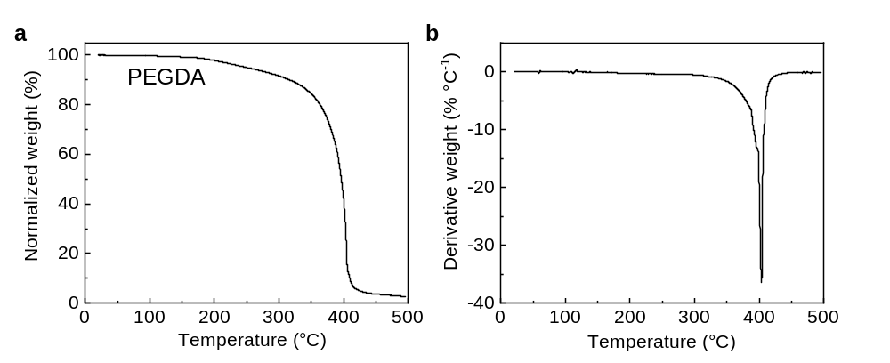
Supplementary Fig. 1 a Thermogravimetric analysis and b derivative thermogravimetry of PEGDA. Thermogravimetric-mass spectrometry analysis (TGA-MS) was performed on a simultaneous thermal analyzer (SDT 650, TA Instruments) with a mass spectrometer. The heating protocol involved heating the sample at a constant rate of 10 °C min⁻¹ under a helium atmosphere (100 mL min⁻¹) up to 500 °C. The TGA-MS results indicated that PEGDA exhibits thermal stability up to 200 °C, beyond which it undergoes significant decomposition. Therefore, it is recommended to use boiling conditions that are typical of those below 100 °C.

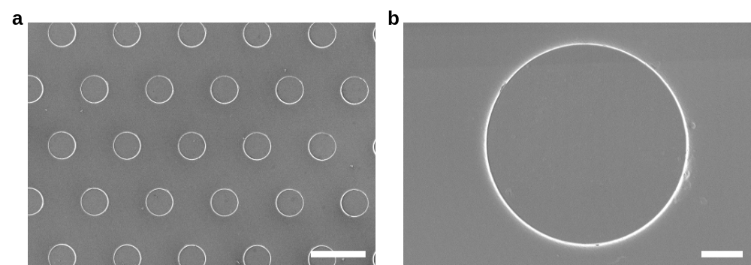
Supplementary Fig. 2 a Scanning electron microscope (SEM) image of the micropatterned hydrogel at a low magnification. The image reveals the overall topographical features of the surface, including the staggered array of the micropillars, the spacing between them, and their diameter. The surface appears to be uniform and well-defined, with smooth edges and minimal defects or irregularities. b Enlarged SEM image in A provides a closer view of the micropatterned surface at a higher magnification. The image reveals more details about the surface, including the fine structures and features of the micropillars and the roughness of the surface. Scale bars: 50 µm in a, and 5 µm in b.

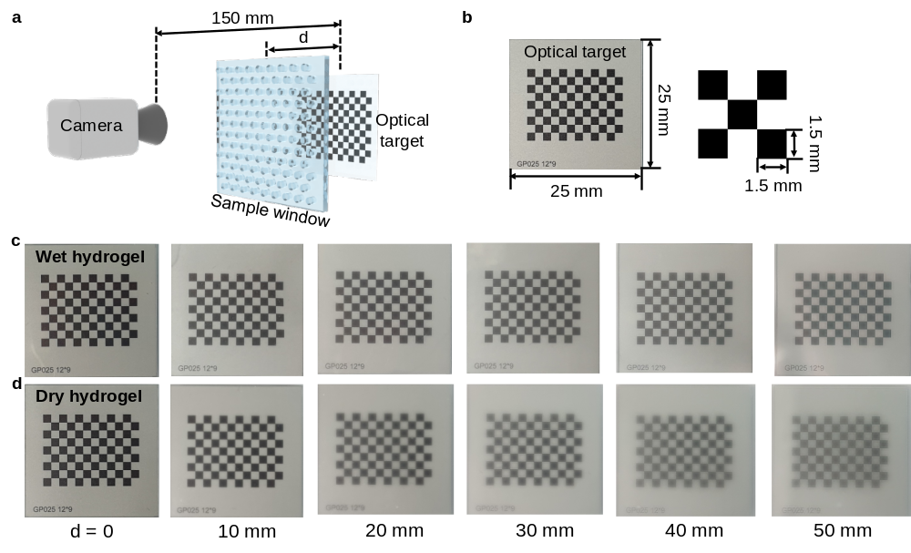
Supplementary Fig. 3 a Schematic illustration of the experimental setup used for optical clarity measurements with varying distances. The setup consists of a camera placed at a distance of 150 mm from the optical target. Digital camera images are captured through a sample window with varying distances, d. b Specific dimensions of the optical target used in the experiments. The target consists of a black and white checkerboard pattern with a dimension of 25 × 25 mm² and a square size of 1.5 × 1.5 mm². c and d display images captured through a wet hydrogel and a sample placed at varying distances from the optical target (0, 10, 20, 30, 40, and 50 mm). The distance from the camera affects the visibility of both wet and dry hydrogel samples. Additionally, the wet hydrogel sample appears clearer in the images than the dry hydrogel sample, due to the presence of water on the surface of the hydrogel.

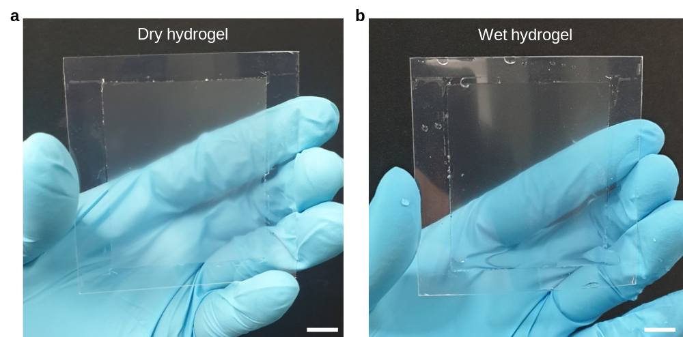
Supplementary Fig. 4 Comparison of optical clarity for dry and wet micropatterned hydrogels. The digital camera images of the large area of a dry and b wet micropatterned hydrogel. The object behind the wet hydrogel appears sharper and more defined than the image of the dry hydrogel, indicating superior optical clarity for the wet hydrogel. Scale bars: 10 mm

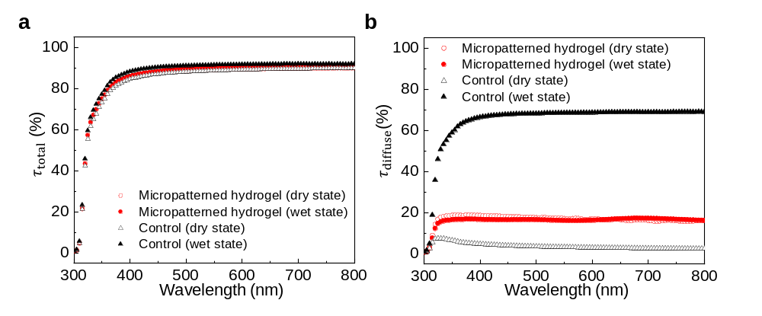
Supplementary Fig. 5 Plots of a total transmittance, $τ_{total}$, b diffuse transmittance, $τ_{diffuse}$, for the micropatterned hydrogel and control sample at both dry and wet states. The total transmittance was comparable for both samples in both states. However, the control sample demonstrated a significant increase in diffuse transmittance from the dry to wet state, whereas the micropatterned hydrogel displayed relatively low diffuse transmittance across both states.

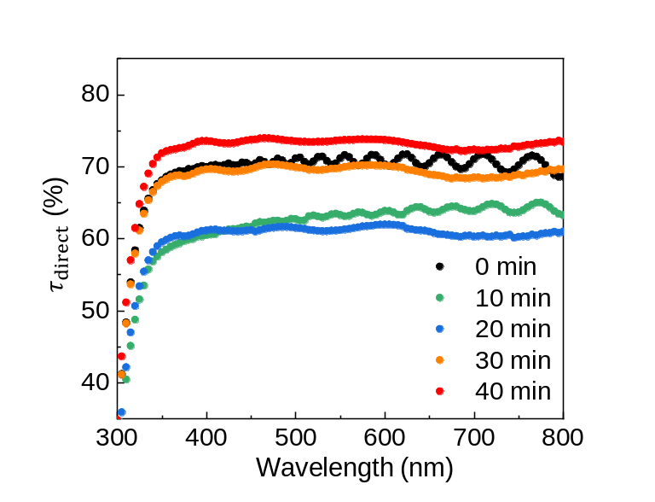
Supplementary Fig. 6 Plot of direct transmittance, $τ_{direct}$, vs. wavelength with varying condensation times on micropatterned hydrogel. We conducted experiments at room temperature with a relative humidity of 30%. The surface is cooled using a ring-shaped Peltier module that enables UV-Vis-NIR spectroscopy measurements. The plot shows direct transmittance as a function of wavelength at different time intervals during the condensation process. Initially, wavy patterns were observed due to the interference between the microstructures and the incident light, as shown in the graphs at 0 and 10 minutes. As the micropillar arrays were filled with water, the structural interference significantly decreased, resulting in smoother patterns of direct transmittance with wavelength, as observed in the graphs at 20, 30, and 40 minutes. This transition from a fogged surface to a water-filled state is clearly demonstrated in the patterns of each graph, highlighting the optical properties of micropatterned hydrogel during the condensation process.

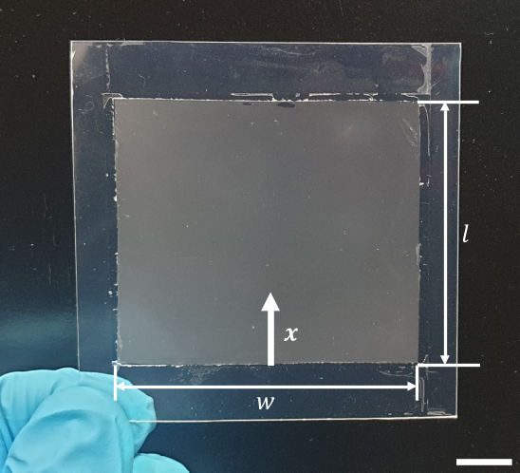
Supplementary Fig. 7 Digital camera image of large-area micropatterned hydrogel on polyester film. $w$ and $l$ indicate the width and length of the micropatterned area, respectively. To calculate the wicking rate, we assume that incoming condensate spreads along the $x$ direction. Scale bar: 10 mm

Supplementary Video 1

Optical clarity test during condensation on flat and micropatterned hydrogels with varying heights.

Supplementary Video 2

Spontaneous droplet spreading on a hydrated micropatterned hydrogel.

Supplementary Video 3

Continuous removal of water droplets from angled surface.

Supplementary Video 4

Assessing optical clarity of micropatterned hydrogel and commercial products under boiling conditions.

Supplementary Video 5

Antifogging performance of micropatterned hydrogel under a cooking condition.

SI References

1. S. J. Kim et al., Liquid spreading on superhydrophilic micropillar arrays. J Fluid Mech 680, 477-487 (2011).
2. A. B. D. Cassie, Contact Angles. T Faraday Soc 44, 11-16 (1948).

