Extended Data Fig. 1 Maps of the conterminous United States, showing (a) locations of active USGS wells (red) and locations of any USGS well that has measurement data between 1920 and 2020 (black); (b) number of measurements per well, between 1920 and 2020; and (c) number of measurements per state, between 1920 and 2020. (d) shows the annual number of wells with measurements (red dashed line) and total number of measurements (black line). The labels in (C) indicate the number for each state.

Extended Data Fig. 2 Maps of the conterminous United States, showing annual average groundwater head (m above sea level) for wells that had measurements during 1940, 1960, 1980, and 2010.

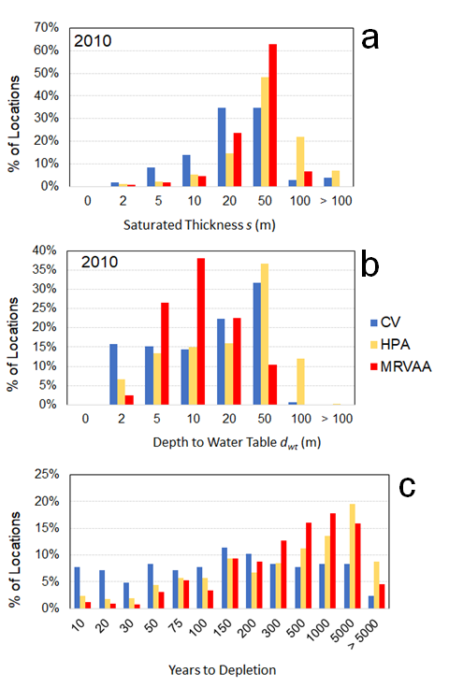
Extended Data Fig. 3 Frequency distributions of (a) depth to water table (m) in 2010, (b) saturated thickness (m) in 2010, and (c) estimated years to depletion, for monitoring well locations in the Central Valley Aquifer (CV), High Plains Aquifer (HPA), and Mississippi River Valley Alluvial Aquifer (MRVAA).

Extended Data Fig. 4 Maps of the conterminous United States, showing annual average water table depth d_{wt} (m below ground surface) for wells that had measurements during 1940, 1960, 1980, and 2010.

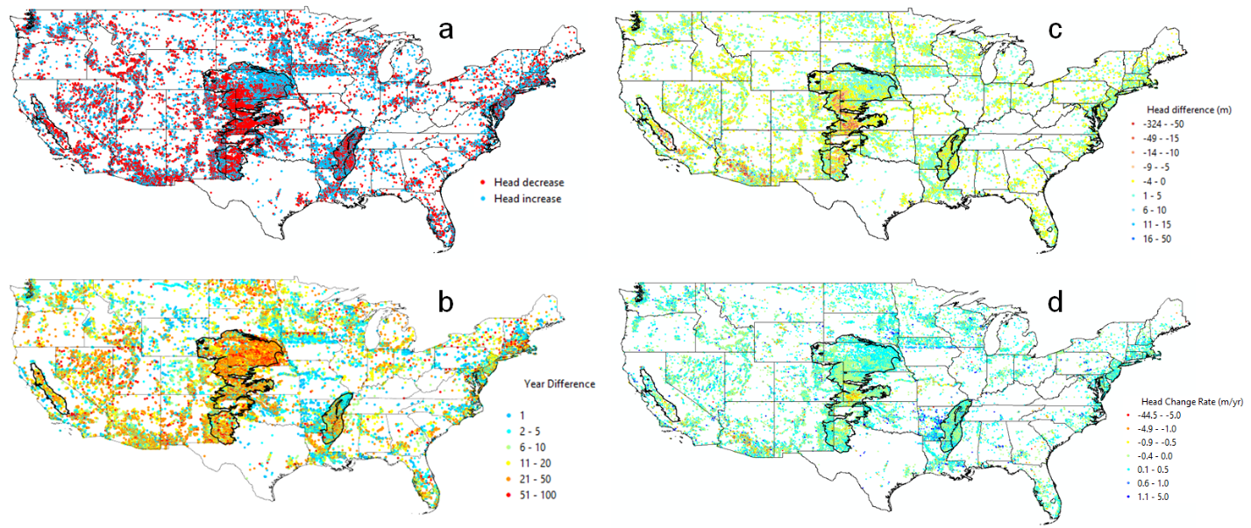
Extended Data Fig. 5 Maps showing (a) locations with groundwater head increase or decrease, (b) number of years, (c) difference in groundwater head (m), and (d) the rate of head change (m/yr) between the earliest and latest sampling times for each monitoring well location.

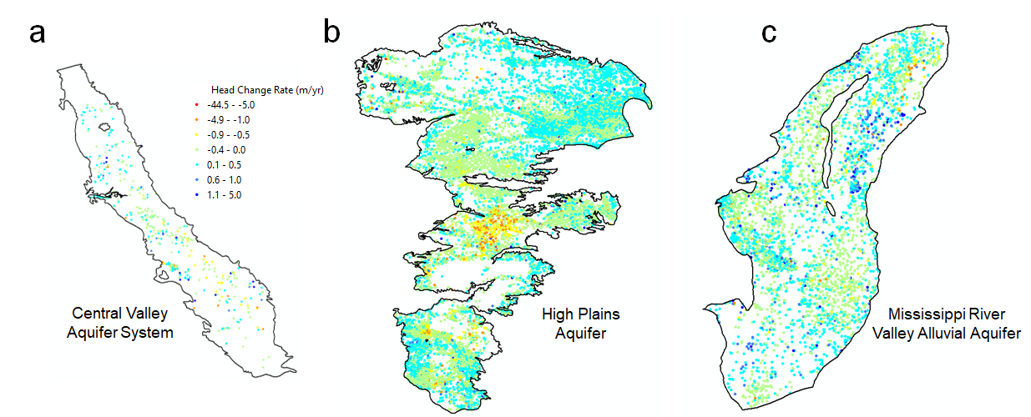
Extended Data Fig. 6 The annual change in groundwater head (m/yr) for the three main stressed unconfined aquifers in the United States: (a) Central Valley Aquifer System, (b) High Plains Aquifer, and (c) Mississippi River Valley Alluvial Aquifer.

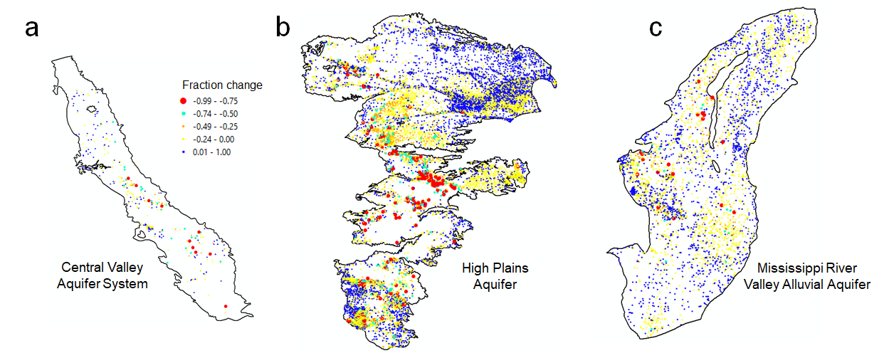
Extended Data Fig. 7 The fraction change in saturated thickness over the period of measurement, for monitoring wells located in the three main stressed unconfined aquifers in the United States: (a) Central Valley Aquifer System, (b) High Plains Aquifer, and (c) Mississippi River Valley Alluvial Aquifer.

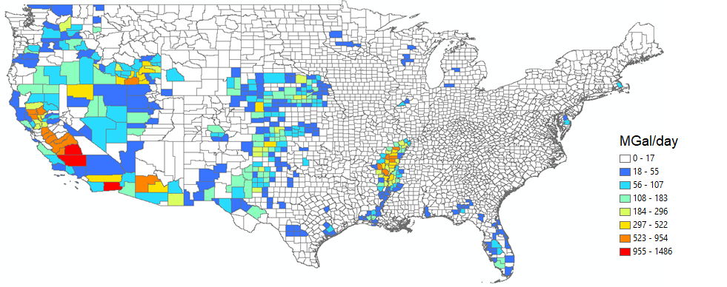
Extended Data Fig. 8 Total groundwater pumped volume for agriculture irrigation (MGal/day) for each county of the 48 states in 2015, as estimated by the USGS (Dieter et al., 2018).

Extended Data Fig. 9 Schematic of procedure workflow to obtain national datasets of annual average water table depth (d_{wt}) and groundwater head (h) during 1920-2020 for USGS monitoring wells located in unconfined aquifers. The image on the left depicts groundwater in unconfined and confined aquifers. The map of unconsolidated sediment thickness is from a global dataset²².

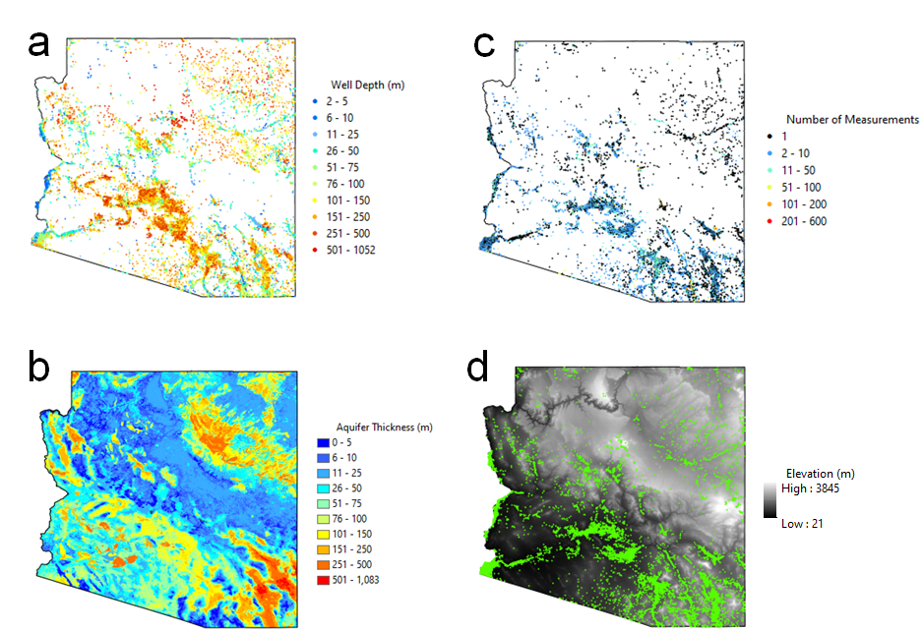
Extended Data Fig. 10 Maps of the state of Arizona, showing (a) location and well depth (m) of each USGS well; (b) aquifer thickness (m), i.e. the thickness of unconsolidated sediments; (c) the location and number of available measurements for each well in an unconfined aquifer; (d) the ground elevation (m) and associated location of each well in an unconfined aquifer.

