Core genes driving climate adaptation in plants
Supplementary Materials

SUPPLEMENTARY METHODS

Dataset selection criteria
We selected datasets for which sequence data were available with either whole genome shotgun data (WGS), pool sequencing (POOL) data, or sequence capture data (CAPTURE). Such datasets provide broad genomic representation and maximise the resolution of the number of genes for each species. We limited our study to datasets with at least five populations distributed along latitudinal, longitudinal and/or altitudinal gradients. Here, the minimum number of populations was set in order to allow for a minimum baseline of statistical power for Kendall’s τ correlations between environment and allele frequency (see below). The list of included datasets are not exhaustive, but rather were selected to achieve a desired number of approximately 20-30 species for which power to detect repeated adaptation has been demonstrated for the methods used here ¹. Datasets also had to provide locality information, either for individual samples or groups of individuals. Species were selected to include both gymnosperms and angiosperms, setting the MRCA of all species sampled at approximately 300 million years ago (Fig S1) ².

SNP-calling
We used two SNP-calling pipelines depending on whether sequencing data came from individuals (WGS and CAPTURE) or came from pools of individuals (POOL). These pipelines were necessarily different, but were based on similar approaches to reduce bioinformatic discrepancies between the data types. For all data types, raw fastq data were retrieved from either the NCBI sequencing read archive (SRA) or the EBI European nucleotide archive (ENA). Accession codes for all data are provided in Table S1.

To process the sequence data, for each species we defined the genomic reference against which the sequence data were aligned. For species for which a reference genome was not available, we chose the reference genome of a closely related species (Table S1). We used inference from an earlier study to construct an optimal SNP-calling pipeline that balanced SNP quality with processing time ³. This study aimed at comparing five different SNP-callers: GATK-HaplotypeCaller, GATK-UnifiedGenotyper ⁴, BCFtools mpileup + call ⁵, Freebayes ⁶, and VarScan ⁷ in terms of computational resources used, and their capacity to recover true genotypes based on a “truth set” of SNPs, developed from lodgepole pine sequence capture data. Here, the “truth set” was based on congruence between mother and haploid offspring genotypes, with errors identified as genotypes that could not have arisen from standard inheritance (ignoring mutation, which should be vanishingly rare). This study revealed variable proportions of mismatched genotypes between the “truth set” and newly called genotypes. Briefly, the combination of mpileup and call programs from the BCFtools suite provided the best balance between low false positives rate and computational time. Therefore, we built and optimised two pipelines based on the same architecture for each individual and pooled data types. The pipelines are available at the following github repositories: Individual-based (https://github.com/JimWhiting91/RepAdapt/) and pool-based (https://github.com/CoAdapTree/varscan_pipeline).

The pipeline for individual-based data was as follows, note that selfing and outcrossing species were processed using the same pipeline. Raw fastq files were cleaned and trimmed for adapter sequences using fastp (v0.20.1) ⁸ before being aligned against the reference genome using bwa-mem (v0.7.17-r1188) ⁹. BAM files were generated, sorted, and indexed using samtools (v1.16.1) ⁵, skipping alignments with MAPQ < 10 (-q 10). We then collected quality metrics with Picard Tools (v2.26.3) ¹⁰ based on alignment summary (CollectAlignmentSummaryMetrics), insert size metrics (CollectInsertSizeMetrics), and coverage (CollectWgsMetricsWithNonZeroCoverage). We then marked and removed duplicates using Picard’s MarkDuplicates and used AddOrReplaceReadGroups to amend read groups. In some cases, datasets split sequencing data from individual samples across multiple technical replicates, so we then merged BAM files within samples with Picard’s MergeSamFiles. We ran a realignment of the cleaned, merged BAM files by running the RealignerTargetCreator and IndelRealigner from the Genome Analysis Tool Kit (GATK v3.8) ⁴ and repeated the aforementioned quality metrics on final BAM files. To identify single-nucleotide polymorphisms (SNPs), we generated genotype likelihoods using BCFtools’ ⁵ mpileup by specifying a minimum mapping quality of 5 for an alignment to be used and retained additional annotation information such as allelic depth (AD). From there, individual pileups were converted into SNP VCFs by using the BCFtools’ call program. We set sample ploidy (-S) information and called for genotype quality (GQ) to be reported while excluding any group samples (-G -) information. Finally, we filtered raw VCF files with VCFtools ¹¹ by removing sites with quality value below 30 (--minQ 30), Genotype Quality below 20 (--minGQ 20), minimum read depth of 5 (--minDP 5), before finally retaining only biallelic (--max-alleles 2) genotypes present in more than 70% of individuals (--max-missing 0.7). For downstream analyses, we performed additional filtering on the basis of minor allele frequency (maf) and minor allele count (mac), retaining only sites with maf > 0.05 and mac > 5, whichever was most stringent.

Pooled data was processed using a similarly structured workflow. Raw fastq files were cleaned and trimmed with fastp and aligned to references with bwa-mem using the additional flag to mark shorter split hits as secondary (-M). BAM files were generated, sorted, and indexed using samtools, skipping alignments with MAPQ < 20 (-q 20) and bedfiles were generated from indexed BAM files using BEDtools (v2.27.1) ¹². Duplicates were then marked and removed with MarkDuplicates before indel realignment was performed with Picard’s RealignerTargetCreator and IndelRealigner. SNP-calling was then performed using mpileup followed by VarScan’s (v.2.4.2) mpileup2cns program. Variants were called on the basis of minimum read depth of 8 (--min-coverage 8), a p-value threshold of 0.05 (--p-value 0.05), a minimum frequency for calling homozygotes of 80% (--min-freq-for-hom 0.8), ignoring variants with >90% support on one strand (--strand-filter 1), minimum base quality at position of 20 (--min-avg-qual 20) and a minimum variant allele frequency of 0 (--min-var-freq = 0). To extract allele frequencies, pooled SNPs were converted to SNP tables using GATK (v4.1.0.0) ¹³ VariantsToTable, splitting multi-allelic sites across multiple rows (--split-multi-allelic) and extracting the AF field. Final SNPTables for POOL data were filtered for indels, retaining only biallelic sites, and a minor allele frequency cutoff of 0.05.

Preparing environmental data
We handled and analysed all environmental data in R (v4.1.3) ¹⁴. For each dataset, for each unique set of latitude-longitude co-ordinate pairs, we extracted bioclimatic variable (bioclim) data from the worldclim database (v2.1) ¹⁵ at 2.5 minute sampling resolution. This resulted in environmental variation across all bioclim variables across all datasets, with the exception of Eucalyptus magnificata and isothermality, which exhibited no variation across sampling sites. These data were not standardised due to the non-parametric nature of associations with allele frequencies in our genotype-environment associations (GEA; see below).

These 19 bioclim variables are, of course, not independent of one another and exhibit substantial covariance. This is to be expected given various bioclim variables are calculated from other bioclim variables, for e.g. isothermality (BIO3) = 100 * mean diurnal range (BIO2)/ temperature annual range (BIO7). In other cases, bioclim variables are simply similar observations, for e.g., maximum temperature in the warmest month (BIO5) and mean temperature in the warmest quarter (BIO10). Many studies seek to remove non-independence within environmental datasets through reducing dimensionality with principal component analysis (PCA) or redundancy analysis (RDA). Reducing dimensionality, whilst reducing nonindependence, does however add significant complications in terms of interpretation, where it can be unclear which environmental contributors to a combined variable are responsible for adaptation. Additionally, such approaches are undesirable in studies of multiple datasets where covariance of bioclim variables will vary among individual datasets, such that combined variables are incomparable. One approach to this issue may be to include environmental data from all datasets in a single dimensionality reduction, however this approach tends to maximise the significance of variation among datasets, which dwarfs variation within datasets and is substantially less relevant to selection pressures and adaptation within datasets. Consequently, the simplest approach in terms of downstream interpretation and making comparisons across datasets is to maintain individual variables and acknowledge the potential non-independence of results among likely covarying variables (Fig S9).

To generate climate change variables describing change in max temperature (tmax) and precipitation (prec) at sampling locations across 50 years of climate change, we extracted historical climate data for tmax and prec variables for all monthly timepoints between 1960-1969 and 2010-2019. Using these, we assembled the distribution of per-site climate variation within each of these decades. As a measure of change, we then estimated a non-parametric effect size between the 1960s and 2010s distributions within each site using the rstatix::wilcox_effsize() function ¹⁶. Thus, a larger effect size is indicative of a greater change in recent climate (example shown in Fig 1C). These two variables did exhibit some association with other bioclim variables, particularly those linked with seasonality (Fig S10). This is likely due to the increased variance of monthly max temperature and precipitation at sites with greater seasonality, which will dampen effect size estimates between decades.

Genotype-Environment Associations (GEA)
We first converted individual-based data into allele frequencies by combining individuals labelled as sampled from the same location and calculating per-sampling site allele frequencies. These should not be considered as populations in the traditional population genetics sense, in that we do not assign individuals on the basis of shared ancestry among individuals. In doing so, we trade off the risk of allele frequency sampling error when only a handful of individuals, or even a single individual, are sampled at a given location, against increased sampling power in downstream genotype-environment associations.

For each dataset, we combined per-sampling site allele frequencies with environmental variables calculated as above, and calculated GEAs on the basis of non-parametric Kendall’s τ correlations (i.e. no correction for population structure). This approach was taken for a number of reasons. Firstly, the non-parametric correlation makes no assumptions about the distribution of allele frequency or environmental variation which is likely to vary substantially among datasets and climate variables. The Kendall’s τ correlation is a rank-based correlation similar to Spearman’s ρ but with adjustments to handle ties. There are an abundance of approaches to perform GEA, some of the most popular being BayPass ¹⁷, PCAdapt ¹⁸, latent-factor mixed modelling (LFMM) ¹⁹, and RDA ²⁰. Each of these approaches includes a correction for potentially spurious associations between allele frequencies and environment driven by spatial autocorrelation between population structure/gene flow and environmental variation. In doing so, these approaches should theoretically reduce false-positives (Type-I error) but incur a drop in power (more false-negatives, Type-II error) ^{21,22}, as seen empirically in other studies ^{23,24}. However, a recent study deploying these methods on datasets created using individual-based simulations of evolution found substantial variation in realised power and false positive rates, with LFMM exhibiting a high power but a false positive rate near 100%, while RDA showed both very low power and low false positive rate ²⁵. Low power for methods including population structure correction was also observed by another simulation study assessing the accuracy of GEA methods ²⁶. Thus, methods that attempt to “control for population structure” cannot reliably disentangle the contributions of genetic drift and natural selection to observed patterns of allele frequency variation within a single species, especially in real empirical datasets where complex phenomena like allele surfing might be particularly problematic ²⁷.

In contrast, our method avoids the pitfalls of correction for population structure by instead relying on comparisons across species to more reliably detect the signature of natural selection repeatedly driving local adaptation. This works better than single-species analyses because if random genetic drift is driving evolution at a given gene in multiple species, we can specify the probability of repeatedly observing a strong association by chance and perform our tests accordingly. There is therefore no need to correct for population structure at the level of the within-species analysis, because this is controlled by our among-species probability model, as deployed in PicMin.

It should be noted however that some major historical expansion and contraction events are shared across species and may have facilitated admixture among closely-related species, for example in Northern Eurasia following glaciation-interglaciation cycles ²⁸. To rule out the potential for such introgression to be driving our observations, we visualised the shared contributions of closely-related species and general phylogenetic signal within our repeatability results and statistically tested phylogenetic signal in our repeatability results.

Within each species in our analysis, each Kendalls’ τ correlation yields a p-value for the correlation between allele frequency and environment, which we convert to empirical p-values (ep-values: the rank of the p-value divided by the number of p-values) within each environmental variable to result in 21 uniform distributions of ep-values across all SNPs for our 21 climate variables. For downstream analyses, we are only concerned with gene-level GEA scores, so we combined evidence from all SNPs within annotated gene boundaries (plus 500 bp flanking regions) using the weighted-Z approach (WZA)²⁵. This approach exploits the signal of elevated linkage among nearby SNPs within genes that is representative of local adaptation and has been shown to have comparable or improved power and error relative to other GEA approaches including BayPass, RDA and LFMM²⁵. The approach combines ep-values from all SNPs within genes and flanks whilst weighting each SNP relative to its expected heterozygosity, resulting in a theoretically normal distribution of per-gene Z-scores (Z_{WZA}).

The uncorrected Z_{WZA} however exhibits heteroscedasticity associated with increased Z_{WZA} variance in genes with more SNPs. We took several post-processing steps to account for this. Firstly, for the most SNP dense genes, we downsampled SNPs in genes with SNP counts above the 75% quantile to the 75% quantile, taking the per-gene Z_{WZA} score as the mean Z_{WZA} calculated over 100 downsampled SNP sets. We also trimmed genes with minimal SNP information, removing genes with fewer than 5 SNPs, or if the 5% quantile of per-gene SNP count was less than 5, we removed the bottom 5% of genes based on SNP count. This process therefore removed, at most, the bottom 5% of genes. We took a modified approach to the WZA for standardising for SNP count across genes. Because the WZA is an approach designed to detect local adaptation, the WZA conservatively estimates the expected mean and variance of Z_{WZA} for a gene of given SNP count by approximating the relationship between Z_{WZA} mean and variance and SNP count using all observed data. However, true-positive GEA outliers could upwardly bias estimates of Z_{WZA} variance under this approach. Because we do not expect false-positive outliers to appear repeatedly across species, we adopted a less conservative approach and only estimated Z_{WZA} mean and variance from the lower half of Z_{WZA} scores (Z_{WZA} < 0). For our analysis, this should improve power within species at the cost of potentially identifying more false-positives, but these should be removed later in the across-species repeatability analysis. Having an approximation for the expected mean and variance of Z_{WZA} for a gene with a given number of SNPs, we calculated a parametric p-value for each gene on the basis of the observed Z_{WZA} using the pnorm() function. Where we had multiple datasets for an individual species (A. thaliana, N = 3; A. lyrata, N = 2; A. halleri, N = 2), we combined Z_{WZA} p-values within genes using Fisher’s approach, assuming each dataset represents an independent test of association between gene and environment, given datasets from the same species do not overlap spatially. Finally, parametric p-values were converted to ep-values to ensure that all species exhibited a uniform distribution of GEA ep-values prior to paralog-correction (see below).

Orthology Assignment
To assess repeatability in the genetics of adaptation across distantly-related species, we chose to assess repeatability at the level of orthogroups: sets of genes across species that are descended from a single gene in the last common ancestor ²⁹. Orthogroups include orthologous genes among species as well as paralogous genes within species. The main benefit of assessing orthogroups, in comparison to more directly-comparable orthologous genes, is that we can assess a greater proportion of genes from each species that may not exhibit simple one-to-one orthologous relationships. To construct orthogroups, we built proteomes for each reference genomes by extracting the protein sequence of the longest isoform for each gene using the AGAT (v1.0.0) scripts agat_sp_keep_longest_isoform.pl and agat_sp_extract_sequences.pl. Proteomes were parsed as input to OrthoFinder2 (v2.5.2) ²⁹ using default settings. The species tree (Fig 1D) based on the reference genomes was inferred using all orthogroups where all genomes were represented (N = 5,003; Fig 1F) ^{30,31}. The topology among major clades of the inferred species tree among reference genome species had good agreement with the equivalent species tree from TimeTree (Fig S11), although there were disagreements regarding sister taxa at the ancestral node of the Eudicot species (all species excluding Pinus taeda, Picea abies and Panicum hallii) and within Populus and Brassicacae clades. Our species tree’s grouping of P. trichocarpa and P. deltoides as sisters is supported by phylogenomics work in Populus ³², and our grouping of Capsella rubella and Boechera stricta as sisters within Brassicaceae is supported by additional phylogenomics ³³. Resulting orthogroups were then filtered for those that would yield the most statistical power, i.e. low rates of paralogy and high rates of species representation. Low rates of paralogy were necessary due to multiple-comparison corrections performed among paralogs within species (see below), thus we removed a genome from an orthogroup if it had >10 paralogs, and retained only orthogroups with at least 20 representative species (this was dropped down to 19 species when analysing isothermality, as no GEA data was calculable for Eucalyptus magnificata for this variable). Of the 44,861 classified orthogroups, 8,470 were retained as high-quality for downstream analyses. The focal 8,470 high-quality orthogroups (20-25 species represented, max paralog N per species = 10; Fig S12), covered 37.1%-61.6% of genes within each genome (Table S2).

Testing for repeatability among sets of distantly-related orthologs is notoriously difficult due to the expectation that rates of one-to-one orthology decline as species become more distantly-related, due to the loss or duplication of genes within lineages over time. Only 355 orthogroups exhibited one-to-one orthology over 20 or more species, representing a significant limitation of scope if only these were to be analysed. This poses the question then of how to test for repeatability given different numbers of paralogous genes among species that share a common orthogroup. Consequently, our approach was designed on the basis of combining tests of association between gene and environment within paralogs within species to yield a single measure of association per-species per-orthogroup.

GEA Repeatability Testing
Because genes are not directly comparable among genomes, we combined per-gene Z_{WZA} ep-values (ep-value_{WZA}) with orthogroup assignments. For each species, we then retained the strongest signal of association (minimum ep-value_{WZA}) within an orthogroup, correcting for the number of paralogs with a Dunn-Šidák correction, akin to Tippett’s method ³⁴. This approach then of taking the strongest genotype-environment association among paralogs within the same orthogroup, as opposed to combining evidence of association among all paralogs, was preferable under the assumption that modification of any paralog, rather than all paralogs, may be sufficient for adaptation if they are functionally similar ³⁵.

For each climate variable, we tested orthogroups with ep-values_{WZA} from at least 20 species (or 19 species for isothermality) for statistical clustering of low ep-values_{WZA} using PicMin ¹. Our null model for the among-species Tippett correction was that adaptation associated with an orthogroup is observed in one or no species. This test is performed by removing the minimum ep-value_{WZA} and testing each of the remaining n-1 ep-values_{WZA} against the expected probability density functions of n-1 random uniform draws. This generates a parametric p-value for each observed ep-value_{WZA} based on how much lower the observed is relative to the beta expectation, which are combined according to Tippett’s method, i.e. taking the minimum p-value corrected for the number of tests with a Dunn-Šidák correction and the expected correlation structure. This combined p-value provides an estimate of the strength of evidence for the orthogroup contributing to repeated adaptation, with the rank of the minimum p-value providing an estimation of the number of species driving the repeatability signature. A feature of PicMin under this null model is that as the number of species being tested increases, the multiple-comparison corrections applied increases to the point at which the distribution of PicMin p-values across randomly distributed uniform p-values is upwardly biassed towards larger p-values (Fig S13). This leads to an expected marginal loss of power. To address this, we simulated randomly distributed uniform p-values from 20-25 species for 1,000,000 orthogroups and ran these through PicMin to generate an empirical distribution of PicMin p-values under our random null model. We used this empirical null distribution to correct our observed PicMin p-values using the qvalue::empPvals() function. For each climate variable analysed, the resulting corrected per-orthogroup PicMin p-values were FDR-corrected, and orthogroups with q-values < 0.5 were considered as showing evidence of repeatability. From here on, we will refer to orthogroups exhibiting repeatability at defined PicMin FDR-thresholds as repeatedly adaptive orthogroups (RAOs).

The decision to categorise RAOs on the basis of an FDR-threshold of 0.5 was taken to include as many true-positives as possible in downstream functional enrichment analyses (see STRING-db analyses), while limiting the inclusion of false positives so that they do not make up the majority in our final set of RAOs. It is important to note that unlike p-values, FDR-adjusted p-value (q-value) thresholds do not carry any expectation for an expected number of q-values given the number of tests performed when all null hypotheses are true. For example, when performing 100, 1000 or 10,000 tests, a p-value threshold of 0.05 carries an expectation of approximately 5, 50, and 500 (5%) significant tests below the threshold when all null hypotheses are true. In contrast, a q-value threshold of 0.5 carries an expectation of ~1 test being significant below the threshold (with a 50% chance of being a false-positive) regardless of the number of tests performed when all null hypotheses are true (Fig S14). This is because the FDR-threshold explicitly defines the proportion of results below that threshold that are expected to be false-positives, not the absolute number of false-positives. Consequently, an enrichment of tests with q-values <0.5 relative to null expectations can be considered a demonstration of an enrichment of true-positives.

We tested this by randomly shuffling ep-values_{WZA} within species within each climate variable 1000 times. We then performed all PicMin tests as for our observed data, FDR-adjusted the p-values within each climate variable, and summed together the number of orthogroups with an FDR q-value <0.5 across the 21 climate variables. Across the 1,000 permutations, we observe an expected median of 36 (mean = 37.9) RAOs with an FDR of <0.5 (between 1 and 2 per climate variable, per randomisation, in line with random uniform expectations) and a maximum of 102. Similar expected values (median = 36, mean = 37.8, max = 102) were obtained when reducing RAOs to unique orthogroups (i.e. an orthogroup may be significant across multiple climate variables). In our observed data we detected 141 RAOs, or 108 unique RAOs, representing a significant enrichment when compared to null expectations.

STRING-db analyses
Testing for repeatability within orthogroups allows us to identify genes or families of genes that may repeatedly be the target of selection for local adaptation to climate. It may however overlook whether genes that belong to different orthogroups, but have similar functional roles or belong to common functional pathways, are also repeated targets of selection. This latter type of repeatability we will refer to as functional repeatability, as it implies that a common functional process is involved in local adaptation, as opposed to a common gene or gene-family. Functional repeatability would be indicative of a conserved biological response involved in local climate adaptation, potentially over a greater number of species than is observed for specific genes.

To explore this, we took the A. thaliana genes from RAOs associated with each climate variable (FDR < 0.5), and asked whether these sets of genes were enriched for protein-protein interactions among orthogroups. We explored interactions within three groups: 1) all unique RAOs across all 21 climate variables; 2) unique RAOs related to temperature variables (bioclim 1-11 and tmax_clim_change); and 3) unique RAOs related to precipitation variables (bioclim 12-19 and prec_clim_change). To quantify interactions among genes, we used the STRING database ³⁶, which derives functional (both direct and indirect) associations among genes by combining information from genomic context predictions, high-throughput lab experiments, conserved co-expression, automated text mining and knowledge transfer among organisms. We hypothesised that gene-sets that were enriched for particular functions would include different orthogroups that included different, but functionally, similar genes that would interact with one another.

To explicitly measure interactions among orthogroups, as opposed to within, we first repeatedly sampled a single random gene from RAOs and quantified STRING interactions among these random single-gene-per-orthogroup gene sets. This was done in order to not count interactions among genes from the same orthogroup, which would be more likely to be functionally similar and potentially interact than random genes. Whilst this approach is conservative, recall that single-copy genes are the most common in our orthogroups (Fig 1E). In the A. thaliana data used here, 58.5% of tested orthogroups were single-copy, with two paralogs the next most common orthogroup size, so in the majority of cases the loss of power incurred through randomly sampling a single gene should be minimal. With a single random gene per orthogroup, we then constructed the STRING network across these genes and counted the number of interactions across the network with medium or greater support (>0.4). We took the mean number of interactions across 1000 networks (each time drawing a random single gene per orthogroup) for each of the three groups of RAOs as the ‘observed’ number of interactions. We finally compared these observed values against 10,000 random draws, where for each iteration we drew a random set of non-RAOs equivalent in size to each of the three groups. From this, we identified which sets of RAOs were associated with significantly more interactions among orthogroups than expected for random gene sets of equivalent size. An excess of interactions suggests that different orthogroups identified as repeatedly adaptive across different sets of species likely contain genes that are performing functionally similar roles but are not orthologous across species. Consequently, these networks may be particularly helpful at identifying more general biological processes that are associated with adaptation to climate if such processes are enriched within highly-interactive networks.

We therefore asked what functions were enriched within all RAOs, temperature RAOs and precipitation RAOs. To do this, we collapsed gene-ontology (GO) assignments for all A. thaliana genes within a given orthogroup and removed duplicated GO terms. For example, if an orthogroup included two paralogs, and paralog 1 has GO terms GO1, GO2, GO3 whilst paralog 2 has GO terms GO2, GO3 and GO4, the GO terms we retained for that orthogroup would be GO1, GO2, GO3 and GO4 (each once). This is important as due to our analysis being ambivalent towards which paralog within an orthogroup may be adaptive, we cannot know which GO terms among paralogs may be relevant. We did this for all 8,470 tested orthogroups to produce a custom GO background, and then assessed enrichment of GO terms within each set of RAOs. Enrichment of GO terms was determined based on the hypergeometric expectation, and p-values were FDR-corrected.

Estimating orthogroup-level pleiotropy and comparing with repeatability
We estimated pleiotropy using two separate approaches: specificity of tissue expression and connectivity within co-expression networks. To calculate tissue specificity, we downloaded tissue expression data for Arabidopsis thaliana from Expression Atlas ³⁷ (accession: E-MTAB-7978 ³⁸). This dataset comprises tissue expression (Transcripts per million - TPM) across developmental stages, tissue types, and sub-tissue type. Because we are interested specifically in specificity across different tissue types, we took the mean TPM across all developmental stages and sub-tissue types within the tissue type field. This resulted in mean TPM within each of the 23 tissue types (see Fig 4A). The tissue specificity metric τ was calculated following Yanai et al. ³⁹ as:

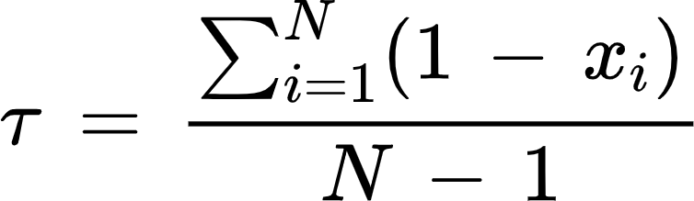

where, for a given gene, x_{i} corresponds to the mean TPM for a given tissue type normalised by the maximum mean TPM across N tissue types. This yielded an estimate of τ for 30,074 A. thaliana genes. Of these, 25,831 could be matched to orthogroups, and of these 15,472 were in the orthogroups tested for repeatability. To condense these per-gene estimates to per-orthogroup estimates, we approached this in two ways. We transformed τ scores into per-gene ep-values based on rank, treating either higher τ estimates (and higher specificity) as lower ep-values or lower τ values (and higher pleiotropy) as lower ep-values. We explored both of these approaches to ensure that choice of the most specific vs. least specific paralog per orthogroup did not affect the interpretation of pleiotropy drawn from this analysis. In each case, we then retained the minimum ep-value per orthogroup and corrected for paralogs with a Dunn-Šidák correction. Finally, we transformed per-orthogroup ep-values to Z-scores (Z_{τ}) with a mean of 0 and sd of 1 across all orthogroups.

This approach therefore reflects our approach based on Tippett’s method for condensing per-gene GEA results to orthogroups. This approach was preferred over taking the mean τ per-Orthogroup as there is no assumption that paralogs should retain specificity/pleiotropy. Indeed, taking the mean τ per orthogroup greatly reduced the occurrence of high τ values in the genome-wide distribution suggesting paralogs within orthogroups vary in their specificity of expression, which may occur due to neofunctionilisation or subfunctionalisation ⁴⁰. Whilst we observed that the number of paralogs decreases as evidence for repeatability increases (Fig S15B), it is important to note that this is not a feature introduced by the data structure and having to correct for the number of paralogs (Fig S15B and Fig 4E, see section on duplications below). It is also worth noting that our approach necessitates extrapolating A. thaliana tissue specificity across diverse species, but similarity of specificity is expected to decline slowly among orthologs given evidence from a comparable time period in tetrapods ⁴¹.

To assess how tissue expression specificity is associated with RAOs, we grouped orthogroups into deciles based on the strongest evidence for repeatability (minimum PicMin p-value) observed for each orthogroup across all 21 climate variables. We then combined Z_{τ}-scores within each decile based on Stouffer’s approach, under a null hypothesis that if there is no association between repeatability and tissue specificity, each decile should draw Z_{τ}-scores randomly from the total distribution and yield Stouffer’s combined Z-scores of approximately 0.

As a complement to tissue specificity, we explored connectivity of genes in co-expression networks. We built two co-expression networks using co-expression data from ATTED-II ⁴² for A. thaliana and M. truncatula. This database summarises gene co-expression data from RNA-seq and microarray sources in a condition-independent manner which is summarised as a standardised Z-score between a given pair of genes. To construct co-expression networks, we treated genes as nodes and Z-scores as edges, where positive Z-scores denote positive co-expression and vice-versa for negative Z-scores. Co-expression gene tables were downloaded for each species: A. thaliana = Ath-u.c3-0; M. truncatula = Mtr-u.c3-0. We discarded all edges with -5 < Z < 2.33 following the recommendations for significant negative/positive co-expression ⁴². The A. thaliana network included 18,570 genes, or 13,424 after retaining only genes in orthogroups tested for repeatability. Similarly, the M. truncatula network included 17,786 genes and 12,558 genes for the same groups. Networks were produced using the igraph package in R. Node betweenness and closeness were calculated using the estimate_betweenness() and closeness() functions respectively. Node degree and strength were calculated as the number of edges and the sum of all edge absolute Z-scores respectively. The same approach was repeated for the co-expression network derived from M. truncatula. Centrality statistics were tested for associations with evidence of repeatability using the same approach as outlined above for tissue specificity.

To assess whether enrichment of pleiotropy was driven by particular climate variables, we repeated the enrichment analyses for tissue expression specificity and A. thaliana node degree using orthogroups exhibiting the strongest signals of repeatability within each climate variables (PicMin p-value < 0.005). Enrichment was determined by combining the per-orthogroup pleiotropy Z-scores using Stouffer’s approach (Fig 4D).

Estimating orthogroup-level duplication and comparing with repeatability
Information on duplications within orthogroups was obtained from the OrthoFinder2 outputs. We retained duplication events that had support >0.7 and occurred at nodes which included species that contributed GEA p-values. This total number of duplications is therefore associated to the number of paralogs within orthogroups, but counting the duplication events as opposed to the number of paralogs avoids counting the same duplication event multiple times. As well as counting the number of duplication events within each orthogroup gene-tree, we also counted specifically the number of duplications that occur within species, i.e. all gene-tree tips downstream of the duplication node include only a single species’ genome. We refer to these as species-specific duplications, and were interested in these due to the potential for sub- and neofunctionalization to occur within species. We also quantified the number of single-copy genes per orthogroup. To examine associations of each of these duplication statistics with repeatability, we again split orthogroups into deciles based on their strongest evidence of adaptive repeatability across the 21 climate variables, and assessed how each per-decile mean duplication metric varied from strongest to weakest evidence of repeatability.

A potential bias between evidence for repeatability and duplication metrics could be introduced due to our method for processing per-orthogroup ep-values requiring a Dunn-Šidák correction based on the number of paralogs (reducing the statistical power more in bigger orthogroups). To test this, we took the observed per-gene ep-values associated with all climate variables and shuffled them 100 times within species and within climate variables before correcting for the number of paralogs as normal. In total this creates 2,100 randomised single-variable p-value sets (21 variables * 100 randomisations). This approach therefore shuffles the biological information contained within the per-gene ep-values but retains the orthogroup and paralog structure within the dataset across species and climate variables. We then ran PicMin on each of the 2,100 sets of randomised data and within each of the 100 randomised sets, calculated the minimum PicMin p-value across the 21 randomised climate variables and used these to group orthogroups into deciles as for our observed data. We could then calculate the mean duplication metrics per decile as for our observed data, and repeated this 100 times to derive 100 randomised means per decile to compare against our observed decile means.

SUPPLEMENTARY RESULTS

Orthogroups tested for repeatability are representative of general genes
A concern when testing for repeatability across species is whether or not the genes within orthogroups that are actually tested for repeatability are representative of all genes. Only genes that were in orthogroups with at least 20 species represented and with no fewer than 10 paralogs were tested for repeatability with PicMin. This decision was made to reduce the total number of tests performed by only testing orthogroups with the most data and so greatest power to detect repeatability across diverse species. The genes in these tested orthogroups (N = 8,470) represented varying proportions of the total genes tested by GEA per-species, ranging from 37.1% in Picea abies to 61.6% in Panicum hallii (Table S2). We first plotted the distributions of per-orthogroup ep-values in tested vs not-tested orthogroups. These plots, summarised for precipitation in the dry month, demonstrate that in general the distribution of tested ep-values for a given climate variable were approximately uniform across most species and did not differ substantially from those that were not tested (Fig S16). If anything, orthogroups tested for repeatability were more likely to include probable adaptive genes than orthogroups that were not tested for repeatability, evidenced as inflated densities of lower per-gene GEA ep-values in tested vs untested distributions.

RAOs are not enriched for phylogenetic signal of GEA results
It is expected that species that are more closely-related may contribute disproportionately to signatures of repeatability, particularly if closely-related species share adaptive variation. Consequently, clusters of closely-related species, for example our Brassicaceae species or Helianthus or Eucalyptus species groups, may be disproportionate contributors to repeatability in our dataset. On the other hand, the PicMin test assumes that each species is independently evolving, so shared standing variation among closely-related species could introduce non-independence into the test. Thus, it is important to assess whether our results include a signal of closely-related species having increased repeatability. A visual inspection of contributions towards repeatability suggests that this is not the case (Fig 2D). However, we also tested each RAO for phylogenetic signal in the distribution of GEA ep-values among species tips. To do this, we took each of the 141 RAOs (some of the 108 unique RAOs were represented across multiple climate variables) and used the phytools::phylosig() ⁴³ function to test each orthogroup for phylogenetic signal of -log10-transformed GEA p-values against random expectations under Brownian evolution. We used the ‘K’ method ⁴⁴ with 1,000 sims (we also used the ‘lambda’ method and obtained the same result). To derive a species-level phylogenetic tree with branch lengths (Fig S6A), we curated our reference genome tree (Fig 1D) and where multiple species were mapped to the same reference genome (for example Helianthus and Eucalyptus) we split tips to include all species and separated species by the minimum branch length in the original reference genome phylogeny. We then asked whether the average ‘K’ value observed in the 141 RAOs differed from 1,000 random draws of 141 orthogroups (excluding the 141 RAOs).

There was limited evidence of significant phylogenetic signal of GEA ep-values within the 141 RAOs. Seven RAOs had phylogenetic clustering signal p-values <0.05, in line with null expectations (5% of tests). The mean ‘K’ value of observed RAOs was 0.081, which was actually lower than the mean ‘K’ (0.086) of 1,000 randomly chosen groups of orthogroups (Fig S6B). These results demonstrate that there was limited evidence of phylogenetic signal driving signatures of repeatability within RAOs, and RAOs did not exhibit elevated phylogenetic signal relative to orthogroups without evidence of adaptive repeatability.

Gene duplication may facilitate adaptive repeatability
Gene duplication has been invoked to explain repeatability variation, notably among conifer species ⁴⁵. Duplications may facilitate repeatable evolution by alleviating functional constraints through sub- or neofunctionalisation ⁴⁰. We asked whether RAOs differed for the total number of duplications within each gene tree, the number of species-specific duplications (where all nodes downstream of the duplication involve a single genome), the number of single-copy genes within each gene tree, and whether species contributing towards repeatability within orthogroups were enriched for duplications (Fig S15A).

Our per-orthogroup pleiotropy metrics were negatively associated with the number of gene duplication events per-orthogroup (expression breadth: ρ = -0.328, p < 2.2⁻¹⁶; node degree: ρ = -0.383, p < 2.2e⁻¹⁶; Fig 4E). Importantly, however, randomising per-gene pleiotropy scores did not produce any association with the number of duplication events per-orthogroup, demonstrating that the orthogroup structure and analysis is not expected to produce spurious associations.

As observed for pleiotropy, grouping orthogroups by their strongest evidence of repeatability highlighted a clear tendency for gene duplication to vary with evidence of adaptive repeatability. Orthogroups with stronger evidence of repeatability were characterised by fewer duplications, fewer species-specific duplications, and a greater number of single-copy genes (Fig S15B). Importantly, these associations with gene duplication were not observed following randomisation within species of per-gene GEA ep-values (black bars in Fig S15B). Species contributing towards repeatability in RAOs (PicMin FDR < 0.5) did not differ in terms of per-species duplications from species with low GEA ep-values (<0.1) from randomly drawn orthogroups (10,000 permutations, p = 0.127). These results therefore suggest that orthogroups with reduced gene duplication may be more likely to be repeatedly associated with adaptation, however it may be difficult to separate out the effects of pleiotropy and duplication, given duplication may promote subfunctionilisation and specialism among duplicated genes ⁴⁶. Indeed, per-orthogroup duplication events were negatively associated with per-orthogroup pleiotropy metrics (Fig 4E).

Interestingly, however, species that were contributing towards repeatability within RAOs were less likely to be single-copy genes within RAOs with respect to random expectations derived from taking species with low GEA ep-values within random sets of orthogroups (Fig S15C). This result therefore contradicts the notion that repeatedly adaptive orthogroups may be associated with reduced duplication, and is in line with previous observations in conifers ⁴⁵. The discrepancy between these results may be explainable due to noisy per-orthogroup estimates as opposed to potentially more relevant per-species estimates of duplication.

Recombination does not drive signals of GEA or repeatability
Recombination rate landscapes, potentially shared to some extent among closely-related species, represent a potential source of bias within our analyses due to the risk that WZA variance may be greatest in regions of low recombination ¹. It is unlikely that this source of bias has a strong effect on our repeatability results, given repeatability is observed to vary among climate variables, all of which are expected to be influenced in the same way by the recombination landscapes within species. Still, we wanted to quantify its effect here for a subset of datasets for which recombination rates were available. Recombination rates were acquired for the following genomes: Arabis alpina ⁴⁷, Arabidopsis lyrata ⁴⁸, Arabidopsis thaliana ⁴⁹ and Helianthus annuus ⁵⁰. These corresponded to nine individual datasets. To examine associations between recombination rate and GEA results (WZA scores corrected for SNP count), we plotted GEA ep-values against ep-values estimated for individual genes according to the weighted mean recombination rate over a given gene. We plotted four random climate variables as a demonstration (Fig S17).

Across the Brassicaceae, there is no observable association between recombination rate and GEA. Each distribution plotted is a uniform distribution of empirical p-values, thus the expected plot when association is minimal reflects regions of density across the whole plotting space. The association is complicated for the Helianthus species, however, exhibiting contrasting associations. H. annuus, and to a lesser extent H. argophyllus, exhibit an association between GEA variance and low recombination, which can be seen particularly clearly for max temp warmest month and H. annuus as all high and low GEA ep-values are observed in regions of low recombination (low recombination ep-value). Conversely, H. petiolaris exhibits a linear association whereby GEA p-values are generally lower in regions of low recombination. This discrepancy between the Brassicaceae and Helianthus may reflect the known adaptive significance of regions of low recombination in these data from Helianthus spp. ⁵¹, therefore these associations may be genuine and biological. In support of this, the association between GEA results and recombination appear stronger in accordance with the proportion of each species genome where large non-recombining regions are observed in the original study (H. argophyllus has the lowest proportion of the genome covered, H. petiolaris has the most). Importantly, given that the effect of recombination is not observed across all datasets, it is unlikely to bias our estimates of repeatability. In addition, even though Helianthus spp do exhibit an association, they do not show any evidence of contributing excessively to our estimates of repeatability in Figs 2C-D.

We also looked into whether genes within the same orthogroup were repeatedly associated with low recombination across species, and whether these overlapped significantly with our RAOs identified across GEA. To do this, we looked at the recombination rates from each of the four species and condensed the ep-values to per-orthogroup p-values using the same Tippett’s approach as was used for the GEA data. We then tested the same 8,470 orthogroups that were tested for climate data using PicMin, in order to identify orthogroups with repeatedly low recombination across the four species. We also removed orthogroups that did not have recombination estimates in all four species, leaving 7,446 to test with PicMin. This analysis identified 9 orthogroups with evidence of repeatedly low recombination across species at an FDR < 0.5. Of these 9, 1 was also identified as an RAO associated with climate at FDR < 0.5 (N = 108). An intersection of 1 does represent an almost ten-fold enrichment above the random expectation of 0.11, however it also only represents >1% of the identified RAOs associated with climate adaptation. From this, we can conclude that some repeatability identified through our GEA analyses may be driven by common regions of low recombination, however the extent of this effect is likely minimal.

Niche-Breadth and GEA power do not predict contributions to repeatability
The variability with which species contribute towards signatures of repeatability across climate variables (Fig 2C) begs the question of whether there are features of individual GEA (individual here referring to any given pair of species-climate) that explain this variation. Variability of contribution could be explained by the power attached to each individual GEA, with the assumption being that species contribute more towards repeatability for GEA with greater power as a result of lower Type-II error. To examine this, we looked at two features of GEA that are likely to affect power: 1) the proportion of genetic variance that can be explained by climatic variation (hereafter GSEA - Genetic Structure Environment Association); 2) the niche-breadth (NB) of climatic variation, which may reflect strength of selection across the sampled range.

We calculated GSEA using partial redundancy analysis (pRDA). We constructed models to explain the variance in a response matrix of per-site allele frequencies, randomly sampled to 10,000 SNPs (with at least 90% of non-missing data per SNP), by predictor matrices of climate variation and spatial variation (latitude and longitude). We opted for latitude and longitude representations of space because these capture the assumptions of isolation-by-distance and spatial autocorrelations with the environment. Alternative approaches, such as Moran’s spatial eigenvectors, accurately capture spatial information in terms of clustering of populations, but it is difficult to interpret these alongside how environmental variation may similarly covary with space. We produced a separate model for each bioclim variable individually, as opposed to modelling all together, in order to link genetic variance explained by individual climate variables back to individual variable GEAs. We considered the total proportion of genetic variance explained by climate as the combined partitions of genetic variation that could be explained exclusively by climate and that could be explained by either climate or space. If a greater proportion of neutral population structure is aligned with axes of environmental variation, GEA may exhibit reduced power as a result of truly adaptive genes co-segregating with an appreciable proportion of genome-wide neutral genetic variation²⁵. We predicted that within species, the strongest contributions towards repeatability signatures would be observed when GSEA was lowest. Across species, however, we did not observe any consistent relationship between GSEA and contribution towards signatures of repeatability (Fig S3).

We calculated niche breadth in two ways to account for variability in means and distribution shapes across variables and species. Firstly, for each dataset and each climate variable, we calculated the species range (max - min) of climatic variation, and then standardised this based on the global range within climate variables. This estimate of niche breadth therefore captures the proportion of global variation present within an individual dataset, with the prediction being that the datasets contributing most to repeatability for a given climate variable will be those where this proportion is greatest. Secondly, we estimated niche-breadth by standardising species’ range values by the mean climate value within each range. This estimate of niche breadth therefore contextualises previous estimates as a proportion of their mean. We opted to explore both of these estimates of niche breadth due to subtle differences in interpretation that come with standardising by either the global range or local mean. Take for example two ranges of precipitation variation between 100-200 mm and 3000-3100 mm. Each of these ranges is equivalent if standardised by the global range, however we expect that a 100mm difference in rainfall may be more significant if it represents a doubling in annual precipitation relative to a small increase. Standardising by the local mean therefore captures differences in relative niche breadth. In each case, we observe no evidence that niche breadth variation is associated with contributions towards signatures of repeatability (Figs S4-S5).

SUPPLEMENTARY FIGURES

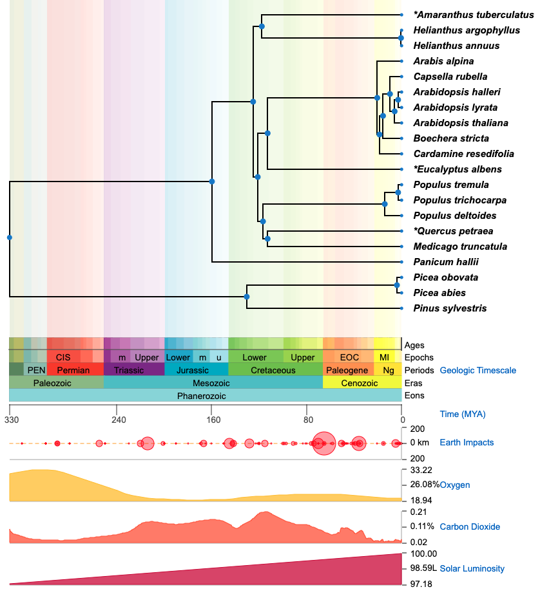
Figure S1: TimeTree ² phylogeny for the species studied here. The phylogeny at the top provides estimates of node ages that are assessed across multiple studies that have dated the splits among clades. Asterisks denote cases where a substitute species was selected by TimeTree to be used as data on the target species was unavailable. The substituted species are not the same as those analysed in our study. Substituted species are: Amaranthus hybridus (A. tuberculatus); Eucalyptus erythrocorys (E. albens); Quercus rubra (Quercus petraea). A number of species are missing that were analysed, but congeneric representatives are shown (missing species: Helianthus petiolaris, E. magnificata, E. sideroxylon, Pinus contorta, Picea glauca x engelmannii).

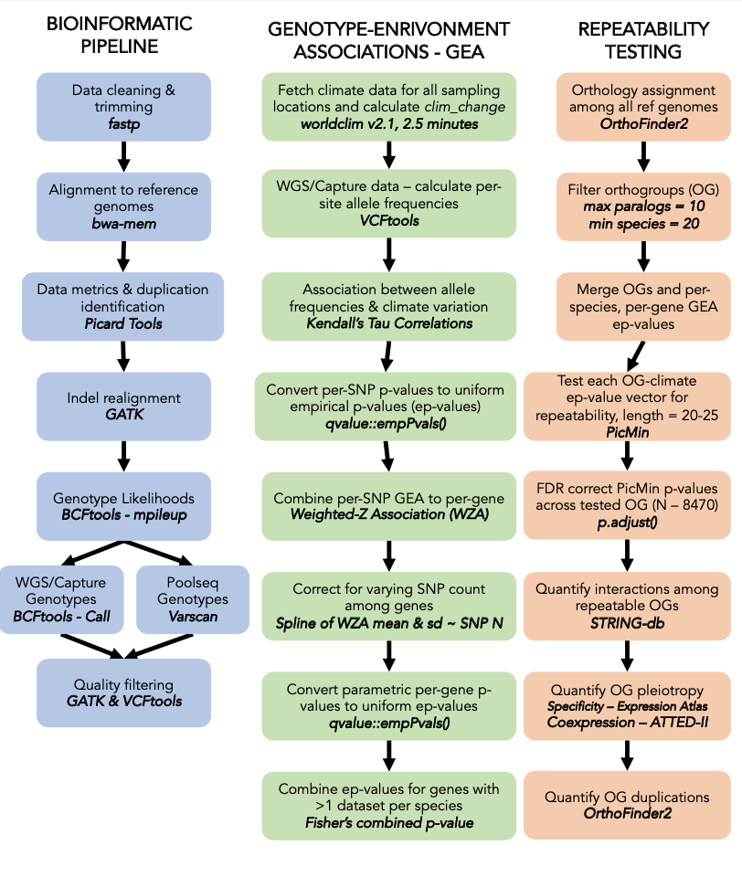
Figure S2: Summary of workflows for SNP-calling, GEA and testing for repeatability signatures.
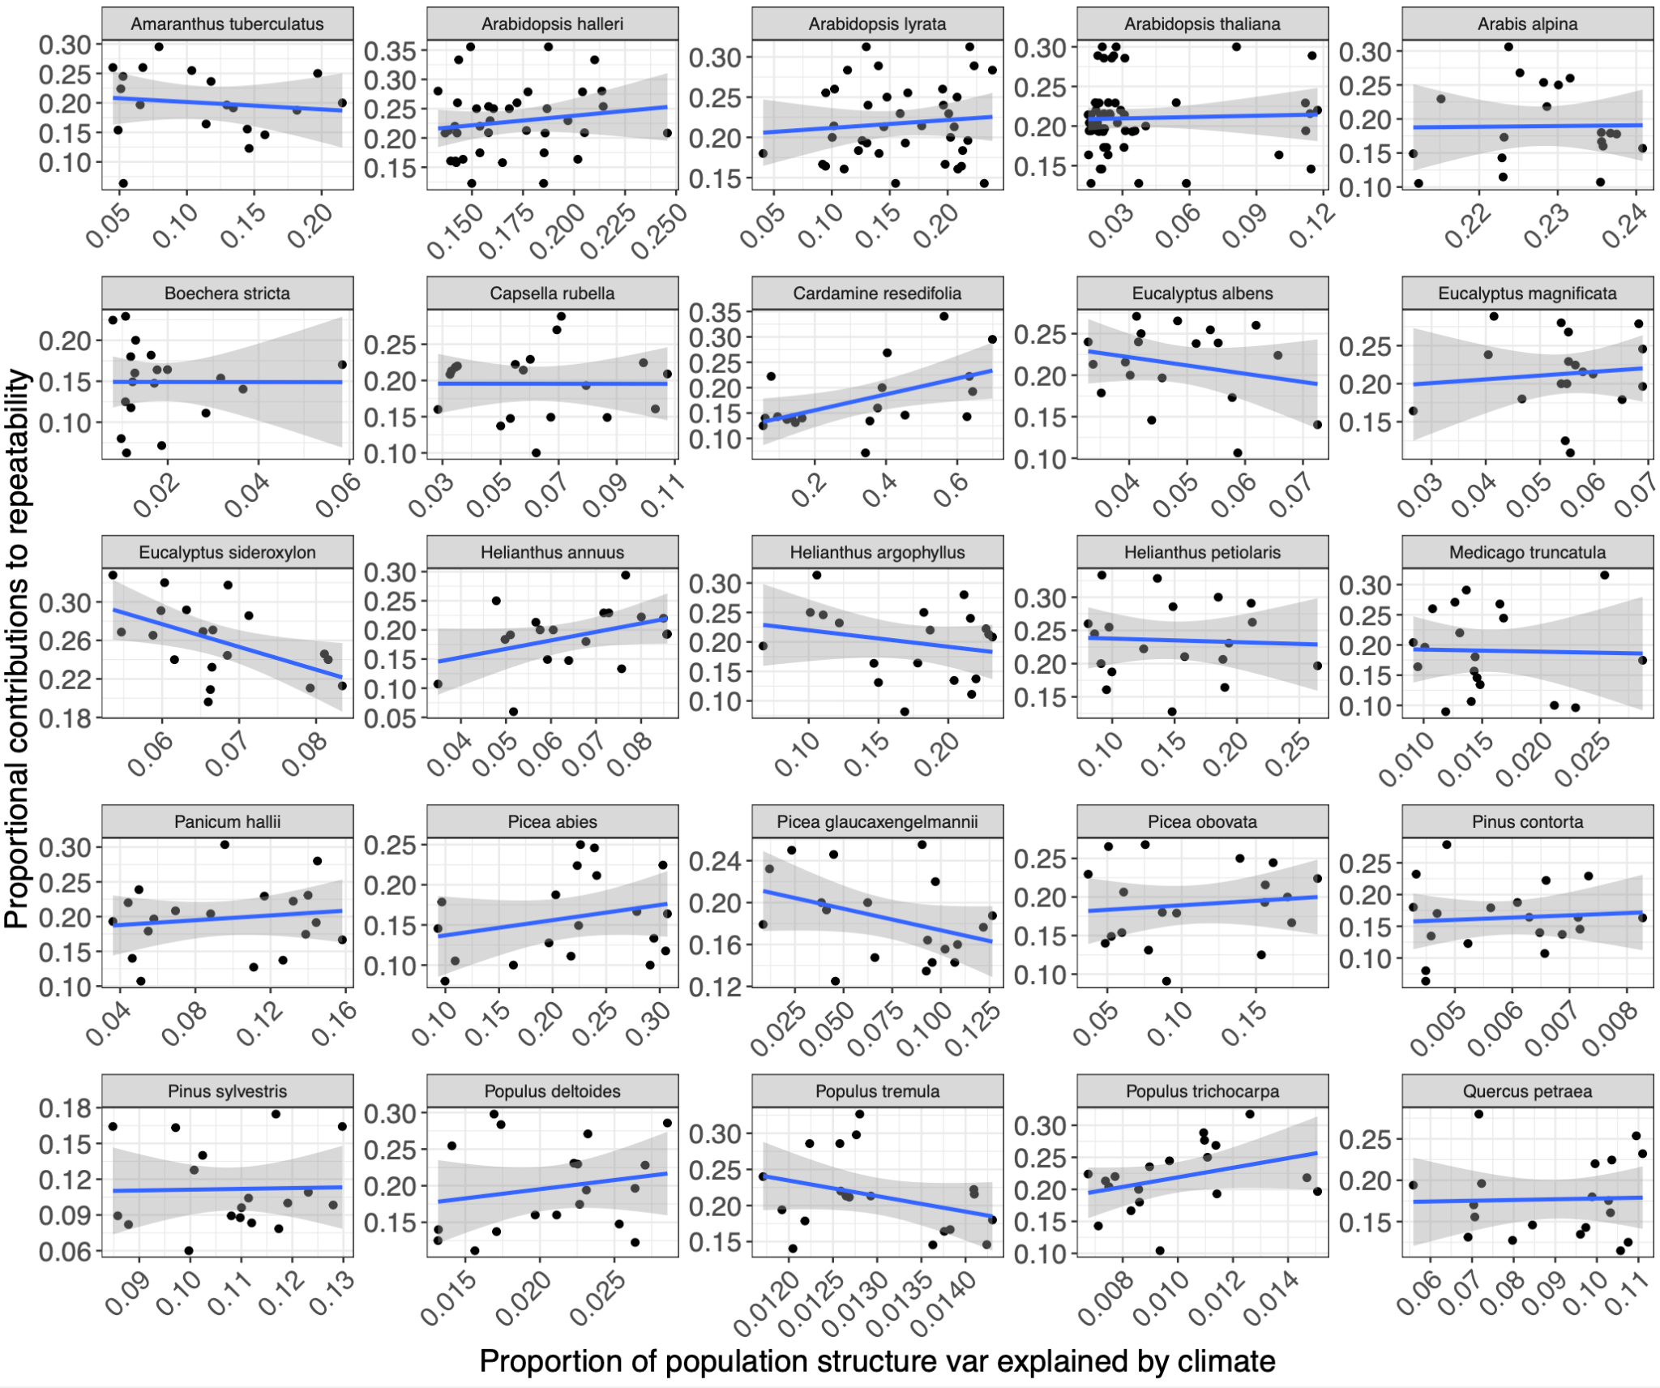

Figure S3: Associations between GEA power, estimated as in the inverse of how much neutral genetic variation is explained by climatic variation, and the extent to which an individual species contributes low p-values to RAOs. The y-axis represents the proportion of RAOs that include a low p-value (<0.1) from a given species. The x-axis is the proportion of neutral genetic variation that is explained by climatic variation, as estimated by pRDA. Each point therefore represents a single GEA combination of species and climate variable. Linear regression lines and standard error are included to provide a general approximation of the relationship.
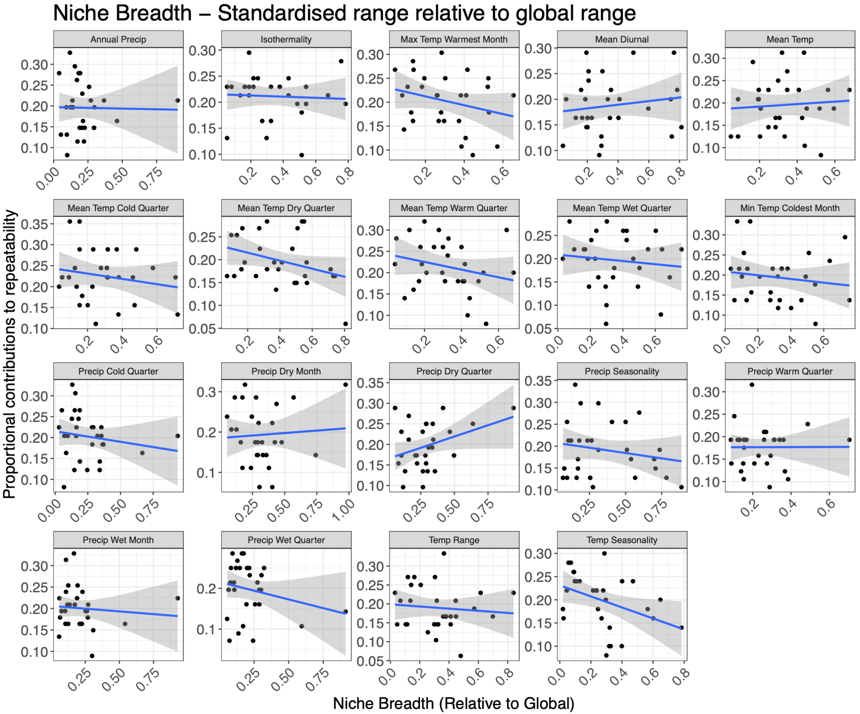

Figure S4: Associations between Niche Breadth, standardised by the global climatic range across all species, and the extent to which an individual species contributes low p-values to RAOs. The y-axis represents the proportion of RAOs that include a contributing p-value from a given species. Each point therefore represents a single GEA combination of species and climate variable. Linear regression lines and standard error are included to provide a general approximation of the relationship.
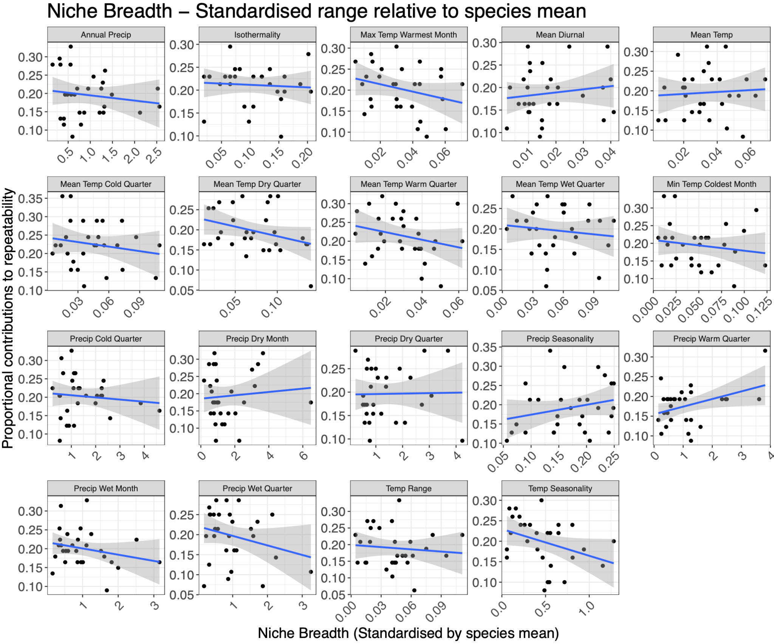

Figure S5: Associations between Niche Breadth, standardised by the local species mean climate, and the extent to which an individual species contributes low p-values to RAOs. The y-axis represents the proportion of RAOs that include a contributing p-value from a given species. Each point therefore represents a single GEA combination of species and climate variable. Linear regression lines and standard error are included to provide a general approximation of the relationship.
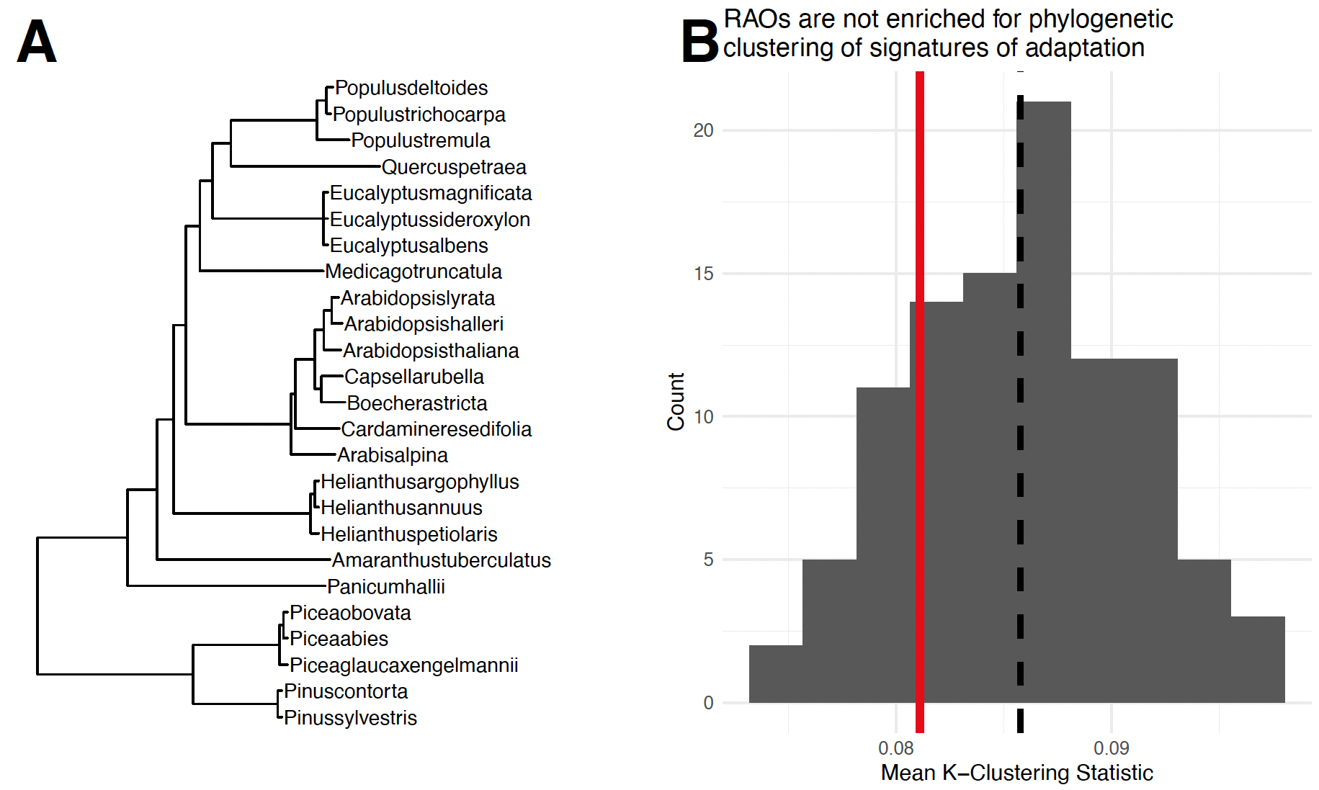
Figure S6: Lack of evidence for phylogenetic signal in RAOs. The species tree that was used for phylogenetic tests is shown in panel A. Panel B shows the distribution of mean ‘K’ values across 1,000 random draws, each of 141 orthogroups. The mean ‘K’ observed in true RAOs is shown as a red line, and the mean of the random distribution is shown as a dashed black line.
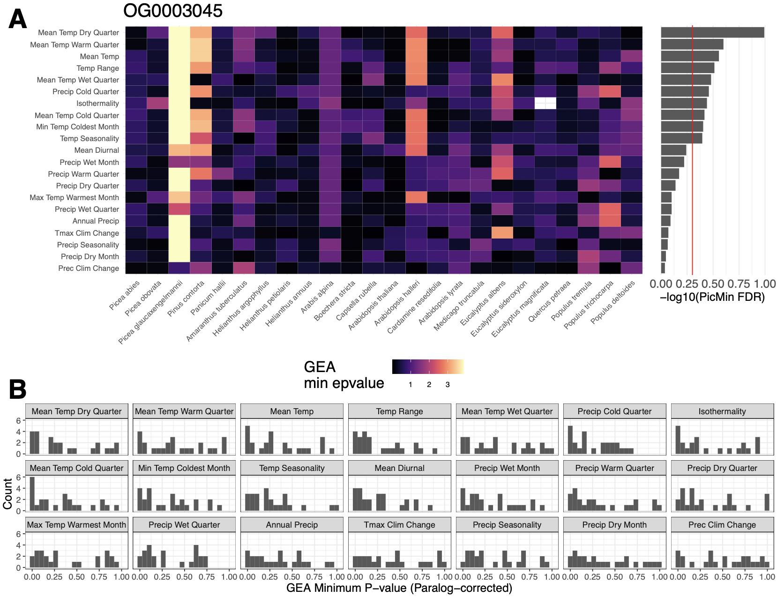

Figure S7: Summary of PicMin results for the orthogroup with the strongest evidence of repeatability across the most climate variables: OG0003045 (Arabidopsis thaliana genes PRR3 and PRR7). Heatmap in (A) shows the per-species -log₁₀-transformed GEA p-value for each species and climate variable. Note that isothermality is absent for Eucalyptus magnificata as there was no climate variation here. Alongside the heatmap, the -log₁₀-transformed PicMin FDR values are shown, and rows are ordered according to the most significant to least significant. Individual GEA p-value vectors are plotted as histograms in (B), with the most significant in terms of PicMin FDR shown in top-left through to least significant in bottom-right.
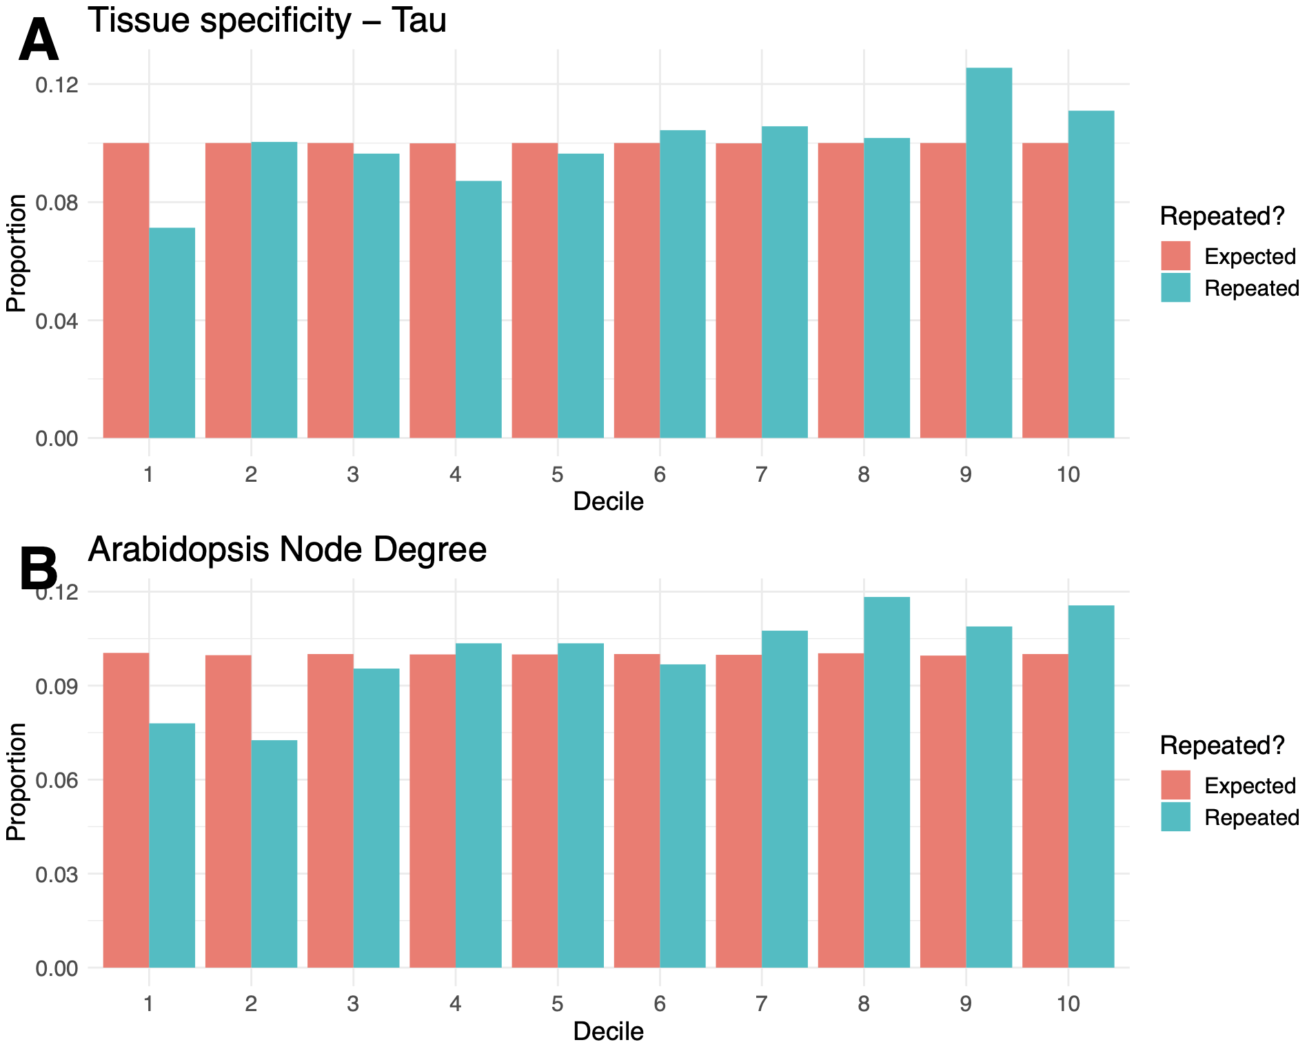

Figure S8: Decile enrichment of pleiotropy measures in orthogroups exhibiting strongest evidence of repeatability (PicMin p-value < 0.005). Each pair of bars shows the proportion of Arabidopsis thaliana genes belonging to the relevant decile based on either specificity of tissue expression (A) or co-expression node degree (B), relative to the random expectation (red bars).
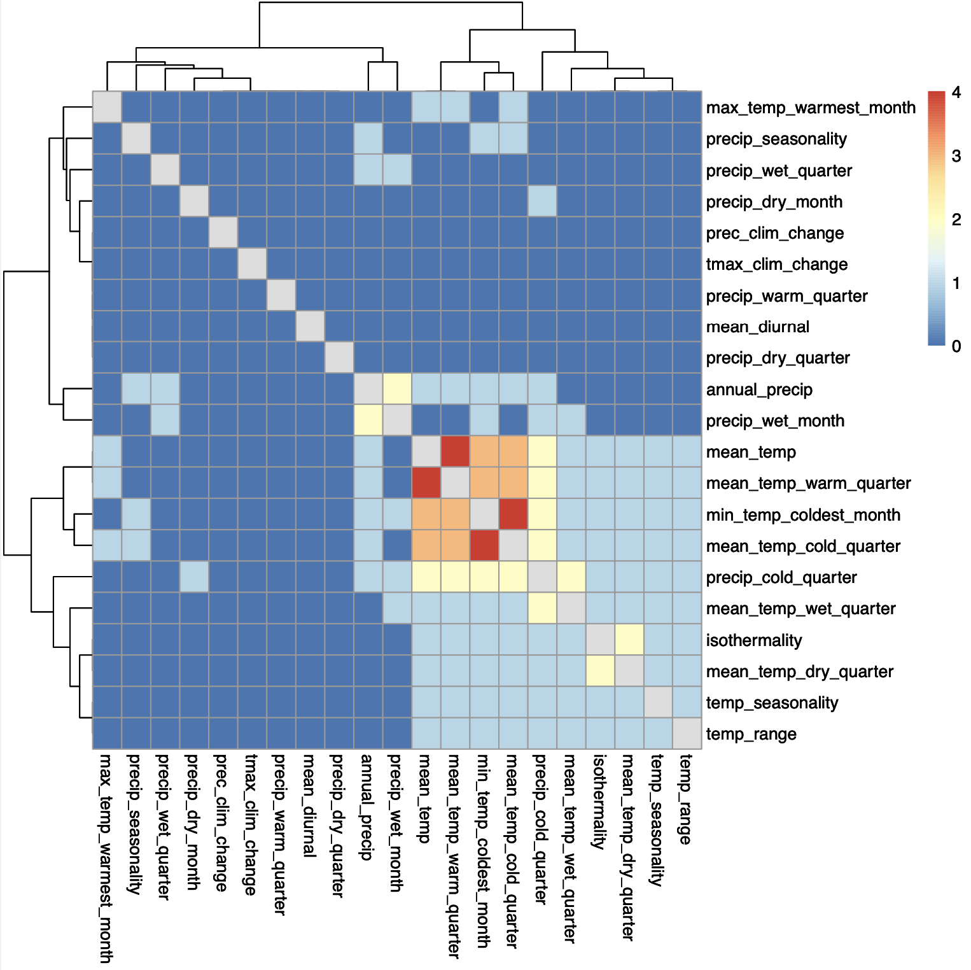

Figure S9: Overlap of RAOs (FDR < 0.5) among different climate variables. Each cell shows the number of orthogroups that were commonly identified through GEA associated with different climate variables. Axes are clustered with dendrograms denoting groups of climate variables with the most similar sets of orthogroups identified.
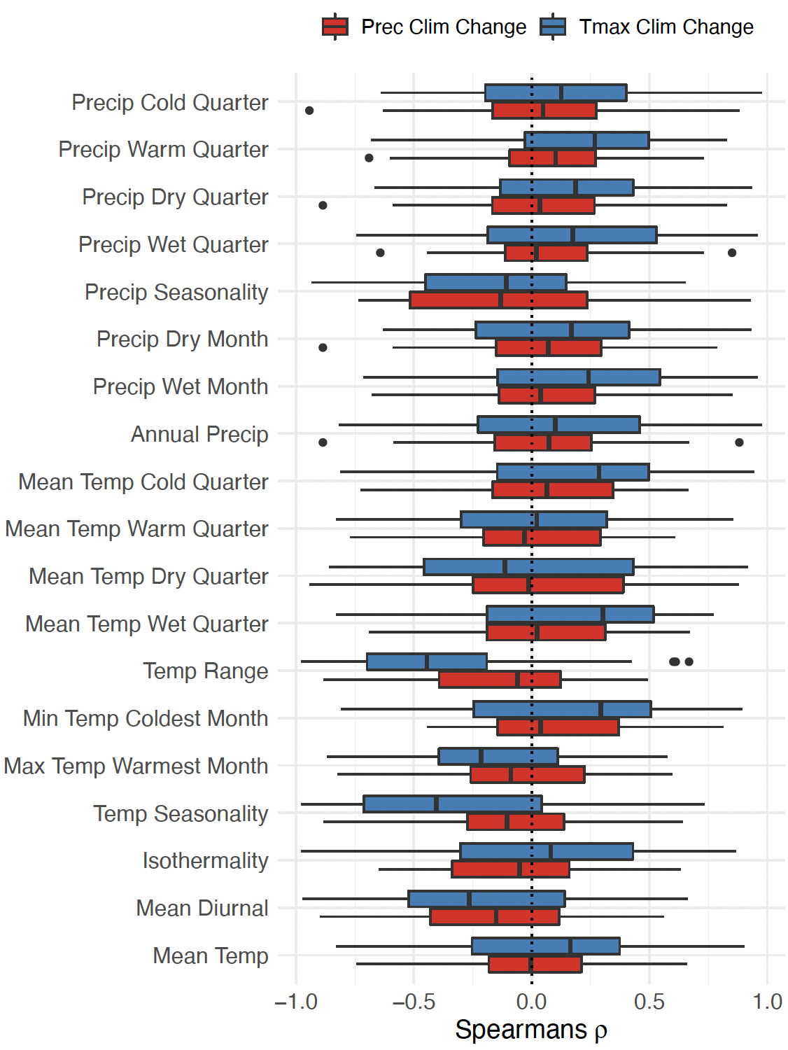
Figure S10: Correlations between climate change variables and other bioclim variables. Each boxplot shows the non-parametric correlation coefficients calculated across all datasets between either precipitation climate change or maximum temperature climate change. Deviations from the central x = 0 are indicative of persistent association between a climate change variable and a given bioclim variable.
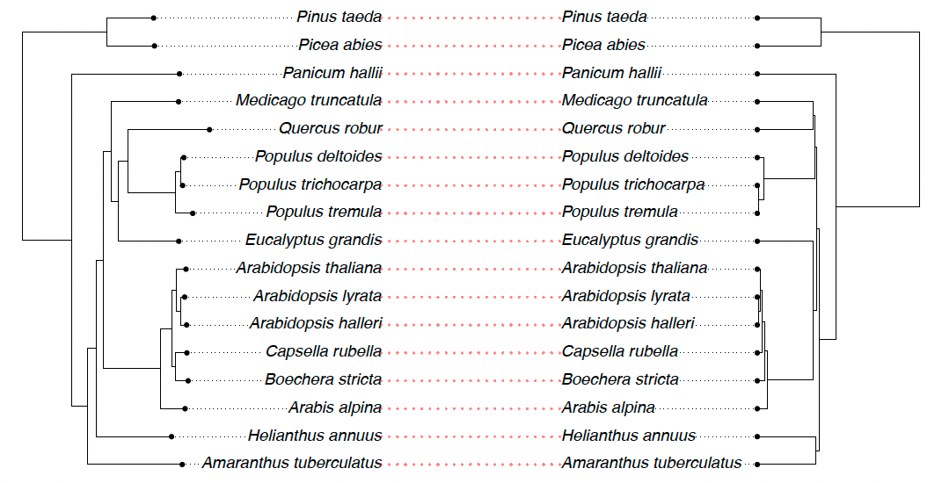

Figure S11: Agreement between the species-tree derived here from 5,003 orthogroups from the 17 reference genome including in this study (left), and the species tree described by TimeTree (right), which is shown in Fig S1.

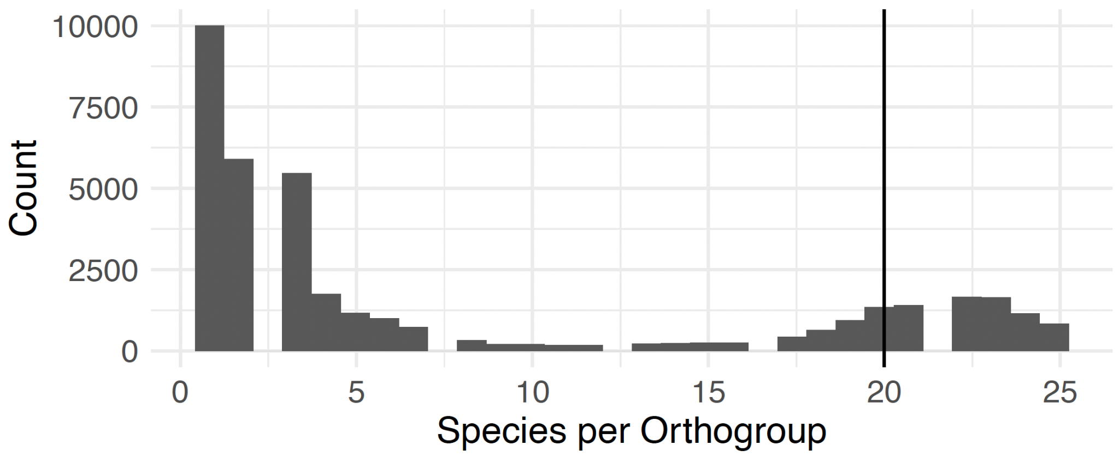
Figure S12: Orthogroup occupancy across species. Histogram shows the distribution of the number of species represented per orthogroup. The black line denotes the cut-off of 20 used for repeatability analyses.

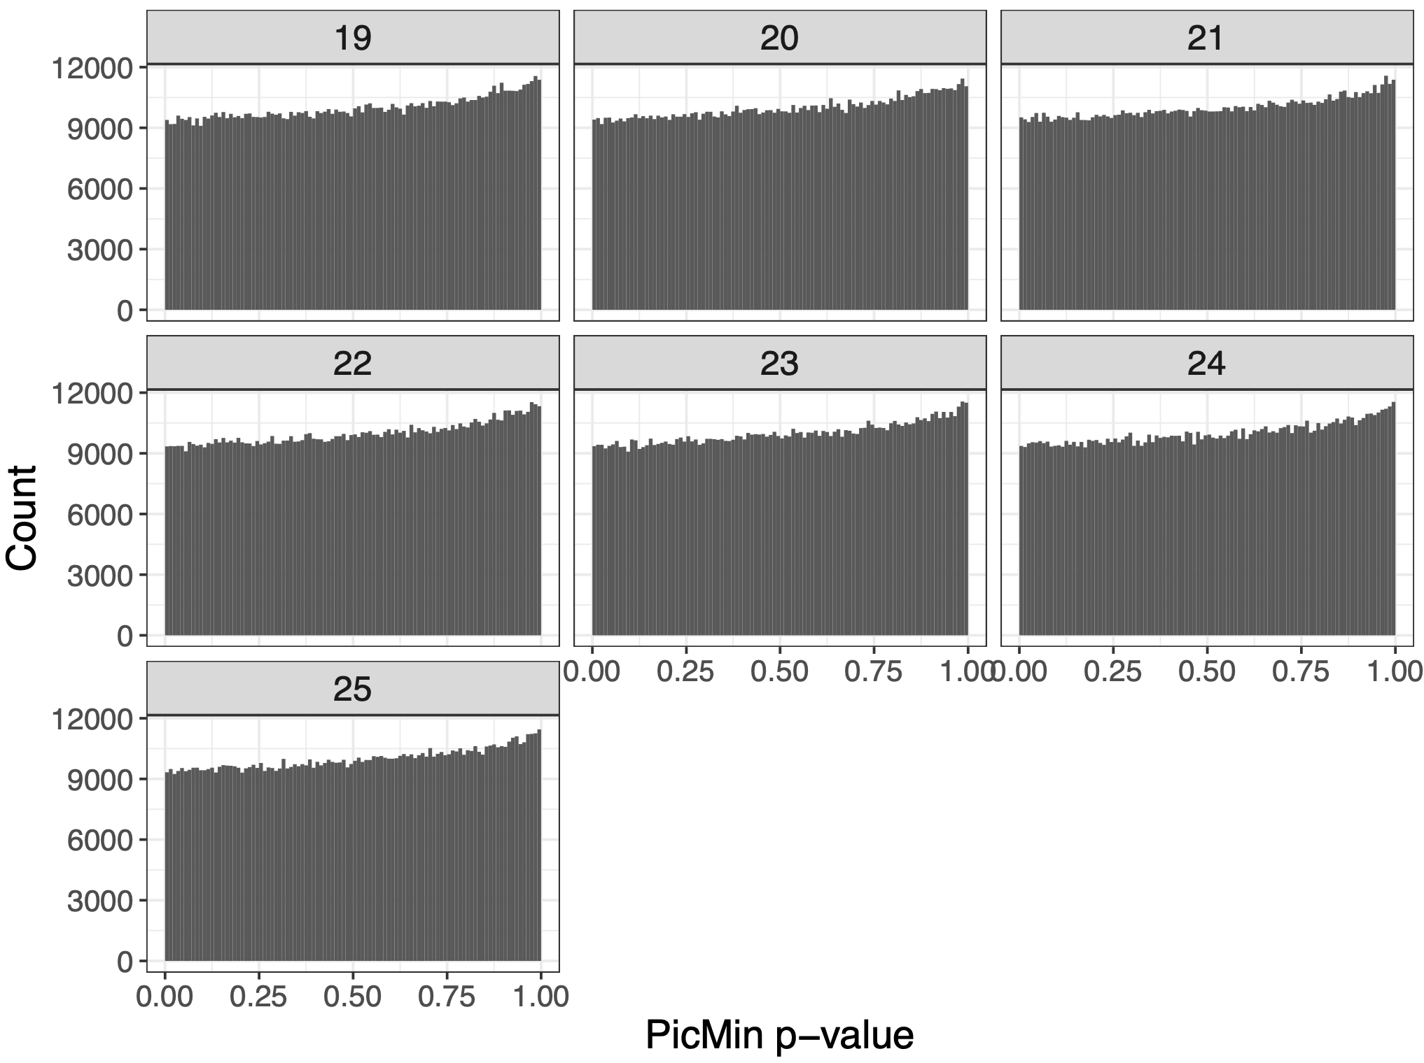

Figure S13: The distribution of p-values derived from PicMin under the null model that no species exhibits adaptation within a given orthogroup. Each panel shows the null distribution under a different number of tested species (19-25). These distributions were produced over 1,000,000 orthogroups per number of species derived from random uniform ep-values, and were used as an empirical null distribution to adjust final PicMin p-values.
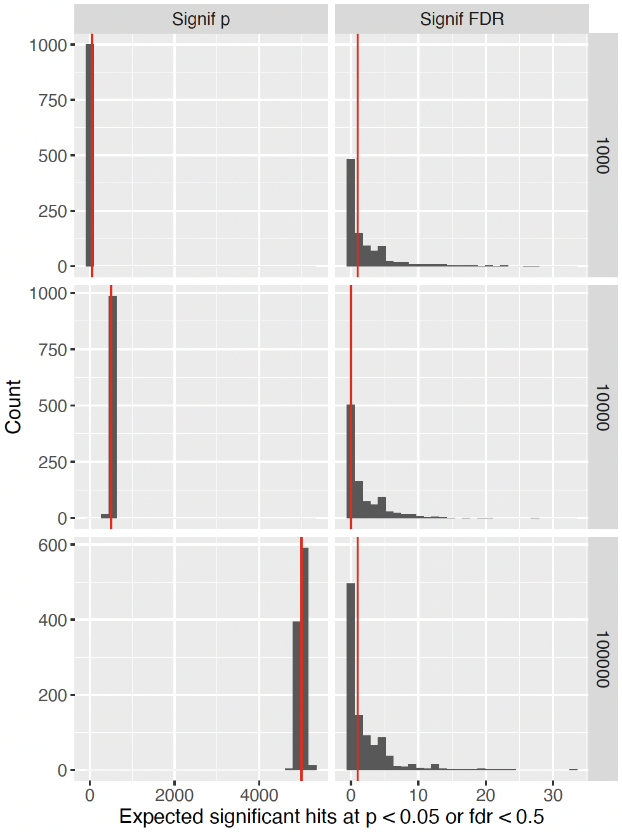

Figure S14: Demonstration of the different expectations for p-values and FDR-corrected q-values when selecting a cut-off. Each histogram represents 1,000 random uniform draws of p-values where all null hypotheses are true, for either 1,000, 10,000, or 100,000 tests. The ‘Signif p’ column shows the distribution of the number of tests with a p-value < 0.05, with the median shown as a red line. The expected number of tests with a p-value < 0.05 increases with the number of tests performed (approximately 5% of tests). The ‘Signif FDR’ column shows the same data FDR-corrected, with the number of tests with an FDR-corrected q-value < 0.5 (the threshold used here), with the median (either 0 or 1) shown as a red line. This simulated data demonstrates that, regardless of the number of tests being performed, there is no expectation for many tests to fall below the FDR < 0.5 threshold as there is for uncorrected p-values.

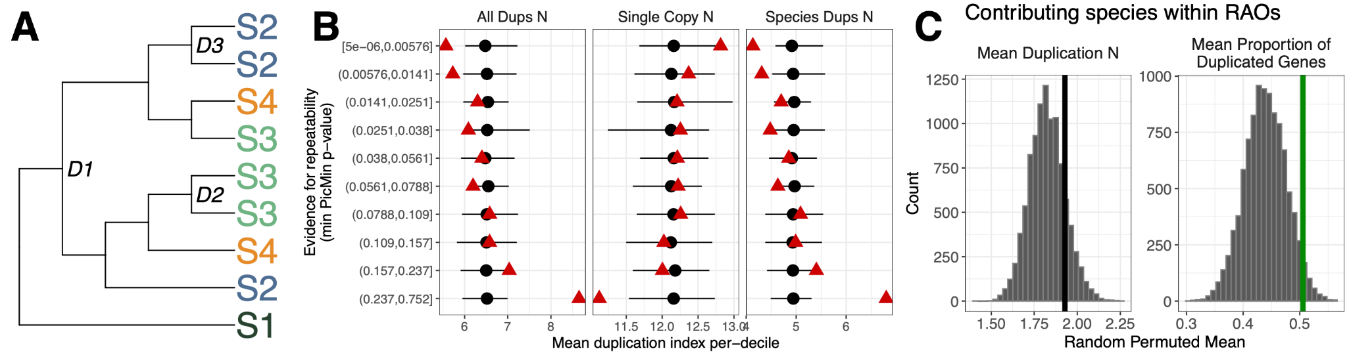

Figure S15: Associations between repeatability and gene duplication within orthogroups. Panel A shows a simplified gene tree with 4 species (S1-S4), 3 duplications (D1-3), and 2 species-specific duplications (D2-3). Panel B shows depletion of duplications in orthogroups grouped according to their strongest evidence of repeatability. The mean duplication value is plotted for each repeatability decile. The black points and lines show a comparable analysis over 100 randomisations of all per-gene ep-values_{WZA} . The black point shows the mean duplication metric per-decile and the lines show the maximum and minimum values across the 100 randomisations. Panel C shows duplication results exclusively looking at contributing species within RAOs, compared with species with low ep-values_{WZA} (<0.1) within 10,000 draws of random orthogroup-climate sets. Lines show the observed mean relative to the distribution of random means, where green lines show permuted p-value < 0.05.

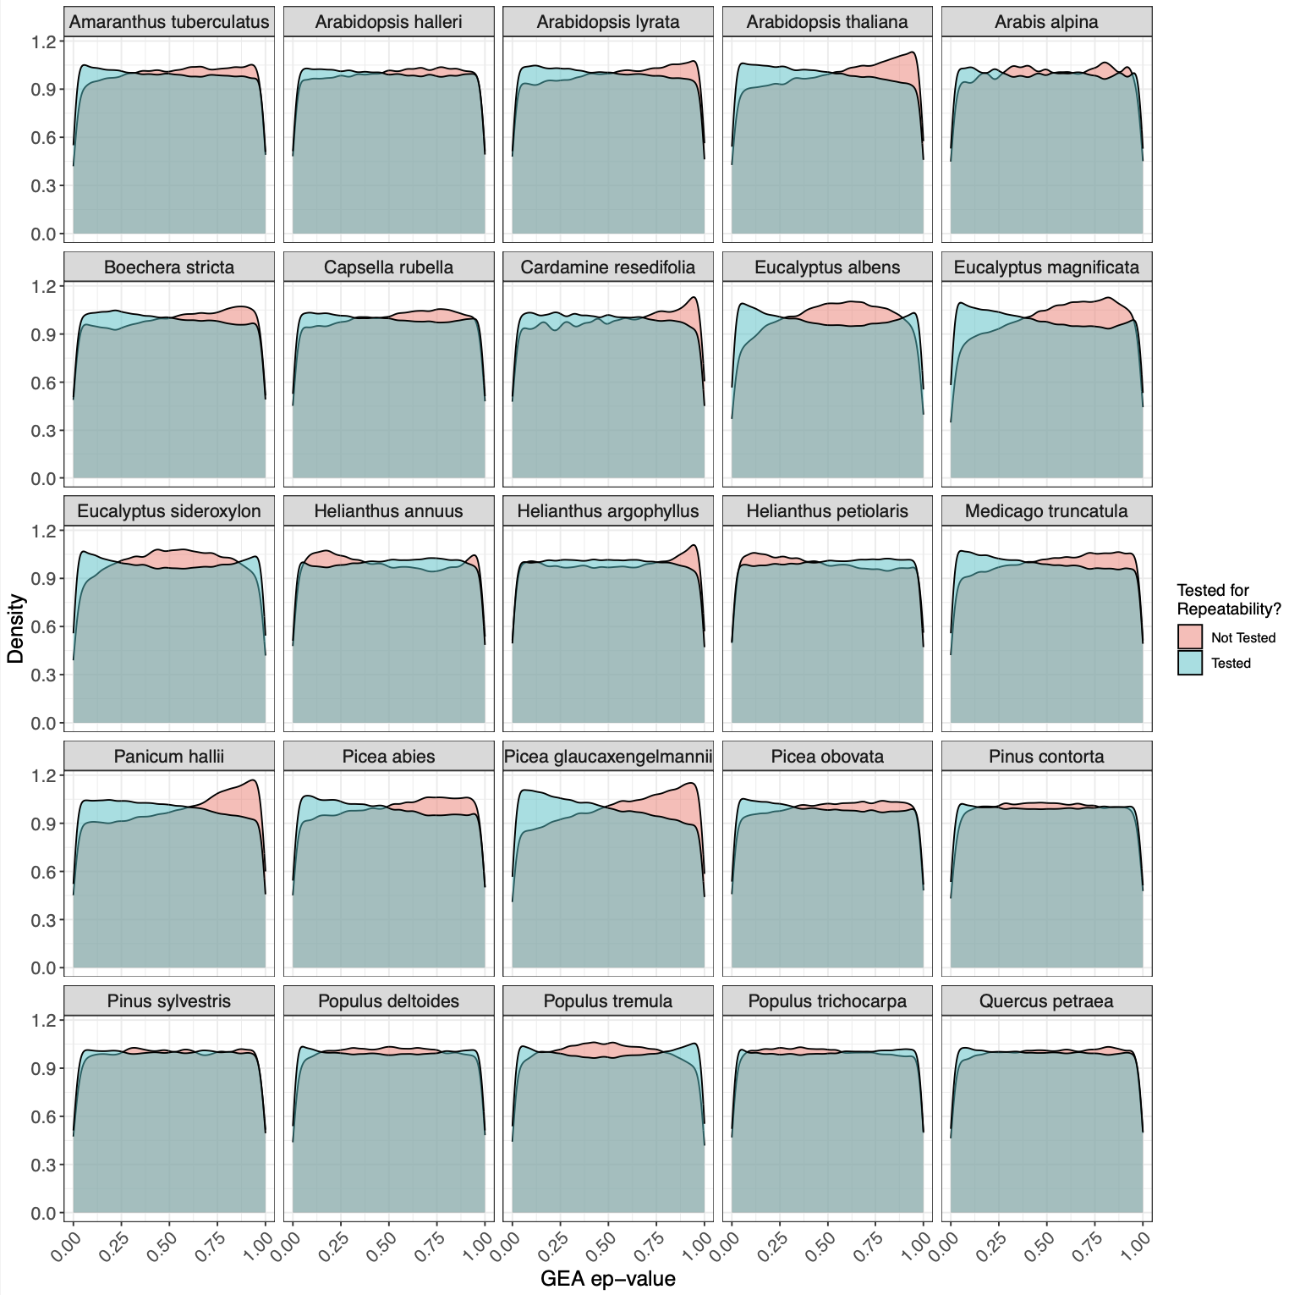

Figure S16: Density distributions of tested vs not-tested orthogroup GEA ep-values. Each facet shows a different species, and fill denotes whether orthogroups were tested for repeatability or not.

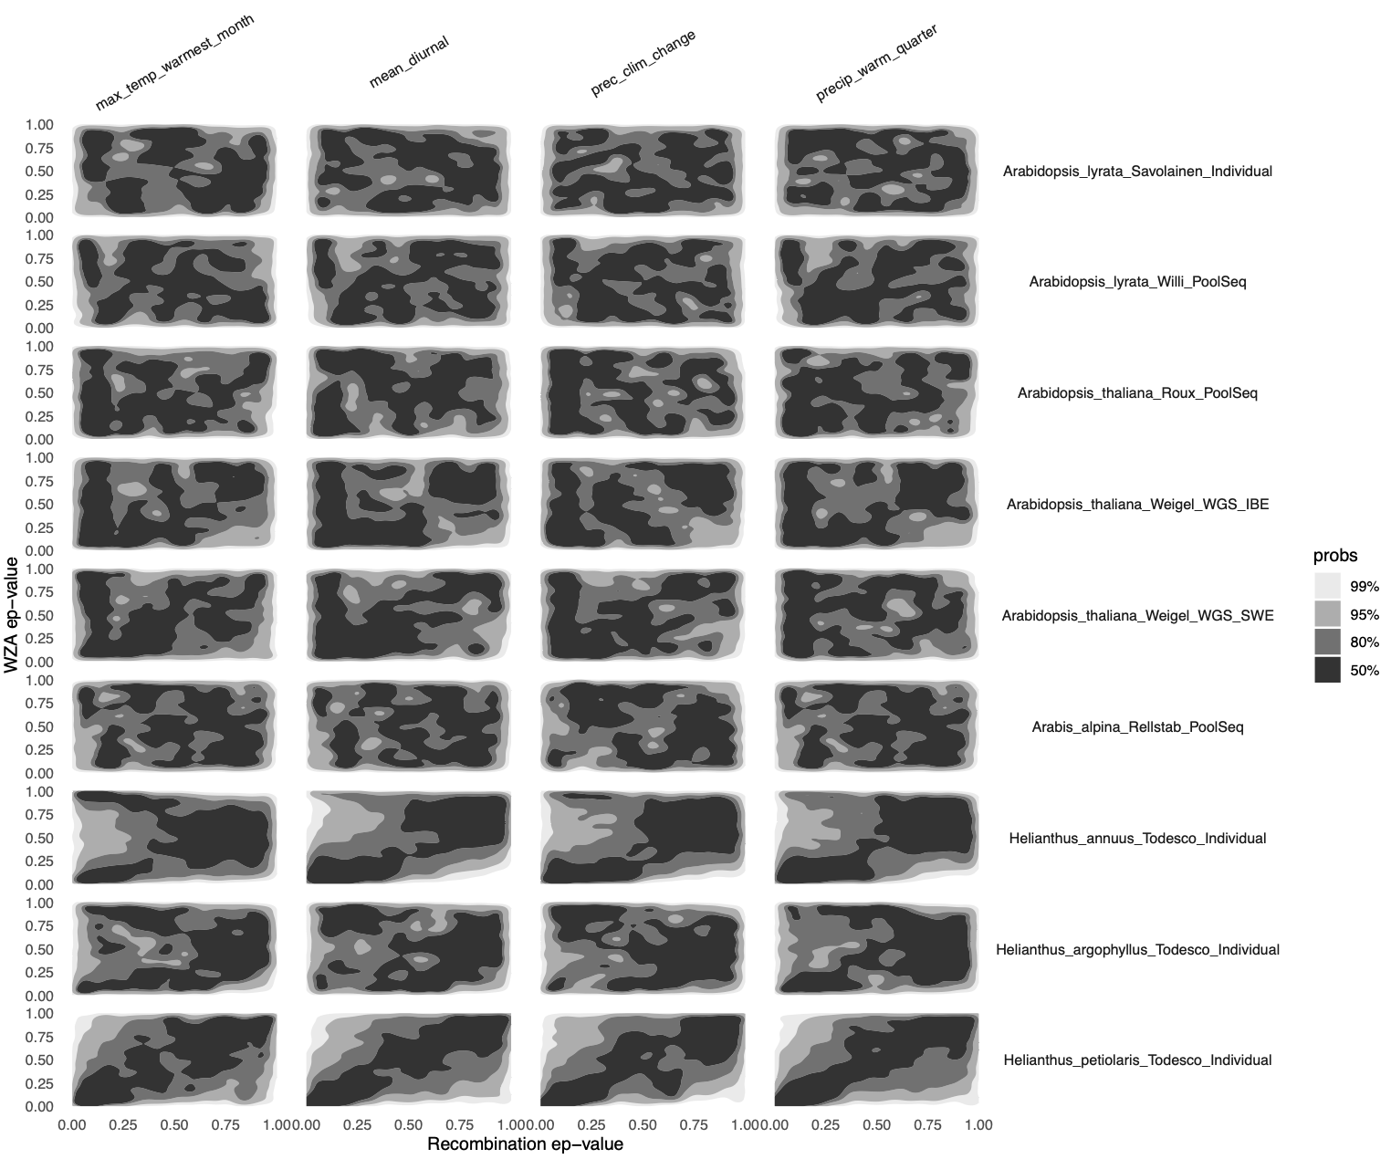

Figure S17: Associations between GEA results and recombination rate. Each facet shows the density of per-gene estimates of association with environment (WZA ep-value corrected for SNP count) and recombination rate (weighted mean, lower ep-value reflects lower recombination). Each axis represents a uniform distribution of empirical p-values, such that if no association exists, regions of high density are observed across the plotting area. Darker regions represent a greater density of genes.

REFERENCES

1. Booker, T. R., Yeaman, S. & Whitlock, M. C. Using genome scans to identify genes used repeatedly for adaptation. Evolution (2022) doi:10.1093/evolut/qpac063.
2. Kumar, S., Stecher, G., Suleski, M. & Hedges, S. B. TimeTree: A Resource for Timelines, Timetrees, and Divergence Times. Mol. Biol. Evol. 34, 1812–1819 (2017).
3. Jasper, R. J. et al. Evaluating the accuracy of variant calling methods using the frequency of parent-offspring genotype mismatch. Mol. Ecol. Resour. 22, 2524–2533 (2022).
4. DePristo, M. A. et al. A framework for variation discovery and genotyping using next-generation DNA sequencing data. Nat. Genet. 43, 491–498 (2011).
5. Danecek, P. et al. Twelve years of SAMtools and BCFtools. Gigascience 10, (2021).
6. Garrison, E. & Marth, G. Haplotype-based variant detection from short-read sequencing. arXiv [q-bio.GN] (2012).
7. Koboldt, D. C. et al. VarScan: variant detection in massively parallel sequencing of individual and pooled samples. Bioinformatics 25, 2283–2285 (2009).
8. Chen, S., Zhou, Y., Chen, Y. & Gu, J. fastp: an ultra-fast all-in-one FASTQ preprocessor. Bioinformatics 34, i884–i890 (2018).
9. Li, H. Aligning sequence reads, clone sequences and assembly contigs with BWA-MEM. arXiv [q-bio.GN] (2013).
10. Broad Institute. Picard Toolkit. Broad Institute, GitHub repository (2019).
11. Danecek, P. et al. The variant call format and VCFtools. Bioinformatics 27, 2156–2158 (2011).
12. Quinlan, A. R. & Hall, I. M. BEDTools: a flexible suite of utilities for comparing genomic features. Bioinformatics 26, 841–842 (2010).
13. Van der Auwera, G. A. & O’Connor, B. D. Genomics in the Cloud: Using Docker, GATK, and WDL in Terra. (‘O’Reilly Media, Inc.’, 2020).
14. R Core Team. R: A Language and Environment for Statistical Computing. Preprint at https://www.R-project.org/ (2022).
15. Fick, S. E. & Hijmans, R. J. WorldClim 2: new 1‐km spatial resolution climate surfaces for global land areas. Int. J. Climatol. 37, 4302–4315 (2017).
16. Kassambara, A. rstatix: Pipe-Friendly Framework for Basic Statistical Tests. Preprint at https://CRAN.R-project.org/package=rstatix (2023).
17. Gautier, M. Genome-Wide Scan for Adaptive Divergence and Association with Population-Specific Covariates. Genetics 201, 1555–1579 (2015).
18. Luu, K., Bazin, E. & Blum, M. G. B. pcadapt: an R package to perform genome scans for selection based on principal component analysis. Mol. Ecol. Resour. 17, 67–77 (2017).
19. Caye, K., Jumentier, B., Lepeule, J. & François, O. LFMM 2: Fast and Accurate Inference of Gene-Environment Associations in Genome-Wide Studies. Mol. Biol. Evol. 36, 852–860 (2019).
20. Capblancq, T. & Forester, B. R. Redundancy Analysis (RDA): a Swiss Army knife for landscape genomics. Methods Ecol. Evol. (2021) doi:10.1111/2041-210x.13722.
21. Lotterhos, K. E. The Effect of Neutral Recombination Variation on Genome Scans for Selection. G3 9, 1851–1867 (2019).
22. Lasky, J. R., Josephs, E. B. & Morris, G. P. Genotype-environment associations to reveal the molecular basis of environmental adaptation. Plant Cell (2022) doi:10.1093/plcell/koac267.
23. DeRaad, D. A. et al. Genome-environment association methods comparison supports omnigenic adaptation to ecological niche in malaria vector mosquitoes. Mol. Ecol. (2021) doi:10.1111/mec.16094.
24. Lasky, J. R. et al. Genome-environment associations in sorghum landraces predict adaptive traits. Sci Adv 1, e1400218 (2015).
25. Booker, T. R., Yeaman, S., Whiting, J. R. & Whitlock, M. C. The WZA: A window-based method for characterizing genotype-environment association. Mol. Ecol. Resour. (2023) doi:10.1111/1755-0998.13768.
26. Lotterhos, K. E. The paradox of adaptive trait clines with nonclinal patterns in the underlying genes. Proc. Natl. Acad. Sci. U. S. A. 120, e2220313120 (2023).
27. Schlichta, F., Peischl, S. & Excoffier, L. The Impact of Genetic Surfing on Neutral Genomic Diversity. Mol. Biol. Evol. 39, (2022).
28. Karunarathne, P., Zhou, Q., Lascoux, M. & Milesi, P. Hybridization mediated range expansion and climate change resilience in two conifers. bioRxiv 2023.01.31.526517 (2023) doi:10.1101/2023.01.31.526517.
29. Emms, D. M. & Kelly, S. OrthoFinder: phylogenetic orthology inference for comparative genomics. Genome Biol. 20, 238 (2019).
30. Emms, D. M. & Kelly, S. STAG: Species Tree Inference from All Genes. bioRxiv 267914 (2018) doi:10.1101/267914.
31. Emms, D. M. & Kelly, S. STRIDE: Species Tree Root Inference from Gene Duplication Events. Mol. Biol. Evol. 34, 3267–3278 (2017).
32. Wang, M. et al. Phylogenomics of the genus Populus reveals extensive interspecific gene flow and balancing selection. New Phytol. 225, 1370–1382 (2020).
33. Nikolov, L. A. et al. Resolving the backbone of the Brassicaceae phylogeny for investigating trait diversity. New Phytol. 222, 1638–1651 (2019).
34. Tippett, L. H. C. The methods of statistics; an introduction mainly for workers in the biological sciences. (Williams & Norgate Ltd, 1931).
35. Gabaldón, T. & Koonin, E. V. Functional and evolutionary implications of gene orthology. Nat. Rev. Genet. 14, 360–366 (2013).
36. Szklarczyk, D. et al. The STRING database in 2021: customizable protein-protein networks, and functional characterization of user-uploaded gene/measurement sets. Nucleic Acids Res. 49, D605–D612 (2021).
37. Papatheodorou, I. et al. Expression Atlas: gene and protein expression across multiple studies and organisms. Nucleic Acids Res. 46, D246–D251 (2018).
38. Mergner, J. et al. Mass-spectrometry-based draft of the Arabidopsis proteome. Nature 579, 409–414 (2020).
39. Yanai, I. et al. Genome-wide midrange transcription profiles reveal expression level relationships in human tissue specification. Bioinformatics 21, 650–659 (2005).
40. Birchler, J. A. & Yang, H. The multiple fates of gene duplications: Deletion, hypofunctionalization, subfunctionalization, neofunctionalization, dosage balance constraints, and neutral variation. Plant Cell 34, 2466–2474 (2022).
41. Kryuchkova-Mostacci, N. & Robinson-Rechavi, M. Tissue-Specificity of Gene Expression Diverges Slowly between Orthologs, and Rapidly between Paralogs. PLoS Comput. Biol. 12, e1005274 (2016).
42. Obayashi, T., Hibara, H., Kagaya, Y., Aoki, Y. & Kinoshita, K. ATTED-II v11: A Plant Gene Coexpression Database Using a Sample Balancing Technique by Subagging of Principal Components. Plant Cell Physiol. 63, 869–881 (2022).
43. Revell, L. J. phytools: an R package for phylogenetic comparative biology (and other things). Methods Ecol. Evol. 3, 217–223 (2012).
44. Blomberg, S. P., Garland, T., Jr & Ives, A. R. Testing for phylogenetic signal in comparative data: behavioral traits are more labile. Evolution 57, 717–745 (2003).
45. Yeaman, S. et al. Convergent local adaptation to climate in distantly related conifers. Science 353, 1431–1433 (2016).
46. Guillaume, F. & Otto, S. P. Gene functional trade-offs and the evolution of pleiotropy. Genetics 192, 1389–1409 (2012).
47. Jiao, W.-B. et al. Improving and correcting the contiguity of long-read genome assemblies of three plant species using optical mapping and chromosome conformation capture data. Genome Res. 27, 778–786 (2017).
48. Hämälä, T., Mattila, T. M., Leinonen, P. H., Kuittinen, H. & Savolainen, O. Role of seed germination in adaptation and reproductive isolation in Arabidopsis lyrata. Mol. Ecol. 26, 3484–3496 (2017).
49. Rowan, B. A. et al. An Ultra High-Density Arabidopsis thaliana Crossover Map That Refines the Influences of Structural Variation and Epigenetic Features. Genetics 213, 771–787 (2019).
50. Huang, K. et al. Mutation Load in Sunflower Inversions Is Negatively Correlated with Inversion Heterozygosity. Mol. Biol. Evol. 39, msac101 (2022).
51. Todesco, M. et al. Massive haplotypes underlie ecotypic differentiation in sunflowers. Nature 584, 602–607 (2020).

