The human microglia responsome: a resource to better understand microglia states in health and disease

Gijsje J.L.J. Snijders^{1,2,3}, Katia de Paiva Lopes^{4,5}, Marjolein A.M. Sneeboer⁶, Benjamin Z. Muller^{3,7,8}, Frederieke A.J. Gigase¹, Ricardo A. Vialle^{4,5}, Roy Missall^{1,3}, Raphael Kubler^{1,3}, Towfique Raj^{2,3,7,8}*, Jack Humphrey^{2,3,7}*, Lot D. de Witte^{1,2,3,7}*

Affiliations:
- Department of Psychiatry, Icahn School of Medicine at Mount Sinai, New York, United States of America
- Nash Family Department of Neuroscience & Friedman Brain Institute, Icahn School of Medicine at Mount Sinai, New York, NY, USA
- Ronald M. Loeb Center for Alzheimer’s disease, Icahn School of Medicine at Mount Sinai, New York, NY, USA
- Rush Alzheimer’s Disease Center, Rush University Medical Center, Chicago, IL, USA
- Department of Neurological Sciences, Rush University Medical Center, Chicago, IL, USA
- Department of Translational Neuroscience, University Medical Center Utrecht Brain Center, Utrecht University, 3584 CG Utrecht, The Netherlands
- Department of Genetics and Genomic Sciences & Icahn Institute for Data Science and Genomic Technology, Icahn School of Medicine at Mount Sinai, New York, NY, USA
- Estelle and Daniel Maggin Department of Neurology, Icahn School of Medicine at Mount Sinai, New York, NY, USA

Table of contents

Supplementary Figure 1: Gene expression of well-known stimulation specific markers across different stimulations p.3
Supplementary Figure 2: Flowchart of quality control of the microglial samples p.4

Supplementary Figure 3: Overview of the data p.5
Supplementary Figure 4: Purity of cultured microglial samples p.6

Supplementary Figure 5: Expression of known apoptotic markers and receptors for inflammatory triggers. p.7
Supplementary Figure 6: Main sources of expression variation and correlation of covariates p.8
Supplementary Figure 7: Sources of variation in the gene expression data p.9

Supplementary Figure 8: Principal component analysis (PCAs) after data adjustment p.10

Supplementary Figure 9: Correlation number of samples and number of differentially expressed genes (DEGs) p.11
Supplementary Figure 10: Differential transcript usage (DTU) across stimulations p.12

Supplementary Figure 11: Number of differentially expressed genes across brain regions in different stimulations p.13

Supplementary Figure 12: Correlating genes between each brain region separately and all brain regions LPS p.14

Supplementary Figure 13: Correlating genes between each brain region separately and all brain regions IFNγ p.15

Supplementary Figure 14: Genotyping QC p.16

Supplementary Figure 15: ResponseQTL discovery rate with different numbers of PEER factors p.17

Supplementary Figure 16: Mapping response cis-eQTLs (reQTLs) in microglia stimulated with LPS p.18

Supplementary Figure 17: Mapping response cis-eQTLs (reQTLs) in microglia stimulated with IFNγ p.19

Supplementary Figure 18: Overlap of age-related genes and stimulation response genes in MiGASTi p.20

Supplementary Figure 19: Differential transcript usage (DTU) in LPS and IFNγ p.21
References p.22

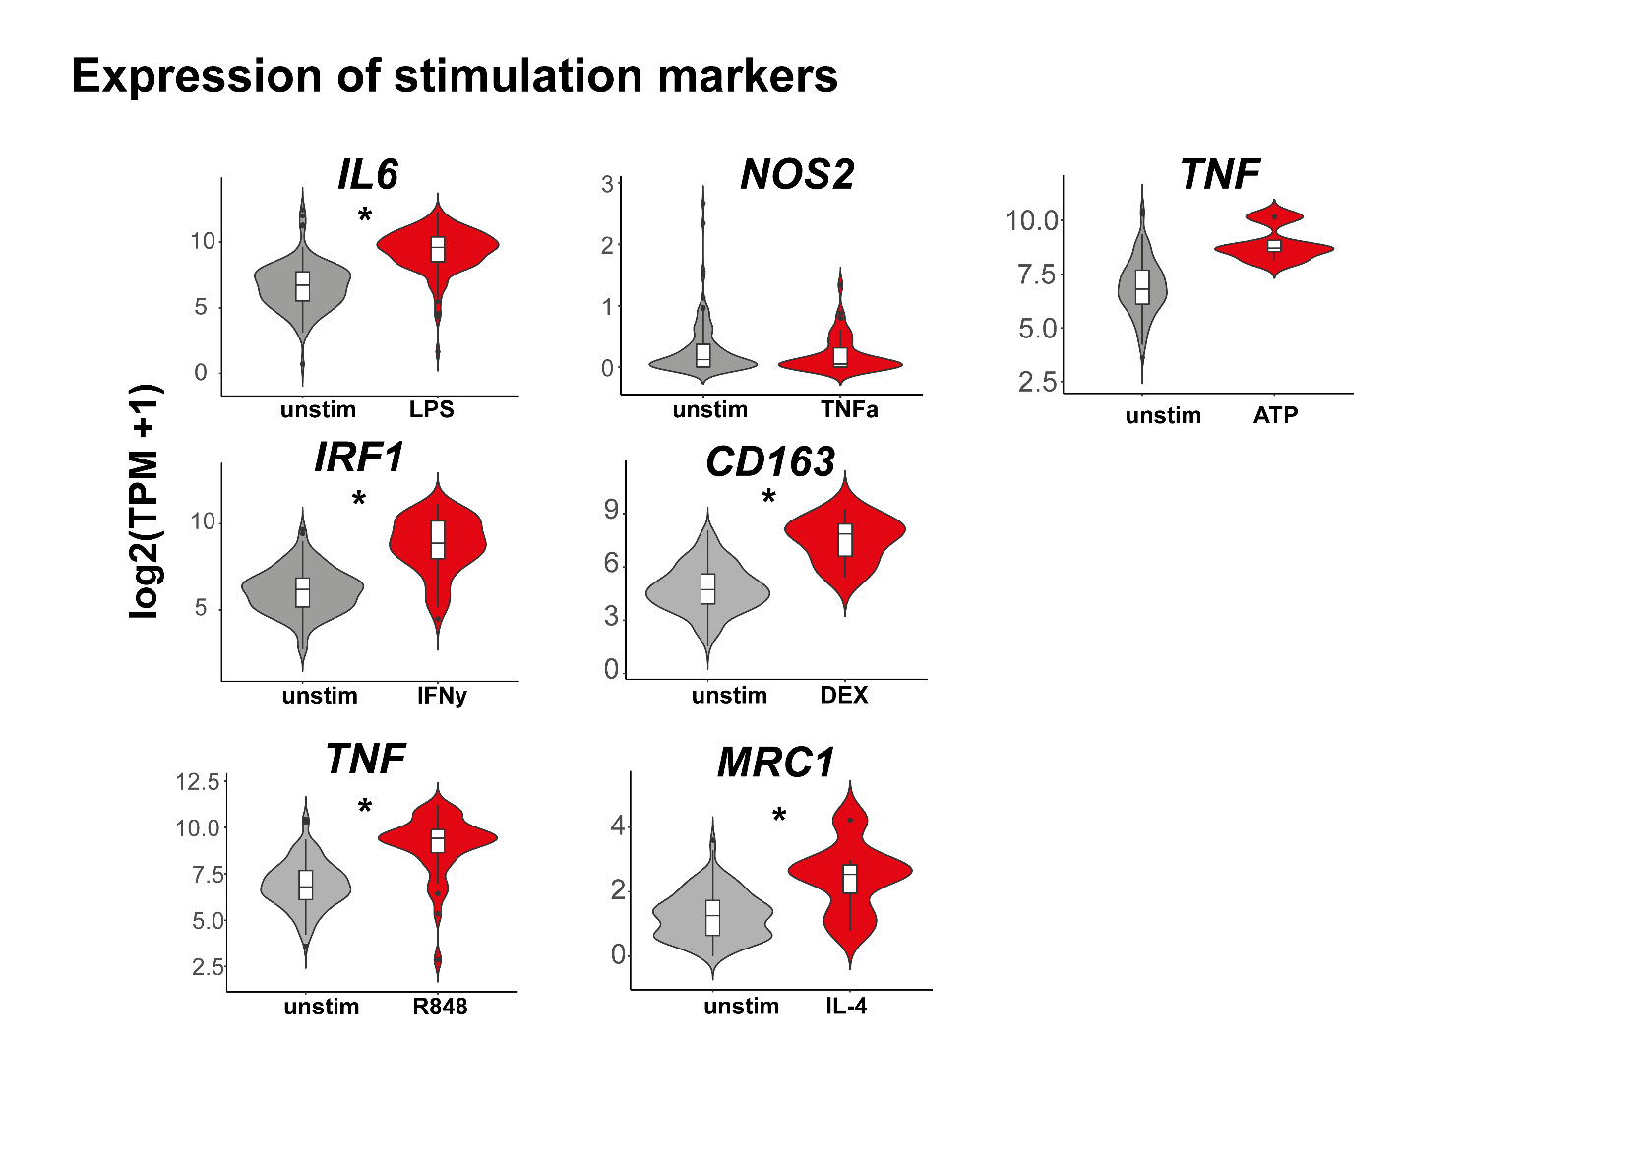
Supplementary Figure 1. Gene expression of well-known stimulation specific markers across different stimulations.
A) Violin plots depicting expression in transcripts per million (TPM) for representative (anti)-inflammatory genes IL6, IRF1, TNF, NOS2, CD163, MRC1, TNF that are known to be upregulated after stimulation with respectively LPS, IFNγ, R848, TNF-α, DEX, IL-4 or ATP in the stimulated compared to the unstimulated samples. * Statistical significance based on adjusted P-values (FDR) derived from the differential expression results.

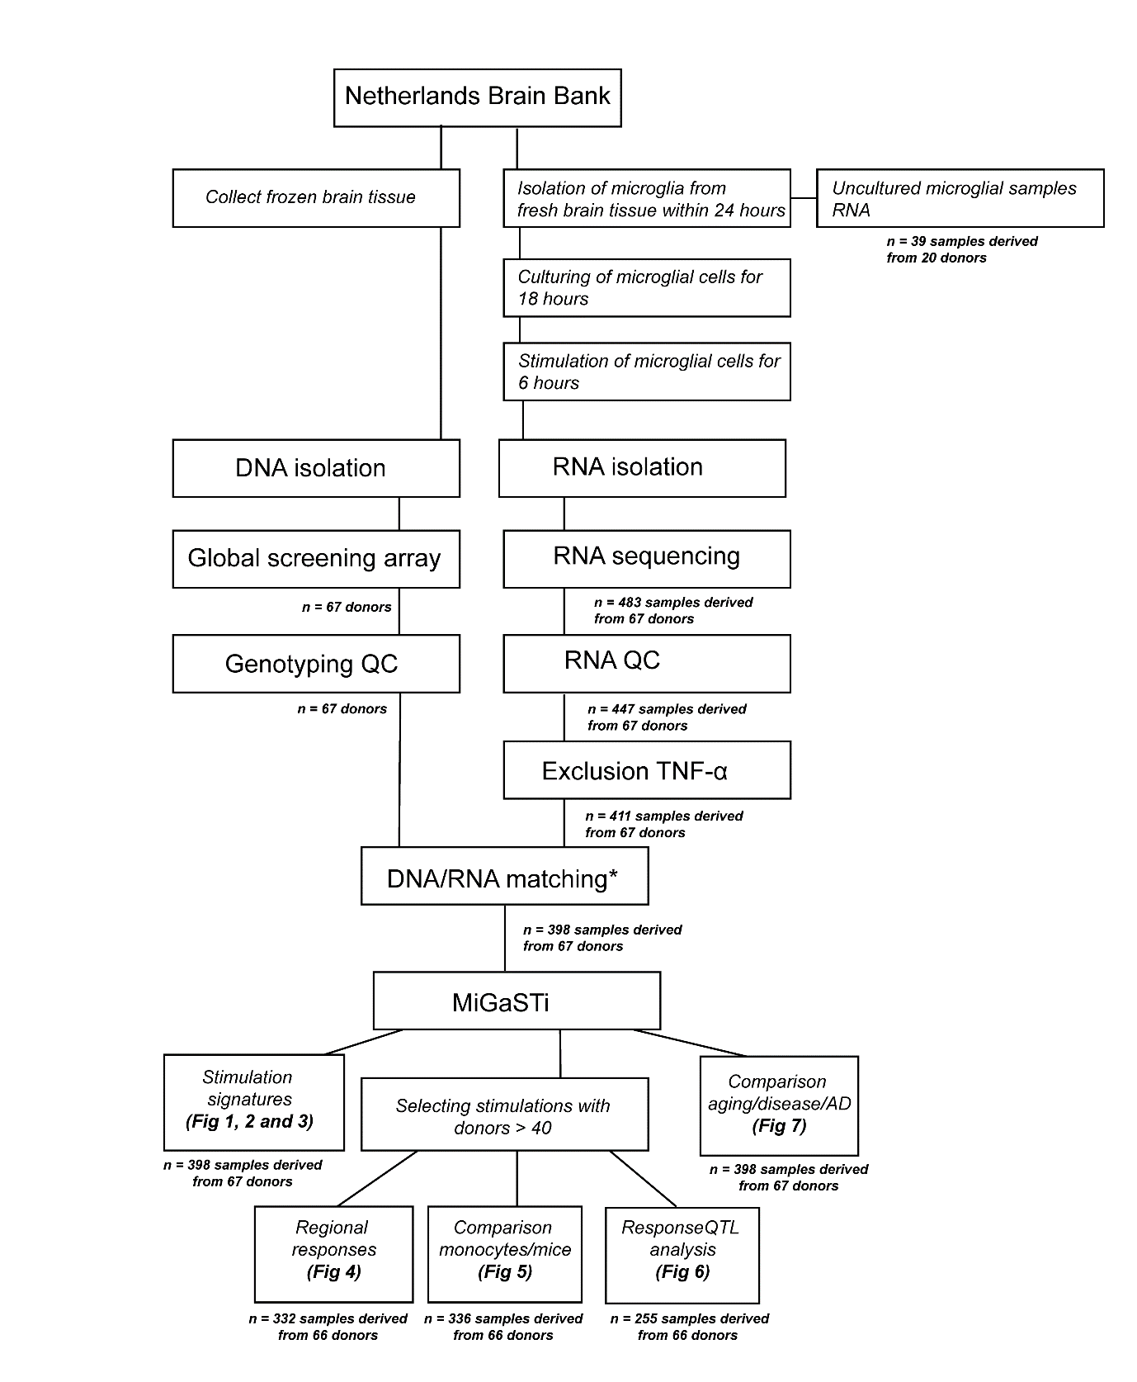
Supplementary Figure 2. Flowchart of quality control of the microglial samples
Abbrevations QC = quality control. * DNA-RNA sample matching using QTL tools- mbv measured by the percentage of concordance at heterozygous and homozygous genotypes.

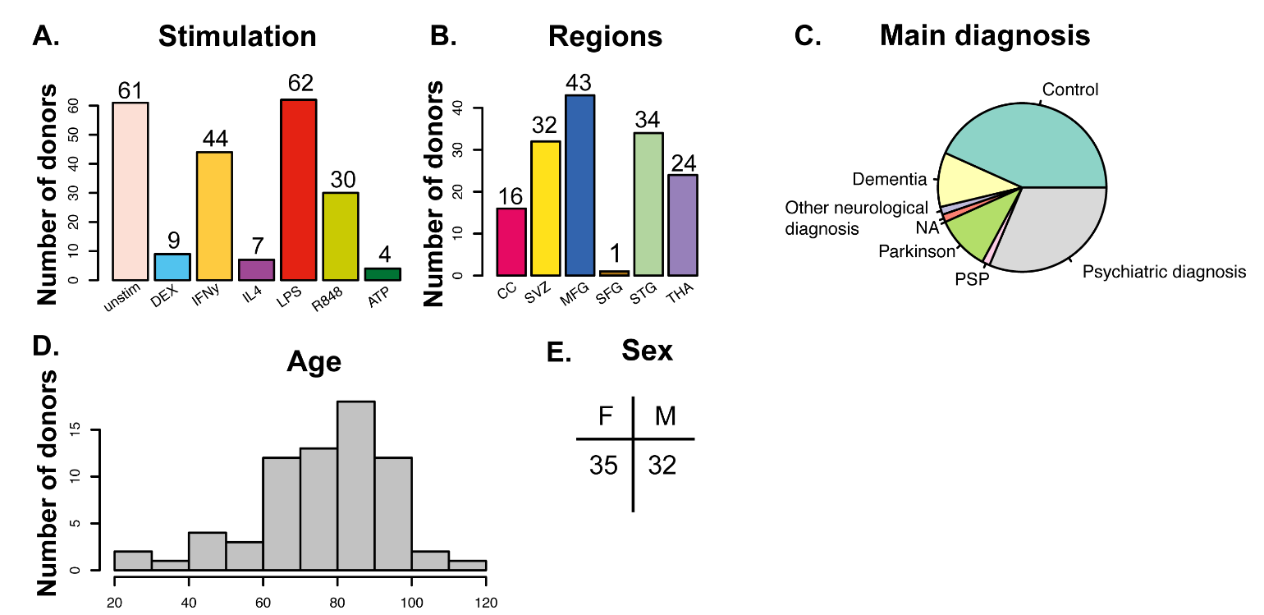
Supplementary Figure 3. Overview of the data.
A) Number of donors by stimulation. B) Numbers of donors by brain region. Each donor donated one up to five brain regions. C) Frequency of diagnosis. D) Age range of the 66 donors in this study. E) The numbers of female (F) and male (M) donors included. Abbrevations ATP: adenine triphosphate, CC: corpus callosum, DEX: dexamethasone, F: female, IFNγ: Interferon gamma, IL4: interleukin-4, LPS: lipopolysaccharide, M: male, MFG: medial frontal gyrus, NA: not applicable, PSP: progressive supranuclear palsy, R848: resiquimod, SFG: superior frontal gyrus, STG: superior temporal gyrus, SVZ: subventricular zone, THA: thalamus, unstim: unstimulated.

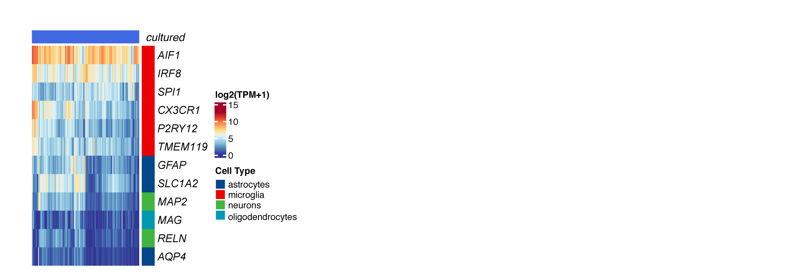
Supplementary Figure 4. Purity of cultured microglia samples.
Expression levels (TPM+1 log2 scale) of cell markers in 398 cultured microglial samples. Blue colors indicate low expression and red colors indicate high gene expression.

Supplementary Figure 5. Expression of known apoptotic markers and receptors for inflammatory triggers A) Heatmap depicting the average expression (TPM+1 log2 scale) of caspases and apoptotic cell markers for each stimulation separately compared to the cultured/uncultured condition. Clustering dendrogram is based on Euclidean distances. B) Expression levels (TPM+1 log2 scale) of known receptor markers for inflammatory triggers for cultured versus uncultured samples. Blue colors indicate low expression and red colors indicate high gene expression.

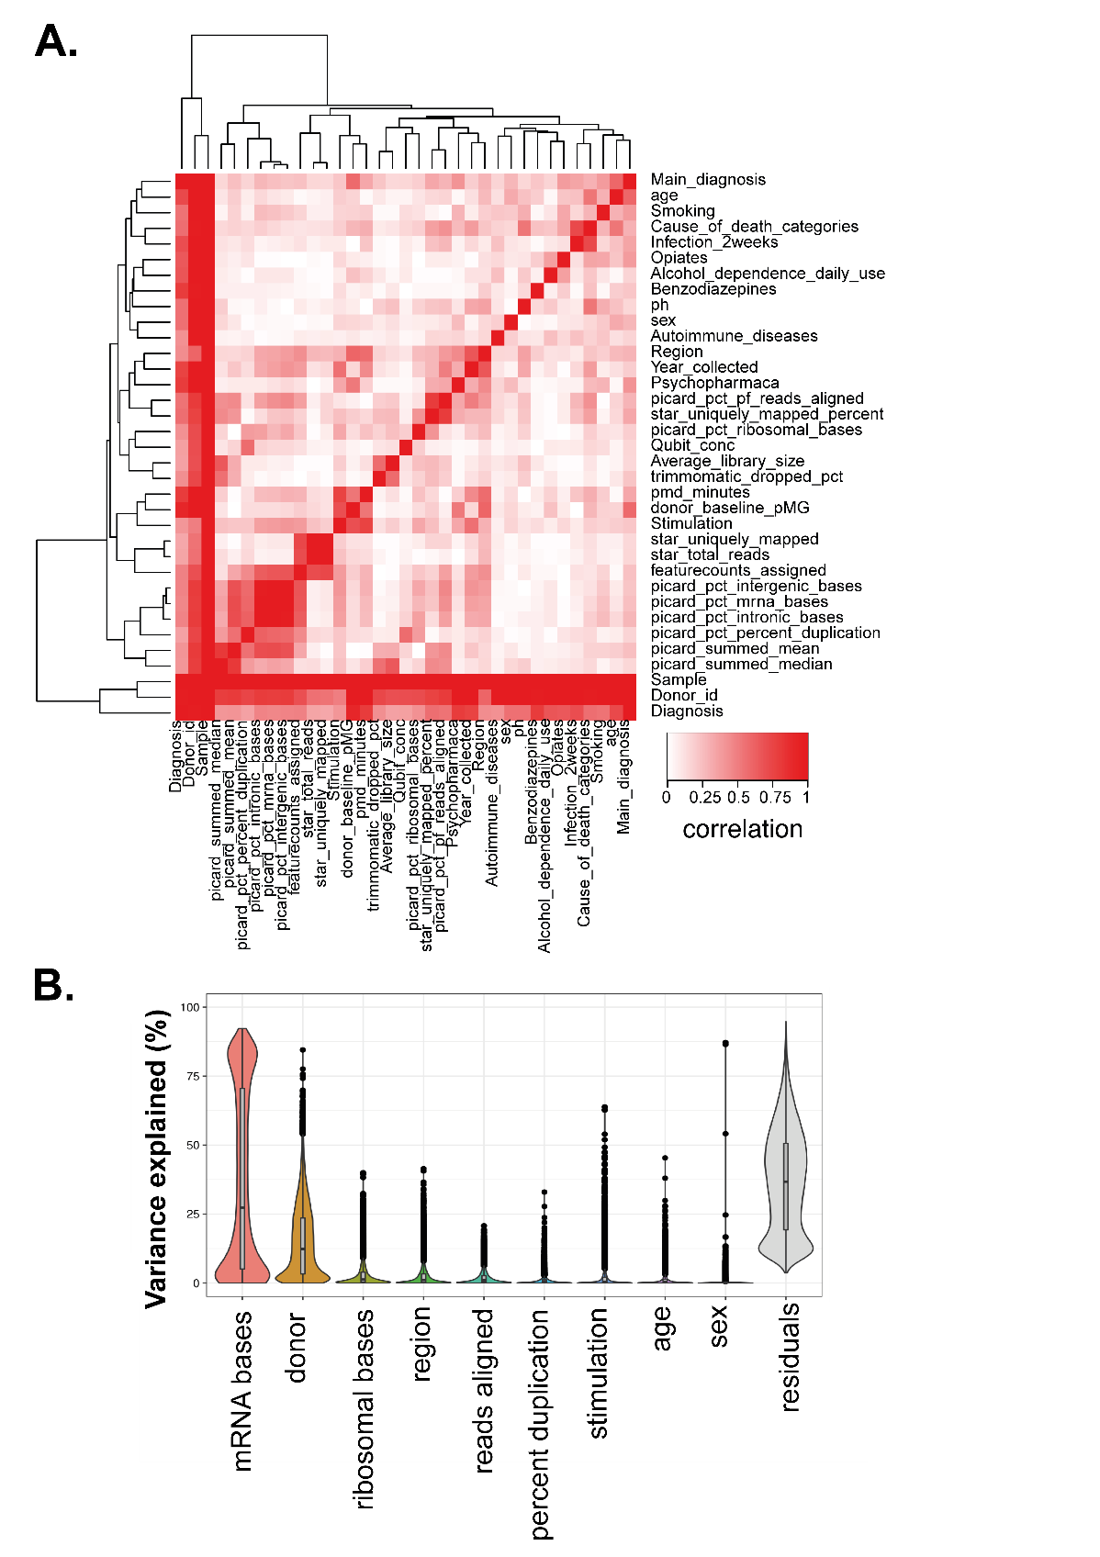

Supplementary Figure 6. Main sources of expression variation and correlation of covariates
A) Pairwise canonical correlation between the covariates. Red indicates high correlation; white indicates low correlation. B) VariancePartition computes variance explained per gene for each variable independently. Boxplots show the median, first and third quartile of the distribution. Jittered points are genes outside 1.5 times the interquartile range. More variance is explained on average by technical factors than clinical factors.

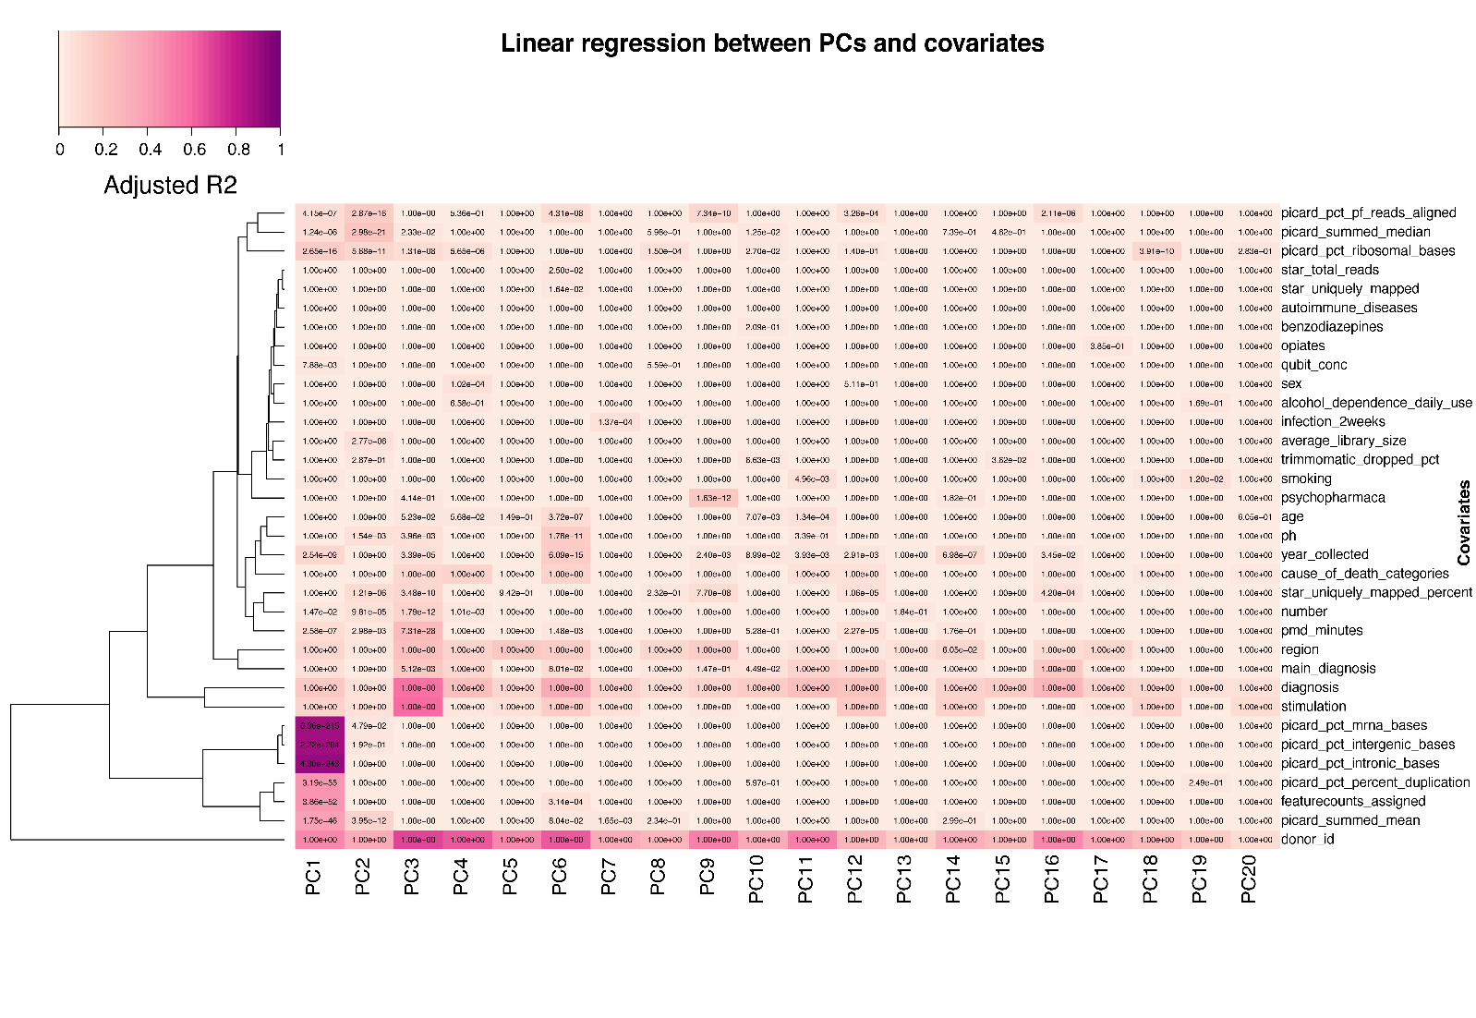Supplementary Figure 7. Sources of variation in the gene expression data Linear regression between the first 20 Principal Components (PCs) and the covariates. Colors correspond to the adjusted R-squared. The P-values are from the Linear regression, two-sided and Bonferroni adjusted.

Supplementary Figure 8. Principal component analysis (PCAs) after data adjustment. PCA after correction by regressing out technical confounders, colored by stimulation, age, brain region and sex. The plots show voom-TMM normalized expression for all 398 cultured microglia samples.

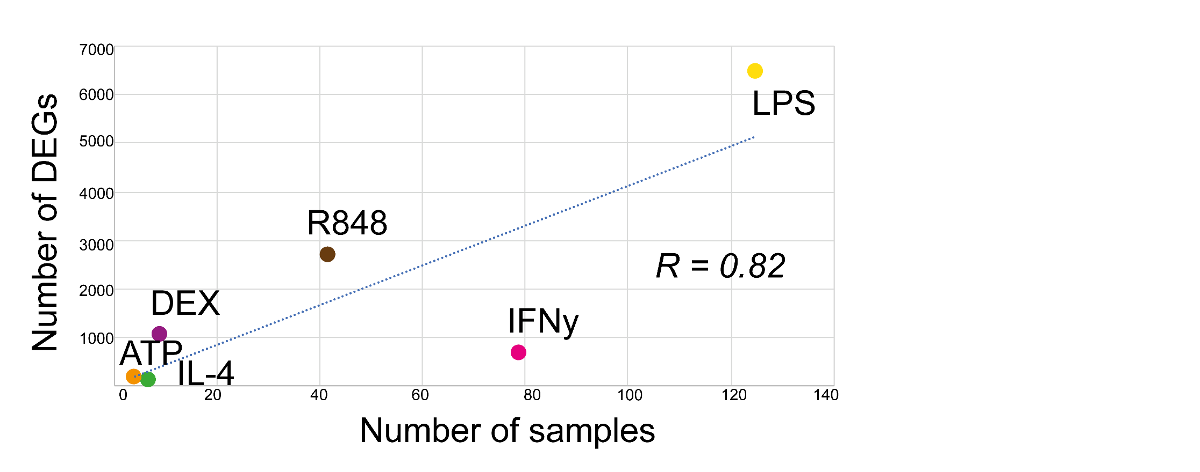

Supplementary Figure 9. Correlation number of samples and number of differentially expressed genes (DEGs). The linear correlation is calculated with Pearson correlation coefficient (R). Abbrevations. ATP: adenine triphosphate, DEX: dexamethasone, IFNγ: Interferon gamma, IL4: interleukin-4, LPS: lipopolysaccharide, R848: resiquimod.

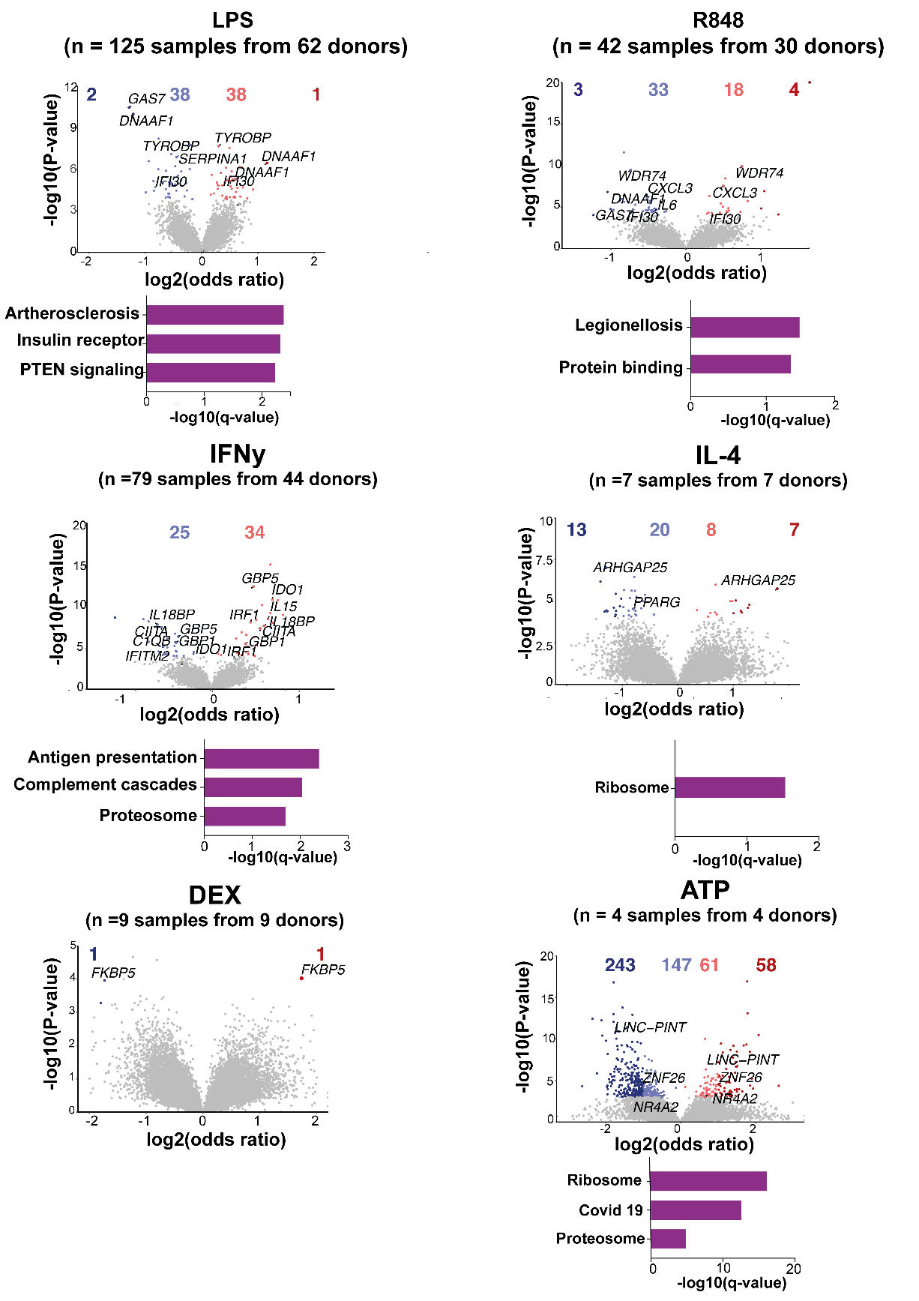
Supplementary Figure 10. Differential transcript usage (DTU) across stimulations. Volcano plots comparing stimulated microglia to controls in all donors. Genes colored by whether or not differentially expressed (empirical FDR < 0.05; grey), differentially expressed but with modest effects ( | odds ratio | 1; orange/blue) and with stronger effects ( | odds ratio | > 1; red/dark blue). Numbers of genes in each category above the plot. Genes related to Alzheimer's disease or stimulation response genes are highlighted. Functional enrichment analyses of all differential expressed genes using IPA or gProfiler2. Significantly enriched terms are shown with q-value 0.05.

 | LPS |  | IFNy |  | R848 |  | IL4 |  | DEX |  | ATP
Tissue | FDR 5% | logFC |1| | FDR 5% | logFC |1| | FDR 5% | logFC |1| | FRD 5% | logFC |1| | FDR 5% | logFC |1| | FDR 5% | logFC |1|
MFG | 376 | 153 | 155 | 6 | 31 | 13 | 622 | 542 | 49 | 47 | 134 | 134
SFG | 44 | 18 | 62 | 59
THA | 226 | 95 | 66 | 61
SVZ | 1895 | 452 | 292 | 178
CC | 90 | 95 | 76 | 67 | 708 | 176

Supplementary Figure 11. Number of differentially expressed genes across brain regions in different stimulations. Abbrevations ATP: adenine triphosphate, CC: corpus callosum, DEX: dexamethasone, FDR: false discovery rate, IFNγ : Interferon-gamma, IL4: interleukin-4, logFC: log fold change, LPS: lipopolysaccharide, MFG: medial frontal gyrus, R848: resiquimod, STG: superior temporal gyrus, SVZ: subventricular zone, THA: thalamus,

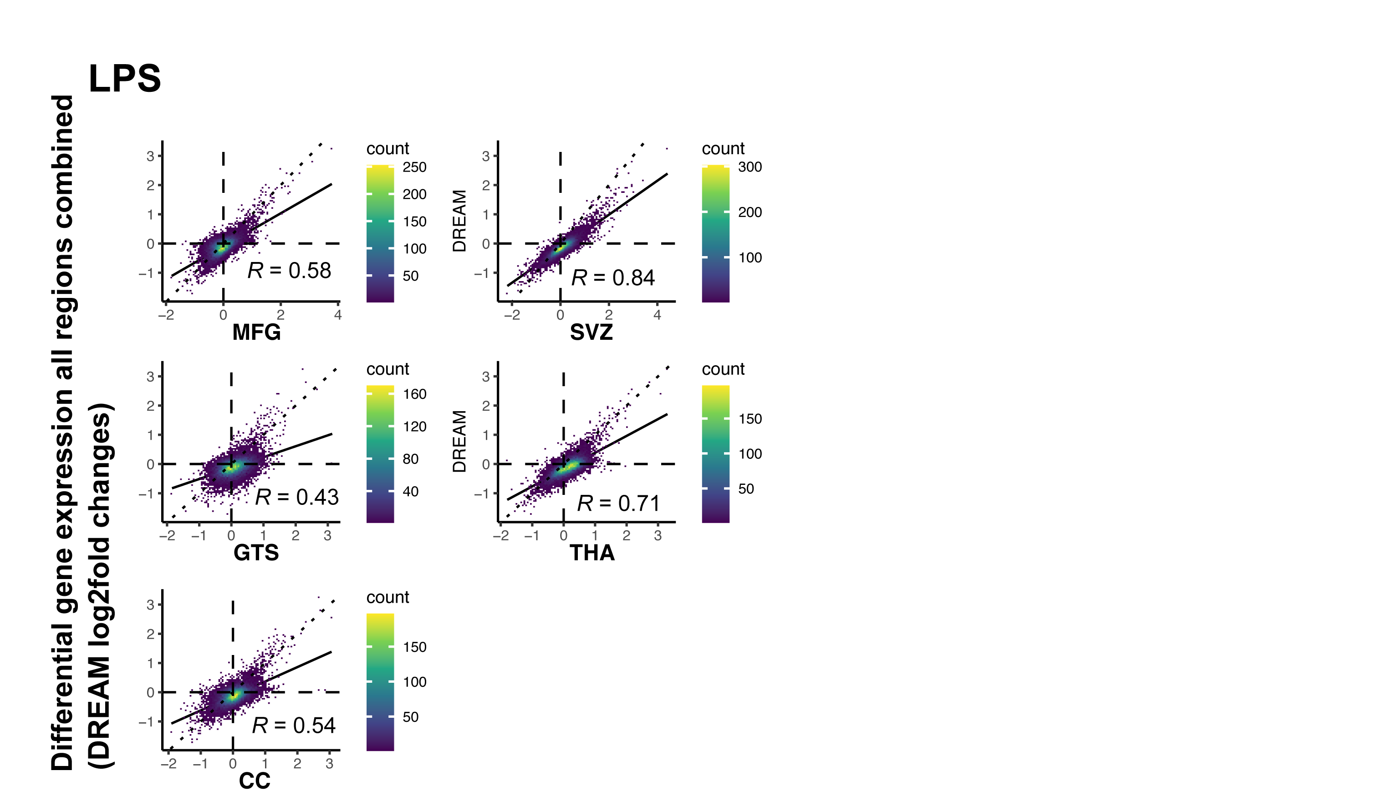

Supplementary Figure 12. Correlating differential gene expression between each brain region separately and all brain regions combined in LPS.
Scatter plots showing pairwise correlations in LPS between differential gene expression results of each brain region separately and all brain regions combined of log₂ fold changes using Pearson correlation. Individual points are genes, color refers to density of overlapping points.

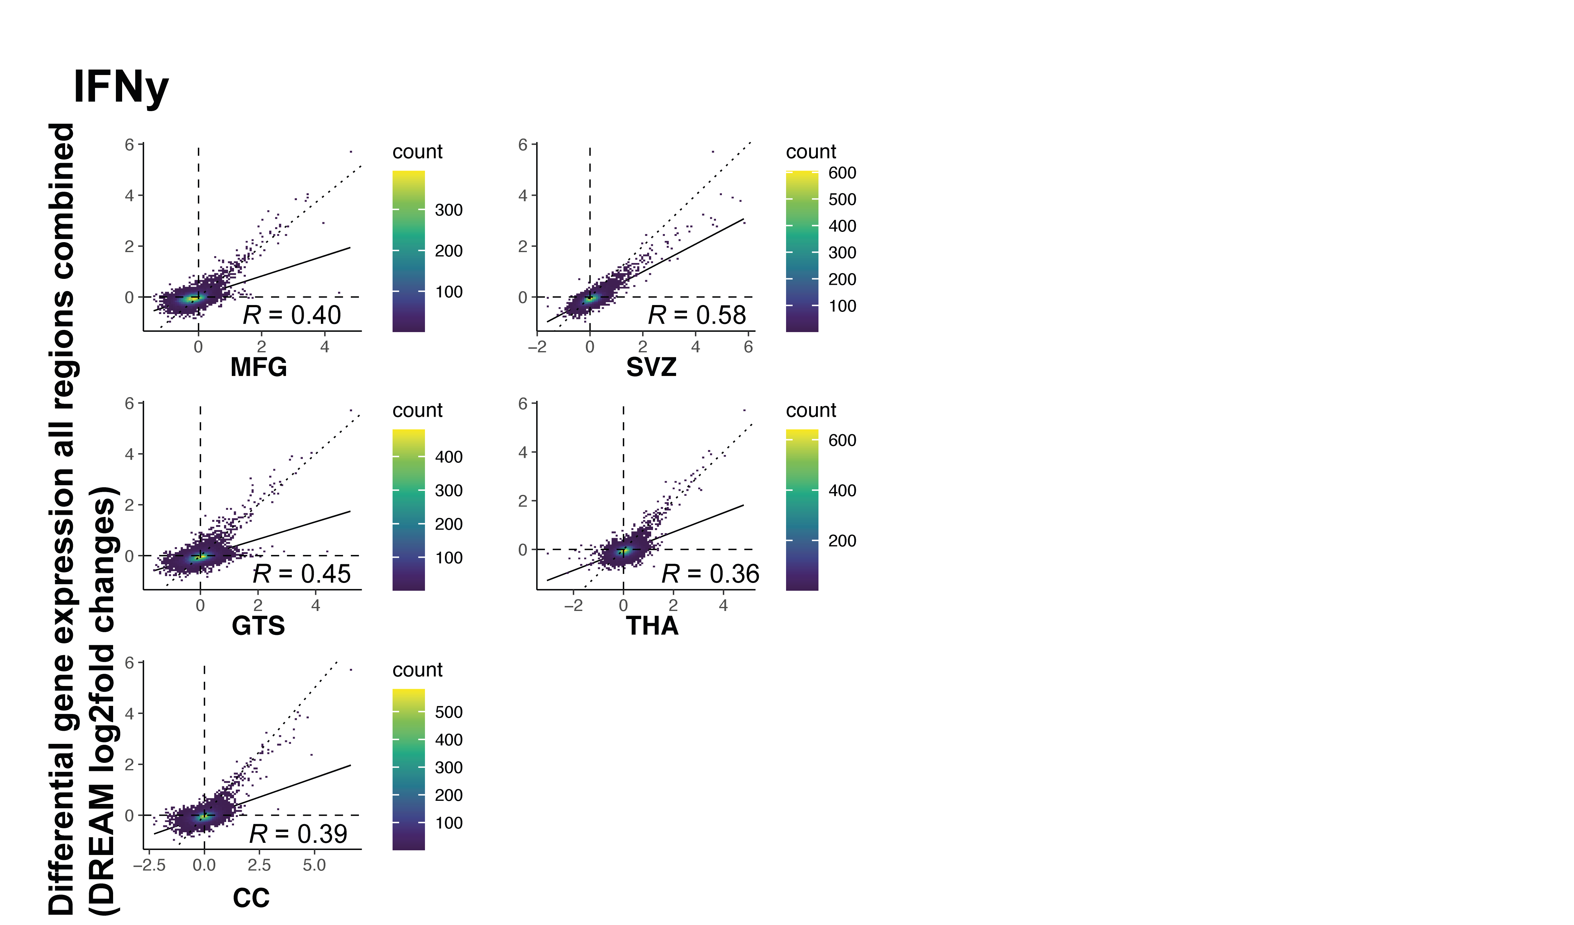

Supplementary Figure 13. Correlating differential gene expression between each brain region separately and all brain regions combined in IFNγ.
Scatter plots showing pairwise correlations in IFNγ between differential gene expression results of each brain region separately and all brain regions combined of log₂ fold changes using Pearson correlation. Individual points are genes, color refers to density of overlapping points.
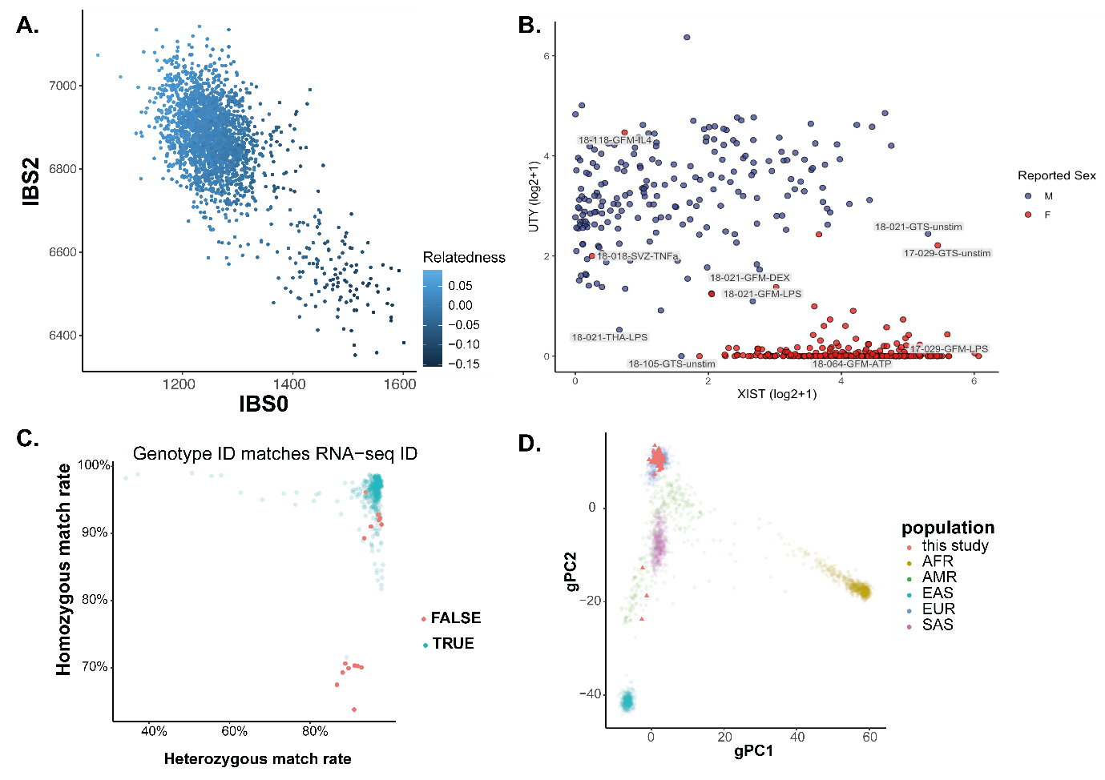

Supplementary Figure 14. Genotyping QC.
A) Relatedness estimates from Somalier. B) Log scaled expression (voom) of sex chromosome genes (UTY and XIST) for each donor colored by reported sex (blue = male, red = female) C) DNA-RNA sample matching using QTLtools- mbv measured by the percentage of concordance at heterozygous and homozygous genotypes. Samples in red failed to match ids between each data. D) First two ancestry principal components of MiGASTi samples (red squares) on top of 1000 Genome individuals colored by major populations. African [AFR], Admixed American [AMR], East Asian [EAS], European [EUR], South Asian [SAS]

Supplementary Figure 15. responseQTL discovery rate with different numbers of principal components.
Upper panel - number of genes with an reQTL at qvalue < 0.05 in LPS and PC threshold. Lower panel - number of genes with an reQTL at qvalue < 0.05 in IFNγ and PCthreshold.

Supplementary Figure 16. Mapping response cis-eQTLs (reQTLs) in microglia stimulated with LPS. Boxplots show interaction between genotype and stimulation on residualized gene expression levels. q refers to adjusted P-value following correction for numbers of tested variants and genes.

Supplementary Figure 17. Mapping response cis-eQTLs (reQTLs) in microglia stimulated with IFN-γ. Boxplots show interaction between genotype and stimulation on residualised gene expression levels. q refers to adjusted P-value following correction for numbers of tested variants and genes.

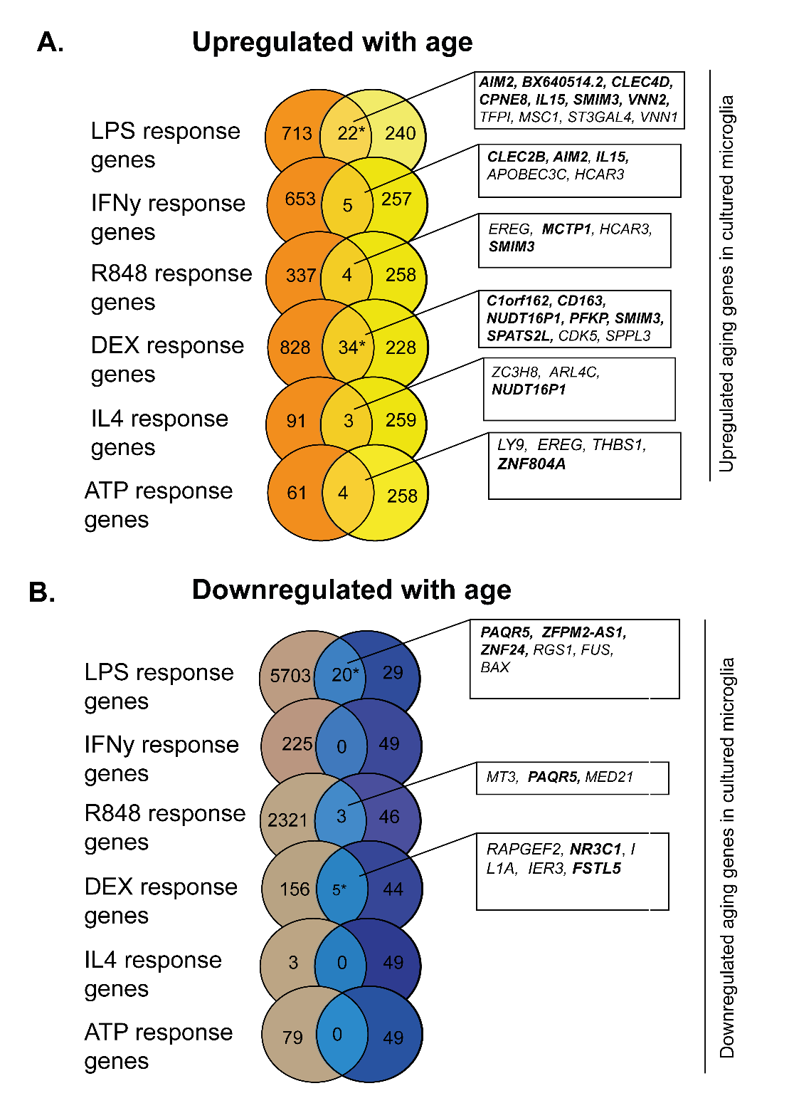

Supplementary Figure 18. Overlap of age-related genes and stimulation response genes in MiGASTi. Enrichment analysis between differentially expressed aging genes with stimulation response genes in MiGASTi. A) *Upregulated in age between LPS and DEX in MiGASTi. Asterisk indicates significant enrichment by a one-sided Fisher’ exact test (upregulated LPS: OR 2.4, p < 0.0001), upregulated DEX: OR 3.4, p < 0.0001) Genes highlighted in bold were replicated upregulated aging genes in MiGA (Lopes et al. 2022) B) Downregulated in age between LPS and DEX. Asterisk indicates significant enrichment by a one-sided Fisher’ exact test (downregulated LPS: OR 1.7, p = 0.04, downregulated DEX: OR 14.4, p < 0.0001). Genes highlighted in bold were replicated aging genes in MiGA (Lopes et al. 2022).

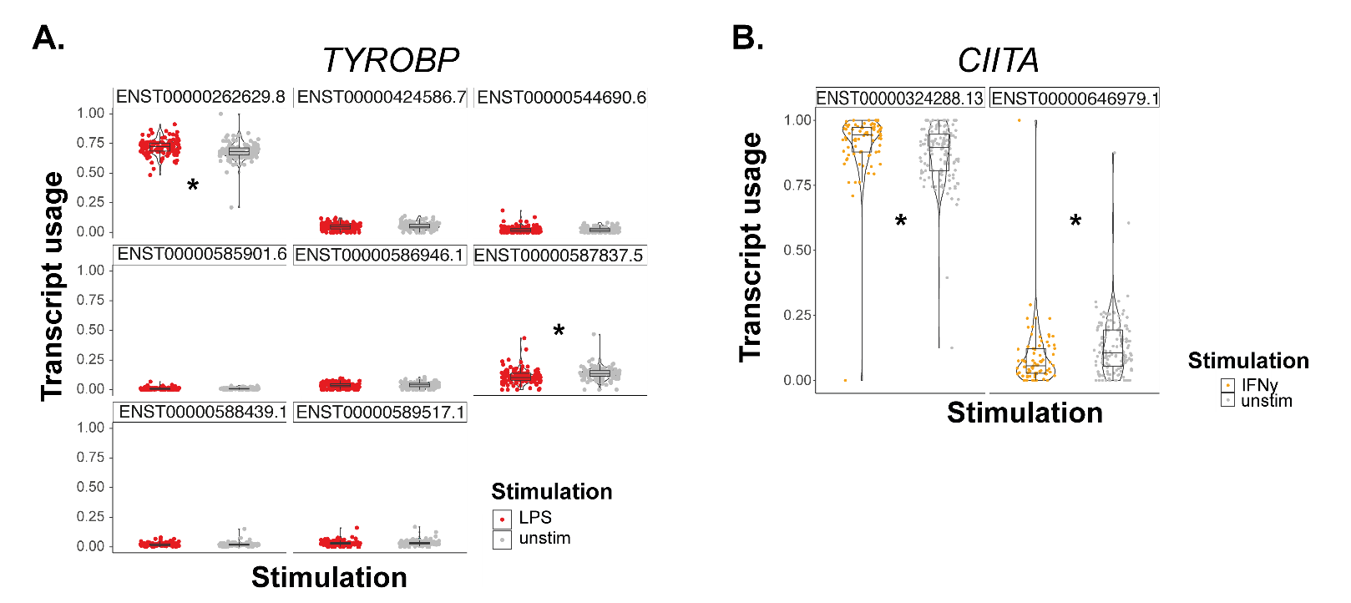

Supplementary Figure 19. Differential transcript usage in LPS and IFNγ. A) Example transcript usage of TYROBP in LPS. Asterisks indicate significance. The DTU signal is driven by a decrease respectively increase in the transcripts ENST00000292629.8 and ENST0000057837.5. B) Example transcript usage of CIITA in IFNγ. Asterisks indicate significance. The DTU signal is driven by a significant decrease respectively increase in the transcripts ENST00000324288.13 and ENST00000646979.1.

References:

Lopes, Katia de Paiva, Gijsje J. L. Snijders, Jack Humphrey, Amanda Allan, Marjolein A. M. Sneeboer, Elisa Navarro, Brian M. Schilder, et al. 2022. “Genetic Analysis of the Human Microglial Transcriptome across Brain Regions, Aging and Disease Pathologies.” Nature Genetics 54 (1): 4–17.

